reference: TUN1807.3

30 July 2018

Dear resident / business owner

REMINDER: Traffic changes, Whitehall Street from Monday 6 August, 2018
The West Gate Tunnel Project will be starting works in your local area to divert and upgrade a section of the North Yarra Main Sewer from the week commencing from Monday 6 August 2018, for approximately 12 months. This work is required before we start tunnelling in 2019.

Whitehall Street detour via Leek Street, Hyde Street and Somerville Road
In order to complete this work, traffic conditions on Whitehall Street, near Somerville Road, will change for up to 12 months. Southbound traffic will be maintained and all northbound traffic will detour on Leek Street, Hyde Street and Somerville Road.

Please refer to the North Yarra Main Sewer Project Fact Sheet that was delivered by Friday 6 July, for a detailed overview of the changes on Whitehall Street, detour route and what you are likely to expect when these works commence from Monday 6 August. Please contact us if you did not receive your copy of the fact sheet.

This detour has been confirmed after considering feedback from residents and businesses, detailed traffic studies and safety assessments. Using this detour route enables us to:
- maintain a direct route for southbound traffic; and
- detour only half of Whitehall Street traffic, limiting the impact on the detour route.

Working hours
- To help reduce disruption to traffic and local businesses, setting up the work zone will take place mostly during the night.
- Once established, construction will take place behind safety barriers, 24 hours a day, 7 days a week.

What to expect
To set up the work zone before 6 August we will:
- be working at night on Leek, Hyde, Somerville and Whitehall Streets (along the detour) with short term road and lane closures at times to change and install new traffic signs, signals, line marking for the long term detour; and
- lift concrete barriers into place to separate the work zone from traffic.
Once the work zone is in place, we will:
- remove asphalt using saw cutters and excavators;
- excavate a 9 and 15 metre shaft to access the existing sewer; and
- connect the new section of sewer with the existing sewer.

There will be no disruption to sewerage services during these early works.

During works
There will be disruptions in the local area, including:
- detours for vehicles, cyclists and pedestrians;
- temporary changes to the existing truck curfew on Hyde Street, between Leek Street and Somerville Road, during daytime hours 8am-6pm (the night time curfew will remain in place and all of the curfews will be reinstated when the sewer works are complete);
- parking along sections of the detour route will be unavailable (refer to detour map below);
- disruption to traffic on Whitehall Street due to lane closures, intersection changes and speed limit reductions; and
- new traffic signal lights at Leek and Youell Streets.

Detour map:

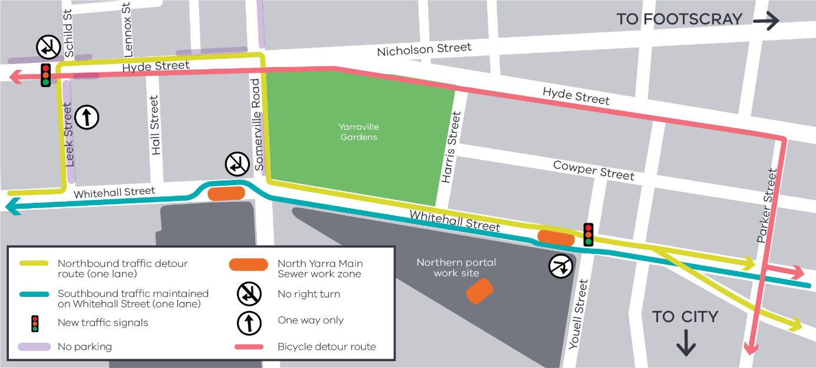
Managing construction

It is important these works and the ongoing traffic changes are actively managed to minimise disruption to the local community, businesses and road users. To do this, we will/have:
- provide clear signage and traffic controllers to safely manage changed traffic conditions;
- installed additional CCTV cameras and intelligent transport systems to monitor compliance;
- provide regular updates about works;
- work with local residents and businesses to minimise impacts; and
- monitor and manage environmental impacts such as dust, vibration and noise, including by:
  - scheduling disruptive works at times when fewer people are likely to be affected;
  - spraying water and using covers to manage dust;
  - monitoring vibration to ensure safe levels are not exceeded; and
  - monitor and alter traffic conditions as needed to maintain traffic flow, access and safety.

Providing feedback:

To help us manage the impacts we will be available to speak directly with at:

Kindred Studios, Harris Street, Yarraville
Wednesday 15 August, 2018
9 am – 11am

Please join us for a coffee and conversation.

For more information about the North Yarra Main Sewer works and traffic changes, please refer to the fact sheet or contact the project team as below.

Contact us

Please contact us if you have any questions or feedback about these works.
westgatetunnelproject.vic.gov.au | facebook.com/westgatetunnelproject
westgatetunnelproject@wda.vic.gov.au | @westgatetunnel
1800 105 105 | West Gate Tunnel Project  GPO Box 4509  Melbourne Victoria 3001
Interpreter service: 13 14 50

