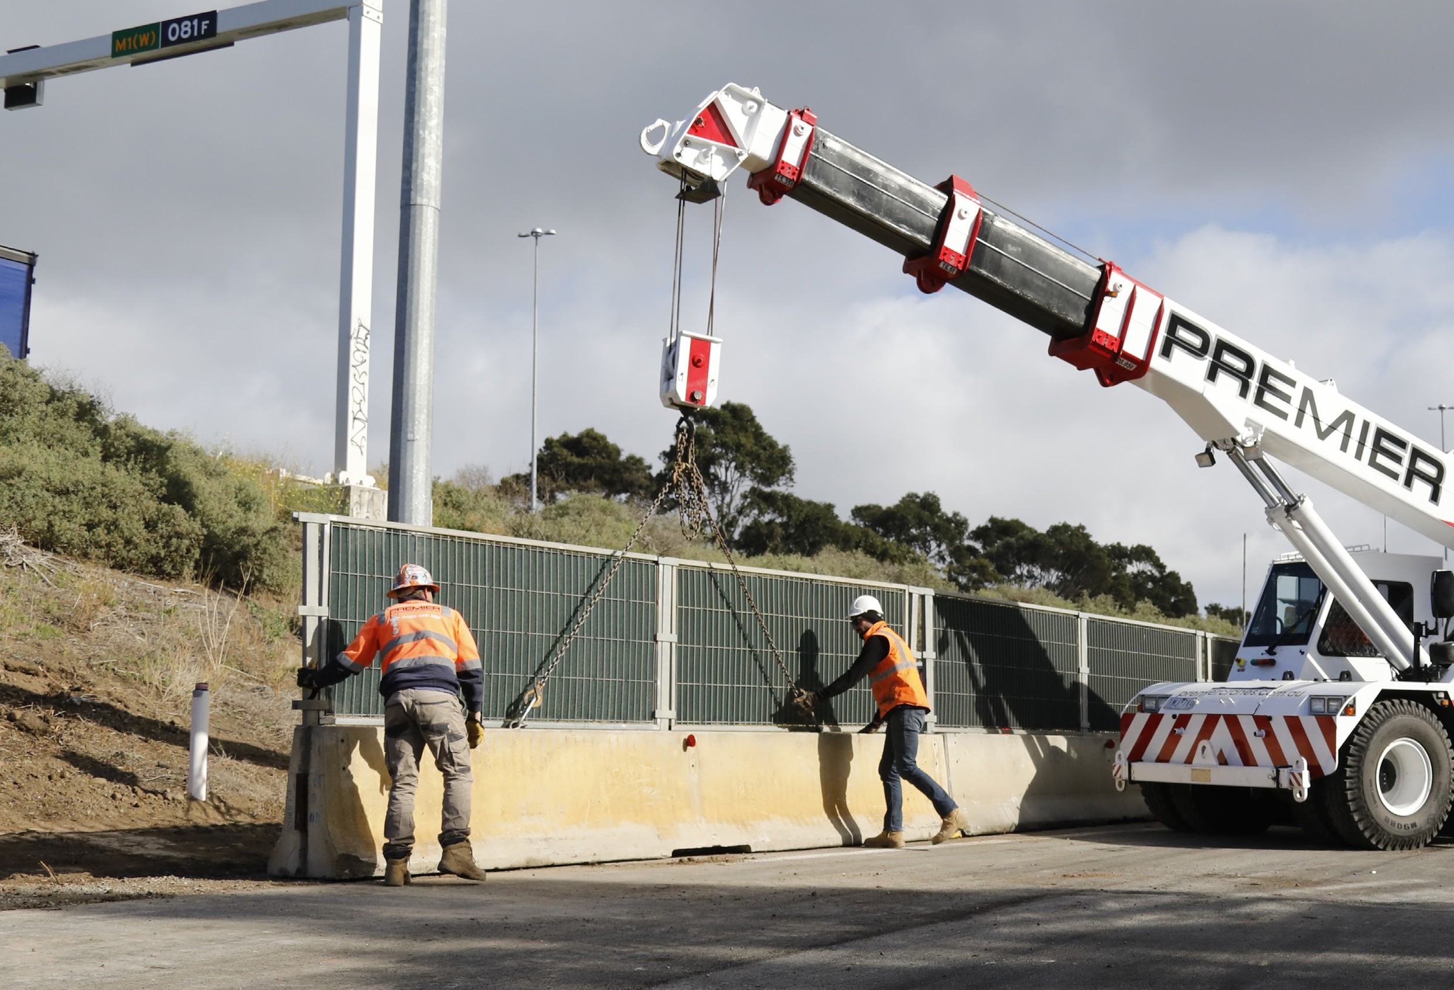



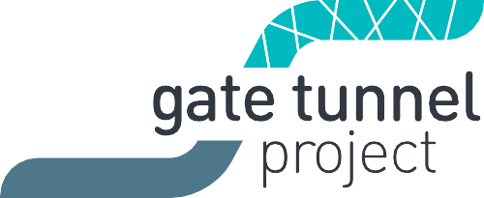



July 2018

# Macintosh HD: Jane:Transurban:Community Update in WORD:PICS:CU graphics for word.jpgWest Gate Freeway widening underway

### Over 800 traffic barriers are now in place between the M80 Ring Road and Williamstown Road, as work gets underway to add four extra lanes and two new tunnel portals to the freeway.

Drivers will have noticed increased construction activity behind the barriers from June, with West Gate Tunnel Project crews starting to excavate and level the earth and move underground utilities.

There will be temporary lane and ramp closures so crews can work safely, including some overnight freeway closures.

To plan ahead, see **westgatetunnelproject.vic.gov.au/ traveldisruptions**

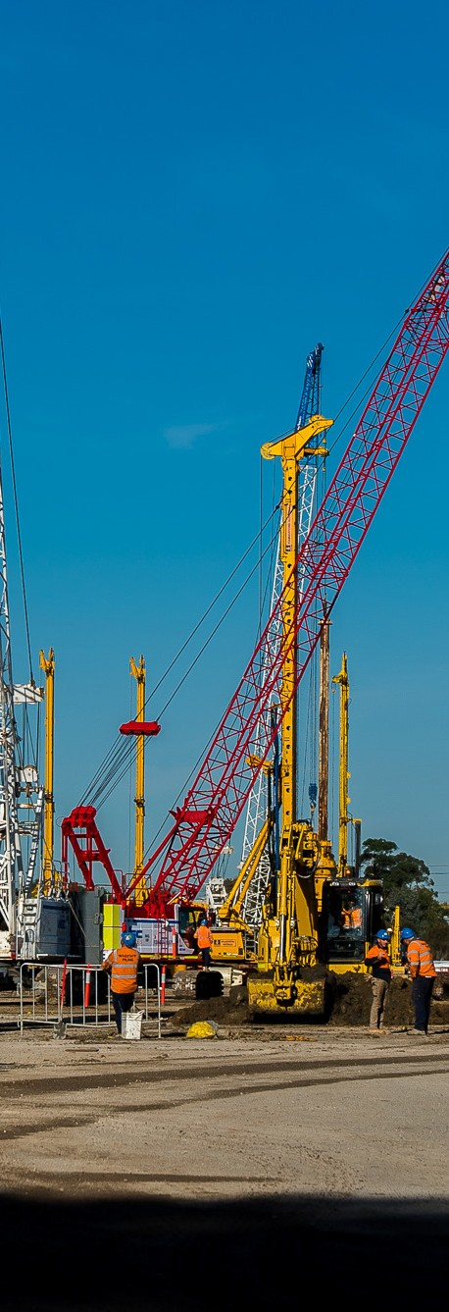Preparation for tunnel boring machine launch

### Construction is well underway at the northern portal site in Yarraville, with retaining walls now being built for the future tunnel entrance.

Piling rigs are inserting over 1,000 concrete and steel columns into the ground on either side of the tunnel entrance, before digging out the space in between.

The entrance will be 330 metres long,

40 metres wide and 22 metres deep at its deepest point. The project’s two tunnel boring machines will be built and launched from here after they arrive in Melbourne early next year.

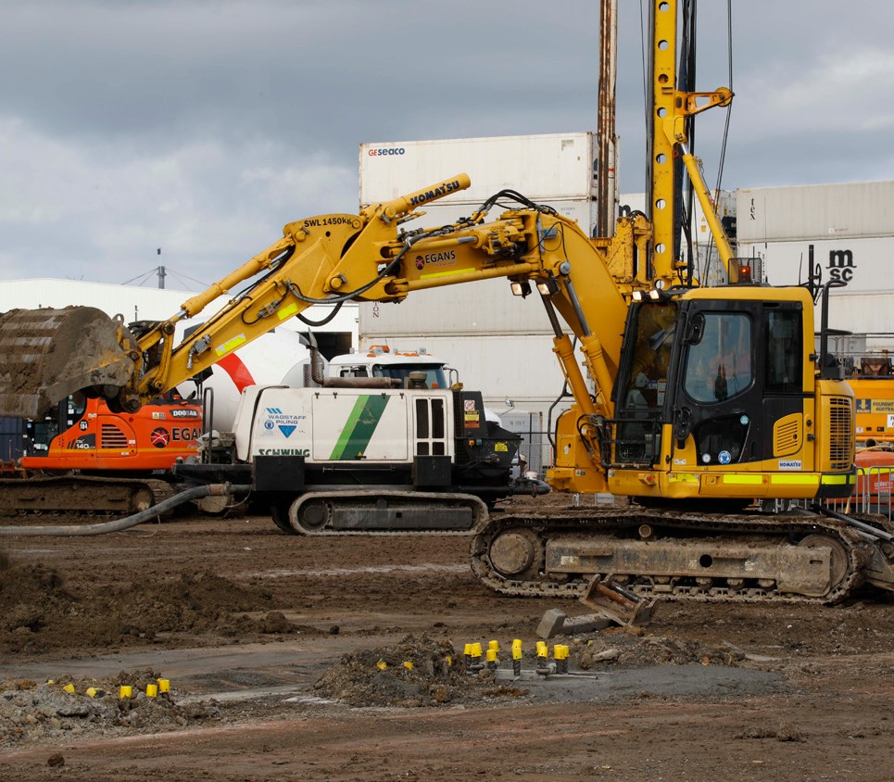

# Program of works

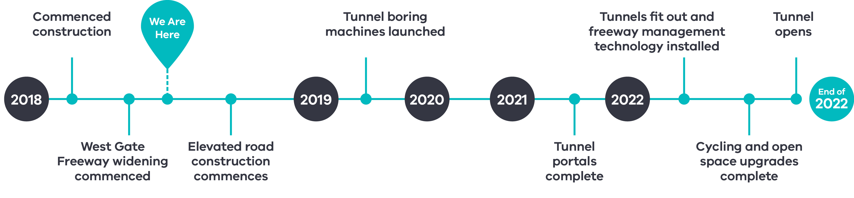

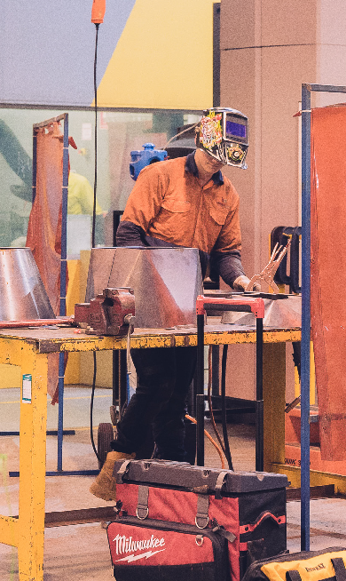Victoria University Polytechnic partners with the West Gate Tunnel Project

West Gate Tunnel Project’s construction contractor, CPB Contractors and John Holland Joint Venture, has partnered with Victoria University Polytechnic to help meet the growing demand for skills in the construction industry.

Under the new partnership, Victoria University Polytechnic will offer civil construction Certificate II, III and IV courses, giving young people more opportunities to learn the skills needed to build projects like the West Gate Tunnel.

To accommodate the additional training needs of the West Gate Tunnel Project, Victoria University Polytechnic has reopened its Werribee East campus as a Technology Precinct centred on Civil Construction.

Interested in working for the project? westgatetunnelproject.vic.gov.au/jobs

West Gate Tunnel Community Liaison Group kicks off

### The first meeting of the new Community Liaison Groups (CLG) have been held with new members welcomed and introduced to the project.

Two groups have been formed – a West CLG and a North CLG with over 25

representatives from suburbs in the west, inner west,

and community groups – doubling the community representation from the planning phase.

The groups build on the success of the planning phase Community Liaison Group which was

instrumental in advocating on behalf of the community.

The members will give an important local perspective on how the project is being delivered, provide a direct

avenue of communication between the community and the project team and share local information.

To learn more and find out how to get in contact with your local member go to westgatetunnelproject.vic. gov.au/clg



Upcoming works in your area

**Widening works are ramping up on the West Gate Freeway,** including the removal of overhead structures, light poles and vegetation along the freeway corridor.

The former   
**Melbourne Market**   
buildings on Footscray Road will be demolished to make way for a construction compound.

West Gate Tunnel Project staff enjoying a coffee at Kindred Cafe

## Supporting local businesses

To cater for the growing West Gate Tunnel Project workforce, which is expected to peak at 6000 people, the project has launched a new

initiative that allows businesses to advertise goods and services directly to workers.

The Workforce Trader Directory encourages project staff to shop local, supporting businesses along the project corridor from Docklands to Laverton.

The directory will be displayed at all West Gate Tunnel Project site offices and an electronic version will be available for workers so business details are right at their fingertips.

Businesses of all sizes are invited to register as soon as possible to make the most of this free service.

Interested businesses can register by emailing [traders@wgtp.com.au](mailto:traders@wgtp.com.au)

#### 

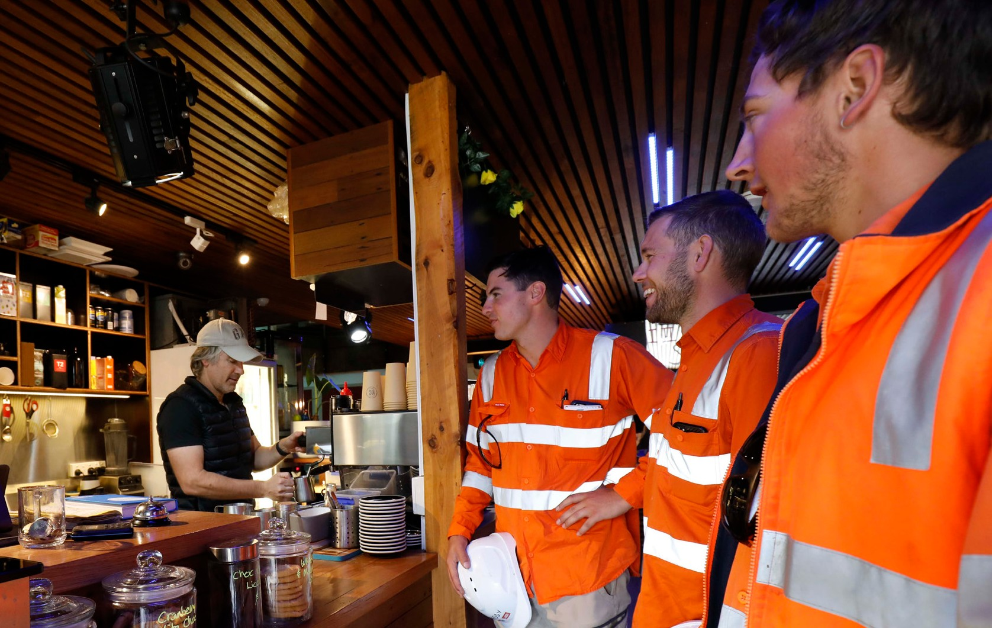

Contact us

The **relocation of   
the North Yarra Main Sewer** on Whitehall Street in Footscray/Yarraville will see traffic detours   
in the area for   
12 months.

**Do you have a question about the project? If you need more information or would like to provide feedback, please get in touch.**

westgatetunnelproject.vic.gov.au [westgatetunnelproject@wda.vic.gov.au](mailto:westgatetunnelproject@wda.vic.gov.au) 1800 105 105

facebook.com/westgatetunnelproject

@westgatetunnel

West Gate Tunnel Project

GPO Box 4509, Melbourne Victoria 3001

 Interpreter service: 13 14 50

If you are deaf, or have a hearing or speech impairment, contact us through the National Relay Service.

For more information, visit[: www.relayservice.gov.au.](http://www.relayservice.gov.au/)