WEST GATE TUNNEL PROJECT UPDATE

Summer construction works
Roadworks are set to ramp up across Melbourne this summer, delivering major infrastructure upgrades in Melbourne’s western suburbs.

ISSUE #16
DECEMBER 2020

Upcoming closures
- West Gate Freeway
Closed between the M80 Ring Road & Grieve Parade from Wednesday 6 January to Monday 11 January.
- M80 Ring Road to West Gate Freeway (inbound entry ramp) Closed from Monday 6 January to Tuesday 22 February.
- Princes Freeway to Geelong Road / Geelong Road to Princes Freeway ramps Closed from Monday 11 January to Tuesday 22 February.

We are taking advantage of the typically quieter time on Melbourne’s roads to carry out significant freeway widening works on the West Gate Freeway and the M80 interchange.
Works on the West Gate Tunnel Project will include demolishing and rebuilding sections of the Grieve Parade overpass and bridge upgrade works at the M80 interchange including realigning ramps and constructing new road pavement.
Starting from early January 2021 through to late-March, there will be major closures along the West Gate Freeway and further ramp closures at the M80, Geelong Road and Princes Freeway. Grieve Parade over the West Gate Freeway will also close for up to a week before being reduced to one lane in each direction over the freeway.
Motorists travelling between Geelong and Melbourne should avoid using the West Gate Freeway as there will be delays of up to 60 minutes. Allow plenty of travel time and check the latest advice on the Big Build website.
Motorists should also be aware of lane closures on the West Gate Bridge between Christmas and early January for annual maintenance works.
Roadworks zones are environments that change regularly, so please drive safely around sites to protect our workers, yourself, your passengers and other road users.

FOR MORE INFORMATION ON CLOSURES AND DETOURS VISIT
bigbuild.vic.gov.au

Image: Grieve Parade bridge that will be rebuilt this summer.

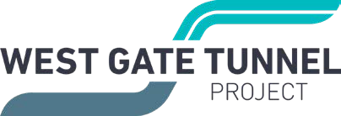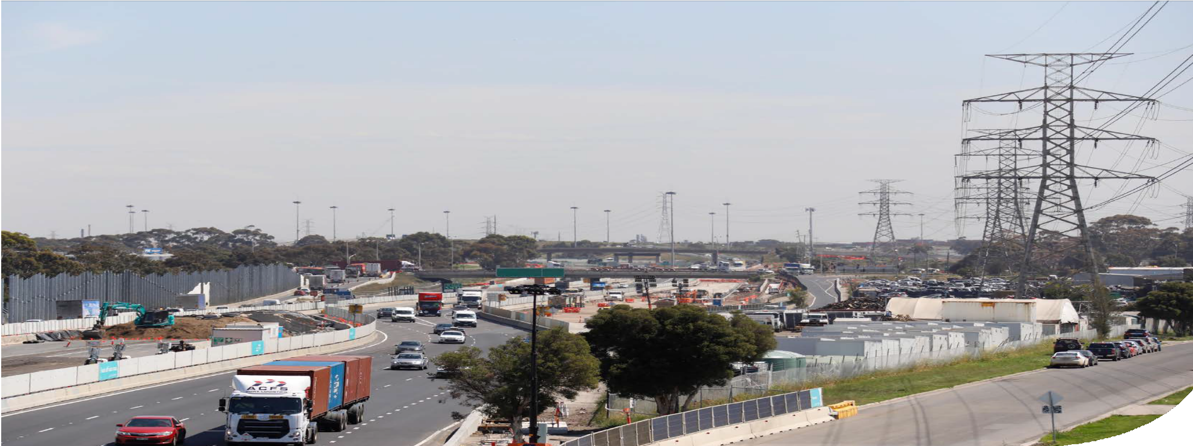


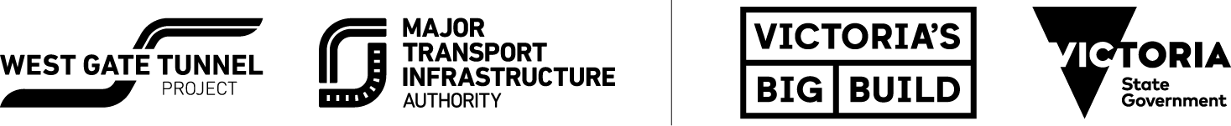

Authorised and published by the Victorian Government, 1 Treasury Place, Melbourne

2020: A YEAR IN REVIEW

Thanks for your patience during 2020 as we continued to build the West Gate Tunnel Project.
2020 has been a year like no other. While there has been less traffic on major roads during Coronavirus restrictions, crews have powered through to achieve some major construction milestones.

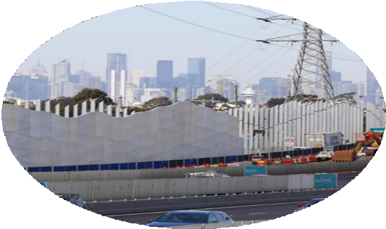
Noise wall installation near Williamstown Road exit.
West Gate Freeway
- Built 10 km of new lanes between the M80 and Williamstown Road and shifted traffic to create a new work area.
- Completed a new bridge across Newport Rail Line to widen the freeway.
- Installed more than 1.3 kilometres
of noise walls between Newport Rail Bridge and Williamstown Road.

Port to City
- Assembled and commissioned the Footscray Road launching gantry that will build a new elevated road connecting the West Gate Tunnel to CityLink and the CBD.
- Installed concrete precast columns at Footscray Road and near CityLink.
- Completed marine piling activities and installed concrete columns in the Maribyrnong River.

Tunnels
- Installed parts for the road, ventilation fan and roof levels at the northern portal.
- Completed construction of the roof deck and poured 35003 of concrete onsite at the citybound tunnel entrance on the West Gate Freeway.

Benalla
- Manufactured thousands of precast concrete products needed to build key infrastructure across the job including crossheads, columns, tunnel segments, barriers and noise walls.

Safer freeway crossings for the community

Two brand-new pedestrian overpasses recently opened connecting the suburbs of Altona North and Brooklyn and Yarraville and Spotswood.

The elevated road builder lifts road segments during testing.

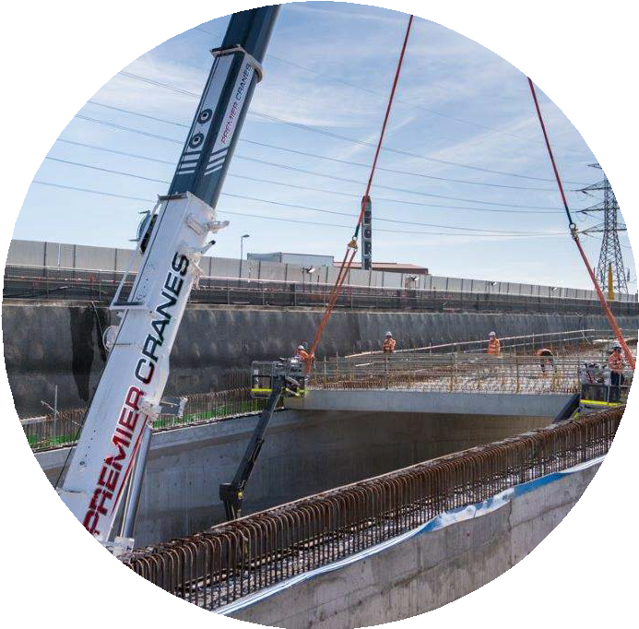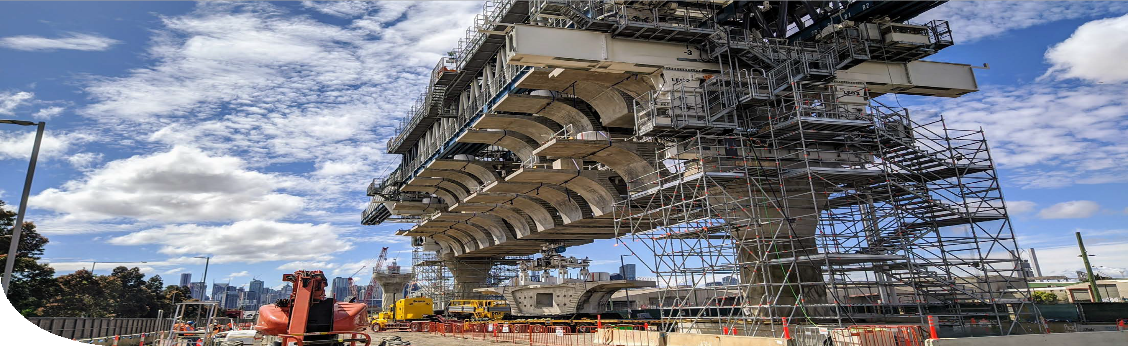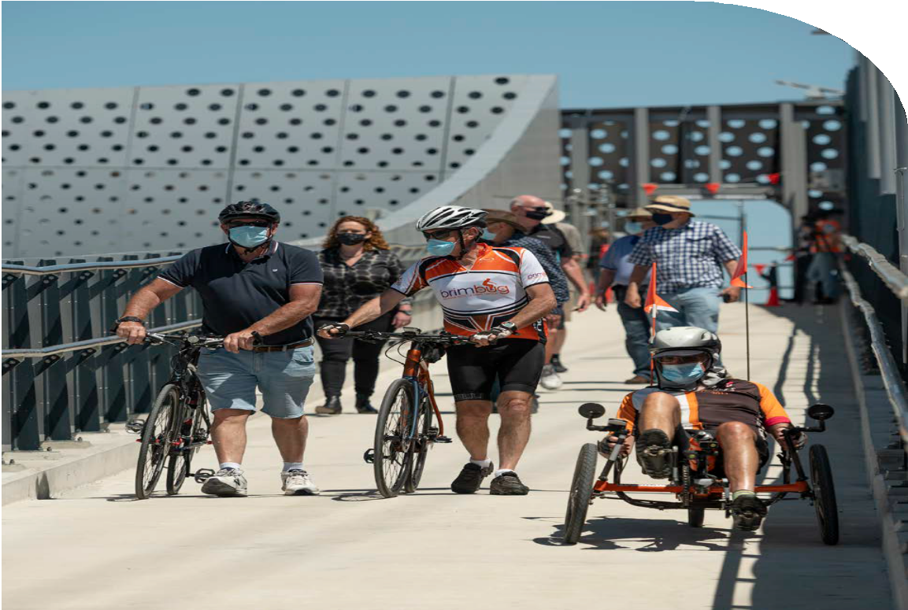Upcoming work in your area
Fast facts – launching gantry
12M WIDE
116M LONG
UP TO 40M HIGH
WEIGHS 1200 TONNES
The West Gate Tunnel Project's Community Liaison Group members using the new overpass linking Brooklyn and Altona North.
West
- Piling and constructing road pavement activities around Hyde Street and Williamstown Road to build the ramps from West Gate Freeway to Hyde Street.
- Ongoing noise wall installation.
Tunnels
- Continue excavation and roof deck installation activities at the outbound tunnel exit on the West Gate Freeway.
East
- Start building the elevated road along Footscray Road.
- Continue installing concrete columns along Footscray Road and the Old Melbourne Fish Market site next to CityLink to support the new elevated road.
- Start road widening and bridge building works at Wurundjeri Way.
- Continue constructing the new and improved walking and cycling bridge at Dynon Road.

Roof deck installation at the outbound tunnel exit on the West Gate Freeway.
The new modern structures have replaced the former 40-year-old structures to provide a safer and better way for pedestrians and cyclists to cross the West Gate Freeway.
The new overpasses have 5.5-metre- wide paths so pedestrians and cyclists can comfortably share the space, and improved safety features including CCTV, lighting and higher barriers.
For those with mobility needs, access has also been improved with the bridges having both steps and Disability Discrimination Act compliant accessible ramps on both sides of the West Gate Freeway.
While the overpasses were closed, a courtesy shuttle bus was provided to local residents to use to safely cross the freeway.

Broken down? Help is on the way
If you're heading away this New Year and will be using the West Gate Freeway or CityLink, keep this QR code and phone number handy.
We know it can be overwhelming to break down on the freeway, especially within a construction zone where emergency lanes aren’t always available.
So, if you find yourself on the West Gate Freeway,
don’t worry, here’s what you do:
- Put your hazard lights on
- Call incident response on 13 33 31
- Stay in your car and wait. Transurban’s incident response team is on their way to help you off the road safely.

Scan this code to watch

Transurban's incident response vehicle will assist you if you break down.

Make your voice heard by joining the West Gate Tunnel Project Community Liaison Group

Are you passionate about seeing positive outcomes in your local community? Get involved in the West Gate Tunnel Project’s Community Liaison Group.
There are two community liaison groups; one each for the west and north, which cover concerns relevant to their project area. The groups provide a way for community members to share local information and tell us how the project is tracking in the eyes of the community, while also hearing first-hand from our construction team about what’s happening and what’s coming up during construction. The two groups meet on alternate months meaning that members only attend a meeting once every two months.
If you are interested in getting involved and becoming a member, email us at
clg@wgta.vic.gov.au for an Expression of Interest form.

Columns to support new bridge structures across the Maribyrnong River.

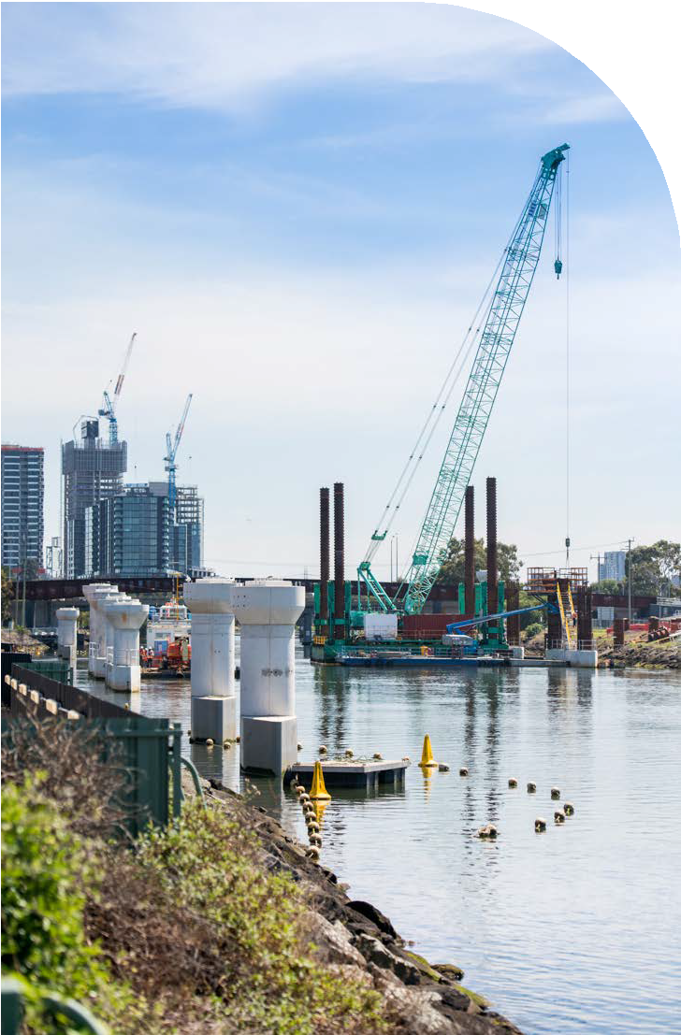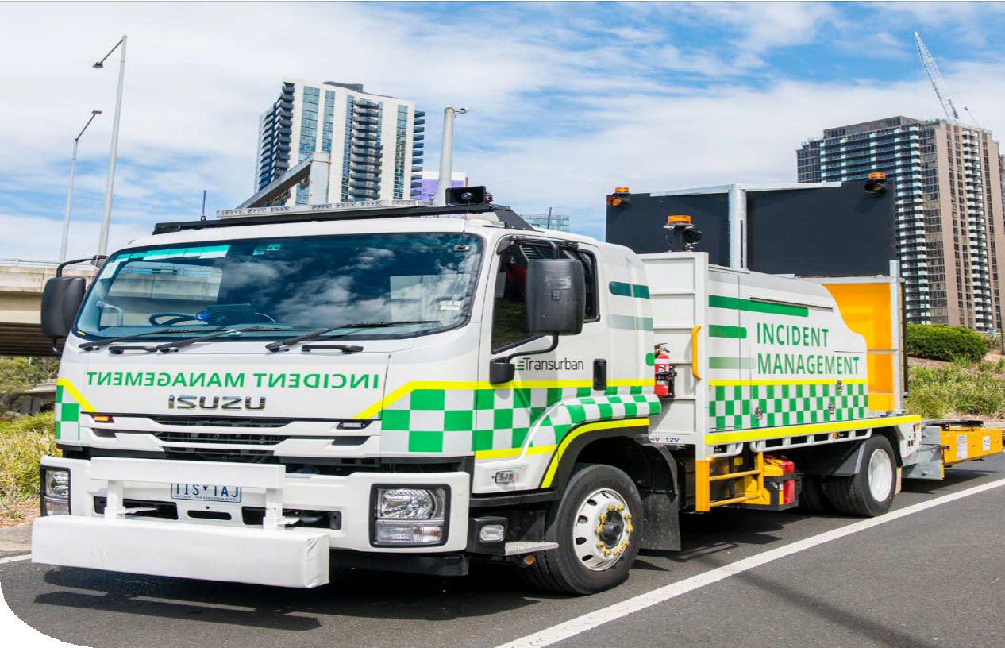CONTACT US
info@wgta.vic.gov.au 1800 105 105
West Gate Tunnel Project Info Centre Corner of Somerville Rd and Whitehall St Yarraville VIC 3013

Follow us on social media
Translation service – For languages other than English, please call 13 14 50.
Please contact us if you would like this information in an accessible format.
If you need assistance because of a hearing or speech impairment, please visit relayservice.gov.au

