WES1809.06

27 September 2018

##### **Start of works notification: Construction vehicle use of Kyle Road**

To make way for the widening of the West Gate Freeway and construction of the outbound tunnel portal, we will be establishing a construction site at the end of Kyle Road (near the freeway).

This means we will need to use Kyle Road to safely access our construction sites while we get on with delivering the West Gate Tunnel Project.

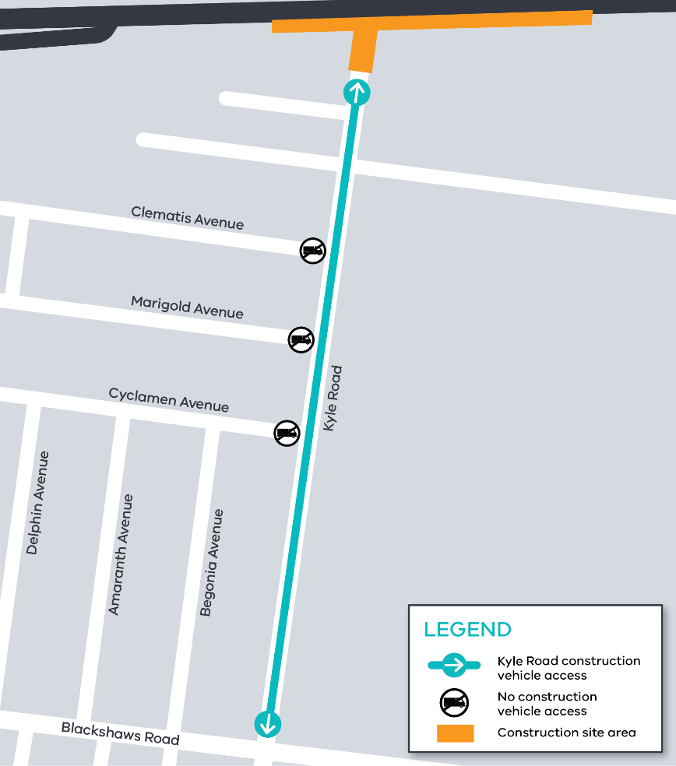Construction vehicles cannot use Clematis Avenue, Marigold Avenue and Cyclamen Avenue to access Kyle Road.

Where (see map on right):

* Kyle Road – entry and exit from Blackshaws Road

When:

* Starting Thursday 11 October 2018, for the duration of the project.

**Work Hours:**

* Monday to Friday 7am to 6pm and Saturday 7am to 3pm.

Night access will be required and we will provide advance notice when significant traffic volume is expected.

What you could expect:

* construction vehicles using Kyle Road to access the work site;
* water spray trucks and street sweepers being used to reduce dust and dirt;
* dirt and rock being covered when it is being transported; and
* intermittent traffic changes when major transport deliveries are required – the latest traffic updates are available at westgatetunnelproject.vic.gov.au/traveldisruptions

**For updates and more information about our works please visit westgatetunnel.vic.gov.au or contact us using the details over the page.**

The most important priority of the West Gate Tunnel Project is the safety of all road users, pedestrians and workers. To ensure we minimise the impact of construction and safety implications, every construction procedure and traffic change goes through a rigorous planning and approval process.

**Safety comes first.**

|  |  |  |  |
| --- | --- | --- | --- |
| **Contact us**  Please contact us if you have any questions or feedback about these works. | | | |
|  | westgatetunnelproject.vic.gov.au |  | facebook.com/westgatetunnelproject | |
|  | westgatetunnelproject@wda.vic.gov.au |  | @westgatetunnel | |
|  | 1800 105 105 |  | West Gate Tunnel Project  GPO Box 4509, Melbourne VIC 3001 | |
|  | **Interpreter service: 13 14 50** |  |  | |

*****The West Gate Tunnel Project includes nearly 9 hectares of new open spaces, including at Precinct 15***

*Artist’s impression only - does not include detailed design*