WES1807.01

13 July 2018

Works notification: Millers Road / West Gate Freeway interchange

Construction of the West Gate Tunnel Project is well underway, and soon we will begin working around Millers Road and the West Gate Freeway interchange as part of freeway widening works and upgrade to Millers Road.

West Gate Freeway widening
27 July 2018 – mid 2019
To allow for the future widening of the freeway and new freeway ramps, we need to build retaining walls alongside three of the freeway ramps at Millers Road, starting at the inbound entry ramp.

These works will include:
- excavation and earth works;
- construction of retaining walls on the freeway ramps and piling; and
- general construction.

Building a temporary inbound exit ramp
1 August 2018 – February 2019
To provide space for the construction of the new inbound exit ramp, we need to build a temporary one first. Preparation works will begin by establishing the area for the temporary ramp.
These works will include:
- clearing vegetation and trees
- installation of a temporary noise wall; and
- removal of an existing section of noise wall

Upgrading Millers Road
27 July 2018 – May 2019
Millers Road (in the area shown on the map below) will be widened by one lane in each direction. We will start with constructing the new southbound lane underneath the freeway and then moving onto the additional northbound lane later in the year.

These works will include:
- setting up traffic barriers beneath the freeway, southbound between Millers Road and the footpath;
- temporary closure of the footpath on the east side of Millers Road beneath the freeway. The footpath on the other side of Millers Road will remain open;
- piling and retaining wall construction on the east side of Millers Road beneath the freeway; and
- utility service investigations ahead of relocation works.

Site compound
27 July 2018 – August 2018
We’re continuing the setup of our construction site adjacent to the Federation Trail as shown on the map. This site will provide facilities for our staff and storage of equipment and materials. You will notice temporary fencing being installed and site sheds moving in.

Long term diversion of Federation Trail
From mid-July 2018
The Federation Trail will be closed between Millers Road and the Newport freight line for approximately four years for freeway widening works and shared-use path upgrades as part of the project. A detour is in place – please refer to the Travel Disruptions page on the website for more detail including a detour map.

What you could expect while we undertake these works:
- mobilising of piling rig, excavator and trucks to remove material;
- dust and dirt will be minimised by using spray trucks and covering dirt and rock when it is being transported;
- construction noise such as excavating and reversing beepers from our machinery and trucks;
- we will monitor noise levels;
- bus stop 232 will remain open; and
- traffic changes will be required including lane, ramp and footpath closures. Signed detours will be in place – latest traffic updates are available at westgatetunnelproject.vic.gov.au.

These works will generally be carried out from Monday to Friday between 7am-6pm and Saturdays between 7am-3pm, however some night works will be required.

When works are scheduled out of hours, or if you’re located close to the works, we will provide further information to you before these works start.

Please note that works may be rescheduled in the event of bad weather or other unavoidable circumstances.

For updates and more information about our works please visit westgatetunnel.vic.gov.au or contact us using the details below.

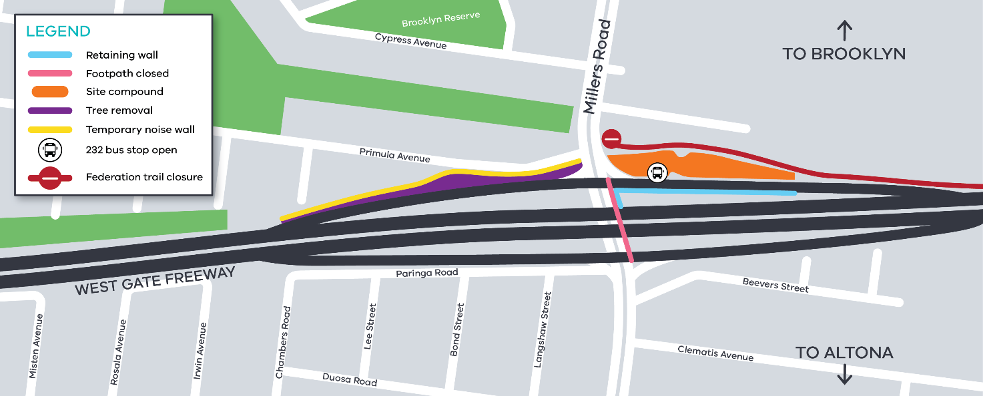
Location of works around West Gate Freeway and Millers Road interchange

Contact us
Please contact us if you have any questions or feedback about these works.

 | westgatetunnelproject.vic.gov.au |  | facebook.com/westgatetunnelproject
 | westgatetunnelproject@wda.vic.gov.au |  | @westgatetunnel
 | 1800 105 105 |  | West Gate Tunnel Project  GPO Box 4509  Melbourne Victoria 3001
 | Interpreter service: 13 14 50

