Reference: WES1811.XX
30 November 2018
Underground service relocations

We recently completed major investigations of services in your area. This process was conducted to help us plan for their relocation as part of the widening of the West Gate Freeway.
We are now ready to move overhead services, such as power lines, underground. If you have received this letter then we are likely to be working on or near your street.
These works will require excavation and temporary access changes along some local streets. Your property is in an area that may be affected.
Before we start these works, we want to talk to you about what we need to do, and how we are planning to limit any construction impacts that may occur.
Community information sessions in your area
We invite you to come along to have a chat about moving overhead services, such as power lines, underground, and the works in your neighbourhood.
From Monday 10 December, you will find us and our West Gate Tunnel Project information van at the carpark behind the 16 Shops in Paringa Road – dates and time below.
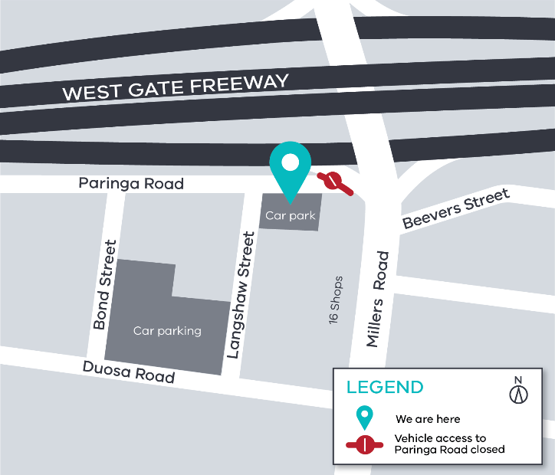

- Monday 10 December between 4pm –7pm
- Tuesday 11 December between 7am-9am
- Thursday 13 December between 11am-1pm
- Saturday 15 December between 10am-12pm

Can’t make it to our community information sessions?
If you can’t make it to our community information sessions, but would like to know more about these upcoming works, please email us at westgatetunnelproject@wda.vic.gov.au or give us a call on 1800 105 105 to book in a time that works for you.

We will be back in touch before we begin these relocations works in your area to provide more detailed information such as start of work dates.

Other works coming up: Paringa Road, Altona North
Installation of new drainage line
3 December 2018 – end of February 2019
We will be working in the road reserve between the noise wall and Paringa Road to install new services as part of the West Gate Freeway widening works.
These works include:
- tree removal from 3 December 2018 between Chambers Road and Bond Street;
- some noise during the day whilst we remove trees;
- site establishment including topsoil removal and installation of site fencing; and
- excavating trenches and laying pipes underground from early January 2019.

Contact us
Please contact us if you have any questions or feedback about these works.
 | westgatetunnelproject.vic.gov.au |  | facebook.com/westgatetunnelproject
 | westgatetunnelproject@wda.vic.gov.au |  | @westgatetunnel
 | 1800 105 105 |  | West Gate Tunnel Project  GPO Box 4509  Melbourne Victoria 3001
 | Interpreter service: 13 14 50
Local and temporary traffic changes will be in place whilst we undertake these works. For more information, visit http://westgatetunnelproject.vic.gov.au/traveldisruptions/.
For updates and more information about our works please visit westgatetunnel.vic.gov.au or contact us using the details below.

