Reference: WES1902.07
12 February 2019
Works update – temporary disruption to your driveway

Construction is well underway on Beevers Street to relocate some existing overhead power lines that currently run along the West Gate Freeway underground. Works are about to start ahead of schedule for stage three and as part of these works, vehicle access to your driveway will be temporarily disrupted.
Temporary disruption to your driveway access
Vehicle access to your driveway will be temporarily blocked from Thursday 14 February to approximately Saturday 23 February 2019.
During this time:
- it is recommended that you park your vehicle at either the Italian Social Club carpark in one of the designated parking spots or on the south side of Beevers Street outside the construction area;
- we have installed a temporary pedestrian access track with lighting across the Italian Social Club grass reserve, so you are able to walk to and from your car if you choose not to be transported by vehicle;
- transport services will be provided to take you and your belongings to and from your home;
- security personnel will be in place 24 hours/7 day a week at the Italian Social Club and the worksite for the duration of the works; and
- footpath access to your property will remain open at all times.

If you wish to be picked up from your home and transported to your parked car at the Italian Social Club, please contact our team on 0439 779 995, between the hours of 7am – 7pm / 7 days a week during the works. If you need transport outside these hours, please contact our team.

If you require any assistance with carrying items to or from your vehicle, please ask one of our friendly onsite team who will be able to assist or feel free to use our transport service.

When you need to move your vehicle:
- if you need access to your vehicle between Thursday 14 February and Saturday 23 February, please ensure your vehicle is moved out of your driveway by 10:00pm on Wednesday 13 February;
- if you are intending to move your vehicle and park at the Italian Social Club carpark on Wednesday 13 February, please access via Clematis Avenue or Marigold Avenue; and
- please ensure you do not park your vehicle in the identified construction area during this time.

Waste collection:
- when works are directly outside your home and vehicle access to your property is blocked, please place your rubbish bins outside your home on Tuesday mornings before lunchtime for collection;
- our project team will collect the bins and move them towards the Millers Road end of the street, so they can be collected by the waste contractor. Once they have been emptied, our project team will move them back to your property for you; and
- if you require a house number sticker for your bin/s, please let the team know and we can provide this for you.

What you could expect:
- an increase in construction vehicles within the area;
- an increase in construction noise during the day from our machinery and trucks; and
- water spray trucks to help manage dust and dirt and loads will be covered when dirt and rock are being transported.

These works will generally be carried out from Monday to Friday between 7am - 6pm and Saturdays between 7am - 3pm, however some night works may be required.

When works are scheduled out of hours and may have a direct impact on you, we will provide further information to you before works start.

Final asphalting works:

Once we conclude our trenching works on Beevers Street, we will need to do a final asphalt and seal of the road. To do this, in late February, Beevers Street will be temporarily closed to all vehicle traffic for up to five days to complete these works quickly and safely. More information will be provided on this in the next week.

Please note that works and timings may change in the event of bad weather or other unavoidable circumstances.
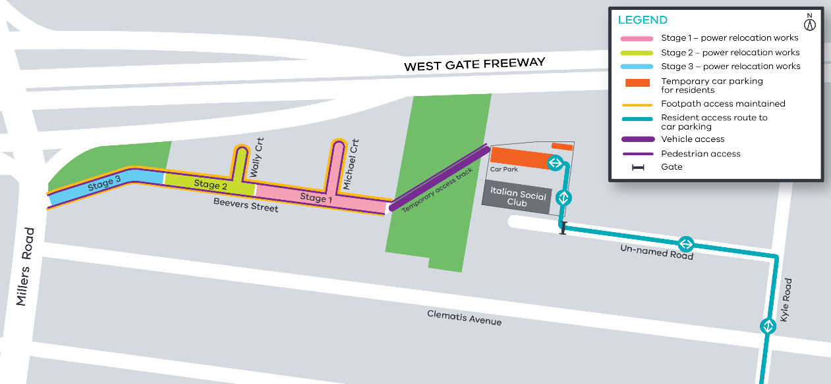
Contact us
Please contact us if you have any questions or feedback about these works.
 | westgatetunnelproject.vic.gov.au |  | facebook.com/westgatetunnelproject
 | info@wgta.vic.gov.au |  | @westgatetunnel
 | 1800 105 105 |  | West Gate Tunnel Project  GPO Box 4509  Melbourne Victoria 3001
 | Interpreter service: 13 14 50

