Reference: WES1903.04
13 March 2019
Upcoming works – Fogarty Avenue power relocation works
Tuesday 26 March – Friday 12 April
To make way for the widening of the West Gate Freeway, we need to safely relocate some high voltage power lines to newly installed monopoles, allowing the removal of two existing lattice towers adjacent to Fogarty Avenue.
One new monopole will be located opposite the Footscray Hockey Club and one opposite Highgate and Cranbrook Streets. The high voltage lattice towers will be removed as part of these works (see map over page). These works will be taking place simultaneously.
These works were previously planned for October 2018 and have been rescheduled to be carried out in the coming weeks.
High-voltage powerline relocation works
Tuesday 26 March 2019 – Friday 12 April 2019
These works include:

- site establishment works;
- assembling the new monopoles using large cranes and elevated work platforms;
- moving power lines from the existing high voltage lattice towers to the new monopoles; and
- removing the existing lattice towers.
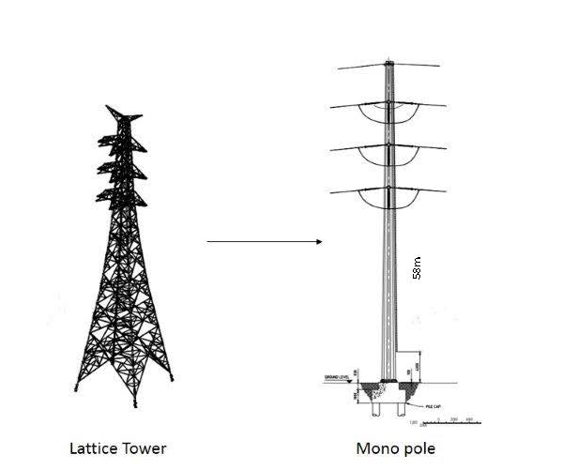
Please also be advised that the section of Fogarty Avenue outside the Footscray Hockey Club car park will need to be closed for two days on Tuesday 26 and Wednesday 27 March in preparation for these works. Additionally, there will be lane closures and traffic management on other days.

The works will be undertaken between 6am - 8pm daily. If works are required outside these times, and will have a direct impact on you, we will provide further information before they start.

Temporary closure of the pedestrian overpass
These works are taking place directly above the pedestrian overpass connecting Muir Street and Fogarty Avenue. For the safety of pedestrians and cyclists, we need to close the pedestrian overpass during the day while we are working on the power cables overhead.
The overpass will be closed daily between 5am - 8pm and re-open nightly between
8pm – 5am from Thursday 28 March to Friday 12 April 2019.
We are working with local schools and other users of the overpass to ensure safe and timely alternatives are available.

A bus will be provided to help Wembley Primary School students and guardians move between the north and south side of the West Gate Freeway on school days. Additionally, a courtesy bus will run for members of the public at nominated times during the day.
The shuttle bus timetable is available at westgatetunnelproject.vic.gov.au.
An alternative pedestrian/bicycle route has also been established while these works are undertaken (see map over page).

What to expect on Fogarty Avenue during these works:
- construction vehicles including excavators, elevated work platform trucks, earthmoving equipment and cranes will use the freeway to access the construction site;
- several large cranes, construction vehicles and equipment will be located on the freeway side of the noise walls;
- low level construction noise from cranes and elevated work platforms;
- dust and dirt will be minimised by using water spray trucks, street sweepers and covering dirt and rock when it is being transported;
- A section of Fogarty Avenue will be closed on Tuesday 26 and Wednesday 27 March 2019 adjacent to the Footscray Hockey Club. Access to the Yarraville Soccer Club and western end of the Footscray Hockey Club carpark shall be maintained via The Avenue. There will be lane closures and traffic management on other days;
- Please observe on-road signage and check our website for up to date local traffic changes www.westgatetunnelproject.vic.gov.au/traveldisruptions

Where to park your car:
- There will be temporary car parking changes on Fogarty Avenue between Wembley Avenue and The Boulevard from Tuesday 26 March to Thursday 4 April 2019. Please observe the signage in place.
- Please ensure you do not park your vehicle in the construction area during this time as access will be blocked and you will be unable to access your vehicle

Please note that works may be rescheduled in the event of bad weather or other unavoidable circumstances.

For updates and more information about our works please visit westgatetunnelproject.vic.gov.au or contact us.

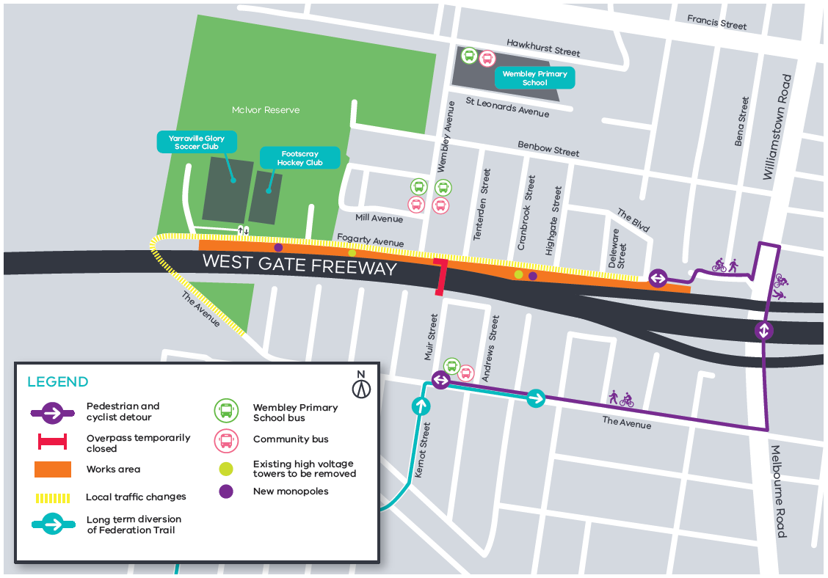

Contact us
Please contact us if you have any questions or feedback about these works.
 | westgatetunnelproject.vic.gov.au |  | facebook.com/westgatetunnelproject
 | info@wgta.vic.gov.au |  | @westgatetunnel
 | 1800 105 105 |  | West Gate Tunnel Project  GPO Box 4509  Melbourne Victoria 3001
 | Interpreter service: 13 14 50

