28 February 2020 WES2002.01
Works notification: Installation of new noise walls

The West Gate Tunnel Project team will soon begin installing new, high-quality permanent noise walls in your area.

The new noise wall will be between eight and nine metres high and will be made of textured concrete panels with pale blue and green coloured acrylic panels at the top in some sections.

As well as being more attractive, the new noise walls will provide you much better protection from freeway noise than the old noise walls.

They have been designed to achieve a daytime average noise level of 63dB(A) at nearby houses, which will mean a significant reduction in noise levels for many residents. Where space permits, planting will also be used to screen the noise walls.

When we expect to start installing noise panels in this area:

starting from mid-March, installation of panels will take approximately eight weeks

acrylic panels (needed in some locations) will be installed mid-to-late 2020

existing noise wall will be removed once the new panels have been installed

Where the noise wall will be installed:
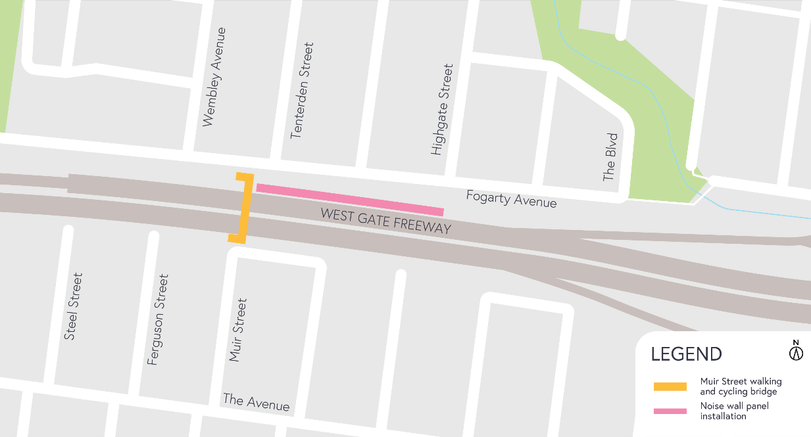

What you can expect during construction and installation:

construction vehicles including concrete trucks, pumps and cranes will be moving in and out of the work areas

dust and dirt will be minimised by using water spray trucks, street sweepers and covering dirt and rock when it’s transported

main access to the construction site will be via West Gate Freeway with minimal site access required via local roads

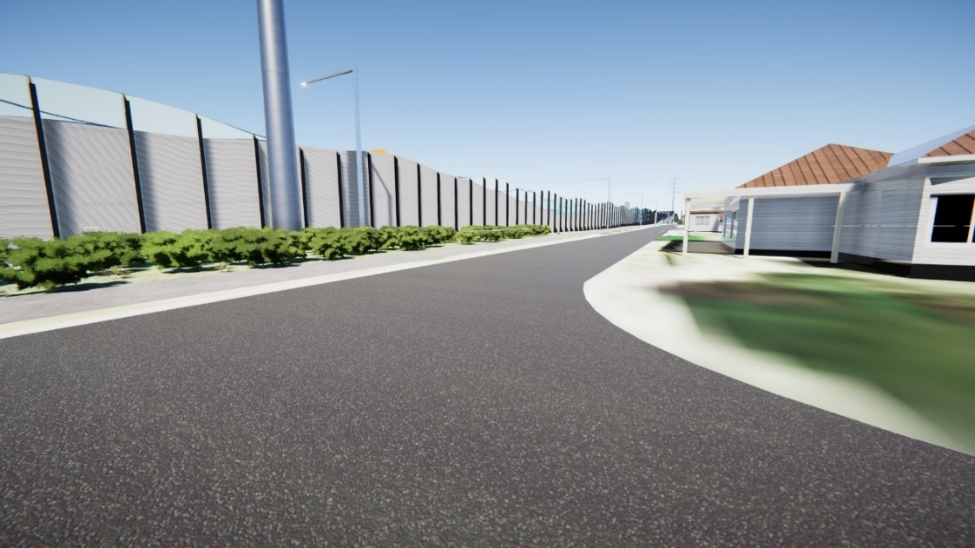
traffic changes including lane, road and ramp closures might be required. The latest traffic updates are available at westgatetunnelproject.vic.gov.au/traveldisruptions.

View from the intersection of Fogarty Avenue and Highgate Street, looking west. Please note that all content within is an artistic representation and visualisation of the final form. The model images and all representations are indicative only.

These works will generally be carried out from Monday to Friday between 7am - 6pm and Saturdays between 7am - 1pm, however some night works may be required. If works are scheduled outside of these hours or at night, we will provide further information to you before works start.

Please note that works may be rescheduled in the event of bad weather or other unavoidable circumstances.

IMPORTANT: You’re welcome to contact us to arrange a phone call or face-to-face meeting if you’d like more information.

