2 January 2020

WES2001.03

Works notification: Ramp closures and detours around the M80 interchange

Monday 13 January to 27 February 2020
As part of works on the West Gate Tunnel Project, we’re planning a six-week concentrated construction campaign around the M80 interchange to make the most of the good weather and take advantage of lower-than-normal traffic volumes that occur during the holiday period. Ramp closures and detours will be in place.
The following ramps will be completely closed for six weeks:
- the city-bound freeway connection from the M80 ring-road to the West Gate Freeway ramp will be closed for widening and reconstruction of a new, stronger road pavement
- the outbound ramp and bridge from Geelong Road to the Princess Freeway for the installation of new columns to the existing bridge. A new (top-down) bridge will also be constructed from the existing bridge abutment.
During the construction campaign, we’ll work around the clock, seven days a week to fit in as much work as possible and to minimise the duration of, and impacts on, residents, businesses and road users.

Temporary changes at the Boundary Road roundabout
Access to the roundabout at Boundary Road/Little Boundary Road/Fairbairn Road in Brooklyn will be restricted to cope with extra traffic resulting from the city-bound ramp closure, including:
- closure of the north-bound access from Little Boundary Road to Fairbairn Road. Businesses located in the Fairbairn Road, Proximity Drive block should access the area from Sommerville Road during this time
- closed access to the roundabout from the east direction (Boundary Road). Traffic will be detoured along Endeavour Way.
We’re working with the Department of Transport and other major construction projects also working in the area to minimise impacts and delays caused by these closures and detours across the local road network.
Other works on Boundary and Fitzgerald Road
There are also other works on Boundary Road and Fitzgerald Road this summer to be aware of as part of the Western Roads Upgrade. The intersection of Boundary Road and Fitzgerald Road will be closed during January. For more information go to bigbuild.vic.gov.au/disruptions.

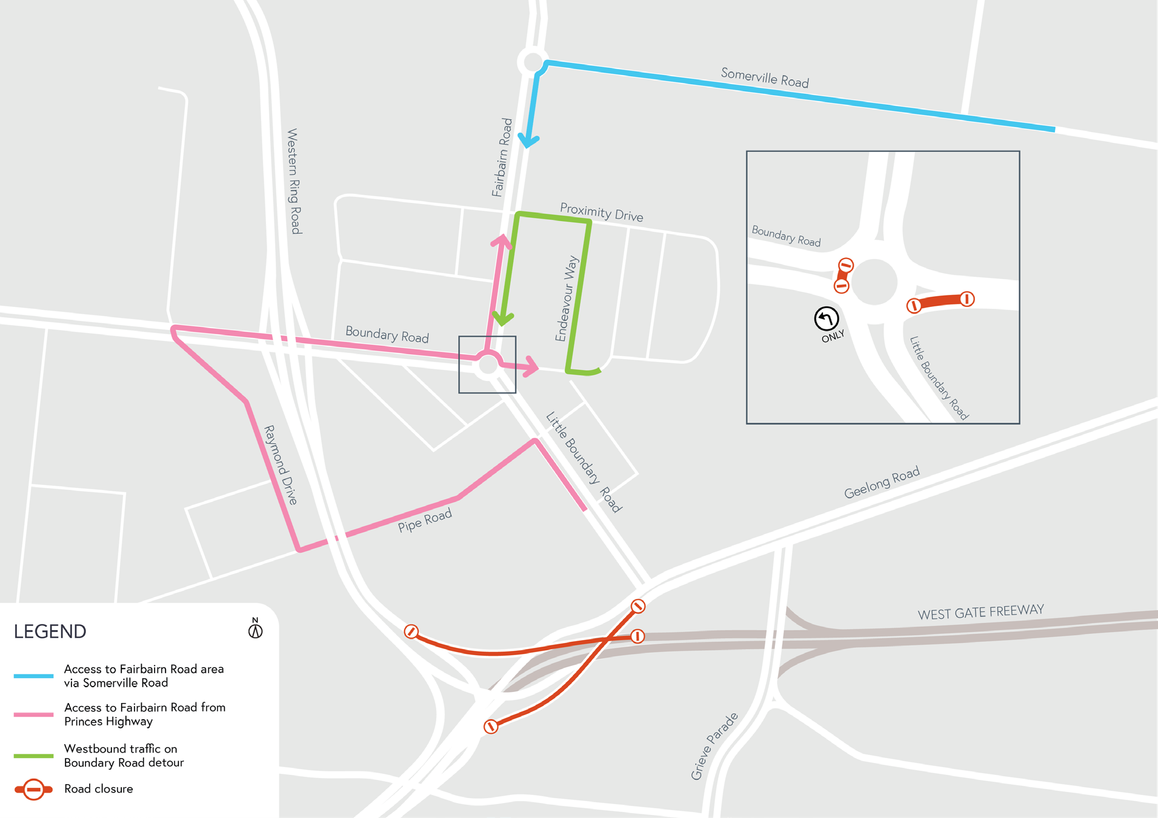
Closures and detours
During the construction campaign:
- You might see more traffic on local roads in the area, so allow more time for your journey.
- Let your staff and delivery drivers know about the detours so they can plan efficient journeys.
- Dust and dirt will be minimised by using water spray trucks, street sweepers, and covering dirt and rock when it’s transported.

Thank you
We appreciate our work can be disruptive and thank you for your understanding and cooperation.
Please note that works might need to be rescheduled in the event of bad weather or other unavoidable circumstances.

Updates
The latest traffic updates and information about other West Gate Tunnel Project works in the area are available at www.westgatetunnelproject.vic.gov.au/
Email us at info@wgta.vic.gov.au to register for future project updates.
Visit www.bigbuild.vic.gov.au for more information about other big builds across Victoria.

westgatetunnelproject.vic.gov.au info@wgta.vic.gov.au
1800 105 105
West Gate Tunnel Project Info Centre Corner of Somerville Rd and Whitehall St Yarraville VIC 3013
Follow us on social media Please contact us if you would like this
information in an accessible format.

Translation service – For languages other than English, please call 13 14 50.

Authorised by the Victorian Government, 1 Treasury Place, Melbourne

