1 June 2020 WES2006.02

Works notification: Millers Road / West Gate Freeway tree removals

To allow for lane widening and realignment works, and before we rebuild the traffic island at the end of Beevers Street, the trees in the centre of Millers Road between Clematis Avenue and the interchange will be removed overnight on Wednesday 10 June.
On the same night, we will also remove trees along a short stretch of the Federation Trail behind our work compound near the Millers Road inbound entry ramp in preparation for future widening of the trail.
The tree removals must be carried out overnight because we need to close traffic lanes to allow for the work.

What you can expect to see and hear:
- construction vehicles and equipment, including chainsaws and a mulcher
- directional lighting
- noise from the use of chainsaws and mulcher
- changed traffic conditions including lane closures between the hours of 9pm to 5am, with signage in place.

Works area
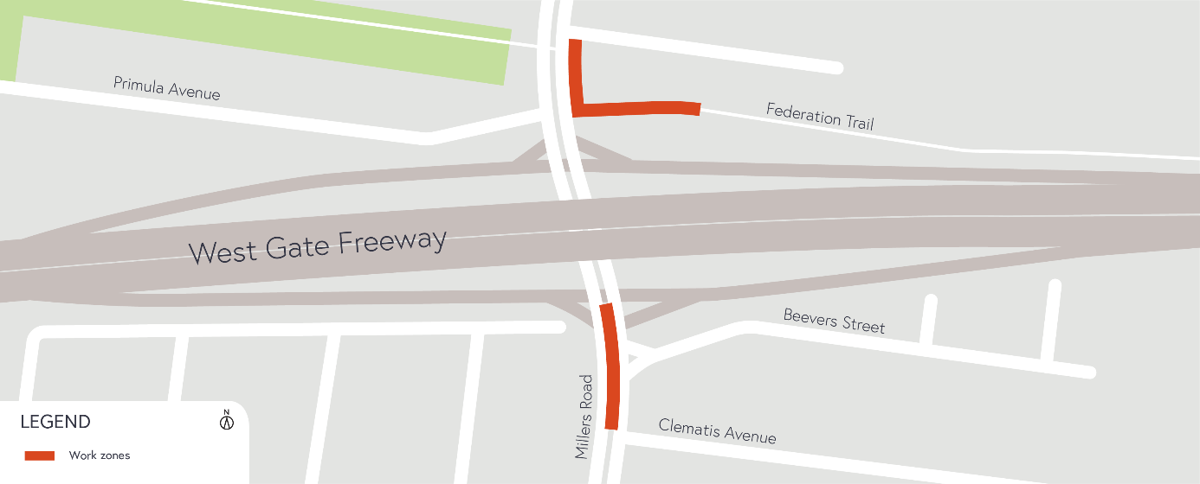

Hours of work
The work will be carried out overnight on Wednesday 10 June from 9pm to 5am.

COVID-19 update
The health and safety of our workers is our key priority as we continue to deliver the West Gate Tunnel Project, as is supporting physical distancing measures in line with current health advice. We have strict protocols in place to protect the safety of our construction workforce and the community. These include enhanced industrial cleaning arrangements and measures to reduce staff contact including staggered shifts and physical distancing. For more information and advice about Coronavirus, please visit coronavirus.vic.gov.au.

Thank you
We appreciate our work can be disruptive and thank you for your understanding and cooperation, particularly during these unprecedented and challenging times.

Please note that works are subject to change and may be rescheduled in the event of unexpected impacts to the construction program. Thank you for your patience during these works.

For updates and more information about our works, please visit westgatetunnelproject.vic.gov.au or call us on 1800 105 105.

