5 May 2020 WES2005.01

Works notification: Hyde Street Ramps
Work on the Hyde Street Ramps is progressing on both sides of the West Gate Freeway between Williamstown Road and Hyde Street, with completion of access tracks and piling of the new inbound exit ramp now well underway.
There is a lot more work that needs to be completed in this area including setting up the new temporary access bridge at Thomas Street and partial demolition of the Socobell building.
Below is a summary of what you can expect to see in the area between May and July 2020.

Inbound exit ramp, including elevated shared use path

piling in Stony Creek Reserve is ongoing for the northern ramp and is expected to continue until January 2021

piling for the new temporary site access bridge at Thomas Street is expected to be completed in May, and the bridge is scheduled to be installed by early June
- construction of pile caps, columns and concrete crossheads at Hyde Street is scheduled to begin in June. Construction will progress west towards the Werribee and Williamstown rail line and will continue for the next 18 months.

Outbound entry ramp

demolition of the northern section of the old Socobell building on Hall Street to make way for the new outbound entry ramp is scheduled to begin in early May

construction of four new safety nets at the West Gate Golf Club is scheduled to begin in early May with the access tracks and working platforms now completed

construction of one new safety net on the AFL oval in the Donald McLean Reserve is scheduled to begin in early May with the access tracks and working platforms now completed

earthworks at Williamstown Road outbound exit and entry ramps will begin in May

piling at the Williamstown Road interchange is scheduled to begin in late June

Shared use path bridge – Hyde Street Reserve:

piling in the Hyde Street Reserve for the shared use path bridge over Stony Creek is scheduled to begin in late July

Hours of work

Our usual hours of work are Monday to Friday between 7am-6pm, and Saturdays between 7am-1pm. However, night works are sometimes required. When works are scheduled out of hours, or if you are located close to the works, we will provide you with further information before the works start.

Please note that works sometimes need to be rescheduled in the event of bad weather or other unavoidable circumstances.

Location of works
The lettering refers to work descriptions on the previous page.

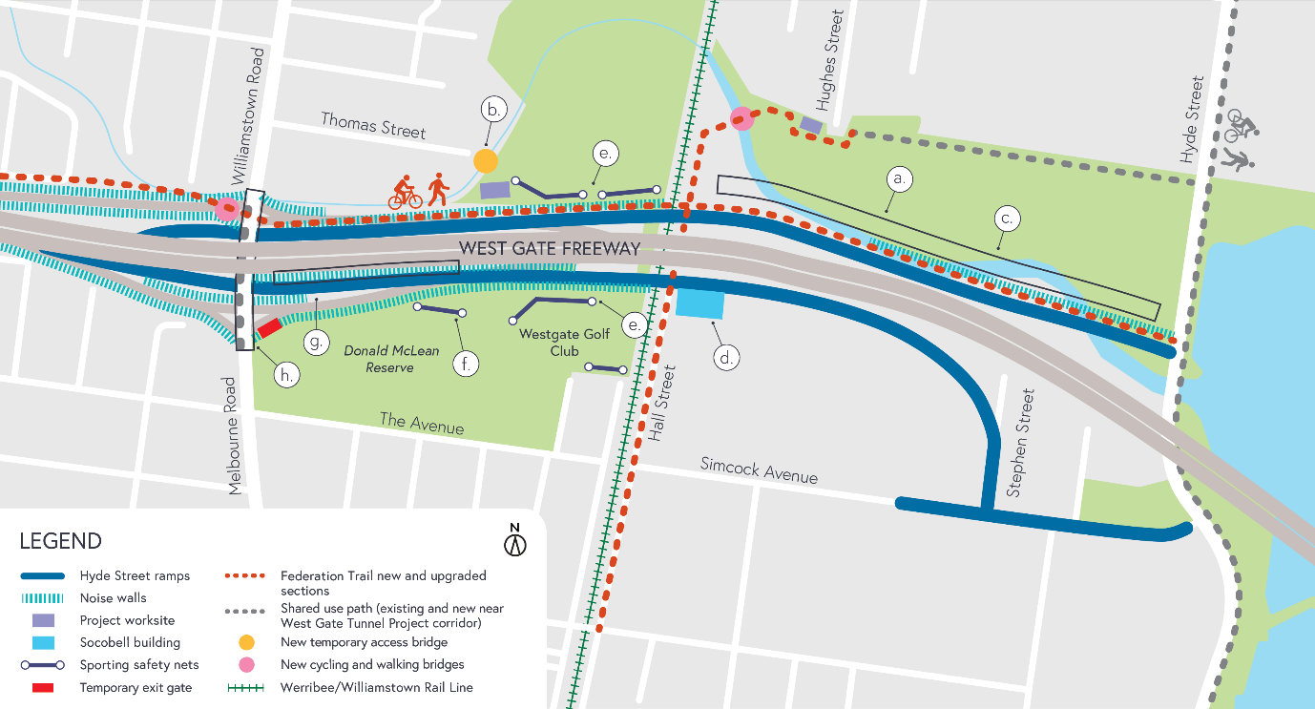

What to expect during these works
- work will be completed behind safety barriers
- construction vehicles including excavators, rollers, piling rigs, water trucks and concrete trucks will be moving in and out of the work areas via our access routes
- construction noise from work activities including machinery and trucks. Vibration may be experienced from piling works
- water spray trucks and road sweepers will be used to manage dust and dirt during works. Trucks removing dirt and rock from the site will be covered
- traffic changes including lane and road closures will be required. Signed detours will be in place. For the latest updates visit westgatetunnelproject.vic.gov.au/traveldisruptions.

Coronavirus COVID-19 update
The health and safety of our workers is our key priority as we continue to deliver the West Gate Tunnel Project, as is supporting social distancing measures in line with current health advice. We have strict protocols in place to protect the safety of our construction workforce and the community. These include enhanced industrial cleaning arrangements, and measures to reduce staff contact, including staggered shifts and physical distancing. For more information and advice about the outbreak of Coronavirus, please visit coronavirus.vic.gov.au.

For updates and more information about our works, please visit westgatetunnelproject.vic.gov.au or call us on 1800 105 105.

