14 September 2020 WES2009.01

Works notification: Ferguson Street drainage works
Work will soon be underway on Ferguson Street to connect new drainage pipes into the West Gate Freeway system. As part of these works, there will be construction activity at the end of Ferguson Street for approximately three weeks.
To facilitate the works, a section of the temporary noise wall will also need to be removed for approximately two days and one night. We will work to reinstate the temporary noise wall panels as soon as possible.
Access to residential driveways will remain available at all times during these works.

Ferguson Street drainage upgrade

Late-September 2020 until mid-October 2020
- footpath access will be maintained, excluding a short section at the end of Ferguson Street (east side)
- property access will be maintained
- waste collection will also be maintained
- street parking at the end of Ferguson Street will be temporarily unavailable during this time – please see the map over the page for location details.

We thank you for your patience while we complete these works.

Where to park your vehicle:
- please do not park your vehicle at the end of Ferguson Street during the works period. Access will be blocked and you will be unable to access your vehicle.
- we recommend that you park your vehicle in your driveway, along the remaining sections of Ferguson Street or other nearby local roads during these works.

Noise wall panel removal
- In order to safely undertake these works, we need to remove a section of the temporary noise wall for approximately two days, in order to connect the drainage pipe. We are unable to do this after the permanent noise wall is installed as it will restrict access to the pipe. Please see the map over the page for location details.
The temporary noise wall panels will be reinstated after approximately two days.

What you could expect:
- an increase in the number of construction vehicles in the area
- access to the construction site via The Avenue, Muir Street and Ferguson Street as required
- preparatory works including detecting underground services using a high-pressure water jet
- an increase in construction noise from our machinery and trucks
- water spray trucks to help manage dust and dirt and loads will be covered when dirt and rock when are being transported

Works area

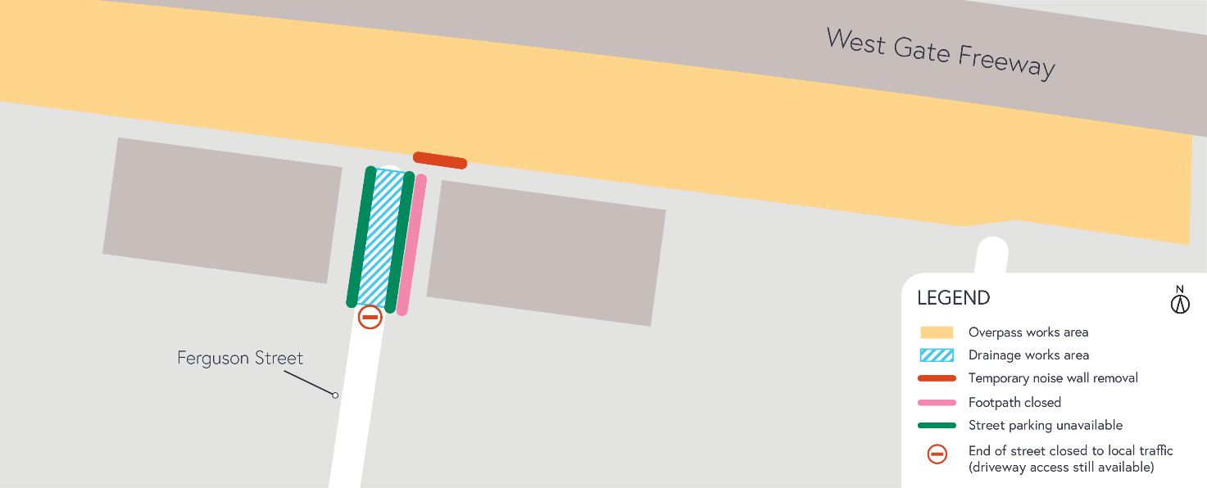

Hours of work

These works will generally be carried out from Monday to Friday between 7am - 6pm and Saturdays between
7am - 1pm, however some night works may be required. When works are scheduled out of hours and may have a direct impact on you, we will provide further information to you before works start.
Coronavirus COVID-19 update
The health and safety of our workers is our key priority as we continue to deliver the West Gate Tunnel Project, as is supporting social distancing and the wearing of masks in line with current health advice. We have strict protocols in place to protect the safety of our construction workforce and the community. These include enhanced industrial cleaning arrangements, and measures to reduce staff contact, including staggered shifts and physical distancing. For more information and advice about Coronavirus, please visit coronavirus.vic.gov.au.
For updates and more information about our works, please visit westgatetunnelproject.vic.gov.au or call us on 1800 105 105.
Please note that works may be rescheduled in the event of bad weather or unexpected impacts to the construction program.

