6 July 2020 WES2004.04 (R)

Reminder notification: Fogarty Avenue shared use path
In April this year we updated you on work we were planning to start in May to build the new shared use path (SUP) which runs from Fogarty Avenue near the reserve.
The SUP will go up and over the Williamstown Road inbound exit ramp via a new bridge which will extend the Federation Trail and connect with the new SUP alongside the Hyde Street inbound ramp.

Construction activity
July 2020 - ongoing

The later than anticipated completion of drainage works at our existing construction site near the reserve at the eastern end of Fogarty Avenue means we can now start construction of the new SUP bridge.

With a project of the scale of the West Gate Tunnel, starting a new set of works often depends on the completion of preceding works in or around the same area, and that has been the case here.

While this work will take place within our existing construction site, the space required for the works will mean the ongoing closure of the SUP that runs over Stony Creek and through the reserve at the eastern end of Fogarty Avenue.

Works to be done from July onwards will include:
- piling to support the new SUP bridge
- constructing piers to support the new SUP bridge
- formwork and concrete pours to create the SUP bridge deck.

This work is part of the West Gate Tunnel Project delivering more than 14 kilometres of new and upgraded paths, making it safer and easier for more people to walk or cycle.

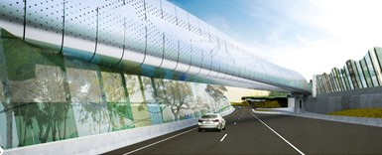
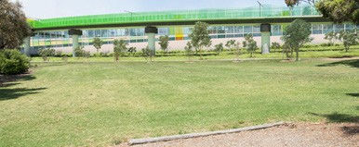
Artistic view of SUP from the reserve at the end of Fogarty Avenue
Artistic view of SUP over the Williamstown Road inbound exit ramp

Hours of work

Our usual hours of work are Monday to Friday between 7am-6pm, and Saturdays between 7am-1pm. However, night works are sometimes required. When works are scheduled out of hours, or if you are located close to the works, we will provide you with further information before the works start.

What to expect during these works:
- work will be completed behind safety barriers
- ongoing closure of the SUP over Stony Creek. A signed detour is in place. This SUP will be reopened once we have completed works in the area
- construction vehicles including excavators, piling rigs, water trucks and concrete trucks will be moving in and out of the work areas via our access routes
- trucks and vehicles continuing to enter and exit our construction sites via local roads
- water spray trucks and road sweepers will be used to manage dust and dirt during works. Trucks removing dirt and rock from the site will be covered
- traffic changes including ramp, lane and local road closures may be required. For the latest updates visit westgatetunnelproject.vic.gov.au/traveldisruptions.

Works area
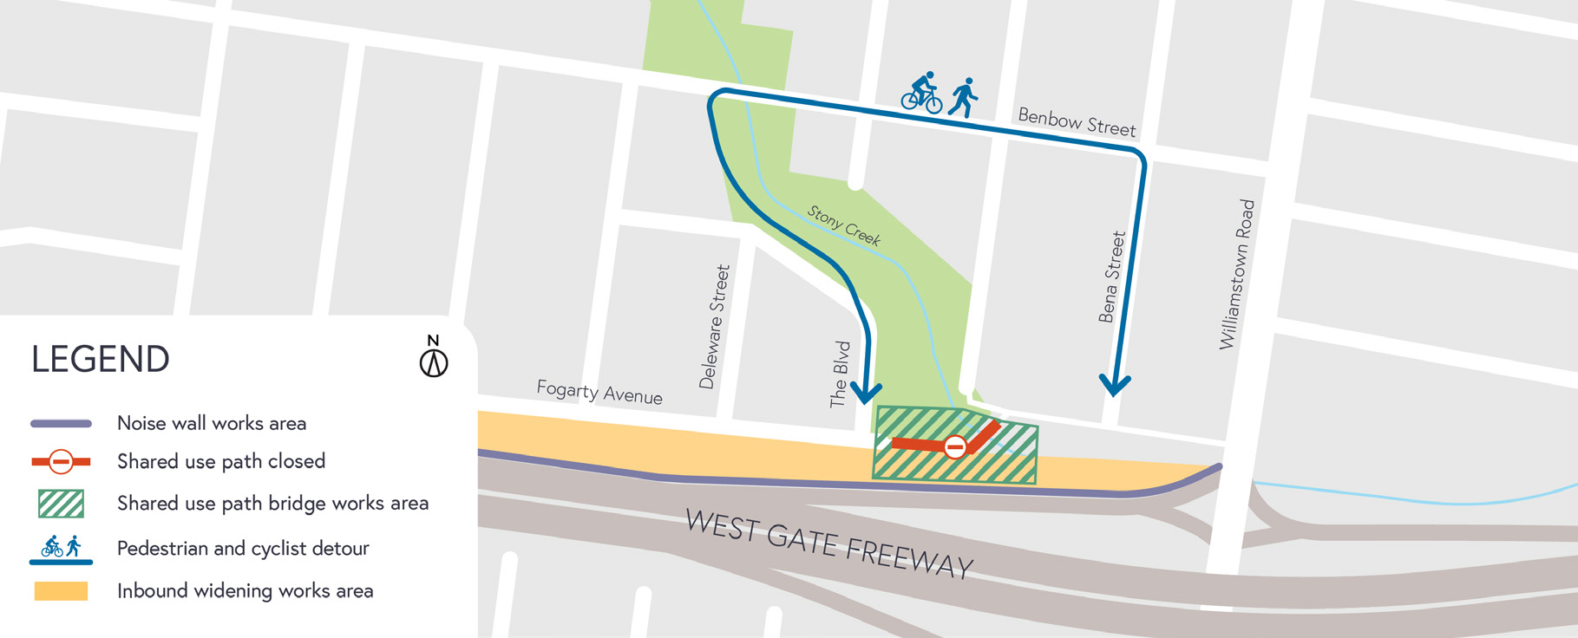

Coronavirus COVID-19 update

The health and safety of our workers is our key priority as we continue to deliver the West Gate Tunnel Project, as is supporting physical distancing measures in line with current health advice. We have strict protocols in place to protect the safety of our construction workforce and the community. These include enhanced industrial cleaning arrangements and measures to reduce staff contact including staggered shifts and physical distancing. For more information and advice about Coronavirus, please visit coronavirus.vic.gov.au.
For updates and more information about our works, please visit westgatetunnelproject.vic.gov.au or call us on 1800 105 105.
Please note that works may be rescheduled in the event of bad weather or unexpected impacts to the construction program. Thank you for your patience during these works.

