1 February 2021 WES2102.01
Works notification: Installation of new noise walls

The West Gate Tunnel Project team will start installing concrete noise wall panels from early February, at the Millers Road outbound on ramp (adjacent to Paringa Road).
The noise wall panel installation will take approximately three weeks to complete throughout February and March and will be undertaken at night. On the nights the works take place, to safely install the panels, the Millers Road outbound entry ramp will be closed. A detour will be in place via the West Gate Freeway and Williamstown Road.
The new noise walls will be around eight-to-nine metres high. In some sections, they will be topped with pale blue and green coloured acrylic panels. Where space permits, planting will be used to screen the noise walls.
The new noise walls will provide you much better protection from freeway noise than the old noise walls. They have been designed to achieve a daytime average noise level of 63dB(A) at nearby houses, which will mean a significant reduction in noise levels for many residents.
What to expect during these works:
- works will be carried out at night, between 9pm and 5am, Monday to Sunday. This is so we can safely install the noise wall panels while the freeway on ramp is closed
- construction vehicles will be moving in and out of the work area at night
- low level noise at night from lifting and installing the concrete panels, however works aren’t anticipated to be disruptive to nearby residents
- the main access to the installation site will be via the freeway
- ramp closure will be required. The latest traffic updates are available at westgatetunnelproject.vic.gov.au/traveldisruptions
Location of noise wall panels:

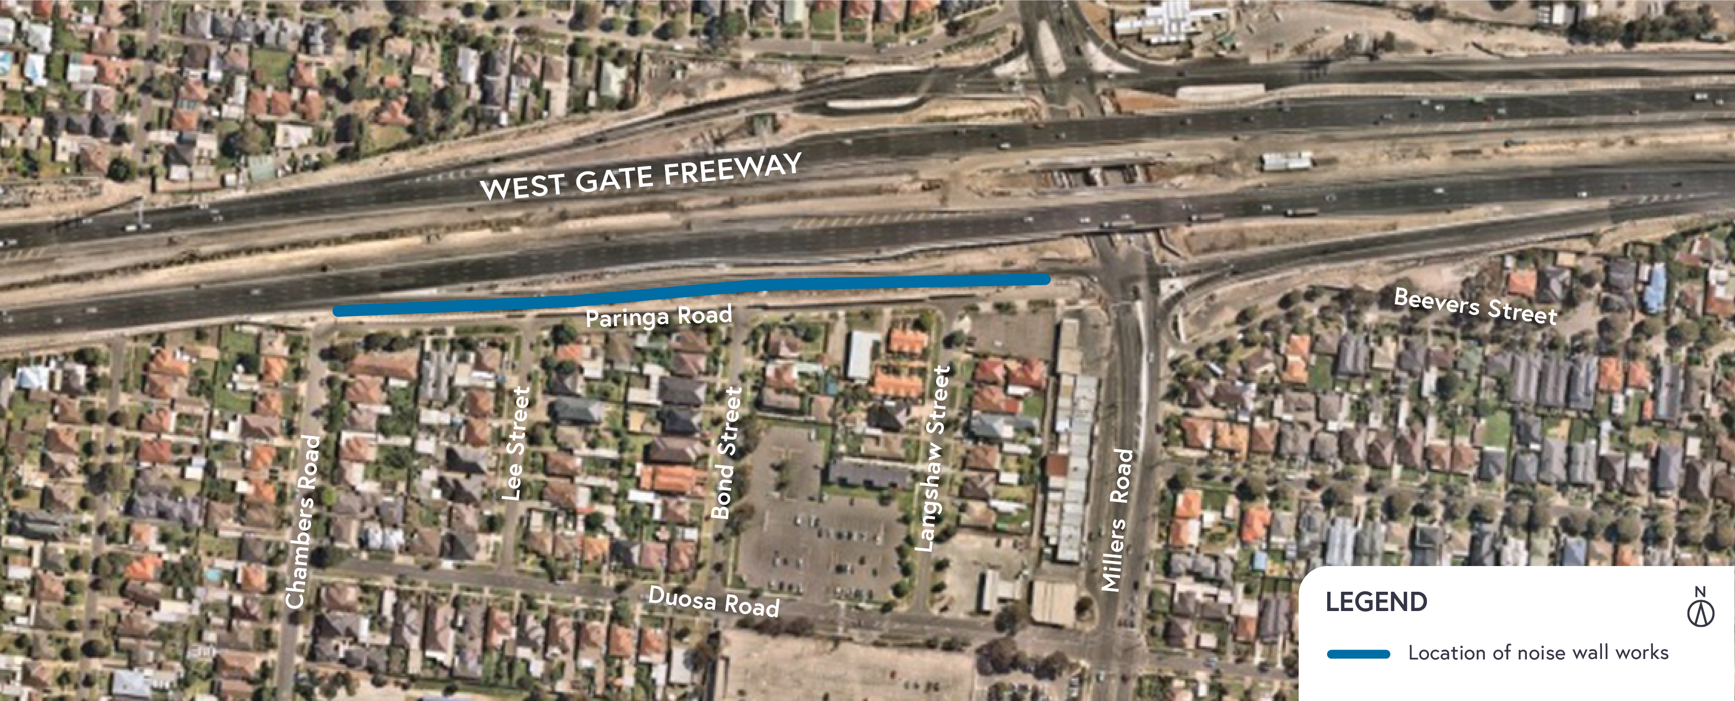

IMPORTANT: If you require more information, you’re welcome to contact us to arrange a phone catch up. Contact details over page.

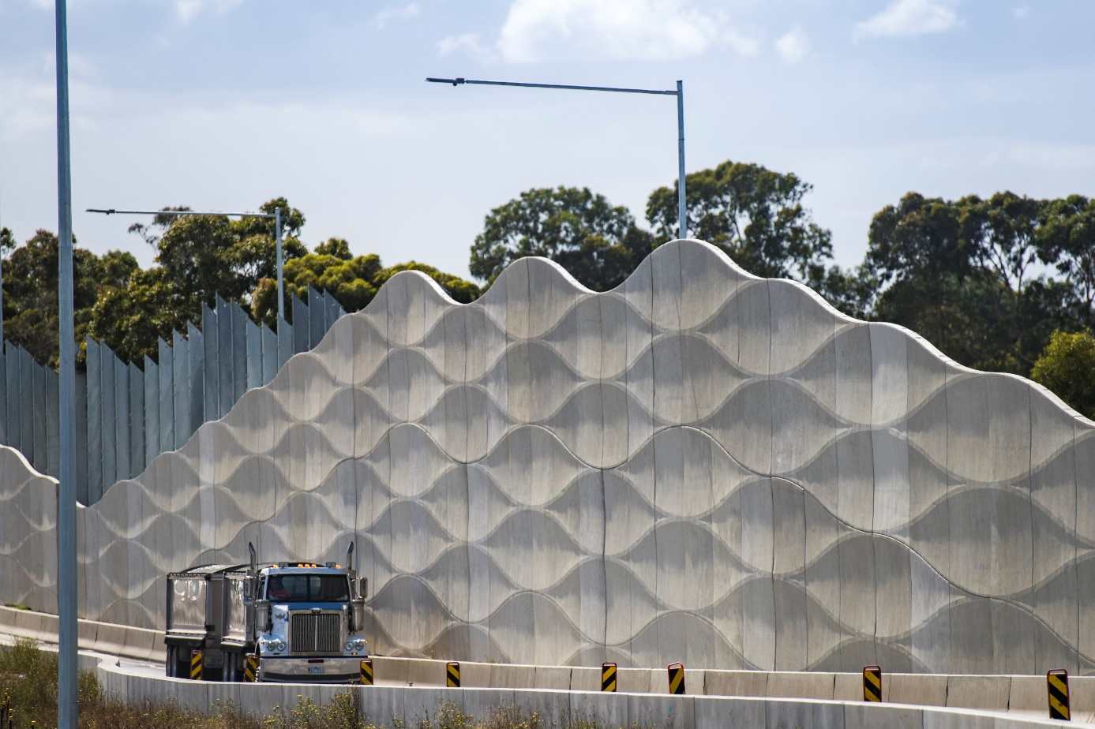
New noise walls installed along the Grieve Parade outbound exit ramp, Brooklyn

Please note that works are subject to change and could be rescheduled in the event of unexpected impacts to the construction program.
If you have any questions about these night works or want to get in touch with the project team, please contact us on 1800 105 105.
For updates and more information about our works please visit westgatetunnelproject.vic.gov.au.

