February 2020

Works notification: Footscray Road
Works are progressing to build the new elevated road above Footscray Road with drainage relocation taking place along the southern edge, ongoing piling works and assembly of the Launching Gantry continuing in the centre median.

Upcoming traffic changes Footscray Road and Sims Street
From February 2020, further traffic changes will take place to create space for works to be completed within the centre median and along the southern edge of Footscray Road.
This will include:
- Traffic lane realignments to take place on Footscray Road, between Dock Link Road and Shepherd Bridge
- Shared use path realignments for cyclists and pedestrians
- Temporary road closures.
Traffic switches, closures and shared use path changes will be implemented during off peak periods and at night. Further notification will be provided to businesses directly impacted and signage will be in place.
When: February 2020 - Works will take place during the day between 7am and 5pm and may also be required at night between 7pm and 5am.

Piling works and pier construction
Piling works are ongoing along Footscray Road between CityLink and the Maribyrnong River. Temporary piling works will take place in the centre median near Shepherd Bridge with changes to the intersection in place during these works. Works will also continue to assemble segments for the elevated road columns along Footscray Road.
Piling works will continue during the day and will also take place at night. Further notification for night works will be provided to directly impacted residents and businesses.
Noise and vibration may be noticeable during these works and ongoing monitoring will be in place.

When: These works will be completed during the day between 7am and 5pm and ongoing at night between 7pm and 5am.

Drainage works
Drainage relocation works along the southern edge of Footscray Road will continue from February.
Drainage works in the Sims Street area will commence in late March 2020 and are expected to take up to one month to complete. This will include:
- Works along Sims Street
- Traffic changes on Sims Street with some impacts to cyclists and pedestrians using the shared use path
- Increased noise levels in the area
- Environmental requirements will be adhered to and managed accordingly.
When: February 2020 - Works will take place during the day between 7am and 5pm and may also be required at night between 7pm and 5am.

Footscray Road at Moonee Ponds Creek
Works will commence to widen the Footscray Road Bridge over Moonee Ponds Creek and construct a new, dedicated pedestrian and cyclist shared use path.
Preparation works are expected to commence from February and will include:
- Site investigations including electronic scanning of roads, non-destructive digging to identify services and drilling boreholes
- Vegetation removal
- Establishment of work zones
- Utility relocation works.
When: February 2020 - During the day and at night between 7am to 5pm and when required between 7pm and 5am.

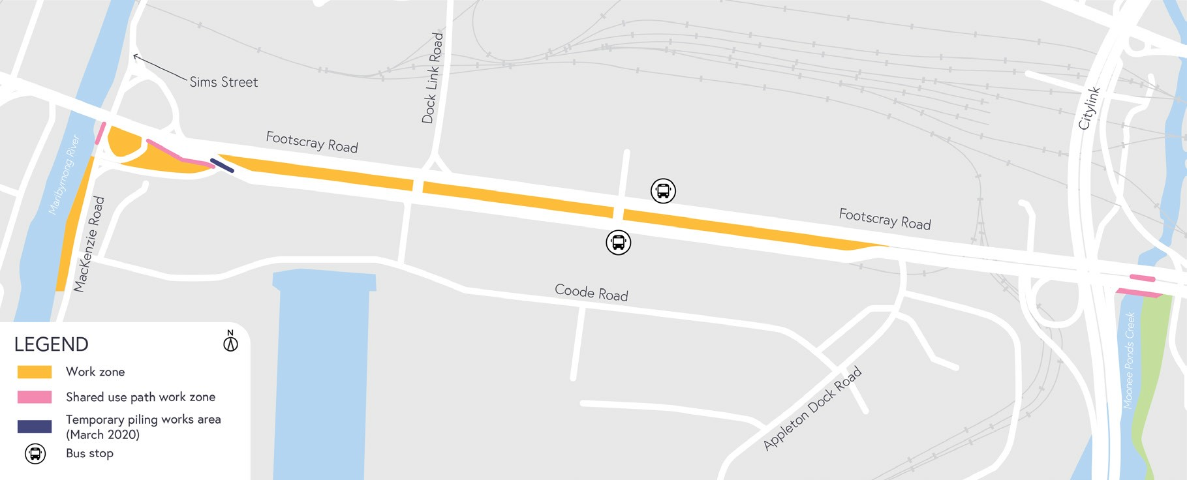

What to expect during construction:
- Works completed both during the day and at night time
- We will notify you if there are any significant changes to the timing of our works
- Traffic management will be in place to manage changed conditions including temporary access changes and signage to guide road users and cyclists
- Dust will be managed on-site with suppression methods
- Piling works can create increased levels of noise and may also cause some vibration
- Assessments have been conducted, which indicate the noise levels are expected to remain within permissible levels as documented in the project’s Environmental Performance Requirements.

We thank you for your patience during these works.

westgatetunnelproject.vic.gov.au info@wgta.vic.gov.au
1800 105 105
West Gate Tunnel Project Info Centre Corner of Somerville Rd and Whitehall St Yarraville VIC 3013
Follow us on social media Please contact us if you would like this
information in an accessible format.

Translation service – For languages
other than English, please call 13 14 50.

Authorised by the Victorian Government, 1 Treasury Place, Melbourne

