6 November 2020

Works update: Dynon Road and Wurundjeri Way

Dynon Road

West Gate Tunnel Project is continuing with works on Dynon Road, mainly on the northern side of Dynon Road from October through to December 2020.

Construction works along Dynon Road
Throughout October, construction on the new southbound on-ramp to Dynon Road commenced, beginning with form work, followed by the pouring of bridge abutments. Driven piling works and pier construction works also took place in the Metro Trains Melbourne car park.
Pile capping on the southbound Dynon Road on-ramp is scheduled to commence in mid-November and will continue into December.
In addition to continued pile capping works on the southbound Dynon Road on-ramp, the installation of precast planks is scheduled to commence in early 2021 in the Dynon Road north area.
When: November 2020 – early 2021. These works will be completed during the day between 7am and 5pm, and at night between 7pm and 5am.

Moonee Ponds Creek
Along the west bank of Moonee Ponds Creek, construction of abutments and piers for the new on ramp have been underway since October.
The 66kV overhead powerlines that run along the east bank of Moonee Ponds Creek from Footscray Road to Dynon Road were decommissioned during October. This will be followed by the further decommissioning of two towers will occur in early to mid-November, in the E-Gate and Port Truckie Diner area.
When: November 2020. These works will be completed during the day between 7am and 5pm, and at night between 7pm and 5am.

E Gate and F Gate
Towards the end of October, a weekend rail occupation took place in E-Gate specifically on the E-Gate engine tracks. This occupation was for the track rectification and to complete the sewer diversion, to allow for the installation of the nearby temporary rail crossing.
Towards the end of November, a weekend rail occupation is scheduled to take at the rail yards in
E-Gate, works will include demolition of the rail worker pedestrian bridge and the decommissioning of the redundant signaling loop.
Construction of the new Metro Trains Melbourne and Yarra Trams storage yard at E-Gate is due to commence in December and continue into early 2021.
When: November – Early 2021. These works will be completed during the day between 7am and 5pm, and at night between 7pm and 5am.

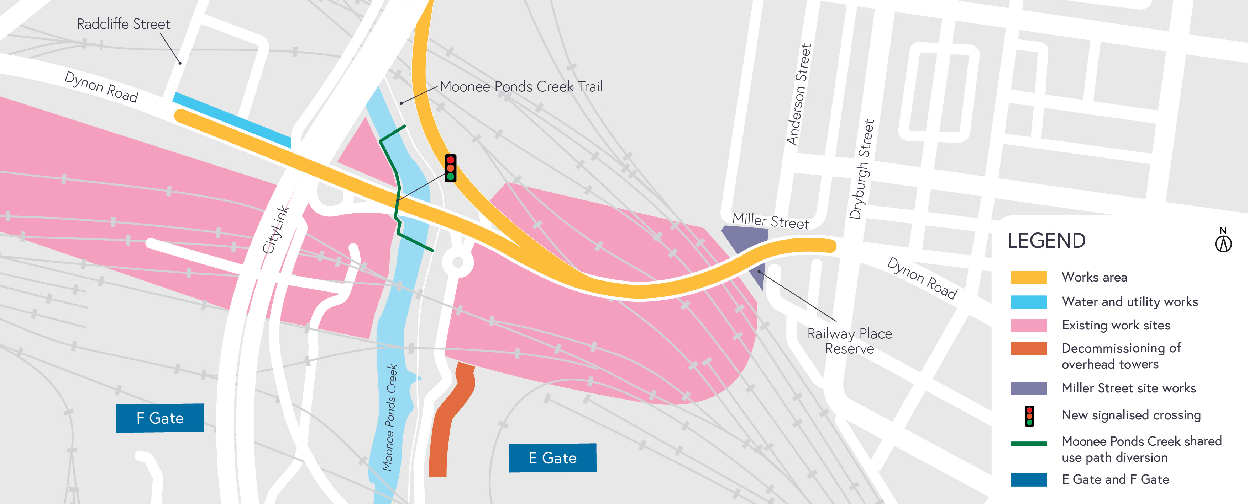

Wurundjeri Way Extension

Pile cap construction has commenced during October along the location of the new Wurundjeri Way Extension, including excavation work, reinforced steel work, formwork and concrete pours. Strut installation and piling works are set to continue on and under CityLink until the end of 2020.

Excavation works
Excavation works and pile cap construction is currently taking place on the Wurundjeri Way Extension bridge and will continue until the end of December 2020.
When: November – December 2020. These works will be completed during the day between 7am and 5pm, and at night between 7pm and 5am.

CityLink Works
Installation of struts has continued on CityLink around the Dynon Road entry ramp and F Gate throughout the month of October. Following this work, crossheads (support structures) are scheduled to be installed adjacent to CityLink during November and December.
Bored piling works for the new Wurundjeri Way Extension Bridge commenced in October and will continue until
late December. Once piling is complete, pile caps will be poured to act as foundations for piers.

Column Installation continues on the south side of Footscray Road, pending precast availability. A large ‘650T crawler’ crane will continue to relocate and install these columns and crossheads.
The relocation of V/Line maintenance facility in F-Gate is due to commence shortly and will take place over several weeks.
Additionally, planning for the relocation of Port Truckie Diner to a new, permanent location is proposed over the coming months.
When: November – December 2020. These works will be completed during the day between 7am and 5pm, and may require some night works. Notification will be provided for out of hours works.

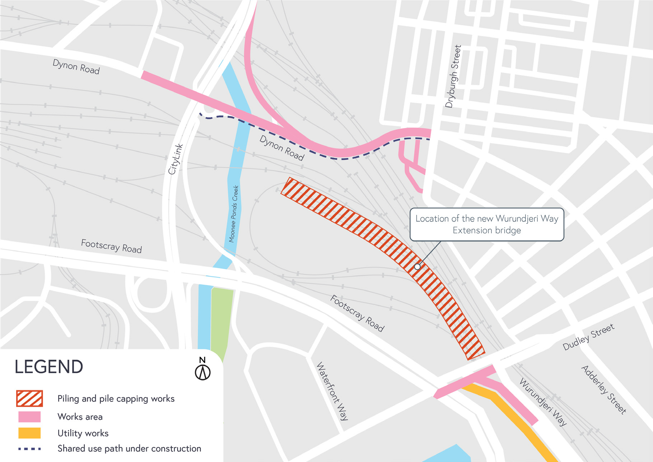

What to expect during construction
- Works completed both during the day and at night time
- We will notify you if there are any significant changes to the timing of our works
- Traffic management will be in place to manage changed conditions, including temporary access
changes to car parking spaces and signage to guide road users and cyclists
- Piling works can create increased levels of noise and may also cause some vibration.

Assessments have been conducted, which indicate the noise levels are expected to remain within permissible levels as documented in the project’s Environmental Performance Requirements.
Please note that works might need to be rescheduled in the event of bad weather or other unavoidable circumstances.

We thank you for your patience during these works.

westgatetunnelproject.vic.gov.au info@wgta.vic.gov.au
1800 105 105
West Gate Tunnel Project Info Centre Corner of Somerville Rd and Whitehall St Yarraville VIC 3013
Follow us on social media Please contact us if you would like this
information in an accessible format.

Translation service – For languages other than English, please call 13 14 50.

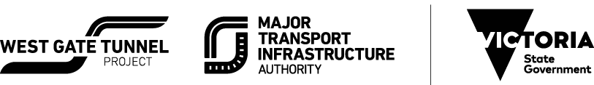

Authorised by the Victorian Government, 1 Treasury Place, Melbourne

