Chapter 4
Feasible alternatives
September 2019

Chapter 4

Feasible alternatives
The PER Guidelines (DoEE, 2018) for North East Link require discussion of the consequences of not proceeding with the action, and of feasible alternatives to the action to the extent reasonably practicable.
Chapter 2 – Objective of the action details the objectives for North East Link. These objectives include improving business access and growth and improving household access to employment and education in Melbourne's north, east and south-east, while also improving freight and supply chain efficiency and industrial growth, and improving access, amenity and safety for the communities in the north-east.
This chapter explains the consequences of not proceeding with the action and discusses the feasible alternatives to the action to the extent that are reasonably practicable. It addresses:
- The consequences of not proceeding with the action
- The alternative strategic interventions and strategic options that were considered
- The alternative alignments that were assessed and why the preferred alignment was chosen
- Feasible design alternatives to the action that will be assessed, including a comparative description of the impact of each alternative on the relevant MNES protected under Part 3 of the EPBC Act and on the environment on Commonwealth land.
The development of North East Link from business case through to the reference project has been iterative, starting with the development and assessment of project objectives and guiding principles, strategic alternatives, defining and selecting corridor alternatives and finally considering design options for the action described in Chapter 3 – Description of the action.

Consequences of not proceeding with the action
The PER Guidelines and Schedule 4 of the EPBC Regulations 2000 require the consequences of not proceeding with the action to be discussed. If North East Link does not proceed, the impacts associated with the action would not occur. However, the North East Link objectives would not be achieved. Under the 'no action' scenario, the existing fragmentation of labour markets and diminished levels of employment access would continue. The absence of North East Link would constrain productivity, growth and competitiveness for Melbourne and Victoria. Improved access, amenity and safety for communities in the north-east of Melbourne would not be achieved.
In the coming decades, traffic volumes in north-east Melbourne are expected to grow in a number of areas including increased orbital trips between the north and east (from 40,000 trips a day to between 50,000 and 60,000 trips per day by 2036) (NELA, 2018a). Greater truck volumes and increased traffic volumes across the Yarra River are also predicted.
Without North East Link, road network performance in north-east Melbourne would deteriorate. Average vehicle speeds are expected to decline, meaning an already slow commute (compared with the rest of Melbourne) would become even slower. While the growth in vehicle trips in north-east Melbourne is lower than the rest of Melbourne, average vehicle speeds are expected to decline at a faster rate, mainly due to the limited capacity of the road network, reliance on a limited number of river crossings and a relative lack of other planned infrastructure upgrades.

Alternative strategic interventions to the action
Alternative strategic interventions to the action were examined as part of the reference design development process. Each strategic alternative was investigated and assessed against the North East Link objectives, as outlined in Table 2-1 in Chapter 2 – Objective of the action. The strategic alternatives assessment involved the development of strategic options, which was undertaken over four stages set out in Figure 4-1.
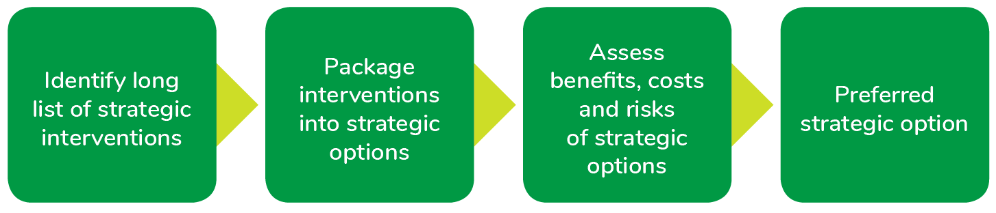
Figure 4-1 Methodology for determining preferred strategic option

Strategic interventions and options

Strategic interventions
A long list of strategic interventions was developed and grouped into three categories:
- Manage demand on the transport network – addressing the need for additional transport services now and into the future through a number of features. Demand management pricing could be used (including tolling new or existing facilities, cordon pricing and vehicle occupancy incentives and restrictions). Land use zoning could also be used to encourage living and working in the same general area as well as active transport to reduce demand on the network.
- Improve productivity – developing options to improve efficiency of the transport network including intelligent transport systems, lane use management, variable speed limits and modifications to freight operations.
- Increase supply of transport assets – increasing capacity and availability of transport assets with measures such as upgrades to existing roads or new arterial roads, a new freeway link, dedicated pedestrian and cycling routes, additional bus services and bus priority lanes, improving freight movements and the potential for new heavy or light rail connections.

Strategic options
Five strategic options were developed. These comprised different combinations of interventions from the strategic interventions summarised above. The strategic options were developed and assessed for their ability to achieve the North East Link objectives, minimise impacts in accordance with the guiding principles for North East Link, and to deliver benefits. The cost, timing, risk and impacts of each strategic option were considered. A preferred strategic option was identified. The findings of the comparative assessment are summarised in Table 4-1. Further detail is provided in the North East Link business case (NELA, 2018a).
Table 4-1 Assessment of strategic options
Strategic option | Description | Assessment
Strategic Option 1 – Network upgrade | Focusing primarily on upgrading existing infrastructure to address constraints in the transport network. | Provides short to medium-term relief to transport capacity problems in the north-east. There are few alternative north-east arterial roads in the area suitable for widening. As a result, this option does not address the orbital connectivity problem and may attract more heavy vehicles onto neighbourhood roads. It would also likely require significant land acquisition for a short to medium-term benefit.
Strategic Option 2 – Demand and productivity management | Implementing demand management pricing, corridor plans (such as extending truck bans, turning movement bans and parking management, enforcing mode priority during peak periods and undertaking advertising campaigns to encourage mode shift) and land use interventions, such as changing zoning to encourage or discourage density around employment and/or residential areas. | Does not fully address the freight problem, as there are limited alternative freight routes, which may attract heavy vehicles onto neighbourhood roads.
Strategic Option 3 – Public transport and freight | Focusing on public transport investments and managing freight movements. | This does not fully address freight movement problems between the north and the south-east, nor last mile deliveries that are carried out mostly via the road network.
Strategic Option 4 – Bypass freeway | Involves constructing a bypass freeway linking the M80 Ring Road (otherwise known as the Metropolitan Ring Road) to the Eastern Freeway, without intermediate interchanges, supported by a package of complementary measures which could include enhancing the local bus network, land use interventions, network management measures and improving pedestrian and cycling infrastructure. | This provides a medium to long-term solution to poor orbital connectivity, inefficient freight movements and congestion on neighbourhood roads. However, it does not provide direct connections to key employment and activity centres to facilitate economic growth and economic opportunities for residents in the north-east.
Strategic Option 5 – Connected freeway | This was the recommended option and included constructing a connected freeway linking the M80 Ring Road to the Eastern Freeway. Known as North East Link, this option incorporates connections to the wider arterial road network and a package of complementary measures similar to the ‘bypass freeway’ option. | Connected freeway – (North East Link) was the recommended option to be progressed for options development. This option provided the most viable solution to the orbital connectivity and capacity problems identified (see Chapter 2 – Objective of the action) and is expected to deliver considerable benefits to the community and industry in the medium to long-term.

Alternative alignments to the action
Having identified North East Link as the preferred strategic option, the next phase of the process was to select the preferred alignment for North East Link. Four corridors (A, B, C and D) were assessed, as shown in Figure 4-2.
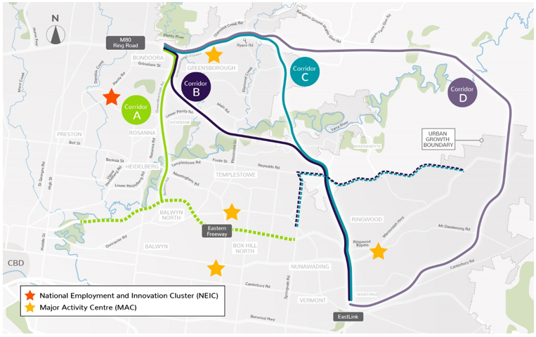
Figure 4-2 North East Link corridor proposed alternatives
To allow for each of the four corridor options to be assessed, and to allow for new or additional information to be incorporated for consideration throughout the process, an iterative approach was adopted. Under this approach, a gradually refined list of options was subject to increasingly detailed assessment, through the following stages:
- Strategic merit test – high level and largely qualitative
- Rapid appraisal – more detailed and with quantitative elements
- Detailed appraisal – mainly quantitative.
The assessment considered the impact of each of the four corridor options on the environment, heritage, economy and social values, regardless of whether these related to State or Commonwealth land, while also taking into account the technical aspects relevant for each corridor. The impact of the four corridor options on public and private land were also considered, as well as feedback from key stakeholders and wider community consultation.

Strategic merit test
This stage was a high level and largely qualitative assessment of the four corridor options, based on key inputs of the initial modelling of traffic conditions, and a comparison of the action against North East Link objectives. At this point, each corridor option was assessed for its potential to deliver anticipated benefits. The strategic merit test did not consider the guiding principles (as set out in Table 2-2 in Chapter 2 – Objective of the action), as failure to meet North East Link objectives was considered a fatal flaw.
During this test, it was found that Corridor D, the longest and most indirect alignment, performed the worst of all options against North East Link objectives. Modelling showed it provided the lowest travel time savings, its ability to attract traffic would be limited, and it would place pressure on green wedge areas in the north-east of Melbourne. Corridor D was therefore dropped from further assessment.

Rapid appraisal
This stage was mostly qualitative, with some quantitative inputs which considered technically feasible potential engineering concepts for Corridors A, B and C. These inputs came from the modelled traffic conditions, cost estimates, preliminary land use modelling, available geotechnical information, impacts on known utilities, and environmental and heritage desktop studies. At this point, each option was assessed against the project objectives as well as the guiding principles.
The rapid appraisal stage did not expressly include an assessment of impacts on matters protected under the Australian Government’s Environment Protection and Biodiversity Conservation Act 1999 (EPBC Act). However, as outlined in Appendix D of the North East Link business case (NELA, 2018a), the assessment of impacts against environmental criteria included how each option would affect:
- Flora and fauna
- Historic and cultural heritage
- Landscape and visual characteristics
- Waterways.
In particular, the assessment of impacts on flora and fauna was based on Victoria’s Department of Environment, Land, Water and Planning (DELWP) NaturePrint Strategic Biodiversity Values map. This mapping tool identifies priority areas for protection based on the importance of the natural values in that location. It combines landscape importance information, such as where there is habitat for threatened species (including those listed under the EPBC Act) or where many threatened species occur, with connectivity and fragmentation information to show the relative biodiversity value of landscapes in Victoria. In the absence of field-verified data on the presence or absence of EPBC Act-listed species across the three corridor options, this was considered to be an appropriate proxy measure for impact on flora and fauna, including EPBC matters.
Corridor B was dropped at this stage, as it was identified it had adequate to poor performance against North East Link objectives compared with Corridors A and C, and had as many, if not more impacts when assessed against the guiding principles. Early estimates also identified Corridor B as the highest cost option, with technical issues that were likely to increase design complexity as further development of the concept progressed.

Detailed appraisal
The detailed appraisal was the key stage of the corridor assessment process. This stage, which only compared Corridors A and C, was predominantly quantitative, with some qualitative inputs from findings of technical and other investigations. At this point, Corridors A and C were assessed against the full range of measures corresponding to the assessment criteria developed from the objectives and guiding principles. Key measures that relate to matters protected under the EPBC Act are expanded on below. Further detail is provided in Appendix D of the North East Link business case (NELA, 2018a).
Impacts on Commonwealth land were not expressly assessed in the detailed appraisal. However, the impact on Simpson Barracks in particular was taken into account when assessing impacts on communities and environmental and cultural assets.

Flora and fauna
The detailed appraisal determined that Corridor A had fewer potential impacts on flora and fauna than Corridor C.
Potential impacts on matters of national environmental significance (MNES) under the EPBC Act and species listed under Victoria’s Flora and Fauna Guarantee Act 1988 were comparable for Corridor A and Corridor C. Neither corridor was expected to have a significant impact on listed fish such as the Australian Grayling. The assessment found both corridors had potential to impact rare or threatened flora and fauna species. The most critical ecological issue was likely to be potential impacts on the listed flora species Matted Flax-lily, which is known to occur within both corridors.
Potential impacts to native vegetation were anticipated to be greater in Corridor C, with five to six times more vegetation intersecting with the alignment, particularly around Currawong Bush Park and Mullum Reserve, compared with Corridor A.
Assessment against the NaturePrint database found that Corridor C would also likely impact double the amount of areas of high ecological value than Corridor A.

Heritage
The detailed appraisal determined the potential impacts on Aboriginal cultural and historical heritage would be greater for Corridor A than for Corridor C. This is primarily because Corridor A intersects with a greater extent of culturally sensitive areas and a greater number of Heritage Overlay places. Potential impacts to currently registered Victorian Aboriginal Heritage Register places were considered to be comparable for both corridors, with low numbers of places likely impacted. No World Heritage, National Heritage or Commonwealth Heritage-listed places were identified in either corridor.

Waterways
The detailed appraisal determined the potential impacts on waterways were comparable for the two corridors. Corridor A would cross eight waterways and Corridor C would cross nine waterways. By tunnelling, direct impacts on the Yarra River would be avoided for both corridors. Both corridors would intersect around 20 hectares of waterway area and riparian zone.
The potential impacts on waterway ecological values were considered greater for Corridor C due to the proposed crossings at Plenty River, Diamond Creek and Mullum Mullum Creek where EBPC or FFG listed aquatic species may occur. While Koonung Creek would be directly affected by Corridor A works, the creek is highly modified and the Land Use Macroinvertebrate Response (LUMaR) index for the creek indicates very poor aquatic macroinvertebrate condition. Accordingly, these potential impacts were considered less significant from an ecological viewpoint.

Groundwater
The detailed appraisal indicated the potential impacts on groundwater were potentially less pronounced for Corridor C compared with Corridor A. Despite the extent of tunnelling works being greater for Corridor C, the hydrogeological conditions along Corridor A would likely be more challenging in terms of permeability and the greater likelihood of connections between groundwater and surface water systems. While engineering solutions were likely to be readily available in either case to effectively minimise impacts on groundwater systems and uses of groundwater, the risks would be more complex for Corridor A due to the connectivity between groundwater and surface water systems.

Key findings of the detailed appraisal
Corridor A was selected as the North East Link corridor because this corridor:
- Best meets North East Link objectives and was assessed as performing very well against the guiding principles compared with all other corridor options
- Provides the best opportunity for connections to the existing road network that respond to travel demand through, in and out of the north-east of Melbourne. This means that Corridor A would attract the most through traffic to the new link out of all corridor options considered, reducing demand on local arterial roads
- Provides better connectivity for all freight journeys and serves a greater number of freight catchments for trucks travelling across the north, east and south-east of Melbourne. This means that Corridor A provides the best opportunity to remove trucks from local roads in the north-east
- Works together with the existing road network in the north-east, enabling the greatest ability to reduce traffic on existing arterial road networks and providing opportunities to improve conditions for more local journeys and on-road public transport
- Connects close to areas of greater activity, providing better access for businesses and residents in the north, east and south-east of Melbourne to workers, jobs and services. Corridor A provides the greatest improvement in business access to labour markets, particularly the opportunity to stimulate jobs growth in the La Trobe National Employment and Innovation Cluster (NEIC) and between the Broadmeadows, Epping, Ringwood and Box Hill Metropolitan Activity Centres
- Enhances the Eastern Freeway to cater for additional North East Link traffic, addressing existing issues in the operation of the freeway and future proofing it for growth
- Provides the best opportunity for improving public transport on the existing network as well as the opportunity to integrate a Doncaster Busway solution along the Eastern Freeway
- Provides the best opportunity to connect and expand existing shared use paths in the north-east
- Offers the most cost-effective solution and the maximum benefits.

Alternative components of the action

Overview
With the announcement of the preferred corridor, North East Link was envisaged to include the following design elements:
- A tunnelled section, with a minimum length from Blamey Road to Manningham Road (described in Section 4.5.2 below)
- A section of the road in a trench, extending from Blamey Road to Watsonia railway station, running alongside Simpson Barracks (described in Section 4.5.2 below)
- Interchanges at M80 Ring Road/Greensborough Bypass, Grimshaw Street, Lower Plenty Road, Manningham Road and the Eastern Freeway (described in Section 4.5.3 below)
- Upgrades to the Eastern Freeway to increase its capacity in both directions, with dedicated carriageways between Middleborough Road and Burke Road to separate through traffic from traffic entering and exiting the freeway (described in Section 4.5.4 below)
- A new Doncaster Busway system along the Eastern Freeway from the Doncaster Park and Ride to Hoddle Street (described in Section 4.5.5 below).
NELP undertook further investigation of feasible alternatives (‘options’) within the preferred Corridor A for these design elements. This section summarises the options investigated. More detail, including figures of each option considered is provided in Attachment IV – Options assessment.
The options associated with the different design elements followed a set of criteria which reflect the transport system objectives and decision-making principles informed by Victoria’s Transport Integration Act 2010. Further detail is provided in Chapter 2 – Objective of the action.
Key aspects of the criteria are described in Table 4-2 and referenced throughout this section.
Table 4-2 Reference project assessment criteria – key aspects
Criteria | Key aspects of criteria | Transport system objective
Traffic and transport | - Functionality of layout  - Accessibility of layout | Integration of transport and land use
Design | - Compliance with standards and best practice including gradient and configuration of road geometry, maintenance access, OH&S and clearances | Efficiency, coordination and reliability
Land planning and environment | - Land acquisition  - Visual impact  - Environmental impact (including impact on MNES and Commonwealth land) | Environmental sustainability, safety, health and wellbeing
Stakeholder and community | - Residential and business accessibility and impacts  - Minimise displacement impacts | Social and economic inclusion
Financial | - Whole of life considerations | Economic prosperity

Community and stakeholder feedback received via community information sessions, Community Liaison Groups, stakeholder meetings and other engagement activities were also considered as part of the options investigation. Responses to feedback are discussed in Chapter 14 – Consultation.

Assessment of feasible options for tunnels
Protecting the Yarra River, its tributaries, floodplains, surrounding environment and culturally significant sites such as Bolin Bolin Billabong is a core requirement for North East Link.
Early feedback from community consultation identified these environmentally and culturally sensitive areas are highly valued by the Traditional Owners of the land – the Wurundjeri people – and the local community. There are also many residential properties within the project boundary, other sensitive receptors (such as schools) and local businesses. Tunnelling would minimise potential impacts to homes, community spaces and culturally and environmentally significant areas.
Tunnels would extend from Blamey Road in the north to south of the Veneto Club in the south, built by a combination of driven (TBM), mined and cut and cover tunnel construction methods. Tunnels would contain three lanes in each direction.
During design development, other options assessed for the tunnelled section of North East Link included:
- Extending the tunnels north of Blamey Road
- Extending the tunnels south to the Eastern Freeway
- Narrowing the tunnels from three lanes to two
- Potential location options for the primary administration and construction for the tunnelling works.

Length of tunnels (northern end)
The section between the M80 Ring Road and Lower Plenty Road has a number of design challenges due to the need to provide interchanges at the M80 Ring Road, Grimshaw Street and Lower Plenty Road, and because the ground in this area rises steeply to the north. Two key options were assessed for this section of road:
- Option A – continuation of the tunnels past Lower Plenty Road to Grimshaw Street
- Option B (reference project) – a trench from Elder Street to Lower Plenty Road.
Option B was progressed to the reference project as it responds to the following aspects of the criteria:
- Design:
Option B provides a horizontal and vertical geometry that responds to the challenging topography within this area. This enables the construction of safe entry and exit ramps at Lower Plenty Road and Grimshaw Street.
- Traffic and transport:
Option B would reduce the number of large vehicles travelling south on Greensborough Road to Rosanna Road (via Lower Plenty Road). These vehicles would then use existing designated routes on the arterial road network to travel to their destinations, including Rosanna Road and Bulleen Road. These over-dimensional vehicles and some vehicles carrying dangerous goods (placarded loads) would not able to travel in the tunnels, consistent with CityLink, EastLink and the yet to be constructed West Gate Tunnel Project.
- Land planning and environment:
While Option A would avoid impacts at Simpson Barracks, and associated impacts on Matted Flax-lily and Commonwealth land, Option A would require acquisition of residential properties on the east side of Sellars Street to facilitate the at-grade interchange at the M80 Ring Road and Greensborough Bypass. Option B was selected as impacts to properties on the east side of Sellars Street would be largely mitigated or removed entirely.

Length of tunnels (southern end)
The options to extend the tunnels on the southern end between Manningham Road and the Eastern Freeway need to consider a number of challenges. These include significant existing traffic volumes on Bulleen Road, acceptable ramp grades to connect to the Eastern Freeway, interfaces with the Koonung Creek and the consideration of a number of sensitive receptors including residential properties, Bolin Bolin Billabong, community facilities, sporting grounds and school facilities. Three key options were assessed for this section of road:
- Option A – viaduct from Manningham Road to the Eastern Freeway over Bulleen Road
- Option B – continuation of the tunnels from Manningham Road to the Eastern Freeway under Bulleen Road
- Option C (reference project) – continuation of the tunnels from Manningham Road to the south of the Veneto Club and viaduct to the Eastern Freeway under Bulleen Road.
Option C was progressed to the reference project for the following reasons:
- Land planning and environment:
Option C would avoid impacts to residential properties on both sides of Bulleen Road due to the tunnelling method underneath residential properties.
- Traffic and transport:
The design of the viaduct structure to the Eastern Freeway would retain a suitable gradient for Bulleen Road to retain access for community facilities and provide efficient traffic functionality onto the Eastern Freeway.
While Option C provides an improved outcome for this section of North East Link compared with options A and B, there are some disadvantages associated with Option C. These include significant property impacts to community facilities such as Boroondara Tennis Centre, Bulleen Oval, tennis/netball courts within the Carey Grammar Sports Complex, the football oval used by Yarra Junior Football League, the Freeway Public Golf Club, the Bulleen Swim Centre and the visual impact associated with the viaduct structures to the Eastern Freeway.
On balance, Option C was progressed to the reference project due to the advantages associated with the design. While there are a number of community facilities impacted, this option avoids all direct residential property impacts in this location.

Width of tunnels – Two versus three lanes within tunnels
Early project assessment looked at the lane options for the tunnels, specifically whether the tunnels would have two or three lanes in each direction.
The estimated daily capacity of the tunnels would be 140,000 vehicles a day. Traffic modelling predicts the tunnels would carry up to 125,000 vehicles a day by the year 2036. The tunnels are also expected to be the busiest section of North East Link once it was operating.
If the North East Link tunnels were constructed with two lanes in each direction, it is expected that upgrading to three lanes in each tunnel would be required not long after the project started operating, which would be costly and disruptive.
As a result, early traffic studies showed that three lanes in each tunnel would be a better traffic and transport solution and provide the capacity required for projected initial and future traffic volumes. The tunnels would be designed and built to operate with three traffic lanes in each direction.

Location of the primary tunnelling work area
The reference project includes two options for the location of the primary administration and construction for the tunnelling works. These are at the following locations:
- Option A – Lower Plenty Road extending north to Blamey Road and described as the northern TBM launch site
- Option B – Bridge Street extending south to Golden Way and described as the southern TBM launch site.
The descriptions of the two launch sites are included in Chapter 3 – Description of the action. Both launch site options are located within the project boundary. While the construction layouts for the sites changes depending on if the launch site was located there, this only means that precise locations of construction sheds/laydown areas would change.

Assessment of feasible interchange options
The decision to locate additional interchanges between North East Link’s connections to the M80 Ring Road and Eastern Freeway was made giving consideration to:
- The existing road network – Grimshaw Street, Lower Plenty Road and Manningham Road are the three arterial roads that intersect with the North East Link alignment.
- The VicRoads SmartRoads framework and Transport for Victoria’s Movement and Place Framework – the SmartRoads approach to managing Victoria’s arterial road network aims to better link transport to adjacent land use, by providing a set of guiding principles for road use by transport mode, place of activity and time of day. Transport for Victoria is also currently developing the Movement and Place Framework to replace the SmartRoads road use hierarchy. The framework defines categories for each road link with respect to functionality, transport mix and environmental conditions to guide the planning and development of an integrated transport network. This also extends to the design of people-friendly streets and defining the best outcomes for cycling, walking and place making.
- Traffic studies and modelling of the origins and destinations of vehicles travelling on North East Link – these studies have identified that interchanges at these locations would allow people to use North East Link to more easily access their destinations in the north-east.
- The ability to provide access to residential and employment areas – interchanges with key arterial roads would allow vehicles travelling on North East Link to travel to and from employment and residential areas in the north-east such as the La Trobe National Employment and Innovation Cluster (NEIC).
Figure 4-3 highlights the location of proposed interchanges at the M80 Ring Road, Grimshaw Street, Lower Plenty Road, Manningham Road and the Eastern Freeway which would provide access to major population and employment centres.
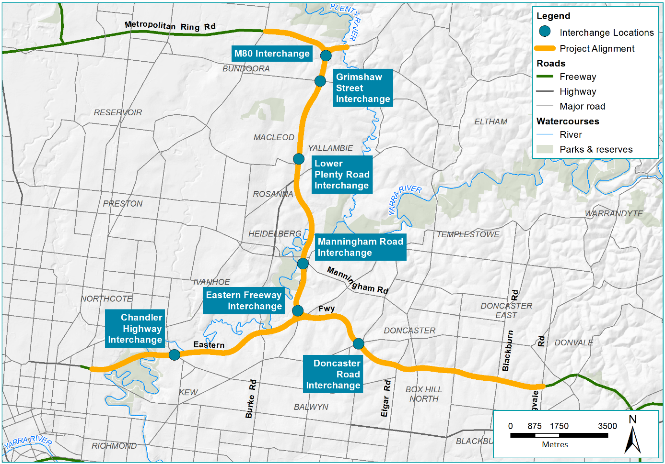
Figure 4-3 North East Link key interchange locations

M80 Ring Road and Greensborough Bypass interchange
The purpose of this interchange is to provide connectivity to the Greensborough Bypass to the east, the M80 Ring Road to the west and south onto North East Link and to remove the signal constraints that are currently at this interchange.
The structure of this interchange was dependent on a number of key challenges and decision points in the options development process.
As explained in Section 4.5.2 above, North East Link tunnels would extend from Blamey Road in the north, to south of the Veneto Club in Bulleen in the south. As a result of the design for the tunnels, the options for the interchange at the M80 Ring Road and Greensborough Bypass were narrowed to two key options. This includes:
- Option A – an elevated road
- Option B (reference project) – a road at-grade.
Option B was preferred as it provides a number of advantages including:
- Traffic and transport:
Option B improves service road and local road access (including pedestrian overpasses), and allows for intersections at Grimshaw Street and Lower Plenty Road.
- Land planning and environment:
Option B minimises visual and amenity impacts as it would be located within the existing M80 Ring Road and Greensborough Bypass road corridors.

Grimshaw Street interchange
Following the selection of the preferred option for the M80 Ring Road interchange as an at-grade road, explained above, the layout of the Grimshaw Street interchange was largely predetermined and takes a single point interchange design configuration. North East Link would be separated vertically from Grimshaw Street to cater for free flowing traffic to and from North East Link. This would be achieved by balancing the lowering of North East Link carriageways and raising of Grimshaw Street.
Key options associated with this interchange were related to the service road provision and local road access around Grimshaw Street. Two options for the service road provision around Grimshaw Street were assessed:
- Option A – no interface with Grimshaw Street
- Option B (reference project) – interface with Grimshaw Street.
Option B was preferred for the following reasons:
- Traffic and transport:
Option B would improve traffic functionality and provide circuitous local access to Watsonia railway station (replacing the current direct access from Elder Street), while maintaining connectivity between Watsonia Neighbourhood Village and Grimshaw Street. At the Grimshaw Street interchange, the service roads would interface with the main interchange allowing movements in all directions.
- Land planning and environment:
Option B does not involve additional land acquisition at AK Lines Reserve and Watsonia Primary School, which would be required for Option A.
- Design:
Option B resolves a number of design challenges, experienced in Option A, associated with the interface between the new service road infrastructure and the Hurstbridge rail line.

Lower Plenty Road interchange
At Lower Plenty Road, North East Link would enter a twin three-lane each way tunnelled section and continue south. An intersection at Lower Plenty Road would provide full entry and exit connectivity for traffic. Key challenges associated with this interchange include requirements to:
- Provide suitable grades for the entry and exit ramps
- Provide cover suitable for the tunnels
- Minimise impacts to the community.
As a result of these competing challenges, a number of configurations were considered for this interchange. Three main options assessed were:
- Option A – standard interchange design
- Option B – new interconnected road design
- Option C (reference project) – Greensborough Road centric design.
Option C was progressed to the reference project for the following reasons:
- Land planning and environment:
Option C contains the intersection within the road reserve (Greensborough Road) as much as practicable to reduce property impacts. While a small number of residential properties north of Lower Plenty Road would need to be acquired, there is a significant reduction in impacts to Simpson Barracks and removal of impacts to residential properties south of Lower Plenty Road.
- Design:
Option C would allow southbound vehicles on North East Link (north of the interchange) to exit to Lower Plenty Road via an exit ramp before the portal. This would enable oversized vehicles and placarded loads (vehicles carrying dangerous goods) that are travelling southbound to exit North East Link before the tunnels begin.
Despite these benefits, Option C would lead to a traffic functionality scenario which is less than optimal. This is due to the complex ramp layouts which are not as intuitive for drivers as in Option B.

Manningham Road interchange
The Manningham Road interchange provides access to the southbound and northbound tunnels from Manningham Road and includes modifications to Manningham Road to maintain access to Bridge Street.
Key challenges associated with this interchange include:
- The challenging grade conditions associated with a portal interchange layout
- A number of significant community facilities and sensitive receptors
- A number of commercial and industrial properties.
As a result of these competing challenges, three key interchange layout options were considered:
- Option A – traditional interchange layout
- Option B – split diamond interchange with access to Avon Street (reference project)
- Option C – split diamond interchange without access to Avon Street (reference project, alternative design)
Options B and C were progressed to the reference project for the following reasons:
- Design:
Options B and C would provide connections to Manningham Road and Bulleen Road, and would have suitable ramp grades from and into the tunnels and sufficient capacity.
- Land planning and environment:
Options B and C would not impact the area north of Bridge Street, including the grounds of the Heide Museum of Modern Art, as significantly as Option A. Option B would also involve reduced impact to the Bulleen Industrial Precinct, and Option C would avoid impacts to residential properties south of the interchange.

Eastern Freeway interchange
The options associated with the Eastern Freeway interchange at the southern end of the project were largely determined by the alignment of the tunnels and the elevation of the interchange. This was assessed in Section 4.5.2 above as part of the assessment of the southern end tunnel length.

Assessment of feasible options to upgrade the Eastern Freeway
The Eastern Freeway is one of the last metropolitan freeways in Melbourne to be upgraded to a fully managed motorway. Daily weekday traffic volumes along the Eastern Freeway range from 128,000 to 178,000 vehicles per day. Congestion can be attributed to three key challenges:
- Merging and weaving at interchanges
- Constrained capacity of the freeway ramps
- Constrained sections of road between interchanges.
North East Link would compound this traffic congestion.
Where North East Link would connect to the Eastern Freeway at Bulleen Road, demand for travel along the Eastern Freeway is expected to increase significantly. According to traffic modelling, approximately 75 per cent of traffic would travel easterly along the Eastern Freeway toward EastLink and 25 per cent to the west.
The Eastern Freeway would be upgraded and modernised between Hoddle Street in the west and Springvale Road in the east to integrate effectively with North East Link, and to cater for the increasing traffic volumes and changing travel demands and also provide greater capacity.
Upgrade works would include widening of the Eastern Freeway to accommodate additional lanes and new dedicated bus lanes between Doncaster Road and Hoddle Street (the ‘Doncaster Busway’, outlined in Section 4.5.5 below).

Eastern Freeway widening
Two key road design options were available for the layout of the Eastern Freeway widening:
- Option A – an unconstrained road design
- Option B (reference project) – a collector distributor design.
Under Option B, a collector distributor design for the Eastern Freeway would separate traffic travelling on ‘express way’ carriageways, from traffic entering and exiting the freeway on local access carriageways. By minimising weaving, this design solution would improve the efficiency of the freeway and the safety of drivers. Additional lanes would provide a suitable level of capacity to support the existing levels of traffic as well as the additional traffic as a result of North East Link. This collector distributor design layout was identified as the preferred option for the reference project.

Tram Road to Middleborough Road short trips
The section of the Eastern Freeway between Tram Road and Middleborough Road is currently used by locals for short trips between Doncaster and Box Hill.
These short trips can be completed via the entry and exit ramps on both carriageways. While trips like this are usually undesirable on the freeway system, at this location this link provides a useful function in the road network, and is used by approximately 400 to 500 vehicles an hour. This is largely because the nearest alternative arterial road routes, Doncaster Road and Whitehorse Road, are remote from the Eastern Freeway and there are no easily useable local road options between Doncaster Road and Whitehorse Road.
In the context of the collector-distributor design proposed for the Eastern Freeway, two options for these short trips were considered:
- Option A – remove short trips
- Option B (reference project) – retain short trips.
Option B was progressed to the reference project, due to the significant number of locals who rely on these short trips. If removed, as in Option A, locals would need to use already congested local roads including Doncaster Road and Whitehorse Road. In contrast, Option B would untangle these traffic movements on the freeway, keep traffic off local roads, maintain traffic flow along the Eastern Freeway and keep drivers safe.

Assessment of feasible Doncaster Busway options
The Doncaster Busway, as part of North East Link, is expected to:
- Enable buses to bypass congestion on the Eastern Freeway and its entry and exit ramps
- Improve the reliability of bus travel times along the Eastern Freeway, with the Doncaster Busway travel time along the Eastern Freeway between Doncaster Road and Hoddle Street predicted to be up to 30 per cent faster in 2036 compared with the non-upgraded Eastern Freeway with no Doncaster Busway improvements
- Allow a higher frequency of services to be implemented, due to faster and more reliable trips between Doncaster Road and Hoddle Street.
Three options for the Doncaster Busway along the Eastern Freeway were assessed:
- Option A – central median from Victoria Park and north side from Burke Road
- Option B – outside lanes from Hoddle Street, central median from Chandler Highway and north side from Burke Road
- Option C (reference project) – outside lanes from Hoddle and north side from Chandler Highway.
Option A was discounted due to key challenges for safely operating and maintaining dedicated bus lanes in the central median of an operating freeway. This design and functional layout would challenge emergency service access to the Doncaster Busway and also may create safety issues for passengers and other traffic if a bus broke down.
Option B was discounted due to issues related to the ramp structures at Chandler Highway. In addition, similar to Option A, Option B was also removed from further consideration due to key challenges with being able to safely operate and maintain dedicated bus lanes in the central median of an operating freeway.
Following further design development and analysis, including consultation with other agencies and bus operators, the assessment found that Option C would provide the most acceptable and efficient outcome. Option C would provide the following beneficial outcomes:
- A direct connection to the existing bus lanes on Hoddle Street and improved travel times
- It would allow bus routes on Chandler Highway to connect to the busway.

The reference project
Following the review and refinement of options for the different key design elements, the reference project was developed for assessment as a part of this PER. In addition to the options described above, key changes made to the design elements were influenced by community and stakeholder engagement and the technical specialist studies.
Through a number of community design update information sessions and ongoing engagement with stakeholders and the community, key issues relevant to the community and stakeholders were incorporated into the options assessment for the reference project. More detail on community and stakeholder consultation is provided in Chapter 14 – Consultation.
The specialist assessments of North East Link impacts through the EES and PER processes also influenced the refinement of the reference project. This largely occurred through the identification of key impacts and collaboration with the design team to identify where impacts could be avoided or where they needed to be managed through the design.
For a complete overview of the reference project, see Chapter 3 – Description of the action.

