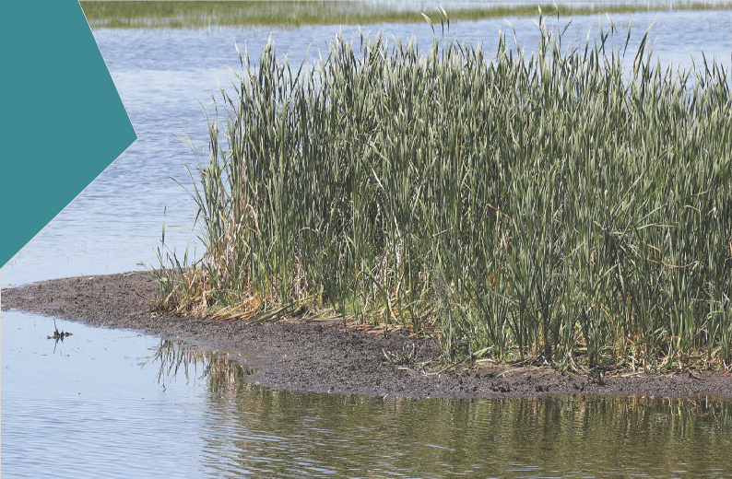

7 ACID SULFATE SOILS AND CONTAMINATION

SECTION PAGE SECTION PAGE

7.1 | What are acid sulfate soils? | 7.3 | 7.4.3 | Spoil generation and assessment | 7.19
7.2 | What is contamination? | 7.3 7.4.4 Landfill capacity assessment 7.20
7.3 | Methodology | 7.4 | 7.5 | Construction impact assessment | 7.21
7.3.1 | Acid sulfate soils | 7.4 | 7.6 | Operation impact assessment | 7.31
7.3.2 | Contamination | 7.5 | 7.7 | Conclusion | 7.39
7.4 | Existing conditions | 7.6
7.4.1 | Acid sulfate soils | 7.6
7.4.2 | Contamination | 7.9

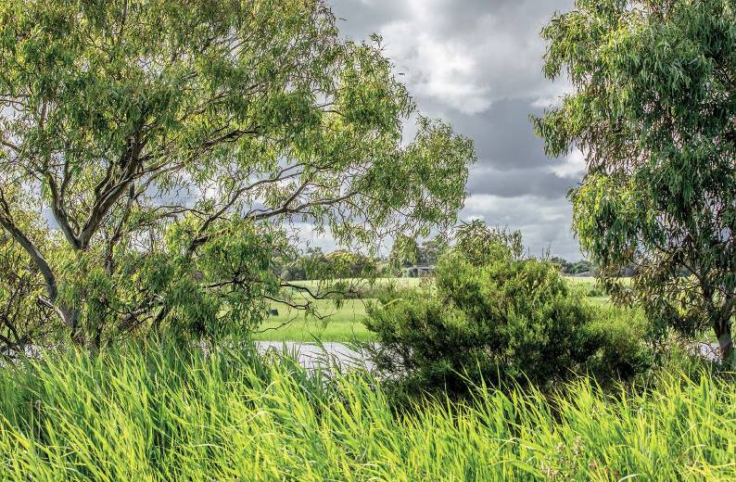

During construction, excavated material (spoil) has the potential to contain contaminated material or acid sulfate soils. Contaminated soil and groundwater, and acid sulfate soils, have the potential to impact human health and the environment, particularly for nearby residents and land uses. This chapter summarises the potential impacts of contaminated soil and groundwater, and acid sulfate soils, which would be disturbed by the projects.
The Scoping Requirements for the EES include the following evaluation objective:
- Contaminated/acid sulfate soils – to prevent adverse environmental or health effects from disturbing, storing or influencing the transport or movement of contaminated or acid-forming material.
To assess the potential effects of contaminated and/or acid sulfate soils on human health and the environment as a result of the projects, an acid sulfate soil, contamination and spoil impact assessment was undertaken.
The assessment included a detailed acid sulfate soil investigation and an indicative soil and groundwater contamination investigation to gain a general understanding of the soil and groundwater conditions of the project areas. The findings of the assessment are presented below, with a detailed report included in EES Technical Report C Acid sulfate soils and contamination.
A summary of the key findings from this chapter is presented in Table 7.1.

Table 7.1 Summary of key findings

Topic | Key finding
Acid sulfate soils and contamination | The projects would prevent adverse environmental or health effects from disturbing, storing or influencing the movement of contaminated or acid-forming material, and be designed to protect beneficial uses. Excavation of material that is likely to be contaminated would be unavoidable, however implementation  of well-defined and established practices to manage environmental and human health risks would be implemented.

7.2 Edithvale and Bonbeach Environment Effects Statement | Acid sulfate soils and contamination

What are acid sulfate soils?

Acid sulfate soil is the common name given to soils containing minerals like iron sulfides – predominately pyrite, which can occur naturally mostly near water bodies. Where acid sulfate soils occur in coastal settings they are commonly referred to as coastal acid sulfate soil.
Since the projects are located within a coastal setting, the acid sulfate soils are referred to as coastal acid sulfate soils in this chapter.
Acid sulfate soils which have not been exposed to air, such as when contained in a layer of waterlogged soil, are known as potential acid sulfate soils (refer to Figure 7.1 below). When these soils are exposed to air (in a process called oxidation) either naturally (for example, during a drought), through soil disturbance (for example, during excavation) or through a lowered water table (for example, in drain construction), the iron sulfides can react with oxygen and water to produce sulfuric acid. The soils which become acidic due to this process are called actual acid sulfate soils.
The oxidation of coastal acid sulfate soils can result in the generation, mobilisation and migration of acidity which can liberate contaminants (for example nutrients and metals) and potentially impact the environment, in-ground structures and human health.

Figure 7.1 Conceptual illustration of acid sulfate soil activation through lowering of groundwater

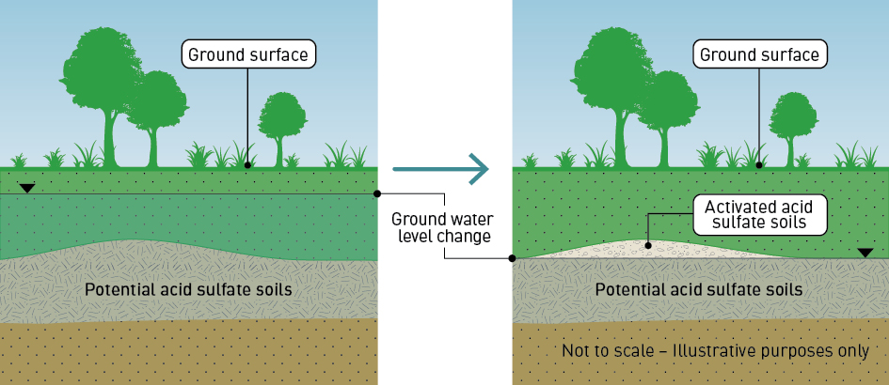

  - What is contamination?
Contamination of land and groundwater is primarily the result of human activity which results in the release of harmful substances, such as industrial chemicals, either directly or indirectly, into the existing environment. Contamination can be caused by both historic and current practices, such as poor storage, handling and disposal of substances.
Typical uses that can or have resulted in contamination of land and groundwater include spills or leaks from service stations, industrial or manufacturing facilities, illegal dumping and uncontrolled filling of a site (for example material brought in for historic maintenance activities that was not properly tested).
Contamination can have a harmful impact on the environment and human health through direct contact with contaminated soil, vapours from the contaminants and from secondary contamination of groundwater and surface water. Many practices from the past, which would be considered unacceptable today,
have resulted in long-term contamination of land and groundwater.
The project areas are largely within an infrastructure corridor that is bounded by road reserves and residential areas, however, there are areas of commercial or industrial uses that may give rise to contamination. Because contamination can migrate through the soil profile and within the flow of groundwater, it is important to also consider potential contamination sources that are outside of the project areas.

Methodology
The method of the impact assessment included:
- identification of historical activities at the project areas that may have caused contamination to soil and groundwater likely to be encountered during construction
- assessment of the potential for acid sulfate soils to be encountered during construction
- assessment of the spoil management options to appropriately manage spoil produced during construction
- assessment of impacts that would occur after construction, as a result of changes in groundwater levels.

Acid sulfate soils
The process for identifying and assessing coastal acid sulfate soils is outlined in the EPA Victoria’s Industrial Waste Management Policy 2009 and Victorian best practice guidelines for assessing and managing coastal acid sulfate soil 2010. These guidelines were used as the basis for developing the methodology used to determine the potential of the projects to interact with coastal acid sulfate soils for the assessment presented in this EES and would be applied during construction so that any coastal acid sulfate soils generated by the projects is managed in accordance with best practice.
The guidelines outline a four-stage process (Stages A to D), which is further detailed below. The guidelines set out when there is a need to manage the soils as coastal acid sulfate soil, with consideration to soil texture and quantity.

Stage A: Preliminary coastal acid sulfate soils hazard assessment
A desktop review was undertaken of available coastal acid sulfate soils maps and previous investigation reports. A site inspection of the project areas was also undertaken to identify any obvious field indicators of coastal acid sulfate soils, such as:
- iron staining
- corroded steel or concrete structures
- swamp tolerant, salt tolerant or marine vegetation.

Stage B: Detailed site soil sampling program and assessment
A soil investigation program was conducted, which included the drilling of 41 bores across both project areas for collection of soil samples at 0.5-metre intervals, to a maximum of 22.5 metres below ground surface.
A total of 1,045 soil samples were collected in accordance with relevant guidelines and analysed by National Association of Testing Authorities (NATA) accredited laboratories. All the soil samples were analysed for indicative field testing of coastal acid sulfate soils and based on the results of these tests, 292 samples were selected for detailed laboratory testing of acidity/neutralising capacity to verify the existence and nature of acid sulfate soils.

Stage C: Surface/groundwater sampling program and assessment
Surface water sampling was not undertaken as permanent surface water features were not identified at either of the project areas. A groundwater assessment for coastal acid sulfate soils and contamination was undertaken as part of the broader hydrogeological assessment for both Edithvale and Bonbeach (refer to EES Technical Report A Groundwater).
The groundwater assessment in relation to the coastal acid sulfate soils assessment included measuring groundwater levels and groundwater sampling. A total of 23 primary groundwater samples were collected, with 11 from Edithvale and 12 from Bonbeach. Samples were analysed by a NATA accredited laboratory for pH, salinity, ions, acidity, alkalinity, heavy metals and nutrients.

Stage D: Coastal acid sulfate soils hazard assessment
The purpose of the Stage D assessment is to determine the level of hazard (low, medium or high) associated with the coastal acid sulfate soil disturbance and to use the hazard rating to determine the planning and management strategies that would be implemented to prevent adverse impacts from disturbing coastal acid sulfate soils. The guidelines require that the results of the Stage B assessments are used to determine the hazard level associated with disturbing acid sulfate soils as a result of the projects. Refer to Section 7.4.1 for the results of the Stage D assessment.

Contamination
To assess the existing contaminated land conditions and identify potential sources of contamination within or near the project areas, a desktop review was undertaken (generally within a 500 metre radius of the project area). This included a review of historical aerial photographs and plans, publicly available literature, and geological, hydrogeological and topographical conditions. A site inspection was also undertaken to document and confirm site features and inspect potential sources of contamination.
Indicative soil and groundwater samples were obtained as part of the intrusive investigation undertaken
for the coastal acid sulfate soils assessment. A total of 89 primary soil samples were collected and analysed from 41 locations (42 samples at Edithvale and 47 samples at Bonbeach). A total of 23 primary groundwater samples were collected, with 11 from Edithvale and 12 from Bonbeach. Samples were analysed for various contaminants such as heavy metals and hydrocarbons and select samples were submitted for analysis of per-and polyfluorinated alkyl substances (PFAS, a relatively new emerging contaminant) based on findings from the desktop assessment. Further details on the location and extent of the intrusive sampling investigation are in Section 4.2.2 of EES Technical Report C Acid sulfate soils and contamination.
The sampling and analysis program was undertaken adjacent to the proposed rail trench to minimise disruption to rail operations and protect the safety of personnel undertaking the field investigation.
The results of the investigation are considered to be indicative of the contamination status of the soils
and groundwater to be encountered during the excavation and provide a reasonable estimate for the volumes and nature of contaminated material that may be excavated and require management. Further testing would be undertaken during the detailed design phase and prior to major excavation in accordance with Australian Standard 4482.1 Guide to the investigation and sampling of sites with potentially contaminated soil, Part 1: Non-volatile and semi-volatile compounds, and be managed in accordance with Environment Protection (Industrial Waste Resource) Regulations 2009 and the Occupational Health and Safety Regulations 2007. This is also included in the Environmental Performance Requirements (EPR references CL1 and CL2) in order to confirm the volumes and nature of contamination to be managed.

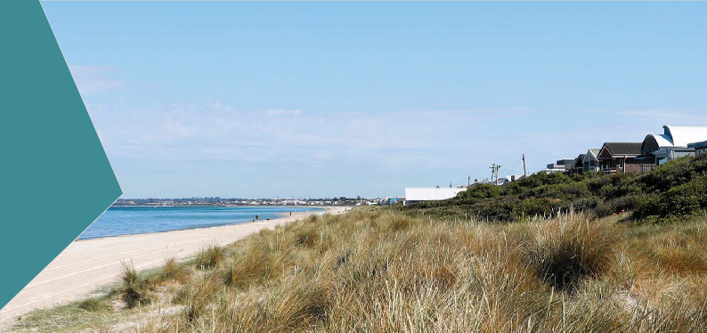Existing conditions

Acid sulfate soils
Coastal acid sulfate soil hazard mapping indicates that the project areas falls within land mapped as ‘prospective’ for coastal acid sulfate soils (based on Victorian State Government mapping data published in 2003), and have a ‘high probability/high confidence’ for the occurrence of coastal acid sulfate soils (Australian Soil Resource Information System (ASRIS) – CSIRO, 2012). However, field indicators for coastal acid sulfate soils were not observed during the site inspection.
The field pH measurements in soils showed that approximately 45 per cent of samples at Edithvale and 31 per cent of samples at Bonbeach indicated the presence of actual acid sulfate soils or potential acid
sulfate soils. The detailed laboratory results indicated that the majority of the samples selected for further analyses (71 per cent at Edithvale and 73 per cent at Bonbeach) were potential acid sulfate soils and could produce acidity when disturbed. The presence of actual acid sulfate soils was noted in 10 sandy to silty clay samples, between five and 10 metres below ground surface at Edithvale. At Bonbeach actual acid sulfate soil was present in four samples, in the fill sand (0.1 to one metre below ground surface) and the deeper sandy to silty clay layer (15 to 16 metres below ground surface). Approximately one third of the Edithvale samples and 39 per cent of the Bonbeach samples recorded net acidity exceeding the criteria given in Victorian best practice guidelines for assessing and managing coastal acid sulfate soil 2010. Based on the analytical results and observations, the likelihood of encountering any coastal acid sulfate soils at deeper layers ranging between 22 to 23 metres below ground is considered low.
The groundwater assessment in relation to acid sulfate soils indicated the presence of existing acidity at both Edithvale and Bonbeach in the shallow aquifer, however, the groundwater has sufficient ability to
neutralise any acidity currently being produced. Groundwater levels and water quality are discussed in detail in Chapter 5 Modelling the water environment.
The Stage D hazard assessment indicates that the hazard associated with the disturbance of coastal acid sulfate soils at the project areas is considered ‘High’. In accordance with the guidelines, it is recommended that where possible, disturbance of coastal acid sulfate soils be avoided. Where this is not possible (for example, when installing the piles and excavating the trench), an Acid Sulfate Soils Management Plan must be developed and include a description of how the proposed works would disturb coastal acid sulfate soils and appropriate management strategies to minimise impacts. The results of the assessment provide confidence on the location of coastal acid sulfate soils in the project areas and a sound and robust Acid Sulfate Soils Management Plan can be developed based on the results for both projects (EPR reference CL2).
Figure 7.2 and Figure 7.3 illustrate the findings of the coastal acid sulfate soils investigation, indicating potential acid sulfate soils are present at both Edithvale and Bonbeach, ranging from approximately 4 metres to 15 metres below the ground surface in the Edithvale project area and 3.5 metres to 16 metres below the ground surface in the Bonbeach project area.

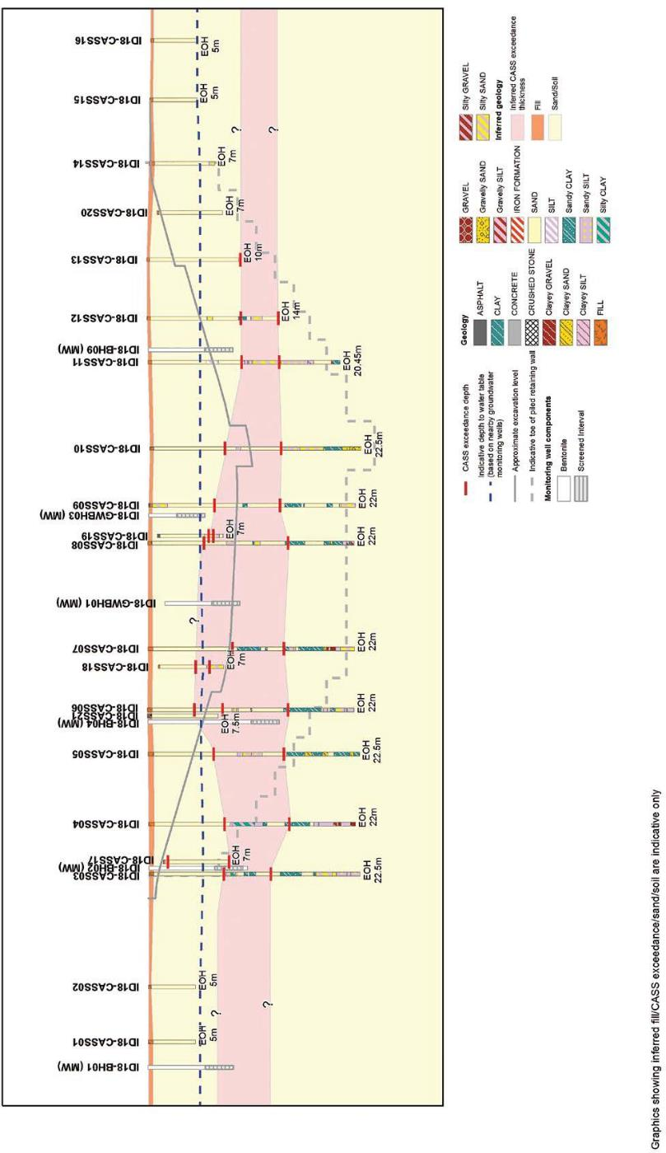
Figure 7.2 Potential waste acid sulfate soils (Edithvale)

A larger format version of this figure is provided in Attachment VI Map book.

Figure 7.3 Potential waste acid sulfate soils (Bonbeach)
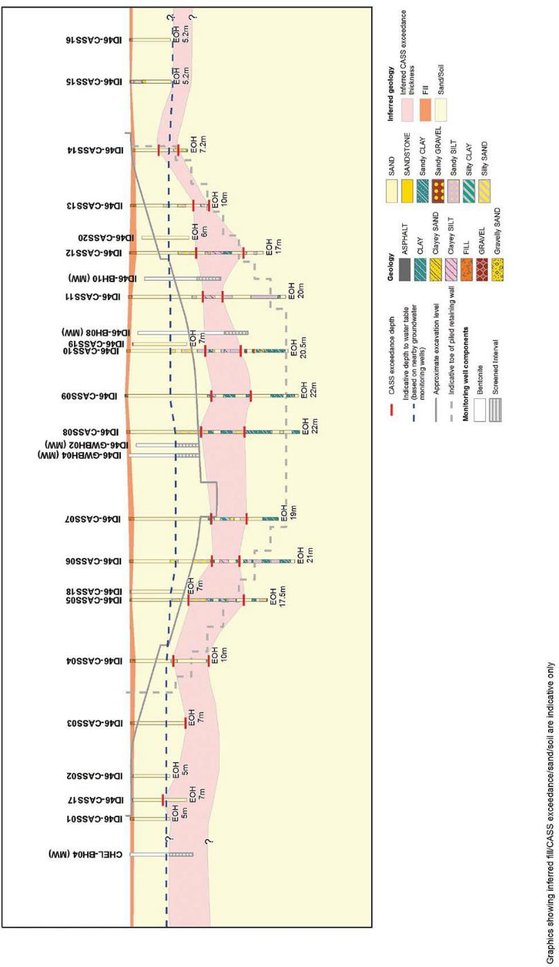

A larger format version of this figure is provided in Attachment VI Map book.

Contamination
Site contamination is reasonably common in Victoria as a legacy of past industrial use and poor waste management practices that would be unacceptable today. Like a lot of areas with a similar history
of industrial and manufacturing uses, combined with poor waste management and environmental practices, there are potentially contaminated sites present along and adjacent to the project areas.
The Edithvale and Bonbeach project areas are located within a modified urban environment. The project areas are underlain by Quaternary age aeolian and swamp deposits, which in turn overlie the Pliocene age Baxter Sandstone or Brighton Group sediments. A variable thickness of anthropogenic fill material overlies the natural geological materials associated with the construction of the local transport and residential/commercial infrastructure.
The desktop review of potential sources of contamination found that there were no priority sites or EPA Victoria licences within the project areas or within a 500 metre radius of the project area. There were no active environmental audits listed within either project area; although six environmental audits had been completed for sites within a 500 metre radius of the Edithvale project area, and two Statements of Environmental Audits had been conducted within a 500 metre radius of the Bonbeach project area. The audit findings from the sites indicated the presence of soils and/ or groundwater contaminated with heavy metals, petroleum hydrocarbons and/or nutrients.
The following table outlines the potential sources of contamination identified in the desktop assessment and site inspection also shown in Figure 7.4 and Figure 7.5. While these site uses do not necessarily mean soil and/or groundwater contamination has occurred in the past, they are generally an indicator of potential sources of contamination. Identification of these types of site uses provides guidance on what type of contamination may be present, which is used to develop contaminant appropriate sampling and analysis programs to identify and characterise the contamination present. This information would be used to manage the construction of the projects and any existing contamination affected by the projects.
Table 7.2 illustrates the potential sources of contamination identified in the desktop assessment within, and adjacent to, the project areas.

Edithvale and Bonbeach Environment Effects Statement
| Acid sulfate soils and contamination 7.9

Table 7.2 Potential sources of contamination

Location | Potential source of contamination
Edithvale
Within project area | Anthropogenic fill material in the rail corridor
 | Quaternary Sands – naturally occurring disseminated pyrite
Outside project area | - Existing and former service stations on Nepean Highway and Station Street  - Former dry cleaners on Nepean Highway  - Commercial/industrial areas on the Nepean Highway  - Boat storage on the Nepean Highway  - Former car dealer on Nepean Highway  - Upholsterer on Nepean Highway  - Mechanics on the Nepean Highway  - Mower sales/service centre on the Nepean Highway  - Three sites issued with Victorian EPA statements of audit (audit numbers 70603-1, 36865-1, 54038-1) due to the presence of soil and/or groundwater contamination
Bonbeach
Within project area | Anthropogenic fill material in the rail corridor, electrical sub-station
 | Quaternary Sands – naturally occurring disseminated pyrite
Outside project area | - Panel beaters on Station Street  - Substation on the Nepean Highway  - Furniture manufacturer on the Nepean Highway  - Mower sales/service centre on the Nepean Highway  - Commercial/industrial areas along the Nepean Highway  - Existing and former service stations on the Nepean Highway and Station Street  - Laundromat on the Nepean Highway  - Two sites issued with Victorian EPA statements of audit  (audit numbers 36865-1, 51704-1) due to the presence of soil and/ or groundwater contamination

Figure 7.4 Part A: Potential contamination sources (Edithvale)
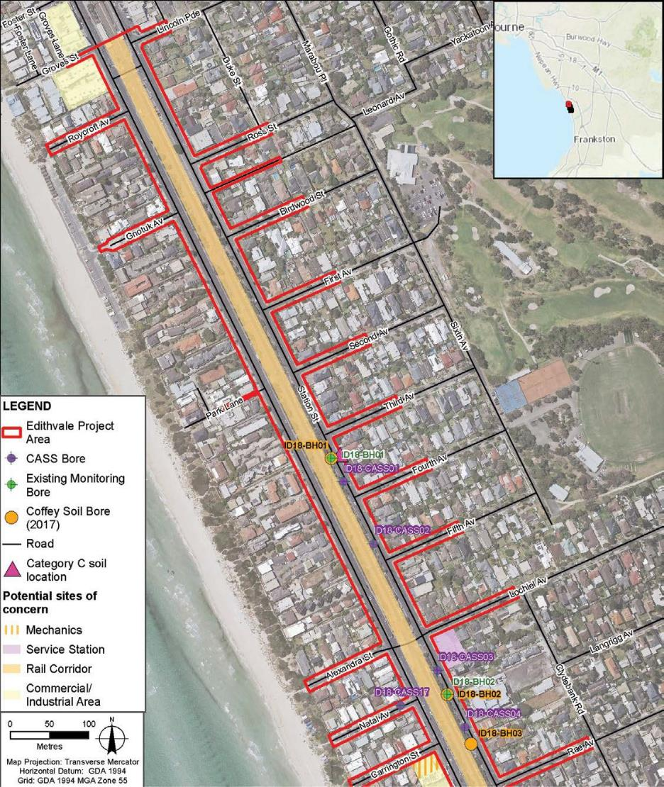

Figure 7.4 Part B: Potential contamination sources (Edithvale)
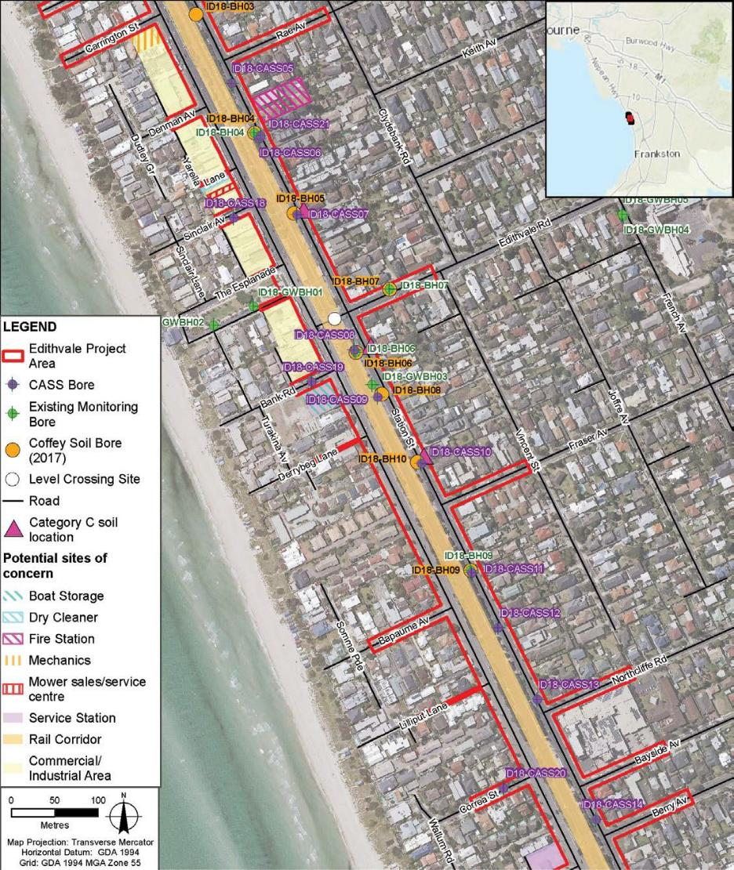

Figure 7.4 Part C: Potential contamination sources (Edithvale)
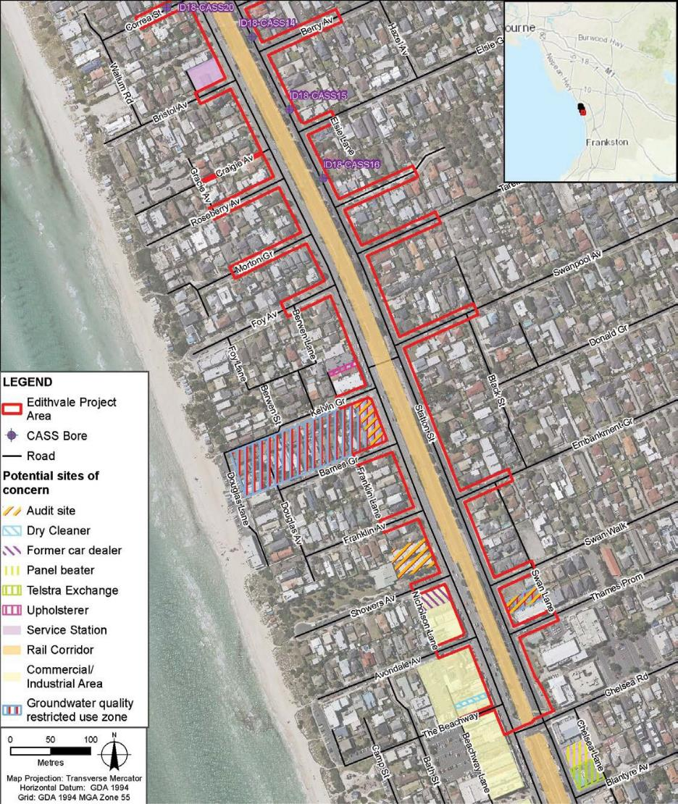

Figure 7.5 Part A: Potential contamination sources (Bonbeach)
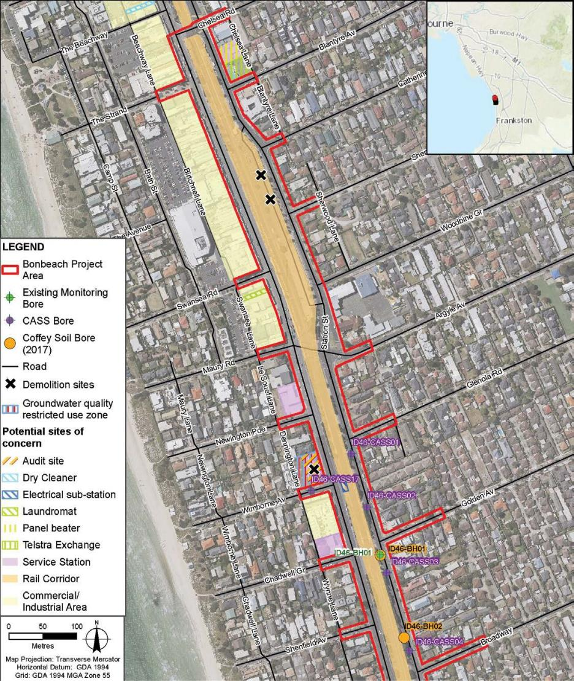

Figure 7.5 Part B: Potential contamination sources (Bonbeach)
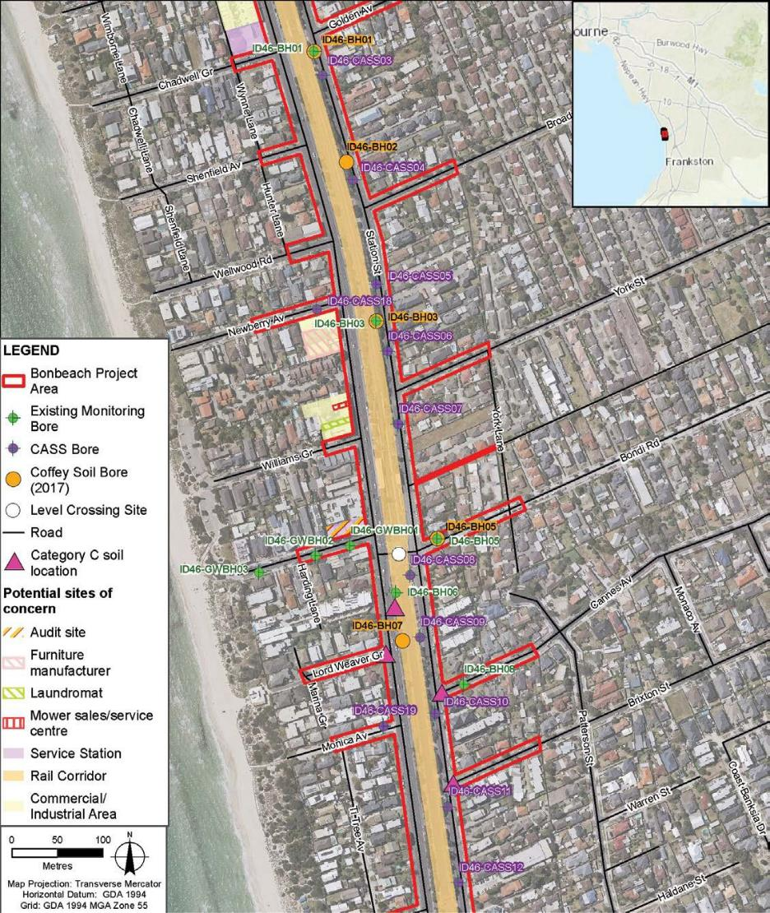

Figure 7.5 Part C: Potential contamination sources (Bonbeach)
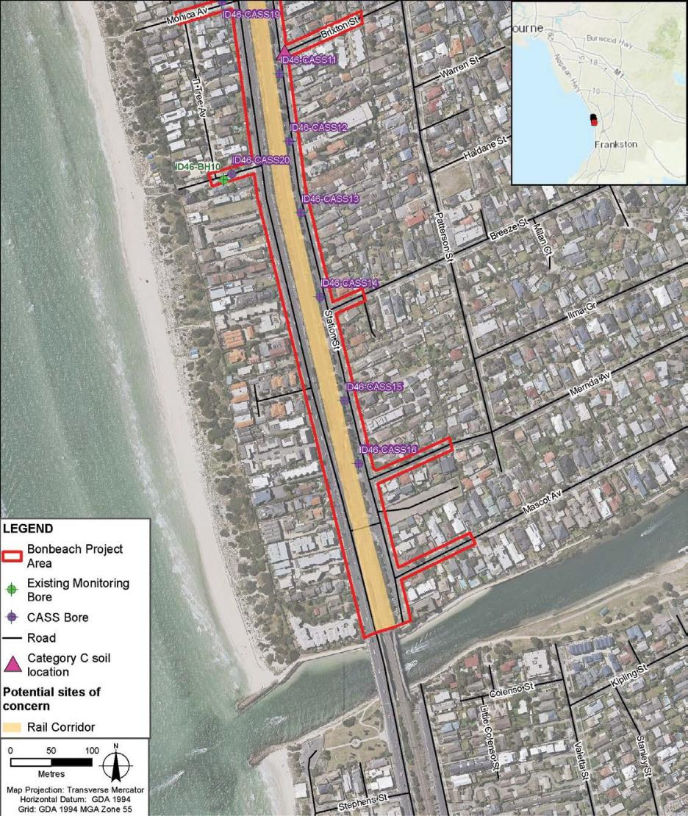

Following the desktop assessment and site inspection, an indicative soil and groundwater investigation was undertaken in conjunction with the intrusive acid sulfate soils investigation. The results of the intrusive soil and groundwater investigations have been used to inform the EES conclusions with respect to identifying the likelihood of contamination being present, but not to classify spoil for waste disposal purposes. To classify spoil for waste disposal purposes in accordance with EPA guidelines, further detailed intrusive investigation, targeted to the potential sources of concern, would be undertaken prior to any excavation (EPR references CL1 and CL2).

Soil sampling results
The soil sampling program consisted of 35 soil samples from the Edithvale project area and 48 soil samples from Bonbeach. A previous soil sampling program consisting of 43 soil samples at Edithvale and 43 at Bonbeach was also undertaken prior to the EES commencing.
The soil sampling programs at Edithvale identified:
- the presence of imported or disturbed fill material between the surface and 0.7 metres below ground surface
- concentrations of contaminants in six locations that would classify the material as Category C contaminated soil
- detectable concentrations of PFAS in three locations in the vicinity of the Edithvale fire station
- The different types of spoil categories are described in Section 7.4.3.
The soil sampling programs at Bonbeach identified:
- the presence of imported or disturbed fill material between the surface and 0.3 metres below ground surface
- concentrations of contaminants in nine locations that would classify the material as Category C contaminated soil
- The presence of imported or disturbed fill material, as well as the samples characterised as Category C contaminated soil, indicates that this material has either been imported from an unknown source and has the potential to have been contaminated at its point of origin, during handling and transport or while being placed at its current location. It is therefore assumed that all the imported or disturbed fill material in the project area would be Category C contaminated soil, which would require disposal at a licenced facility. These results further support the findings of the desktop assessment that the project area contains sources of contamination, which have resulted in contaminated soil in the upper portions
of the soil profile.
Category C is the lowest classification of contamination within the EPA soil classification guidelines and can be readily managed to minimise adverse impacts by adopting best practice management techniques, such as disposal to an appropriately licenced facility, or treatment subject to the nature and concentrations of contaminants (EPR reference CL1). Based on the desktop assessment, there is also a risk that there could be small amounts (less than 0.1 per cent) of Category B and Category A contaminated soils, associated with the substation at Bonbeach. These are higher classifications of contamination and require specialised handling and treatment, in accordance with EPA Victoria’s Industrial Waste Regulation Guidelines. All other soil samples analysed in the indicative soil sampling program, other than those where actual or potential acid sulfate soils were observed (refer to Section 7.4.1), were within the criteria for ‘clean fill’. These samples tended to be in the deeper portions of the soil profile where soil has not been disturbed or impacted by historic land uses. This accounts for the majority (71 per cent at Edithvale and 73 per cent at Bonbeach) of the total material to be excavated.

Groundwater results
The groundwater investigations at the project sites sampled 11 groundwater monitoring bores at Edithvale and 12 at Bonbeach (23 bores in total). The groundwater investigation at both Edithvale and Bonbeach found concentrations of metals in both the upper and lower aquifers which exceeded the levels considered acceptable for the following groundwater beneficial uses:
  - maintenance of ecosystems
  - potable water supply
  - agriculture, parks and gardens
  - stock watering.
Refer to Chapter 5 Modelling the water environment for a description of groundwater beneficial uses at the project sites.
Other groundwater contamination issues noted at Edithvale and Bonbeach during the investigation included:
  - per-and polyfluorinated alkyl substances (PFAS) in two bores in the vicinity of the fire station at Edithvale above the freshwater ecosystem and drinking water guidelines
  - phenol in one bore located near a restricted groundwater use zone
  - hydrocarbons and phenols in one bore located near a commercial/industrial area
  - phenols and/or volatile organic compounds in three bores located near the rail corridor.
The desktop assessment, supported by the findings of the indicative soil and groundwater investigation, has identified that there are contaminants
of concern present in the project areas, but that this is almost exclusively made up of soil likely
to be classified as Category C which can be readily managed using well established construction management techniques and compliance with EPA guidelines. A targeted soil and groundwater contamination assessment would occur prior
to the works commencing (EPR references CL1 and CL4) to inform management of contaminated soil and groundwater, and to comply with EPA requirements for the testing and categorization of spoil before it is removed from site. The targeted assessment would take into account land use history to understand the potential impacts to the environment and human health and a systematic sampling program would be developed to categorise spoil for waste disposal purposes.

7.18 Edithvale and Bonbeach Environment Effects Statement | Acid sulfate soils and contamination

Spoil generation and assessment
Spoil is waste soil or rock produced during excavation and construction activities. Once generated, spoil is classified by its hazard categorisation so that it can be managed in accordance with the current environmental legislation. The table below summarises the key spoil classifications that would apply to this project.
Spoil hazard classification
Under Victorian legislation, producers of contaminated spoil must categorise their spoil into one of four categories: Category A, B, C or clean fill. The categorisation determines the management options (for example reuse or disposal) that are available for that material.
Spoil must be sampled in accordance with the Industrial Waste Resource Guidelines, and then assessed against the thresholds set by the Victorian EPA. The following table summarises spoil hazard classification categories in Victoria.

Spoil hazard category | Description | Management options
Clean fill | Non-hazardous fill material that may include soil, rock and stone from naturally occurring materials. | Use of fill material is not regulated; however, must take into account general obligations (under the Environment Protection Act 1970) to prevent adverse impacts on the environment and human health.
Category C | The lowest class of prescribed industrial waste or contaminated soil. | Accepted at a number  of licensed landfills in Victoria, once the landfill has reviewed analytical results and agreed to accept the soil.
Category B | Contaminated soil categorised between Category A and C. | Accepted at only one licensed landfill and/or a limited number of treatment facilities in Victoria.
Category A | The highest class of prescribed industrial waste and cannot be disposed of to landfill without being treated. | Must be treated either onsite or offsite, or stored pending availability of an appropriate treatment technology. Once treated (or partially treated) the soils may be reclassified and, if appropriate, retained on site or disposed of to a licensed facility.

Modelling estimates that 358,094 cubic metres of excess spoil is expected to be produced during the excavation and construction works for the Edithvale and Bonbeach projects. These volume calculations have had a ‘bulking density’ factor applied to them to allow for the expansion of the material when it is excavated, also referred
to as ex-situ volumes. Spoil would be generated during the following construction activities:
- site establishment including:
  - stripping and clearing within the project area
  - establishment of site fencing, staff facilities and lay down areas
  - installation of access roads
- excavation for piling, foundations and the rail trench
- removal of existing level crossing infrastructure.
The estimated spoil volumes based on the desktop and indicative soil contamination investigations, and developed using a three-dimensional model, are given below:

Table 7.3 Spoil volumes

Spoil category | Edithvale level crossing removal  (m3 ex-situ) | Bonbeach level crossing removal  (m3 ex-situ)
Fill material | 120,341 | 145,639
Solid inert waste | 0 | 0
Contaminated soil – Prescribed industrial waste
Category A | 0 | 50
Category B | 0 | 50
Category C | 11,440 | 28,704
Waste acid sulfate soil | 43,355 | 8,515
Total | 175,136 | 182,958

Given the constrained nature of the project sites, there is limited opportunity to re-use spoil on the site and the best option for managing spoil is to dispose of it at an appropriately licensed facility, most likely a landfill. It is anticipated that spoil would be tested before it is excavated and removed directly from site to an appropriately licensed facility.

Landfill capacity assessment
As there are a number of other large infrastructure projects happening in Melbourne at the same time (including the Melbourne Metro Rail Tunnel Project and the Westgate Tunnel Project), a high-level assessment of the capacity of the existing landfills in Melbourne (and surrounds) to handle the volume of spoil materials generated by the three projects (this project, the Melbourne Metro Rail Tunnel Project and the Westgate Tunnel Project) was undertaken to ensure there is enough space available to take the material. The findings of this assessment are summarised below:
- For these three projects, 73 per cent of spoil is estimated to be categorised as fill material. As the use of fill material off-site is not regulated and is not required to be disposed at an EPA licenced landfill, it is considered that there is sufficient capacity to manage the combined estimated volume of fill expected to be generated.
- There is considered to be sufficient capacity within EPA licenced landfills to accommodate the approximate 358,094 cubic metres (ex-situ) of Category C contaminated soils to be generated during the three projects. This could be further reduced by application of treatment technologies to reduce contaminant concentrations and/or leachability to allow for Category C soils to be reclassified as fill material post treatment. Furthermore, Category A and B soils can also potentially be reclassified as Category C soils post treatment. Reclassification of material would require additional testing and application to EPA Victoria.

  - Edithvale and Bonbeach Environment Effects Statement | Acid sulfate soils and contamination

    - Offsite disposal of waste acid sulfate soil can only occur at a premise that is licenced to accept waste acid sulfate soil in accordance with the Environment Protection Act 1970. The Act provides a framework for preventing and controlling air, land and water pollution as well as noise, increasing resource efficiency, reducing waste and improving environmental performance. There is considered to be sufficient capacity within EPA licenced and/or approved facilities to accommodate the approximately 878,670 cubic metres (ex-situ) of waste acid sulfate soil to be generated during the three projects, of which approximately 6 per cent is expected to be generated by the Edithvale and Bonbeach level crossing removal projects.
Overall, the volume of spoil produced by the projects, and the subsequent landfill space required, is considered minor in the context of the other major infrastructure projects occurring in Melbourne. Given the amount of spoil to be generated by the projects, it is unlikely that sourcing an appropriate disposal facility for the spoil would be an issue.

Construction impact assessment

Construction activities at both the Edithvale and Bonbeach level crossing removal projects would be minimised within the project areas to reduce disruption outside the works area (for example on adjacent roads). Additionally, the project design of a trench does not require fill for its construction. As such, there is not expected to be any opportunity to re-use the spoil from the excavation, and disposal at an appropriate facility is considered the primary option to manage spoil.

Acid sulfate soils
The spoil assessment modelling has indicated that approximately 14 per cent of the total soil excavated or 51,870 cubic metres (ex-situ) is considered likely to be waste acid sulfate soils. This estimate is based on regional geology as well as the sampling program results and therefore is considered to be a reliable prediction of what would likely be encountered.
When exposed to the air, acid sulfate soils can produce sulfuric acid. The oxidation of acid sulfate soils can result in the generation, mobilisation and migration of acidity which can liberate contaminants (for example nutrients and metals) and potentially impact the environment, in-ground structures and human health. Once released from the soil profile, sulfuric acid and its subsequent impacts (discussed further below) can persist in the environment for as long as the sulfuric acid is being generated.

Contaminated soil
Based on the desktop investigation and field investigations undertaken, it is expected that some of the soil to be excavated would be contaminated through existing and historical land uses, such as the use of fill material in the rail corridor and adjacent land uses such as a fire station, services stations and drycleaners. Contaminants such as metals, hydrocarbons, asbestos and other industrial chemicals are considered likely to be present in some of the soil excavated. An indicative intrusive investigation was undertaken adjacent to the proposed rail trench to minimise disruption to rail operations and protect the safety of personnel undertaking the field investigations. The results of the investigations are therefore considered to be indicative of the contamination status of the shallow soils to be excavated.
Approximately 11 per cent of the total spoil to be excavated or 40,144 cubic metres (ex-situ) is expected to be categorised as Category C contaminated soil. It has been assumed that approximately 100 cubic metres of soils beneath the substation in the Bonbeach project area (less than 0.01 per cent of the total spoil to be excavated) would be contaminated by Polychlorinated Biphenyls (PCBs) and categorised as either Category A or Category B contaminated soil.

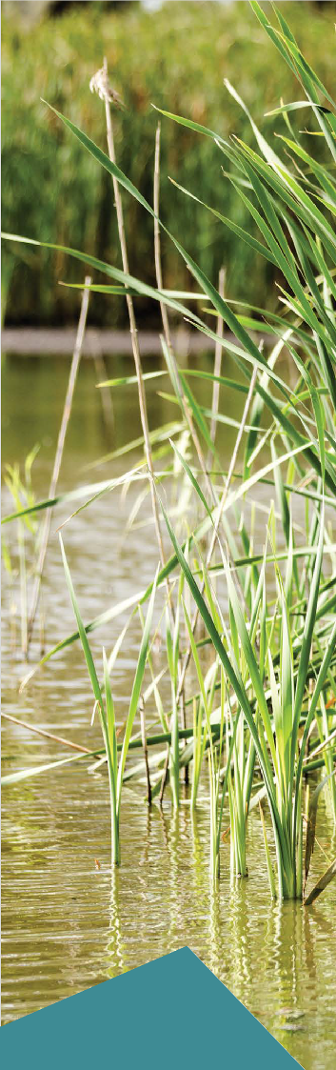

Soil samples obtained in the vicinity of the fire station adjacent to the Edithvale site reported detectable concentrations of PFAS. This material would need to be treated differently to other contaminated soils as landfilling of PFAS-impacted solid wastes is not currently considered to be a suitable waste management solution by EPA Victoria and other alternatives such as treatment, onsite containment or secured temporary storage would need to be considered. The EPA has issued an interim position statement (in October 2017) and is currently considering recommendations for the management of low concentration PFAS contaminated soil. Once it has determined the acceptability of landfill disposal, this information would be made available and landfilling of PFAS material may or may not be considered viable
for this project. If it is not considered viable, an appropriate management strategy would be agreed with the EPA, and this could include (in accordance with EPA Victoria’s PFAS management hierarchy):
    - destruction of PFAS contaminated material
    - immobilisation and onsite containment (unlikely to be an option for the projects as the sites are highly constrained)
    - immobilisation and offsite removal to a specific landfill cell (agreement would be required from EPA Victoria and the landfill operator).

Risk assessment
The scoping requirements for the EES require the identification and evaluation of the effects of waste acid sulfate soil and contaminated
soil on environmental and human health values during construction. The following risks have been identified to provide an analytical framework for addressing this requirement. This section includes an assessment of the likelihood and consequence of the risk occurring.
The identified contamination and acid sulfate soils risks are outlined in the table below. The risks in Table 7.4 would only occur during the construction period and would apply to both the Edithvale and Bonbeach sites. Risks that occur during both construction and operation are addressed in Section 7.6.
Construction risks discussed in Table 7.4 were all assessed as negligible. This is because the desktop and intrusive investigations completed have provided information on the type and volumes of material expected to be encountered. This enables management plans to be developed to guide the handling and management of the material to be excavated, in accordance with the existing policies and guidelines, which would minimise the risk of significant environmental and/or health impacts.

7.22 Edithvale and Bonbeach Environment Effects Statement | Acid sulfate soils and contamination

Table 7.4 Risk table – construction

Risk ID | Risk name | Risk pathway | Initial EPR | Initial risk | Final EPR | Residual risk
CL50 | CASS/  contaminated soil (physical environment) | Disturbance, handling, storage or disposal of CASS/contaminated (including asbestos) soil results in  adverse health and environmental  impacts to land | EPR CL1 – Spoil Management Plan  EPR CL2 – Acid Sulfate Soil Management Plan | Negligible | As initial EPR | Negligible
CL51 | CASS/  contaminated soil (odour) | Disturbance, handling, storage or disposal of CASS/contaminated soil leads to the generation of odorous material and results in a loss of amenity | EPR CL1 – Spoil Management Plan  EPR CL2 – Acid Sulfate Soil Management Plan  EPR SC1 – Community and Stakeholder Engagement Management Plan | Negligible | As initial EPR | Negligible
CL52 | Contaminated groundwater | Disturbance, handling, storage or disposal of acidic  and/or contaminated groundwater results in adverse health and environmental impacts | EPR CL4 – Acidic and/or contaminated groundwater (construction) | Negligible | As initial EPR | Negligible
CL53 | Unknown contamination | Unknown contamination encountered during construction results in environmental, health or amenity impacts | EPR CL1 – Spoil Management Plan  EPR CL4 – Acidic and/or contaminated groundwater (construction) | Negligible | As initial EPR | Negligible
CL54 | Spill | Fuel/chemical spill results in adverse health or  environmental impact | EPR CL3 – Waste management | Negligible | As initial EPR | Negligible
CL55 | Other waste streams | Management of other waste (solid inert, liquid, organic, packaging and food scraps) results in  environmental impact | EPR CL1 – Spoil Management Plan  EPR CL3 – Waste management plan | Negligible | As initial EPR | Negligible
CL56 | Non- compliance (waste transport/ disposal) | Transport or disposal of CASS and/or contaminated soil is not in compliance with EPA Victoria permit/ licence and results  in an environmental  impact. | EPR CL1 – Spoil Management Plan  EPR CL2 – Acid Sulfate Soil Management Plan | Negligible | As initial EPR | Negligible
CL57* | Contamination (vapour) – Edithvale | Intersection of contaminated soil and/or groundwater resulting in vapour impacts on  human health | EPR CL1 – Spoil Management Plan  EPR CL2 – Acid Sulfate Soil Management Plan  EPR CL4 – Acidic and/or contaminated groundwater (construction)  EPR GW3 – Groundwater Management Plan (construction) | Negligible | As initial EPR | Negligible
*Risk CL57 only applies to the project at Edithvale.

Disturbance, handling, storage or disposal of CASS/contaminated soil (including asbestos)
Adverse health and environmental impacts to land (Risk CL50)
Interaction with acid sulfate soils
The main activities during the construction phase which have the potential to encounter or activate acid sulfate soils in the project areas are installation of the pile walls and excavation of the trenches.
The disturbance of acid sulfate soils is likely to have a negligible risk of impact on human health and the surrounding environment. This is because the likely occurrence of potential acid sulfate soils in the area to be excavated has been established by undertaking a detailed intrusive investigation in accordance with
EPA Victoria’s Industrial Waste Management Policy 2009 to enable effective management measures to be put in place. The sampling undertaken during the detailed investigation is in accordance with the Victorian best practice guidelines for assessing and managing coastal acid sulfate soils 2010 and is therefore considered sufficient to develop an appropriate management plan (including disposal options) to minimise impacts during construction works.
As stated above, the assessment shows that acid sulfate soils are either present or would be generated during the excavation works between four and 15 metres below ground surface at Edithvale and 3.5 and 16 metres below ground surface at Bonbeach. This means that approximately 14 per cent of the total material to be excavated or 51,870 cubic metres (ex-situ) of acid sulfate soils is expected to require management from the project areas.
The management measures for potential acid sulfate soils are outlined below.

Pile installation
Spoil generated by the pile installation would likely contain some acid sulfate soil when it is brought to the surface. The total volume of spoil expected to be generated from piling in both project areas is 65,787 cubic metres (ex-situ) and approximately 48 per cent of this volume is estimated to be waste acid sulfate soils.
The primary proposed management measure would be to remove soil predicted to be acid sulfate soil from the site immediately and transport it to a facility licensed to receive such soils. It is not expected that any acid sulfate soils would be stockpiled on site.
Also, potential acid sulfate soil that is already in the ground may be exposed to air during the piling activities. However, the pile installation process would have minimal time (likely to be less than eight hours depending on pile installation technique) between the spoil being excavated and the pile being installed, and therefore is considered unlikely to activate the potential acid sulfate soils that are not being excavated. A maximum
of 18 hours exposure to air without treatment is considered an acceptable timeframe for coastal acid sulfate soils, such as those in the project area, according to the Victorian best practice guidelines for assessing and managing coastal acid sulfate soils 2010.

Excavation of the trenches
Excavation of the trenches is likely to activate potential acid sulfate soils generally at 4 metres below ground surface at Edithvale and 3.5 metres below ground surface at Bonbeach. Figure 7.2 and Figure 7.3 show schematic sections of the proposed excavations and the depths where they are expected to intersect with potential acid sulfate soils
at Edithvale and Bonbeach. At Edithvale (Figure 7.2), there is high potential of intercepting the potential acid sulfate soils layer during excavation of the rail trench and associated infrastructure. The modelled volume of potential acid sulfate soils likely to be generated at Edithvale is 43,355 cubic metres (ex-situ). At Bonbeach (Figure 7.3) the depths where samples exceeded the acid sulfate soil management criteria are mostly located below the depth of the excavation. As such, at Bonbeach, there is limited potential of intercepting potential acid sulfate soil – approximately 2,000 cubic metres is expected to be generated during excavation of the water storage structure and the associated deeper sections of the trench.
The pile walls on either side of the trench would be constructed prior to excavation of the trench itself. This would prevent any ground or surface water in the trench area from mobilising into the surrounding groundwater environment. This would effectively prevent acidic water (generated by contact between water and exposed acid sulfate soils) from contaminating existing groundwater or soils adjacent to the trench while it is being excavated. The pile walls would extend several metres below the deepest excavation point which would also prevent the potential for contamination as a result of the activation of acid sulfate soils.

  - Edithvale and Bonbeach Environment Effects Statement | Acid sulfate soils and contamination

Interaction with contamination
Due to the land uses history of the project areas and their surrounds, and elevated concentrations
of contaminants of concern identified in shallow soils adjacent to the construction areas, it is expected that contaminated soils would be encountered during the excavation works. Approximately 11 per cent of the material to be excavated is expected to be classified as contaminated soil.
The disturbance of contaminated soils is considered likely to have a negligible risk of impact on human health and the environment; this is because soil material to be excavated would be categorised prior to excavation through an in-situ sampling program in accordance with EPA Victoria Industrial Waste Resource Guidelines (IWRG) and Australian Standards before being removed from the site to a licenced landfill
or treatment facility.
Due to the limited space within the construction boundary, there would be no opportunity to re-use
or stockpile the excavated soils and as such, all soils would be transported directly off site, minimising the risk of adverse health and environmental impacts to the community.

Management measures for acid sulfate soils and contamination
Given the constrained sites and the need to construct the trenches within the existing rail alignment, there is no opportunity to move the locations of the piled walls of the trench to minimise the amount of potential acid sulfate soil or contaminated soil encountered.
The primary proposed management measure would be to remove soil predicted to be acid sulfate soil, contaminated soil and other excavated material from site immediately and transport it to a facility licensed to receive such soils.
The following management measures would be embedded in the EPRs (EPR references CL1 and CL2) to manage risk of the disturbance, handling, storage or disposal of CASS/contaminated soil that could result in adverse health and environmental impacts to the community:
    - A Spoil Management Plan would be developed and implemented that includes, but is not limited to:
      - applicable regulatory requirements
      - identifying the nature and extent of spoil (clean fill and contaminated spoil) across the construction areas
      - roles and responsibilities
      - identification of management measures for storage, handling and transport of spoil for the protection of health and the environment
      - identification, design and development of specific management measures for temporary stockpile areas
      - identifying potential sites for management for disposal of any spoil
      - monitoring and reporting requirements
      - identifying locations and extent of any prescribed industrial waste (PIW) (including asbestos) and characterising PIW prior to excavation
      - identifying suitable sites for disposal of PIW.
The Spoil Management Plan would include sub-plans as appropriate, including an Acid Sulfate Soil Management Plan (EPR reference CL2).
    - An Acid Sulfate Soil Management Plan would be prepared prior to construction of the project
as a sub-plan of an overarching spoil management plan in accordance with the Industrial Waste Management Policy (Waste acid sulfate soils) 1999, and EPA Publication 655.1 Acid sulfate soil and rock. The sub-plan would also be in accordance with EPA regulations, standards and best practice guidelines and be prepared in consultation with the EPA. This sub-plan would include:
      - identifying locations and extent of potential acid sulfate soils
      - assessing potential risk and impact for human health, odour and environment
      - identifying and implementing measures to prevent oxidation of acid sulfate soil wherever possible
      - identifying suitable sites for management or disposal of acid sulfate soil.

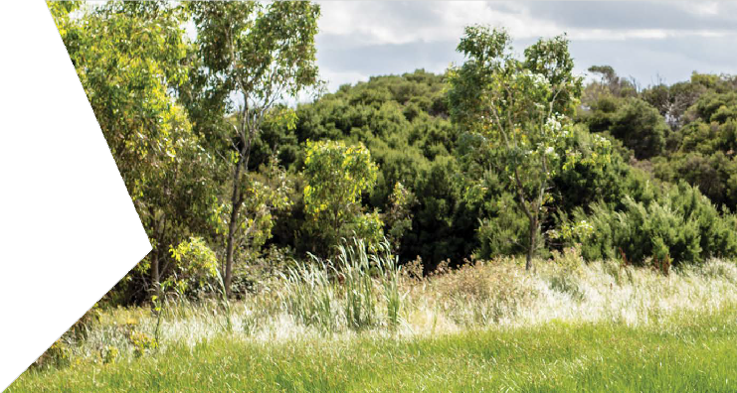Generation of odorous material results in a loss of amenity (risk CL51)
Odorous material can be generated when soils containing sulphides are exposed to air and hydrogen sulphide is produced (also known as rotten egg gas) or contaminated soil containing odorous wastes (such as petroleum hydrocarbon impacted soils) are excavated and exposed to air. While such soils are exposed, either by excavation, in stockpiles or on the side of a trench, they can continue to emit odour that could be considered unpleasant by people in the area. The odour can also be spread outside of the
project area as material is transported off-site or during strong winds. This can lead to a loss in amenity (for instance people not wanting to be in the vicinity) for the surrounding area.
Given that the potential presence of contaminated and acid sulfate soils has been identified in the construction area, it is considered likely that the spoil excavation process would expose odorous material, however, the risk that it would result in a loss of amenity is considered negligible. This is because the material is not proposed to be stockpiled on site and unexcavated soil would be managed to minimise odours during the excavation period, when odorous material would be exposed (for example before the concrete slab is installed in the base of the trench). Furthermore, the exposure of any odorous material would be temporary and limited to the main occupation of the rail corridor (estimated to be six-weeks, see Chapter 2 Rationale and project descriptions).
Management of spoil in accordance with EPR_CL1 and EPR_CL2, as described above, would also minimise the impacts of odour on surrounding amenity. There are additional measures that would be undertaken to minimise odour impacts during the excavation and transportation of spoil including but not limited to:
- periodic monitoring of the aesthetics of the material excavated and proposed for transportation
- if odorous material is identified, it must be segregated and odour emissions assessed with the appropriate gas monitoring equipment
- if trigger levels are exceeded, implementing appropriate occupational health and safety measures
- odour mitigation measures must be put in place prior to transporting the material off site for treatment and/or disposal. This may include spraying the material with an odour neutralising agent.
In addition to the measures described above, a Community and Stakeholder Engagement Management Plan (EPR reference SC1) would be used to let surrounding users know of the potential impacts associated with the construction occupation period, including odour.

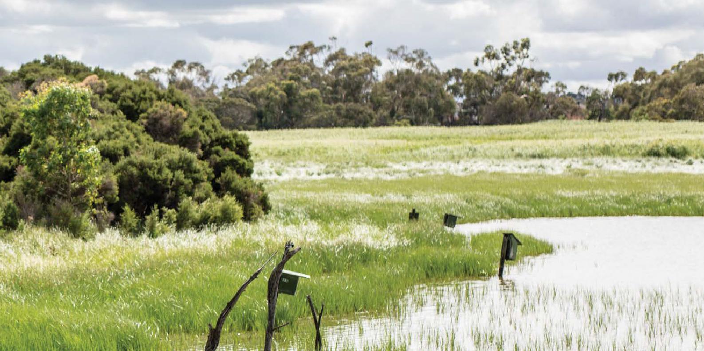
Disturbance, handling, storage or disposal of acidic and/or contaminated groundwater
The disturbance of acidic and/or contaminated groundwater is considered likely to have a negligible risk of impact on human health and the environment. This is because the projects are not likely to need
to manage a significant amount of groundwater.
Groundwater impacted by the projects would be limited because the deep pile walls that support the sides of the proposed trench would be inserted prior to the excavation of the trench. The pile walls would prevent groundwater entering the excavated area. This means that only ground water trapped between the two pile walls would need to be removed from the trench as a result of construction. A conservative estimate (based on spoil volumes to be excavated and groundwater flow rates) of the volumes of groundwater expected to be removed from the excavations is 20,800 litres at Edithvale and 21,700 litres at Bonbeach.
Any contaminated groundwater encountered during the excavation would be a result of the historic land uses within the project areas and their surrounds, and elevated concentrations of contaminants of concern in groundwater adjacent to the construction areas. The groundwater was found to be slightly acidic to neutral in the shallow aquifer during the groundwater investigation completed for this EES. There is also a possibility for the potential acid sulfate soils present in the project areas to generate acidity when exposed to air during the excavation. This acidity can alter the groundwater quality at a particular area.
Groundwater can be readily managed through well-established construction management techniques. The projects would be required to develop and implement measures to manage acidic and/or contaminated groundwater during construction, to EPA Victoria requirements, including (EPR reference CL4):
- a baseline groundwater quality assessment (taking into account site history) at least three months prior to commencement of trench excavation
- implementing a system to manage and/or dispose of intercepted groundwater (if required) which may be a trade waste agreement (TWA) with the relevant utility authority or other measures in accordance with relevant guidelines and legislation (if a TWA is not granted)
- collection, treatment, disposal and handling of contaminated groundwater and/or slurries including vapours
- monitoring of intercepted groundwater quality
- implementing contamination plume management (if required)
- treating and monitoring impacted groundwater (including vapours) prior to disposal in accordance with licence and/or agreement.

The risk of an adverse environmental impact resulting from contaminated or acidic groundwater being released into the environment is considered negligible. This could occur if groundwater was allowed
to soak back into the ground or discharged untreated to stormwater or a surface water body. Adverse human health impacts could result if skin contact or ingestion of contaminated or acidic groundwater occurred.
These risks are considered negligible because they would be managed in accordance with EPR CL4 which includes a requirement for a pre-construction baseline groundwater assessment to understand the condition of the groundwater including identifying contaminants of concern and concentrations prior to excavation and disposing of any groundwater encountered during construction in accordance with EPA requirements. The most likely option for disposing of this water would be a TWA with the relevant utility authority to dispose
of treated water off-site to sewer. Treatment and monitoring of impacted groundwater would occur prior to disposal to sewer in accordance with the TWA.
There is expected to be minimal opportunity to interact with groundwater outside the construction footprint during construction. The current construction technique would include the installation of a cut off wall prior to the commencement of excavation to prevent the ingress or egress of groundwater into or from the construction zone.

Unknown contamination (risk CL53)
It is possible that unknown contamination would be encountered during construction. The risk to the environment, health or amenity as a result of interaction with unknown contamination is assessed as being negligible.
This is because all soil to be removed would be tested before it is excavated (known as an in-situ intrusive soil investigation) in accordance with EPA Victoria Industrial Waste Resource Guidelines and Australian Standards for sampling.
A baseline groundwater assessment to understand the groundwater condition including contaminants
of concern and concentrations, would be completed prior to excavation works commencing (EPR references CL1 and CL4). This would minimise the potential for unknown contamination to be encountered during construction. The investigation would be completed prior to the trench excavation commencing and would be designed to obtain a thorough understanding of the soil character. Excavation between the pre-constructed pile walls would also reduce the risk of any contamination leaving the project site in an uncontrolled manner as the pile walls provide an effective containment system.

Fuel/chemical spill (risk CL54)
During construction, vehicles, plant and machinery would be operating within the construction zone.
There is a possibility that spills may occur during the refuelling of vehicles, plant and machinery or through the use of chemicals required as part of the construction process.
The risk of such a spill being extensive enough to result in a significant adverse health or environmental impact is assessed as being negligible. This is because the following management measures, included in a Construction Environmental Management Plan (CEMP) (EPR reference CL3) would be in place:
- refuelling of vehicles in designated areas only and management of the areas to ensure any spill can be contained
- minimising fuel and other fluids stored on site
- provision of spill kits with apparatus to contain any spill at the construction site and fuel storage areas to enable rapid management of spills
- ensuring staff are trained in spill containment and in using the spill kits provided
- use of well-maintained plant to minimise the potential for spills to occur
- development of procedures to remove, treat and/or dispose soil that becomes contaminated due to a fuel or chemical spill.

Management of other waste (solid inert, liquid, organic, packaging and food scraps) (risk CL55)
Waste other than soil and groundwater would be generated by the projects at the construction site. These wastes are expected to be generated by daily activities such as material deliveries, washing and meal times.
If these wastes are not appropriately contained, they could be released into the environment resulting
in adverse impacts (as described above). The projects would be required to develop and implement a Waste Management Plan as part of a CEMP (EPR reference CL3). The risk of other waste being discharged into the environment and resulting in a significant adverse impact is considered negligible with the following measures included in the CEMP to specifically mitigate this risk:
- site induction for all construction personnel outlining waste management requirements (such as the use of waste and recycling facilities and maintenance of a clean site policy)
- appropriate chemical management procedures such as minimising use and storage of chemicals on site and use of bunded storage facilities
- storing litter, particularly that which is able to be windblown or is putrescible, in a lidded bin from which material cannot escape
- containing washing residues, slurries and other contaminated water within designated areas, including appropriate treatment and/or disposal
- designating vehicle-washing areas
- using temporary fencing as a secondary containment measure for litter
- adopting the waste management hierarchy consistent with the Environment Protection Act 1970 in assessing waste management options.

Transport or disposal of CASS and contaminated soils (risk CL50 and CL51)
In accordance with the spoil assessment (EES Technical Report C Acid sulfate soils and contamination), there is estimated to be 358,094 metres cubed (ex-situ) of spoil generated by both projects. Spoil excavated from the site (including contaminated soil and acid sulfate soil) would require transport and disposal to an appropriately licensed facility.
A preliminary assessment of the spoil breakdown has indicated there is sufficient capacity available
in landfills in Victoria to accept the type of spoil generated (fill material, acid sulfate soils and Category A, B and C contaminated soils). The projects would be required to prepare and implement a Spoil Management Plan (EPR reference CL1) and an Acid Sulfate Soil Management Plan (EPR reference CL2). The risk of non- compliance with EPA Victoria guidelines resulting in a significant adverse impact to the environment is considered negligible with the following measures included in the plans to specifically mitigate this risk:
- sampling and analysing soil material to be excavated prior to excavation in accordance with EPA Victoria Industrial Waste Resource Guidelines (IWRG) and Australian Standards for sampling, and determining transport and treatment requirements, if any, prior to disposal or reuse
- identifying soil containing asbestos fibre to enable appropriate handling and transport
- identifying suitably licenced facilities for the disposal of soil material generated
- management of contaminated soil within the project area to ensure material is segregated according to its transport and disposal requirements
- a tracking system that allows verification of the suitability of soil movement from the site to a licensed landfill or treatment facility
- specification of the type of vehicles to be used for waste movements
- measures to ensure transport certificates/records are completed and maintained on file.

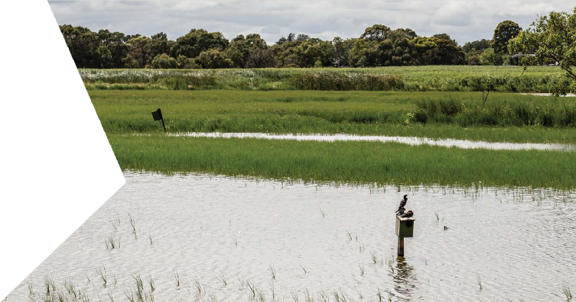Soil and/or groundwater vapour (risk CL57)
Vapours associated with contaminated soil and/or contaminated groundwater that could be encountered during the trench excavation has the potential to impact human health. This is considered to be a negligible risk because there would be minimal opportunity for the general public to interact with vapours from contaminated soil or contaminated groundwater. Volatile contaminants (such as those generated by a
fuel plume in groundwater) may be present in the soil and/or groundwater due to existing contamination. Depending on the contaminant concentration and depth, the contaminants may not be present at the surface.
Excavation of surface soils during construction has the potential expose volatile contamination at depth, creating a pathway for gases and vapour to migrate from a subsurface source of vapour-forming chemicals into buildings or other enclosed spaces via cracks in the foundation and/or openings for utility lines. The indicative contamination assessment undertaken as part of this EES identified possible sources of vapour-forming chemicals in the vicinity of the project area, for example service stations. Exposure to soil vapours can have an adverse impact to human health through the generation of odour, inhalation or flammability.
Vapour impacts are generally associated with a build-up of vapours in a confined space. As the trench construction methodology would be an open trench, vapours released during the excavation would readily dissipate, minimising the potential for vapour to impact the health of the general public.
To further mitigate the potential for the project to generate a vapour risk, a targeted soil and groundwater investigation (EPR references CL1 and GW3) would be undertaken prior to excavation commencing. In the areas that have been identified as potential sources for vapours (for example in the vicinity of service stations), the results would indicate the level of volatile organic compounds present in the soil and/or groundwater. This would guide the requirement for further management which would also assess the risk of human health impacts.
Based on the current understanding of the potential sources of vapour-forming chemicals and the construction methodology, the likelihood of adverse impacts is considered negligible. Undertaking further targeted assessment within the construction footprint would provide greater certainty around the potential for adverse human health impacts, maintaining the risk level at negligible.

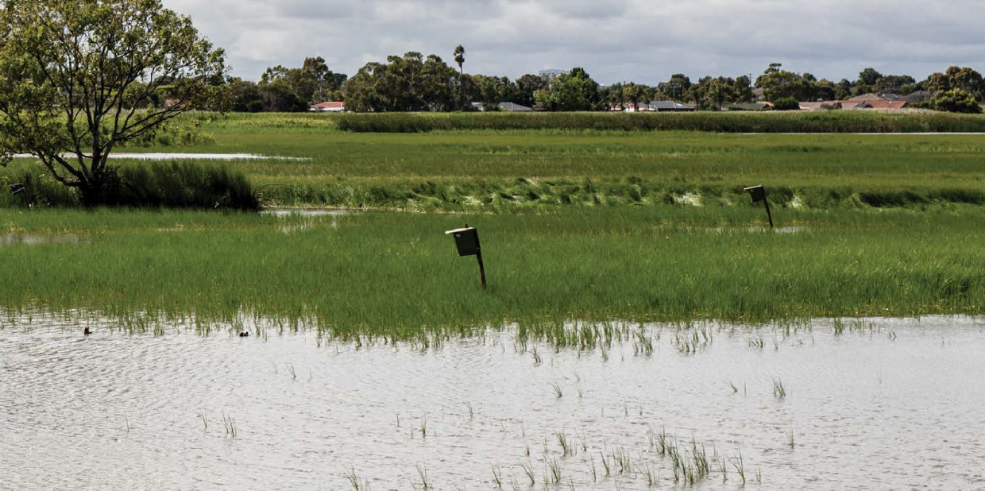
Operation impact assessment

The acid sulfate soils and contamination impacts identified for the operations phase of the Edithvale and Bonbeach level crossing removal projects are outlined below. The potential impacts described in Table 7.5 would commence from the installation of the pile walls but would continue into the operation phase and are therefore assessed as operational risks.
An assessment of risks and impacts posed by the projects was undertaken in accordance with the method described in Chapter 4 Assessment framework. An initial risk assessment was undertaken to assess potential risks to the environment arising from the implementation of the project at Edithvale. As discussed in Chapter 5 Modelling the water environment, through the risk and impact assessment process, a need to manage groundwater at Edithvale was identified to reduce the potential changes to groundwater levels caused by the pile walls and associated impacts.
To manage potential impacts predicted through the initial assessment, an EPR was developed which would reduce the magnitude and extent of project-induced groundwater level changes at Edithvale (EPR reference GW2). An engineering solution was developed and modelled to demonstrate that a mitigation measure could be adopted to minimise the impact of the project on groundwater levels to the extent that the performance outcomes in EPR_GW2 could be achieved.
As discussed in Chapter 5 Modelling the water environment the predicted groundwater mounding and drawdown, and the associated impacts, at Bonbeach are significantly less than those modelled at Edithvale. The groundwater flow direction is different at Bonbeach and no mitigation measures are required at this location. This is reflected in the consistency of risk levels between the initial and residual risks at Bonbeach in the table below.

Table 7.5 Risk table – operation

Risk ID | Risk name | Risk pathway | Initial EPR | Initial risk | Final EPR | Residual risk
GW60 | CASS  activation – Edithvale | Drawdown on the down gradient side of trench and mounding on up gradient side of the trench could result in changes in groundwater levels, which could give  rise to activation of CASS and/or mobilise any existing acidity and groundwater acidification affecting beneficial uses of land and groundwater. | EPR GW1 –  Rail trench design  EPR GW3 –  Groundwater Management and Monitoring Plan | Moderate | EPR GW1 –  Rail trench design  EPR GW2 –  Groundwater  EPR GW4 –  Groundwater Management and Monitoring Plan  EPR CL5 – Acidic and/or contaminated groundwater (operation) | Negligible
GW62 | Contaminant migration – Edithvale | Mounding on the up gradient side of trench, drawdown on down gradient side of trench, and  groundwater physically diverted either to the north or south along the up gradient side  of the trench could alter contamination plume migration, adversely impacting on beneficial uses of land and groundwater. | EPR GW1 –  Rail trench design  EPR GW3 –  Groundwater Management and Monitoring Plan  EPR CL1 – Spoil Management Plan  EPR CL4 –  Acidic and/or contaminated groundwater (construction) | Moderate | EPR GW1 –  Rail trench design  EPR GW2 –  Groundwater  EPR GW4 –  Groundwater Management and Monitoring Plan  EPR CL1 – Spoil management plan  EPR CL4 – Acidic and/or contaminated groundwater (construction)  EPR CL5 – Acidic and/or contaminated groundwater (operation) | Minor
GW67 | CASS  activation – Bonbeach | Drawdown on the down gradient side of trench and mounding on upgradient side  of the trench could result in changes in groundwater levels, which could give rise to activation of  CASS and/or mobilise any existing acidity and groundwater acidification affecting beneficial uses of land and groundwater. | EPR GW1 –  Rail trench design (Edithvale and Bonbeach)  EPR GW3 –  Groundwater Management and Monitoring Plan | Minor | EPR GW1 –  Rail trench design (Edithvale and Bonbeach)  EPR GW2 –  Groundwater  EPR GW4 –  Groundwater Management and Monitoring Plan  EPR CL5 – Acidic and/or contaminated groundwater (operation) | Minor

Risk ID | Risk name | Risk pathway | Initial EPR | Initial risk | Final EPR | Residual risk
GW69 | Contaminant migration – Bonbeach | Mounding on the up gradient side  of trench, drawdown on down gradient side of trench,  and groundwater physically diverted either to the north or south along the up gradient side  of the trench could alter contamination plume migration adversely impacting on beneficial uses of land and groundwater. | EPR GW1 –  Rail trench design (Edithvale and Bonbeach)  EPR GW3 –  Groundwater Management and Monitoring Plan  EPR CL1 – Spoil management Plan  EPR CL4 –  Acidic and/or contaminated groundwater (construction) | Negligible | EPR GW1 – Rail  trench design (Edithvale and Bonbeach)  EPR GW2 –  Groundwater  EPR GW3 –  Groundwater Management and Monitoring Plan  EPR CL1 – Spoil management plan  EPR CL4 – Acidic and/or contaminated groundwater (construction)  EPR CL5 – Acidic and/or contaminated groundwater (operation) | Negligible

Potential activation of CASS and groundwater acidification from groundwater drawdown (risk GW60 and GW67)
Groundwater modelling undertaken as part of the groundwater impact assessment shows that the installation of the pile walls on both sides of the trench at Edithvale and Bonbeach would change the groundwater levels and result in a fall in groundwater levels (known as drawdown) to the west of the rail trench and a rise in groundwater levels (known as mounding) to the east of the rail trench. Drawdown and mounding would commence within months of installing the pile walls and would continue over the life of the trench.
As described in Section 7.4.1, potential acid sulfate soils have been identified in the project area.
Some of the potential acid sulfate soils are located at and around the same depth as the existing water table. The decrease in groundwater levels has the potential to oxidise the sulfide minerals present in these soils, and leach acidity, metals and nutrients into groundwater because the drawdown exposes previously submerged potential acid sulfate soils. This may cause acidification of groundwater potentially affecting the protected beneficial uses (refer to Chapter 5 Modelling the water environment for definition of beneficial uses).
The risk levels associated with groundwater drawdown and mounding resulting in activation of potential acid sulfate soils are different for each project area and have been addressed separately below.

Edithvale
At Edithvale, actual acid sulfate soils have been identified in the project area at depths of five and 10 meters below ground surface. These depths are below the existing groundwater level, so the risk of mobilisation of existing acidity due to mounding of groundwater on the up gradient side of the trench as a result of an increase of groundwater level is negligible.
The majority of the potential acid sulfate soils have been identified below sea level as shown on Figure 7.6. The water table would not drop below sea level at coastal locations and, as such, any potential acid sulfate soils located below sea level can only be activated through excavation and not from lowered groundwater levels.
The initial assessment found a moderate risk of activation of acid sulfate soils and acidification of groundwater at Edithvale.

To reduce the risks associated with groundwater drawdown at Edithvale an engineering solution was developed to limit the magnitude and extent of mounding and drawdown. The engineering solution is described in Chapter 2 Rationale and project descriptions.
The performance of the engineering solution was modelled (see Appendix H of EES Technical Report A Groundwater) to demonstrate that it would be able to achieve the performance outcomes specified in EPR_GW2, which includes a requirement that the projects would not result in degradation to groundwater quality that would preclude beneficial uses of groundwater.
The groundwater model developed for the EES was used to model the impact on groundwater at Edithvale following construction of the trench and the proposed engineering solution to manage groundwater flow. The maximum drawdown was 0.2 metres within 50 metres of the rail trench. This level of groundwater drawdown is well within the range of natural variation and is considered to result in a negligible risk
of impact.
It is considered very unlikely that potential acid sulfate soil would be activated from groundwater being lowered. Figure 7.6 shows the results of the implementation of the engineering solution in relation to the location of potential acid sulfate soils. Additionally, it is possible that the potential acid sulfate soils in these areas have already been activated due to natural variations in groundwater levels already exposing them to oxygen. This is supported by the groundwater results for the shallow aquifer which shows presence of existing acidity, however, there was sufficient capacity measured in the groundwater to neutralise this acidity.
A Groundwater Management and Monitoring Plan (EPR reference GW3) would be implemented to monitor groundwater quality and levels. The monitoring program would enable monitoring of the project to ensure compliance with the relevant EPRs, in particular EPR_GW2. Although activation of acid sulfate soils is considered unlikely to occur, monitoring would also enable early detection of impacts as a result of potential acid sulfate soil activation and groundwater acidification. A Groundwater Quality Mitigation Plan would be implemented if the groundwater monitoring identifies groundwater acidification is occurring (EPR reference CL5). The Groundwater Quality Mitigation Plan would include measures to maintain or manage the beneficial use of groundwater affected by acidification.

Bonbeach
At Bonbeach, the groundwater modelling predicted that groundwater levels would fall by a maximum
of 0.7 metres adjacent to the rail trench on the western side. The majority of potential acid sulfate soils have been identified below sea level except in two limited locations, shown on Figure 7.7. These areas are located within the zone of predicted groundwater change and would be impacted by the predicted groundwater drawdown. It is considered almost certain that any potential acid sulfate soil would be exposed to oxygen as a result of decreasing groundwater levels in these areas, however, the extent of potential acid sulfate soil is confined to two relatively small locations. It is also possible that the potential acid sulfate soils in these areas have already been activated due to natural variations in groundwater levels already exposing them to oxygen. This is supported by the groundwater results for the shallow aquifer which shows the presence of existing acidity, however there was sufficient capacity measured in the groundwater to neutralise this acidity. Subsequently, the risk of the activated acid sulfate soil, as a result of the pile wall installation and
associated groundwater drawdown, having an impact on beneficial uses was assessed as having a minor risk level and would be managed in accordance with EPR_GW2.
The likely effectiveness of the engineering solution described in Chapter 2 Rationale and project descriptions
has been assessed using the groundwater model prepared for the EES. The solution has been found to be ineffective at Bonbeach due to the difference in the direction of groundwater flow in this location.
The engineering solution would therefore not be an effective additional mitigation for this potential impact. A detailed assessment is provided in Appendix H of EES Technical Report A Groundwater.
A Groundwater Management and Monitoring Plan (EPR reference GW3) would be implemented
to monitor groundwater quality and levels. The monitoring program would enable monitoring of the performance of the project against the modelled predictions and would also provide further confidence in the model results. This would enable early detection of impacts by potential acid sulfate soil activation and groundwater acidification. A Groundwater Quality Mitigation Plan would be implemented if the groundwater monitoring identifies groundwater acidification is occurring (EPR reference CL5). The Groundwater Quality Mitigation Plan would include measures to maintain or manage the beneficial use of groundwater affected by acidification.

Figure 7.6 Geotechnical borehole locations and indicative depth to CASS (Edithvale)
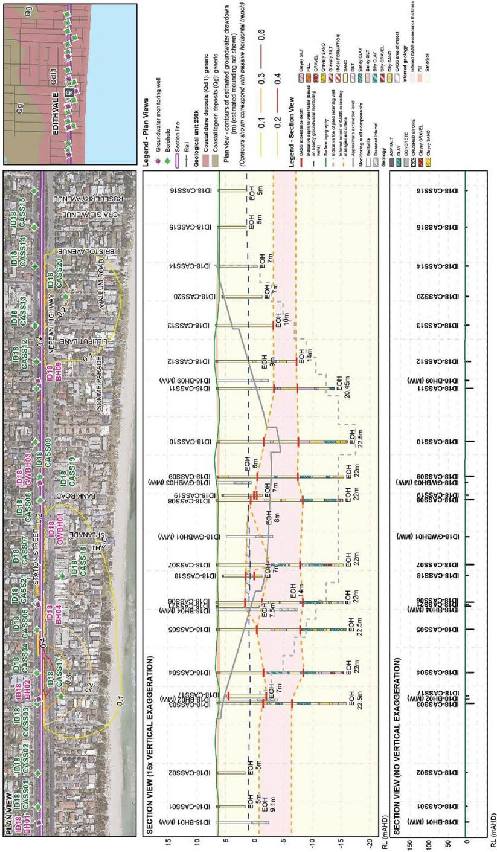

A larger format version of this figure is provided in Attachment VI Map book.

Figure 7.7 Geotechnical borehole locations and indicative depth to CASS (Bonbeach)
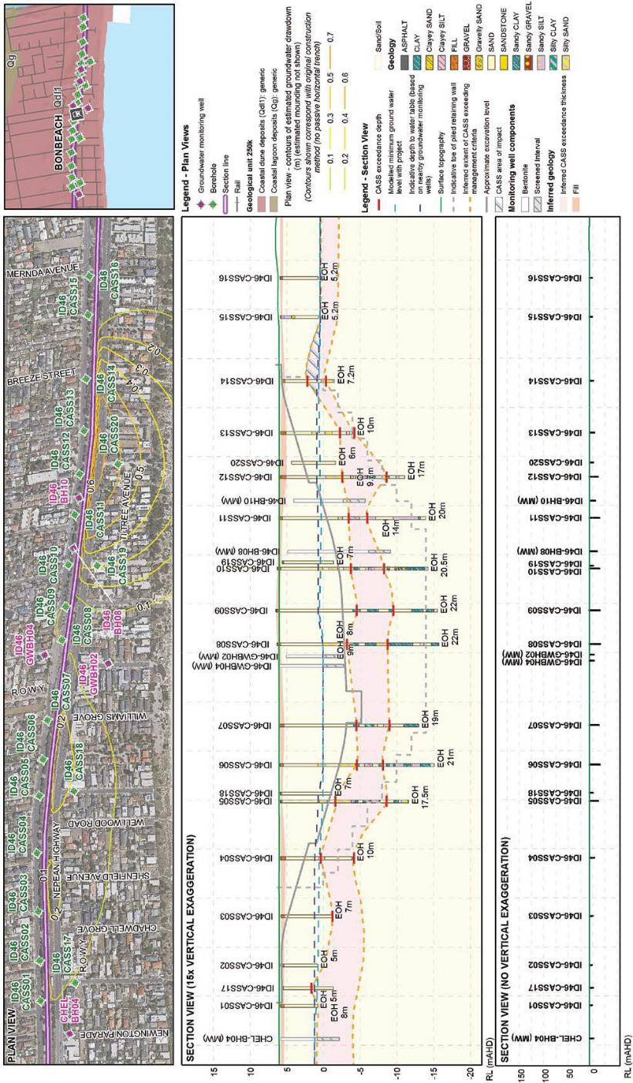

A larger format version of this figure is provided in Attachment VI Map book.

Movement of contamination plumes from groundwater changes (risk GW62 and GW69)
The construction of the pile walls on both sides of the trench at each site has the potential to change hydrogeological conditions. Groundwater modelling included in EES Technical Report A Groundwater shows that the effect of the pile walls on groundwater would be:
- levels would rise (mounding) to the east of the rail trench
- levels would fall (drawdown) to the west of the rail trench
- groundwater flow would be diverted to the north or south by the rail trench.
Drawdown and mounding would commence within months of installing the pile walls and would continue over the life of the trench.
Depending on the amount of groundwater level change and diversion of groundwater, it could cause the migration of any existing contaminant plumes, associated with potential sources of contamination, into previously non-impacted areas of groundwater. Migration of contaminant plumes could result in adverse changes to groundwater chemistry (contamination) precluding some or all of the beneficial uses of groundwater (as defined in the State Environment Protection Policy – Groundwaters of Victoria) and/or land (as defined in the State Environment Protection Policy – Prevention and Management of Contamination of Land).

Edithvale
As discussed in Chapter 5 Modelling the water environment, through the risk and impact assessment process, a need to manage groundwater at Edithvale was identified to reduce the potential changes to groundwater levels caused by the pile walls and associated impacts.
To manage this risk associated with the pile walls, a potential engineering solution which would improve
the flow of groundwater around the pile walls compared to the predictions obtained from the initial assessment was developed and modelled for the Edithvale level crossing removal project. In considering a potential engineering solution, performance outcomes were developed to provide minimum requirements for development of technical designs (EPR reference GW2). Ultimately, the solution would need to ensure that the difference in groundwater levels on either side of the trench would not result in:
- groundwater mounding that increases water logging at ground level
- groundwater drawdown that could cause ground subsidence and adverse impact to subsurface structures
- degradation to groundwater quality that would preclude beneficial use of groundwater
- changes to groundwater that would have significant impacts on groundwater dependent ecosystems.
Refer to Chapter 5 Modelling the water environment for further details.
The risk of contaminant migration impacting beneficial uses of groundwater and/or land (following the installation of the pile walls) was initially assessed as having a moderate risk level. This is because the initial groundwater modelling predicted that groundwater flow paths would be altered as a result of the pile wall installation and that groundwater mounding (increase in groundwater level) of up to 0.9 metres within
50 metres of the rail trench, and groundwater drawdown (decrease in groundwater level) of 1.4 metres within 50 metres of the rail trench would occur. Groundwater flowing toward the bay would also be diverted to the north or south by the pile wall.
The implementation of an engineering solution to reduce changes in groundwater levels at Edithvale consequently reduced the risks associated with the movement of contamination plumes from groundwater changes. The groundwater modelling of the engineering solution demonstrated a significant reduction in the potential for groundwater level changes compared to the initial assessment. The maximum drawdown after the introduction of the engineering solution was 0.2 metres within 50 metres of the rail trench and the maximum mounding was 0.2 metres within 50 metres of the rail trench. This would reduce both the amount of groundwater level change and the extent of the area affected by groundwater level changes.

This would result in a reduction in the number of potential sources of contamination within the reduced area of groundwater change to two services stations and the Edithvale fire station. The combination of a reduction of the extent of drawdown and mounding and a reduction in the number of potential sources of
contamination within the area of impact results in a reduction in the risk of contaminant migration impacting some or all of the beneficial uses of groundwater from moderate to minor. Furthermore, the management, monitoring and mitigation regime (EPR reference GW3 and CL5) would provide early detection of impacts and the application of appropriate mitigation measures. Such an approach is commensurate with a minor risk level.
The groundwater management plan for the construction period would include a targeted baseline groundwater assessment, taking into account the site history (EPR reference CL4). This can be used to identify if groundwater contamination plumes exist within the area of groundwater level change and the extent of the plumes (if present). After installation of the pile walls, implementation of a Groundwater Management and Monitoring Plan (EPR reference GW3) would continue to enable the monitoring of groundwater quality and levels and would provide early detection of impacts (if identified). A Groundwater Quality Mitigation Plan would be implemented if the groundwater monitoring identifies that groundwater plume migration is occurring
(EPR reference CL5). It would include measures to manage the beneficial uses of groundwater affected by contaminated groundwater plume migration or acidification attributable to the projects.

Bonbeach
The risk of contaminant migration impacting beneficial uses of groundwater and/or land as a result of drawdown, mounding and physical diversion of the groundwater at Bonbeach from the installation of the pile walls was assessed as a negligible risk level. This is because within the area of predicted groundwater
change there are only three identified potential sources of contamination: a furniture manufacturer, a mower sales/service centre and a laundromat. All three identified potential sources of contamination are down hydraulic gradient of the pile wall and are located where groundwater drawdown is predicted to be 0.15 metres, which is within the range of natural groundwater level variability. In the unlikely event of contaminant plume migration occurring, the implementation of groundwater monitoring, management and mitigation plans (EPR references GW3 and CL5) would provide early detection of impacts and the application of appropriate mitigation measures.

Conclusion

The existing conditions assessment identified that the project was likely to interact with both acid sulfate soils (actual and potential) and contaminated soil and groundwater during construction. Acid sulfate soils naturally occur in the area and contaminated soil and groundwater is present as a result of historical land uses.
The spoil assessment estimated that 358,000 cubic metres of spoil (ex-situ) would be generated by the project across both areas. The majority of this (71 per cent at Edithvale and 73 per cent at Bonbeach) is likely to be classified as fill material. Waste acid sulfate soil (15 per cent) and Category C prescribed industrial waste (11 per cent) would also be produced by the projects. There is also expected to be some minor volumes of Category A and B prescribed industrial waste present.
A number of risks as a result of interactions with acid sulfate soils and contamination were identified and assessed. These risks were primarily associated with adverse impacts to human health and/or the
environment. A risk assessment, taking into consideration the results of the existing conditions assessment and the application of risk minimisation and management measures resulted in all but two of the risks identified (discussed further below) being assessed as negligible. The reason most of the risks were found to be negligible is because the projects have been designed to include aspects that minimise the risks associated with acid sulfate soils and contamination, including the installation of the pile walls prior to the construction of the trench to minimise the potential for groundwater ingress into the trench and the rapid trench construction period that minimises the length of time soil would be exposed. Additionally, the development and application of management plans to specifically address spoil management, acid sulfate soils and construction techniques in accordance with current policies and guidelines, would further minimise the potential for adverse impacts as a result of the projects. These are further outlined below.
The two remaining risks that were assessed as minor were associated with changes to groundwater levels as a result of the installation of the trench and were applicable for construction (from when the pile walls were installed) and through operation:
- activation of acid sulfate soils as a result of groundwater level drawdown
- movement of contamination plumes as a result of groundwater mounding and drawdown and the presence of the trench.
Impacts associated with these risks are more pronounced at Edithvale than at Bonbeach. Implementation of a potential engineering solution which would reduce groundwater level changes across the trench at Edithvale, resulted in a decrease in the risk levels to negligible for acid sulfate soil activation, and minor for the movement of contaminant plumes.
The risks caused by groundwater level changes at Bonbeach were considered sufficiently low such that alteration to the modelled design would not be required to achieve the performance outcomes listed in EPR_GW2.
The lesser impact predicted at Bonbeach is primarily due to the difference in local groundwater flow direction, which is perpendicular to the pile wall at the Edithvale site, resulting in greater impedance of groundwater throughflow. At the Bonbeach site, groundwater flows towards the south, towards Patterson River. At areas where the flow line is parallel to the pile wall, less impedance on groundwater throughflow is predicted.
The locations of the pile walls relative to the location of the local groundwater flow divide at Bonbeach also act to reduce impacts predicted at Bonbeach. At Bonbeach, the groundwater flow divide is inferred to approximately coincide with the rail trench, resulting in limited opportunity for the pile walls to interrupt lateral flow of groundwater across the rail trench.
Furthermore, the impact of these risks at Bonbeach was assessed as minor for acid sulfate soil activation (because there are only limited, small areas of acid sulfate soils that could become activated), and negligible for the movement of contaminant plumes without any additional management of groundwater (because the identified potential sources of contamination fall within an area of drawdown that falls within the range of natural variability).

The impacts associated with these risks would be managed in accordance with the established legislative framework for acid sulfate soils and contamination and through the implementation of EPRs requiring the following management and mitigation measures:
- preparation of a Spoil Management Plan which would include:
  - completion of a sampling program to classify the nature and extent of contamination levels prior to excavation
  - management measures for the storage, handling and transport of spoil to protect human health and the environment
  - identification of suitable disposal facilities for material excavated
- preparation of an Acid Sulfate Soil Management Plan which would include:
  - identification, on a site plan, of the location and extent of acid sulfate soils likely to be encountered
  - identification of suitable sites for the management or disposal of acid sulfate soils
- development of a CEMP to reduce adverse impacts during construction such as designating areas for vehicle refuelling and washing, the provision of spill kits to contain any spills that may occur and providing litter bins to contain waste on site
- development of measures to manage acidic and/or contaminated groundwater including:
  - completing a baseline groundwater assessment prior to commencing construction
  - implementing a system to manage and/or dispose of intercepted groundwater (if required) which may be a TWA with the relevant utility authority or other measures in accordance with relevant guidelines and legislation (if a TWA is not granted)
  - undertaking groundwater monitoring during construction.
Management of the risks associated with changes to groundwater levels after the installations of the pile walls would be through the implementation of EPRs requiring the following:
- the trenches at Edithvale and Bonbeach must be designed to ensure that groundwater level changes (as a result of the projects) do not result in degradation to groundwater quality that would preclude beneficial use of groundwater from contaminants or acid sulfate soils (EPR references GW1 and GW2).
- development and implementation of a Groundwater Management and Monitoring Plan (EPR reference GW3)
- development of trigger levels for changes in groundwater level and / or quality that require mitigation plans to be implemented (EPR reference CL5).

