TUN1810.1

23 October 2018

WORKS UPDATE - WHITEHALL STREET CONSTRUCTION AREAS
Over the next few months, works at the Northern Portal, Tunnelling Hub, and North Yarra Main Sewer diversion sites continue as construction on the West Gate Tunnel Project progresses. Here’s what is happening in the area over the next couple of months with a map to help locate each of the areas.

North Yarra Main Sewer Diversion
The North Yarra Main Sewer diversion is progressing well at both upstream and downstream areas on Whitehall Street. The next key activity will be launching the mini Tunnel Boring Machine from the Northern Portal site to commence boring the new section of the sewer. Working hours will be 24 hours a day, 7 days a week and the activities will include:
- Shaft piling and concrete works at Somerville Road/Whitehall Street work area;
- Launching the mini TBM and the pipe jacking process that will construct the new 3-metre diameter sewer diversion; and
- Implementing traffic management changes near Somerville Road
  - Southbound traffic will be moved to the east side of the road on Whitehall Street, south of Somerville Road. Signage and line marking will direct traffic through the changed environment.
  - Northbound traffic will continue to use the detour route of Leek Street, Hyde Street and Somerville Road
What is pipe-jacking?
Individual sections of connecting sewer pipe will be installed one at a time behind the mini TBM as it tunnels through the ground, continually pushing it forward – a process called ‘pipe jacking’. These pipes will become the new section of the sewer.

2. Northern Portal
In preparation for tunnelling next year, the main focus will be on excavation to create the tunnel entrance. Works on site will be 24 hours a day, 7 days a week and will include:
- Concrete and foundation works;
- Excavation and spoil removal via covered trucks to a temporary handling facility in Sunshine. For this activity, the truck movements are expected to range from 3-4 trucks per hour from 6am – 6pm and approximately 1-2 trucks per hour from 6pm – 6am;
- Installation of the site’s 250-tonne gantry crane which will stand approximately 25 m high; and
- Connecting the new electricity substation to the electricity grid to power the tunnelling activity.

3. Tunnelling Hub at 221 Whitehall Street
Over the next few months we will be progressing works at the Tunnelling Hub. Works will include completion of the spoil handling facility, installing traffic signals at the entry and exit of 221 Whitehall Street and construction of a spoil conveyor over Somerville Road between our two construction sites on Whitehall Street. The covered spoil conveyor will move dirt and rock from the Northern Portal into the spoil handling facility.

4. Youell Street closure – Mid November (one week)

Youell Street (East of Whitehall St) will be closed for one week from mid-November at Whitehall Street to complete underground cabling works to connect the new high voltage electricity substation to the electricity grid. The new substation will provide the required power for our construction activities, lighting and tunnelling.

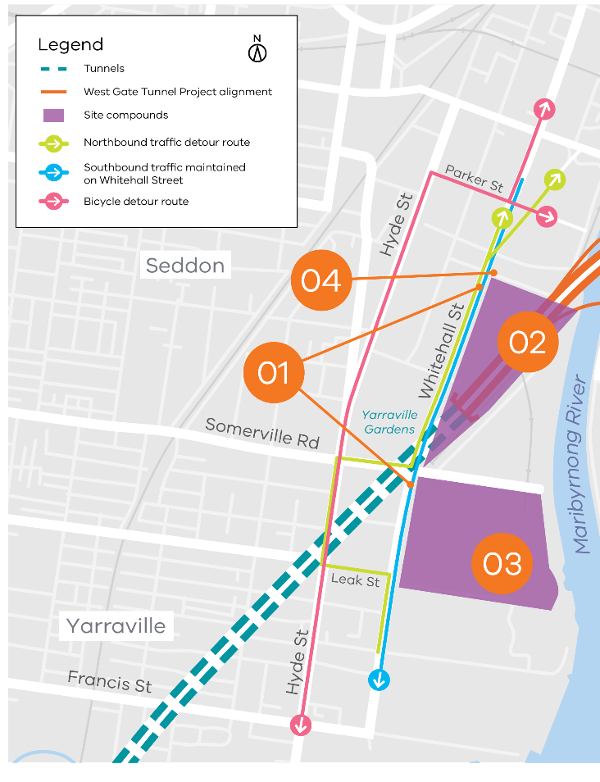
The road will be closed temporarily to enable these works to be completed safely and efficiently. Traffic management will be in place with access maintained for local businesses.

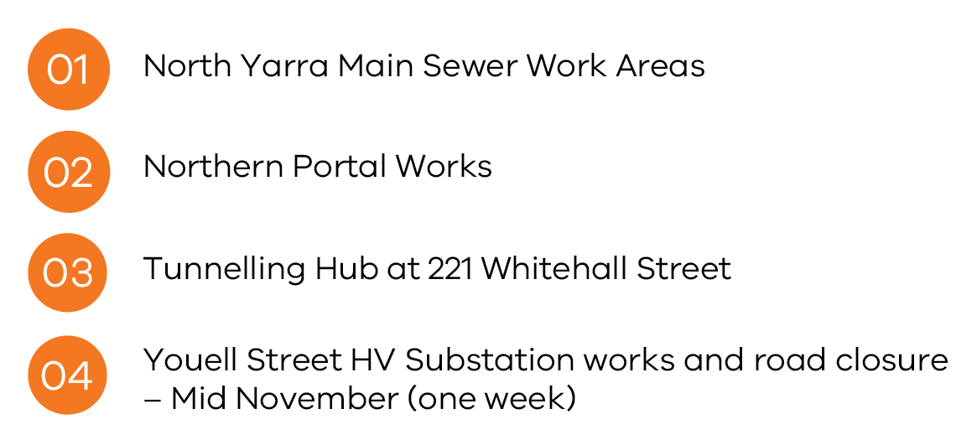
Whitehall Street Construction Areas

Tunnelling monitoring equipment installation project wide
Advanced monitoring equipment is currently being installed along the length of the Project. The state of the art systems will provide effective real-time monitoring of groundwater levels, ground movement, structural loading, noise, air quality and vibration for the duration of the tunnelling activity.
For more information about any of the upcoming works and traffic changes, please contact us.
Contact us
Please contact us if you have any questions or feedback about these works.
westgatetunnelproject.vic.gov.au | facebook.com/westgatetunnelproject
westgatetunnelproject@wda.vic.gov.au | @westgatetunnel
1800 105 105 | West Gate Tunnel Project  GPO Box 4509  Melbourne Victoria 3001

