TUN1910.01

21 October 2019

Works notification: Southern portal site building demolition
Works continue at our Southern portal site, where the outbound tunnel will meet the West Gate Freeway, to establish our construction site at the end of New and Watson Streets, South Kingsville.

For four weeks from early-November, we will demolish three low-rise brick buildings and two steel sheds containing asbestos cladding within the site. All asbestos will be removed in accordance with the safety approved procedures and standards by a fully licensed and approved asbestos contractor.

There is also one steel shed on the site that will be demolished early 2020. We will confirm timing later this year.

For demolition works on this site, working hours will be:

- Monday to Friday 7:00am to 5:00pm

- Saturday 7:00am to 3:00pm

Asbestos removal may be taken from site outside of these hours, if required.

What to expect during building demolition works:

- Vehicles will generally exit to and from site using Kyle Road.
- Vehicle movements to and from site will be coordinated by a traffic controller.
- All demolition materials will be loaded by an excavator within the site boundary.
- Dust control measures include site water points, wetting down of open areas, covered trucks and street sweeping.
- A 1.8 metre high temporary fence will be installed around the site boundary during demolition.
- Signage will be in place as per requirements to advise of demolition works, construction vehicles and other general construction hazards.

An increase in vehicle movements around the site is expected due to demolition works as well as some additional construction traffic on Kyle Road due to ongoing outbound southern portal site works.
WANT TO BE KEPT IN THE LOOP FOR WORKS IN THE AREA?
If you would like email updates for the works in this notification please email the project team at info@wgta.vic.gov.au and type “Southern portal updates” in the subject line.

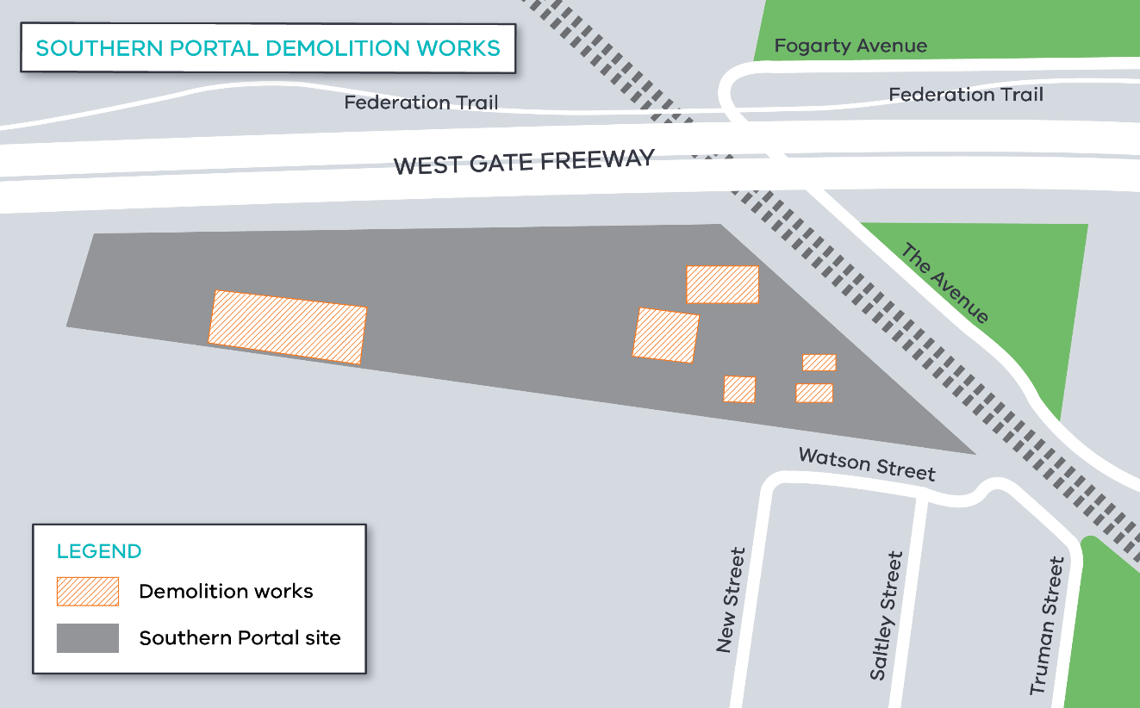

While we expect this work will have some associated noise, we will take steps to minimise noise and will monitor any impacts. Thank you for your patience while we undertake these important activities.

Contact us

Please contact us if you have any questions or feedback about these works.

 | westgatetunnelproject.vic.gov.au |  | facebook.com/westgatetunnelproject
 | info@wgta.vic.gov.au |  | @westgatetunnel
 | 1800 105 105 |  | West Gate Tunnel Project  GPO Box 4509, Melbourne VIC 3001
 | Interpreter service: 13 14 50

