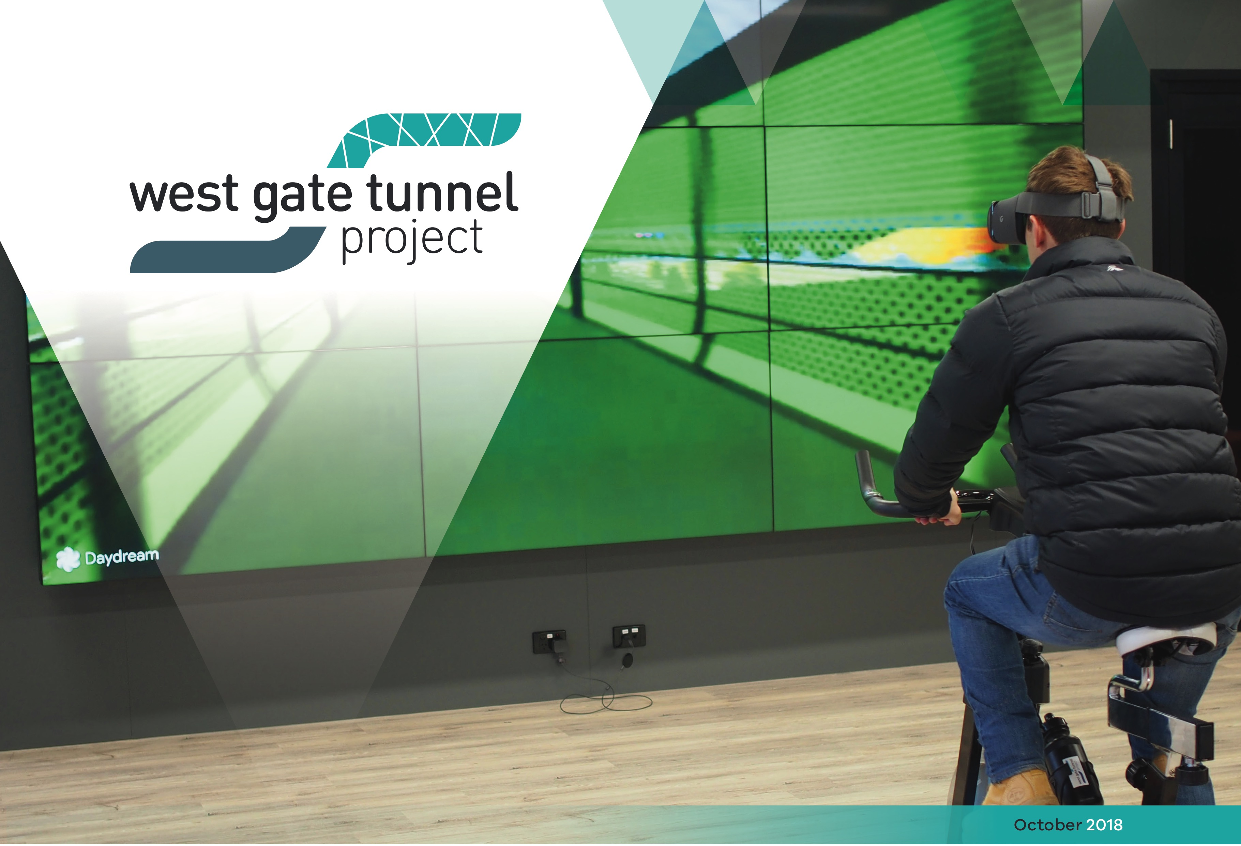

West Gate Tunnel Info Centre opens its doors



## A virtual reality ride through the new West Gate Tunnel Project veloway, and an interactive model of Melbourne’s west in

2022 are just some of the features you can check out at the new West Gate Tunnel Project Info Centre.

Visitors to the Info Centre will also see a scale model of the five-storey, 90-metre long tunnel boring machines that will dig the twin tunnels between the West Gate Freeway and the Maribyrnong River.

Located at the project’s tunnelling hub site on the corner of Whitehall Street and Somerville Road in Yarraville, the Info Centre is open to the public through the construction period until 2022.

People are invited to drop in any time during opening hours, and group visits can be arranged for organisations keen to learn more about the project.

Parking and pedestrian access is available on site via Somerville Road.

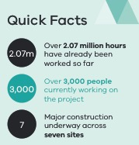

### Opening hours

**Monday to Friday: 10am-5pm** (excluding public holidays) **Saturday: 10am-4pm**

More information, including how to book group visits, can be found at **westgatetunnelproject.vic.gov.au/ contact**

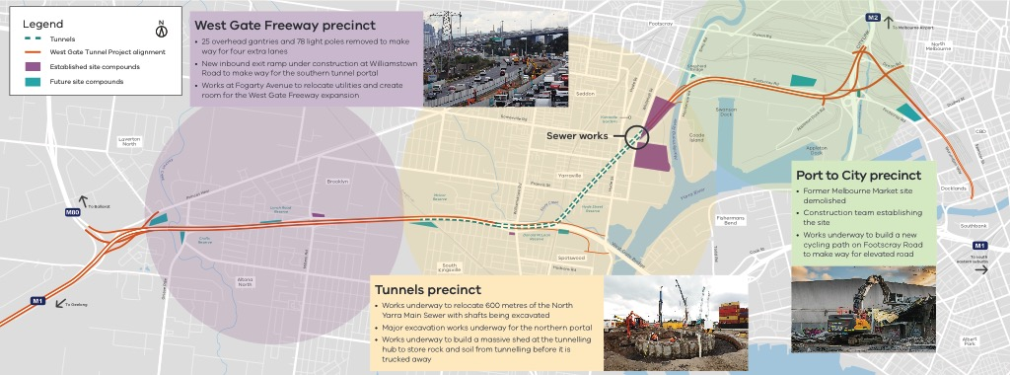

Construction update

Work is well underway on the West Gate Tunnel Project with construction happening at a number of major locations. The key work happening at the moment is widening the West Gate Freeway and digging the holes where the tunnel boring machines will start tunnelling from next year.

Upcoming works in your area

### West Gate Freeway

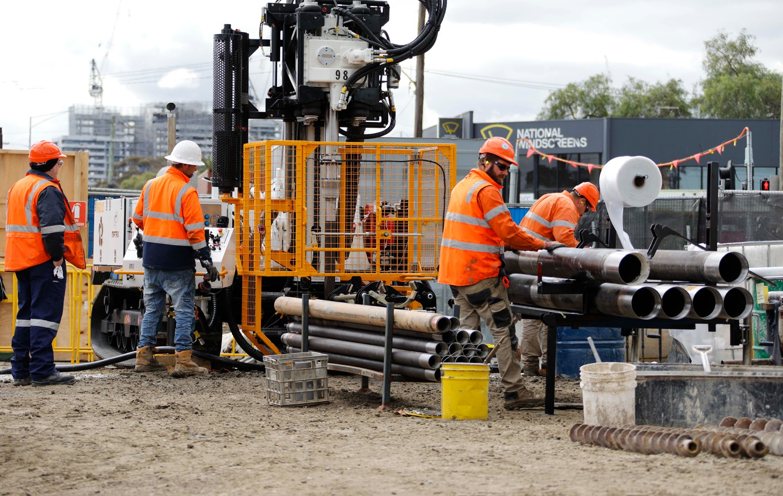

Freeway widening works are ramping up at the Millers Road and Williamstown Road interchanges to make space for four new freeway lanes

Port to City

Construction zones are being set up along Footscray Road as works get underway to build the new elevated road and bridges over the Maribyrnong River

Tunnel Zone

A mini TBM will get to work excavating 600m of new sewer and a massive shed will be built at our tunnelling hub site on Whitehall Street to store rock and soil from tunnelling before it is trucked away

North Yarra Main Sewer diversion underway

Works to divert the North Yarra Main Sewer are progressing well. You may have noticed construction crews hard at work on Whitehall

Street excavating the deep access shafts so we can launch our mini tunnel boring machine (TBM) to divert the sewer before tunnelling begins on the West Gate Tunnel.

Over the next 12 months, the mini TBM will build 600 metres of new sewer, moving it safely out of the way of the West Gate Tunnel.

Whitehall Street is now closed northbound between Leek Street and Somerville Road for 12 months while the sewer relocation is underway. During this time, northbound traffic is being detoured via Leek Street, Hyde Street and Somerville Road before re-joining Whitehall Street.

Whitehall Street is also reduced to one lane of traffic in each direction between Parker Street and Somerville Road.

### Contact us

Do you have a question about the project? If you need more information or would like to provide feedback, please get in touch.

westgatetunnelproject.vic.gov.au [westgatetunnelproject@wda.vic.gov.au](mailto:westgatetunnelproject@wda.vic.gov.au) 1800 105 105

facebook.com/westgatetunnelproject

@westgatetunnel

West Gate Tunnel Project

GPO Box 4509, Melbourne Victoria 3001

 Interpreter service: 13 14 50

If you are deaf, or have a hearing or speech impairment, contact us through the National Relay Service.

For more information, visit[: www.relayservice.gov.au.](http://www.relayservice.gov.au/)