WES1805.01
8 May 2018

Works notification:

Starting works at Millers Road / West Gate Freeway interchange
In the coming months you will see works starting around the West Gate Freeway / Millers Road interchange. This is in preparation for, widening of the freeway and upgrading Millers Road.

Construction site establishment
20 May – June 2018
Before we can start on major construction activities, we need to create safe working spaces for our teams. Around the Millers Road interchange, this will involve:
- clearing vegetation and trees in the area. These works will be done mostly during the day, but we are planning to work on Millers Road on the nights of Sunday 20 May and Monday 21 May (between the exit and entry ramps) from 10pm to 5am; this work will require the use of chainsaws and mulchers;
- setting up barriers on the outbound exit and entry ramps;
- removing traffic islands and installing temporary ones; and
- ongoing general construction including earth works, kerb removal, site protection and implementing traffic changes.

Utility Service investigation works
20 May – November 2018

Utility investigation works will be carried out across Paringa Road and Primula Avenue to identify utilities in the area prior to relocation or removal. This will involve:
- electronic scanning of roads and footpaths; and
- non-destructive digging (NDD) to identify services such as gas and water.

Utility Service installation works
June – November 2018
High voltage electric conduit and cabling will be installed underground along Paringa Road and Beevers Street and under Millers Road and the West Gate Freeway. This will involve:
- some temporary traffic changes to be implemented in the area; and
- trenching and cable installation along residential streets and microtunneling under Millers Road and the West Gate Freeway.
There will be changes involving access to Paringa Road from Millers Road, for which additional information will be provided to residents before works start.

Setting up our Millers Road site office
2 June 2018 – August 2018
A construction site will be set up on Millers Road, adjacent to Federation Trail, to provide facilities, including sheds and offices, for our staff and storage of equipment and materials.

What you could expect while we undertake these works:
- detours will be in place to help safely navigate people and vehicles around the work areas;
- construction noise, from our machinery and trucks and an increase of construction vehicles in the area; and
- traffic changes including lane and ramp closures and footpath detours.

These works will generally be carried out during the hours: Monday to Friday between 7am-6pm and Saturdays between 7am-3pm, however some night works will be required.

When works are scheduled during out of hours or if you’re located close to the works, we will provide further information to you before works start.

While up-to-date traffic impacts will always be available at westgatetunnelproject.vic.gov.au, we will be sure to inform you of any additional changes or impacts that arise from these works.

Please note that works may be rescheduled in the event of bad weather or other unavoidable circumstances.
For updates and more information about our works please visit westgatetunnel.vic.gov.au or contact us using the details below.

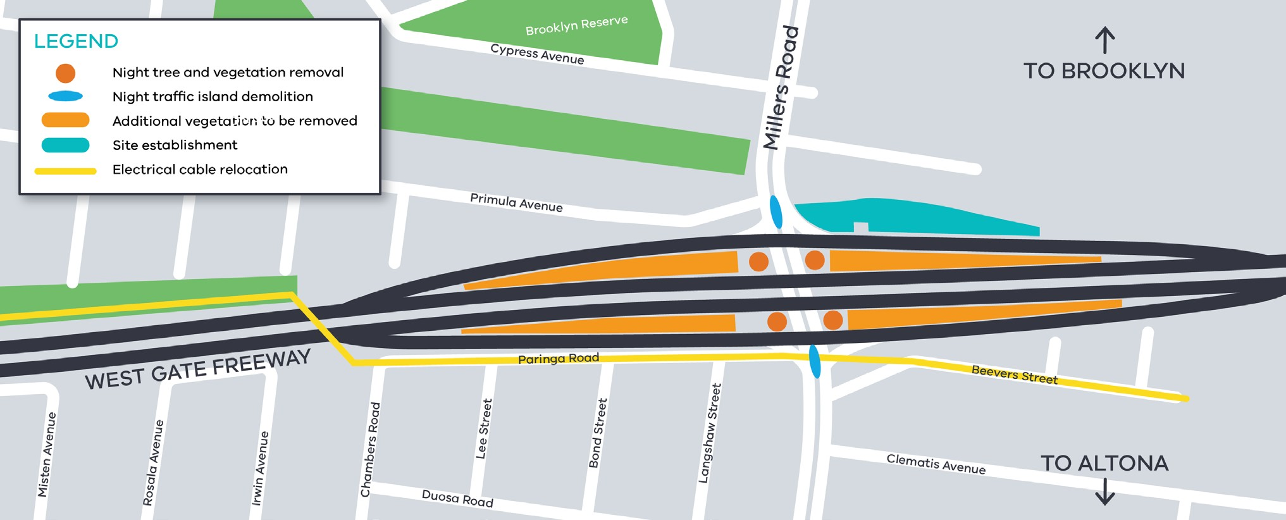
Location of works around West Gate Freeway and Millers Road interchange

Meet the team at the Altona Gate Shopping Centre
Saturday 26 May 2018, 10am -2pm
Come and talk to the team building the West Gate Tunnel Project when we are at the Altona Gate Shopping Centre. We will be set up between Kmart and Coles. The team will be able to answer your questions about works that are taking place in the local area.

Contact us

Please contact us if you have any questions or feedback about these works.
westgatetunnelproject.vic.gov.au
westgatetunnelproject@wda.vic.gov.au
1800 105 105
facebook.com/westgatetunnelproject
@westgatetunnel
West Gate Tunnel Project
GPO Box 4509
Melbourne Victoria 3001
Interpreter service: 13 14 50

