Reference: WES1808.01
5 October 2018
Works update – temporary disruptions

Construction has begun on Fogarty Avenue to safely relocate some existing power lines and install new drainage. As part of these works, Fogarty Avenue will be temporarily closed at the intersection of your street.
Temporary closure of Fogarty Avenue
9 October to 27 October 2018

- Fogarty Avenue will be closed between Wembley Avenue and the Footscray Hockey Club from 9 October to 27 October;
- driveway and footpath access will be maintained;
- a local detour will be in place during this time; and
- parking along sections of Fogarty Avenue will be unavailable during this time – please see the map below for location details.

What you could expect:
- an increase in construction vehicles within the area;
- an increase in construction noise from our machinery and trucks;
- water spray trucks to help manage dust and dirt and covered loads when dirt and rock when are being transported; and
- traffic changes will be required and signed detours will be in place – latest traffic updates are available at www.westgatetunnelproject.vic.gov.au/traveldisruptions.

These works will generally be carried out from Monday to Friday between 7am - 6pm and Saturdays between 7am - 3pm, however some night works may be required.

When works are scheduled out of hours and may have a direct impact on you, we will provide further information to you before works start.

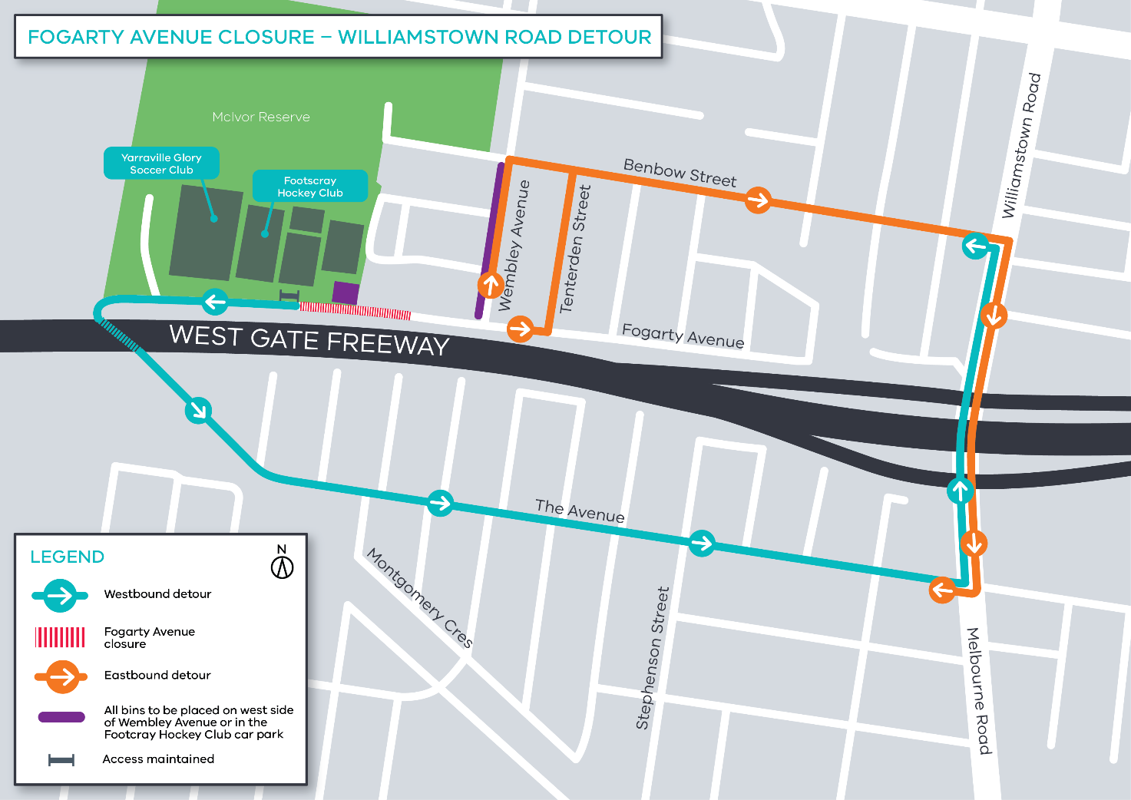

Please note that works may be rescheduled in the event of bad weather or other unavoidable circumstances.
For updates and more information about our works please visit westgatetunnel.vic.gov.au or contact us using the details below.

Contact us

Please contact us if you have any questions or feedback about these works.
westgatetunnelproject.vic.gov.au
westgatetunnelproject@wda.vic.gov.au
1800 105 105
facebook.com/westgatetunnelproject
@westgatetunnel
West Gate Tunnel Project
GPO Box 4509
Melbourne Victoria 3001
Interpreter service: 13 14 50

Reference: WES1808.01
26 September 2018
Works update – temporary disruptions

Construction has begun on Fogarty Avenue to safely relocate some existing power lines and install new drainage. As part of these works, Fogarty Avenue will be temporarily closed at the intersection of your street.
Temporary closure of Fogarty Avenue
3 October to 13 October 2018

- Fogarty Avenue will be closed between Wembley Avenue and the Footscray Hockey Club from 3 October to 13 October;
- driveway and footpath access will be maintained;
- a local detour will be in place during this time; and
- parking along sections of Fogarty Avenue will be unavailable during this time – please see the map below for location details.

What you could expect:
- an increase in construction vehicles within the area;
- an increase in construction noise from our machinery and trucks;
- water spray trucks to help manage dust and dirt and covered loads when dirt and rock when are being transported; and
- traffic changes will be required and signed detours will be in place – latest traffic updates are available at www.westgatetunnelproject.vic.gov.au/traveldisruptions.

These works will generally be carried out from Monday to Friday between 7am - 6pm and Saturdays between 7am - 3pm, however some night works may be required.

When works are scheduled out of hours and may have a direct impact on you, we will provide further information to you before works start.

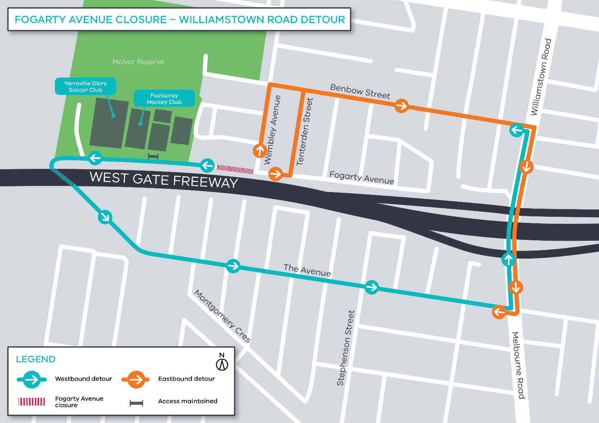

Please note that works may be rescheduled in the event of bad weather or other unavoidable circumstances.
For updates and more information about our works please visit westgatetunnel.vic.gov.au or contact us using the details below.

Contact us

Please contact us if you have any questions or feedback about these works.
westgatetunnelproject.vic.gov.au
westgatetunnelproject@wda.vic.gov.au
1800 105 105
facebook.com/westgatetunnelproject
@westgatetunnel
West Gate Tunnel Project
GPO Box 4509
Melbourne Victoria 3001
Interpreter service: 13 14 50

Reference: WES1808.01
26 September 2018
Works update – temporary road closure

Construction has begun on Fogarty Avenue to safely relocate some existing power lines and install new drainage. As part of these works, Fogarty Avenue will be temporarily closed adjacent to your property.
Temporary closure of Fogarty Avenue
3 October to 13 October 2018
- vehicle access along Fogarty Avenue between Wembley Avenue and the Footscray Hockey Club will be temporarily blocked from 3 October to 13 October;
- driveway and footpath access will be maintained; and
- parking along sections of Fogarty Avenue will be temporarily unavailable during this time – please see the map below for location details.

Where to park your vehicle:
- ensure you do not park your vehicle on Fogarty Avenue between Wembley Avenue and the Footscray Hockey Club during the times above. Access will be blocked and you will be unable to access your vehicle; and
- it is recommended that you park your vehicle Wembley Avenue or in the Footscray Hockey Club car park for the duration of these works.
What you could expect:
- an increase in construction vehicles within the area;
- an increase in construction noise from our machinery and trucks;
- water spray trucks to help manage dust and dirt and covered loads when dirt and rock when are being transported; and
- traffic changes will be required and signed detours will be in place – latest traffic updates are available at www.westgatetunnelproject.vic.gov.au/traveldisruptions.

These works will generally be carried out from Monday to Friday between 7am - 6pm and Saturdays between 7am - 3pm, however some night works may be required.

When works are scheduled out of hours and may have a direct impact on you, we will provide further information to you before works start.

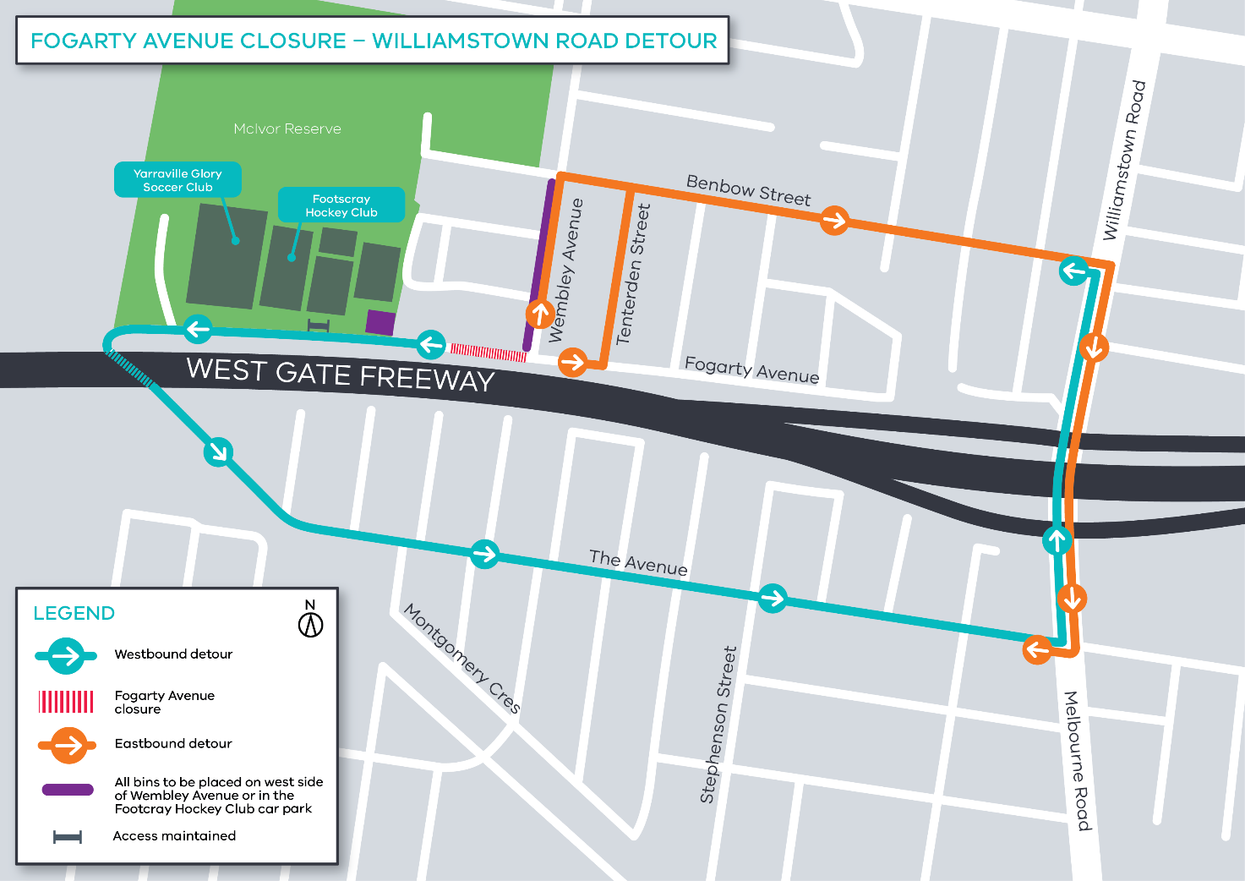

Please note that works may be rescheduled in the event of bad weather or other unavoidable circumstances.

For updates and more information about our works please visit westgatetunnel.vic.gov.au or contact us using the details below.
Contact us

Please contact us if you have any questions or feedback about these works.
westgatetunnelproject.vic.gov.au
westgatetunnelproject@wda.vic.gov.au
1800 105 105
facebook.com/westgatetunnelproject
@westgatetunnel
West Gate Tunnel Project
GPO Box 4509
Melbourne Victoria 3001
Interpreter service: 13 14 50

Reference: WES1808.01
26 September 2018
Works update – temporary driveway disruption

Construction has begun on Fogarty Avenue to safely relocate some existing power lines and install new drainage. As part of these works, vehicle access to some driveways will be temporarily disrupted.
Temporary disruption to your driveway access
3 October to 13 October 2018
- vehicle access to driveways along Fogarty Avenue between Wembley Avenue and the Footscray Hockey Club will be temporarily blocked from 3 October to 13 October;
- work will progress from east to west along this section i.e. towards McIvor Reserve;
- footpath access to your property will remain;
- if you require your vehicle during this time, please ensure it is moved out of your driveway before your closure date; and
- parking along sections of Fogarty Avenue will also be temporarily unavailable during this time – please see the map below for location details.

If you require any assistance with carrying items to or from your vehicle, please ask one of our onsite team, they will be able to assist you.

When you need to move your vehicle:
- if you need access to your vehicle between 3 October to 13 October, please ensure your vehicle is moved out your driveway by 7am on your driveway closure date.

Where to park your vehicle:
- it is recommended that you park your vehicle on either Wembley Avenue or in the Footscray Hockey Club car park for the duration of these works; and
- ensure you do not park your vehicle on Fogarty Avenue during the times above. Access will be blocked and you will be unable to access your vehicle.
Waste collection:
- place rubbish bins on the west side of Wembley Avenue. Bins placed on the east side of these streets may not be emptied – please see the map below for location details.

What you could expect:
- an increase in construction vehicles within the area;
- an increase in construction noise from our machinery and trucks;
- water spray trucks to help manage dust and dirt and covered loads when dirt and rock when are being transported; and
- traffic changes will be required and signed detours will be in place – latest traffic updates are available at www.westgatetunnelproject.vic.gov.au/traveldisruptions.

These works will generally be carried out from Monday to Friday between 7am - 6pm and Saturdays between 7am - 3pm, however some night works may be required.

When works are scheduled out of hours and may have a direct impact on you, we will provide further information to you before works start.

Please note that works may be rescheduled in the event of bad weather or other unavoidable circumstances.
For updates and more information about our works please visit westgatetunnel.vic.gov.au or contact us using the details below.

Contact us
Please contact us if you have any questions or feedback about these works.
 | westgatetunnelproject.vic.gov.au |  | facebook.com/westgatetunnelproject
 | westgatetunnelproject@wda.vic.gov.au |  | @westgatetunnel
 | 1800 105 105 |  | West Gate Tunnel Project  GPO Box 4509  Melbourne Victoria 3001
 | Interpreter service: 13 14 50
13 September 2018
Works update – temporary disruptions

Construction has begun on Fogarty Avenue to safely relocate some existing power lines and install new drainage. As part of these works, Fogarty Avenue will be temporarily closed at the intersection of your street.
Temporary closure of Fogarty Avenue
20 September to 27 September 2018

- Fogarty Avenue will be closed between Cranbrook Street and Wembley Avenue from 20 September to 27 September;
- driveway and footpath access will be maintained;
- a local detour will be in place during this time; and
- parking along sections of Fogarty Avenue will be unavailable during this time – please see the map below for location details.

Waste collection:
- closure of Tenterden Street and Fogarty Avenue intersection will limit access for waste collection trucks; and
- place rubbish bins on the west side of Tenterden Street for collection from 20 September to 27 September – please see the map below for location details.

What you could expect:
- an increase in construction vehicles within the area;
- an increase in construction noise from our machinery and trucks;
- water spray trucks to help manage dust and dirt and covered loads when dirt and rock when are being transported; and
- traffic changes will be required and signed detours will be in place – latest traffic updates are available at www.westgatetunnelproject.vic.gov.au/traveldisruptions.

These works will generally be carried out from Monday to Friday between 7am - 6pm and Saturdays between 7am - 3pm, however some night works may be required.

When works are scheduled out of hours and may have a direct impact on you, we will provide further information to you before works start.

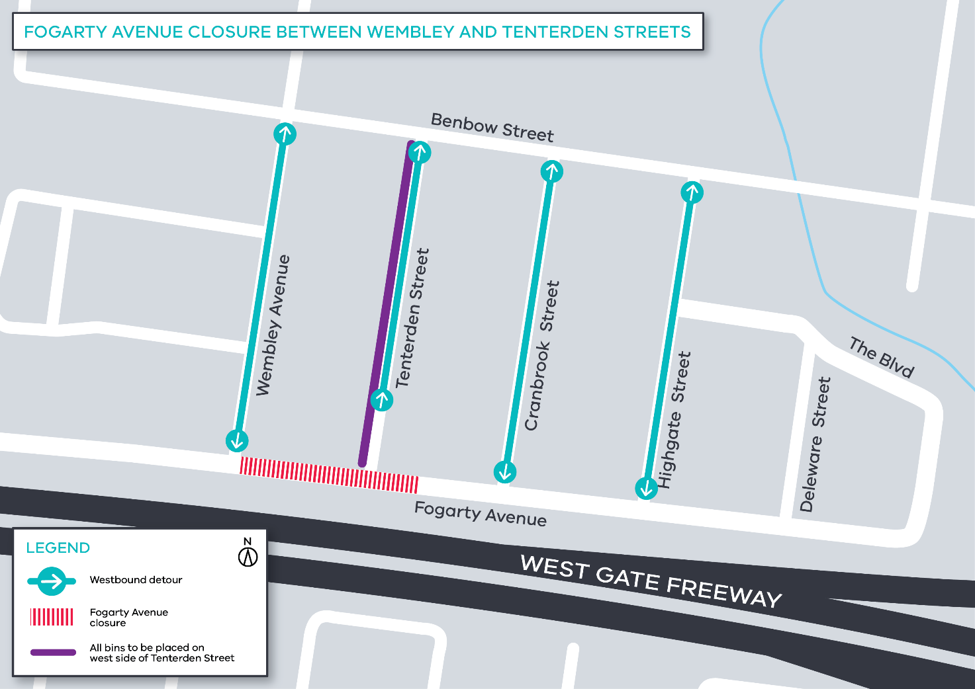

Please note that works may be rescheduled in the event of bad weather or other unavoidable circumstances.
For updates and more information about our works please visit westgatetunnel.vic.gov.au or contact us using the details below.

Contact us

Please contact us if you have any questions or feedback about these works.
westgatetunnelproject.vic.gov.au
westgatetunnelproject@wda.vic.gov.au
1800 105 105
facebook.com/westgatetunnelproject
@westgatetunnel
West Gate Tunnel Project
GPO Box 4509
Melbourne Victoria 3001
Interpreter service: 13 14 50

Reference: WES1808.01
13 September 2018
Works update – temporary road closure

Construction has begun on Fogarty Avenue to safely relocate some existing power lines and install new drainage. As part of these works, Fogarty Avenue will be temporarily closed adjacent to your property.
Temporary closure of Fogarty Avenue
20 September to 27 September 2018
- vehicle access along Fogarty Avenue between Cranbrook Street and Wembley Avenue will be temporarily blocked from 20 September to 27 September;
- driveway and footpath access will be maintained; and
- parking along sections of Fogarty Avenue will be temporarily unavailable during this time – please see the map below for location details.

Where to park your vehicle:
- ensure you do not park your vehicle on Fogarty Avenue between Cranbrook Street and Wembley Avenue during the times above. Access will be blocked and you will be unable to access your vehicle; and
- it is recommended that you park your vehicle on either Tenterden Street or Cranbrook Street for the duration of these works.
What you could expect:
- an increase in construction vehicles within the area;
- an increase in construction noise from our machinery and trucks;
- water spray trucks to help manage dust and dirt and covered loads when dirt and rock when are being transported; and
- traffic changes will be required and signed detours will be in place – latest traffic updates are available at www.westgatetunnelproject.vic.gov.au/traveldisruptions.

These works will generally be carried out from Monday to Friday between 7am - 6pm and Saturdays between 7am - 3pm, however some night works may be required.

When works are scheduled out of hours and may have a direct impact on you, we will provide further information to you before works start.

Please note that works may be rescheduled in the event of bad weather or other unavoidable circumstances.

For updates and more information about our works please visit westgatetunnel.vic.gov.au or contact us using the details below.
Contact us

Please contact us if you have any questions or feedback about these works.
westgatetunnelproject.vic.gov.au
westgatetunnelproject@wda.vic.gov.au
1800 105 105
facebook.com/westgatetunnelproject
@westgatetunnel
West Gate Tunnel Project
GPO Box 4509
Melbourne Victoria 3001
Interpreter service: 13 14 50

Reference: WES1808.01
13 September 2018
Works update – temporary driveway disruption

Construction has begun on Fogarty Avenue to safely relocate some existing power lines and install new drainage. As part of these works, vehicle access to some driveways will be temporarily disrupted.
Temporary disruption to your driveway access
20 September to 27 September 2018
- vehicle access to driveways along Fogarty Avenue between Cranbrook Street and Wembley Avenue will be temporarily blocked from 20 September to 27 September;
- work will progress from east to west along this section i.e. towards McIvor Reserve. We will make direct contact with you within two days to confirm your driveway closure date;
- footpath access to your property will remain;
- if you require your vehicle during this time, please ensure it is moved out of your driveway before your closure date; and
- parking along sections of Fogarty Avenue will also be temporarily unavailable during this time – please see the map below for location details.

If you require any assistance with carrying items to or from your vehicle, please ask one of our onsite team, they will be able to assist you.

When you need to move your vehicle:
- if you need access to your vehicle between 20 September to 27 September then please ensure your vehicle is moved out your driveway by 7am on your advised driveway closure date.

Where to park your vehicle:
- it is recommended that you park your vehicle on either Tenterden Street or Cranbrook Street for the duration of these works; and
- ensure you do not park your vehicle on Fogarty Avenue between Cranbrook Street and Wembley during the times above. Access will be blocked and you will be unable to access your vehicle.
Waste collection:
- place rubbish bins on the west side of Tenterden Street. Bins placed on the east side of these streets may not be emptied – please see the map below for location details.

What you could expect:
- an increase in construction vehicles within the area;
- an increase in construction noise from our machinery and trucks;
- water spray trucks to help manage dust and dirt and covered loads when dirt and rock when are being transported; and
- traffic changes will be required and signed detours will be in place – latest traffic updates are available at www.westgatetunnelproject.vic.gov.au/traveldisruptions.

These works will generally be carried out from Monday to Friday between 7am - 6pm and Saturdays between 7am - 3pm, however some night works may be required.

When works are scheduled out of hours and may have a direct impact on you, we will provide further information to you before works start.

Please note that works may be rescheduled in the event of bad weather or other unavoidable circumstances.
For updates and more information about our works please visit westgatetunnel.vic.gov.au or contact us using the details below.

Contact us
Please contact us if you have any questions or feedback about these works.
 | westgatetunnelproject.vic.gov.au |  | facebook.com/westgatetunnelproject
 | westgatetunnelproject@wda.vic.gov.au |  | @westgatetunnel
 | 1800 105 105 |  | West Gate Tunnel Project  GPO Box 4509  Melbourne Victoria 3001
 | Interpreter service: 13 14 50
Reference: WES1808.01
3 September 2018
Works update – temporary disruptions

Construction has begun on Fogarty Avenue to safely relocate some existing power lines and install new drainage. As part of these works, Fogarty Avenue will be temporarily closed at the intersection of your street.
Temporary closure of Fogarty Avenue
6 September to 13 September 2018

- Fogarty Avenue will be closed between Cranbrook Street and Tenterden Street from 6 September to 13 September;
- driveway and footpath access will be maintained;
- a local detour will be in place during this time; and
- parking along sections of Fogarty Avenue will be unavailable during this time – please see the map below for location details.

Waste collection:
- closure of Cranbrook Street and Fogarty Avenue intersection will limit access for waste collection trucks; and
- place rubbish bins on the west side of Cranbrook Street for collection from 6 September to 13 September – please see the map below for location details.

What you could expect:
- an increase in construction vehicles within the area;
- an increase in construction noise from our machinery and trucks;
- water spray trucks to help manage dust and dirt and covered loads when dirt and rock when are being transported; and
- traffic changes will be required and signed detours will be in place – latest traffic updates are available at www.westgatetunnelproject.vic.gov.au/traveldisruptions.

These works will generally be carried out from Monday to Friday between 7am - 6pm and Saturdays between 7am - 3pm, however some night works may be required.

When works are scheduled out of hours and may have a direct impact on you, we will provide further information to you before works start.

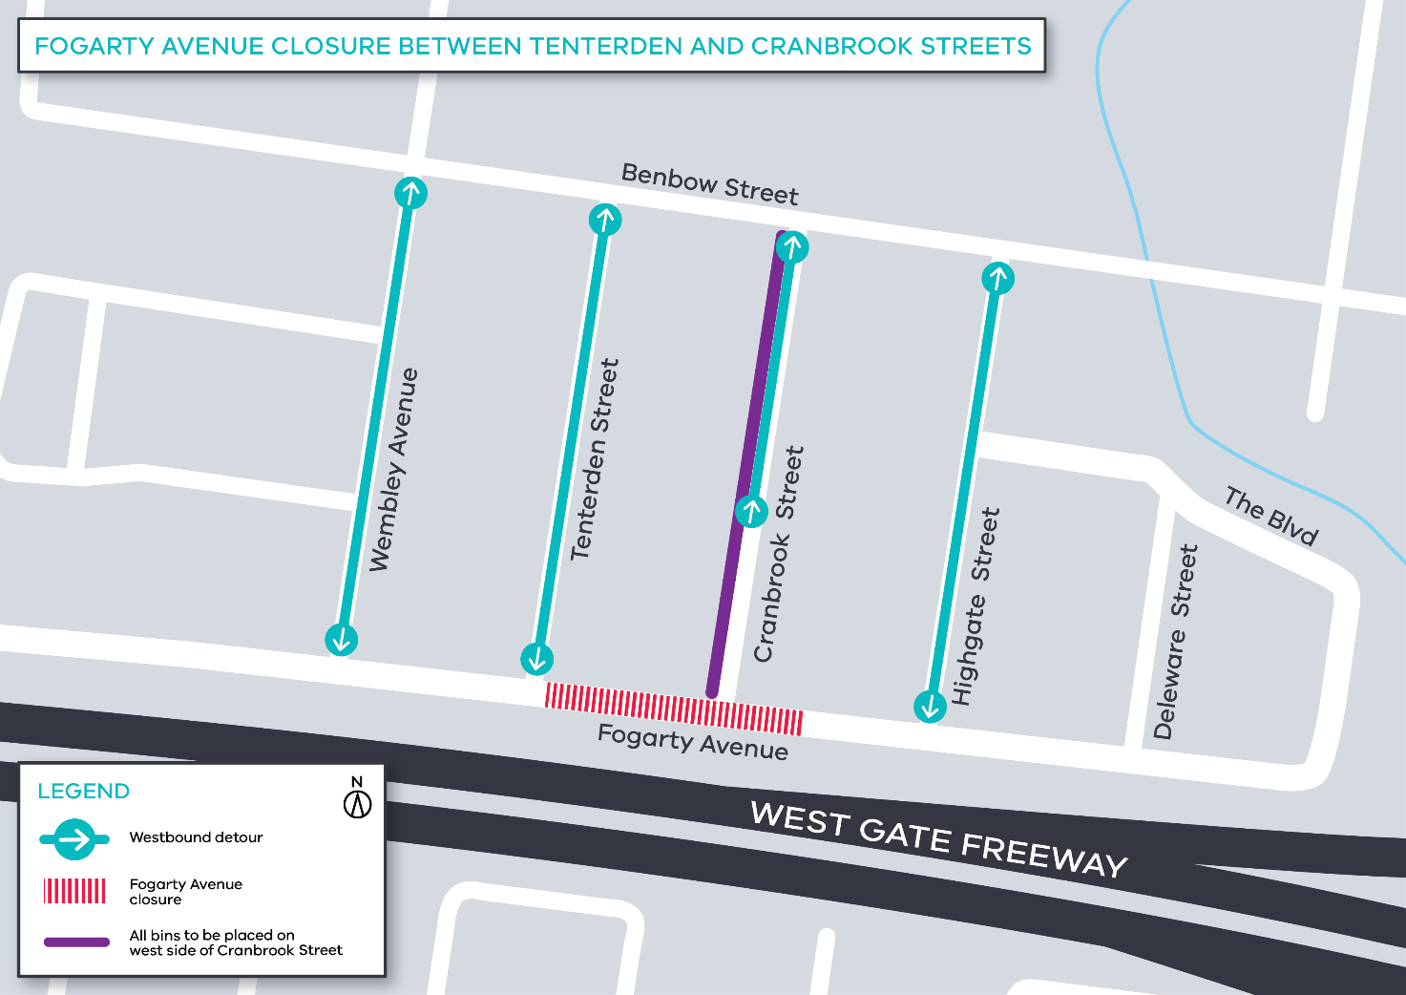

Please note that works may be rescheduled in the event of bad weather or other unavoidable circumstances.
For updates and more information about our works please visit westgatetunnel.vic.gov.au or contact us using the details below.

Contact us

Please contact us if you have any questions or feedback about these works.
westgatetunnelproject.vic.gov.au
westgatetunnelproject@wda.vic.gov.au
1800 105 105
facebook.com/westgatetunnelproject
@westgatetunnel
West Gate Tunnel Project
GPO Box 4509
Melbourne Victoria 3001
Interpreter service: 13 14 50

3 September 2018
Works update – temporary road closure

Construction has begun on Fogarty Avenue to safely relocate some existing power lines and install new drainage. As part of these works, Fogarty Avenue will be temporarily closed adjacent to your property.
Temporary closure of Fogarty Avenue
6 September to 13 September 2018
- vehicle access along Fogarty Avenue between Cranbrook Street and Tenterden Street will be temporarily blocked from 6 September to 13 September;
- driveway and footpath access will be maintained; and
- parking along sections of Fogarty Avenue will be temporarily unavailable during this time – please see the map below for location details.

Where to park your vehicle:
- ensure you do not park your vehicle on Fogarty Avenue between Cranbrook Street and Tenterden Street during the times above. Access will be blocked and you will be unable to access your vehicle; and
- it is recommended that you park your vehicle on either Cranbrook Street or Tenterden Street for the duration of these works.
What you could expect:
- an increase in construction vehicles within the area;
- an increase in construction noise from our machinery and trucks;
- water spray trucks to help manage dust and dirt and covered loads when dirt and rock when are being transported; and
- traffic changes will be required and signed detours will be in place – latest traffic updates are available at www.westgatetunnelproject.vic.gov.au/traveldisruptions.

These works will generally be carried out from Monday to Friday between 7am - 6pm and Saturdays between 7am - 3pm, however some night works may be required.

When works are scheduled out of hours and may have a direct impact on you, we will provide further information to you before works start.

Please note that works may be rescheduled in the event of bad weather or other unavoidable circumstances.
For updates and more information about our works please visit westgatetunnel.vic.gov.au or contact us using the details below.

Contact us

Please contact us if you have any questions or feedback about these works.
westgatetunnelproject.vic.gov.au
westgatetunnelproject@wda.vic.gov.au
1800 105 105
facebook.com/westgatetunnelproject
@westgatetunnel
West Gate Tunnel Project
GPO Box 4509
Melbourne Victoria 3001
Interpreter service: 13 14 50

3 September 2018
Works update – temporary driveway disruption

Construction has begun on Fogarty Avenue to safely relocate some existing power lines and install new drainage. As part of these works, vehicle access to some driveways will be temporarily disrupted.
Temporary disruption to your driveway access
6 September to 13 September 2018
- vehicle access to driveways along Fogarty Avenue between Cranbrook Street and Tenterden Street will be temporarily blocked from 6 September to 13 September;
- work will progress from east to west along this section i.e. towards McIvor Reserve. We will make direct contact with you within two days to confirm your driveway closure date;
- footpath access to your property will remain;
- if you require your vehicle during this time, please ensure it is moved out of your driveway before your closure date; and
- parking along sections of Fogarty Avenue will also be temporarily unavailable during this time – please see the map below for location details.

If you require any assistance with carrying items to or from your vehicle, please ask one of our onsite team, they will be able to assist you.

When you need to move your vehicle:
- if you need access to your vehicle between 6 September to 13 September then please ensure your vehicle is moved out your driveway by 7am on your advised driveway closure date.

Where to park your vehicle:
- it is recommended that you park your vehicle on either Cranbrook Street or Tenterden Street for the duration of these works; and
- ensure you do not park your vehicle on Fogarty Avenue between Cranbrook Street and Tenterden Street during the times above. Access will be blocked and you will be unable to access your vehicle.
Waste collection:
- place rubbish bins on the west side of Cranbrook Street. Bins placed on the east side of these streets may not be emptied – please see the map below for location details.

What you could expect:
- an increase in construction vehicles within the area;
- an increase in construction noise from our machinery and trucks;
- water spray trucks to help manage dust and dirt and covered loads when dirt and rock when are being transported; and
- traffic changes will be required and signed detours will be in place – latest traffic updates are available at www.westgatetunnelproject.vic.gov.au/traveldisruptions.

These works will generally be carried out from Monday to Friday between 7am - 6pm and Saturdays between 7am - 3pm, however some night works may be required.

When works are scheduled out of hours and may have a direct impact on you, we will provide further information to you before works start.

Please note that works may be rescheduled in the event of bad weather or other unavoidable circumstances.
For updates and more information about our works please visit westgatetunnel.vic.gov.au or contact us using the details below.
Contact us

Please contact us if you have any questions or feedback about these works.
westgatetunnelproject.vic.gov.au
westgatetunnelproject@wda.vic.gov.au
1800 105 105
facebook.com/westgatetunnelproject
@westgatetunnel
West Gate Tunnel Project
GPO Box 4509
Melbourne Victoria 3001
Interpreter service: 13 14 50

Reference: WES1808.01
20 August 2018
Works update – temporary driveway disruption

Construction has begun on Fogarty Avenue to safely relocate some existing power lines and install new drainage. As part of these works, vehicle access to some driveways will be temporarily disrupted.
Temporary disruption to your driveway access
27 August to 1 September 2018
- vehicle access to driveways along Fogarty Avenue between Deleware Street and Cranbrook Street will be temporarily blocked from 27 August to 1 September;
- work will progress from east to west along this section i.e. towards McIvor Reserve. We will make direct contact with you within two days to confirm your driveway closure date;
- footpath access to your property will remain;
- if you require your vehicle during this time, please ensure it is moved out of your driveway before your closure date; and
- parking along sections of Fogarty Avenue will also be temporarily unavailable during this time – please see the map below for location details.

If you require any assistance with carrying items to or from your vehicle, please ask one of our onsite team, they will be able to assist you.

When you need to move your vehicle:
- if you need access to your vehicle between 27 August to 1 September then please ensure your vehicle is moved out your driveway by 7am on your advised driveway closure date.

Where to park your vehicle:
- it is recommended that you park your vehicle on either Deleware Street, Highgate Street or Cranbrook Street for the duration of these works; and
- ensure you do not park your vehicle on Fogarty Avenue between Deleware Street and Cranbrook Street during the times above. Access will be blocked and you will be unable to access your vehicle.
Waste collection:
- place rubbish bins on the west side of Highgate Street. Bins placed on the east side of these streets may not be emptied – please see the map below for location details.

What you could expect:
- an increase in construction vehicles within the area;
- an increase in construction noise from our machinery and trucks;
- water spray trucks to help manage dust and dirt and covered loads when dirt and rock when are being transported; and
- traffic changes will be required and signed detours will be in place – latest traffic updates are available at westgatetunnelproject.vic.gov.au/traveldisruptions.

These works will generally be carried out from Monday to Friday between 7am - 6pm and Saturdays between 7am - 3pm, however some night works may be required.

When works are scheduled out of hours and may have a direct impact on you, we will provide further information to you before works start.

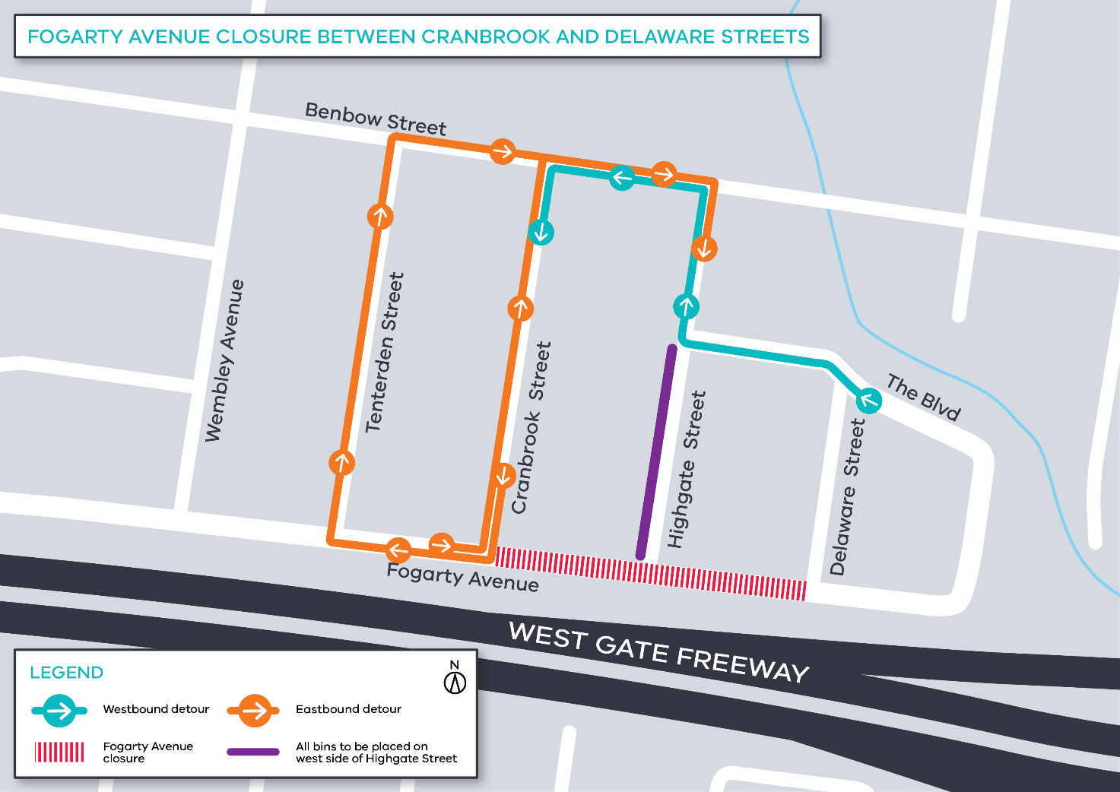
Please note that works may be rescheduled in the event of bad weather or other unavoidable circumstances.
For updates and more information about our works please visit westgatetunnel.vic.gov.au or contact us using the details below.
Contact us
Please contact us if you have any questions or feedback about these works.
 | westgatetunnelproject.vic.gov.au |  | facebook.com/westgatetunnelproject
 | westgatetunnelproject@wda.vic.gov.au |  | @westgatetunnel
 | 1800 105 105 |  | West Gate Tunnel Project  GPO Box 4509  Melbourne Victoria 3001
 | Interpreter service: 13 14 50

Reference: WES1808.01
20 August 2018
Works update – temporary road closure

Construction has begun on Fogarty Avenue to safely relocate some existing power lines and install new drainage. As part of these works, Fogarty Avenue will be temporarily closed adjacent to your property.
Temporary closure of Fogarty Avenue
27 August to 1 September 2018
- vehicle access along Fogarty Avenue between Deleware Street and Cranbrook Street will be temporarily blocked from 27 August to 1 September;
- driveway and footpath access will be maintained; and
- parking along sections of Fogarty Avenue will be temporarily unavailable during this time – please see the map below for location details.

Where to park your vehicle:
- ensure you do not park your vehicle on Fogarty Avenue between Deleware Street and Cranbrook Street during the times above. Access will be blocked and you will be unable to access your vehicle; and
- it is recommended that you park your vehicle on either Deleware Street, Highgate Street or Cranbrook Street for the duration of these works.
What you could expect:
- an increase in construction vehicles within the area;
- an increase in construction noise from our machinery and trucks;
- water spray trucks to help manage dust and dirt and covered loads when dirt and rock when are being transported; and
- traffic changes will be required and signed detours will be in place – latest traffic updates are available at westgatetunnelproject.vic.gov.au/traveldisruptions

These works will generally be carried out from Monday to Friday between 7am - 6pm and Saturdays between 7am - 3pm, however some night works may be required.

When works are scheduled out of hours and may have a direct impact on you, we will provide further information to you before works start.

Please note that works may be rescheduled in the event of bad weather or other unavoidable circumstances.

For updates and more information about our works please visit westgatetunnel.vic.gov.au or contact us using the details below.

Contact us
Please contact us if you have any questions or feedback about these works.
 | westgatetunnelproject.vic.gov.au |  | facebook.com/westgatetunnelproject
 | westgatetunnelproject@wda.vic.gov.au |  | @westgatetunnel
 | 1800 105 105 |  | West Gate Tunnel Project  GPO Box 4509  Melbourne Victoria 3001
 | Interpreter service: 13 14 50

Reference: WES1808.01
20 August 2018
Works update – temporary disruptions

Construction has begun on Fogarty Avenue to safely relocate some existing power lines and install new drainage. As part of these works, Fogarty Avenue will be temporarily closed at the intersection of your street.
Temporary closure of Fogarty Avenue
27 August to 1 September 2018

- Fogarty Avenue will be closed between Deleware and Cranbrook Streets from 27 August to 1 September;
- driveway and footpath access will be maintained;
- a local detour will be in place during this time; and
- parking along sections of Fogarty Avenue will be unavailable during this time – please see the map below for location details.

Waste collection:
- closure of Highgate Street and Fogarty Avenue intersection will limit access for waste collection trucks; and
- place rubbish bins on the west side of Highgate Street for collection from 27 August to 1 September – please see the map below for location details.

What you could expect:
- an increase in construction vehicles within the area;
- an increase in construction noise from our machinery and trucks;
- water spray trucks to help manage dust and dirt and covered loads when dirt and rock when are being transported; and
- traffic changes will be required and signed detours will be in place – latest traffic updates are available at westgatetunnelproject.vic.gov.au/traveldisruptions

These works will generally be carried out from Monday to Friday between 7am - 6pm and Saturdays between 7am - 3pm, however some night works may be required.

When works are scheduled out of hours and may have a direct impact on you, we will provide further information to you before works start.

Please note that works may be rescheduled in the event of bad weather or other unavoidable circumstances.
For updates and more information about our works please visit westgatetunnel.vic.gov.au or contact us using the details below.

Contact us
Please contact us if you have any questions or feedback about these works.
 | westgatetunnelproject.vic.gov.au |  | facebook.com/westgatetunnelproject
 | westgatetunnelproject@wda.vic.gov.au |  | @westgatetunnel
 | 1800 105 105 |  | West Gate Tunnel Project  GPO Box 4509  Melbourne Victoria 3001
 | Interpreter service: 13 14 50

