WES1902.01

5 February 2019

Works notification: Cullen Court, Spotswood
As part of the West Gate Tunnel Project we’re diverting a large sewer pipe that runs underneath the West Gate Freeway.

We’ve started works at the Melbourne Road compound and will soon begin using specialist equipment to dig and build the new sewer pipe underground from the compound towards the end of Cullen Court.

A summary of what the works are and what you can expect are outlined below.

Sewer diversion - end of Cullen Court
7 February to early March 2019
These works will be completed during the day and include:
- installation of traffic barriers and site fencing at the end of Cullen Court;
- excavating a section of the road within the construction site, which will include rock breaking;
- retrieving the specialist equipment (pipe-jack) from the excavated area;
- constructing a manhole shaft to allow future access to the sewer pipe; and
- reinstating the road to safely and securely cover the manhole shaft.

Waste collection service changes
Residents of Cullen Court are asked to please place their bins on the east side of the court from 7 February (see map over page) until early March. We will provide an update prior to works being completed.
The waste collection services for garbage, recycling and green waste have advised they will reverse their trucks into the court. .

What to expect on Cullen Court during these works:
- the end of Cullen Court will be closed to vehicle access, with pedestrian access still maintained to all properties;
- emergency services vehicles will have access to Cullen Court at all times;
- there will be a temporary planned disruption to water services. Further notification will be provided by City West Water closer to the confirmed date. This disruption is not expected to last longer than one day;
- noise from our works during the day from 7am to 6pm, including breaking rock and concrete;
- construction vehicles will be entering and exiting the construction site from the Melbourne Road compound via the end of Cullen Court;
- water spray trucks will be used to manage dust and dirt during the works and trucks removing dirt and rock from the site will be covered; and
- the construction site will be monitored as part of ongoing security across the project area.

See map below for work location details
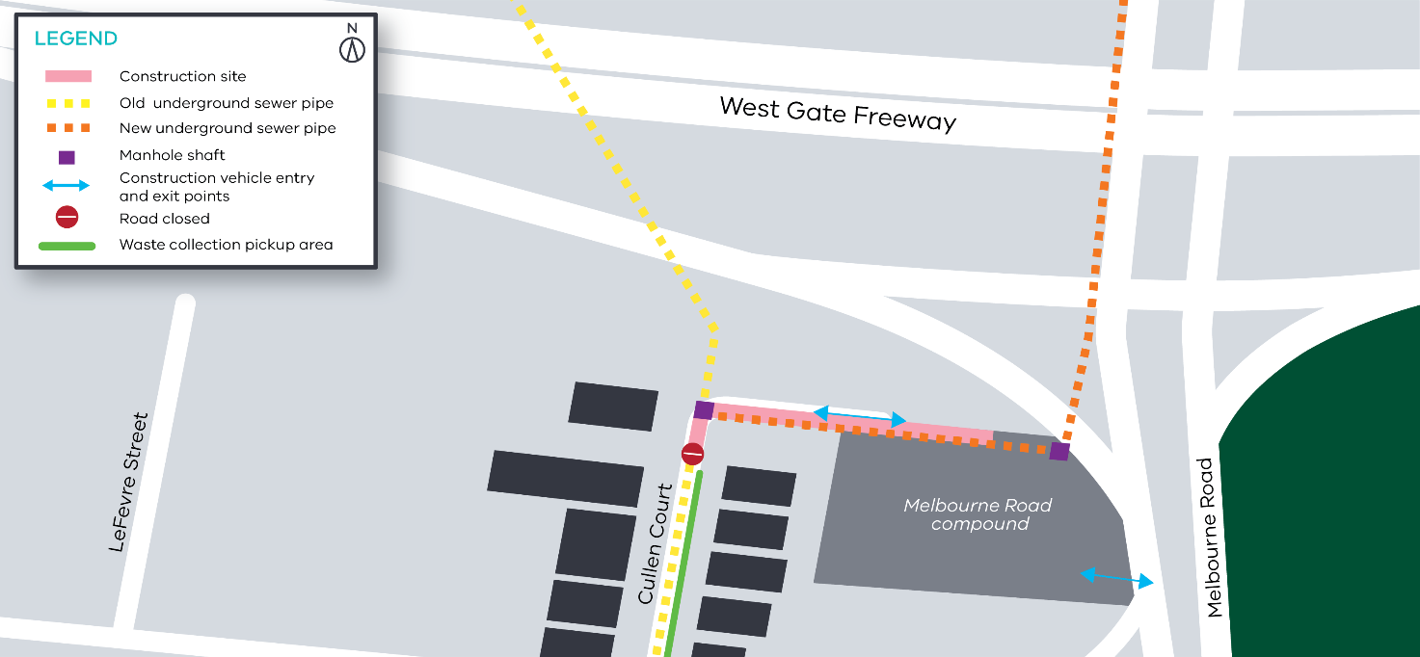

Contact us
Please contact us if you have any questions or feedback about these works.
westgatetunnelproject.vic.gov.au
info@wgta.vic.gov.au
1800 105 105
facebook.com/westgatetunnelproject
@westgatetunnel
West Gate Tunnel Project
GPO Box 4509
Melbourne Victoria 3001
Interpreter service: 13 14 50

Please note that works may be rescheduled in the event of bad weather or other unavoidable circumstances.

