WES1909.02
25 September 2019

Works update – short term daytime closure of Paringa Road
Wednesday 9 October to Friday 11 October
We are building new retaining walls to allow for widening of the Millers Road outbound entry ramp. To do this safely we need to close Paringa Road between Chambers Road and Langshaw Street during the day between 7am and 6pm on the days above.
The closure will allow a crane to safely lift retaining wall panels over the temporary noise walls on Paringa Road into our worksite on the freeway.
The crane will arrive on site at 7am and the panels will be installed during the day. The crane will be removed by 6pm each night. Footpath access will be maintained.
This means that between 7am and 6pm each day, residents will not have access to their driveways. If you wish to use your vehicle during this time please park it on one of the side streets before 7am each morning.
When:
- 7am to 6pm daily, from Wednesday 9 October to Friday 11 October, inclusive.

Waste collection changes for Wednesday 9 October:
- please place your rubbish bins in Chambers Road, Bond Street, Lee Street or Langshaw Street on the east side (the Millers Road side) so they can be collected by the waste contractor
- please ensure your bin is moved to this location by 11pm on Tuesday night for collection early on Wednesday morning.

Where
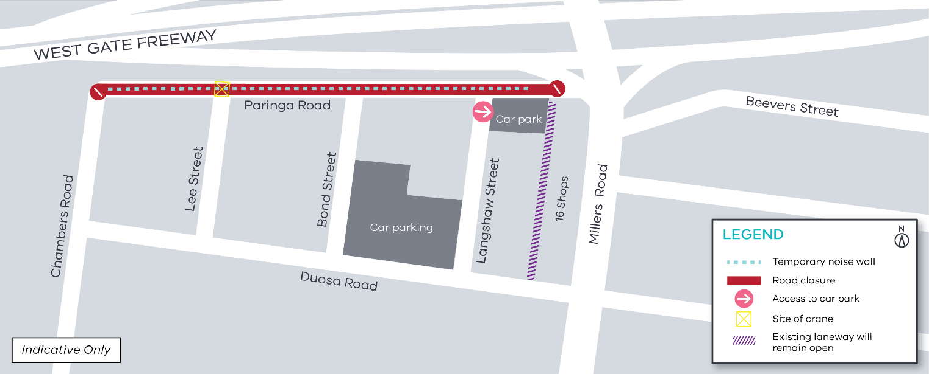
What to be aware of:
- the work will involve truck movements and crane operations. The crane will lift concrete panels over the temporary barriers into our work site
- footpath access to your property and along Paringa Road will be maintained, and pedestrians will be escorted through the lifting zone when panels are being lifted into position
- the carpark behind the 16 shops will remain open during this closure, with access from Langshaw Street.

Please note that works may be rescheduled in the event of bad weather or other unavoidable circumstances.
For updates and more information about our works please visit westgatetunnelproject.vic.gov.au or contact us using the details below.

The latest traffic updates are available at westgatetunnelproject.vic.gov.au/traveldisruptions
Contact us
Please contact us if you have any questions or feedback about these works.
 | westgatetunnelproject.vic.gov.au |  | facebook.com/westgatetunnelproject
 | info@wgta.vic.gov.au |  | @westgatetunnel
 | 1800 105 105 |  | West Gate Tunnel Project  GPO Box 4509, Melbourne VIC 3001
 | Interpreter service: 13 14 50

