WES2001.06
13 January 2020

Works notification: Fogarty Avenue, Williamstown Road to Newport Rail

Construction is continuing along Fogarty Avenue and the West Gate Freeway from Newport Rail Bridge to Williamstown Road, including drainage, powerline relocations, sewer replacement and installation of noise wall panels.
While these works will continue throughout 2020 and 2021, below is a summary of what you can expect to see in the area from January to April 2020, including:
- Fogarty Avenue drainage and widening works;
- Fogarty Avenue community information session;
- Wembley Avenue powerline relocation;
- Newport Rail Bridge works;
- Williamstown Road sewer pipe diversion; and
- Works at the West Gate Freeway/Williamstown Road interchange
Advance notice will be provided for noisy works likely to impact residents.

Fogarty Avenue drainage and widening works

Find out more about what is happening along Fogarty Avenue
We know that the works along Fogarty Avenue have been disruptive and appreciate the patience you have had with us.
Once we complete these drainage works, we will be able to continue with completing installation of new noise walls, building the Federation Trail extension and new planting.
To help get a better understanding of what is happening in your neighbourhood, both in the short and long-term, we are hosting a neighbourhood pop-up on Saturday 18 January, at McIvor Reserve from 10:00am to 1:00pm.
13 January – early March 2020
As notified earlier, we need to come back and complete the drainage works at the Fogarty Avenue and Wembley Avenue intersection. These works will commence on Monday, January 13 and are expected to be completed by early March 2020. During this time there will also be night works along Fogarty Avenue, across the Footscray Hockey Club, for widening works.
This means the through connection via The Avenue will be closed from 13 January and will reopen to traffic in early March 2020.
These works will include:
- excavating a section of road along Fogarty Avenue, near Wembley Avenue;
- installing new drainage pipes;
- reinstating the road;
- placing fill and material to build new pavement; and
- concrete works to build new retaining and noise walls.
Where these works will impact access to residential driveways, we will contact residents directly.

Fogarty/Wembley Avenue powerline relocations
Late February – April 2020
Work is also continuing at the Fogarty Avenue and Wembley Avenue intersection to relocate overhead power lines underground from late February to April 2020.
The southern end of Wembley Avenue (between Mills and Fogarty Avenue) is required to be closed during these works. From early March, local traffic will be able to access their properties via The Avenue, Fogarty Avenue and Tenterden Street while these works are underway. Please see the map for details.
These works will include:
- excavating a section of road at the Fogarty Avenue and Wembley Avenue intersection;
- boring a small tunnel deep underground, from Wembley Avenue to the south side of the freeway;
- relocating power lines underground; and
- reinstating the road.
Night works may be required and advance notice will be provided for noisy works.

Traffic changes to Fogarty Avenue and The Avenue
Due to drainage works on Fogarty Avenue, the through connection via The Avenue will be closed from 13 January and will reopen to traffic in early March 2020.
Once this connection is open, local traffic will be able to use The Avenue to access the south and north sides of the freeway. Traffic management will continue to be in place on The Avenue and underneath Newport Rail Bridge, throughout 2020 and 2021.
This section of road will also experience continued intermittent road closures during this time. Please visit westgatetunnelproject.vic.gov.au for road closure dates. You can also subscribe to weekly traffic alerts by emailing us at info@wgta.vic.gov.au.
Changes to bus route 432 are still in place and will continue in the first half of 2020. More information can be found on Public Transport Victoria’s website at www.ptv.vic.gov.au/live-travel-updates.

Newport Rail Bridge works
13 January – ongoing
Construction is well underway to widen Newport Rail Bridge and the freeway, and will continue from 13 January 2020. These works will include:
- removing barriers from the freeway centre median;
- installing bridge beams;
- replacing bridge bearings;
- removing concrete on the bridge using a high-pressure water jet; and
- pouring concrete to form the bridge deck.
We’re also continuing to build a new bridge near The Avenue, which will become part of new separated lanes for drivers heading outbound. These works will include piling works for bridge piers and construction bridge piers.
Night works will be required from January through to April. Advance notice will be provided for noisy works – notably when we have to use high-pressure water jets to remove concrete.

Williamstown Road sewer pipe diversion

Asbestos removal
We are currently undertaking asbestos removal works as part of the West Gate Tunnel Project.

Reserve at east end of Fogarty Avenue
During January and February, we will be safely removing asbestos in the reserve, east of Fogarty Avenue. A temporary road closure at Fogarty Avenue and The Boulevard intersection will be in place during this time.
The removal works are to be undertaken by an appropriately licensed asbestos removal contractor licensed by Worksafe Victoria.
The removal works are also being undertaken with the supervision of a qualified hygienist in accordance with the Victorian Occupation Health and Safety Regulations with appropriate controls including air monitoring on the boundaries of the work area.

13 January – March 2020
Work is progressing to relocate a large underground sewer pipe, from the reserve at the east end of Fogarty Avenue to the Williamstown Road inbound exit ramp. These works will include:
- launching pipe-jacking equipment from the reserve;
- retrieving equipment at the Williamstown Road inbound exit ramp; and
- constructing and reinstating the manhole shaft to allow future access to the sewer pipe.
The shared use path connecting The Boulevard and Eirene Street will continue to remain closed. See the map for details. Night works will be required in January and February and advance notice will be provided for noisy works.

West Gate Freeway / Williamstown Road interchange
Early 2020
Installation of new noise wall panels along the Williamstown Road inbound exit ramp is underway, and will continue throughout early 2020. A small section of temporary noise wall is required to be removed at the east end of Fogarty Avenue, as part of drainage works.
We are also continuing to replace a water main pipe underneath the freeway, along Williamstown Road, which requires the pedestrian detour on the east side under the bridge. Once the water main pipe is replaced, work will start to widen the northbound carriageway, construct traffic islands, and install traffic lights and drainage.
Night works may be required and advance notice will be provided for noisy works.

What to expect during these works:
- work will be completed behind safety barriers;
- construction vehicles including excavators, piling rigs, water trucks and concrete trucks will be moving in and out of work areas via our access routes;
- increase in construction vehicles regularly using designated routes including local roads within residential areas. This will include light vehicles, heavy trucks, concrete trucks and delivery of large equipment;
- construction noise and intermittent localised vibration from our construction site;
- there will be no vibration and noise impacts from pipe-jacking the new sewer pipe as the work will take place deep underground;
- water spray trucks and street sweepers will be used to manage dust and dirt and trucks carrying dirt and rock will be covered;
- the construction site will be monitored as part of ongoing security across the project area; and
- traffic changes will be required and signed detours will be in place – latest traffic updates are available at westgatetunnelproject.vic.gov.au/disruptions.

Map of upcoming works:
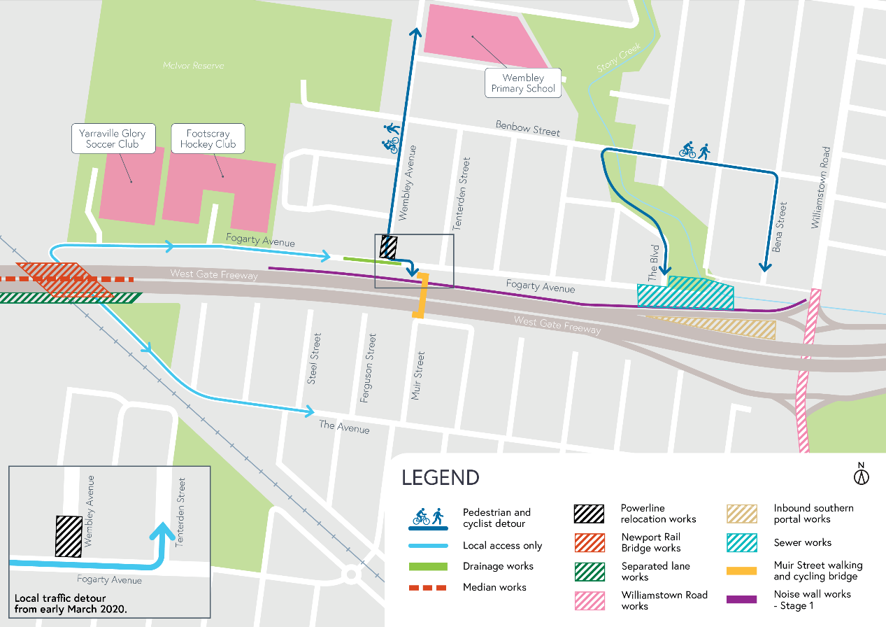

Day works will be carried out Monday to Friday between 7am - 6pm and Saturdays between 7am - 1pm.

Please note that works are subject to change and may be rescheduled in the event of unexpected impacts to the construction program.

Thank you for your patience during these works.

