30 September 2020 WES2009.03

Works notification: Newport Rail Bridge
We are continuing to widen and strengthen the bridge over Newport Rail to build the new lanes.
Upcoming works include lifting and installing new barriers onto the bridge and pouring concrete to connect the barriers to the bridge surface. This will require the closure of The Avenue under the freeway for approximately two weeks.

Barrier installation and concrete pour

Mid to late October 2020
To safely lift and install the new barriers on to the bridge, we will need to close a section of The Avenue to vehicles from mid-October for approximately two weeks. We will send a reminder closer to the date. During this time, local traffic will be able to access the south and north sides of the freeway via Williamstown Road with signed detours in place.
The footpath underneath the bridge will remain open, with a localised diversion in place to safely detour pedestrians and cyclists around the works.
The community shuttle bus will also detour via Williamstown Road during this time, with the bus stop outside the Footscray Hockey Club closed while these works take place.

What to expect during these works:
- work will be completed during the day and behind safety barriers
- construction vehicles including cranes, delivery trucks and concrete trucks will be moving in and out of the work areas via designated routes
- construction noise from work activities including machinery and trucks
- construction vehicles continuing to use designated routes, including local roads, within residential areas
- traffic changes including road closures will be required. Signed detours will be in place.

For the latest traffic updates visit westgatetunnelproject.vic.gov.au/traveldisruptions.
Works area
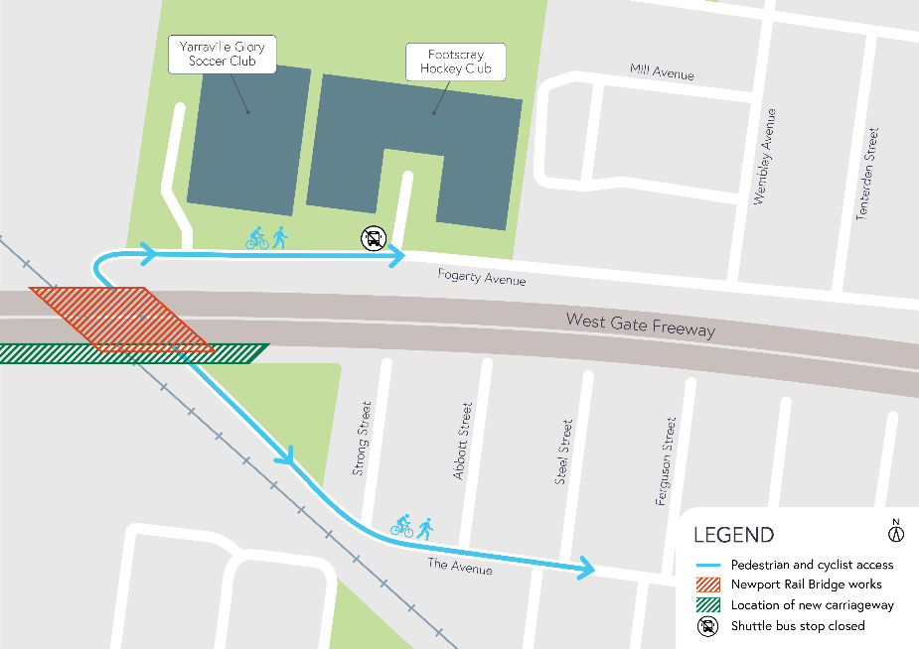

COVID-19 update
The health and safety of our workers is our key priority as we continue to deliver the West Gate Tunnel Project, as is supporting social distancing and the wearing of masks in line with current health advice. We have strict protocols in place to protect the safety of our construction workforce and the community. These include enhanced industrial cleaning arrangements, and measures to reduce staff contact, including staggered shifts and physical distancing. For more information and advice about Coronavirus, please visit coronavirus.vic.gov.au.

Thank you
We appreciate our work can be disruptive and thank you for your understanding and cooperation, particularly during these unprecedented and challenging times.

Please note that works are subject to change and may be rescheduled in the event of unexpected impacts to the construction program. Thank you for your patience during these works.

For updates and more information about our works, please visit westgatetunnelproject.vic.gov.au or call us on 1800 105 105.

