30 July 2020 WES2007.02

Works notification: Temporary traffic changes on Fogarty Avenue
Work is continuing on Fogarty Avenue to connect new drainage pipes into the West Gate Freeway system. As part of these works, one lane on Fogarty Avenue will be temporarily closed in sections between the Footscray Hockey Club and Wembley Avenue.
A stop/go arrangement will be in place so vehicles will be able to travel through Fogarty Avenue, one direction at a time. Access to residential driveways will remain available at all times during these works.

Fogarty Avenue drainage traffic changes
Early August 2020 until late August 2020
- traffic will be reduced to one lane between 228 Fogarty Avenue and 220 Fogarty Avenue from early August to mid August
- traffic will be reduced to one lane between 218 Fogarty Avenue and 102 Wembley Avenue from mid August to late August
- footpath access will be maintained
- property access will be maintained
- waste collection will also be maintained
- parking along sections of Fogarty Avenue will be temporarily unavailable during this time – please see the map below for location details.

Fogarty Avenue longer-term traffic changes

Please note that Fogarty Avenue will also be closed between Wembley Avenue and Tenterden Street from early August until late 2020, as we continue to build the ramp for the new pedestrian overpass. See map for location details.
We thank you for your patience while we complete these works.

Where to park your vehicle:
- please you do not park your vehicle on Fogarty Avenue in the following locations and times. Access will be blocked and you will be unable to access your vehicle.
  - 228 Fogarty Avenue to 220 Fogarty Avenue from early August to mid August 2020
  - 218 Fogarty Avenue to 102 Wembley Avenue from mid August to late August 2020
- we recommend that you park your vehicle along the remaining sections of Fogarty Avenue or other nearby local roads during these works.

Noise wall panel removal
- In order to safely undertake these works, we need to remove sections of the existing noise wall and replace with a temporary barrier, adjacent to the work areas – please see the map below for location details. New noise wall panels are expected to be installed following completion of these works.

What you could expect:
- an increase in the number of construction vehicles in the area
- an increase in construction noise from our machinery and trucks
- water spray trucks to help manage dust and dirt and covered loads when dirt and rock when are being transported
- traffic changes will be required and signed detours will be in place – latest traffic updates are available at www.westgatetunnelproject.vic.gov.au/traveldisruptions.

Works area
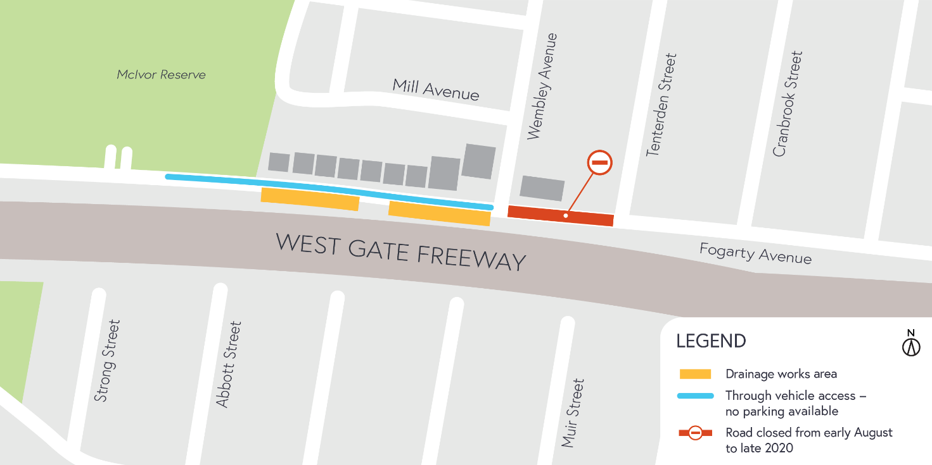

Hours of work

These works will generally be carried out from Monday to Friday between 7am - 6pm and Saturdays between
7am - 1pm, however some night works may be required. When works are scheduled out of hours and may have a direct impact on you, we will provide further information to you before works start.
Coronavirus COVID-19 update

The health and safety of our workers is our key priority as we continue to deliver the West Gate Tunnel Project, as is supporting social distancing measures in line with current health advice. We have strict protocols in place to protect the safety of our construction workforce and the community. These include enhanced industrial cleaning arrangements, and measures to reduce staff contact, including staggered shifts and physical distancing. For more information and advice about Coronavirus, please visit coronavirus.vic.gov.au.
For updates and more information about our works, please visit westgatetunnelproject.vic.gov.au or call us on 1800 105 105.
Please note that works may be rescheduled in the event of bad weather or unexpected impacts to the construction program.

