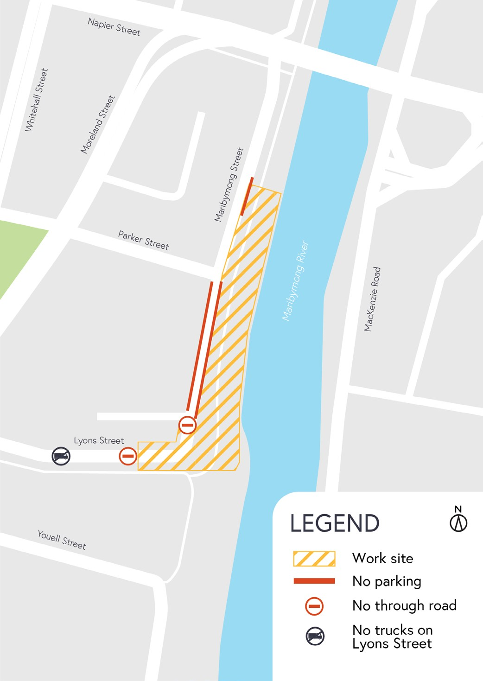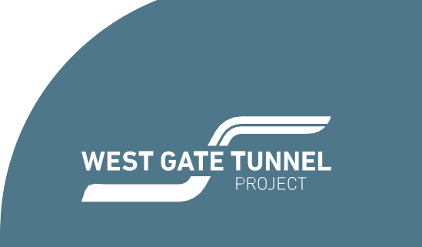

February 2020

Works notification: Maribyrnong River
Works to construct the new bridges across the Maribyrnong River, linking the West Gate Tunnel to the elevated roadway above Footscray Road continue. This notification details what to expect over the next few months.

Changes to Maribyrnong Street
To build the new bridges over the Maribyrnong River, there will be changes made to Maribyrnong Street during the construction process.
A new long-term traffic set up along Maribyrnong Street from March 2020 will include:
- removal of car parks on Maribyrnong Street, south of Parker Street
- truncation of Maribyrnong and Lyons Streets.

This means vehicles will no longer be able to drive from Maribyrnong Street to Lyons Street or walk between the two.
The truncation is part of the permanent design of the area to accommodate the new Maribyrnong River bridges and access to the tunnel.
Once the new traffic arrangement is in place, construction of a crane pad and laydown area will be ongoing within the worksite.
Works are planned to take place between Mondays and Saturdays, 7am to 5pm. Night works will be advised as required.
From mid-2020, large bridge girders will be arriving for installation. Additional traffic changes in the area will be required for these works. More information will be provided closer to the date.

Piling works and pier construction on Maribyrnong River banks
River bank piling works, and pier construction will continue on both sides of the Maribyrnong River for approximately six months. Piling works are taking place along Mackenzie Road and will start on the west bank of the Maribyrnong River between Lyons Street and Youell Street from March 2020.
Works are planned to take place between Mondays and Saturdays, 7am to 5pm.

Utility relocations
Utility works continue within the area including power relocation and gas works in Youell and Whitehall Streets, which will be ongoing from February to April.
These works will be staged and delivered using a combination of open trenching and cable installation. These works will be delivered by the utility providers’ preferred contractors and supported by the Project team.
Works have been scheduled to take place during day and night to minimise impact to the community. Further notification will be provided for night works.
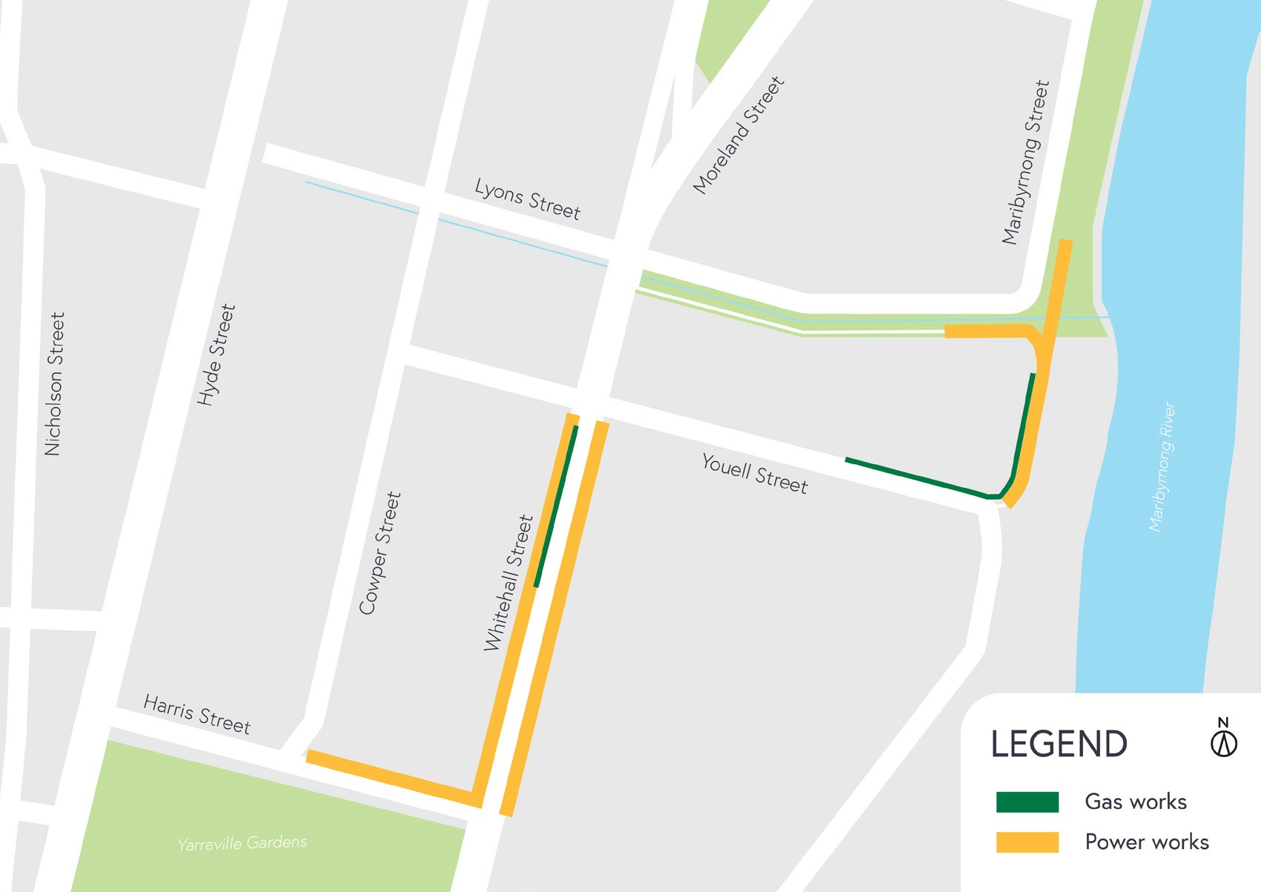

What to expect during construction
- We will notify you if there are any significant changes to the timing of our works.
- Traffic management will be in place to manage changed conditions including temporary access, changes to car parking spaces and signage to guide road users and cyclists.
- Dust will be managed on site.
- Some construction activities can create increased levels of noise and vibration.
Assessments have been conducted, which indicate the noise and vibration levels are expected to remain within permissible levels as documented in the project’s Environmental Performance Requirements.

We thank you for your patience during these works. We will continue to notify you as these works progress.

westgatetunnelproject.vic.gov.au info@wgta.vic.gov.au
1800 105 105
West Gate Tunnel Project Info Centre Corner of Somerville Rd and Whitehall St Yarraville VIC 3013

Follow us on social media Please contact us if you would like this
information in an accessible format.

Translation service – For languages other than English, please call 13 14 50.

Authorised by the Victorian Government, 1 Treasury Place, Melbourne

