Chapter 4
EES assessment framework

Chapter 4

EES assessment framework

Introduction
An assessment framework was developed for North East Link to ensure a consistent and transparent approach to the evaluation of potential impacts on the environment.
This chapter describes the components of the assessment framework and how they underpin the Environment Effects Statement (EES) process.

Overview of the EES assessment framework
The relationships between the components of the EES assessment framework are shown in Figure 4-1.
The key components of the assessment framework are:
- Legislation and policy and scoping requirements
- Assessment approach
- Project development
- Consultation.
The legislation and policy and the scoping requirements provide a foundation for the EES assessment. These requirements were used to determine the technical studies to be undertaken and the matters to be investigated.
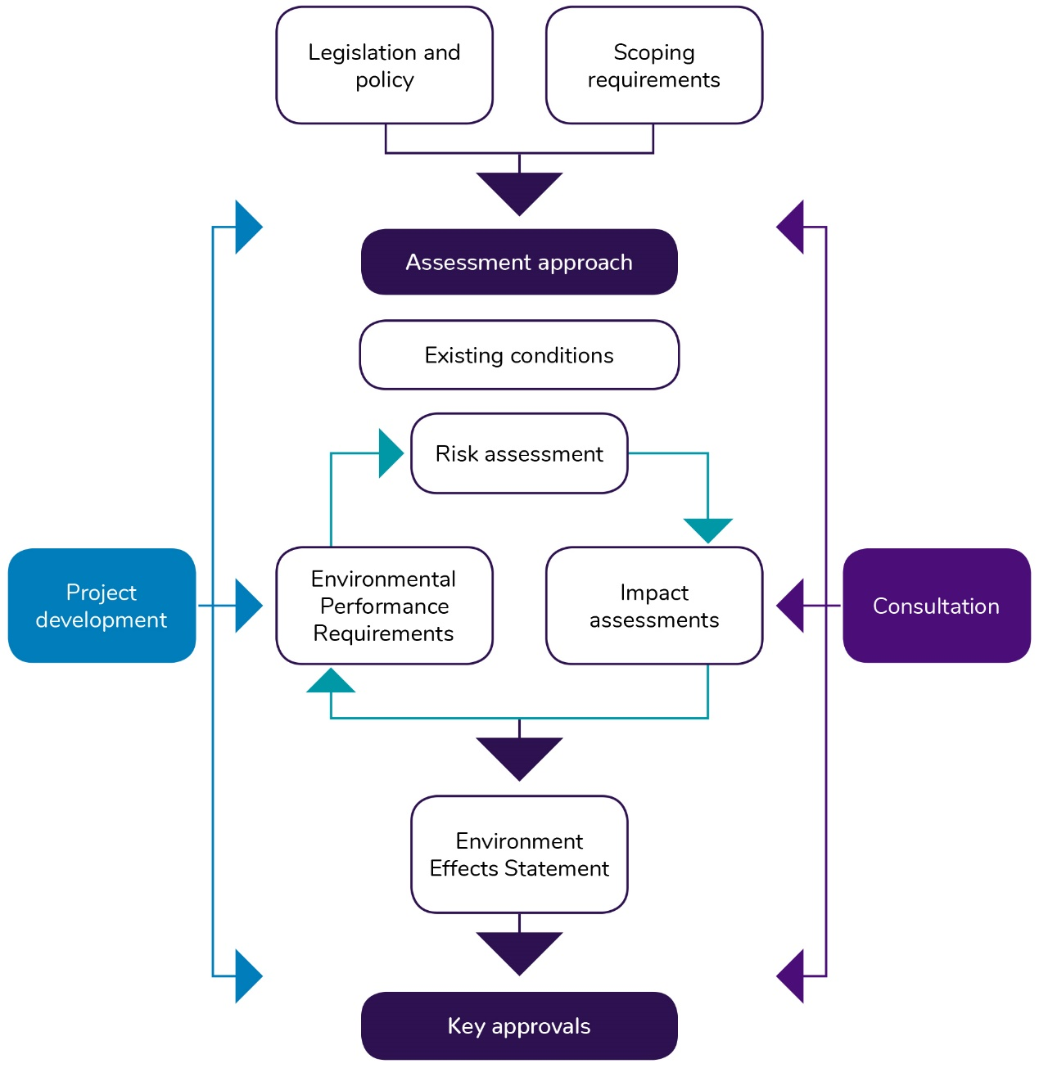
Figure 4-1 EES assessment framework

Project development and stakeholder consultation activities had strong links with the EES assessments undertaken. The technical studies informed and were informed by these activities.
Ultimately the outputs from the technical studies are brought together in the completed EES, which informs decisions on the key approvals being the Works Approval and the Planning Scheme Amendments, which are discussed further in Chapter 3 – Legislative framework.

Scoping requirements
The assessment framework responds to the applicable legislation and policy and the scoping requirements, incorporating the evaluation objectives. The evaluation objectives identify desired environmental outcomes for North East Link as established by the Minister for Planning.
Table 4-1 presents the North East Link evaluation objectives, corresponding legislation and locations of where each evaluation objective is addressed within the EES report, attachments and technical reports. This table only includes an overview of key legislation, which is detailed in Chapter 3 – Legislative framework. Further legislation and policy is described in each of the technical reports.
Chapter 27 – Environmental management framework (EMF) is relevant for all evaluation objectives as it provides a framework for managing and monitoring the environmental effects of North East Link and as such has not been included in Table 4-1.
Table 4-1 EES draft evaluation objectives and corresponding legislation
Evaluation objective | Key legislation | Relevant EES chapter, technical report and attachment
Transport capacity, connectivity and traffic management  To increase transport capacity and improve connectivity to, from and through the northeast of Melbourne, particularly freight movement via the freeway network instead of local and arterial roads, while managing the effects of the project on the broader and local road, public transport, cycling and pedestrian transport networks. | Road Management Act 2004 (Vic)  Transport Integration Act 2010 (Vic)  Planning and Environment Act 1987 (Vic) | Chapter 9 – Traffic and transport  Technical report A – Traffic and transport
Health, amenity and environmental quality  To minimise adverse air quality, noise and vibration effects on the health and amenity of nearby residents, local communities and road users during both construction and operation of the project. | Environment Protection Act 1970 (Vic)  Planning and Environment Act 1987 (Vic)  Transport Integration Act 2010 (Vic)  Public Health and Wellbeing Act 2008 (Vic) | Chapter 10 – Air quality  Chapter 11 – Surface noise and vibration  Chapter 12 – Tunnel vibration  Chapter 18 – Human health  Chapter 23 – Contamination and soil  Chapter 26 – Greenhouse gas  Technical report B – Air quality  Technical report C – Surface noise and vibration  Technical report D – Tunnel vibration  Technical report J – Human health  Technical report O – Contamination and soil  Technical report R – Greenhouse gas  Attachment VI – Works Approval
Social, business, land use and infrastructure  To manage effects of the project on land use and the social fabric of the community with regard to wellbeing, community cohesion, business functionality and access to goods, services and facilities. | Planning and Environment Act 1987 (Vic)  Transport Integration Act 2010 (Vic)  Public Health and Wellbeing Act 2008 (Vic)  Disability Discrimination Act 1992 | Chapter 13 – Land use planning  Chapter 14 – Business  Chapter 17 – Social  Technical report E – Land use planning  Technical report F – Business  Technical report I – Social  Attachment V – Draft Planning Scheme Amendment
Landscape, visual and recreational values  To minimise adverse effects on landscape values, visual amenity, recreational and open space values and to maximise the enhancement of these values where opportunities exist. | Planning and Environment Act 1987 (Vic) | Chapter 7 – Urban design  Chapter 15 – Arboriculture  Chapter 16 – Landscape and visual  Chapter 17 – Social  Technical report H – Landscape and visual  Technical report G – Arboriculture  Technical report I – Social Attachment II – Urban design strategy
Habitat and biodiversity  To avoid or minimise adverse effects on vegetation (including remnant, planted and regenerated) listed rare and threatened species and ecological communities, habitat for listed threatened species, listed migratory species and other protected flora and fauna, and address offset requirements for residual environmental effects, consistent with relevant State policies. | Flora and Fauna Guarantee Act 1988 (Vic)  Wildlife Act 1975 (Vic)  Catchment and Land Protection Act 1994 (Vic)  Planning and Environment Act 1987 (Vic) | Chapter 15 – Arboriculture  Chapter 25 – Ecology  Technical report G – Arboriculture  Technical report Q – Ecology
Cultural Heritage  To avoid or minimise adverse effects on Aboriginal and historical cultural heritage values. | Aboriginal Heritage Act 2006 (Vic)  Heritage Act 1995 (Vic)  Planning and Environment Act 1987 (Vic) | Chapter 19 – Historical heritage  Chapter 20 – Aboriginal cultural heritage  Technical report K – Historical heritage  Technical report L – Aboriginal cultural heritage
Land stability  To avoid or minimise adverse effects on land stability from project activities, including tunnel construction and river and creek crossings. | Planning and Environment Act 1987 (Vic)  Water Act 1989 (Vic) | Chapter 12 – Tunnel vibration  Chapter 21 – Ground movement  Chapter 24 – Surface water  Technical report D – Tunnel vibration  Technical report M – Ground movement  Technical report P – Surface water
Waste management  To manage excavated spoil and other waste streams generated by the project in accordance with the waste hierarchy and relevant best practice principles. | Environment Protection Act 1970 (Vic)  Chapter 23 – Contamination and soil | Technical report O – Contamination and soil
Catchment values  To avoid or minimise adverse effects on the interconnected surface water, groundwater and floodplain environments. | Environment Protection Act 1970 (Vic)  Yarra River Protection (Wilip-gin Birrarung murron) Act 2017 (Vic) | Water Act 1989 (Vic)  Chapter 22 – Groundwater  Chapter 24 – Surface water  Technical report N – Groundwater  Technical report P – Surface water
Greenhouse gases  To demonstrate that the project will contribute to the need for an effective, integrated and climate change-resilient transport system that provides a wide range of travel choices for all Victorians. | Transport Integration Act 2010 (Vic)  Environment Protection Act 1970 (Vic)  Planning and Environment Act 1987 (Vic)  Climate Change Act 2017 (Vic) | Chapter 26 – Greenhouse gas  Technical report R – Greenhouse gas  Attachment I – Sustainability approach

Assessment approach
Technical studies were undertaken to address the EES scoping requirements and demonstrate how each evaluation objective is met. The EES assessment has used a systematic risk-based approach to understanding the existing environment, the potential impact of the project on the environment and to evaluate the effectiveness of measures to avoid, minimise or manage risks and impacts.
This section describes the key steps in the development of the individual technical studies: establishing existing conditions, engaging with communities and stakeholders, undertaking a risk assessment, undertaking an impact assessment and forming Environmental Performance Requirements (EPRs) to set outcomes to be achieved through mitigation of potential risks and impacts.

Existing conditions
The assessment of the current condition of the environment is called an existing conditions assessment. An existing conditions assessment identifies the environmental context for North East Link and provides the baseline conditions for the impact assessment. It includes identifying and characterising the significance of existing assets, values and uses that could be affected by the project. Each of the 18 technical studies completed for this EES undertook an existing conditions assessment, which collectively provides the environmental context for the project.
The geographic area for each assessment differed for each technical study to reflect differences in the extent of risks and impacts for each discipline. In some cases, this area extends beyond the project boundary described in Chapter 8 – Project description. For example, the existing conditions assessment for surface water considered the current quality of streams and rivers around the construction footprint, including Koonung Creek, Yarra River, Banyule Creek, Yando Main Drain and Merri Creek which are well beyond the project boundary.
The existing conditions for each of the technical studies are summarised in Chapters 9–26 and detailed in Technical reports A–R.

Risk assessment
An environmental risk assessment was conducted for North East Link using an approach consistent with AS/NZS ISO 31000:2009 Risk Management Principles and guidelines. This is an Australian standard that provides guidance on managing risk faced by organisations.
The risk management process for North East Link adopted involved risk identification, risk analysis, risk evaluation and risk treatment. The full risk method for North East Link is described in Attachment III – Risk report.
The following tasks were undertaken to identify, analyse and evaluate risks:
- Develop likelihood and consequence criteria and a risk matrix
- Use existing conditions and identify applicable legislation and policy to establish the context for the risk assessment
- Consider construction and operational activities in the context of existing conditions to determine risk pathways
- Identify standard controls and requirements (EPRs) to mitigate identified risks
- Assign likelihood and consequence ratings for each risk to determine risk ratings considering design, proposed activities and standard EPRs.
While there are clear steps in the risk process, it does not follow a linear progression and requires multiple iterations of risk ratings, pathways and EPRs as the technical assessments progress. Demonstrating this evolution, a set of initial and residual risk ratings and EPRs are produced for all technical reports which are presented in Attachment III – Risk report.

Definition of risk and impact
The EES assessment differentiates between risks and impacts as follows:
- A risk is the function of the likelihood of an adverse event occurring and the potential consequences of the event
- An impact relates to the outcome of an event in relation to an asset, value or use.

Rating risk
Risk ratings were assessed by considering the likelihood and consequence of an event occurring. In assessing the consequence, the extent, severity and duration of the risks were considered.
This process is presented in Figure 4-2 and discussed below.
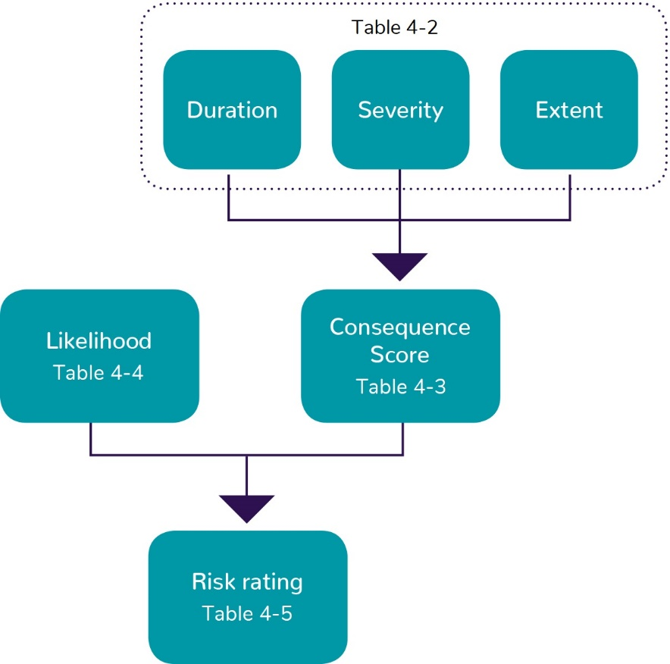
Figure 4-2 Assessing risk ratings

Assigning the consequences of risks
‘Consequence’ refers to the maximum credible outcome of an event affecting an asset, value or use. Consequence criteria are presented in Table 4-2 and have been developed for the North East Link EES in the form of whole of EES criteria rather than discipline specific criteria to enable a consistent assessment of consequence across the range of potential environmental effects. Consequence criteria were assigned based on the maximum credible consequence of the risk pathway occurring. Where there was uncertainty or incomplete information, a conservative assessment was made on the basis of the maximum credible consequence.
Consequence criteria have been developed to consider the following characteristics:
- Extent of impact
- Severity of impact
- Duration of threat.
The descriptors for these characteristics guided the specialists to consistently define and rate the maximum credible consequence. In applying the severity criteria specialists have taken into account discipline specific factors such as legislative status, vulnerability and rarity of assets, values and uses. Severity has been assigned a greater weighting than extent and duration as this is considered the most important characteristic.
Each risk pathway was assigned a value for each of the three characteristics, which were added together to provide an overall consequence rating as shown in Table 4-3.
Table 4-2 Characterisation of consequence
Characteristic | Factor | Value
Extent | Wider region | 4
 | Corridor | 3
 | Municipality | 2
 | Local | 1
Severity | Very high  A very high degree of impact on an environmental asset, value or use of moderate or higher significance, or  A very high number of impacts on environmental assets, values or uses, or  Impacts on environmental assets, values or uses of very high significance. | 8
 | High  A high degree of impact on an environmental asset, value or use of moderate or higher significance, or  A high number of impacts on environmental assets, values or uses, or  Impacts on environmental assets, values or uses of high significance. | 6
 | Medium  A moderate degree of impact on an environmental asset, value or use of moderate or higher significance, or  A moderate number of impacts on environmental assets, values or uses, or  Impacts on environmental assets, values or uses of moderate significance. | 4
 | Low  A low degree of impact on an environmental asset, value or use, or  A low number of impacts on environmental assets, values or uses, or  Impacts on environmental assets, values or uses of lower significance. | 2
 | Very low  A very low degree of impact on an environmental asset, value or use, or  A very low number of impacts on environmental assets, values or uses, or  Impacts on environmental assets, values or uses of very low significance | 0
Duration | Permanent (>7 years) | 4
 | Long term construction (>2 – 7 years) | 3
 | Medium term construction (>3 months – 2 years) | 2
 | Short term construction (0 – 3 months) | 1

Table 4-3 Consequence ratings
Value total | 2–4 | 5–7 | 8–10 | 11–13 | 14–16
Overall consequence | Negligible | Minor | Moderate | Major | Severe

Assigning the likelihood of risk
’Likelihood’ refers to the chance of an event happening and the maximum credible consequence occurring from that event. The likelihood criteria are presented in Table 4-4.
Table 4-4 Likelihood of an event occurring
Planned | The event is certain to occur
Almost certain | The event is almost certain to occur one or more times a year
Likely | The event is likely to occur several times within a five-year timeframe
Possible | The event may occur once within a five-year timeframe
Unlikely | The event may occur under unusual circumstances but is not expected  (ie once within a 20-year timeframe)
Rare | The event is very unlikely to occur but may occur in exceptional circumstances  (ie once within a 100-year timeframe)

Risk matrix
Risk levels were assessed using the matrix presented in Table 4-5. The consequence and likelihood were assessed using the criteria in Tables Table 4-3 and Table 4-4 above.
Table 4-5 Risk matrix
Likelihood | Consequence
 | Negligible | Minor | Moderate | Major | Severe
Rare | Very low | Very low | Low | Medium | Medium
Unlikely | Very low | Low | Low | Medium | High
Possible | Low | Low | Medium | High | High
Likely | Low | Medium | Medium | High | Very high
Almost certain | Low | Medium | High | Very high | Very high
Planned | Planned (negligible) | Planned (minor) | Planned (moderate) | Planned (major) | Planned (severe)

Planned effects
North East Link would result in some planned events, being events with outcomes that are certain to occur (ie planned impacts such as land acquisition), as distinct from risk events where the chance of the event occurring and its consequence is uncertain. Although planned events are not risks, these were still documented in the risk register as part of Attachment III – Risk report for completeness and assigned a consequence level to enable issues requiring further assessment to be prioritised. These planned events were assessed further through the impact assessment process.

Risk evaluation and treatment
The risk assessment process was used as a screening tool to prioritise potential impacts and the subsequent level of assessment undertaken as part of the impact assessment. For example, an issue that was given a risk level of medium or above, or was identified as a planned event with a consequence of minor or above, would go through a more thorough impact assessment process than a low risk.
Where initial risk ratings were found to be ‘medium’ or higher, or were planned events with a consequence of ‘minor’ or higher, options for additional or modified EPRs or design changes were considered where practicable. It should be noted that the consequence ratings presented for risks and planned events are solely based on the consequence criteria in Table 4-2. The impacts potentially arising from these risks and planned events were assessed in further detail through the impact assessment process.

Impact assessment
The change that would result from the implementation of North East Link is called an impact. Impacts can be positive or negative. The nature and extent of any impact is measured against the existing conditions assessment, considering the differences between the project and ‘no project’ scenarios.
The following factors may be considered when determining the significance of potential environmental impacts of the project:
- Extent, severity and duration of impact on assets, values and uses
- The relationship between different impacts on the environment
- The likely effectiveness of measures to avoid, minimise and manage adverse impacts
- The likelihood that any given environmental impact would occur
- Benchmarks and requirements set by statutory requirements and environmental approvals
- The policies and guidelines that apply to the proposed projects
- Community expectations
- The principles of ecologically sustainable development as defined in the Ministerial guidelines for assessment of environmental effects (DSE, 2006).
Specific methods for impact assessment were determined by specialists for each technical report to assess the magnitude of impacts.
The impact assessments for each of the technical studies are summarised in Chapters 9–26 and detailed in Technical reports A–R. The studies recommended EPRs to set environmental outcomes for North East Link. Where potential impacts were determined to require treatment, additional or revised EPRs were identified, or design changes were made, to reduce risks and impacts.
While the impact assessment is largely informed by the risk assessment, it is a cyclical process. The impact assessment provides a thorough understanding of potential risks and subsequently determines additional requirements for EPRs. Using this information, the risk assessment is then revisited to determine residual risk levels.

Environmental performance requirements
The EPRs define the environmental outcomes that must be achieved during design, construction and operation of North East Link, regardless of the detailed design solutions adopted.
The 18 technical specialists developed an initial set of EPRs as part of the impact assessments. These initial EPRs were based on compliance with legislation and standard requirements that are typically incorporated into the delivery of major road projects. Through the risk assessment process outlined above, the initial set of EPRs was refined and expanded to a final set of EPRs. The progression of EPRs from initial to final is detailed in Attachment III – Risk report.
The relevant EPRs are listed in each technical report, and a full set of EPRs is included in Chapter 27 – Environmental management framework.

Assessing cumulative impacts
It is acknowledged that a number of major infrastructure projects will be under construction in Melbourne at the same time as North East Link, including the West Gate Tunnel Project and the Metro Tunnel Project. These projects are generally similar in nature and have the potential for similar impacts as North East Link, albeit in different geographic areas.
Where impacts from more than one of these projects are separated geographically and affect different assets, values or uses, cumulative impacts would not be expected. Where impacts from more than one of these projects have the potential to affect the same assets, values or uses, cumulative impacts could result. Cumulative impacts of North East Link combined with these major projects have been assessed in the technical studies as relevant. For example, the contamination and soil impact assessment has considered the potential for the disposal of the combined spoil volumes from these projects exceeding the available landfill capacity in and around Melbourne.
In addition, the M80 Ring Road (otherwise known as the Metropolitan Ring Road) is being upgraded where it intersects with the northern end of North East Link. The upgrade activities associated with this are scheduled to occur before construction of North East Link starts, so a prolonged construction period may occur. The baseline of the traffic and transport, noise and vibration and air quality impact assessments has incorporated the planned road configuration changes associated with the M80 Ring Road upgrade.

Consultation
To understand the key issues of particular concern to local communities and stakeholders, the North East Link Project (NELP) has undertaken a comprehensive program of public engagement to keep the community informed about project progress, seek input on project design and development, and identify and respond to stakeholder and community concerns. The findings of stakeholder and community consultation were considered during the project’s design development and the preparation of the EES.
Through ongoing engagement with local councils and relevant government agencies, the issues and policy priorities of state and local government were incorporated into the EES. This was particularly evident through the Technical Reference Group (TRG), Community Liaison Groups, Community Technical Discussion Groups, stakeholder working groups and community groups, who have provided advice on key issues and concerns from their respective areas of interest.
Chapter 5 – Communications and engagement provides further detail on the stakeholder and community engagement for North East Link.

Project development
Ongoing development of the project is a key input to the EES assessment as refinement of the reference project can assist in mitigating environmental impacts. Project development encompasses activities such as consideration of project alternatives, development of project description and development of construction method. These activities occur in parallel with the EES assessment process and provide the reference project assessed by the EES.
Chapter 6 – Project development and Chapter 8 – Project description provide details of this process, and design, construction and operation of North East Link.

Key approvals
The EES is not an approval in itself, but the assessment of environmental effects through the preparation of an EES and the Minister’s assessment informs the decisions of statutory decision makers in relation to the key approvals required for the project to proceed. These key approvals are the Works Approval and the Planning Scheme Amendment.
Chapter 3 – Legislative framework provides further details of the environmental assessment process and principal planning, environmental and heritage approvals required for North East Link.

Scope of technical studies
The scopes of the technical studies are summarised in Table 4-6 below.
The technical studies included in the EES are interrelated to provide a thorough understanding of potential impacts. Data and information acquired from some studies were applied and analysed in others where relevant. For example, transport modelling was needed to inform air quality modelling. As a result, studies were developed in sequence to ensure information required for each study was available. The specialist studies often cross-reference each other to provide alignment and clarity of scope across the technical reports and EES as a whole. Table 4-6 summarises key interdependencies between disciplines, acknowledging that there are other more minor relationships not captured here.
A number of specialist studies were peer reviewed to provide further confidence in the findings and conclusions. The review considered the assumptions, methodology, assessment criteria and scope applied in the report. The peer review reports are appended to each of the technical reports. The technical studies that have been peer reviewed are indicated in Table 4-6.
Table 4-6 Scope of technical studies
Technical report | Discipline | Scope | Links to other technical reports
A | Transport | Impacts to transport functionality including impacts on motor vehicle traffic, freight, public transport, walking and cycling throughout the construction and operation of North East Link.  This study was peer reviewed. | - Air quality  - Surface noise and vibration  - Social and community  - Human health  - Land use planning  - Greenhouse gas
B | Air quality | Impacts to ambient air quality associated with surface roads and tunnel operation and at sensitive receptors due to dust associated with the construction of North East Link.  This study was peer reviewed. | - Human health  - Social and community  - Traffic and transport
C | Surface noise and vibration | Impacts to noise and vibration levels due to plant and machinery during construction, traffic during construction and operation, and stationary plant such as ventilation structures during operation of North East Link.  This study was peer reviewed. | - Human health  - Air quality  - Vibration and regenerated noise  - Traffic and transport  - Historic heritage  - Social and community  - Land use planning  - Landscape and visual  - Ecology
D | Tunnel vibration | Impacts to vibration and regenerated noise levels at residential and commercial buildings, and other utility infrastructure during construction and operation of North East Link. | - Historical heritage  - Surface noise and vibration
E | Land use planning | Impacts to the continuation of existing land uses and built form character, including residential, commercial, industrial and recreational values. This includes an assessment of impacts that are inconsistent with existing Victorian and local government plans, strategies or policies. | - Business  - Urban design  - Landscape and visual  - Social and community  - Traffic and transport
F | Business | Impacts on businesses (and interdependent businesses) in the immediate vicinity of the project, due to acquisition, access changes, visual impact, noise and vibration and air pollution during construction and operation of North East Link. | - Air quality  - Land use planning  - Landscape and visual  - Surface noise and vibration  - Social and community  - Traffic and transport  - Urban design
G | Arboriculture | Impacts on planted trees and associated canopy cover during construction of North East Link. | - Ecology  - Landscape and visual  - Social and community  - Urban design  - Historical heritage
H | Landscape and visual | Impacts to landscape and view lines from public and private locations during the construction and operation of North East Link. | - Urban design  - Land use planning  - Aboriginal cultural heritage  - Arboriculture  - Historical heritage  - Social and community  - Surface water  - Traffic and transport
I | Social | Impacts on social amenity and access to community facilities including temporary and permanent displacement of residents and accessibility to recreational areas, local businesses and community facilities. | - Land use planning  - Landscape and visual  - Air quality  - Surface noise and vibration  - Traffic and transport  - Arboriculture  - Human health
J | Human health | Impacts to human health due to changes to air quality, noise, traffic and social and community changes during construction and operation of North East Link.  This study was peer reviewed. | - Air quality  - Surface noise and vibration  - Contamination  - Traffic and transport  - Social and community
K | Historical heritage | Impacts to historical heritage values due to vibration and subsidence, partial or full removal of heritage places and new built form associated with North East Link during construction and operation. | - Surface noise and vibration  - Vibration and regenerated noise  - Ground movement  - Aboriginal cultural heritage  - Arboriculture  - Landscape and visual
L | Aboriginal cultural heritage | Impacts to Aboriginal cultural heritage values due to the disturbance of Aboriginal places and disturbance or removal of Aboriginal cultural heritage materials. | - Ecology  - Groundwater  - Surface water  - Landscape and visual
M | Ground movement | Impacts to ground movement due to the construction of the tunnels, cross passages and other large excavations, during construction and operation of North East Link. | - Groundwater  - Vibration and regenerated noise
N | Groundwater | Impacts to groundwater including changes to availability, hydraulic connectivity, existing contaminated groundwater, and contamination of groundwater due to spills, during construction and operation of North East Link.  This study was peer reviewed. | - Ecology  - Contamination  - Ground movement  - Surface water
O | Contamination and soil | Impacts due to the disturbance of contaminated soil acid sulphate soil, contaminated materials, spills or leaks, and the release of vapours from contaminated groundwater, and the potential impacts to human health and the environment during construction of North East Link. | - Groundwater  - Human health  - Surface water  - Transport
P | Surface water | Impacts to drainage and surface water flow and quality, and subsequent impacts to private properties, public safety, river bed or bank erosion due to flooding.  This study was peer reviewed. | - Ecology  - Groundwater  - Contamination  - Landscape and visual
Q | Ecology | Impacts on terrestrial and aquatic ecology including native vegetation and flora and fauna species and communities during construction and operation. This includes impacts on habitats upon which species may be dependant including waterways within and adjacent to North East Link.  This study was peer reviewed. | - Arboriculture  - Surface water  - Groundwater  - Contamination  - Surface noise and vibration  - Aboriginal cultural heritage
R | Greenhouse gas | Direct and indirect impacts to greenhouse gas emission levels due to the construction and operation of North East Link. | - Traffic and transport  - Ecology  - Arboriculture

