Chapter 15
Arboriculture

Chapter 15

Arboriculture
This chapter provides an assessment of the arboriculture impacts associated with the construction and operation of North East Link. This chapter is based on the impact assessment presented in Technical report G – Arboriculture.

When trees grow together in a city, town or suburb they form urban forests that are important for liveability, human health and wellbeing, and the urban environment. They encourage walking and cycling, provide shading through the forest canopy and habitat for urban flora and fauna.
The construction and operation of North East Link has the potential to impact trees and the urban forest in Melbourne’s north-east.
What is arboriculture?
Arboriculture is the study and management of trees

The EES scoping requirements set out the following evaluation objectives:
- Landscape, visual and recreational values – To minimise adverse effects on landscape values, visual amenity, recreational and open space values and to maximise the enhancement of these values where opportunities exist.

- Habitat and biodiversity – To avoid or minimise adverse effects on vegetation (including remnant, planted and regenerated), listed rare and threatened species and ecological communities, habitat for listed threatened species, listed migratory species and other protected flora and fauna, and address offset requirements for residual environmental effects, consistent with relevant State policies.
An arboricultural assessment was undertaken for the project. The assessment involved the investigation of the existing planted amenity trees and tree groups to understand the potential impacts to trees and how the urban forest may be affected.
What are planted amenity trees?
Planted amenity trees are trees and tree groups that are not considered to be ‘Scattered Trees’ nor located within Ecological Vegetation Classes (EVCs) as defined by Victoria’s Department of Environmental, Land, Water and Planning (DELWP) Guidelines for the removal, destruction or lopping of native vegetation. These and other forms of vegetation are considered in the ecological flora assessment provided in Technical report Q – Ecology.

Other aspects relevant to the above evaluation objective include impacts to landscape and visual and ecology. Assessments of these aspects are addressed in the following technical reports:

- Chapter 16 and Technical report H – Landscape and visual
- Chapter 25 and Technical report Q – Ecology.

Method
Informed by the risk assessment described in Chapter 4 – EES assessment framework, the arboriculture assessment entailed the following key tasks:
- Review of relevant national, state and local legislation and policy.
A study area for arboriculture was established. The study area is bound by the North East Link project boundary as shown in Figure 15-1. The study area is divided into components which are further divided into precincts. Planted amenity trees within Banyule Flats and Warringal Parklands, between precincts 1D and 2E, have not been assessed as it is anticipated the tunnels in this area and associated effects from construction and operation would not impact on the planted amenity trees above. The study area does not include trees located in private residential or commercial properties.
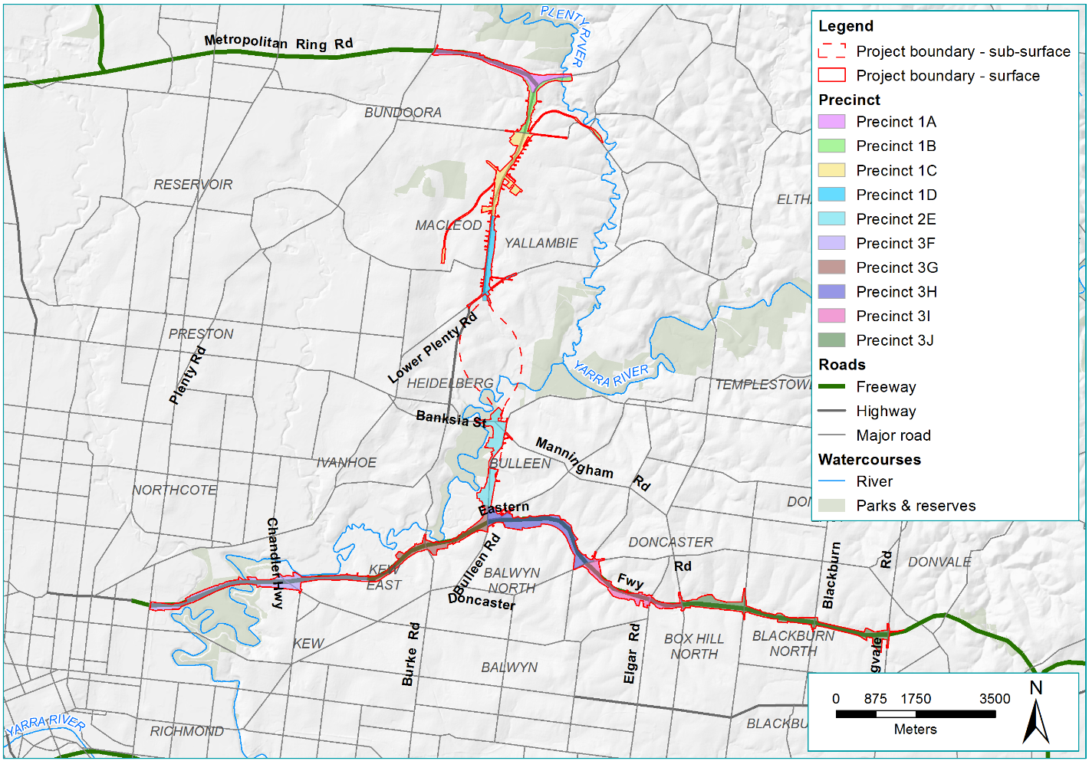
Figure 15-1 Arboriculture study area
- A desktop assessment was undertaken to characterise the planted amenity tree and tree groups within the project boundary.
- Councils and relevant land owners were consulted to obtain other information relevant to the arboriculture assessment.
- Field assessments were undertaken to provide a better understanding of existing planted amenity trees and urban forest around North East Link.
- For this assessment, a tree is defined as a woody perennial, usually having one dominant vertical trunk. The minimum size of tree included in the assessment was three metres, consistent with the DELWP Guidelines for the removal, destruction or lopping of native vegetation. The assessment did not include shrubs.
- For each tree or tree group data in relation to age and useful life expectancy (ULE) was collected to allow the identification of planted amenity trees in the public realm that have been assessed to contribute to the urban landscape (semi-mature, mature and over-mature trees) and which are considered to be viable beyond the anticipated timeframe of the project’s delivery. Trees with a ULE of 10 years or more are described in this chapter as Medium or Long Term Viable (MLTV) trees.
What information was collected on trees?
Ground-based assessments were undertaken within the study area precincts, with each tree or tree group identified to the species level where possible. Data was collected for each tree or tree group, as follows:
- Taxon
- Common Name
- Origin
- Diameter at breast height (DBH) [estimated]
- Height [as a range]
- Width [estimated]
- Age
- Health
- Structure
- Useful life expectancy.
- A risk assessment was undertaken to prioritise the impact assessment and the development of controls.
- An assessment of the potential arboriculture impacts during the project’s construction and operation was undertaken. The assessment considered planted amenity trees. Trees within EVCs and scattered trees were assessed and are summarised in Chapter 25 – Ecology.
- Environmental Performance Requirements (EPRs) were developed in response to the impact assessment. The residual risk ratings and the assessment of impacts presented in this chapter assume implementation of the EPRs. Refer to Chapter 27 – Environmental management framework for the full list of EPRs.

Existing conditions
This section outlines the existing conditions of the North East Link study area that relate to arboriculture.

The existing condition for arboriculture have been characterised in terms of the following aspects:
- Tree and urban forest character
- Number of trees within the project boundary.
These are presented in the following sections.
What is treed character?
Treed character is the attributes of a group of trees within the landscape.

Tree and urban forest character
The tree and urban forest character within the project boundary generally consists of planted indigenous, Victorian native and Australian native trees, with relatively few exotic trees.
The arboriculture assessment documented the treed character for the three project elements, each divided further into discrete precincts. A summary of the treed character for each precinct is contained in Table 15-1. The precincts are presented, from north to south, in Figure 15-2, Figure 15-3 and Figure 15-4 in the next section.
Table 15-1 Treed character around North East Link
Precinct | Description of treed character
Precinct 1.A | M80 Ring Road  This precinct is located in the northern part of the study area starting at Plenty Road at its western extent. It is set back from the running lanes and is densely planted with large native trees, forming near continuous over-canopy on each side of the road reservation.
Precinct 1.B | M80 Ring Road, Greensborough Bypass to Grimshaw Street  This precinct starts at the eastern end of the M80 Ring Road. The road reservation of the Greensborough Bypass is densely planted but with generally smaller trees that do not provide the same, large-scale canopy cover as plantations along the M80 Ring Road. The vegetation within this precinct provides a buffer between the bypass and adjacent residential areas.
Precinct 1.C | Greensborough Bypass and Greensborough Road, Grimshaw Street to Yallambie Road  The Greensborough Bypass and Greensborough Road reservations have a distinctively open landscape character, with relatively few large trees. Large trees are generally confined to adjacent recreational reserves such AK Lines Reserve and Gabonia Avenue Reserve in Watsonia, Winsor Reserve in Macleod and a reserve in Service Road, Watsonia.
Precinct 1.D | Greensborough Road, Yallambie Road to River Gum Walk  Similar to Precinct 1.C to the north, the Greensborough Road contains only a limited number of street trees with a generally open landscape character. To the east side of the road reservation is a near-continuous band of large, predominantly indigenous trees within Simpson Barracks that form a native Plains Grassy Woodland EVC (assessed in Technical report Q – Ecology) and Borlase Reserve at the southern end of Greensborough Road.
Precinct 2.E | Manningham Road to Koonung Creek, Bulleen  Banksia Park and Yarra River parklands have many more trees compared with the relatively sparsely treed streetscapes of the commercial and light industrial precinct to the south and east of the parklands. Although Bulleen Road contains limited street tree plantations in the south of the precinct, there are extensive, large plantings within the adjacent school playing fields, Bulleen Park and Veneto Club that provide a leafy outlook to the streetscape. Plantings primarily comprise indigenous, Victorian and Australian native species.
Precinct 3.F | Hoddle Street to Belford Road  The freeway road reservation within this precinct is open and relatively treeless. Tree plantations where they do occur are clustered at entry and exit ramps. Public reserves adjacent to the freeway are strongly indigenous in character, with dense plantings of large native trees. The vacant VicRoads site to the west of Chandler Highway contains native and exotic species of varying scale.
Precinct 3.G | Belford Road to Bulleen interchange  Trees in the freeway road reservation within this precinct are generally planted in single species plantations which in combination form strong elements in the broader landscape. The landscape character of public parklands (including the Freeway Public Golf Course) is consistent throughout this precinct, dominated by large Eucalypts, including locally indigenous, Victorian and Australian native species.
Precinct 3.H | Bulleen Interchange to Doncaster Road  The treed character of this precinct is dominated by large, indigenous and other native trees within the freeway reservation on its north side and freeway plantations that integrate into adjacent parkland plantations within the Koonung Creek Reserve to the south. The scale of the trees and resultant canopy, especially those on the north side of the freeway, provide useful shadowing of adjacent running lanes. Adjacent parklands, especially Koonung Creek Reserve, have a predominantly indigenous, semi-natural character, and include trees within Plains Grassy Woodland and Swampy Riparian Woodland EVCs (assessed in Technical report Q – Ecology).
Precinct 3.I | Doncaster Road to Tram Road  Within this precinct, the vegetation along the Koonung Creek trail to the south of the freeway integrates with freeway plantations, providing a strong, treed character in this section. Extensive portions of vegetation along the south side of the freeway within the Koonung Creek trail are classified as the EVC Riparian Woodland. Public reserves to the north of the freeway—namely Stanton Street and Katrina Street Reserves—have broadly native planting themes, including locally indigenous, Victorian and Australian native species.
Precinct 3.J | Tram Road to Springvale Road  As for Precinct 3.I to the immediate west, this section of the Eastern Freeway has a stronger treed character than older sections of the freeway west of Doncaster Road. Extensive native tree plantations within the freeway reservation considerably soften the highly urbanised freeway environment. Plantings have been undertaken in large blocks or monocultures of generally indigenous and Victorian native trees that are now maturing and provide important canopy cover along sections of the freeway within this precinct. Adjacent reserves are predominantly native in character and contain indigenous, Victorian and Australian native species.
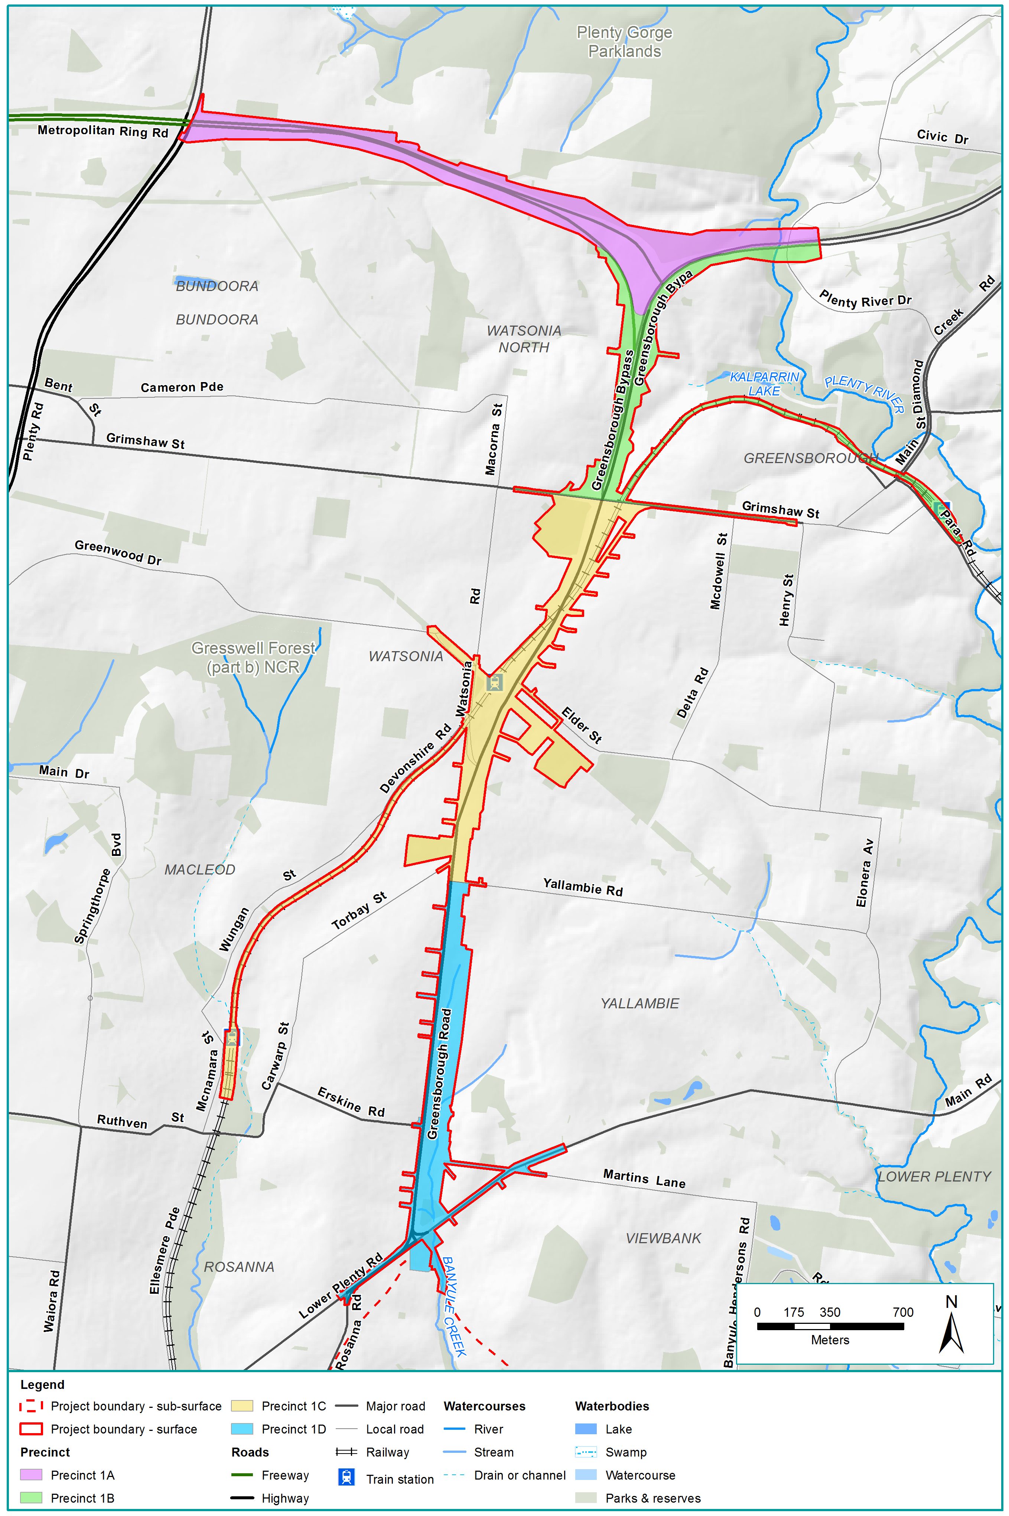
Figure 15-2 Arboriculture assessment precincts: M80 Ring Road to River Gum Walk
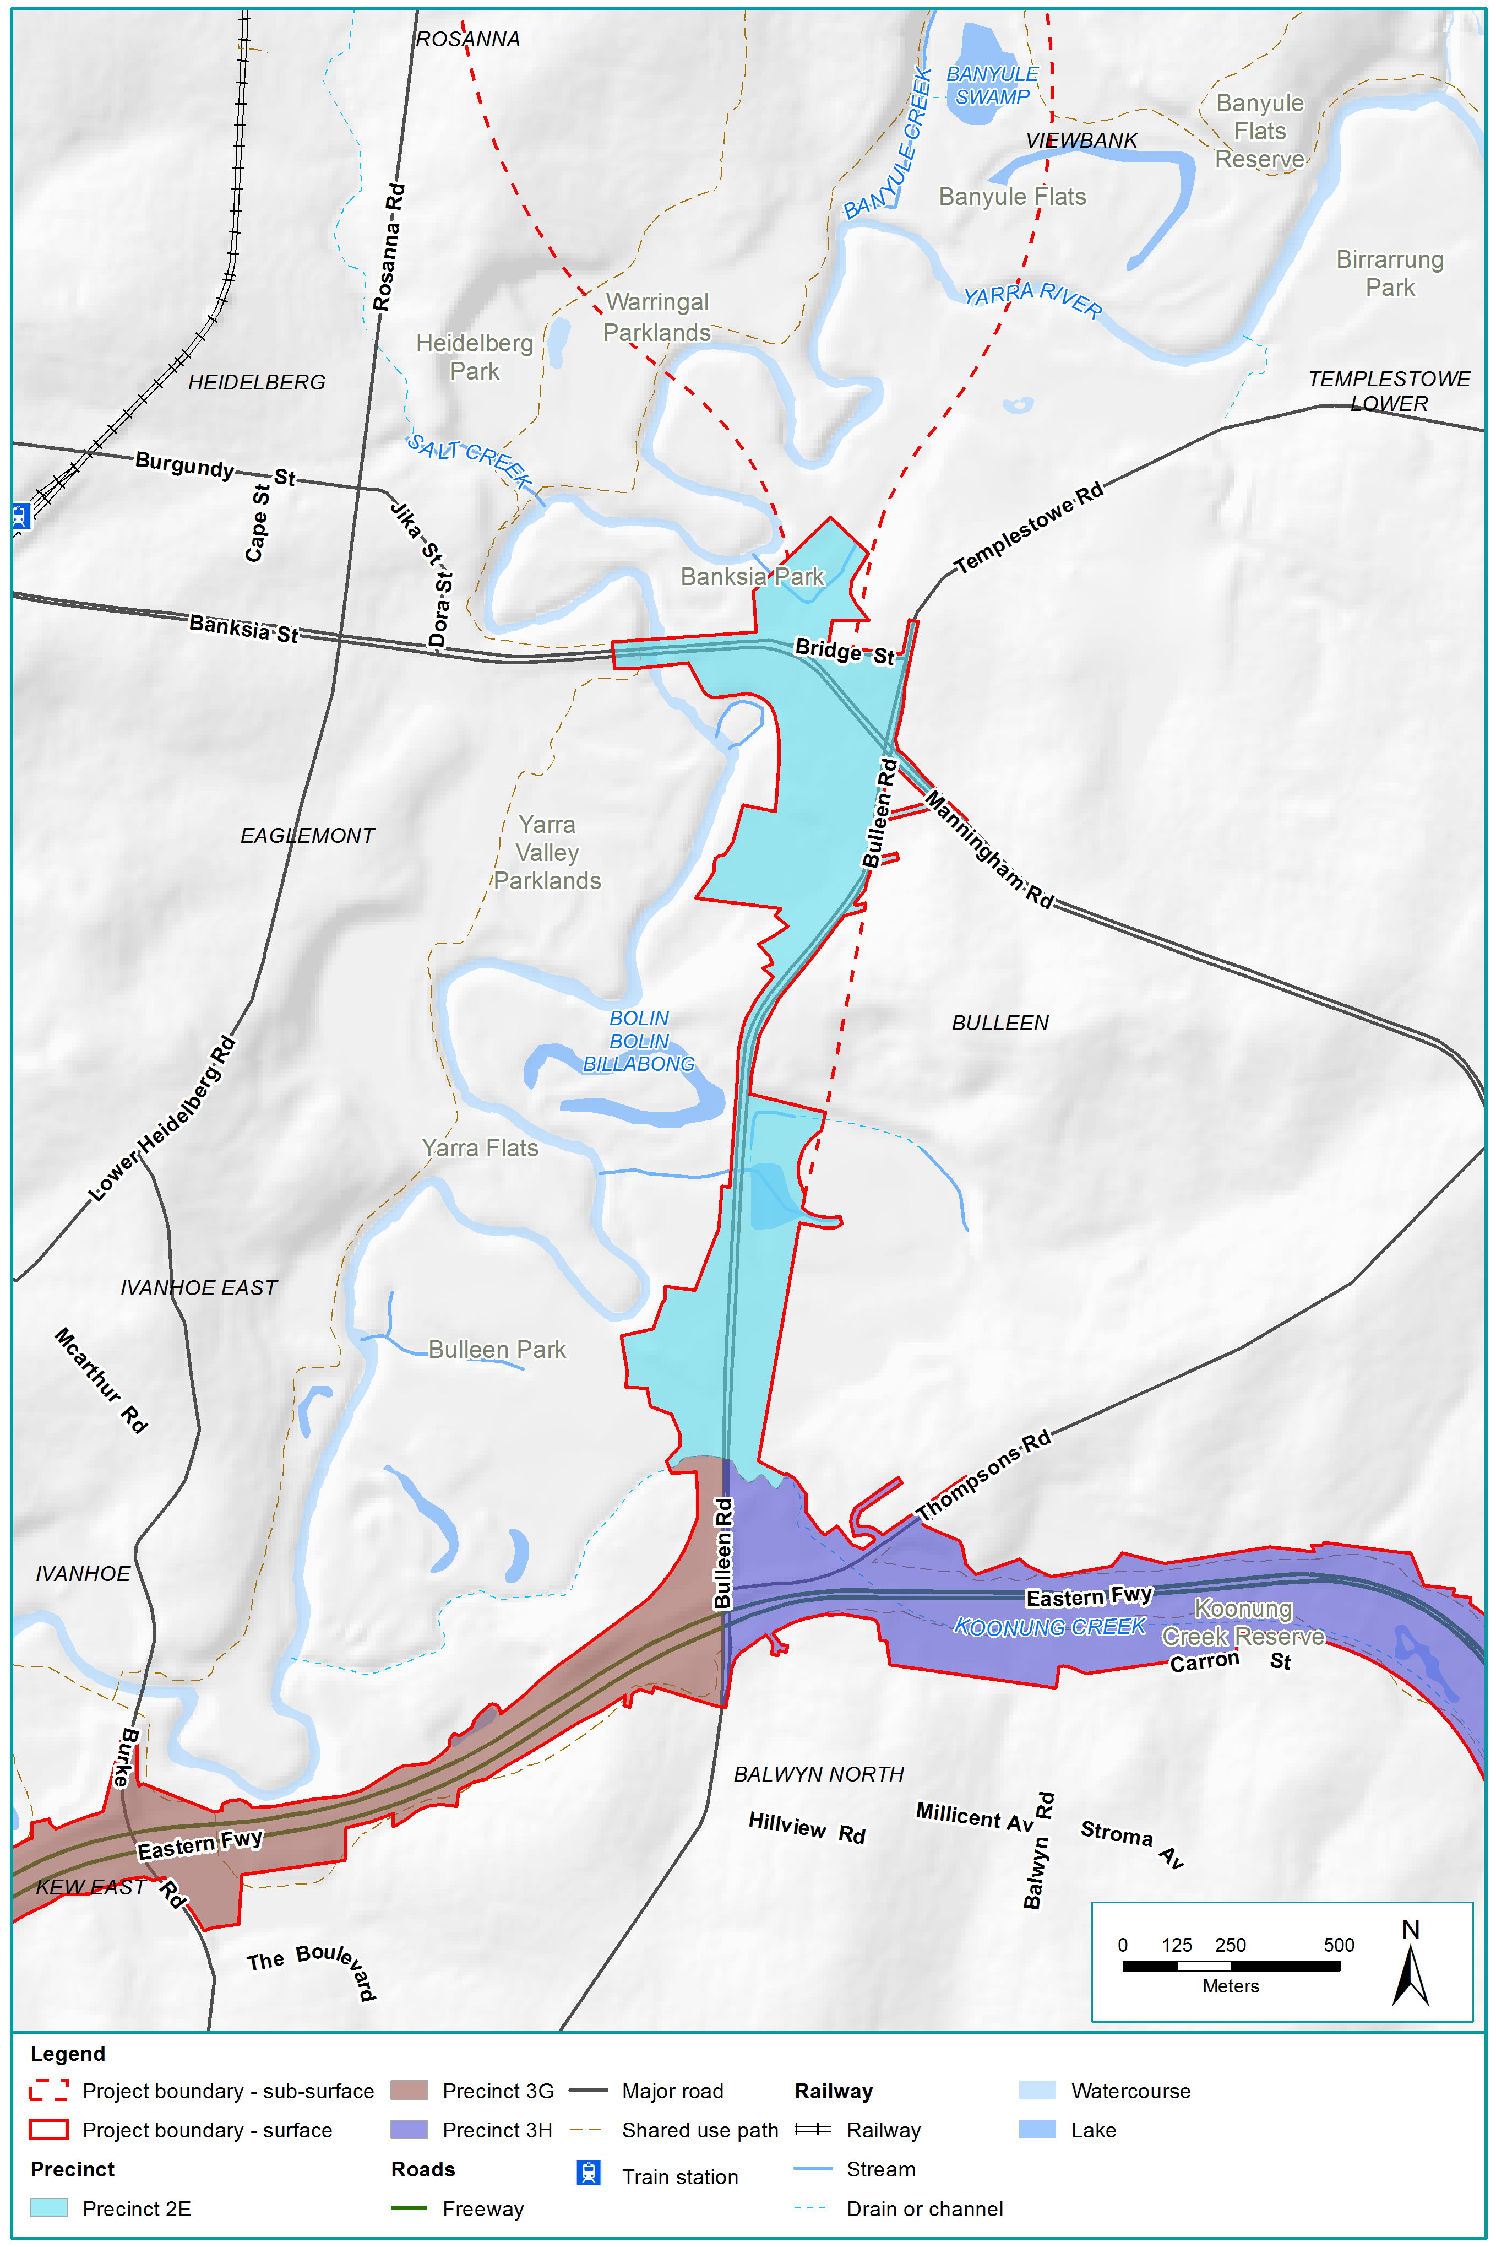
Figure 15-3 Arboriculture assessment precincts: Manningham Road to Koonung Creek
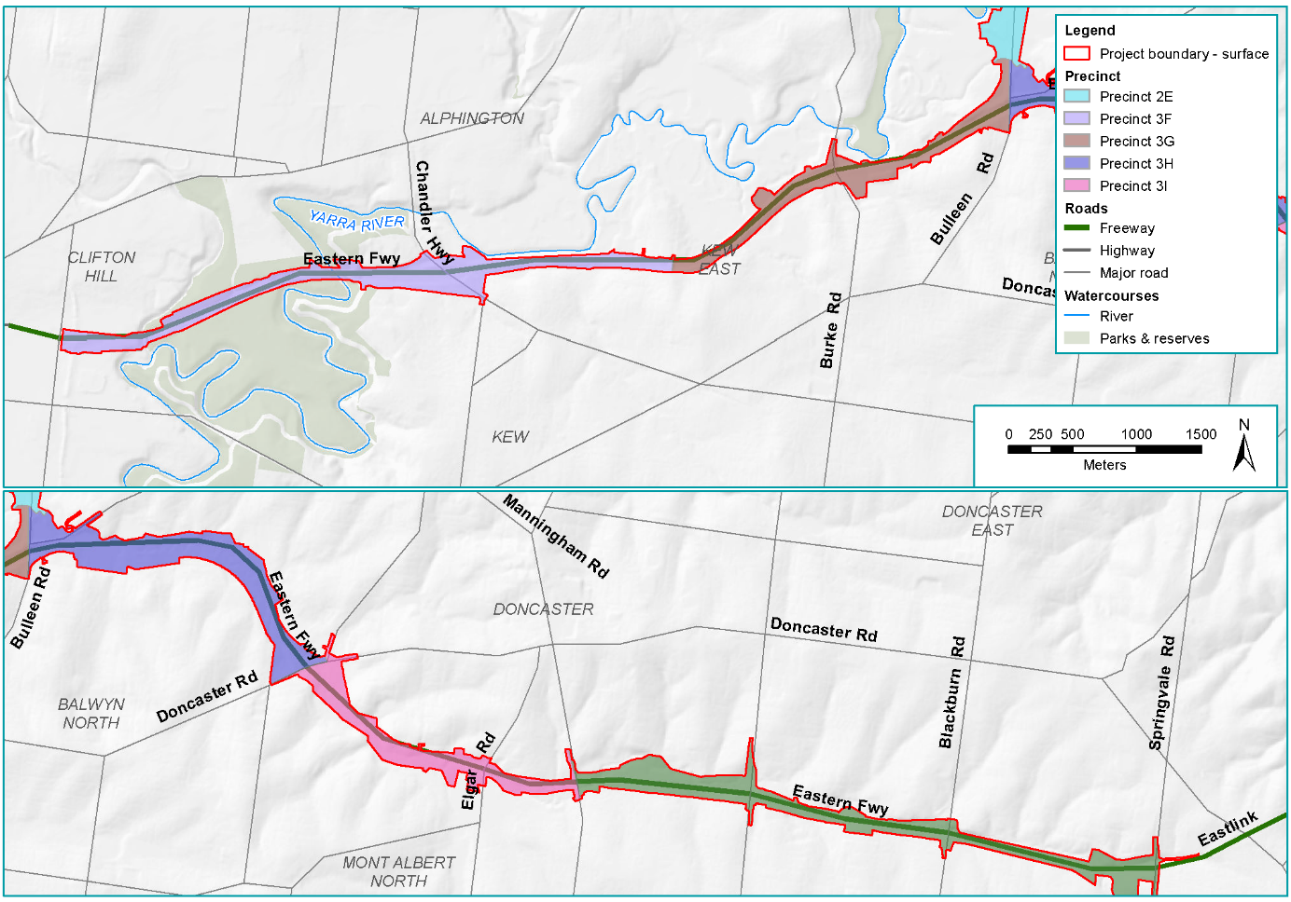
Figure 15-4 Arboriculture assessment precincts: Eastern Freeway

Number of trees within the project boundary
An estimate of the number of trees was completed by undertaking an inventory of planted amenity trees and tree groups located within the proposed project boundary. The estimated number of trees per precinct is summarised in Table 15-2. Trees within the road zone are within VicRoads-managed land where road improvement, widening and other works are a potential consequence of the use of this land. Trees in this zone are therefore at greater risk of damage or removal with or without the project compared with trees that are not located in a road zone.
Table 15-2 Estimated number of planted amenity trees within the project boundary
Precinct | Description | MLTV | Non-MLTV | Total | Total within road zone
Precinct 1.A | M80 Ring Road | 3,447 | 940 | 4,387 | 4,330
Precinct 1.B | M80 Ring Road, Greensborough Bypass to Grimshaw Street | 1,739 | 1,634 | 3,373 | 2,922
Precinct 1.C | Greensborough Bypass and Greensborough Road, Grimshaw Street to Yallambie Road | 1,050 | 801 | 1,851 | 810
Precinct 1.D | Greensborough Road, Yallambie Road to River Gum Walk | 285 | 94 | 379 | 114
Precinct 2.E | Manningham Road to Koonung Creek, Bulleen. | 837 | 386 | 1,223 | 181
Precinct 3.F | Hoddle Street to Belford Road | 1,687 | 1,060 | 2,747 | 1,668
Precinct 3.G | Belford Road to Bulleen interchange | 1,816 | 1,066 | 2,882 | 1,965
Precinct 3.H | Bulleen interchange to Doncaster Road | 2,219 | 1,349 | 3,568 | 1,321
Precinct 3.I | Doncaster Road to Tram Road | 1,221 | 366 | 1,587 | 1,163
Precinct 3.J | Tram Road to Springvale Road | 2,982 | 968 | 3,950 | 2,847
Total |  | 17,283 | 8,664 | 25,947 | 17,321

Construction impact assessment
This section discusses the construction impacts associated with North East Link that relate to arboriculture.
The potential impacts associated with the construction of North East Link that relate to planted amenity trees and the urban forest is grouped into the following aspects:
- Reduction of planted amenity trees and urban forest canopy
- Impacts to planted amenity trees from construction activities.
The assessment considered the risk of changes to planted amenity trees and the urban forest during construction. The potential for impacts associated with these aspects are discussed in the following sections.

Reduction of trees and urban forest canopy
The project’s construction may cause changes to planted amenity trees and the urban forest canopy. The risk pathway associated with reducing planted amenity trees and the urban forest canopy is described in Table 15-3 and discussed below.
Table 15-3 Risk table: Construction – reduction of trees and urban forest canopy
Risk ID | Risk pathway | Risk rating
Risk AR01 | Removal of trees for construction resulting in reduction of urban forest canopy cover | Planned (major consequence)

Reduction of trees and urban forest canopy

The removal of planted amenity trees during the project’s construction would reduce the urban forest (risk AR01). The planned removal of trees would allow for the construction of new and upgraded roadways, shared use paths, drainage and associated infrastructure. Areas may also be temporarily required for construction compounds and access to these areas.
What are MLTV trees?
Trees categorised as medium or long-term viable (MLTV) are semi-mature, mature and over-mature trees with a life expectancy of more than 10 years.

The assessment determined that of the approximately 26,000 planted amenity trees within the project boundary, around two-thirds of these are categorised as MLTV. This includes trees that are planned for removal to make space for the project’s proposed infrastructure, as well as trees with potential of risk of removal within the project boundary.
The number of planted amenity trees planned for removal to allow space for proposed infrastructure is around 16,000 with approximately 65 per cent of these being MLTV trees. Another 10,000 planted amenity trees within the project boundary would be potentially impacted (that is, at risk of removal or damage), with approximately 65 per cent of these being MLTV trees. Details of the number within each precinct are presented in Table 15-4.
Table 15-4 Summary of planted amenity trees planned or potentially impacted
Precinct | Description | Planned for removal |  |  |  | Potentially impacted
 |  | MLTV | Non-MLTV | Total | Total within road zone | MLTV | Non-MLTV | Total | Total within road zone
1.A | M80 Ring Road | 2,886 | 726 | 3,612 | 3,605 | 561 | 214 | 775 | 725
1.B | M80 Ring Road, Greensborough Bypass to Grimshaw Street | 1,289 | 1,434 | 2,723 | 2,644 | 450 | 200 | 650 | 278
1.C | Greensborough Bypass and Greensborough Road, Grimshaw Street to Yallambie Road | 734 | 582 | 1,316 | 781 | 316 | 219 | 535 | 29
1.D | Greensborough Road, Yallambie Road to River Gum Walk | 168 | 63 | 231 | 47 | 117 | 31 | 148 | 67
2.E | Manningham Road to Koonung Creek, Bulleen. | 636 | 269 | 905 | 95 | 201 | 117 | 318 | 86
3.F | Hoddle Street to Belford Road | 411 | 149 | 560 | 528 | 1,276 | 911 | 2,187 | 1,140
3.G | Belford Road to Bulleen Interchange | 1,148 | 573 | 1,721 | 906 | 668 | 493 | 1,161 | 1,059
3.H | Bulleen Interchange to Doncaster Road | 1,488 | 981 | 2,469 | 1,282 | 731 | 368 | 1,099 | 39
3.I | Doncaster Road to Tram Road | 547 | 160 | 707 | 605 | 674 | 206 | 880 | 558
3.J | Tram Road to Springvale Road | 1,317 | 253 | 1,570 | 966 | 1,665 | 715 | 2,380 | 1,881
Total |  | 10,624 | 5,190 | 15,814 | 11,459 | 6,659 | 3474 | 10,133 | 5,862

To maximise tree retention and reduce canopy loss, arboricultural assessments would inform the detailed design and maximise planted amenity tree retention where practicable. These assessments would also inform the selection of construction methods to minimise the removal or potential impacts to trees (EPR AR1). The Construction Environmental Management Plan would include a Tree Protection Plan (EPR AR2) which would identify:
- Trees to be retained in the immediate vicinity of the works
- Tree protection actions to ensure that trees proposed to be retained are adequately protected from the impact of construction or related activities before those works started and in accordance with AS4970-2009 Protection of trees on development sites.

Impacts to trees and the urban forest from construction activities
Impacts to trees may arise during the project’s construction from beyond the footprint of the proposed permanent infrastructure. The risk pathways associated with these impacts are described in Table 15-5 and discussed below.
Table 15-5 Risk table: Construction – changes to trees and the urban forest from construction activities
Risk ID | Risk pathway | Risk rating
Risk AR02 | Damage to trees on periphery of construction leading to death, damage or destabilisation, including mechanical impacts from cranes, piling rigs and vehicular access resulting in damage to tree crowns; lopping of tree crowns for installation of temporary aerial services leading to damage to trees by poor pruning practices | Low
Risk AR03 | Modification to adjacent soil profiles resulting in droughting, waterlogging and/or deoxygenation of root zones leading to reduced tree health or death primarily due to construction access through parkland, including set down areas resulting in soil compaction and reduced tree health. | Low

Damage to trees and the urban forest from construction activities
Construction activities have the potential to damage or destabilise trees on the periphery of construction areas (risk AR02). This could include:
- Damage to the crown of trees by vehicles accessing construction areas
- Destabilisation of trees from the use of construction equipment such as cranes or piling rigs
- Lopping or pruning of tree crowns to allow space for construction services such as the installation of temporary aerial services such as lighting and power.
A pre-construction site assessment would be conducted to confirm trees within the area with the potential to be impacted. Arboricultural assessments would inform the project’s detailed design and the selection of construction methods to minimise potential impacts to trees (EPR AR1). The Construction Environmental Management Plan would include a Tree Protection Plan (EPR AR2) which would identify:
- Trees to be retained in the immediate vicinity of the works
- Tree protection actions to ensure that trees proposed to be retained are adequately protected from the impact of construction or related activities before those works started and in accordance with AS4970-2009 Protection of trees on development sites.

Construction activities changing soil conditions
Construction activities have the potential to change the soil conditions within the root zones of trees resulting in soil drying, waterlogging or deoxygenation. This could be caused by any number of activities including:
- Modification to runoff by construction of new infrastructure such as drainage or pavements
- Temporary roads and paths to access construction areas
- Construction compounds and laydown areas.
A pre-construction site assessment would be conducted to confirm the trees within the area with the potential to be impacted. Arboricultural assessments would inform the project’s detailed design and the selection of construction methods to minimise potential impacts to trees (EPR AR1). The Construction Environmental Management Plan would include a Tree Protection Plan (EPR AR2) which would identify:
- Trees to be retained in the immediate vicinity of the works
- Tree protection actions to ensure that trees proposed to be retained are adequately protected from the impact of construction or related activities before those works started and in accordance with AS4970-2009 Protection of trees on development sites.

Operation impact assessment
This section discusses the operational impacts associated with North East Link that relate to arboriculture.
The identified impacts on trees and the urban forest during North East Link’s operation are:
- Availability of area for the re-establishment of trees and the urban forest
- Changes to growing conditions for trees and the urban forest.
The assessment considered the risk of changes to trees and the urban forest with respect to understand the potential impacts to trees and how the urban forest may be affected. It has included EPRs that would minimise impacts.
The potential for impacts associated with these aspects are discussed in the following sections with the risk pathways described in Table 15-6 and discussed below.
Table 15-6 Risk table: Operation – changes to the availability of space and growing conditions for trees and the urban forest
Risk ID | Risk pathway | Risk rating
Risk AR04 | North East Link roads, bridges, tunnels and associated infrastructure would prevent the re-establishment of urban forest canopy within the vicinity of the project. | Medium
Risk AR05 | Modification to growing conditions by new structures, such as shading and drawdown of groundwater resulting in poor growing conditions and reduction of urban forest canopy cover | Low

Availability of area for the re-establishment of trees and the urban forest
Roads, bridges and other infrastructure associated with the project could prevent the re-establishment of the planted amenity trees and the urban forest canopy (risk AR04). This is because the amount of land the project infrastructure occupies would reduce the availability of suitable land for planted amenity trees and urban forest replacement.
The long-term loss of planted amenity trees and urban forest canopy would be mitigated through the development and implementation of a Tree Canopy Replacement Plan (EPR AR3). The plan would require replacement of canopy lost due to the project, and achieve a net gain in tree canopy over time. Existing tree canopy and actual tree removals would be required to be measured to assess the extent of tree and urban forest canopy impact. Replacement planting would be located as close as possible to the project with the following hierarchy used for tree planting locations:
      - Where canopy is lost within the North East Link project boundary
      - Adjacent to the North East Link alignment
      - Within Victorian Government and local council land within the municipalities of Manningham, Boroondara, Nillumbik, Yarra, Whitehorse and Banyule
      - Within the wider north-east Melbourne region.
Landscape plans would determine the number, species and location of each tree planted within the project area combined with spatial modelling to determine vulnerability to heat and pedestrian activity, areas where planted trees could replace canopy gaps or provide corridors for biodiversity or assist with stormwater management.

Changes to growing conditions for trees and the urban forest
Growing conditions for trees may change due to the project which may reduce the urban forest canopy (risk AR05). Changing in growing conditions could include increased overshadowing, changes to groundwater levels or ground settlement from new or modified infrastructure.
Established trees are not considered particularly vulnerable to changes in direct sunlight. Changes to overshadowing from the project are discussed in Chapter 16 – Landscape and visual.
Construction of the road trench and tunnels has the potential to cause groundwater drawdown and reduce the availability of groundwater for trees. The potential impacts associated with reduced groundwater availability are considered to be minor as most planted amenity trees assessed have roots within the upper metre of soil profile and so are unlikely to rely on groundwater as a key source of water. However, some older indigenous trees such as River Red Gums (Eucalyptus camaldulensis) have the capability to extend roots down to greater depths and access underlying groundwater.
The potential impacts associated with trees and groundwater levels are similar during the project’s operation and construction and so impacts are only described in this section. Details of the impact of the availability of groundwater for trees are discussed further in Chapter 25 – Ecology.
Ground settlement would be greatest closest to the tunnel portals and sections of the road in trenches. Trees are planned for removal to construct the project at these areas. Other locations of ground settlement are minor and unlikely to impact the viability of trees to be retained.

Cumulative impact assessment
North East Link is one of several major infrastructure projects planned or under construction in Victoria. Within the Melbourne metropolitan area, work is underway on the Metro Tunnel and the West Gate Tunnel Project as well as a number of Level Crossing Removal projects.
During construction, loss of trees and associated canopy is inevitable for such large-scale, transformative projects. In addition, consolidation of housing density, especially in inner urban and around suburban activity centres has seen the loss of trees, especially where traditional single dwellings have made way for more intensive multi-unit developments.
The cumulative impacts of infrastructure projects and intensification of urban development is a continuing decline of the overall canopy cover across Melbourne. In recognition of the importance of the urban forest, especially its mitigating effects on urban heat islands, the re-establishment of trees and urban forest canopy lost due to major infrastructure is now seen as an essential component of project delivery. The Metro Tunnel and West Gate Tunnel Project both have requirements that seek to replace trees lost due to these projects.
Similarly, the importance of the urban forest has been recognised in the planning of North East Link with an objective to ensure that a long-term goal of the project’s delivery is the re-establishment of urban canopy cover through EPR AR3.

Conclusion
This chapter has described existing conditions and assessed potential impacts and associated risks to planted amenity trees and the urban forest around North East Link.
Overall, the character of trees and the urban forest within the project area is defined by planted indigenous, Victorian native and Australian native trees, with relatively few exotic trees. The scale and canopy cover provided by trees through the project area is variable.
The greatest impact to trees and the urban forest would be from the planned removal of trees. However the assessment of potential tree losses is conservative and it is likely the number of trees removed would be reduced through the implementation of the project EPRs. The project infrastructure would reduce the availability of suitable land for planted amenity trees and urban forest replacement and potential changes to tree growing conditions such as drying or flooding of the root zone of planted amenity trees are considered unlikely to occur.
The implementation of the project EPRs (described in full in Chapter 27 – Environmental management framework) would minimise impacts on trees and the urban forest by maximising tree retention through arboriculture assessments informing the detailed design, development of a Tree Protection Plan to protect trees from construction activities and a Tree Canopy Replacement Plan to replace canopy lost due to the project, which could include plantings outside the project boundary although they would be located as close as possible to the project.
Based on the EES evaluation objective described at the beginning of this chapter, effects of the project on trees and the urban forest have been assessed and EPRs have been identified to minimise or avoid impacts to the environment and amenity.

