Chapter 24
Surface water

Chapter 24

Surface water
This chapter provides an assessment of the surface water impacts associated with the construction and operation of North East Link. This chapter is based on the impact assessment presented in Technical report P – Surface water.

Surface water quality and hydrology are important to the health and sustainability of Melbourne’s urban creeks, river systems and floodplains. It is important the project is designed to maintain water quality and floodplain function.
North East Link lies within the urban reaches of the Yarra River catchment. This highly urbanised part of Melbourne includes long-established residential areas, industrial precincts, parks and reserves, and community and recreation facilities.
There are many locations where the project would interface with an existing floodplain. At these locations, obstruction of existing flow paths has the potential to change the existing flood extent. If not managed appropriately, this could pose a flood risk to public safety, surrounding properties and infrastructure.
What is surface water?
Surface water is water located on the earth’s surface including rivers, creeks, lakes and wetlands. Surface water can be:
Permanent (perennial) – present throughout the year
Semi-permanent (ephemeral) – present for part of the year
Anthropogenic – made by people ranging from lakes, dams and other water storage bodies

Flooding of the North East Link tunnels also has the potential to pose a public safety risk.
The EES scoping requirements set out the following evaluation objectives:
- Land stability – To avoid or minimise adverse effects on land stability from project activities, including tunnel construction and river and creek crossings
- Catchment values – To avoid or minimise adverse effects on the interconnected surface water, groundwater and floodplain environments.
To assess the potential impacts of North East Link, a surface water impact assessment was undertaken. The assessment involved the investigation of the flooding, water quality, geomorphology and water supply to understand potential surface water changes and how these aspects may be affected.
Other aspects relevant to the project’s evaluation objectives include impacts relating to ground movement, groundwater, contamination and soil and ecology. Assessments of these aspects are addressed in the following technical reports:
- Chapter 21 and Technical report M – Ground movement
- Chapter 22 and Technical report N – Groundwater
- Chapter 23 and Technical report O – Contamination and soil
- Chapter 25 and Technical report Q – Ecology.

Method
Informed by the risk assessment described in Chapter 4 – EES assessment framework, the surface water assessment involved the following key tasks:
- A review of relevant policy, national and state legislation.
- The establishment of a study area for surface water encompassing surface water features including waterways, drains and other surface water bodies potentially impacted by North East Link, which are shown in Figure 24-1.
- A desktop assessment to characterise the existing conditions for flooding, water quality, geomorphology and water supply.
- Consultation with local councils and relevant land owners, and the catchment management authority Melbourne Water to obtain other information relevant to the surface water assessment.
- Modelling (including the assessment of climate change) in general accordance with Melbourne Water standards for infrastructure projects in flood-prone areas and Flood Mapping Projects Guidelines and Technical Specifications. For consistency with local planning schemes the range of events considered included a 1% AEP design event.
- A risk assessment to focus the impact assessment and development of controls.
- An assessment of the potential surface water impacts during the project’s construction and operation.
- Development of Environmental Performance Requirements (EPRs) in response to the impact assessment. The residual risk ratings and the assessment of impacts presented in this chapter assume implementation of the EPRs. Refer to Chapter 27 – Environmental management framework for full list of EPRs.
What is 1% AEP?
The Annual Exceedance Probability (AEP) defines the likelihood of a flood being equalled or exceeded in any given year. The most commonly used definition in planning is the 1% AEP or 1 in 100(AEP) flood event until recently the term 100 year (ARI) flood event was also in common usage. A 1% AEP flood event refers to a flood level that has a one in a hundred, or 1%, chance of being equalled or exceeded in any year (a 1% AEP event is approximately equivalent to a 100 year average recurrence interval {ARI} event).
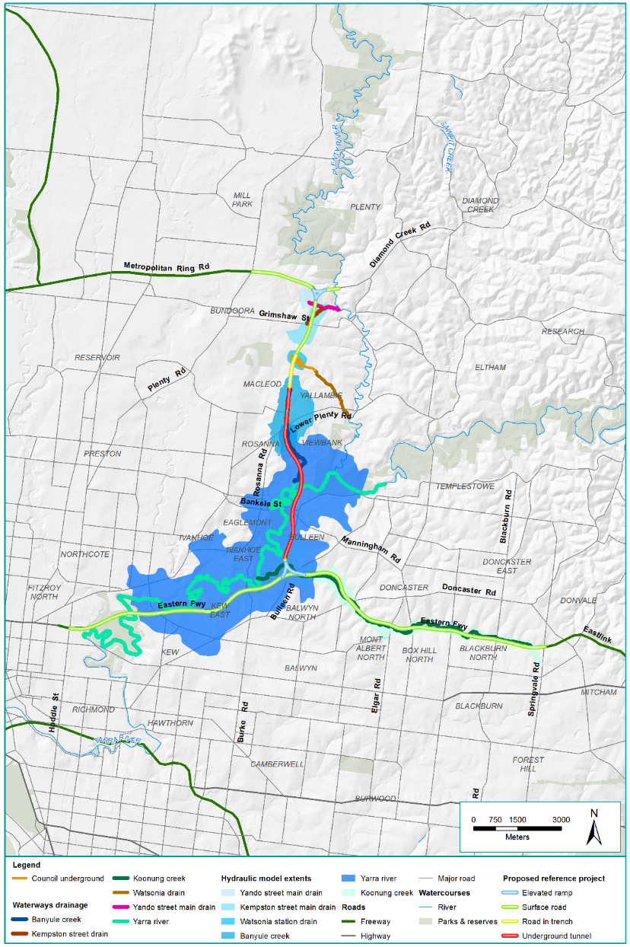
Figure 24-1 Surface water study area

Existing conditions
This section outlines the existing conditions of the North East Link study area that relate to surface water.
The assessment established the existing conditions for waterways around the project that are most likely to experience changes. These waterways and associated catchments are summarised in Table 24-1.
Table 24-1 Waterways around North East Link
Feature | Location description | Catchment description
Yando Street Main Drain | An underground drainage system that passes under Greensborough Bypass just south of the M80 Ring Road interchange. | Majority of catchment is urbanised including some open space areas with a range of vegetation densities.
Kempston Street Main Drain | An underground drainage system that passes under Greensborough Bypass just north of Grimshaw Street. | A fully urbanised catchment with some grassed reserves for power transmission and recreation.
Watsonia Station drain | An underground drainage system that passes under Greensborough Bypass around Watsonia railway station. | A fully urbanised catchment serving Watsonia railway station.
Banyule Creek | A small watercourse that rises in the area of the Simpson Barracks and flows south to join the Yarra River. | An urbanised catchment, with the exception of large vegetated open space within Simpson Barracks and the downstream creek reserve.
Yarra River | A large watercourse beginning on the southern slopes of the Great Dividing Range in the forested Yarra Ranges National Park and flowing into Port Phillip Bay. The area under investigation for the project is east of Clifton Hill and west of Lower Plenty and has four major bridge crossings within this reach. | The catchment is forested, agricultural and urban along its alignment. Within the study area there is a number of different land uses including public recreation and conservation. Between Banksia Street and Chandler Highway the floodplain is generally well vegetated.
Koonung Creek | A large and heavily modified watercourse beginning near Springvale Road in Blackburn North and flowing west to join the Yarra River just north of the Freeway Public Golf Course. The creek is approximately 12 kilometres long, with 2.4 kilometres enclosed in a built drain. Previous construction of the Eastern Freeway significantly altered Koonung Creek with some sections realigned, a number of culverts installed and banks modified, some with rock armouring. | The catchment is almost entirely urban with parklands located along various reaches of the creek.

The assessment then considered the changes to waterways and other surface water features with regard to the following aspects:
- Flooding
- Water quality
- Geomorphology
- Water supply.
These are presented in the next sections.

Flooding

This section summarises the existing flooding conditions for the waterways potentially affected by the project. Flooding may be influenced by a number of factors including rainfall, season and topographic features of the landscape that may allow, prevent or direct water flow across an area.
A range of flood events were assessed by flood modelling. A summary of some of this modelling is provided in Table 24-2. The peak flood depths in the 1% AEP are provided in Figure 24-2 to Figure 24-11 in the section to follow.

What is flooding?
Flooding is the temporary overflow of a body of water over a normally dry area.
For North East Link, flooding is investigated around the surface water features.

Table 24-2 Existing flooding conditions for waterways around North East Link
Waterway | Existing flooding conditions
Yando Street Main Drain | Overland flow along this drain occurs when the capacity of the underground drainage system is exceeded. This occurs for events with an AEP of between 10% and 5% AEP. In the 1% AEP event, surcharge from the underground drainage system flows through the shared use path culvert beneath the Greensborough Bypass and inundates some residential properties in the vicinity.
Kempston Street Main Drain | Under existing conditions, the 1% AEP flood extent inundates nearby private residential properties both upstream and more significantly downstream of the Greensborough Bypass.
Watsonia Station drain | Surface flooding is evident upstream of Greensborough Road in a 1% AEP event, but is relatively shallow and mostly affects the southbound lane of Watsonia Road and parts of the railway station car park reserve. More significant surface flooding occurs along the backs of properties on the downstream (east) side of Greensborough Road.
Banyule Creek | Flooding due to a 1% AEP event along the ephemeral waterways within Simpson Barracks is typically less than 0.5 metres deep although greater depths exist in defined waterways and water bodies.  Within the publicly accessible Commonwealth land south of Simpson Barracks, Banyule Creek deepens and becomes more defined. Flood depths greater than two metres are estimated in a 1% AEP event. Downstream of Drysdale Street, the 1% AEP flood extent expands onto and over Borlase Street and inundates private property.
Yarra River | The 1% AEP flood extent covers an extensive area utilised for public open space and recreational facilities as well as some areas of private residential, commercial and industrial properties along the fringes of the floodplain.  The approach road on both sides of Manningham Road West Bridge is overtopped in a 1% AEP event, by up to two metres. Bulleen Road, between the Trinity College Sports Sporting Complex and the Eastern Freeway, is overtopped by up to six metres of floodwater in the 1% AEP event. The Eastern Freeway is inundated to the west of Burke Road and east of Chandler Highway.  Between Birrarrung Park and the Chandler Highway, the floodplain provides a significant amount of flood storage and as a result water surface elevations across the floodplain are relatively consistent. Flow from the Chandler Basin is controlled by a relatively confined section of the Yarra River at and downstream of the Chandler Highway.
Koonung Creek | Within the upper reaches of Koonung Creek from Springvale Road to Middleborough Road the 1% AEP flood extent is confined within the creek channel, surrounding parklands or publicly accessible vegetated area and does not extend to private properties.  Downstream of Middleborough Road, flood extents expand and impact some private properties surrounding the Melbourne Water Tram Road retarding basin. Flood waters overtop the basin which contains depths of greater than four metres in the 1% AEP event.  Upstream of the ‘arch culvert’ under Elgar Road, the Koonung Creek flood extent expands into private properties to the south of the Eastern Freeway. Downstream of Elgar Road, Bushy Creek joins Koonung Creek. The 1% AEP flow inundates various ovals within Elgar Park on the east and private properties to the west of Elgar Road. The Elgar Park ovals attenuate inflows from Bushy Creek.  The inundation extent resulting from the combined Koonung Creek and Bushy Creek flows extend across a series of wetlands. The flood extent is confined to the creek further downstream through a rock cutting, which was constructed alongside the Eastern Freeway. Downstream of this cutting the flood extent widens, before entering a culvert and crossing to the north of the Eastern Freeway near the Doncaster Park and Ride.  Downstream of Doncaster Road the creek is within an underground arch drain. Flood extents for the length of the ‘arch drain’ are defined by a variety of issues including the overflow from the ‘arch drain’ and capacity of the local stormwater network entering the arch drain. The Yarra River 1% AEP flood extent intersects with the Koonung Creek 1% AEP flood extent, in the area that includes the Trinity Grammar School Sporting Complex, Marcellin College and the Carey Grammar Sports Complex.  The outlet of the ‘arch drain’ is downstream of Thompson Road, where the Koonung Creek flood extent expands across the Trinity Grammar School Sporting Complex and Marcellin College adjacent to Bulleen Road. Three, 3.3 metre wide by 3.0 metre high culverts beneath Bulleen Road convey flood waters towards the Yarra River. In the 1% AEP flood event on Koonung Creek, flows overtopping Bulleen Road are up to 0.5 metres deep.  In addition to the Koonung Creek catchment, the local catchment situated to the east of and including the Trinity Grammar School Sporting Complex has been modelled. Floodwaters from the 1% AEP event spread across most of the sporting ovals and water supply dam, before flowing through five 2.4-metre diameter overflow culverts beneath Bulleen Road into a wetland system on the western side of Bulleen Road, which discharges to the Yarra River.

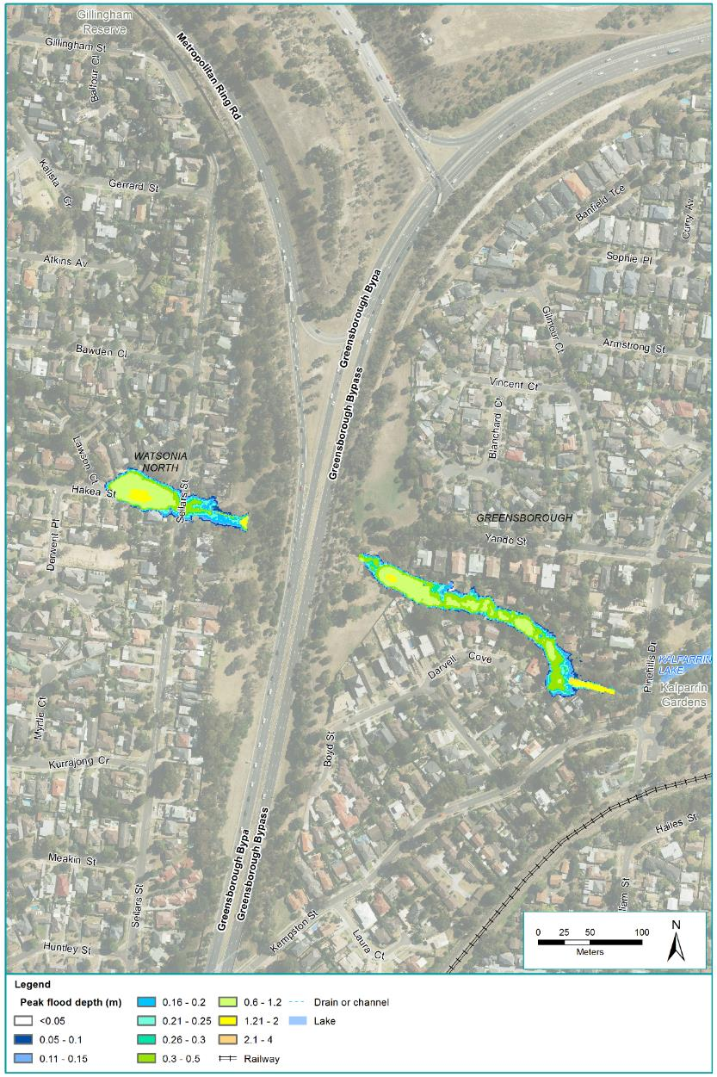
Figure 24-2 Modelled flooding (1% AEP peak depth) around Yando Street Main Drain
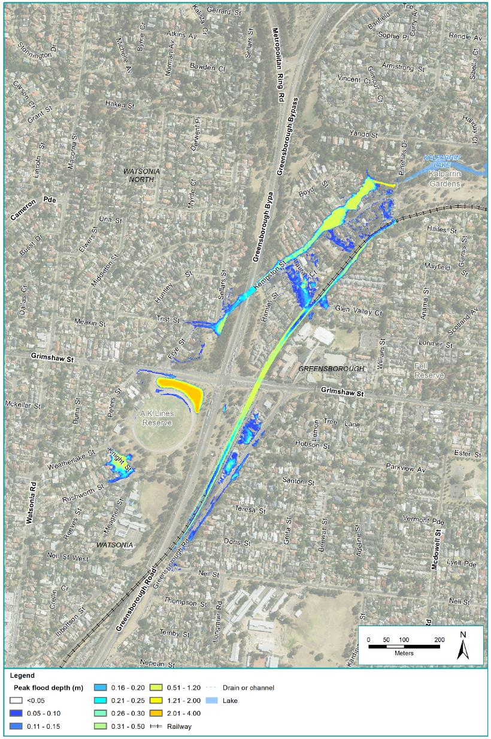
Figure 24-3 Modelled flooding (1% AEP peak depth) around Kempston Street Main Drain
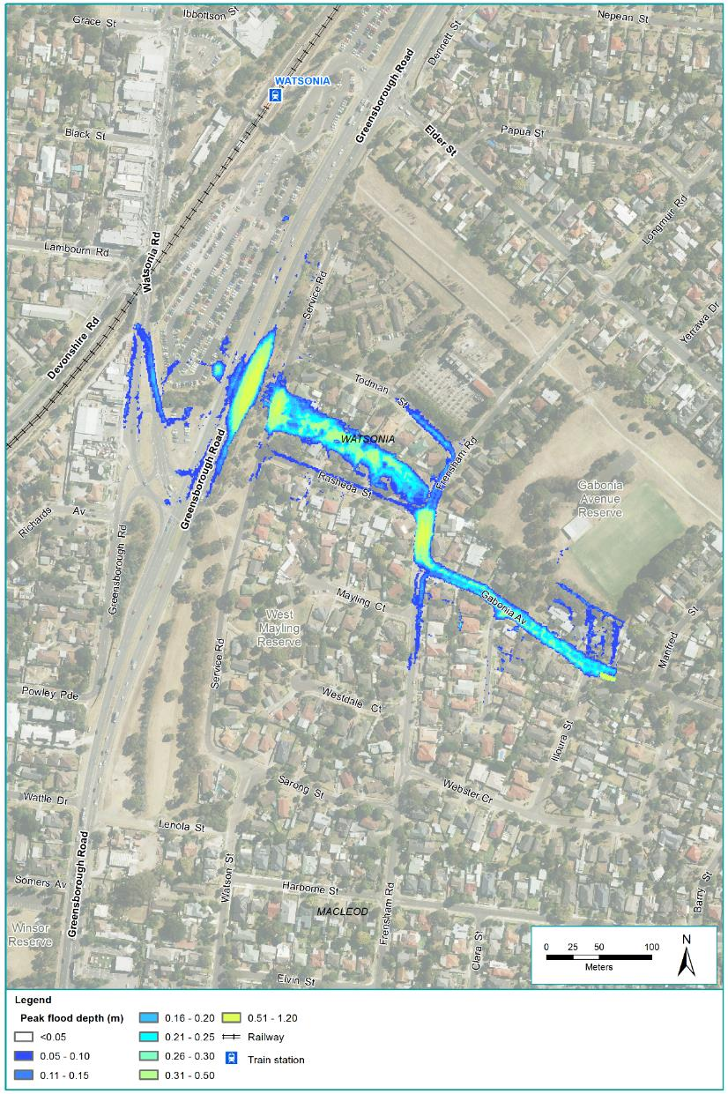
Figure 24-4 Modelled flooding (1% AEP peak depth) around Watsonia Station drain
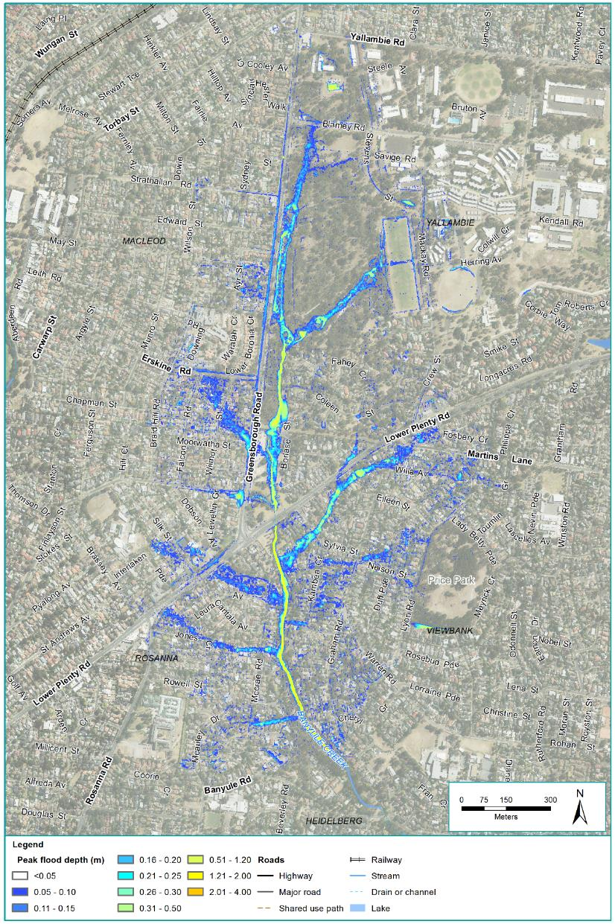
Figure 24-5 Modelled flooding (1% AEP peak depth) around Banyule Creek
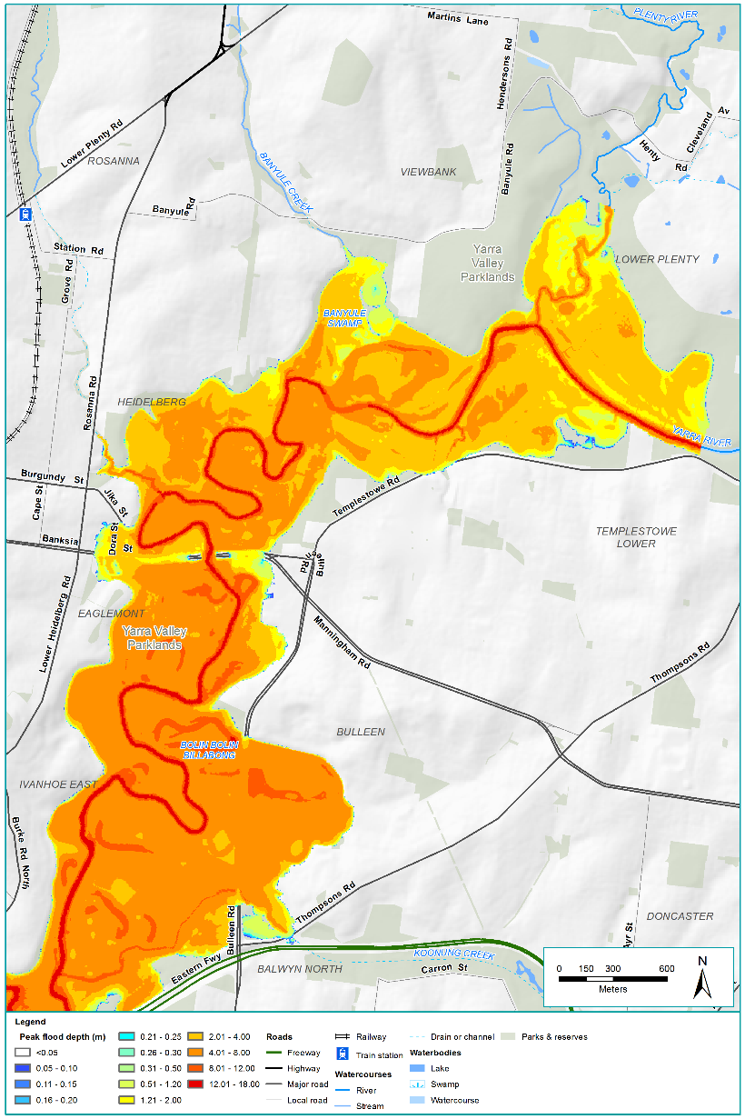
Figure 24-6 Modelled flooding (1% AEP peak depth) around the Yarra River (1 of 3)
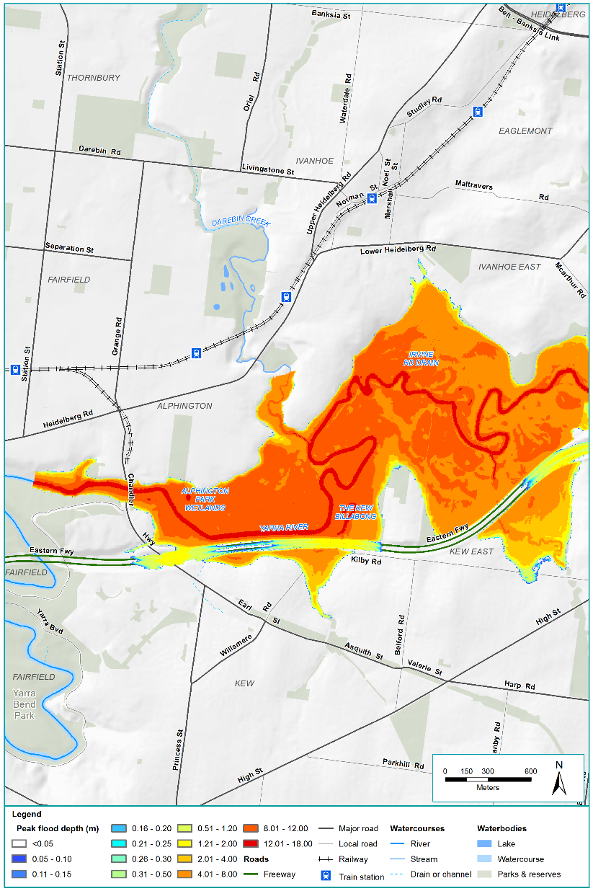
Figure 24-7 Modelled flooding (1% AEP peak depth) around the Yarra River (2 of 3)
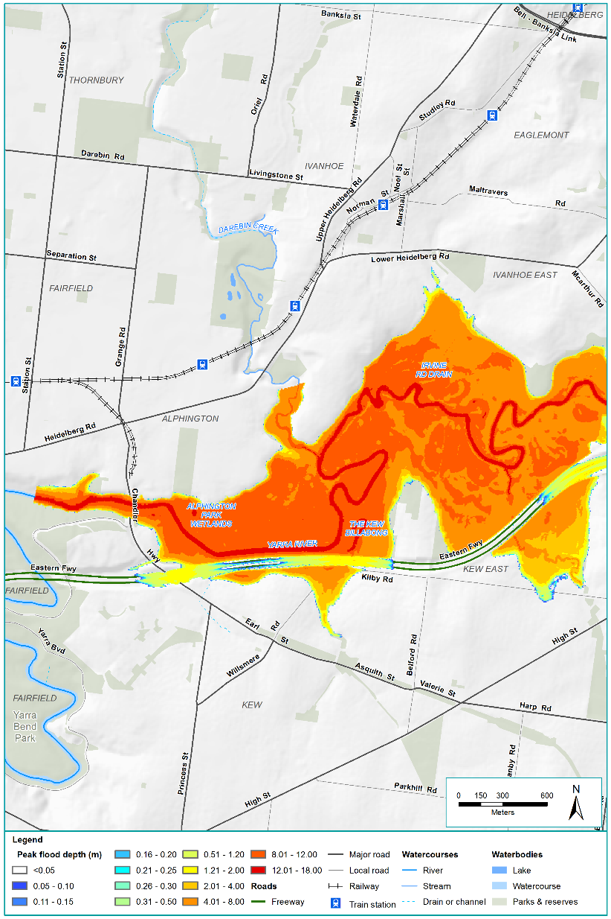
Figure 24-8 Modelled flooding (1% AEP peak depth) around the Yarra River (3 of 3)
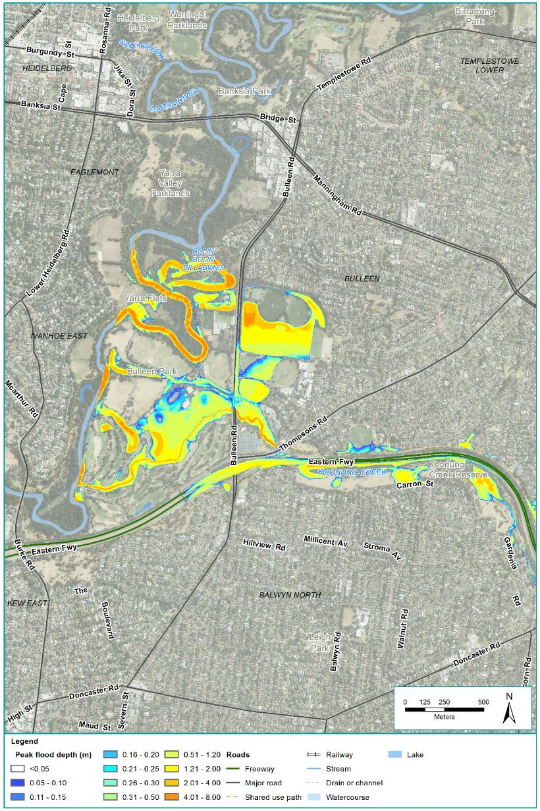
Figure 24-9 Modelled flooding (1% AEP peak depth) around Koonung Creek (1 of 3)
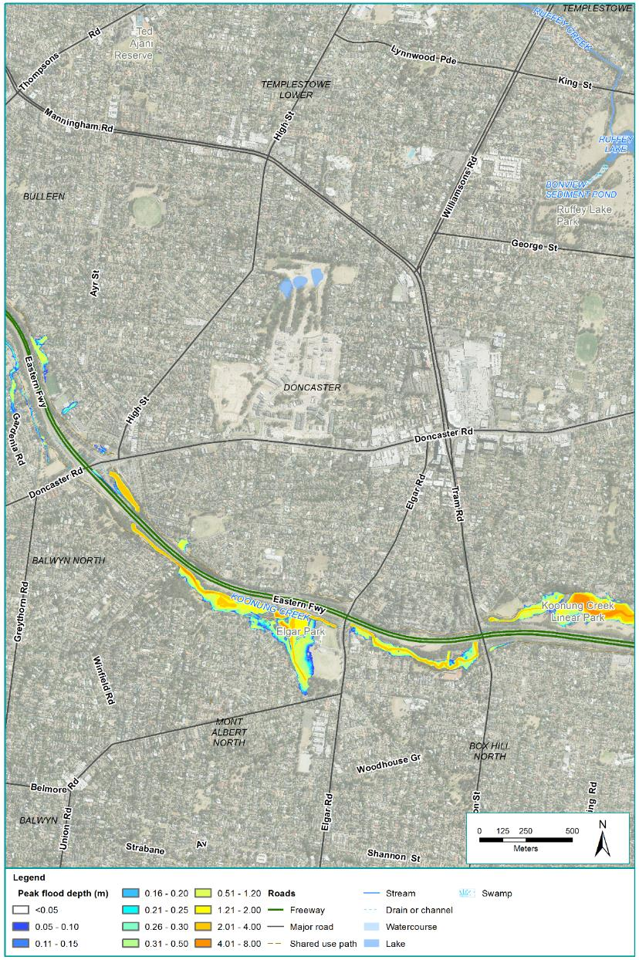
Figure 24-10 Modelled flooding (1% AEP peak depth) around Koonung Creek (2 of 3)
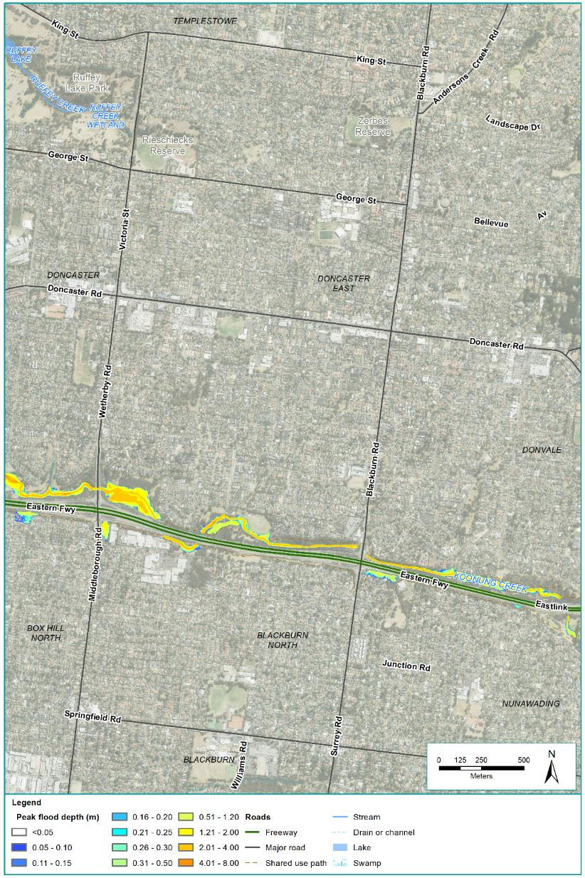
Figure 24-11 Modelled flooding (1% AEP peak depth) around Koonung Creek (3 of 3)

Water quality

This section summarises water quality for key waterways around the project. Water quality may be influenced by a number of factors including the surrounding geomorphology, urbanisation and vegetation.
Water quality data was obtained for key water quality parameters from Melbourne Water and EPA Victoria monitoring stations at the Yarra River and Koonung Creek and Waterwatch data was obtained for sites at Banyule Creek.
What are water quality parameters?
Water quality parameters are the key measures that indicate water quality and include dissolved oxygen, electrical conductivity (salinity), pH, turbidity, total nitrogen and total phosphorus.
Monitoring results are summarised in the Technical report P – Surface water.

This data was compared with the SEPP (Waters) objectives to evaluate existing water quality as summarised in Table 24-3. Additionally, the Victorian Government collects information and undertakes a water quality analysis which is available from the Yarra and Bay website. The most recent results of this analysis are provided in Table 24-3.
Table 24-3 Existing water quality for key waterways around North East Link
Waterway | Status against SEPP (Waters) objectives | Summary of Yarra and Bay analysis
Banyule Creek | Partially met | No information available
Yarra River | Mostly met | Good rating: pH and salinity  Poor rating: water clarity, nutrients and metals  Overall: poor, within the study area, however improving
Koonung Creek | Partially met | Fair rating: pH  Poor rating: water clarity, nutrients, metals, dissolved oxygen and salinity  Overall: consistently very poor

Geomorphology

This section summarises the condition and stability of key surface water features around the project.
The condition and stability of waterways varies across the project. This is due in part to variations in natural formations and the varying degree of urbanisation across the landscape.
The surface water features and their respective geomorphic conditions are summarised in Table 24-4.
What is geomorphology?
Geomorphology relates to the study of landforms, their origin and evolution.
For North East Link, the key features affecting the condition and stability of waterways are associated with the bed and banks of Banyule Creek, Koonung Creek and the Yarra River.

Table 24-4 Geomorphic conditions for key waterways around the project
Waterway | Geomorphic conditions
Banyule Creek | A small ephemeral watercourse originating within Simpson Barracks as a surface flow path immediately downstream of the culvert under Blamey Road. The top of the catchment appears to align with Yallambie Road although there is no defined flow path until south of Blamey Road. The stream form becomes more defined near the Simpson Barracks boundary and combines with a tributary flow path from the east, although the general flow path is north-south.  Towards Drysdale Road the channel profile flattens and is heavily inundated with vegetation such as reeds. Downstream of Drysdale Road, within Borlase Reserve, the channel profile steepens and is straightened with local signs of bank erosion present.  South of Lower Plenty Road, the creek becomes more incised with the placement of rocks and local areas of high energy with local drainage outfalls entering the creek channel. This section includes occasional bed incisions and local bank erosion.
Yarra River | Melbourne’s major waterway, originating in the Yarra Ranges with considerable river flats and billabongs along its course which generally flows from east to west. Indigenous vegetation and remnant riparian vegetation surrounding the river provide habitat and contribute to the protection of water quality and flow regimes. Along its course land use includes forest, agriculture and urbanised areas.  Between Diamond Creek and Merri Creek confluences, bed and banks are relatively stable and well vegetated although somewhat weedy. The main channel comprises pools with the occasional gravel riffles and runs.  While much of the Yarra River floodplain has been cleared over time due to urbanisation, some billabongs remain relatively intact such as Annulus Billabong and Bolin Bolin Billabong.
Koonung Creek | A heavily modified watercourse, due to the construction of the Eastern Freeway, with considerable sections being realigned and banks being stabilised with rock armouring.  Evidence of local bank erosion is present east of Elgar Road caused by upstream bridge constriction and the height of the existing bank exposing tree roots and threatening bank stability.  Downstream of the Bushy Creek and Koonung Creek confluence, there is evidence of lateral bank migration. Local erosion is present in Koonung Creek between the arch culvert opposite Clifton Street and the crossing east of Elgar Road.

Water supply
Various storages exist within the Yarra River floodplain, including a dam built within the Trinity Grammar School Sporting Complex and irrigation storages developed as part of the Bolin Bolin Integrated Water Management Project.

The Trinity Grammar wetlands located upstream of the Trinity Grammar water storage receives water from a local urban catchment to the east of the site. Stormwater from these wetlands flows into a dam located on the Trinity Grammar School Sporting Complex grounds. Water stored in this dam is used for the irrigation of sporting ovals within the Trinity Grammar School Sporting Complex and the Marcellin College grounds.
Private licences can be obtained from Melbourne Water to extract water from Yarra River. To supplement the water available for irrigation from the dam, the Trinity Grammar School Sporting Complex has a current licence to extract water from the Yarra River.
Manningham City Council also has a licence to extract water from the Yarra River which it uses to supplement stormwater harvested as part of the Bolin Bolin Integrated Water Management Project. This project undertaken in partnership with the City of Boroondara and Carey Baptist Grammar school provide irrigation for a number of independent sports grounds located at Bulleen Park, the Carey Sports Complex and the Freeway Golf Course.

Construction impact assessment
This section discusses the construction impacts associated with North East Link that relate to surface water.
The potential impacts associated with the construction of North East Link in relation to surface water are grouped into to the following aspects:
- Flooding
- Water quality
- Geomorphology
- Water supply.
The assessment considered the risk of changes to surface water with respect to the above aspects and where needed has identified Environmental Performance Requirements (EPRs) to manage the impacts. Risk associated with surface water would be managed by the appointed contractor during the project’s construction. The potential for impacts associated with these aspects are discussed in the following sections.

Flooding
Changes to flooding regime and floodplain function may arise from the construction of North East Link. The risk pathways associated with flooding are described in Table 24-5 and potential impacts are discussed below.
Table 24-5 Risk table: Construction – flooding
Risk ID | Risk pathway | Risk rating
Risk SW01 | Construction activities causing an increase in flood frequency, velocity or level which affects users or assets within the floodplain. | Medium
Risk SW03 | Construction activities causing unintended damage to drainage assets resulting in an unacceptable increase in flooding risk. | Medium

Construction activities have the potential to increase flood risk due to the temporary placement of construction buildings, structures, materials or vehicles within the floodplain or due to damage to the assets (risks SW01, SW03).
While structures, equipment and materials would be kept out of flood prone areas wherever possible, it is inevitable that temporary placement within the floodplain would be necessary in a number of areas which may displace flood water and increase flood risk. The level and location of flooding risk may vary between sites and each construction phase. Increased flooding could materialise as an increase in flood frequency or an increase in flood levels, and if not mitigated may affect properties within or adjacent to the existing floodplain. Construction activities and associated risk relevant for each waterway and associated floodplain are summarised in Table 24-6.
Table 24-6 Proposed construction activities that have the potential to change flooding risk around North East
Construction activity | Waterway and associated floodplain
 | Yando Street Main Drain | Kempston Street Main Drain | Watsonia Station drain | Banyule Creek | Yarra River | Koonung Creek
Clearance of vegetation |  |  | ● | ● | ● | ●
Drainage modification works to the underground drain | ● |  | ●
Temporary access track construction |  |  |  | ● | ● | ●
Temporary fencing to separate public activities from the construction sites | ● | ● | ● | ● | ● | ●
Establishment, use and removal of construction compounds within the floodplain |  | ● |  | ● | ● | ●
Storage of spoil |  |  |  | ● | ●
Realignment and decommissioning of existing drain |  |  | ●
Earthworks, drainage, pavement construction, barriers, and lighting installation | ● | ● | ● | ● | ● | ●
Relocation of nearby utilities |  |  | ● | ● |  | ●
Local drainage works including diversion of overland flow paths and redirection of flows |  |  | ● | ● |  | ●
Embankment construction | ● | ● |  | ●
Modification of existing retarding basin |  | ● |  | ● |  | ●
Excavation of area adjacent to waterway |  |  |  | ● |  | ●
Construction of surface roads adjacent to the waterway |  |  |  | ● | ● | ●
Shared use path construction | ● | ● | ● | ● | ● | ●
Construction of portals and road ramps within the floodplain |  |  |  | ● | ● | ●
Construction of flood barriers |  | ● | ● | ● | ● | ●
Diversion, realignment and/or undergrounding of parts of the waterway |  |  |  | ● |  | ●
Reinstatement | ● | ● | ● | ● | ● | ●

An alternative tunnel boring machine (TBM) launch site has been assessed north of Lower Plenty Road, known as the northern TBM launch site. While no long-term operational impacts are anticipated, there is potential for this alternative launch site to result in impacts during construction, particularly with respect to flood flows along Banyule Creek to the north of Lower Plenty Road.
Consideration of the modelling results and a range of design concepts indicates there is a feasible surface water solution for the northern TBM launch site although it would require careful planning, analysis, detailing and implementation due to the limited area at this location to maintain an acceptable surface water outcome during the construction phase and may result in more severe constraints on stockpile configurations.
The potential risk of increased flood levels for property within the floodplain would be mitigated through the following:
- A Surface Water Management Plan to manage surface water during construction including measures such as maintaining existing flow paths, drainage lines and floodplain storage (EPR SW5)
- The assessment of flood risk through modelling of temporary works to demonstrate that the project meets the flood level, flow and velocity requirements (EPR SW6)
- Provide adequate clearances and access for ongoing maintenance of drainage assets (EPR SW10)
- Minimise impacts and interference with third-party property and infrastructure that could cause damage or impacts (EPR B3).

Water quality
Waterway modifications, storage and handling of hazardous materials and mobilisation of soil or contaminants have the potential to affect water quality during the construction of North East Link. The risk pathways associated with water quality are described in Table 24-7 and potential impacts are discussed below.
Table 24-7 Risk table: Construction – water quality
Risk ID | Risk pathway | Risk rating
Risk SW02 | Construction activities on existing flow paths including piped flow, causing a change in flow to downstream water quality assets impacting on the performance of the asset. | Low
Risk SW06 | Hazardous materials during construction of the project being released into the waterways resulting in adverse impacts on the beneficial uses of the receiving water. | Medium
Risk SW07 | Construction activities causing sediment or contaminants to be released into the waterways resulting in adverse impacts on the beneficial uses of the receiving water. | Medium

Stormwater or runoff can collect soil and other materials as it moves through drainage systems and waterways. This could include the release of contamination already present in soils or pollutants from the bottom of waterways and other waterbodies from activities required for the project’s construction.

Changes to water quality from alterations to flow
Construction activities have the potential to cause a change in flow regime to downstream water quality assets which may impact on the performance of an asset (risk SW02). Changes may include:
- Increased or reduced flow
- Peakier flow
- Increased sediment or pollutants.
To manage these changes, any discharges and runoff would be required to meet State Environment Protection Policy (Waters) (EPR SW1). This would be completed through a water quality monitoring program to be conducted before and during construction (EPR SW4) to assist the Surface Water Management Plan that would be implemented during construction (EPR SW5).

Changes to water quality from contamination and soil
Construction activities such as site clearance, earthworks and excavation may cause soils or contaminants present in soils such as heavy metals and waste products to be released into waterways which may adversely impact water quality (risk SW07). The impact would vary depending on the soil type and the nature of any contaminant present and the amount transferred to a waterway. Soils entering waterways may increase turbidity and reduce the light transmitted through water, which is important for aquatic flora.
Pollutants may include contaminated sediments, asbestos, solid inert waste, oils and chemicals. Hazardous materials used during construction such as fuels and machine lubricants may become mobilised, as a result of accidental spills, and be transported by stormwater during a rainfall event and be released into the waterways resulting in adverse impacts to the waterway (risk SW06).
Contamination along the alignment of the project is quite limited and would be required to be characterised and managed through a Spoil Management Plan and to meet EPA Victoria requirements (EPR CL1). Further details with regard to contamination are summarised in Chapter 23 – Contamination and soil.
To manage water quality, any discharge or runoff would be required to meet State Environment Protection Policy (Waters) (EPR SW1) and waterway modifications would be undertaken in a manner that minimises potential for pollution (EPR SW8). This would be checked through a water quality monitoring program to be conducted before and during construction (EPR SW4) implemented as part of the Surface Water Management Plan (EPR SW5). The management plan would include guidelines for best practice sediment and erosion control and requirements for the location and bunding of any stored contaminated material. Potential spills of hazardous materials would be managed through the Construction Environmental Management Plan by measures such as minimising the storage of hazardous materials and installation of bunds to contain spills (EPR CL5).

Geomorphology
Changes to the beds and banks of waterways associated with the construction of North East Link have the potential to affect waterway stability. The risk pathways associated with the changes to geomorphic conditions are described in Table 24-8 and potential impacts are discussed below.
Table 24-8 Risk table: Construction – geomorphology
Risk ID | Risk pathway | Risk rating
Risk SW04 | Construction activities resulting in bed or bank erosion causing instability of assets adjacent to the waterway. | Medium
Risk SW05 | Construction activities resulting in bed or bank erosion impacting on the beneficial uses of the receiving water. | Medium

Construction activities within waterways or floodplains have the potential to change the bed or the banks and alter the geomorphic characteristics of waterways (risk SW04). These changes have the potential to result in erosion and sediment transfer further downstream and change the water quality (risk SW05). The potential changes for waterways relevant to the project are summarised in Table 24-9.
Table 24-9 Activities that may affect waterway stability
Waterway | Activities that may affect waterway stability
Banyule Creek | Construction activities would include the diversion of approximately 1,400 metres of open drain, creek, and tributaries, from Blamey Road to Lower Plenty Road replacing this section of the creek with culverts and overland flow paths with a new retarding basin upstream of Lower Plenty Road. No changes are proposed south of Lower Plenty Road.
Koonung Creek | Construction activities would include underground diversion or realignment of sections of creek totalling approximately 1,500 metres which would require the clearing of vegetation in the floodplain prior to the re-establishment of new vegetation. As part of these works some currently piped sections of Koonung Creek would be returned to a naturalised open channel. While already significantly modified due to construction of the Eastern Freeway, works undertaken within Koonung Creek or its floodplain that involve removing soil from the bed or banks of the creek could alter the landform or geomorphic characteristics of the waterway.

All works on waterways or within floodplains would be undertaken to meet the requirements of Melbourne Water in consultation with relevant local councils and property managers, and any waterway modifications would minimise the potential for erosion which can impact on the beneficial uses of the waterway (EPR SW8). Preparation and implementation of a Surface Water Management Plan specifying the required mitigation measures, as well as asset condition assessments before and after construction works would avoid or minimise adverse effects on waterway stability (EPR SW5).
Waterway stability, including bank stability, would be preserved by maintaining existing flow conditions, minimising the works in or around the waterways, appropriate timing of works (aligned with low flow periods) and regular monitoring of the water quality upstream and downstream of the works to detect potential erosion and subsequently bank stability (EPR SW4) and would be implemented as part of the Surface Water Management Plan (EPR SW5). Implementation of these controls would address the requirements of the State Environment Protection Policy (Waters) and prevent water quality impacts (EPR SW1). The potential for subsidence due to the tunnelling is discussed in Technical report M – Ground movement and is understood to be insignificant with respect to the function and stability of Banyule Creek and the Yarra River.
For works undertaken along Koonung Creek or Banyule Creek that involve removing soil from the bed or banks, the potential for erosion would be mitigated by the provision of suitable erosion protection on banks, efficient vegetation establishment or other control measures to address any bed or bank instability (EPR SW9) and these mitigations would be implemented as part of the Surface Water Management Plan (EPR SW5).

Water supply
Construction of North East Link may affect existing water supply assets being used for irrigation. The risk pathway associated with changes to water supply is described in Table 24-10 and potential impacts are discussed below.
Table 24-10 Risk table: Construction – water supply
Risk ID | Risk pathway | Risk rating
Risk SW08 | Construction activities leading to changes to water storages or supplies of irrigation assets affecting users. | Low

Construction activities have the potential to change water storage and irrigation supplies of existing users (risk SW08). This would be due to water storage areas being used for construction of the project.
Construction of North East Link would require the area currently used for the private dam within the Trinity Grammar School Sporting Complex to build the southern extent of the tunnel. The dam would need to be modified during construction and would be reinstated by the time construction is complete. Trinity Grammar wetland, between the upstream catchment diversion and the downstream water storage dam and other local drainage paths could be affected by changes to the dam.
An alternative stormwater supply for irrigation purposes would be required during construction to meet the irrigation demand of both the Trinity Grammar School Sporting Complex and Marcellin College (EPR SW12). Other secondary functions of this system such as local drainage and flood mitigation would also need to be adequately maintained by the proposed works (EPR SW6). Waterway modifications would be considered upstream of the Trinity Grammar wetland to ensure the potential changes to flow regime of the wetland are minimised (EPR SW8). A suitable water supply would be required to be maintained for Bolin Bolin Integrated Water Management Project if local drainage is rerouted for construction of the tunnels (EPR SW12). This could be achieved using the existing water extraction licence from the Yarra River or by provision of an alternative water supply during project construction.

Operation impact assessment
This section discusses the operational impacts associated with North East Link that relate to surface water.

The impacts identified for the operation of North East Link that relate to surface water are grouped according to the following themes:
- Flooding
- Water quality
- Geomorphology
- Water supply.
What is afflux?
Afflux is the change in water level from its normal level, usually occurring upstream of an obstruction that reduces the waterway or floodplain to less than its existing capacity.

The assessment considered the risk of changes to surface water with respect to the aspects listed above. It has included Environmental Performance Requirements that would manage impacts. The potential for impacts associated with these aspects are discussed in the following sections.

Flooding
Changes to flooding regime and floodplain function may arise during the operation of North East Link. The risk pathways associated with flooding are described in Table 24-11 and potential impacts are discussed below.
Table 24-11 Risk table: Operation – flooding
Risk ID | Risk pathway | Risk rating
Risk SW09 | Project assets causing an increase in flood frequency, velocity or level which affect users or assets within the floodplain. | Medium
Risk SW17 | A flood event occurring during the operation of the tunnel causing inundation of the tunnel resulting in an impact to public safety. | Medium
Risk SW19 | Insufficient capacity of road drainage design due to increased rainfall intensities from climate change resulting in an impact to public safety | Medium

Yando Street Main Drain
This assessment has investigated the potential for project assets to cause an increase in flood frequency, velocity or level which affect users or assets within the floodplain of Yando Street Main Drain (risk SW09). Project infrastructure that has the potential to reduce floodplain storage capacities for Yando Street Main Drain includes:
- Widening of Greensborough Bypass
- New shared use paths on earth filled abutments adjacent to North East Link.
Modelling of the reference project design was undertaken to quantify the potential impacts on flood risk. The reference project results in the following predicted flood impacts for events ranging from a 20% AEP through to a 1% AEP with climate change:
- No significant change to existing flooding of private property on Sellars Street
- Localised afflux within the floodplain upstream of Greensborough Bypass of up to 100 millimetres
- Localised afflux within the floodplain downstream of Greensborough Bypass of up to 80 millimetres
- No significant change to existing flooding of private properties further downstream.
Figure 24-12 shows the difference in peak 1% AEP flood depth along the Yando Street Main Drain with the project.
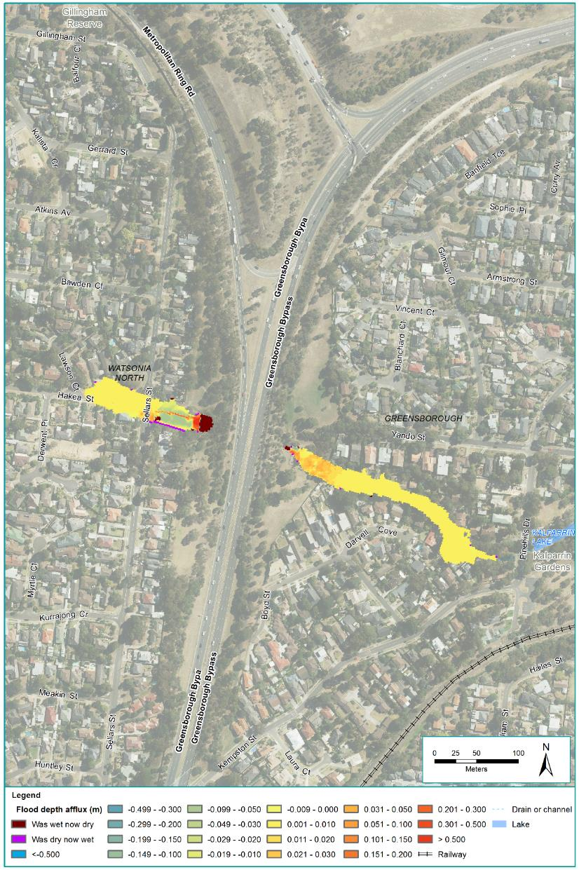
Figure 24-12 1% AEP flood depth afflux for Yando Street Main Drain
The potential for an increase in flood risk would be mitigated by ensuring the risk from changes to flood levels, flow and velocities are minimised (EPR SW6). This would be achieved through further design refinement during detailed design, and may potentially involve land modifications to increase the floodplain storage upstream and downstream of Greensborough Bypass. Modelling of the final design to confirm the adopted mitigation measures adequately offset the impacts on flood levels would also be undertaken to demonstrate compliance with the requirements of Melbourne Water and any other relevant drainage authority.

Kempston Street Main Drain
This assessment has investigated the potential for project assets to cause an increase in flood frequency, velocity or level which affect users or assets within the floodplain of Kempston Street Main Drain (risk SW09). The floodplain storage capacity for Kempston Street Main Drain has the potential to be impacted by a floodwall proposed to be installed adjacent to a new shared use path. The floodwall is required to prevent the shared use underpass beneath Grimshaw Street from becoming an additional outlet to the retarding basin and discharging water to the north beneath Grimshaw Street, but it effectively reduces the storage capacity within an adjacent retarding basin, displacing floodwater.
Modelling of the reference project was undertaken to quantify the potential impacts on flood risk. Modelling indicates that for the design storms investigated, most locations would experience very little change in flood level due to the reference project. Locations where impacts are predicted include:
- Flood levels in the AK Lines Retarding Basin and the depth of flow overtopping Grimshaw Street is increased by up to 40 millimetres in the 1% AEP event
- Flood depth at the corner of Trist Street and Sellars Street, immediately upstream of the top of Kempston Street and within the existing floodplain, is increased by around 220 millimetres.
Figure 24-13 shows the difference in peak 1% AEP flood depth along the Kempston Street Main Drain with the project.
The potential for an increase in flood risk would be mitigated by ensuring the risk from changes to flood levels, flow and velocities are minimised (EPR SW6). This would be achieved through further refinement during detailed design to integrate the retarding basin and shared use path, and may potentially include steepening of grass batters at the retarding basin adjacent to the shared use path or moving the shared use path slightly further east. Modelling of the final design to confirm that the adopted mitigation measures adequately offset the impacts on flood levels would be undertaken to demonstrate compliance with the requirements of Melbourne Water and any other relevant drainage authority.
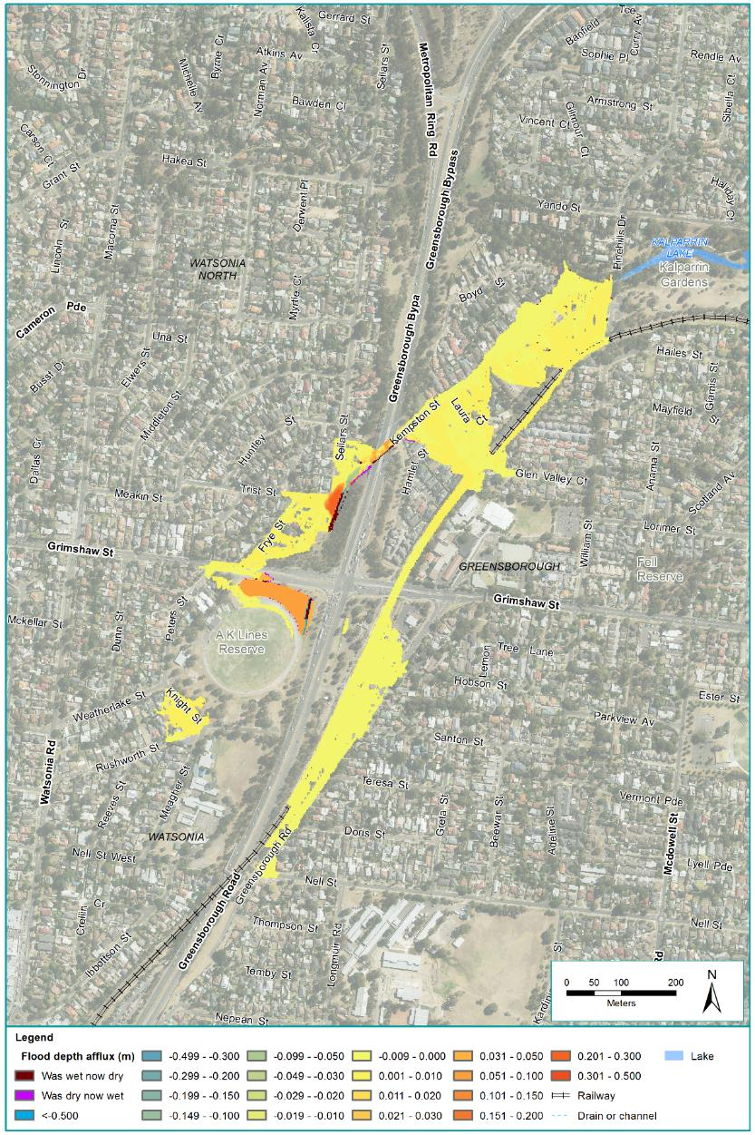
Figure 24-13 1% AEP flood depth afflux for Kempston Street Main Drain

Watsonia Station drain
This assessment has investigated the potential for project assets to cause an increase in flood frequency, velocity or level which affect users or assets within the floodplain of the Watsonia Station drain (risk SW09). The floodplain storage and conveyance for the Watsonia Station drain has the potential to be impacted by the proposed road and car park works to the west of the North East Link alignment and the proposed open trench section of North East Link obstructing the existing overland flow path. These changes potentially reduce attenuation and downstream levels as well as increase upstream ponding levels and divert overland flow across a land bridge to the south of its current alignment.
Modelling of the reference project was undertaken to quantify the potential impacts on flood risk. Modelling indicates that for the design storms investigated, most locations would experience very little change in flood level due to the reference project. The key findings are as follows:
- Flood depths upstream (west) of North East Link on Watsonia Road increased by up to 100 millimetres for the larger events
- Flood depths in the new upstream service road of up to 600 millimetres in the larger events although fairly dry for events up to and including the 10% AEP
- Flood depths in the downstream service road increase in the smaller events by less than 200 millimetres and are generally reduced for the modelled 1% AEP and larger events
- Flooding through the rear of properties fronting Rasheda Street is increased by around 100 millimetres in more frequent events although experiences some modest reductions of less than 100 millimetres in the larger events modelled
- Levels in Rasheda Street and Frensham Road are not significantly changed.
Figure 24-14 shows the difference in peak 1% AEP flood depth along the Watsonia Station drain with the project. The estimated impacts on private property for the smaller flood events described above are provided in Technical report P – Surface water.
Further modelling of the final design to confirm that adopted mitigation measures adequately offset the impacts on flood levels would need to be undertaken to meet the City of Banyule and Melbourne Water requirements (EPR SW6). Mitigation may potentially involve land modifications to increase the floodplain storage both upstream and downstream of Greensborough Bypass. Consultation with the City of Banyule and other stakeholders would occur through the detailed design process.
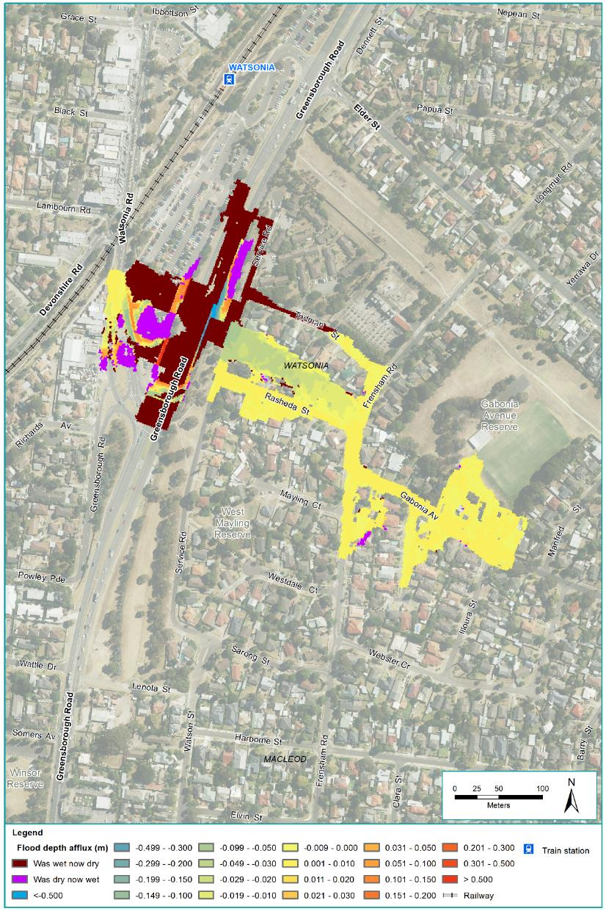
Figure 24-14 1% AEP flood depth afflux for Watsonia Station drain

Banyule Creek
This assessment has investigated the potential for project assets to cause an increase in flood frequency, velocity or level which affect users or assets within the floodplain of Banyule Creek (risk SW09). The floodplain storage capacity for Banyule Creek has the potential to be impacted by the North East Link tunnels, tunnel portals and ventilation structures that would be located within the existing Banyule Creek floodplain that would displace floodwater in a 1% AEP flood event. In addition, the project would result in Banyule Creek being diverted into a drainage system to either side of the North East Link roadway, between Simpson Barracks and Lower Plenty Road. As a result, the existing flood regime would be significantly altered. Storage ponds near to Lower Plenty Road have been included in the design to mitigate potential downstream flood risks resulting from a potential loss of attenuation.
Modelling of the reference project was undertaken to quantify the potential impacts on flood risk. Modelling indicates that with appropriate design in compliance with the EPRs, that the project poses no significant increase in flood depths for any of the events or locations assessed, and no private property would have an increased flood risk.
Figure 24-15 shows the difference in peak 1% AEP flood depth along Banyule Creek with the project.
The potential for an increase in flood risk would be mitigated by ensuring the risk from changes to flood levels, flow and velocities are minimised (EPR SW6), as has been demonstrated with the reference project. Modelling of the final design would confirm the final design adequately complies with the requirements of Melbourne Water and any other relevant drainage authority.
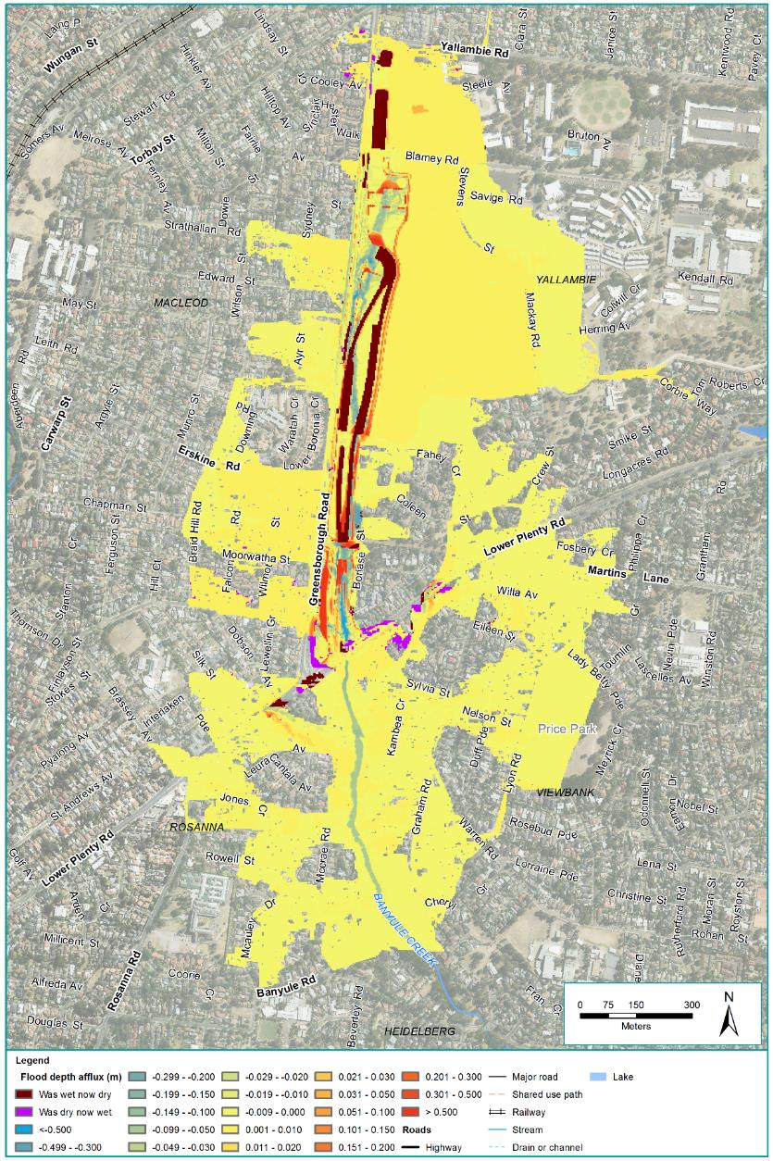
Figure 24-15 1% AEP flood depth afflux for Banyule Creek

Yarra River
This assessment has investigated the potential for project assets to cause an increase in flood frequency, velocity or level which affect users or assets within the Yarra River floodplain (risk SW09). The floodplain storage capacity for the Yarra River has the potential to be impacted by a new interchange at Manningham Road, a tunnel portal and associated ventilation facility located south of the Veneto Club and further to the south surface road and elevated ramps connecting to the Eastern Freeway via a new interchange. These would be located with the existing Yarra River floodplain and would displace floodwater in a 1% AEP flood event.
Modelling of the reference project was undertaken to quantify the potential impacts on flood risk. Modelling indicates that for the design storms investigated, the loss of flood plain storage would have little impact on flood levels.
Due to the road level at Manningham Road, the reference project may cause some localised increases in flood levels (less than 25 millimetres) upstream of Manningham Road. While this is a small increase it continues a substantial distance upstream before fully dissipating.

Smaller increases are predicted along the Eastern Freeway near Burke Road due to a slight lowering of the Eastern Freeway and to the east of Bulleen Road from Koonung Creek. Although these small increases may be further mitigated, a preliminary assessment of the number of properties potentially affected was undertaken and is summarised in Table 24-12. Buildings within the flood extent would not necessarily experience above floor flooding.
Table 24-12 Estimated impact during a 1% AEP Yarra River flood
Location | Maximum afflux(m) | Additional properties affected by flooding | Flooded properties exposed to an increase in flood level | Main buildings within flood extent exposed to an increase in flood level
Eastern Freeway  (near Burke Road) | 0.015 | 0 | 1 | 1
Koonung Creek  (east of Bulleen Road) | 0.016 | 0 | 2 | 0
Yarra River  (north of Manningham Road) | 0.022 | 0 | 123 | 46
Yarra River  (north of Banyule Road) | 0.01 | 0 | 122 | 33
Total | N/A | 0 | 248 | 80

Figure 24-16 shows the difference in peak 1% AEP flood depth along the Yarra River with the project.
The potential for an increase in flood risk would be mitigated by ensuring the risk from changes to flood levels, flow and velocities are minimised (EPR SW6). This would be achieved through further design refinement during detailed design, and may potentially include modifying the level of Manningham Road. Modelling of the final design to confirm the adopted mitigation measures adequately offset the impacts on flood levels would be undertaken to demonstrate compliance with the requirements of Melbourne Water and any other relevant drainage authority.
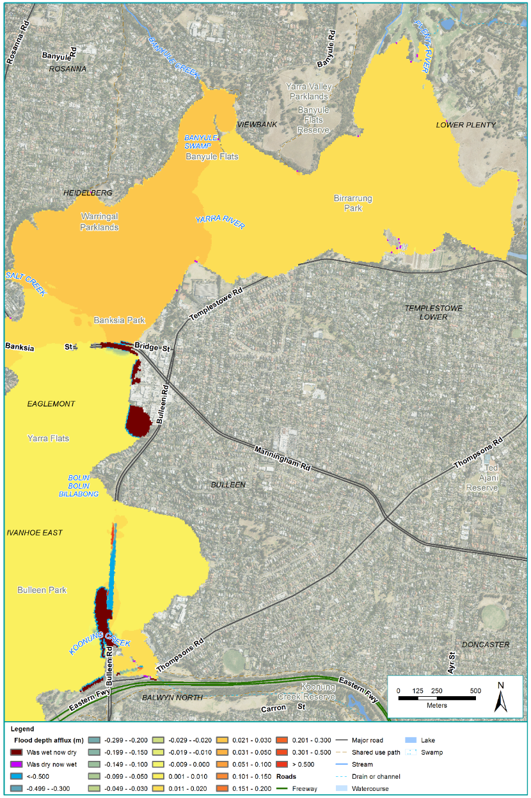
Figure 24-16 1% AEP flood depth afflux for Yarra River

Koonung Creek
This assessment has investigated the potential for project assets to cause an increase in flood frequency, velocity or level which affect users or assets within the floodplain of Koonung Creek (risk SW09). Project infrastructure that has the potential to reduce floodplain storage capacities for Koonung Creek includes:
- Widening of the Eastern Freeway with new lanes
- Diversion and undergrounding of some sections of the existing open channel.
The project also includes provision of compensatory flood storage ponds along Koonung Creek to mitigate potential flood risks.
Modelling of the reference project was undertaken to quantify the potential impacts on flood risk, and noted that:
- There is widespread reduction in flood levels to the north of the freeway between Tram Road and Middleborough Road which reduces flood levels on some private properties for example reductions of 150 millimetres in properties fronting Grange Park Avenue.
- There is no significant change to flooding along Gardenia Road.
- Between Doncaster and Elgar Roads, there is a mix of small reduction in flood levels (~12 mm) and no significant change to existing flooding of residential properties along Valda Avenue. Some localised increases in flooding in this area are limited to parklands with no impact to private properties. Flood extents are generally reduced.
- Between Elgar Road and Tram Road, there is slight reduction of flood levels and extents.
- East of Middleborough Road there are no changes to flood levels as the works do not impact the flood prone areas or the capacity of drainage assets.
Modelling has identified a number of locations for design refinement during the detailed design phase, as summarised in Table 24-13.
Table 24-13 Potential mitigations for residual Koonung Creek flood impacts
Location | Potential flood impact | Potential mitigation
Downstream of Thompson Road | Reduced flood levels on the upstream (east) side of Bulleen Road with a slight increase in the downstream (west) side of Bulleen Road of less than 100 mm | Small reduction in the low flow capacity of the new cross culverts is expected to improve this outcome
Inbound Bulleen Road onramp | The shared use underpass doesn’t have a flood barrier in place and subsequently shows increased flooding in the freeway, especially in the more frequent events. | Protect the shared use underpass with a flood barrier such that the local catchment doesn’t drain through the underpass onto the Eastern Freeway
Southern edge of the Eastern Freeway from Wilburton Parade to Mountain View Road | Removal of existing surface flooding also removes a location which would currently inundate the Eastern Freeway in significant events near Mountain View Road. Flooding on the freeway is reduced, although ponding in the reserve increases with afflux in larger events extending across Carron Street into private property. 1% AEP levels in Carron Street are expected to increase by approximately 400 mm. | This may potentially be reduced by providing a high level outlet from this area or additional storage in the parkland.
Northern side of the Freeway between Bulleen Road and Doncaster Road | There are local increases in flood levels at a number of discrete locations. This is due to a fast flow rate of Koonung Creek which results in a build-up of water trying to get into the inlets during a flood event, and a reduction in local flood storage as a result of the freeway widening. | These issues would individually benefit from local terrain modifications and refinement of upstream storages to slow Koonung Creek.
Between Tram Road and Middleborough Road. | On the south side of the Eastern Freeway, the properties along Eram Road (near Heathfield Rise) experience a flood level increase of up to 90 mm in short duration (smaller volume high intensity) events due to a loss of existing local flood storage. The reductions in flood levels on the north of the freeway increase the outlet capacity from this area sufficiently that in longer duration (lower intensity) events flood levels reduce by up to 250 mm. | Balance water transfer from north to south side of freeway

Figure 24-17 and Figure 24-18 show the difference in peak 1% AEP flood depth along Koonung Creek with the project.
The potential for an increase in flood risk would be mitigated by ensuring the risk from changes to flood levels, flow and velocities are minimised (EPR SW6). This would be achieved through further design refinement during detailed design, which may involve the mitigation measures summarised in Table 24-13. Modelling of the final design to confirm the adopted mitigation measures adequately offset the impacts on flood levels would also to be undertaken to demonstrate compliance with the requirements of Melbourne Water and any other relevant drainage authority.
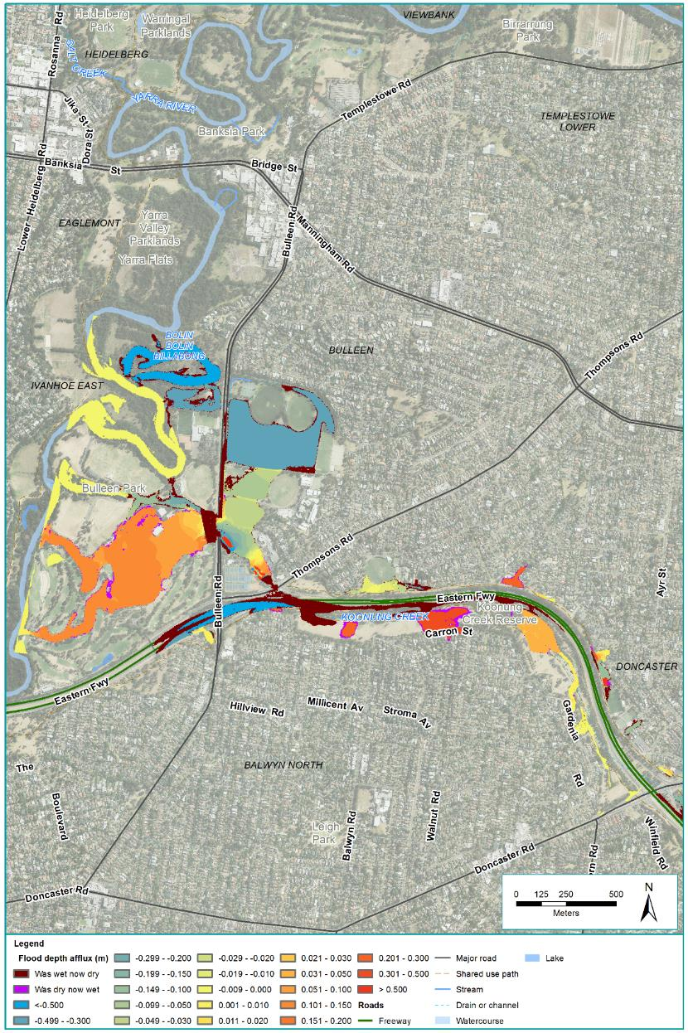
Figure 24-17 1% AEP flood depth afflux for Koonung Creek A
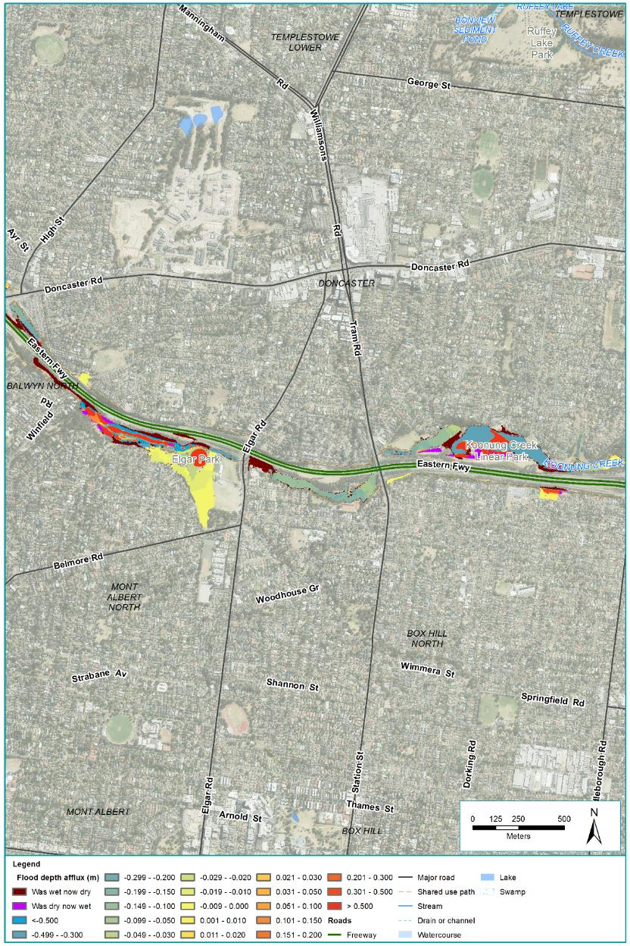
Figure 24-18 1% AEP flood depth afflux for Koonung Creek B

Public safety
This assessment has also investigated the potential for a flood event to occur during the operation of the tunnels, inundating the tunnels and resulting in a risk to public safety (risk SW17). The tunnels could potentially be inundated due to flooding of Banyule Creek at the northern portal, or the Yarra River at the southern portal and Manningham Road interchange.
The northern tunnel portal is located within a flood prone area of Banyule Creek for the reference project, which may be subject to flash flooding. Due to the short length and steep nature of the catchment, flash flooding typically occurs within one to two hours of rain starting. Accordingly, without mitigation there would be limited time to evacuate the tunnel before it was inundated in a significant flood event.
Suitable design standards for the tunnel entrances were developed using a risk based approach which considered a number of scenarios and characteristics.
At the northern portal and Lower Plenty Road interchange the relatively small catchment, small runoff volumes and the lack of warning time has led to the development of a design which copes with a probable maximum flood event (estimated by applying the worst conceivable rainfall event to a catchment with conditions conducive to generating floods).
Hydraulic modelling indicates the safety risk associated with flooding of the northern portal can be physically managed with a combination of diversion of flood waters, suitable road grading and inclusion of floodwalls to protect the threshold. Further protection would be afforded by the implementation of suitable operation and emergency management plans (EPR SW7).
The southern tunnel portals and Manningham Road interchange are located within a flood prone area of Yarra River for the reference project. To manage the risk of flooding of the tunnels, the project would include floodwalls and road geometry carefully considered to provide passive protection during large flood events.
Given the large size of the Yarra River floodplain, peak flows for large floods typically occur several days following rain in the upper catchment. The substantial lead time for large flooding events provides the opportunity to evacuate the tunnels in an extreme flood event. Consequently the tunnel entrances at the southern portal and Manningham Road interchange have been designed with an understanding that a combination of active and passive measures (examples of each being flood gates and floodwalls respectively) would manage the potential for flooding.
Operation, maintenance and emergency management plans would be implemented, detailing the evacuation process in the case of an oncoming flood (EPR SW7). Modelling has demonstrated that with the floodwalls and the implementation of operation management plans and procedures, tunnel users and tunnel infrastructure can be adequately protected and safety risks are minimised.

Climate change
If road drainage is designed with insufficient capacity to accommodate increased rainfall intensities from climate change this could result in the potential for reduced safety during floods (risk SW19).
To reduce this risk, drainage systems designed to remove surface water resulting from rainfall on new roads would be designed to Austroads Standards, and the project’s design would consider the potential effects of climate change with and without the project for current climate and projected future climate change conditions (EPR SW13).
Climate change conditions were considered in the flood modelling of cross drainage undertaken for this impact assessment. The future climate change conditions adopted for the assessment of cross drainage were an increased rainfall intensity of 19% in accordance with Melbourne Water recommendations. Consideration of potential sea level rise is not significant at this elevation and distance from the coast. The results of the modelling did not identify a significant difference in flooding impact for climate change scenarios compared with non-climate change scenarios.

Water quality
Diversion of stormwater, spills from vehicles, increased contaminant load from impervious surfaces and discharges from the tunnel drainage system have the potential to affect water quality during the operation of North East Link. The risk pathways associated with water quality are described in Table 24-14 and potential impacts are discussed below.
Table 24-14 Risk table: Operation – changes from groundwater movement
Risk ID | Risk pathway | Risk rating
Risk SW10 | Diversion of stormwater, causing a change in flow to downstream water quality assets impacting on the performance of the asset. | Low
Risk SW15 | Spills from traffic during operation of the project being released into the waterways resulting in adverse impacts on the beneficial uses of the receiving water. | Medium
Risk SW16 | Increase in impervious area leading to an increase in contaminants being released into the waterways resulting in adverse impacts on the beneficial uses of the receiving water. | Medium
Risk SW18 | Water from tunnel drainage system being discharged to waterways resulting in adverse impacts on the beneficial uses of the receiving water. | Medium
Risk SW21 | Project assets reducing the effectiveness of water quality treatment resulting in adverse impacts on the beneficial uses of the receiving water. | Medium

The potential impacts associated with these risk pathways are discussed in the following section. These have been separated into risks associated with runoff from surface roads, water collected from tunnels, and diversion of waterways.

Surface roads
There are two main ways that surface water has the potential to be contaminated:
- By contaminated runoff from additional road surface area flowing into waterways (risk SW16)
- By spills or accidents occurring on North East Link flowing into waterways (risk SW15).
North East Link includes the construction of approximately 700,000 m² of additional pavement. Stormwater runoff from road surfaces can contain oils, greases and sediment have the potential to affect water quality if discharged to the stormwater drainage system, and subsequently the waterways, without treatment.
To minimise the potential for pollutants to end up in the waterways, a number of water treatment features have been included in the reference project along the alignment that would filter and treat the stormwater captured by the new road surfaces. These water sensitive urban design (WSUD) features include wetlands, bioretention ponds and storage dams which range from approximately 45 m² to 3,000 m² in size. For example, a large 3,000 m² wetland area is proposed at the M80 Ring Road and Greensborough Road interchange, beneath the North East Link elevated roads. This wetland would collect and treat runoff from the new roads and ramps in the vicinity.
Modelling was undertaken to test the effectiveness of the WSUD features included in the reference project. This modelling has shown that the pollutant reduction requirements of Best Practice Environmental Management Guidelines (1999) (BPEMG) can be achieved using a subset of the potentially available sites. Complying with the BPEMG in operation would assist in meeting the SEPP (Waters) over the long term for pollutant concentrations in receiving waters (EPR SW1).
This impact assessment has also investigated the potential for spills of hazardous materials during project operations to pollute waterways (risk SW15). To minimise the potential of spilled liquids ending up in waterways, the project would include the provision of spill containment on new and upgraded road sections including within the tunnels consistent with Austroads guidelines. Further, procedures would be established to respond to any spills of hazardous materials that occur during project operation (EPR SW2).

Tunnels
This impact assessment has investigated the potential for the discharge of these water sources to lead to an increase in contaminants being released into waterways (risk SW18).
During the operation of North East Link, the tunnel drainage system would collect water from the following sources:
- Groundwater seepage (refer to Technical report N – Groundwater)
- Deluge of firefighting substances from testing and accidents
- Rain water from vehicles
- Direct runoff from the approach ramps at the tunnel portals.
Water collected from these sources can contain oils, greases and sediment that has the potential to lead to reduced water quality if discharged to the stormwater drainage system, and subsequently the waterways, without treatment.
To reduce the potential for pollutants to end up in waterways, the project would require a water quality treatment plant to manage and potentially treat the water collected in tunnels before discharge. Subject to the characteristics of the collected water, the discharge may be to sewer or stormwater or reused subject to approval. If discharged to stormwater, the water would be required to be treated to meet SEPP (Waters) (EPR SW1) and have approval from relevant authority before discharge (EPR SW3).

Diversion of waterways
There is the possibility the diversion of existing flow paths including piped flow could cause a change in flow to downstream water quality assets which can adversely impact the performance of the asset (risk SW10). This risk can be mitigated through careful design responding to the hydraulic modelling of flood levels, flows and velocities (EPR SW6), the integration of water sensitive urban design (EPR SW11), and considering the effects of climate change (EPR SW13).
The project assets may impact the performance of an existing water quality asset such as the wetlands south of the Eastern Freeway adjacent to Koonung Creek. This could adversely affect the beneficial uses of the receiving waterway (risk SW21). Retaining or replacing the existing water quality assets would be required to address any direct impact (EPR SW14).

Geomorphology
Changes to the volume and location of water discharges during operation of North East Link have the potential to cause erosion and affect the stability of waterway banks. The risk pathways associated with the changes to geomorphic conditions are described in Table 24-15 and potential impacts are discussed below.
Table 24-15 Risk table: Operation – erosion
Risk ID | Risk pathway | Risk rating
Risk SW11 | Increase in impervious area resulting in an increase in flow discharge leading to bed or bank erosion, causing instability of assets adjacent to the waterway. | Low
Risk SW12 | Increase in impervious area resulting in an increase in flow discharge leading to bed or bank erosion impacting on the beneficial uses of the receiving water. | Low
Risk SW13 | Change in drainage alignment or discharge location concentrating flow and leading to bed or bank erosion, causing instability of assets adjacent to the waterway. | Medium
Risk SW14 | Change to drainage alignment or discharge location concentrating flow and leading to bed or bank erosion, causing increased sediment loads impacting on the beneficial uses of receiving waters. | Medium

The project increases the amount of paved surface through the creation of new roads and ramps, carparks and shared use paths. As the volume of stormwater runoff from roads to waterways increases, there is a risk of peak stormwater inflows changing the stability of those receiving waterways (risks SW11, SW12, SW13 and SW14). The anticipated changes are summarised in Table 24-16.
Table 24-16 Changes to key waterways
Waterways | Changes
Banyule Creek | Diversion of approximately 1,400 metres of creek, and tributaries, from Blamey Road to Lower Plenty Road converting this section of the diverted creek with culverts and overland flow paths with a new retarding basin upstream of Lower Plenty Road. Additionally there would be increased pavement within the catchment. No changes are proposed south of Lower Plenty Road.  Without the mitigation, described below, increase in flow may lead to bed and bank erosion downstream and pose a risk to assets adjacent to the waterway.
Yarra River | No changes are proposed directly to the waterway, however structures and embankments associated with the new tunnel portals and the associated interchanges, substations and vent structures have the potential to alter discharge locations and result in the concentration of flow leading to bed or bank erosion causing instability of assets adjacent to the waterway.  Proposed structures and embankments are generally not within active parts of the floodplain and are unlikely to be significantly affected.
Koonung Creek | The underground diversion or realignment of sections of creek totalling approximately 1,500 metres would result in some parts of the creek being placed in a pipe or culvert. As part of these works some currently piped sections of Koonung Creek would be returned to a naturalised open channel.  Culverts can initiate upstream bed erosion if they are inappropriately recessed into the bed of the waterway and the replacement of a waterway with a hydraulically smooth conduit can cause high flow velocities to be generated resulting in new erosion problems.  Some sections the creek may receive more shading from the new freeway noise walls than under existing conditions. Shading of a creek can cause the loss of essential ground cover vegetation resulting in bed and bank erosion.

Permanent works would be designed, constructed and maintained so as not to increase flood risk associated with overland flow paths or modify the flow regime of waterways to minimise risk from changes to flood levels, flows and velocities (EPR SW6). Any waterway modifications would minimise the potential for erosion which can impact the beneficial uses of the waterway. These modifications to waterways would be designed and undertaken in a way that mitigates the effects of changes to flow and minimises the potential for erosion (EPR SW8). Water sensitive urban design and integrated water management principles would be applied in the stormwater treatment design (EPR SW11). This would include the addition of water treatment areas which would reduce erosion and consequently sediments loads. The new noise walls along the Eastern Freeway, and other elevated structures would be designed to limit shading and overshadowing of vegetation, to maintain bank stability (EPR LP4).
Works undertaken within the waterway or floodplain that involve removing soil from the bed or banks of the creek would have mitigation measures such as the provision of suitable erosion protection on banks, efficient vegetation establishment or other erosion control measures suitable to mitigate the potential for bed or bank instability (EPR SW9). Works on waterways or within floodplains would be undertaken to the satisfaction of Melbourne Water or the relevant drainage authority in consultation with relevant local councils and property managers.
Implementation of these controls would also assist in meeting the State Environment Protection Policy (Waters) requirements and preventing water quality impacts (EPR SW1). The potential for subsidence due to the tunnelling is discussed in Technical report M – Ground movement, and is understood to be insignificant with respect to the function and stability of Banyule Creek and the Yarra River.

Water supply
Operation of North East Link may affect existing water supply assets being used for irrigation. The risk pathway associated with changes to water supply is described in Table 24-17 and potential impacts are discussed below.
Table 24-17 Risk table: Construction – water supply
Risk ID | Risk pathway | Risk rating
Risk SW20 | Project assets leading to changes to water storages or supplies of irrigation assets affecting users. | Low

Project changes have the potential to change water storage or supplies of irrigation to existing users (risk SW20). This could result from water storage areas being unable to be reinstated due to North East Link infrastructure.
The private dam on the Trinity Grammar School Sporting Complex would be impacted by the construction of the cut and cover tunnels at Bulleen Road. If this functionality was not appropriately reinstated, North East Link may impact upon the stormwater storage for irrigation purposes of Trinity Grammar School Sporting Complex and Marcellin College. The existing stormwater supply would need to be maintained to meet the currently supplied irrigation demand of the Trinity Grammar School Sporting Complex and Marcellin College (EPR SW12). This is expected to be achieved through the construction of a new storage dam, or alternative water supply arrangements. Other secondary functions of this system such as local drainage and flood mitigation would also need to be adequately maintained by the proposed works (EPR SW6).
A suitable supply to the newly constructed Bolin Bolin Integrated Water Management Project would also be reinstated to minimise any long-term adverse impacts to the water management project (EPR SW12). Likely solutions are to reconnect to the existing catchment or to provide an alternative water source.

Cumulative impact assessment
The surface water cumulative impact assessment considered flooding and water quality.
There is also the potential for cumulative impacts due to the combined effects of North East Link and other separate upgrades to the M80 Ring Road planned by VicRoads in the immediate vicinity and with respect to the upgrade of the Chandler Highway bridge across the Yarra River. However, no cumulative impacts have been identified because the construction periods of these projects would not overlap and each project would be designed to meet the relevant flooding and water quality requirements during their operation.

Flooding
The potential effects of increased stormwater runoff and reduced attenuation on flooding risk have been assessed. Based on the assessment undertaken and the proposed EPRs, it is expected that flooding risk can be managed locally (typically at the sub-catchment level) in accordance with the requirements of Melbourne Water or any other relevant drainage authority. Accordingly, cumulative flooding impacts are unlikely.
With respect to floodplain storage, North East Link would reduce the current floodplain storage in relation to Yando Street Main Drain, Kempston Street Main Drain, Banyule Creek, the Yarra River and Koonung Creek. Modelling indicates that local treatment measures (such as retarding basins and underground storage) at Yando Street Main Drain and on Banyule Creek are expected to demonstrate that downstream environments are not adversely affected. This would be confirmed as part of detailed design (EPR SW6).
For the Yarra River, the expected impacts are small and in themselves not likely to be significant. Mitigation works may however be required to address the potential for cumulative impacts from numerous projects over time to prevent the incremental reduction in performance of the overall system from lots of small independently insignificant changes and if needed this mitigation would be designed in consultation with Melbourne Water and any other relevant drainage authority. While the potential mitigation measures for residual flood impacts are still being refined for Kempston Street Main Drain, Watsonia Station drain and Koonung Creek, the expectation is that detailed design development and associated modelling would verify that downstream impacts can be mitigated (EPR SW6).

Water quality
With respect to water quality, water sensitive urban design (WSUD) measures are proposed as part of the project design to manage water quality. This would be undertaken at a sub-catchment level, although in certain locations it would be done in the wider catchment. Overall no adverse cumulative impacts on water quality are expected.

Conclusion
This chapter has identified and assessed existing conditions, potential impacts and associated risks to surface water for North East Link.
The study area is located predominantly in the Yarra River catchment with the Yarra River and its tributaries Banyule Creek and Koonung Creek intersecting with the project. Other tributaries of the Yarra River in this area would not be affected by the project. Other overland flow paths that would experience changes from the project include the Yando Street Main Drain, Kempston Street Main Drain and the Watsonia Railway Station drain.
Surface water within the Yarra River tributaries in the study area are generally of poor quality and only some water parameters meet the SEPP (Waters) objectives. Banyule Creek is a small modified watercourse that rises in the areas of Simpson Barracks and flows south, out falling in the Yarra River. Koonung Creek is a large and heavily modified watercourse following construction of the Eastern Freeway. The Yarra River is a large watercourse with significant environmental, heritage and amenity values. Within the study area its catchment is urbanised and vegetated. Water storage for irrigation of several sporting and recreational venues is present.
The risks to flooding, water quality, waterway stability and water supply were assessed to be low to medium. The assessment determined there could be a localised minor increase in flood water levels and there is potential for some pollution and contamination to enter surface water systems. The geomorphic conditions of Banyule Creek and Koonung Creek would change and there is potential for erosion in these watercourses and the Yarra River. Water supply for irrigation of sporting fields would require management.
Refinements during the detailed design phase would improve compliance with the EPRs and further reduce impacts associated flooding risks. The design of the project including the addition of water treatment areas would assist in protecting surface water quality. Banyule Creek and Koonung Creek, and structures surrounding the Yarra River would be designed to minimise erosion on beds and banks of these watercourses. Alternative water supply would be provided to replace the water supply for irrigation of sporting fields where affected.
Based on the EES evaluation objective described at the beginning of this chapter, effects of the project on surface water have been assessed and EPRs have been identified (described in full in Chapter 27 – Environmental management framework) to minimise or avoid impacts to flooding, water quality, waterway stability and water supplies.

