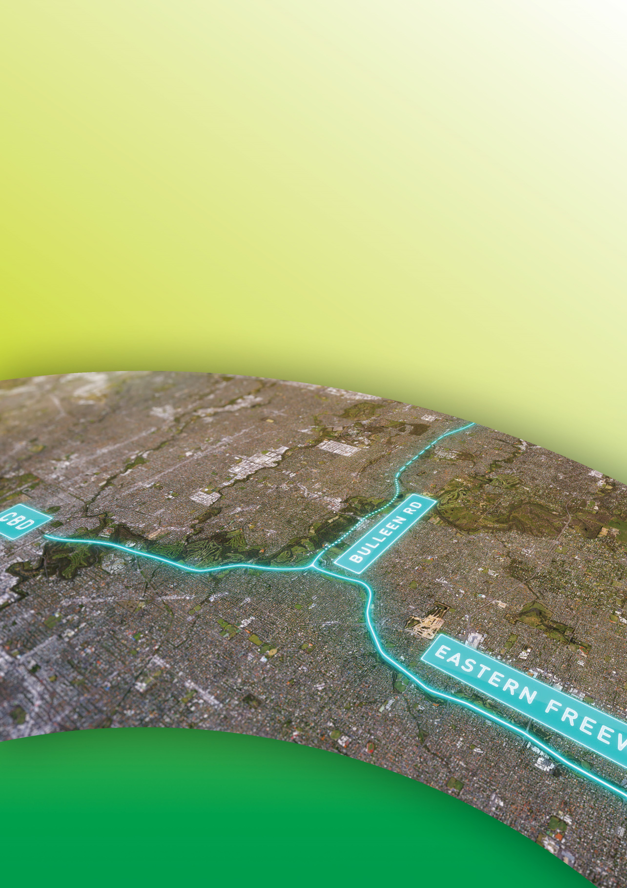
Public Environment Report

Attachment II

PER Content guide
September 2019

Attachment II
PER Content guide
Table II-1 provides a summary of the requirements set out by the PER Guidelines, and explains where each of the requirements of the PER Guidelines (DoEE, 2018) can be found in this Public Environment Report (PER). A copy of the PER guidelines can be found in PER Attachment I – PER Guidelines.

The PER was finalised following exhibition of the draft PER and the receipt of public and stakeholder submissions. A summary of the comments contained in submissions and how those comments have been addressed is provided in Attachment VIII – Submissions report.

Attachment II – PER Content guide | II–1

Table II-1 PER content guide

PER Guidelines reference |  | PER Guidelines requirements | Section(s) where addressed
1.1. | General content | General requirements for the structure and contents of the PER document and its appendices. | General guidance has been considered in preparation of the whole PER.  Detailed technical information, studies and information to support the main PER, including the known variables or assumptions made in the assessment are in:  - PER Technical Appendix A – Flora and fauna technical report  - PER Technical Appendix B – Groundwater technical report  - PER Technical Appendix C – Surface water technical report  - PER Technical Appendix D – Commonwealth land technical report.
1.2. | Format and style | General requirements for the format and style of the PER document and its appendices. | General guidance has been considered in preparation of the whole PER.  Appendices containing detailed technical information and other information that would be made publicly available are:  - PER Technical Appendix A – Flora and fauna technical report  - PER Technical Appendix B – Groundwater technical report  - PER Technical Appendix C – Surface water technical report  - PER Technical Appendix D – Commonwealth land technical report  - PER Technical Appendix E – Project boundary and EPBC boundary coordinates.  A list of Abbreviations for the PER is on page A&G–1. The Glossary of the PER is on page A&G–4.  A copy of the PER Guidelines is in Attachment I.  A list of persons and agencies consulted during the PER is in Attachment V.  The names of the persons involved in preparing the PER and the work done by each of these persons is in Attachment VI.

PER Guidelines reference |  | PER Guidelines requirements | Section(s) where addressed
2. | Specific content | Lists the matters the Department considers may be significantly impacted by the proposed action which includes, but is not limited to:  - Matted Flax-lily (Dianella amoena) (endangered)  - Grassy Eucalypt Woodland of the Victorian Volcanic Plain (critically endangered)  - Swift Parrot (Lathamus discolor) (critically endangered)  - Australian Painted Snipe (Rostratula australia) (endangered)  - Australasian Bittern (Botaurus poiciloptilus) (endangered)  - Macquarie Perch (Macquaria australasica) (endangered)  - River Swamp Wallaby-grass (Amphibromus fuitans) (vulnerable)  - Clover Glycine (Glycine latrobeana) (vulnerable)  - Growling Grass Frog (Litoria raniformis) (vulnerable)  - Australian Grayling (Prototroctes maraena) (vulnerable)  - Latham’s snipe (Gallinago hardwickii) (migratory).  The environment on Commonwealth land, namely the Simpson Barracks. | A description of the matters is provided in Chapter 5. Impacts on these matters are covered in Chapter 7.
A description of the environment on Commonwealth land is covered in Chapter 5.
Impacts on the environment relating to Commonwealth land are covered in Chapter 9.

PER Guidelines reference |  | PER Guidelines requirements | Section(s) where addressed
2.1. | General information | (a) The title of the action. | Section 1.2.1 provides the title of the action.
 |  | (b) The full name and postal address of the designated proponent. | Section 1.2.2 provides the full name and postal address of the designated proponent.
 |  | (c) A clear outline of the objective of the action. | Section 1.2 provides the objective of the action.
 |  | (d) The location of the action. | The location of the action is provided in Section 1.2.3 and PER Technical Appendix E – Project boundary and EPBC boundary coordinates.
 |  | (e) The background to the development of the action. | The background to the development of the action is provided in Section 1.2.4.
 |  | (f) How the action relates to any other actions. | How the action relates to other actions is provided in Section 1.2.5.
 |  | (g) The current status of the action. | Section 1.2.6 provides the current status of the action.
 |  | (h) The consequences of not proceeding with the action. | Section 1.2.7 and Section 4.1 provide the consequences of not proceeding with the action.
2.2. | Description of the action | The PER must include a detailed description of all construction and operational components of the action. This should include the precise location (including coordinates) of all works to be undertaken, structures to be built or elements of the action that may have impacts on MNES.  The description of the action must also include details on how the works are to be undertaken (including stages of development and their timing) and design parameters for those aspects of the structures or elements of the action that may have impacts on MNES. | A description of the action is provided in Chapter 3 and PER Technical Appendix E – Project boundary and EPBC boundary coordinates.

PER Guidelines reference |  | PER Guidelines requirements | Section(s) where addressed
2.3. | Feasible alternatives | The PER must include a discussion of any feasible alternatives to the action to the extent reasonably practicable, including:  - If relevant, the alternative of taking no action  - A comparative description of the impacts of each alternative on the relevant MNES protected under Part 3 of the EPBC Act  - Sufficient detail to make it clear why any alternative is preferred to another. | No action alternative is discussed in Section 4.1.  The impacts of the project design alternatives considered are presented in Section 4.4 (alignment options) and Section 4.5 (alternative components).  Further detail has been presented in Attachment IV – Options assessment.
2.4. | Description of the environment | - Information on MNES within the study area including:  - Description abundance, distribution, ecological relationships of threatened species and ecological communities in the study area  - Description of known threats to, and assessment of quality and importance of, species or communities’ habitats in the study area  - Description of scope, timing and methodology for studies or surveys including assessment of the adequacy of any surveys undertaken. | Information on MNES are presented in Chapter 5.1.
 |  | (b) A description of the surface and groundwater resources relevant to the action and listed threatened species or communities; and migratory species. | A description of the surface water resources relevant to the action and listed threatened species and communities and migratory species is presented in Section 5.2.1 and PER Technical Appendix C – Surface water technical report.  A description of the groundwater resources relevant to the action and listed threatened species and communities and migratory species is presented in Section 5.2.2 and PER Technical Appendix B – Groundwater technical report.
 |  | (c) A description of the Commonwealth land environment to be affected by the proposal. | A description of the Commonwealth land to be affected by the action is presented in Section 5.3 and PER Technical Appendix D – Commonwealth land technical report.

PER Guidelines reference |  | PER Guidelines requirements | Section(s) where addressed
2.5. | Relevant impacts | - Requirements for the assessment of impacts on the Specific content listed in Section 2 of the guidelines. This includes assessment of:  - Direct, indirect, cumulative and facilitated impacts  - Long and short term impacts and if they are reversible  - Analysis of impact significance  - If any impacts are unpredictable or unknown and any additional data that may be needed  - Illustration of impacts using maps  - Description of assessment methodology. | An assessment of impacts on MNES is presented in Chapter 7 and PER Technical Appendix A – Flora and fauna technical report.  An assessment of impacts on the environment on Commonwealth land is presented in Chapter 9 and PER Technical Appendix D – Commonwealth land technical report.
 |  | (b) Requirement to address cumulative impacts. | Cumulative impacts have been addressed in Section 6.3. Facilitated impacts have been addressed in Section 6.4.
 |  | (c) Requirement to address ‘facilitated’ impacts at a local, regional, state and national scale.
2.5.1. | Listed threatened species and ecological communities; and migratory species | Specific requirements for assessment of the impacts on MNES (threatened species, ecological communities and migratory species). These include:  - Number of individuals and area of occupancy affected  - Impacts on population and community  - Loss, alteration or fragmentation of habitat and breeding sites. | The assessment of impacts on MNES is described in Chapter 7 with further detail in PER Technical Appendix A – Flora and fauna technical report.
2.5.2. | Water related impacts | Requirement to assess impacts to waterways and groundwater that could potentially affect MNES or their habitat. | The assessment of impacts to waterways that could potentially affect MNES or their habitat is presented in Section 8.5 with further detail in PER Technical Appendix C – Surface water technical report.  The assessment of impacts to groundwater that could potentially affect MNES or their habitat is presented in Section 8.3 with further detail in PER Technical Appendix B – Groundwater technical report.

PER Guidelines reference |  | PER Guidelines requirements | Section(s) where addressed
2.5.2.1. | Groundwater | Detailed requirements for the Groundwater studies including:  - Description of groundwater characteristics (levels, gradients, flows) of the proposed action area including baseflow to the Yarra River and other waterways and assessment of cumulative impacts  - Identification of groundwater dependant ecosystems and potential impacts on them  - Hydrogeological conceptualisation, investigations, modelling and assessment of construction and operation, short and long term impacts including recovery and re-equilibration  - Assessment of drawdown of local aquifers and impacts on site uses  - Description of construction groundwater management measures and future groundwater monitoring regimes. | The detailed requirements for the groundwater studies have been addressed in PER Technical Appendix B –Groundwater technical report and summarised in Section 5.2, Section 8.2 and Section 8.3.
2.5.2.2. | Surface water | Detailed requirements for the surface water studies including:  - Description of design and construction of diversion channels  - Description of data from baseline monitoring of water quality and flows in potentially affected watercourses  - Assessment of risks and impacts of future erosion and runoff and potential spills of hazardous substances  - Description of mitigation measures and future surface water monitoring regimes. | The detailed requirements for the groundwater studies have been addressed in PER Technical Appendix C – Surface water technical report and summarised in Section 5.2, Section 8.4 and Section 8.5.

PER Guidelines reference |  | PER Guidelines requirements | Section(s) where addressed
2.5.3. | Commonwealth land – whole of the environment | Requirements for the assessment of the whole of the environment on Commonwealth land (and the environment elsewhere that may be directly and indirectly affected by actions on Commonwealth land (see Significant Impact Guidelines (DSEWPAC 2013b) which is taken to be defined both by a stated buffer of ‘500 m of the disturbance footprint’ and by the need to assess impacts on the environmental and ecological services provided by the Commonwealth land at a ‘landscape level’.  The requirements include description of resources used for the assessment, description of the matters affected and assessment of:  - Flora and Fauna  - People and communities (including the Defence estate as a distinct community)  - Cultural and heritage values  - Landscapes and soils  - Water resources  - Pollutants, chemicals, and toxic substances. | An assessment of impacts on the whole of the environment on Commonwealth land is presented in Chapter 9 with further detail in PER Technical Appendix D – Commonwealth land technical report.  Impacts associated with the following matters are presented in:  - Flora and fauna – Section 9.2.1 and Section 9.3.1  - People and communities – (including the Defence estate as a distinct community) Section 9.2.2 and Section 9.3.2  - Cultural heritage values – Section 9.2.3 and Section 9.3.3  - Landscapes and soil – Section 9.2.4 and Section 9.3.4  - Water resources – Section 9.2.5 and Section 9.3.5  - Pollutant, chemicals and toxic substances – Section 9.2.6 and Section 9.3.6.

PER Guidelines reference |  | PER Guidelines requirements | Section(s) where addressed
2.6. | Proposed avoidance and mitigation measures | Requirements for descriptions of safeguards and mitigation, including a consolidated list of measures, which include:  - Details of the impacts to which measures relate  - Maps showing the measures’ location  - The anticipated effectiveness of the measures and the expected environmental outcomes of their use  - Baseline data and/or proposed monitoring to demonstrate achievement of outcomes  - Description of habitat rehabilitation including management, methodology and timing  - Statutory or policy basis and agency responsible for approval of measures  - Cost of the mitigation measures  - An overall framework for management, mitigation and monitoring including provision for independent auditing. | Measures to avoid, mitigate and monitor impacts are discussed in Chapter 7, Chapter 8 and Chapter 9.  Chapter 10 provides a consolidated list of the mitigation proposed and an implementation framework.

PER Guidelines reference |  | PER Guidelines requirements | Section(s) where addressed
2.7. | Residual impacts/ environmental offsets | (a) Requirement for description of likely residual impacts (the ‘Relevant impacts’ referred to in Section 2.5 of the PER Guidelines following the implementation of mitigation measures referred to in Section 2.6. | Residual impacts are discussed in Chapter 7, Chapter 8 and Chapter 9.
 |  | - Requirement for an offset strategy for residual impacts if relevant, consistent with the EPBC Environmental Offsets Policy, including:  - Details of size, location, boundaries, tenure, landscape and ecology of the proposed offset site  - Justification of how the offset package will maintain or improve the viability of the affected matter, including detail of actions to be undertaken, their timing, the risk of damage or degradation of the offset site and legal mechanisms proposed to prevent this happening  - Cost of the offsets package. | Chapter 11 summarises the project’s approach to environmental offsets.
2.8. | Environmental outcomes | Requirement for specific, measurable and achievable outcomes for MNES which should be based on the EPBC Outcomes-based conditions policy 2016 and guidelines and include:  - The impacts to which the outcome relates  - Performance measures for outcomes  - Baseline data used to define the outcome  - Risks of non-achievement  - Capability of achieving the outcome  - The proposed management framework, performance indicators, milestones, independent audits, monitoring and adaptive management, record keeping, publication and reporting processes proposed to achieve the outcome. | Chapter 12 describes the environmental outcomes proposed for the action based on the Commonwealth outcomes based conditions policy (DoE 2016).

PER Guidelines reference |  | PER Guidelines requirements | Section(s) where addressed
2.9. | Other approvals and conditions | Details of requirements for approval or conditions that apply to the proposed action from other jurisdictions or authorities, including any relevant conditions. | Chapter 13 describes the other approvals or conditions that apply to the proposed action.
2.10. | Consultation | Requirement for description of any consultation undertaken in the cause of the assessment. | Chapter 14 describes the public consultation undertaken for North East Link.
2.11. | Environmental record | Requirement to disclose the environmental record of person(s) proposing to take the action. | Chapter 15 presents the proponent’s environmental record.
2.12. | Economic and social matters | Requirement to assess positive and negative impacts of the project including economic costs and benefits and construction and operational employment, including costs and benefits of alternative options. | Chapter 16 describes the social and economic rationale for the action.
2.13. | Information sources provided in the PER | Requirement for information on the source, currency, reliability and uncertainty of data provided in the PER. | Information sources used for the PER have been described in Chapter 17 and presented in Attachment VII.
2.14. | Conclusion | Requirement for an overall conclusion based on compliance with principles of Ecologically Sustainable Development. | Chapter 18 provides a concluding statement on the adherence of the project to principals of ecologically sustainable development and the Objects of EPBC Act.

