- 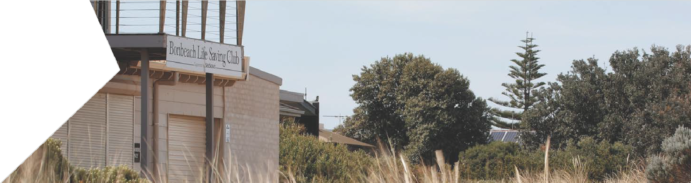POTENTIAL LOCAL IMPACTS AT EDITHVALE AND BONBEACH

SECTION PAGE SECTION PAGE

8.1  8.2 | Introduction  Noise and vibration | 8.2  8.3 | 8.7.2  8.7.3 | Construction impact assessment Operation impact assessment | 8.37  8.39
8.2.1 | Existing conditions | 8.4 | 8.8 | Social | 8.41
8.2.2 | Construction impact assessment | 8.6 | 8.8.1 | Existing conditions | 8.41
8.2.3 | Operation impact assessment | 8.10 | 8.8.2 | Construction impact assessment | 8.42
8.3 | Traffic | 8.14 | 8.8.3 | Operation impact assessment | 8.44
8.3.1 | Existing conditions | 8.14 | 8.9 | Business | 8.45
8.3.2 | Construction impact assessment | 8.17 | 8.9.1 | Existing conditions | 8.45
8.3.3 | Operation impact assessment | 8.23 | 8.9.2 | Construction impact assessment | 8.46
8.4 | Historic heritage | 8.24 | 8.9.3 | Operation impact assessment | 8.48
8.4.1 | Existing conditions | 8.25 | 8.10 | Landscape and visual | 8.49
8.4.2 | Construction impact assessment | 8.28 | 8.10.1 | Existing conditions | 8.49
8.4.3 | Operation impact assessment | 8.28 | 8.10.2 | Construction impact assessment | 8.53

  - Aboriginal cultural heritage 8.29
    - Existing conditions 8.29
    - Construction impact assessment 8.29
8.10.3 Operation impact assessment 8.54
  - Ecology 8.59
    - Existing conditions 8.59
    - Construction impact assessment 8.62
8.6 | Surface water | 8.31
8.6.1 | Existing conditions | 8.31 | 8.12 | Land use | 8.67
8.6.2 | Construction impact assessment | 8.31 | 8.12.1 | Existing conditions | 8.67
8.6.3 | Operation impact assessment | 8.33 | 8.12.2 | Construction impact assessment | 8.67
 |  |  | 8.12.3 | Operation impact assessment | 8.69
8.7 | Air quality | 8.35
8.7.1 | Existing conditions | 8.35

Introduction

This chapter discusses the potential environmental effects during construction and operation at both project sites that may require management through an Environmental Management Framework, as required by Section 3.5 of the Scoping Requirements. It discusses how these activities, and associated changes, would affect either the physical environment or the community surrounding the level crossings.
The assessment of impacts is based on the construction and operation activities described in Chapter 2 Rationale and project descriptions.
The impact assessment is made up of a number of specific studies on the following aspects of the environment:

      - noise and vibration (Section 8.2)
      - traffic (Section 8.3)
      - historic heritage (Section 8.4)
      - Aboriginal cultural heritage (Section 8.5)
      - surface water (Section 8.6)
      - air quality (Section 8.7)
- social (Section 8.8)
- business (Section 8.9)
- landscape and visual (Section 8.10)
- ecology within project areas (Section 8.11)
- land use (Section 8.12).

The potential impact of the projects on each of these aspects of the environment has been studied in detail by qualified specialists. The detailed impact assessments are provided in the attached Technical Reports D to N.
The impact assessment studies have been used to inform the risk assessment process outlined in Chapter 4 Assessment framework, and the preparation of Environmental Performance Requirements (EPRs).
The EPRs have been developed to ensure that potential impacts surrounding the project sites can be avoided, minimised or managed to reduce the level of risk from the projects. A complete listing of the EPRs is available in Chapter 9 Environmental Management Framework, as required by Section 3.5 of the Scoping Requirements for the EES issued by the Minister for Planning (September 2017). The EPRs should be read in conjunction with this chapter.
This chapter includes a section on each aspect of the environment listed above. Each section includes a table showing the risk pathways associated with the relevant environmental aspect and a rating that shows the level of residual risk after the final EPRs developed to manage the risks are in place.
A full breakdown of each risk and risk rating presented in this chapter is provided in Attachment II
Environmental Risk Report.
Potential operational risks for groundwater are discussed in Chapter 5 Modelling the water environment, the Edithvale-Seaford Wetlands are discussed in Chapter 6 Edithvale-Seaford Wetlands and groundwater dependent ecosystems and potential impacts associated with coastal acid sulfate soils and contamination are discussed in Chapter 7 Acid sulfate soils and contamination.

Noise and vibration

Noise and vibration have the potential to cause annoyance and interfere with everyday life. Construction of the projects would generate noise and vibration from the use of construction machinery, excavation, installing piles, building new railway infrastructure and roadworks.
This has the potential to reduce amenity near the works. The extent to which this occurs would depend upon the duration of the activity and the level of noise and vibration it generates. Management of noise and vibration during construction is important to minimise amenity impacts, and prevent vibration-induced structural damage.
Train movements are also a source of noise and vibration, and have the potential to affect human health, amenity, infrastructure and other assets. As the project would alter the physical environment through which trains would pass, the changes to existing levels of noise and vibration during operation have been assessed in order to understand the potential impacts on sensitive receptors.

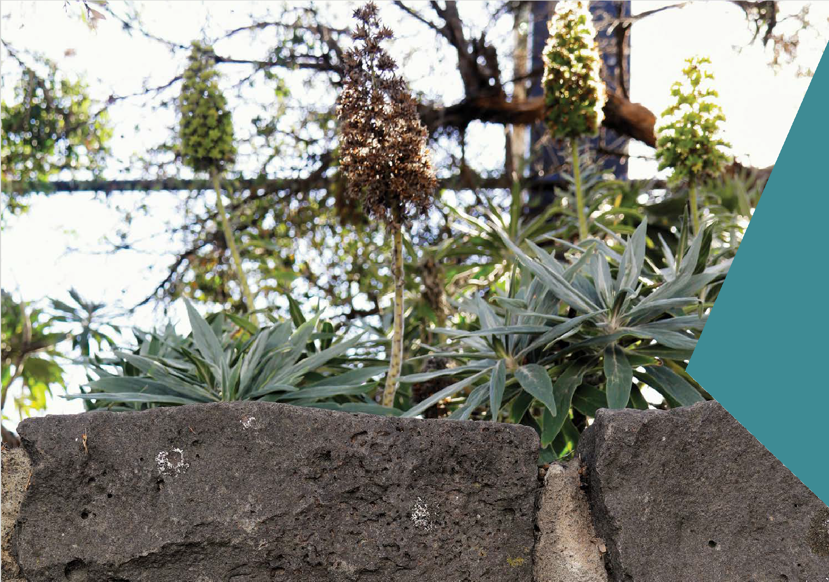What is a sensitive receptor?
Sensitive receptors are locations, assets, values or uses that are considered to be sensitive to a particular activity or impact that would affect its continued use.

Examples include residences, aged care and schools which may be sensitive to amenity impacts such as noise

Measurements of noise
The following terminology is used throughout the assessment:
- A–weighted decibel, abbreviated to dB(A), is a unit used to represent sound pressure level on a logarithmic scale. A-weighting (A) is a frequency filter applied to measured noise to represent how the human ear hears sound. Noise limits applicable to environmental impacts are typically specified in terms of dB(A).
- L_{Aeq}, is the equivalent continuous sound pressure level measured over a specific period (in dBA), and is often referred to as the average sound pressure level over time.

- L_{Aeq,16hr}, is the continuous sound pressure level measured during ‘day-time’, being the 16-hour period from 6am to 10pm.
- L_{Aeq,86hr}, is the continuous sound pressure level measured during ‘night-time’, being the 8-hour period from 10pm to 6am.
- L_{Amax}, is the maximum ‘A’-weighted sound pressure level that occurs during a given measurement period. This value represents the 95th percentile of the loudest sound pressures reached.
Changes in noise levels typically need to exceed

There are two versions of L_{Aeq} used for this assessment:
that have been
3 dB(A) before they are perceptible to the human
ear, as demonstrated by Table 8.1.

Table 8.1 Perceived change in decibel levels

Change in sound level | Perceived change to the human ear
±1dB | Not perceptible
±3dB | Threshold of perception
±5dB | Clearly noticeable
±10dB | Twice as loud

A noise and vibration impact assessment has been prepared and is provided in Technical Report H Noise and Vibration. This section summarises the outcomes of the assessment of construction and operational impacts as a result of the Edithvale and Bonbeach level crossing removal projects.

    - Existing conditions

Noise
The closest noise sensitive receptors near the projects are the residential properties located along Nepean Highway and Station Street. At these locations, the local noise environment is largely dominated by road traffic noise from Station Street and Nepean Highway, as well as rail traffic noise along the Frankston rail line. The receptors near both the Edithvale and Bonbeach sites currently experience similar noise conditions.
Monitoring of the existing noise conditions was undertaken at sensitive receptors across both sites.
At Edithvale, the average daytime noise level was recorded between 55 and 64 L_{Aeq},16hr, while at night it was typically between 51 and 58 L_{Aeqq},8hr. The maximum noise level experienced at Edithvale during the day was 89 L_{Amax}, and during the night it was 83 L_{Amax}.
At Bonbeach, the average daytime noise level was recorded between 53 and 63 L_{Aeq},16hr, while at night it was typically between 47 and 58 L_{Aeq},8hr. The maximum noise level experienced at Bonbeach during the day was 88 L_{Amax}, and during the night it was 81 L_{Amax}.
Figure 8.1 presents a comparison of these average and maximum noise levels to familiar typical noise levels. These results are typical of the noise levels expected to be experienced by residents living adjacent to busy roads.

Figure 8.1 Existing noise levels recorded at Edithvale (left) and Bonbeach (right) compared to some typical noise levels

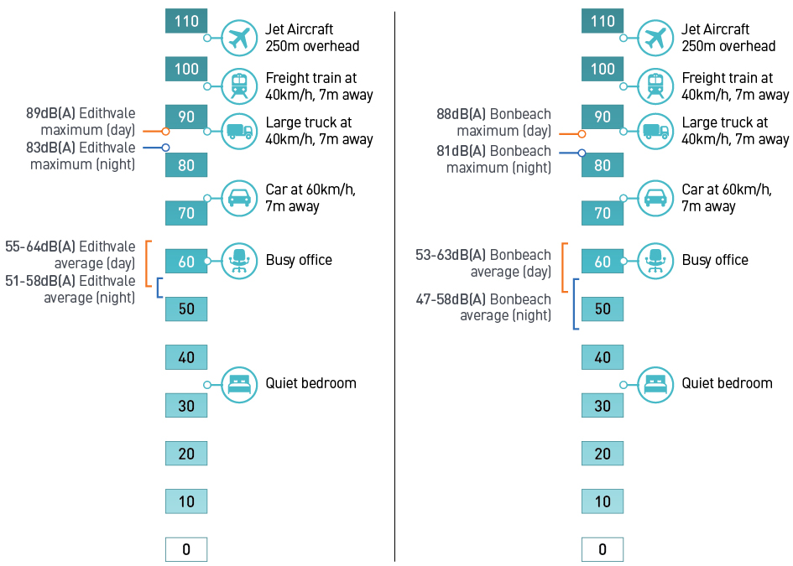

Vibration
Vibration also has the potential to affect amenity and is therefore measured in terms of its likelihood to lead to ‘adverse comments’, whereby occupants express negative responses to vibration, as defined by British Standard BS 6472-1:2008 Guide to evaluation of human exposure to vibration in buildings. This standard specifies the vibration dose values (VDV) used to assess the human response to vibration impacts.
Vibration measurements were recorded six metres from the track to understand the existing typical vibration levels at Edithvale and Bonbeach that are generated by passing trains.
As shown in Table 8.2, the vibration levels recorded were below the level at which adverse comments
are generally reported, according to vibration standards BS6472-1:2008. As a result, the vibration currently caused by passing trains is unlikely to affect amenity at nearby sensitive receivers. No other sources of vibration are known to exist near the projects.

Table 8.2 Vibration Dose Values (VDV) compared to criteria at closest sensitive uses

Scenario | Day (m.s-1.75) | Night (m.s-1.75)
Passenger trains | 0.016 | 0.010
Freight trains | 0.005 | 0.004
All train movements | 0.016 | 0.010
Criteria (VDV for low probability of adverse comments) | 0.2 to 0.4 | 0.1 to 0.2

    - Construction impact assessment
The noise and vibration risks identified for the construction phase of the Edithvale and Bonbeach level crossing removal projects are summarised in Table 8.3. The risk levels are the residual risk remaining after the implementation of the EPRs and controls discussed below.

Table 8.3 Noise and vibration risks – construction

Risk ID | Risk name | Risk pathway | Final EPR | Residual risk
NV15 | Night-time construction noise | Night-time noise during construction exceeds limits causing loss  of amenity at sensitive receptors. | EPR NV2 Construction noise  EPR SC1 Community and Stakeholder Engagement Management Plan  EPR SC2 Respite and Relocation Policy | Moderate
NV16 | Night-time construction noise (unplanned) | Unplanned night- time noise during construction exceeds limits causing loss of amenity at sensitive receptors. | EPR NV2 Construction noise  EPR SC1 Community and Stakeholder Engagement Management Plan | Minor
NV17 | Day-time construction noise | Day-time noise during construction causes increase to existing noise levels resulting in a loss of amenity at sensitive receptors. | EPR NV2 Construction noise  EPR SC1 Community and Stakeholder Engagement Management Plan  EPR SC2 Respite and Relocation Policy | Minor
NV19 | Day-time construction noise (unplanned) | Unplanned day- time work during construction causes increase to existing  noise levels resulting in a loss of amenity at sensitive receptors. | EPR NV2 Construction noise  EPR SC1 Community and Stakeholder Engagement Management Plan | Negligible
NV20 | Vibration (Amenity) | Vibration exceeds limits resulting in loss of amenity. | EPR NV2 Construction noise  EPR SC1 Community and Stakeholder Engagement Management Plan | Minor
NV21 | Vibration (Structure damage) | Vibration during construction results in structural damage. | EPR GM1 Pre-construction condition Surveys | Negligible

Construction Noise
It is acknowledged that construction activities generate noise, and would be particularly impactful during the main occupation where works would be occurring 24 hours a day (for further information of the main occupation, refer to Chapter 2 Rationale and project descriptions). During construction, noise pollution (particularly occurring near built-up areas) may cause annoyance to neighbouring communities. During this time, LXRA is committed to delivering the projects in accordance with the specific EPRs developed for the projects and current guidelines and standard requirements to manage all noise impacts during the construction phase, aiming to ensure that impacts to community amenity are minimised.
To limit potential impacts resulting from construction noise undertaken during the evening, at night, or on weekends, the Victorian EPA’s Noise Control Guidelines, Publication 1254, October 2008 would be used as a guideline. As shown in Table 8.4, these guidelines do not specify criteria for construction activities undertaken during the day, but do for activities outside normal working hours.

Table 8.4 Adopted construction noise criteria

Time | Construction noise criteria
Normal working hours  - 7am to 6pm Monday to Friday  - 7am to 1pm Saturday | No specific limits
Weekend and evening hours  - 6pm to 10pm Monday to Friday  - 1pm to 10pm Saturday  - 7am to 10pm Sunday | 10 dB(A) above existing background levels for a period of up to 18 months  5 dB(A) above existing background levels after 18 months
Night period  - 10pm to 7am Monday to Sunday | Noise must be inaudible within a habitable room of any residential premises
(Source: EPA’s Noise Control Guidelines, Publication 1254, October 2008)

Night-time noise (risks NV15 and NV16)
Noise-generating construction activities would occur at night during the main six-week occupation period when the rail corridor is closed to enable construction of the proposed rail trenches, as well as intermittently during site preparation and piling works.
Given the residential nature of the Edithvale and Bonbeach areas, the receptors at both sites that have the highest potential to be affected by any changes to noise conditions are residential dwellings along Station Street and Nepean Highway adjacent to the project works. Noise impacts may also be experienced by residents further back from the existing rail alignment.
Noise levels would be managed in accordance with Victorian EPA’s Noise Control Guidelines where possible. Where it is not possible to meet these or the requirement that noise must not be audible within a habitable room of a residence between 10pm and 7am, a Construction Noise and Vibration Monitoring Plan (CNVMP) would be implemented to minimise the potential for noise impacts to sensitive receptors (EPR reference NV2). Measures would be implemented to minimise the risk of impacts from construction noise, including:
      - identifying sensitive receptors along the project alignment
      - details of construction activities and an indicative schedule for construction works, including the identification of noise generating construction activities that have the potential to impact sensitive receptors
      - standard noise management measures such as:
        - scheduling noisy works to typical construction hours where feasible (i.e. Monday to Friday 7am to 6pm, and Saturday 7am to 1pm).
        - limiting night works outside of the main occupation periods
        - planning site works to limit vehicle movements to certain locations and time periods
        - substituting noisy plant or processes with quieter options (e.g. broadband reversing and movement alarms instead of conventional beepers)
        - providing temporary noise barriers where practicable
        - monitoring of noise associated with construction
        - notifying residents who may be impacted by noise in advance of the works
        - a procedure for managing complaints.
The measures outlined above (EPR reference NV2) would be implemented to minimise the noise generated during the evening and night time works for all project phases to minimise noise impact as much as possible.

During the main occupation, works would occur 24 hours a day to minimise the length of time that the railway is closed. Complete avoidance of noisy works during the evening and night time would extend the main occupation and rail closure from the proposed six weeks to at least 12 weeks, resulting in significant additional disruption to the approximately 40,000 people who use the Frankston rail line each day.
During the main occupation period, reduction of the night and evening construction noise levels to comply with the EPA guideline limits is unlikely to be possible for all receptors because of their proximity and the intensity of construction activities. Construction noise levels during the night and evening are predicted to exceed the guideline limits recommended by EPA Victoria on occasion during the six-week main occupation period at some receptor locations. This may mean noise levels would be 10 dB(A) or more above existing background levels during the evening, or audible within a habitable room of residential premises during the night.
In these circumstances, the CNVMP must outline airborne noise management levels and mitigation measures for evening and night time works. The management level is not a noise limit or target, but represents noise levels above which community reaction may be adverse and which should trigger mitigation actions to minimise the noise impact. Depending on noise levels, noise mitigation measures may include:
    - offer of respite
    - offer of relocation in accordance with a Respite and Relocation Policy (EPR reference SC2) and Community and Stakeholder Engagement Management Plan (EPR reference SC1).
A key mitigation for night time noise is the development and implementation of the Respite and Relocation Policy, once a detailed understanding of the noise impacts from construction are known (EPR reference SC2).
The relocation policy would be developed and implemented by the Alliance that is formed to deliver the projects (for more information on the Alliance approach to delivering the projects, see Chapter 9 Environmental Management Framework). The relocation policy would provide the option for residents affected by night time noise during construction to be temporarily relocated during noisy works.
A Community and Stakeholder Engagement and Management Plan (EPR reference SC1) would be developed and implemented to ensure that clear and timely engagement occurs to inform the community about noisy works. The plan would ensure the community is aware of potential impacts, assist in minimising noise-related disturbance and provide guidance for advising residents about the relocation policy.
Some impacts from noise during construction works would result in a loss of amenity, including disruption associated with relocation. The risk associated with night-time noise from construction has been assessed
as moderate given that receptors have the potential to be impacted during the main occupation period, however a relocation policy would be in place and clear, timely information regarding noisy works would be provided.
There is also the potential for the adopted EPA noise limits (as set out in Table 8.4) to be unexpectedly exceeded at night-time for unplanned activities occurring during site preparation works (outside of the main occupation period). Unplanned noise activities may include late oversize deliveries to site, or daytime works that overrun into the evening or night (such as time critical concrete pours). These activities may affect local amenity and result in complaints from the community. To control this risk, the CNVMP would be implemented, specifying measures to minimise noise (EPR reference NV2), as well as a complaints management system (EPR reference SC1) and onsite noise monitoring (EPR reference NV2). As a result, any impact would be unlikely and short term, and the risk of a loss of amenity due to unplanned noise therefore has a minor rating.

Day-time noise (risks NV17 – NV19)
There are no set EPA noise limits prescribed for day-time construction work. Day-time construction works would occur over an 18-month period, with variable levels of noise generated during that time.
Noise levels would generally be managed through scheduling and planning of works, in accordance with the CNVMP (EPR reference NV2). Given that noisier works would be planned for the daytime and that the noise sensitive receivers would generally be located more than 20 metres away from the main construction machinery, day-time noise levels generated by the works would be noticeable at receptors but are expected to be within a range that would be considered reasonable for short periods.

A Community and Stakeholder Engagement Management Plan (CNVMP) would be implemented for community stakeholders and land owners potentially affected by noise and vibration from construction works, specifying the requirements to provide advanced notice of works (planned) and procedures for resolving complaints (EPR reference SC1). Therefore, the risk of daytime noise resulting in a loss of amenity would have a minor rating.
Unexpectedly noisy works also have the potential to occur during the day-time for time-critical activities. These would be minimised through the implementation of the CNVMP (EPR reference NV2) and the impact would be temporary in nature; therefore this has a negligible risk rating.

Construction Vibration
Construction activities that cause vibration have the potential to affect sensitive receivers within the study area by affecting amenity or through structural damage to buildings. The activity with the greatest potential for vibration impacts to receivers is piling. Other construction activities that may cause vibration impacts include earthworks and ground compaction.

Vibration – amenity (risks NV20)
The receptors that have the potential to be impacted by amenity changes due to vibration generated by the projects are the residential dwellings along Station Street and Nepean Highway. Vibration Dose Values (VDVs) for human comfort are provided in Table 8.2.
Driven piles are likely to have vibration impacts at nearby receivers and the VDVs for human comfort may be exceeded. Dynamic pile testing could also potentially exceed the VDVs for human comfort at nearby receptors.
However, management of risk of impacts from vibration levels would be provided through an assessment of potential impacts expected during construction based on known construction methods (EPR reference
NV3). This may require monitoring of sensitive receptors. If impacts from vibration are anticipated, mitigation measures may include:
      - substituting high vibration plant or processes with lower vibration options
      - using vibration monitoring to inform management and mitigation
      - communication with potentially affected residents through the Community and Stakeholder Engagement Management Plan (EPR reference SC1) to give advanced warning to residents of the impending works
      - respite or relocation of residents (EPR reference SC2), if necessary
The likelihood of this risk occurring is low, and as a result the impact would generally be short-term and temporary in nature, and therefore the loss of amenity would be a minor risk.

Vibration – structure damage (risks NV21)
Guideline values for structural damage are adopted from the German Standard DIN 4150-3: 1999 Vibration in buildings – Part 3: Effects on structures, and summarised in Table 8.5.

Table 8.5 Adopted construction vibration limits for structures

Type of structure | Vibration at the foundation (mm/s) |  |  | Vibration (mm/s) at horizontal plane of highest floor
 | At a frequency of 1 Hz to 10 Hz | At a frequency of 10 Hz to 50 Hz | At a frequency of 50 Hz to 100 Hz
Buildings used for commercial purposes, industrial buildings and buildings of similar design | 20 | 20 to 40 | 40 to 50 | 40
Residential dwellings and buildings of similar design and/or occupancy | 5 | 5 to 15 | 15 to 20 | 15
Structures that, because of their particular sensitivity to vibration, cannot be classified under lines 1 and 2 and are of great intrinsic value | 3 | 3 to 8 | 8 to 10 | 8

The potential for structural damage would be controlled by identifying the structures with the potential
to be impacted by vibration during the construction period, and if necessary, completing condition surveys and monitoring of these structures (EPR reference NV3).
Contingency measures would be implemented, if necessary, as a result of the monitoring to reduce vibration levels. With the adoption of these controls, and due to the distance between the construction activities and receptors, it is unlikely that structural damage limits in Table 8.5 would be exceeded. Therefore, the risk of vibration levels resulting in structural damage would be negligible.
From the risk assessment, the greatest noise and vibration risk identified during construction was night time works during the main occupation. This work would occur over a six-week period and could not be further mitigated. The other risks from noise or vibration could occur throughout the 18-month construction period. The residual risk is considered to be negligible after management and mitigation is in place.

Operation impact assessment
The noise and vibration risks identified for the operation phase of the Edithvale and Bonbeach level crossing removal projects are summarised in Table 8.6. The risk levels presented are the residual risk remaining after the implementation of the EPRs and controls discussed below.

Table 8.6 Noise and vibration risks – Operation

Risk ID | Risk name | Risk pathway | Final EPR | Residual risk
NV14 | Night time operational noise | Night-time noise during operation exceeds limits causing loss of amenity at sensitive receptors. | EPR NV1  Operational noise | Negligible
NV18 | Day-time operational noise | Day-time noise during operation exceeds limits causing loss of amenity at sensitive receptors. | EPR NV1  Operational noise | Negligible
NV20 | Vibration (amenity) | Vibration exceeds limits resulting in loss of amenity. | No EPR required | Negligible

Passenger and freight trains
Noise thresholds
The Victorian Government’s Passenger Rail Infrastructure Noise Policy (PRINP) has been established to guide transport bodies and planning authorities in their consideration of the impacts of rail noise from improved or new passenger rail infrastructure. The PRINP investigation thresholds are outlined in Table 8.7. Options for avoiding, minimising and mitigating railway noise should be considered if noise exceeds the investigation thresholds.

Table 8.7 PRINP investigation thresholds for redevelopment of existing passenger rail infrastructure

Time | Type of receiver | Investigation threshold(s)
Day  (6am to 10pm) dB(A) | Residential dwellings and other buildings where people sleep including aged person homes, hospitals, motels and caravan parks.  Noise sensitive community buildings including, schools, kindergartens and libraries | 65 dB(A) L_{Aeq} and change in L_{Aeq} of 3 dB(A) or more  or  85 dB(A) LAmax and change in LAmax of 3 dB(A) or more
Night  (10pm to 6am) dB(A) | Residential dwellings and other buildings where people sleep including aged person homes, hospitals, motels and caravan parks | 60 dB(A) L_{Aeq} and change in L_{Aeq} of 3 dB(A) or more  or  85 dB(A) LAmax and change in LAmax of 3 dB(A) or more
(Source: Table C, Attachment 2 of PRINP)

Train noise modelling
Noise modelling was done to understand any changes to the noise environment as a result of train movements after the construction of the projects.
Noise levels were modelled to predict average (L_{Aeq}) and maximum (L_{Amax}) noise levels from trains for both day-time and night-time periods. Under the PRINP, the assessment of maximum noise levels (or L_{Amax}) is based on the 95th percentile.
Two scenarios were modelled for comparison — the current situation (without the projects), and following delivery of the projects (with the projects). The model was set up to simulate the movements of the three different types of train that occur on the Frankston rail line:
      - electric passenger trains – noise from electric passenger trains is typically generated by the interaction between wheel and rail
      - diesel passenger trains – similar to electric trains, noise is created by the interaction of wheel and rail, as well as additional noise from the diesel engine
      - freight trains – these are typically diesel operated and involve a locomotive pulling along trailing wagons. Noise from freight trains consists of engine noise from the locomotive (typically from the exhaust at the top of the locomotive), and noise from the interaction of wheel and rail for freight wagons.
Upon the completion of the projects, the number of trains assumed to pass through the study area each day are shown in Table 8.8.

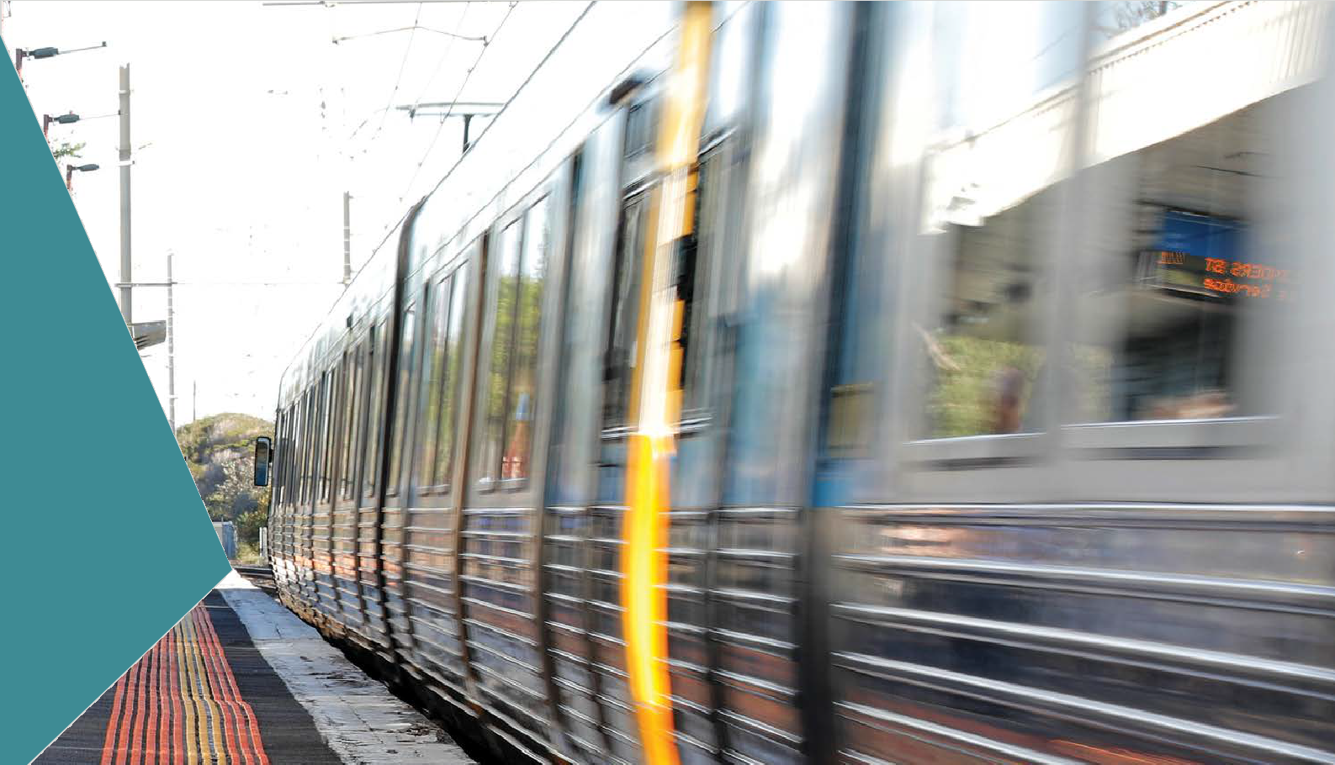Table 8.8 Train movements considered by the noise model at project opening

Vehicle type | Length | Speed | From city: Day | From city: Night | To city: Day | To city: Night
Electric passenger train | 143 m | 95 km/hr | 96 | 13 | 97 | 14
Diesel passenger train | 26 m | 95 km/hr | 0 | 1 | 1 | 0
Freight train | 650 m | 65 km/hr | 2 | 1 | 2 | 1

The noise modelling considered both day and night time investigation thresholds as defined by the PRINP.

The investigation threshold for average noise level is based on the noise generated by electric passenger, diesel passenger and freight train movements. The maximum noise level is based on the 95th percentile loudest noise generated by the same movements.

Noise levels (NV14, NV18)
Currently, the passenger and freight trains operate in an open rail line, with no specific noise or vibration attenuation. The lowering of the rail line into trenches would create a shielding effect, whereby some
of the noise generated by the trains would be blocked by the walls of the trench.
The modelling shows that because of shielding of noise provided by the trench walls, passenger rail noise levels at the majority of receiver locations are generally reduced by around 5 dB(A). A 5dB reduction in noise is expected to be clearly noticeable to the human ear. The largest reduction in noise from passenger rail movements occurs at the deepest points of the trench, around Bonbeach and Edithvale stations.
Where freight locomotives are moving up the gradient to exit the trench, noise is increased because of the need for a higher locomotive notch (or throttle) setting. However, this effect does not meet the investigation thresholds in the PRINP.
Refer to Technical Report H Noise and Vibration for a complete set of noise contours at both sites.

To summarise, the modelling shows that the PRINP thresholds would not be exceeded and that (EPR NV1) would be complied with. The projects would result in lower average noise levels compared to current levels because of the trench design and the removal of the level crossing warning signals. Therefore, the risk of noise levels exceeding the investigation levels in the PRINP and resulting in an impact to amenity at sensitive receptors due to noise is assessed as negligible.

Noise from stations and fixed rail infrastructure
Inert rail infrastructure associated with the rail line is required to comply with the Victorian State Environment Protection policy (SEPP N-1) limits. SEPP N-1, developed by the Environment Protection Authority (EPA) Victoria, prescribes procedures for determining the statutory environmental noise limits which apply at sensitive receptors. It aims to protect people from industry noise that may affect normal domestic and recreational activities, including sleep at night. The substation at Edithvale is required to comply with SEPP N-1. The substation could be located in one of two positions as seen in Figure 8.2.

Figure 8.2 Potential location of substation at Edithvale

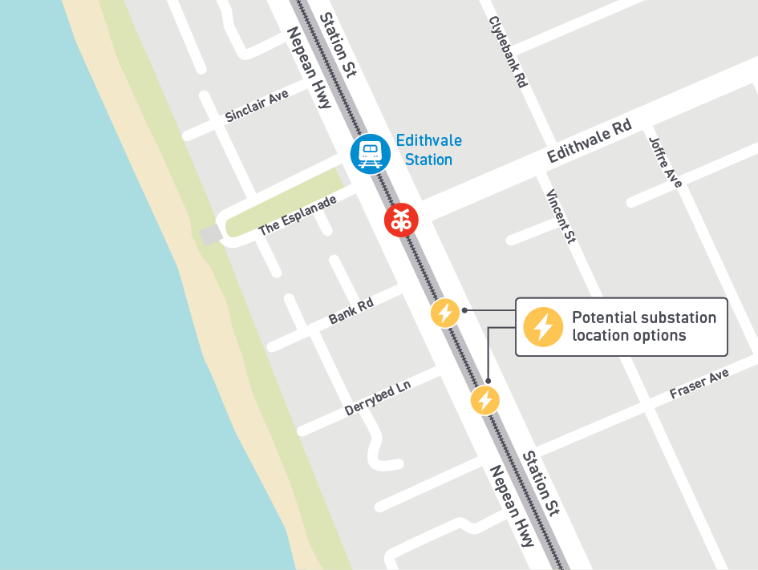

Noise limits are calculated by taking into account existing background noise levels, and the type of area in which the sensitive receptor is located. The design of the substation would ensure that any noise generated by the substation is under the SEPP N-1 noise limit.
Additionally, the stations at Bonbeach and Edithvale would need to achieve the SEPP N-1 noise limit. The primary source of noise from the station would be from the public address (PA) system. The PA system will be designed to ensure that noise emissions achieve compliance with SEPP N-1 limits.

Vibration (risk NV20)
Vibration is affected by the distance between the source and the receptor. As the railway corridor would not be any closer to sensitive receptors than is currently the case, operational vibration levels are not expected
to be different from existing conditions. At distances greater than 15 metres from the rail line, vibration levels are predicted to be below the levels likely to cause an impact on nearby residents and receptors. Therefore, the risk of vibration levels exceeding the criteria and resulting in a loss of amenity would be negligible.

Traffic

The safe and efficient operation of the road network is a key factor in how the community moves through and uses its neighbourhood. The removal of the level crossings at Edithvale and Bonbeach would improve transport options in the area by providing safe east-to-west access across the railway line for all modes of transport, including pedestrians. Currently, traffic disruption is experienced across a wider area than the immediate surrounds
of the project areas, with boom gates down at Edithvale for an average of 42 minutes during the weekday morning peak, and 45 minutes at Bonbeach.
During construction, it is important to understand potential transport impacts so that they can be appropriately managed and do not result in unacceptable impacts to the community and businesses. Such impacts would be temporary and could include increased road congestion and delays, restricted access and mobility across the rail corridor, longer travel times and increased crashes.
Understanding the likely changes resulting from the projects is also important to inform the community and stakeholders about the proposed design and how the transport network would function on completion of the works.
A traffic impact assessment has been prepared and is provided in Technical Report G Traffic. This section summarises the outcomes of the assessment of impacts during construction and following completion of the Edithvale and Bonbeach level crossing removal projects.

    - Existing conditions

Edithvale
The Edithvale Road level crossing is located at the end of Edithvale Road between Station Street and Nepean Highway. Nepean Highway is classified as an arterial road under the management of VicRoads and is a key north-south route in the bayside suburban road network. Station Street is a local road under
the management of Kingston City Council that provides a localised movement and access function. Edithvale Road is the extension of Springvale Road and connects the beachside suburbs between Mordialloc and Patterson River to the Mornington Peninsula Freeway and suburbs to the north and east.
The estimated Annual Average Daily Traffic (number of vehicles per day) for Nepean Highway, Station Street and Edithvale Road is shown in Figure 8.3.

Figure 8.3 Annual Average Daily Traffic – Edithvale
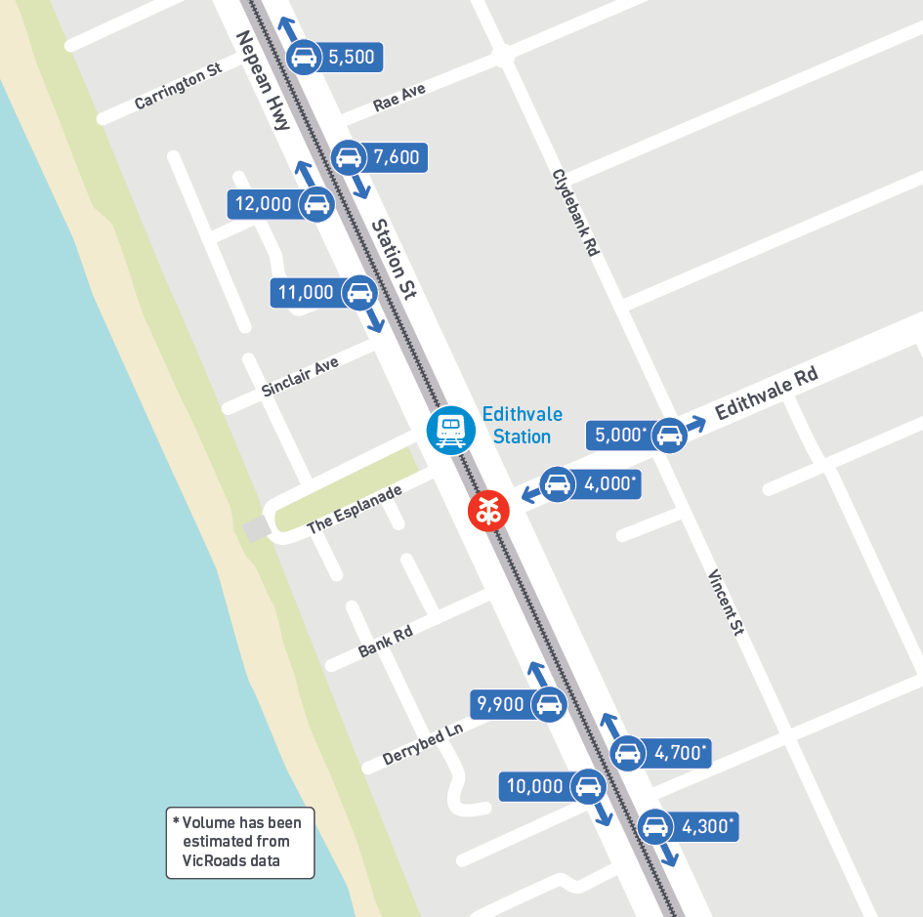

Traffic data indicates that morning and afternoon peak hour traffic volumes on Nepean Highway, Station Street and Edithvale Road near the level crossing are less than the typical capacity for this type of road (which is considered an urban road with interrupted flow).

Site observations found that vehicles travelling through the Nepean Highway, Station Street and Edithvale Road intersections are subject to delays under the current operation of the intersections and boom gates. Traffic signal data indicates the boom gates are down for an average of 42 minutes during the weekday morning peak between 7-9am. The duration of boom gate closures invites risk-taking behaviour from road users trying to ‘beat’ the red lights and boom gates to avoid lengthy waits. This behaviour is likely to compound as population growth places further demand on the road and rail networks.
At Edithvale, long queues were seen during traffic observations, however each approach to the intersections cleared almost every time after the boom gates were raised apart from the north approach on Nepean Highway.
Statistics provided by Transport Safety Victoria and the Office of the National Rail Safety Regulator for the Edithvale level crossing indicate that in the 10-year period ending on the 31 December 2014 there was one fatal collision between a train and road vehicle and seven near miss incidents between a train and pedestrian. Statistics taken from VicRoads’ Crashstats database for the same period indicate that there were 11 casualty crashes that did not involve a train, recorded within 20 metres of the level crossing on Edithvale Road.
Three bus routes (numbers 706, 858 and 902) travel along Station Street, however none use the level crossing. The 858 and 902 bus routes also use Edithvale Road.

Station Street is a Strategic Cycling Corridor (corridors designated to improve cycling to and around major activity centres) and existing Principal Bicycle Network route (a network of existing and proposed cycle routes identified to help people ride to major destinations). Edithvale Road is also an existing Principal Bicycle Network route. Cyclist counts were also undertaken for the project. Cyclist volumes on a weekday were relatively evenly spread between Nepean Highway and Station Street with a very low number of cyclists using Edithvale Road. Cyclist numbers on Station Street and Nepean Highway increase significantly on weekends.
Pedestrian counts were undertaken for formal (i.e. signalised) and informal crossing points at Edithvale. The results show that the Station Street pedestrian crossing has significantly higher pedestrian volumes than the crossing of Nepean Highway.

Bonbeach
The Station Street level crossing at Bonbeach is located at the intersection of Nepean Highway, Station Street and Bondi Road. The designation and function of Nepean Highway and Station Street are as discussed above for Edithvale. Bondi Road is a local road that serves as an access to residential land use and sporting facilities.
The estimated Annual Average Daily Traffic (number of vehicles per day) for Nepean Highway, Station Street and Bondi Road is shown in Figure 8.4 below.

Figure 8.4 Annual Average Daily Traffic – Bonbeach 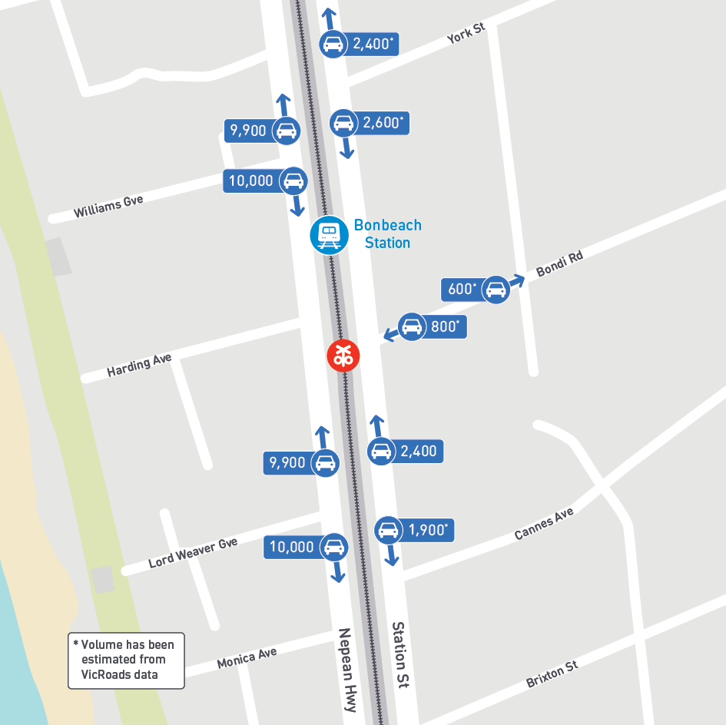

Traffic data indicates that morning and afternoon peak-hour traffic volumes on Nepean Highway, Station Street and Bondi Road near the level crossing are less than the typical capacity for this type of road.
Traffic observations found that vehicles travelling through the Nepean Highway, Station Street and Bondi Road intersection are subject to delays under the current operation of the intersection and boom gates and in particular, those vehicles turning across the level crossing. Traffic signal data indicates the boom gates are down for an average of 45 minutes during the weekday morning peak between 7am and 9am.
The duration of boom gate closures invites risk-taking behaviour from road users trying to ‘beat’ the red lights and boom gates to avoid lengthy waits. This behaviour is likely to compound as population growth places further demand on the road and rail networks.
Statistics provided by Transport Safety Victoria and the Office of the National Rail Safety Regulator for the Bonbeach level crossing indicate that in same 10-year period as referenced above there was one non-fatal collision incident between a train and road vehicle, three near miss incidents between a train and road vehicle and five near miss incidents between a train and pedestrian. Statistics taken from VicRoads’ Crashstats database for the same period indicate that there were 16 casualty crashes that did not involve a train, recorded within 20 metres of the Station Street / Bondi Road level crossing.
There are no bus routes on this section of Nepean Highway or Station Street.
Nepean Highway is a Strategic Cycling Corridor and existing Principal Bicycle Network route in the area of the level crossing. A cyclist count during the week at Bonbeach found that cyclist volumes are evenly spread across Nepean Highway and Station Street, although there is an early southbound movement
on Nepean Highway.
Pedestrian counts were undertaken for formal (i.e. signalised) and informal crossing points at Bonbeach. The results show that the Station Street pedestrian crossing has significantly higher pedestrian volumes than the crossing of Nepean Highway. Surveys of informal crossing locations indicated most pedestrian traffic was to and from the station from parking on the western side of Station Street.

Construction impact assessment
The traffic risks identified for the construction phase of the Edithvale and Bonbeach level crossing removal projects are outlined in Table 8.9.

Table 8.9 Traffic and transport risks – construction

Risk ID | Risk name | Risk pathway | Final EPR | Residual risk
T28 | Traffic (delay during main works) | Construction (including rail shutdowns) reduces road capacity and/or increases traffic volumes resulting in delays and increased travel time during the piling and main rail occupation. | EPR T1 Transport Management Plan  EPR T2 Public Transport Disruption Management Plan  EPR T3 Pedestrian and cyclist connectivity EPR T8 Emergency services | Moderate
T29 | Traffic (delay outside main works) | Construction (including rail shutdowns) reduces road capacity and/or increases traffic volumes resulting in delays and increased travel time outside the piling and main rail occupation. | EPR T1 Transport Management Plan  EPR T2 Public Transport Disruption Management Plan  EPR T3 Pedestrian and cyclist connectivity EPR T8 Emergency services | Minor

Risk ID | Risk name | Risk pathway | Final EPR | Residual risk
T30 | Traffic (dirt on roads) | Plant and spoil trucks deposit construction debris on public roads leading to dust generation, perceived  loss of amenity and public health and safety issues. | EPR T7 Debris on roads | Negligible
T31 | Traffic  (road safety) | Construction results in disruption to the  transport network and/ or increases in traffic volumes leading to increased crashes or the perception that the area is less safe. | EPR T1 Transport Management Plan | Minor

Construction traffic and road safety (risk T28, T29, T31)
Implementing significant transport infrastructure projects (such as level crossing removals) in constrained urban areas often results in a level of disruption to access and mobility. Work during the construction phase of the level crossing removal projects has the potential to impact traffic operations and road safety. Aspects of construction that have been identified as having the greatest potential to result in impacts include:
    - construction traffic
    - lane closures (vehicle and bicycle lanes) and parking removal
    - road closures
    - rail line closures
    - pedestrian crossing and footpath closures.
The types of vehicular trips associated with demolition and construction activities include heavy vehicles bringing machinery to site, mobile plant travelling to site, workers travelling to site, delivery of materials, and removal of excavated spoil and debris.
During the first half of the main occupation the number of vehicle movements to each site is expected to peak between 1300 and 1600 vehicles per day (2600 to 3200 trips total including those both to and from site). This includes vehicles of all types, with approximately 1000 trucks a day removing spoil and 300 staff
vehicles travelling from the construction compounds to site. For the remainder of the occupation the number of vehicle movements to each site is expected to be between 400 and 600 per day (800 to 1200 trips total) comprising of workforce, supervisors and material deliveries.
The temporary construction areas would also generate traffic as a result of construction workers traveling to work and deliveries made to the areas. During the first half of the main occupation about 150 to 250 vehicle movements are expected to each sites’ temporary construction areas by construction workers travelling to work each day.
The same number of movements is expected in the reverse direction when workers travel home. The number of workers travelling to and from site is expected to be lower outside the main occupation.
The total number of vehicle movements to the construction compounds would depend on how the delivery of materials and plant to site is managed. If the temporary construction areas are used as staging points
for the delivery of materials to site (other than them being delivered directly to site) and the delivery vehicles do not use the roads between the site and construction compounds, the total number of construction vehicle movements on key roads near the works should be unchanged.
While construction laydown areas have not yet been identified, vehicle movements between those and the project areas would be determined prior to the construction phase in consultation with Kingston City Council and VicRoads. It is anticipated that these movements would preferably use arterial roads where possible.
Some use of Station Street may be unavoidable, and hence it has been included in this assessment. The potential construction vehicle routes for Edithvale and Bonbeach can be seen in Figure 8.5.

Figure 8.5 Part A: Potential construction routes for Edithvale 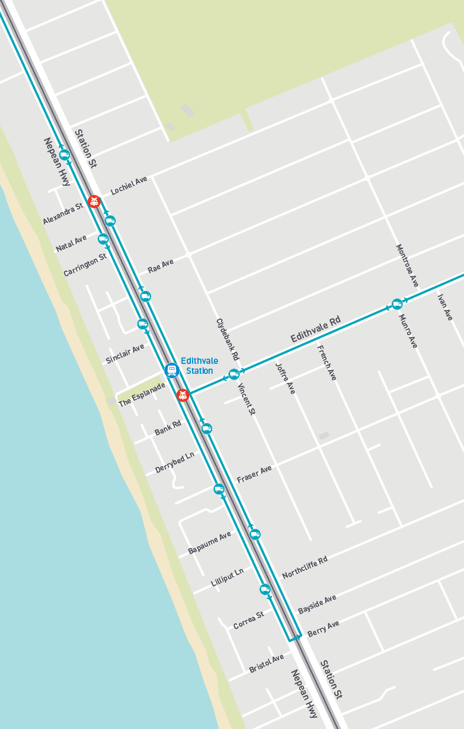

Figure 8.5 Part B: Potential construction routes for Bonbeach 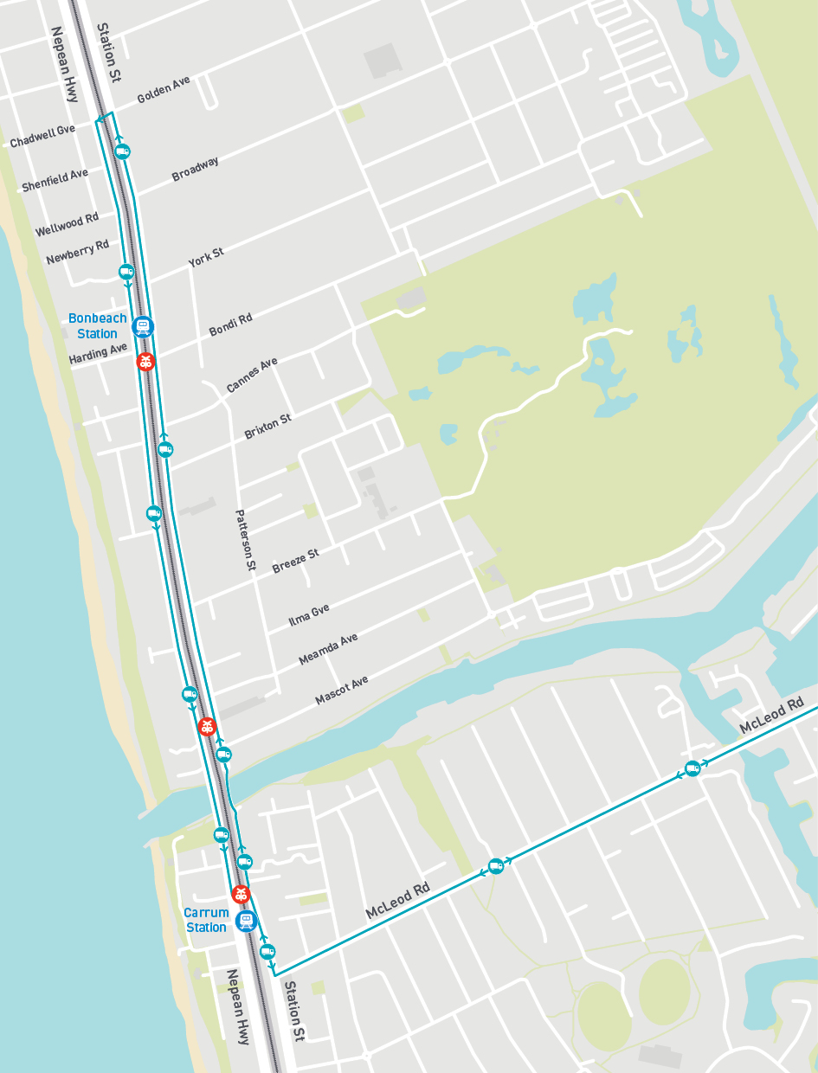

The risk levels are therefore reflective of the uncertainty of how the traffic will behave during this time. Construction traffic during the main works period is expected to result in an overall increase in traffic in proximity to the construction sites, however a number of factors could impact the road network including:
      - the completion of the bridge connecting Station Street over Patterson River prior to the commencement of works at Edithvale and Bonbeach, providing an additional alternate route for north-south traffic
      - the type of traffic management required on Nepean Highway and Station Street during the main occupation (temporary lane closures or temporary lane realignments)
      - temporary road closures and associated diversions
      - a shift in travel mode due to rail line closures (for example, train users may prefer to drive during this time)
Road users may seek alternative routes or avoid the area. Outside of the main works, increases to traffic volumes are expected to be less apparent because of the lower volume of construction traffic.
To facilitate construction activities for both projects it is expected that lane closures (either full or partial), including cycle lanes (where present), would be required on Nepean Highway and Station Street at times during the works. Lane closures or part lane closures are anticipated for southbound through and turning lanes on Nepean Highway (including indented parking) and northbound traffic and cycle lanes on Station Street (including indented parking bays). Reducing Nepean Highway to a single lane of traffic travelling southbound during the afternoon peak while maintaining current traffic levels would likely exceed the capacity of one lane. This would result in increased queueing and delays, which would be further exacerbated by the increased traffic from construction. During off peak times, congestion would still be expected, however the level of impact would be lessened due to traffic volumes being lower.
Road closures are expected to be required at times during the works to facilitate construction activities for both projects including piling and abutment works as well as during the main occupation. Road closures are anticipated to be required on Edithvale Road between Nepean Highway and Station Street, and in Bonbeach at Station Street between Nepean Highway and Bondi Road. The intersections of Station Street and Edithvale Road and Station Street and Bondi Road may also need to be partially or fully closed at times. Road closures would increase traffic along detour routes but may not exceed the mid-block capacity of these roads.
To allow for construction it is expected that the Frankston rail line will be closed at times between Mordialloc and Frankston. This is because the construction site is highly constrained and the removal of the level crossings and construction of new stations cannot occur while trains are operating. The rail line is expected to be closed for six weeks during the main occupation period and at other times (for a shorter duration) during the construction period as required, usually overnight or during weekends. It is common practice
to run rail replacement buses during rail line closures, however this can result in a longer travel time for commuters as the buses operate on the road and are therefore subject to traffic congestion and delays. It could also result in more people choosing to use their cars over the bus replacement service which could further exacerbate traffic congestion and delays.
There would also be a number of pedestrian crossing and footpath closures required during the construction period. This has the potential to increase travel distances and therefore result in longer journey times for pedestrians. Pedestrian crossing and footpath closures have the potential to impact safety if alternate facilities cannot be provided to the same standard or if the closures encourage pedestrians to adopt risky behaviour.
The risk that construction activities would result in traffic delays and increased travel times outside of the period when the piling works and main rail occupation occurs has been assessed as minor. During the piling works and main rail occupation period there is anticipated to be a higher level of traffic delays and associated impacts, and as a result this has been assessed as a moderate risk level. The risk that construction results in increased crashes or the perception that the area is less safe has been assessed as a minor risk level.
These risk levels would be achieved through the implementation of a range of management and mitigation measures such as those outlined further below. These measures would be documented in a Transport Management Plan developed in consultation with, and to the satisfaction of, relevant road management authorities (EPR reference T1).

The Transport Management Plan would establish measures designed to minimise disruption to affected users and stakeholders. While the development of the plan is closely linked to the adopted construction methodology and would therefore be prepared by the project Alliance, the types of measures that would be considered include:
    - rail replacement bus services during the rail line closures, including investigating the possibility of running two types of rail replacement services – one ‘stopping all stations’ and one running express to serve the needs of different users
    - provision of alternative parking spaces for public and commuter parking and construction-related parking, the location of these will be dependent on the proposed construction methodology
    - identification of routes for construction vehicles travelling to and from the construction site, minimising the use of local streets where practicable and promoting the use of arterial roads and higher order local roads (where necessary, for example Station Street)
    - temporary signalisation at intersections identified as detour routes (where signalisation does not currently exist) and/or upgrades to detour routes where required
    - implementation of a communications strategy, including extensive use of Variable Message Signs and local alerts, to advise affected users, potentially affected users, relevant stakeholders and the relevant road authorities of any changes to transport conditions to allow the community to plan ahead
    - management of any road closures, including provision of diversion routes for vehicles, cyclists and pedestrians to maintain connectivity
    - maximise the capacity (the amount of traffic that can be carried) of Nepean Highway and Edithvale Road during peak periods
    - timing lane and road closures, oversized load deliveries and pedestrian disruptions to minimise impacts (for example, at times when traffic volumes are lower, avoiding the weekday peak period or weekends during summer when the number of beachgoers will be higher).
These measures would be developed with safety of traffic, pedestrians and cyclists during the construction period as a key guiding principle.
During construction the projects would also:
    - maintain and enhance, where practicable, pedestrian and cyclist connectivity during construction (EPR reference T3) by providing, for example:
- advance notification of works to encourage cyclists and pedestrians to seek alternate routes
- traffic signal modifications to provide additional pedestrian crossing time
- provision of temporary pedestrian crossings in close proximity to the existing crossings
- the development and implementation of signed detour or diversion routes for pedestrians and cyclists
- conducting particularly disruptive activities outside times where large volume of pedestrians are expected (such as the weekday peak period or during summer)
    - reinstate vehicle and pedestrian access (EPR reference T6) as soon as possible after works are completed
    - maintain access requirements for vehicles and pedestrians to emergency services at all times and, where practicable, to other key health and medical facilities, through consulting with relevant emergency services (EPR reference T8).
While the effective implementation of these measures would assist to provide for the efficient and safe operation of the transport network during construction, the unavoidable nature of this impact and the volume of construction traffic necessary to construct the projects is such that there would be residual impacts felt by the community. Residual traffic impacts associated with the construction period are expected to be greatest during the piling works and main rail occupation period and in morning and evening peak periods when existing traffic volumes and the demand for public transport travel are highest.

Amenity (risk T30)
Managing dirt and debris from being transferred to roads from construction activities would be undertaken by street sweeping, covering all truck loads and monitoring the surrounding road network to identify issues as they arise. Further measures that could be implemented if dirt and debris are causing issues within the surrounding community include the installation of vehicle washing facilities and/or rumble grids for vehicles exiting the construction site. This would mitigate the impacts of construction traffic from tracking dirt on public roads (EPR reference T7) and maintain a negligible risk rating for this issue.

Operation impact assessment
The traffic risks identified for the operation phase of the Edithvale and Bonbeach level crossing removal projects are outlined in Table 8.10.

Table 8.10 Traffic risks – operation

Risk ID | Risk name | Risk pathway | Final EPR | Residual risk
T26 | Traffic (operations) | New road network layout and signalling may not adequately cater for the safe and efficient movement of traffic following level crossing removal, resulting in unacceptable intersection performance and/or increased crashes. | EPR T4 Intersection design and performance | Negligible
T27 | Traffic (connectivity) | Connectivity for pedestrians and cyclists is negatively impacted by level crossing removal, resulting in increases to travel distance and/or time resulting in social and business impacts. | EPR T3 Pedestrian and cyclist connectivity  EPR T6 Vehicle and pedestrian access | Negligible
T32 | Traffic (change in AQ) | Changes in traffic flows at the level crossing results in air quality impacts. | EPR T4 Intersection design and performance | Negligible
T33 | Traffic (change in noise) | Changes in traffic flows at the level crossing results in noise impacts. | EPR T4 Intersection design and performance | Negligible
Note that:
- Risk T32 is discussed in Section 8.7 in relation to air quality
- Risk T33 is discussed in Section 8.2 in relation to noise and vibration.

Traffic operations (risk T26)
Removal of the level crossings is expected to result in improved safety by removing the potential for conflict between trains and road users. This would benefit both current users of the road network and any future users who previously avoided the level crossings.
Removal of the level crossings would mean that rail and road-based transport would no longer interact at each level crossing site. As a result, the intersections would not need to cater for boom gates being down for 42 minutes and 45 minutes during the morning peak at Edithvale and Bonbeach respectively.
The removal of the trains from the intersections is therefore expected to improve the functionality and efficiency of the road network.
The traffic assessment for the projects recognises that each intersection is a small part of a complex transport network in the area that is affected by the interaction of pedestrians, cyclists, on-road public transport, trains and private vehicles. The assessment considers how the removal of the two level crossings would contribute to the overall road-based transport network, and concludes the intersections at both Edithvale Road and Station Street/Bondi Road are expected to have acceptable intersection performance following level crossing removal (EPR reference T4).
The removal of the level crossings would provide VicRoads with the opportunity to upgrade signal phasing and optimise intersection performance. Without the trains moving through the intersections, signal phases are able to run more frequently and can be allocated more or less cycle time as required in response
to demand. This is expected to result in reduced delays and enhanced reliability for cross-rail corridor movements. Removal of the trains from the intersections would allow traffic signal cycle times to be allocated in a way that better balances the competing demands for movement from pedestrians, cyclists, public transport and general traffic.

While the project areas are highly constrained in terms of land availability for designing the new intersections, a range of traffic modelling and design tools have been used in consultation with road management authorities to inform the future intersection design to cater for the existing and predicted traffic (EPR reference T4). The design process would endeavour to provide spare capacity within the design to cater for traffic volumes higher than predicted.
Additionally, one of the key principles of the design process is to provide for safe vehicle movements. While the intersection layout and signal phasing of the intersection will be further refined in subsequent design stages by the project Alliance in consultation with VicRoads, modelling done as part of this EES indicates that the proposed modifications to the configuration of intersections can operate at an acceptable level of service.
The implementation of established intersection and signalling design principles and processes (including Safety in Design) is considered adequate to mitigate unacceptable impacts to traffic operations and road safety and therefore the residual risk is considered negligible.

Traffic connectivity (risk T27)
Changing the connections as a result of the projects could potentially restrict pedestrian and cyclist connectivity by removing existing pedestrian and cyclist crossings and informal pedestrian and cyclist crossing points and opportunities (i.e. when the boom gates are down). This could lead to an impact
on pedestrian and cyclist connectivity and their subsequent use of the area. However, it should be noted that reducing the potential for informal and uncontrolled crossing of the railway or roads would increase safety by reducing the risk that a pedestrian is struck by a train or vehicle.
Upgrades to the road network would address substandard elements of the current road design (such as lane widths and merge distances) and may also assist to reduce the likelihood of crashes for pedestrian and cycle facilities through the intersections.
The projects would be designed and constructed to provide suitable routes for pedestrians and cyclists to maintain connectivity after construction (EPR reference T6). This would be through the provision
of pedestrian bridges across the rail corridor, retention of existing pedestrian crossings at signalised intersections and provision of a north-south shared-use path on the western side of Station Street. Crossing points of the railway would be developed in consultation with the community and road management authorities (EPR reference T3). The projects may be able to improve pedestrian access across the railway
if feedback from the community leads to improvements to the current crossing locations. This would reduce the likelihood of unacceptable impacts to pedestrian and cyclist connectivity resulting in increases to travel distance and journey time. The implementation of these controls is considered adequate to mitigate for unacceptable impacts, and therefore the residual risk is considered negligible.

Historic heritage

Historic heritage refers to built form and archaeological remains of buildings and places dating from after European settlement, as distinct from Aboriginal heritage which is discussed in Section 8.5.
Historic heritage provides a connection to the history and identity of a place. The appropriate management of heritage places ensures that the heritage value of the places, and their contribution to the local area,
is conserved for present and future generations.
In Victoria, heritage places of state significance are recognised and protected through listing on the Victorian Heritage Register under the Heritage Act 2017 (Heritage Act) and through Heritage Overlays in local planning schemes in accordance with the Planning and Environment Act 1987 (P&E Act). Places of local heritage significance are identified and protected through Heritage Overlays. In addition, the Victorian Heritage Inventory (which is also administered under the Heritage Act) protects archaeological remains over 75 years in age.
The Commonwealth Environment Protection and Biodiversity Conservation Act 1999 (EPBC Act) protects places on the World Heritage List, National Heritage List and Commonwealth Heritage List Australia wide, including in Victoria.

Both direct and indirect risks to heritage associated with construction activities exist, particularly
with respect to demolition or modification of heritage-listed buildings. Excavation works may also result in damage or destruction of archaeological sites. Newly constructed built-form may result in indirect impacts due to visual changes to the landscape character and setting of historic heritage places.
A historic heritage assessment has been prepared and is provided in Technical Report N Historic heritage. This section summarises the outcomes of the assessment for the Edithvale and Bonbeach level crossing removal projects.

    - Existing conditions
The Edithvale and Bonbeach project areas do not include, nor adjoin, any heritage places listed on the National Heritage List, Commonwealth Heritage List, Victorian Heritage Register or Victorian Heritage Inventory.
The existing Edithvale and Bonbeach railway stations are not identified as heritage places and their demolition would have no heritage impact.
The area to the west of the Edithvale project area comprises commercial buildings from the interwar and post-war periods. To the east are one- and two-storey residential properties. There is one site of local heritage significance (Chelsea Clock Tower, within Heritage Overlay 28, HO28, in the Kingston Planning Scheme) in the Edithvale project area; however, it is not within the construction area
(refer to Figure 8.6 and Figure 8.8).
Located to the west of the Bonbeach project area are mid-to-late twentieth century commercial buildings. To the east of the project area are brick houses from the late twentieth century. One site
of local heritage significance (Chelsea Railway Station, HO31) is located in the Bonbeach project area; however, it is not within the construction area (refer to Figure 8.7 and Figure 8.9).
In addition, there are a number of Heritage Overlay sites situated adjacent to, but outside, the project areas. These are shown in Figure 8.8 and Figure 8.9, and the potential effects of the projects on
all heritage values discussed in this section are discussed in Section 8.4.2 and Section 8.4.3.

Figure 8.6 Chelsea clock tower  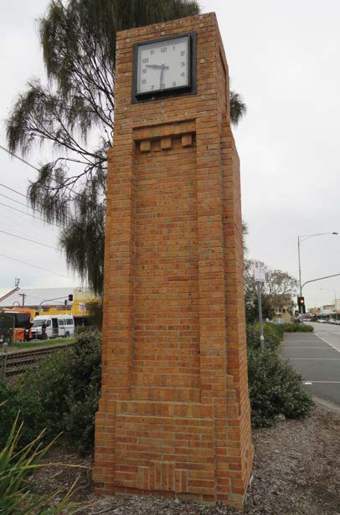 | Figure 8.7 Chelsea Railway Station  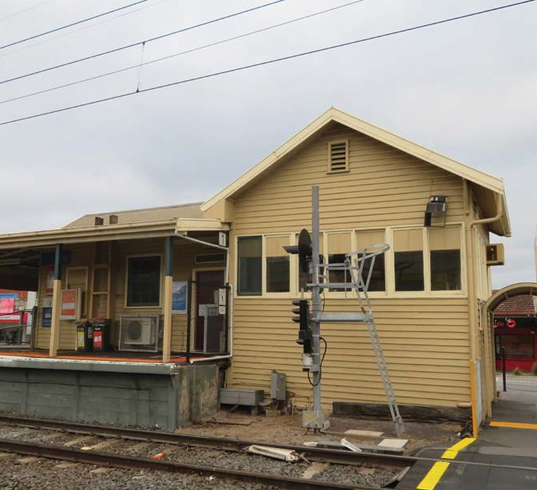

Figure 8.8 Heritage Overlay places in the vicinity of the Edithvale project area
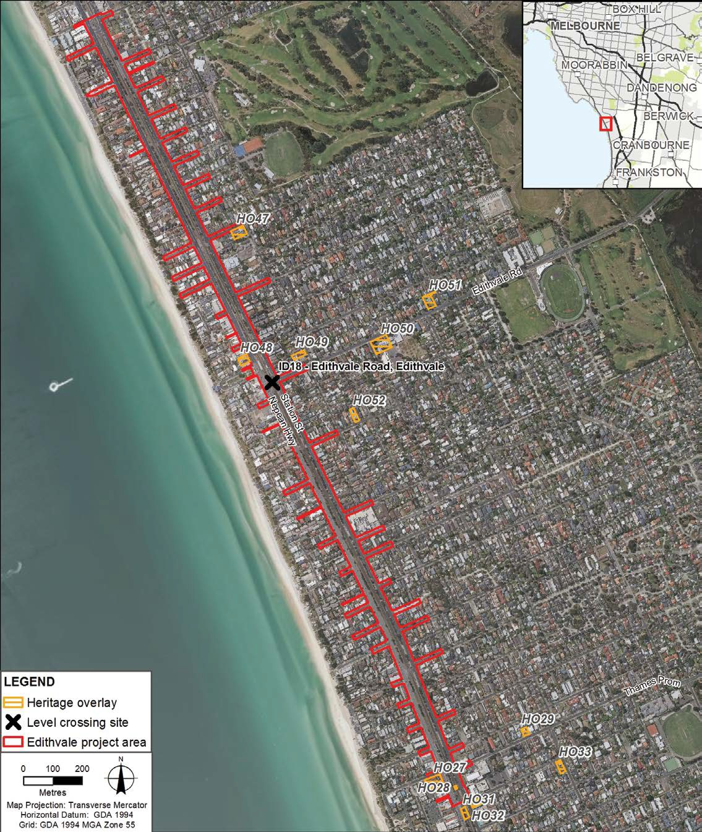

Figure 8.9 Heritage Overlay places in the vicinity of the Bonbeach project area
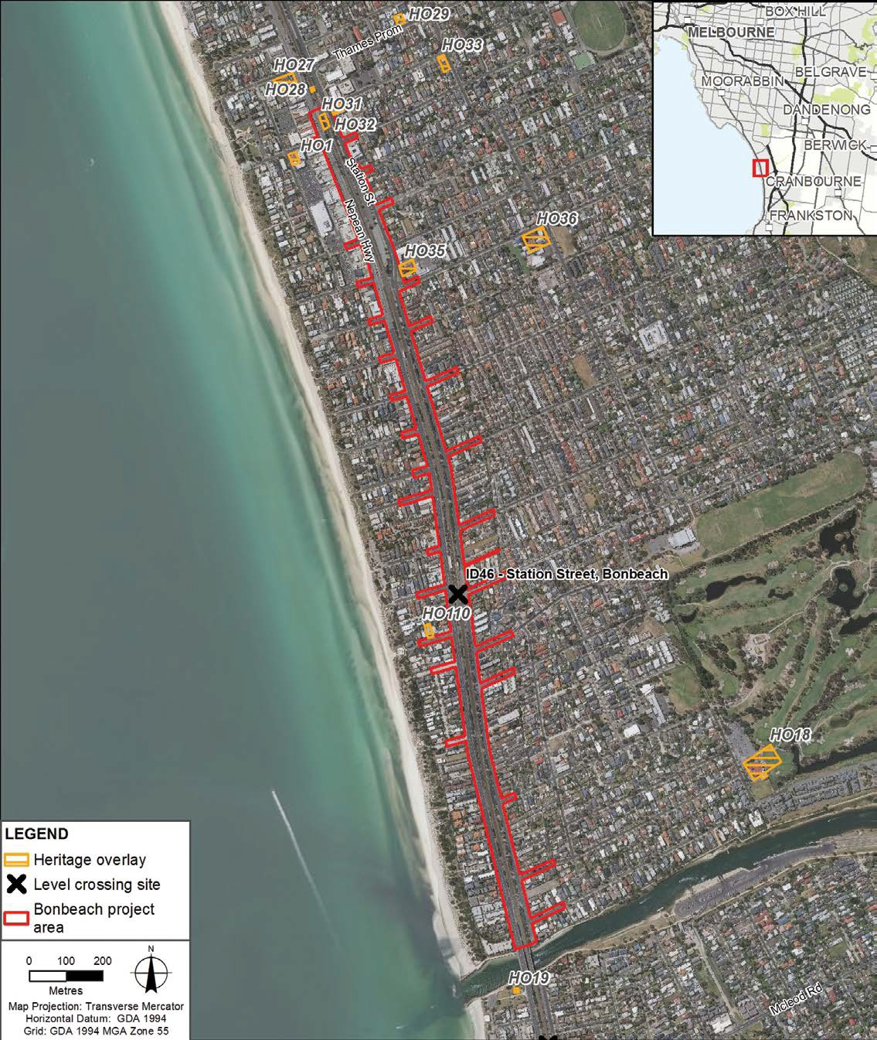

    - Construction impact assessment
The historic heritage risks identified for the construction phase of the Edithvale and Bonbeach level crossing removal projects are outlined in Table 8.11.

Table 8.11 Historic heritage risks – construction

Risk ID | Risk name | Risk pathway | Final EPR | Residual Risk
HH4 | Disturbance of identified  historic heritage | Disturbance of identified historic heritage places (included in the Heritage Overlay) resulting in loss of heritage value | EPR HH2  Heritage overlay sites | Negligible
HH5 | Disturbance of non-identified historic heritage | Disturbance of not previously identified historic heritage places and sites (archaeological places and sites not included in the Victorian Heritage Inventory) resulting in loss of heritage value | EPR HH1  Unidentified historical archaeological sites | Negligible

Disturbance of historic heritage (risks HH4 and HH5)
The construction activities within the project areas would have no impact on any heritage places of national or state significance. The two sites of local heritage value within the project areas – Chelsea Clock Tower (HO28) and Chelsea Railway Station (HO31) – are not within the footprint of the proposed infrastructure
and associated works which would be undertaken such that there would be no impact to either site (EPR reference HH2).
Whilst there are no known archaeological sites listed on the Victorian Heritage Inventory within the project areas, there is potential for archaeological values to exist. Therefore, a protocol for managing previously unrecorded archaeological sites and remains discovered during construction works would be prepared prior to the commencement of works and in consultation with Heritage Victoria. The protocol would provide a process for addressing any archaeological remains which are uncovered and would set out
a specific procedure for dealing with remains, including any requirement or procedure for obtaining consents (EPR reference HH1).
While the consequences of these risks would be moderate or minor respectively, they are considered unlikely to occur as a result of the removal of the level crossings. Implementing the EPRs and adopting appropriate management controls would further reduce the risk of impacting heritage values, and it is unlikely that there would be a loss of heritage values due to the projects. Therefore, the risk of disturbance of identified and non-identified historic heritage resulting in loss of heritage value during construction is negligible.

Operation impact assessment
One risk was identified in relation to historic heritage during the operation phase (i.e. due to the design
of the projects) of the Edithvale and Bonbeach level crossing removal projects and is outlined in Table 8.12.

Table 8.12 Historic heritage risks – operation

Risk ID | Risk name | Risk pathway | Final EPR | Residual Risk
HH6 | Visual impact on historic heritage | Visual impact of new buildings and barriers along the length of trench to the setting of heritage places. | EPR HH3  Heritage values | Negligible

Visual impact on identified historic heritage (risk HH6)
The projects would construct new buildings and landscape elements such as barriers and screening, footbridges (and a substation at Edithvale). These elements would alter the streetscape setting of the heritage places that adjoin the project areas shown in Figure 8.8 and Figure 8.9.
The design of new buildings, barriers and screening would be in accordance with the Urban Design Guidelines (UDG) prepared for the projects, which would include reference to adjoining heritage places, their setting and significance. The projects would be designed in accordance with the UDG to avoid or minimise, as far as is practicable, adverse visual impacts on adjoining heritage places (EPR reference HH3) to create a well-defined identity and sense of place (refer to Attachment VII Urban Design Guidelines – Edithvale and Attachment VIII Urban Design Guidelines – Bonbeach).
These heritage places are already viewed in the context of a varied streetscape and therefore implementing the UDGs and EPRs, would reduce the risk of visually impacting heritage values as a result of the new infrastructure to negligible.

Aboriginal cultural heritage

Heritage is the relationship between people and their past. Aboriginal cultural heritage can include culturally or spiritually significant places for Aboriginal people. Archaeological evidence within the Melbourne metropolitan region suggests an extensive history of human occupation dating back at least 31,000 years.
During construction of the projects, there is the potential to impact known or previously unrecorded Aboriginal cultural heritage places and associated values as a result of ground disturbance. Once the projects are complete, there would be no risk to Aboriginal cultural heritage.
An Aboriginal cultural heritage impact assessment has been prepared and is provided in Technical Report M Aboriginal cultural heritage. This section summarises the outcomes of this assessment for the Edithvale and Bonbeach level crossing removal projects.

    - Existing conditions
Aboriginal cultural heritage in the vicinity of the Edithvale and Bonbeach project areas has been assessed by reviewing the project boundary’s geographic and environmental context, an assessment of the historical environment, and review of relevant heritage databases.
There are no registered Aboriginal cultural heritage places within either of the Edithvale or Bonbeach project areas, which may be due in part to a combination of (among other factors) a lack of previous detailed investigations in the area and the level of ground disturbance and development since European settlement.
Within one kilometre of the combined project areas, there are two registered Aboriginal cultural heritage places, comprising of low density artefact distributions. These are located outside the southern extent of the Edithvale component of the Edithvale-Seaford Wetlands. This suggests that there may be potential for
additional Aboriginal cultural heritage to exist in the area which would be investigated during the preparation of a Cultural Heritage Management Plan (CHMP) in accordance with the Aboriginal Heritage Act 2006.
Should Aboriginal cultural heritage be identified during this process, it would be documented and listed on the Victorian Aboriginal Heritage Register prior to the commencement of works.

Construction impact assessment
The Aboriginal cultural heritage risks identified for the construction phase of the Edithvale and Bonbeach level crossing removal projects are outlined in Table 8.13.

Table 8.13 Aboriginal cultural heritage risks – construction

Risk ID | Risk name | Risk pathway | Final EPR | Residual Risk
ACH1 | Disturbance of known Aboriginal cultural heritage | Disturbance of previously registered Aboriginal cultural heritage places resulting in loss of heritage value | EPR AH1  Cultural Heritage Management Plan | Negligible
ACH2 | Disturbance of unknown common Aboriginal cultural heritage | Disturbance of not previously registered common Aboriginal cultural heritage places resulting in loss of heritage value | EPR AH1  Cultural Heritage Management Plan | Negligible
ACH3 | Disturbance of unknown rare Aboriginal cultural heritage | Disturbance of not previously registered rare Aboriginal cultural heritage places resulting in loss of heritage value | EPR AH1  Cultural Heritage Management Plan | Negligible

Disturbance of Aboriginal cultural heritage (risks ACH1, ACH2 and ACH3)
There are no currently registered Aboriginal cultural heritage places within the project areas; therefore it is unlikely that there would be a loss of heritage values during construction. While there are no previously recorded Aboriginal cultural heritage places within the project areas, there is potential for them to occur despite the high level of historic disturbance within the project areas. Unauthorised disturbance of Aboriginal cultural heritage places is a breach of the Aboriginal Heritage Act 2006, and the CHMP is a statutory approval that would contain measures that must be implemented to manage (i.e. collect, store and possibly repatriate) Aboriginal cultural material (including those identified and registered during the preparation of the CHMP). The CHMP also establishes contingency measures that must be implemented should previously unrecorded Aboriginal cultural heritage be encountered during works (EPR reference AH1).
More specifically, the CHMP would include measures that relate to:
    - management of Aboriginal cultural heritage found during works
    - custody and management of Aboriginal cultural heritage recovered
    - management of the discovery of ancestral (human) remains
    - review and compliance with the CHMP.
Implementing the CHMP and adopting the measures to protect and manage previously unrecorded Aboriginal cultural heritage places would result in a negligible risk. The projects’ potential to impact the heritage value of unrecorded Aboriginal cultural heritage places would be unlikely, and obtaining an approved CHMP would manage the risk of encountering heritage and ensure that any impacts to Aboriginal heritage
is lawful under the Aboriginal Heritage Act 2006.

Surface water

Modifying the characteristics of an urban stormwater catchment, through processes such as land use change and development, can have a significant impact on the nature of stormwater runoff. These changes could result in greater volumes of runoff and increased sources and loads of pollutants in runoff.
Stormwater runoff from construction areas and the completed trench would require management to prevent water quality or capacity issues.
A surface water impact assessment has been prepared and is provided in Technical Report E Surface Water. This section summarises the outcomes of the assessment of surface water impacts as a result of the Edithvale and Bonbeach level crossing removal projects.

Stormwater runoff

Stormwater runoff is rainfall that flows over the ground surface. It is created when rain falls on roads, other paved surfaces and already saturated soils that do not allow water to soak into the ground.
Runoff ends up in drains, nearby streams, rivers and ultimately, for these areas, in Port Phillip Bay.

Unmanaged runoff can erode watercourses
as well as cause flooding after the stormwater collection system is overwhelmed by the additional flow. Runoff can also cause water pollution due to potential contaminants
that the water is carrying.

    - Existing conditions
The Edithvale and Bonbeach project sites are located between the Nepean Highway and Station Street, both of which are flat. Run-off from land to the east of the rail corridor drains into the Centre Main Drain, which runs north-south along the western side of the Edithvale component of the Edithvale-Seaford Wetlands. Stormwater reaches the drain via overland flow or the underground stormwater system.
The drain discharges stormwater collected north of Thames Promenade into Mordialloc Creek, and from south of Thames Promenade into the Patterson River, both via a stormwater pump station.
Run-off from the western side of the rail corridor discharges to Port Phillip Bay.
There is no existing formal drainage network to capture stormwater from the rail corridor; because it sits higher than the adjacent land and is unsealed. Rainfall typically soaks into the soil and any excess run-off currently flows over the land onto the adjacent roadside drains and into the Council stormwater networks. Given its elevation, the rail corridor is not subject to flooding.
Given the low-lying and flat topography of the Edithvale and Bonbeach areas, the majority of local drainage assets already operate at capacity which results in frequent flooding of local streets and low-lying areas.

Construction impact assessment
The identified risks for the surface water environment associated with the construction phase of the Edithvale and Bonbeach level crossing removal projects are outlined in Table 8.14.

Table 8.14 Surface water risks – construction

Risk ID | Risk name | Risk pathway | Final EPR | Residual Risk
SW22 | Site dewatering (runoff capacity) | Dewatering of the trenches following a storm results in a reduction in capacity in the  local stormwater infrastructure elsewhere and results in flooding | EPR SW3 Drainage network – construction  EPR SW5 Flood protection – construction | Negligible
SW23 | Site dewatering (runoff quality) | Dewatering of the trenches following a storm results in stormwater above SEPP limits being pumped to receiving water bodies. | EPR SW1 Stormwater management – construction | Negligible
SW24 | Stormwater runoff | Stormwater runoff is above SEPP limits and enters receiving water bodies. | EPR SW1 Stormwater management – construction | Negligible

Disposal of runoff (risk SW22)
Rain water that collects in the trench during construction would require ‘dewatering’, that is, appropriate management and disposal to prevent flooding and enable construction to continue. This would occur through the use of temporary pumps which would transfer the water to a dedicated discharge point.
It is acknowledged that the existing local drainage infrastructure has limited additional capacity
to cater for stormwater to be discharged from the trench if the network is still conveying surface runoff (i.e. during rainfall events).
If stormwater from the trench is to be discharged to the local network, this would require approval from Kingston City Council and would need to meet EPA water quality requirements (see water quality below). The water would need to be discharged in a controlled manner (i.e. after the rainfall event) so that it does not exceed the capacity of the local drainage network or increase surrounding flood levels (EPR references SW3 and SW5). To achieve this, the projects would have the following options:
    - Implement on-site water storage in the form of a large tank or retarding basin.
    - Construction works in the flooded sections of the trench may be delayed until the water can be removed from the trench without exceeding the capacity of the surrounding drainage infrastructure.
    - A temporary discharge point could be provided or water could be pumped to a water truck and carted away. Disposal of carted water would be in accordance with EPA requirements.
By implementing the above controls, dewatering of the trench following a storm is unlikely to reduce the capacity of the local stormwater infrastructure and result in flooding. Therefore, the risk of the impact would be negligible.

Water quality (risks SW23 – SW24)
Runoff from stockpiled material and areas of exposed soil, including within the trenches during construction, has the potential to transport sediment or pollutants to the local drainage network and adversely impact water quality within receiving waters. Receiving waters potentially include Patterson River via the Centre Main Drain, and Mordialloc Creek.
Rain water would be removed from the trench and managed in accordance with EPA Victoria's Publication 480 Environmental Guidelines for Major Construction Sites and State Environment Protection Policy (Waters of Victoria) (EPR reference SW1) to ensure discharges to stormwater do not exceed 30 NTU (NTU is a measure of the amount of sediment in water). This could be achieved through visual observation and/ or testing. Stormwater runoff would also be managed in accordance with EPA Victoria's Publication 480 Environmental Guidelines for Major Construction Sites (EPR reference SW1) to minimise the potential for impacts to water quality.

Compliance with EPA requirements and the relevant EPRs could be achieved through minimising the generation of waste water and diverting external overland surface water flows from the excavated area. Other measures may include:
      - minimise the extent and duration the areas are disturbed (or cleared)
      - provision for a sediment basin to allow course material to settle out
      - monitoring of pumped water quality
      - minimising volume and area of stockpiled material
      - minimising the time construction materials are stockpiled.
If stockpiling of material excavated from the trench is required, measures to minimise impacts to stormwater quality include:
      - bunding or silt fences to trap sediment
      - using gradual slopes to prevent runoff or movement of material.
The implemented Construction Environmental Management Plan (CEMP) would specify measures to characterise, treat and dispose of potentially contaminated runoff (EPR reference EMF2).
With the implementation of these controls, stormwater runoff is unlikely to exceed the SEPP (Waters of Victoria) limits during construction. Therefore, the risk of stormwater entering Patterson River and Port Phillip Bay above the SEPP (Waters of Victoria) limits during construction of the projects would be negligible.

Operation impact assessment
The surface water risks identified for the operation of the Edithvale and Bonbeach level crossing removal projects are outlined in Table 8.15.

Table 8.15 Surface water risks – operation

Risk ID | Risk name | Risk pathway | Final EPR | Risk level
SW22 | Site dewatering (runoff capacity) | Dewatering of the trenches following a storm results in a reduction in capacity in the local stormwater infrastructure elsewhere and  results in flooding | EPR SW4 Drainage network – operation  EPR SW6 Flood protection – operation | Negligible
SW23 | Site dewatering (runoff quality) | Dewatering of the trenches following a storm results in stormwater above  SEPP limits being pumped to receiving water bodies. | EPR SW2 Water quality – operation | Negligible

Hydraulic capacity (risk SW22)
Stormwater that currently falls on the rail corridor infiltrates directly into the soil with little run-off to the surrounding drainage network. Construction of a concrete lined trench would prevent this infiltration and
as a result, there would be a small increase in the overall volume of stormwater that requires management.
Discharging collected stormwater directly and immediately to the existing network without appropriate management and mitigation measures could potentially result in additional surface flows and increased flood levels. Due to the limited capacities within the stormwater drainage system surrounding the sites, surface water discharges from each project would therefore be required to have no adverse impact to the drainage network (EPR reference SW4). The projects would also be required to be designed to comply with the relevant approval authority requirements for flooding and overland flows (EPR reference SW6).

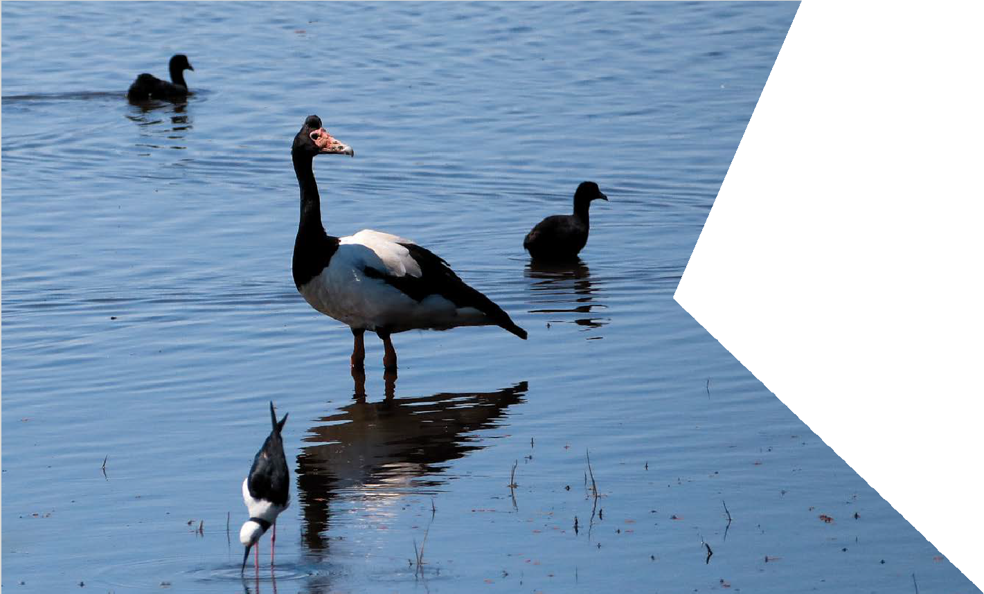To manage the risk of increased flooding and comply with the EPRs (EPR references SW4 and SW6), there are a range of potential options that could be implemented:
    - an alternative outfall to Centre Main Drain could be installed
    - a rising main could be installed along the rail alignment to discharge to Patterson River
    - the two-hour water storage tank beneath the rail trench could be used to hold runoff in a storm and manage flow rates into the existing stormwater system. The water storage facility would be designed to accommodate rainfall equivalent to a one in 100-year two-hour storm including an allowance
for the climate change scenario discussed in Chapter 10 Sustainability and climate change
    - liaise with Kingston City Council to develop a stormwater strategy.
With the implementation of one of the above stormwater management approaches and compliance with relevant approval authority requirements for flooding and overland flows, the risk the projects pose to flood risk and surface water would be negligible.

Water quality (risk SW23)
Collected stormwater runoff from the rail corridor has the potential to affect water quality at the receiving waterbody. To prevent such impacts, stormwater would be treated to meet the requirements of the relevant authority (i.e. SEPP Waters of Victoria and its discharge limits for receiving environments) (EPR reference SW2). The potential pollutants in the runoff would be reduced in accordance with the Victorian Stormwater Committee’s Best Practice Environmental Management Guidelines (CSIRO, 1999). This would require the implementation of a water quality treatment strategy to remove the pollutants and satisfy water quality targets.
Options for water treatment include water sensitive urban design (WSUD) and integrated urban water management. This may include the installation or use of measures such as a bio-filter to treat stormwater prior to discharge. Bio-filters would be placed between the trench outfall and the local drainage network and filled with a porous filter material and planted with vegetation. Bio-filters have the effect of removing pollutants from stormwater runoff by using natural and physical processes from the porous material and vegetation to treat the stormwater. The inclusion or utilisation of a WSUD treatment would result in a net water quality benefit from the projects, as water currently discharges from this section of rail untreated.
Implementing the EPRs and adopting WSUD, such as bio-filters to remove pollutants from stormwater runoff, would reduce the risk to negligible. Stormwater would be treated to meet the SEPP (Waters of Victoria) discharge limits. Therefore, it is unlikely that dewatering of trenches following a storm would result in stormwater above the SEPP (Water of Victoria) limits being pumped to Patterson River, Mordialloc Creek and Port Phillip Bay.

Air quality

Air quality is a measure of the suitability of air for humans and for the physical environment such as plants and animals. In Victoria, air quality is regulated under the State Environment Protection Policy (Ambient Air Quality) (SEPP AAQ) and SEPP (Air Quality Management) (SEPP AQM).
SEPP (AQM) sets air quality policy for the state of Victoria to ensure that the environmental quality objectives of SEPP (AAQ) are met. Ambient air quality is measured, in part, by the levels of particulates, carbon monoxide, sulphur dioxide and nitrogen dioxide in the air environment. SEPP (AQM) has set intervention levels based on potential health impacts on sensitive receptors and adopted from the National Environment Protection Measure (NEPM). NEPM is a legal instrument specifying national standards for a variety of environmental issues, including air quality. For ambient monitoring purposes, standards and goals are set in SEPP (AAQ). When assessed or monitored levels exceed the intervention levels in SEPP (AQM), the projects are then required to develop an environmental management plan in order to minimise, manage or mitigate any impacts to air quality.
Changes in air quality may arise from construction activities such as site clearance, ground excavations and the exposure of contaminated soils, which each have the potential to generate amenity impacts from dust, odours and other emissions. Resultant changes in air quality also have the potential to affect the beneficial uses of the air environment, including human health as a result of aggravating existing respiratory diseases such as asthma and bronchitis, or increase the risk of respiratory problems.
Air quality may also be affected after the removal of the level crossings. By lowering the rail line into a trench, air emissions from freight trains would be dispersed differently from a trench relative to the current above-ground situation. Changes to traffic flows from the removal of the level crossings in the local areas could also result in localised changes, positive or negative, to air quality from vehicle emissions.
An air quality impact assessment has been prepared and is provided in Technical Report I Air quality. This assessment identifies potential air quality risks and how to manage or mitigate them. This section summarises the outcomes of the air quality assessment for the Edithvale and Bonbeach level crossing removal projects.

    - Existing conditions
The existing air quality at and around the Edithvale and Bonbeach project areas is typical of the Melbourne metropolitan air environment. The project areas are on the interface between the urbanised metropolitan area and the generally pollutant-free Port Phillip Bay. Being close to the Bay means that existing air quality is higher than average for Melbourne because coastal areas are subject to weather conditions that cause the dispersal of pollutants in the air more readily. Existing air quality is shown in Figure 8.10.
Ambient air quality levels are measured at EPA Air Quality Monitoring Stations, with the two closest and most indicative at Brighton and Dandenong. The measured ambient air quality indicators at these locations, and therefore by extrapolation at Edithvale and Bonbeach, were well below the air criteria limits of SEPP (AQM) and the NEPM. The monitoring stations showed that:
      - the NEPM objectives for air quality were met for carbon monoxide, sulphur dioxide and nitrogen dioxide
      - the annual particulate matter of 10 micrometres or less in diameter was approximately 60 per cent lower than the level where particulate matter would become a concern.

Why have EPA Air Quality Monitoring Stations at Brighton and Dandenong been used?

The Brighton and Dandenong Air Quality Monitoring Stations are part of a network of air quality monitoring stations across Victoria, providing population exposure levels to key air quality pollutants, as required by NEPM.

The Brighton and Dandenong stations provide a guide to air quality and potential health impacts across the whole south-east region of Greater Melbourne, including the Edithvale and Bonbeach areas.

Figure 8.10 Existing air quality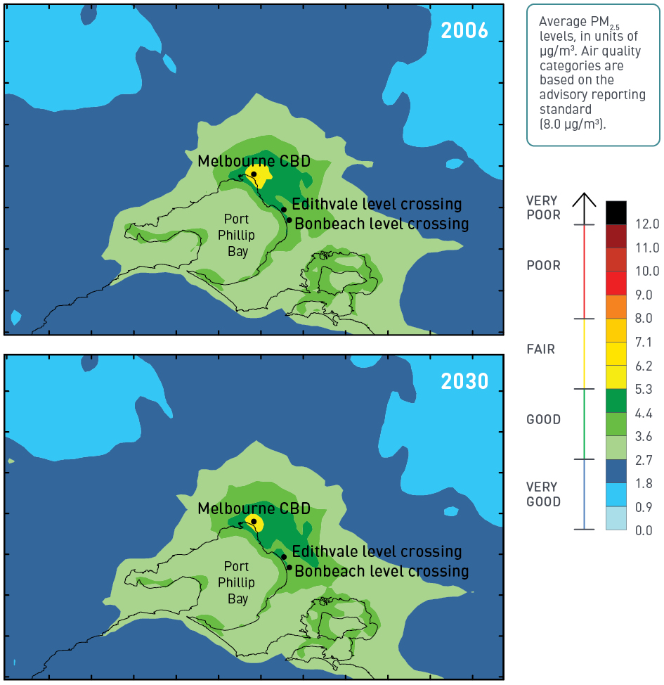

The operation of diesel trains impacts air quality from the emissions associated with the combustion of diesel fuel. On the Frankston rail line there are six diesel freight train movements on weekdays and four on weekends. Two diesel V/Line trains operate every weekday.
The air quality impact assessment identified a number of sensitive receptors for the Edithvale and Bonbeach level crossing removal projects. For the purpose of an air quality impact assessment, a sensitive receptor is defined as a site or area requiring a particular focus on protecting the air quality due to the sensitive nature of its use. These areas include hospitals, schools, residences and parks/open space in close proximity to the project areas. The closest sensitive receptors to the project areas are the residents located along Nepean Highway and Station Street.

Construction impact assessment
The air quality impacts identified for the construction phase of the Edithvale and Bonbeach level crossing removal projects are outlined in Table 8.16.

Table 8.16 Air quality risks – construction

Risk ID | Risk name | Risk pathway | Final EPR | Residual Risk
AQ9 | Air quality  – dust (amenity) | Off-site dust levels results in perceived loss of amenity | EPR AQ1 Air quality (construction)  EPR AQ2 Air quality management | Negligible
AQ10 | Air quality  – dust (health) | Off-site dust levels above limits causes health impacts | EPR AQ1 Air quality (construction)  EPR AQ2 Air quality management | Negligible
AQ11 | Air quality  – plant combustion | Off-site NOX, SOX, CO, benzene, polycyclic aromatic hydrocarbons  above SEPP (Air Quality Management) levels resulting in health impacts to sensitive receptors | EPR AQ1 Air quality (construction) EPR AQ2 Air quality management | Negligible
AQ12 | Air quality  – odour | Odour from contaminated soils (including acid sulfate soils) resulting  in amenity impacts | EPR CL2 Acid Sulfate Soil management plan  EPR CL3 Waste management | Negligible

Dust emissions (risks AQ9 and AQ10)
The generation of dust during construction depends on a number of aspects including the area of exposed land, size of any stockpiles, and the type, size and moisture content of exposed soils and stockpiles. The causes of dust include wind and vehicle movements. Larger particles settle close to their source due to their larger mass, while smaller particles can be dispersed at greater distances due to their potential to become airborne. Higher moisture contents bind soil particles together, weighing it down so it is less able to
disperse. The handling and transfer of spoil and other construction materials can also cause dust emissions.
Prior to construction, the project areas and temporary construction areas would be prepared for construction activity, which typically involves removal of vegetation, levelling the sites, and installing access tracks which are most often gravel. Each of these can result in exposed soils that have the potential to generate dust when subject to wind or vehicle movements. During construction, excavation and handling of spoil has the potential to generate dust from exposed and stockpiled soils, including from trucks as spoil is being removed from site.
During the excavation of the trenches, the excavated spoil would be predominately sandy and moist in nature, which is less prone to generating dust. The groundwater in the vicinity of the projects is relatively shallow (refer to Technical Report A Groundwater), and therefore the soils are generally expected to have a higher moisture content that would further reduce potential for dust emissions during excavation. Dust from excavation is still a risk for the projects, although it is expected to be less significant than if excavation was occurring in dryer and finer soils.
Dust generation can also be caused by truck movements on exposed surfaces including unsealed haul routes within construction areas. For the Edithvale and Bonbeach level crossing removal projects, none of the proposed external haul routes (i.e. public arterial roads) are unsealed, however internal routes within construction areas may be for short distances.
Should dust emissions occur, they have the potential to affect a number sensitive receptors nearby, predominately residents fronting Station Street and Nepean Highway.

Dust management for the projects would be conducted in accordance with EPA Publication 480 Environmental Guidelines for Major Construction Sites (EPR reference AQ1) and to comply with SEPP (AQM) (EPR reference AQ2). Specific measures may include:
    - identifying the main dust sources and the location of sensitive land uses
    - describing the proposed dust management and monitoring system including (but are not limited to):
- the use of dust suppressants such as spraying water from a water cart kept at site to maintain the necessary moisture contents appropriate for the soil type
- minimising the silt content of unsealed road surfaces (i.e. through using a coarser crushed rock) within project sites to reduce the potential for dust generation associated with truck movements
- ensuring that exposed spoil (i.e. stockpiles and in trucks) are covered where possible and, in particular, during high wind events
    - routinely reviewing weather predictions
    - continuous air quality monitoring and real-time alert systems, where deemed appropriate, in the event of measured exceedances
    - protocols for record-keeping
    - protocols to ensure that site personnel advise the site manager if excessive dust emissions are observed
    - describing the mitigation measures that would be implemented to ensure compliance with air quality criteria
    - addressing monitoring requirements for key sensitive receptors.
Implementing the dust management measures outlined above and adopting an appropriate monitoring regime in accordance with EPR_AQ1 would minimise the risk of air quality impacts to the health and amenity of nearby residents, open spaces and community, and ensure that air quality remains below the limits set by the SEPP (AQM). Therefore, it is unlikely that there would be a greater than negligible risk of impact to amenity or human health during construction due to off-site dust. Adopting the controls outlined in this section would maintain the risk at a negligible rating.

Combustion (risk AQ11)
Air quality at Edithvale and Bonbeach could be impacted by the operation of machinery, plant and vehicles during the construction phase of the projects. Exhaust gases from vehicles and machinery have the potential to impact on human health or cause a loss of amenity in the areas surrounding the project areas and temporary construction areas.
While the projects would generate a considerable number of truck and vehicle movements, the number of trips is low relative to existing traffic volumes on the local and arterial road network adjacent to the projects (refer to Technical Report G Traffic).
The number of vehicle trips associated with the projects is expected to peak at between 1300 and 1600 vehicles per day for around three weeks during the excavation of the trenches. This includes vehicles of all types with approximately 1000 trucks per day removing spoil from the trenches, and 300 staff vehicles. For the remainder of the main construction period, vehicle numbers between 400 and 600 per day can be expected, comprising of workforce, supervisors and material deliveries. For comparison, existing traffic volumes have been measured on Nepean Highway and Station Street at approximately 17,000 and 10,000 vehicles, respectively, between the hours of 6am and 7pm (refer to Technical Report G Traffic). During the night the relative contribution of vehicles associated with the projects to local vehicle emissions would increase, however, overall vehicle numbers would be lower than during the day and this, combined with the generally good ambient air quality, means it is not expected that the projects would result in an exceedance of SEPP (AQM) criteria.
Combustion emissions at the project sites would be managed in accordance with EPA Victoria Publication 480 Best Practice Environmental Management: Environmental Guidelines for Major Construction Sites.
Combustion emissions would be controlled by ensuring all vehicles and machinery are fitted with appropriate emission control equipment. In addition, frequent maintenance and servicing of the manufacturers’ specification can also aid in the management of combustion emissions (EPR references AQ1 and AQ2).
The location of the projects adjacent to a major arterial road means the additional traffic generated by the projects relative to existing conditions is relatively low. Further, implementing combustion management measures and appropriate mitigation controls (EPR references AQ1 and AQ2) would maintain air quality to an acceptable standard in accordance with SEPP (AAQ). Combustion emissions are therefore unlikely to have an impact on human health or amenity, and adopting these controls would maintain the risk at a negligible rating.

Odour (risk AQ12)
An offensive odour is one that has the potential to affect the health and wellbeing of an individual as a result of the intensity, character, frequency and duration of the odour. Odours can be produced by the excavation of organic material (such as the acid sulfate soils discussed in Chapter 7 Acid sulfate soils and contamination) and vehicle exhausts.
As discussed in Chapter 7 Acid sulfate soils and contamination, the excavation of the rail trenches are likely to encounter potential acid sulfate soils, which under certain conditions when disturbed can produce
sulphuric acid and potentially release an odour-causing gas sulphur dioxide (commonly referred to as ‘rotten egg gas’). There is also the potential of encountering contaminated material which may generate odours from organic material (hydrocarbons) during excavation.
It is anticipated that odours would be produced by the potential acid sulfate soils likely to be encountered
by the projects. This impact is considered to be unavoidable, however, it would be minimised by implementing an Acid Sulfate Soil Management Plan (EPR reference CL2) which would include measures for implementation to prevent oxidation of acid sulfate soils.
Waste materials encountered during construction or spills could also generate localised odours. Waste management, staff training and spill response would be managed during the construction of the projects through a CEMP (EPR reference CL3).
Given these mitigation measures it is considered unlikely that amenity would be significantly impacted by odour during construction activities, resulting in a negligible risk rating for offensive odours.

Operation impact assessment
Two risks were identified in relation to air quality during the operation of the Edithvale and Bonbeach level crossing removal projects. These risks relate to health and amenity, and are outlined in Table 8.17.

Table 8.17 Air quality risks – operation

Risk ID | Risk name | Risk pathway | Final EPR | Residual Risk
AQ13 | Air quality (diesel train emissions) | Diesel train emissions (such as particulates, nitrogen dioxide, sulphur dioxide, carbon monoxide benzene, polyaromatic hydrocarbons) above SEPP Air Quality Management levels resulting in health impacts to sensitive receptors. | No EPR required | Negligible
T32 | Traffic (change in air quality) | Changes in traffic flows at the level crossings results in air quality impacts | EPR T4  Intersection design and performance | Negligible

Diesel train emissions (risk AQ13)
The combustion emissions from diesel engine trains on the Frankston rail line in the vicinity of the Edithvale and Bonbeach level crossing removal projects were assessed against the SEPP (AQM).
The assessment assumed worst-case scenario train volumes of six diesel freight train movements on weekdays and four movements on weekends, and two diesel powered V/Line Sprinter train movements on a weekday (twin cars rotated from Frankston to the Melbourne maintenance yard).
Combustion emissions from freight trains can cause the release of air pollutants associated with transport projects including carbon monoxide, sulphur dioxide, nitrogen dioxide, particulates, benzene and polycyclic aromatic hydrocarbons into the air environment.
Passenger trains are powered by electricity rather than a combustion or diesel engine and do not result in direct air emissions within the project area.
Air quality modelling was done to predict the change in air quality at sensitive receptors resulting from diesel trains operating through the trenches relative to existing conditions. Impacts from rail combustion were estimated from the number, type and time of diesel train movements according to the Metro Trains Melbourne timetable. The model assumed all timetabled diesel train movements occur in order to predict the maximum potential impact of the projects.
The predicted impact of air quality emissions after the removal of the level crossings were found to be well within the air quality levels specified in SEPP (AQM) – contribution of diesel trains was modelled
to be six per cent or less of the total allowable level for the suite of emissions controlled by SEPP (AQM). These emissions levels would not result in health impacts to sensitive receptors. For a more detailed breakdown of emissions against intervention levels, refer to Technical Report I Air Quality.
On this basis, no measures to avoid, minimise and manage air quality impacts for rail combustion would be required.

Air quality impacts due to changes to traffic conditions (risk T32)
The operation of cars and trucks produces air emissions from the combustion of fuel. After the Edithvale and Bonbeach level crossings are removed and the signalised intersections operate independently of train movements, traffic movements in the local area can be expected to change. The emission rate is a function of vehicle type, speed (in particular acceleration) and distance travelled, and vehicle speed is the only parameter that would vary after the projects.
Under conditions and at times when congestion is reduced, vehicular emissions in the vicinity of the level crossings could be expected to reduce, resulting in improved air quality. The phasing of the traffic
signals is a matter for the relevant road managers (i.e. VicRoads) and would be designed to optimise traffic flows, balancing the demands of Nepean Highway, Station Street, Edithvale Road and Bondi Road (EPR reference T4). Should any increase in vehicle emissions occur as a result of changed traffic conditions, air quality would be highly unlikely to breach the levels set by SEPP (AAQ) given the generally good air quality and the highly localised contribution traffic emissions at each junction make to overall air quality. As such, the risk of impact to air quality has not been modelled in detail and is considered to be negligible.

Social

Changes in the urban environment can have intended and unintended impacts on the quality of life of surrounding individuals and communities. It is important to anticipate the outcomes of proposed changes so that measures can be implemented to minimise adverse social impacts and maximise project benefits.
A social impact assessment has been prepared and is provided in Technical Report L Social. This section summarises the outcomes of the assessment of construction and operational impacts on residents, the community and the infrastructure facilities they use as a result of the Edithvale and Bonbeach level crossing removal projects.

    - Existing conditions
The study areas considered by the social impact assessment include:
      - regional study area: comprising the Kingston City Council local government area (LGA)
      - local study area: comprising the suburbs of Edithvale and Bonbeach where the level crossings are located
      - community infrastructure: comprising the suburbs of Edithvale, Chelsea and Bonbeach, as community and recreation facilities across the three suburbs have the potential to be affected by the proposed works and temporary laydown areas.
The key findings of the existing conditions assessment, based on interpretation of the demographic characteristics of the study area, are as follows:
      - the Edithvale-Seaford Wetlands, Patterson River and the coastline provide natural amenity and contribute to a large network of open space and recreation areas
      - as the rail line runs parallel to the foreshore it is considered a barrier to east-west pedestrian movement and funnels essential access to the beach via the pedestrian crossings
      - the two suburbs have a population of more than 12,000 people, and steady population growth is expected over the next 20 years
      - approximately 15 per cent of the population of both Edithvale and Bonbeach travel to work by train
      - the number of cars on the roads has increased in the Kingston City Council LGA and residents are concerned by congestion and parking issues
      - there is a large amount of community infrastructure across Edithvale, Chelsea and Bonbeach, particularly child care centres and schools, aged care services, and open space and recreation facilities which are heavily used and highly valued by the community
      - Chelsea is considered a welfare hub for the surrounding area with a number of health, wellbeing and social support services
      - a number of community infrastructure facilities are located along the likely haul routes of Edithvale Road, Argyle Avenue and Thames Promenade.

Construction impact assessment
The social risks identified for the construction phase of the Edithvale and Bonbeach level crossing removal projects are outlined in Table 8.18.

Table 8.18 Social risks – construction

Risk ID | Risk name | Risk pathway | Final EPR | Residual Risk
S34 | Amenity | Construction activities lead to reduced amenity for nearby residents and social infrastructure facilities due to combined impacts from increased noise and vibration, dust, odour, reduced visual amenity, changes to traffic conditions. | EPR SC1 Community and Stakeholder Engagement Management Plan  EPR SC2 Respite and Relocation Policy | Moderate
S35 | Lifestyle disruption (cycle and pedestrians) | Disruption to cycle paths and pedestrian walkways and pedestrian crossings leading to reduced opportunities for community interaction and active lifestyle. | EPR SC1 Community and Stakeholder Engagement Management Plan  EPR T1 Transport Management Plan | Minor
S36 | Lifestyle disruption (rail and road users) | Disruption to rail and road operations during construction resulting in increased travel times for public transport users and other road users. | EPR SC1 Community and Stakeholder Engagement Management Plan  EPR T2 Public Transport Disruption Management Plan | Minor

Amenity (risk S34)
As discussed throughout this chapter, construction activities are likely to increase noise, vibration and dust, and result in changes to traffic and the visual amenity for residents and social infrastructure facilities located near the project sites. The potential amenity impacts are addressed under other technical studies within the EES, including traffic, landscape and visual, air quality, and noise and vibration.
It is recognised that when combined, impacts associated with amenity changes are likely to temporarily disturb the local residents from going about their daily lives and limit the enjoyment of indoor and outdoor spaces in close proximity to the project area. For example, this could result in the need for doors and windows of people’s homes to be closed due to construction noise on warmer days, which may lead to annoyance and frustration; or construction equipment and fencing leading to reduced visual amenity of the surrounding area.

Some disruption during construction would be unavoidable, however these impacts would be temporary for the duration of construction, with the main impacts expected to be limited to the six-week main occupation period (for a description of the duration of different aspects of the construction process, see Chapter 2 Rationale and project descriptions). Such impacts are most likely to be experienced by residents and community infrastructure along Station Street, Nepean Highway and truck haul routes (for a discussion of potential truck routes see Section 8.3.2 Traffic).
Amenity impacts would be managed through implementation of EPRs and adherence to appropriate regulatory standards for issues such as noise and air quality. Appropriate EPRs for noise, air quality and other technical areas are discussed in other sections of this chapter, and provided in full in Chapter 9 Environmental Management Framework.
The preparation and implementation of a Community and Stakeholder Engagement Management Plan would ensure regular and ongoing communication and engagement with residents and advanced notification of construction activities and potential disruptions (EPR reference SC1). The plan would ensure the community is kept aware of potential impacts, and would include procedures for handling and investigating complaints and enquiries.
Furthermore, a Respite and Relocation Policy would be prepared to manage situations where construction activities would be likely to cause sustained loss of amenity for residents, such as temporary loss of street access to homes or noisy night works during the main occupation period (EPR reference SC2). The Respite and Relocation Policy would be developed and implemented by the Alliance that is formed to deliver the project (for more information on the Alliance approach to delivering the projects, see Chapter 9 Environmental Management Framework). The Respite and Relocation Policy would provide the option for eligible residents affected by night time noise during construction to be relocated during noisy works to minimise the amenity impacts of the projects.
Some impacts during construction works would result in an actual or perceived loss of amenity, including disruption associated with relocation. The risk associated with amenity during construction has been assessed as moderate given that a Respite and Relocation Policy would be in place and clear, timely information regarding construction activities would be provided.

Lifestyle disruption (pedestrians and cyclists) (risk S35)
Changes to cycle paths and pedestrian walkways and crossings has the potential to affect community connectivity and could result in reduced opportunities for active living and community interaction.
In turn, this could affect community identity and local values.
Pedestrian and cycle paths close to the projects, along haul routes, and at construction laydown areas may be affected by diversions or closures. A number of pedestrian crossings that cross the rail line would be inaccessible at times during the construction period. The lifestyle disruption from changes to access, and pedestrian and cycling paths would be temporary and may be felt at various stages of the construction phase.
Access across the rail corridor via the existing level crossings is likely to be closed during the main occupation period (six weeks) and potentially at other times during the construction works (i.e. when piling is occurring in the vicinity).
A Transport Management Plan would be implemented during the construction activities to minimise the disruption to pedestrians and cyclists (EPR reference T1). This would detail alternative cycling and pedestrian routes (if required) to maintain safe connectivity. Appropriate signage indicating disruptions and proposed detour routes would also be implemented, ensuring safe crossing points are provided. Although alternative routes and detours would be identified through careful traffic management planning, disruptions may affect residents and visitors that rely on the crossings or routes. The use of detours has the potential to increase travel time.
A Community and Stakeholder Engagement Management Plan would be implemented to ensure the local communities are advised of access changes in advance to enable them to adjust their journey and find an alternate route if required (EPR reference SC1). The plan would also include procedures for handling and investigating complaints and enquiries.
With the implementation of these controls it is unlikely that there would be significant disruption to community lifestyle during construction of the projects. Therefore, the risk of impacting community lifestyle as a result of changes to pedestrian and cycling paths would be minor.

Lifestyle disruption (rail and road users) (risk S36)
Changes to rail and road functionality have the potential to affect access routes and community connectivity, disrupt people’s usual routines and affect their ability to get to where they need to go.
The overall construction activities are expected to be completed within 18 months, with the greatest disturbances to road and rail users during the closure of the Edithvale and Bonbeach train stations commencing four weeks prior to the six-week main occupation period during which time the rail line would be closed to allow construction activities to occur 24 hours a day, seven days a week. This is further discussed in Section 8.3. The continuous works during the closure of the railway would reduce the overall timeframe of the most significant disruption. Road and lane closures may be required during this time.
Weekend rail shutdowns may also be required outside the main occupation period. When the rail line is closed, commuters would need to find alternative modes of transport and familiarise themselves with the changes to transport and connectivity. As part of a Public Transport Disruption Management Plan,
a bus replacement service would operate to replace train services and minimise disruptions to the extent practicable (EPR reference T2). Without the trains, additional traffic would be expected on the roads in the area (including buses replacing trains) and road users may also be delayed. Changes in travel arrangements may cause frustration for daily commuters. Stress and anxiety may also be experienced by some vulnerable groups such as the elderly and school children.
A Community Engagement and Stakeholder Management Plan would include measures to advise the community of expected changes so that they can make alternative arrangements (EPR reference SC1).
The alternative services provided would still allow people to get to their desired destination. With the implementation of these controls, the potential for road and rail users to experience lifestyle disruption would be reduced and the risk would be minor.

Operation impact assessment
A number of operational risks identified for the projects were considered to have potential social consequences; however, these have been addressed by other technical disciplines including landscape and visual, traffic, air quality and noise. There are no further social impacts identified for the operational activities of the projects which are not already addressed in other studies. The projects are considered to deliver a number of benefits including:
    - improved amenity
- urban design improvements – provision of design opportunities such as new station buildings and public realm improvements in station forecourts and streetscapes surrounding the projects
- new station precincts – new infrastructure and modern station facilities to improve the general look and feel of the area
    - improved access and connectivity
- proposed crossings offer safer access over the rail corridor
- improved road connections with the beach, and east-west links for access to local shops/businesses and community infrastructure
- opportunities for a shared-user path, pedestrian and cycle infrastructure and linkages
- improved station access, with two points of entry
- improved station safety, with more access points, CCTV, Crime Prevention Through Environmental Design (CPTED) principles
- less traffic congestion at existing level crossings.
It is noted that the Edithvale-Seaford Wetlands offer a number of avenues for community activities, such as recreational bird watching on weekends, educational tours for schools and other groups, community tree planting and opportunities for volunteering with the Friends of Edithvale-Seaford Wetlands, and opportunities for social networking, especially for elderly age groups. Significant impacts to the ecological value of the wetlands were not identified in Technical Report B Ecology: Wetlands and groundwater dependent ecosystems and therefore social impacts on these communities would not result from the projects.

Business

The Edithvale and Bonbeach level crossing removal projects are located opposite small but locally-significant commercial centres along Nepean Highway. These retail strips form a continuous one-sided ‘high street’ environment, including small tenancies comprising cafes, retail shops, and personal and professional services. The removal of the level crossings at Edithvale and Bonbeach have the potential to impact the local businesses
in the immediate area during both the construction and operation phases of the projects.
A business impact assessment has been prepared and is provided in Technical Report K Business. This section summarises the outcomes of the assessment.

    - Existing conditions
At Edithvale, local businesses are clustered in three blocks between Natal Avenue and Derrybeg Lane. As of October 2016, there are 54 businesses located along the strip consisting of mostly small retail,
hospitality and service businesses. Figure 8.11 below indicates the type of businesses present at Edithvale.

Figure 8.11 Breakdown of business at Edithvale by type

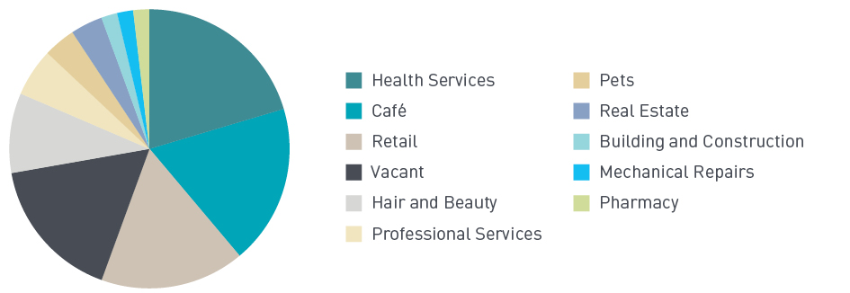

At Bonbeach, local businesses are clustered in two blocks between Newberry Avenue and Harding Avenue. As of September 2016, there are 12 businesses operating along the strip which is of a smaller scale to Edithvale and therefore does not include some services at Edithvale such as a post office, supermarket and pharmacy. Figure 8.12 below indicates the types of businesses at Bonbeach.

Figure 8.12 Breakdown of business at Bonbeach by type

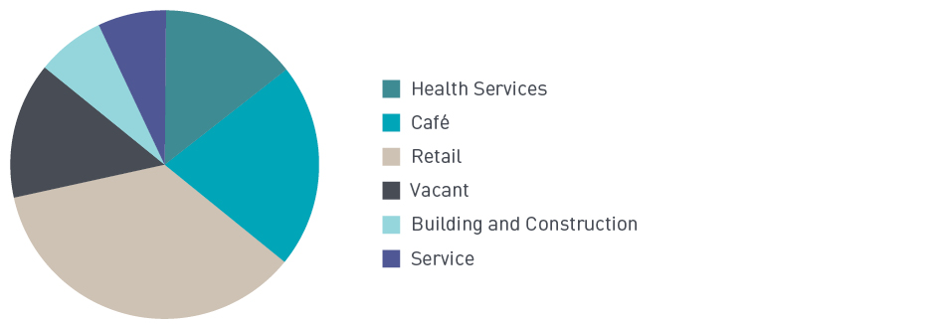

Most of these workplaces hire fewer than 20 people, and analysis of businesses within the relevant statistical area encompassing both Edithvale and Bonbeach indicates that the majority of businesses have a turnover of less than $50,000.
As part of the business impact assessment, LXRA engaged with Kingston City Council and local traders,
to provide an understanding about how the businesses operate as a small shopping precinct, and identified potential impacts to businesses during the construction and operation phases of the projects.
Trader engagement enabled understanding of how individual businesses operate and informed the risk and impact assessment processes. At Edithvale, 20 businesses were selected for trader engagement as a representative selection of the businesses operating near the Edithvale level crossing removal project.
Thirteen interviews were conducted and where interviews were not possible, letters were left at the business to inform them of the trader engagement being conducted. Similarly at Bonbeach, four interviews were conducted and three letters left. Overall, most traders were very supportive of the projects.

Construction impact assessment
The business risks identified for the construction phase of the Edithvale and Bonbeach level crossing removal projects are outlined in Table 8.19 below.

Table 8.19 Business risks – construction

Risk ID | Risk name | Risk pathway | Final EPR | Residual Risk
B7 | Decreased revenue (construction) | Businesses suffer from temporary loss of revenue due to changed traffic conditions and other construction impacts | EPR B1 Business disruption plan EPR AQ1 Air quality (construction) EPR AQ2 Air quality management EPR T1 Transport Management Plan  EPR CL2 Acid Sulfate Soil Management Plan EPR NV2 Construction noise  SC1 Community and Stakeholder Engagement Management Plan | Minor

Decreased business revenue (B7)
Disruption to local businesses could occur during the construction phase of the projects, through:
    - the loss of available car parking
    - loss of access to businesses
    - impacts to amenity
    - These disruptions have the potential to adversely impact businesses by causing a temporary loss of revenue.
Loss of available car parking
During the construction phase, it is likely that there would be a loss of public and commuter car spaces to temporarily accommodate construction activity. Discussions with traders raised concerns that the loss of available car parking would adversely affect businesses in the area, many of whom noted that the vast majority of their employees and customers travel by private vehicles to their businesses.
Currently, all-day car parking spaces are located on the east side of Nepean Highway which are generally used by commuters. Timed car parking spaces (approximately half to two hours in duration) are located on the west side of Nepean Highway immediately adjacent to businesses. Access to these car parking spaces could be limited during the construction phase of the projects due to lane closures. Impacts to the car parking spaces could inhibit staff access to local businesses, and potentially reduce the number of customers willing to access the precincts. Traders also expressed concerns that potential impacts could be compounded if construction activity coincides with summer when these car parks are also
used by visitors to the nearby beaches.

During the construction phase, consideration would be taken to manage the treatment of car parking spaces (EPR reference B1). Planning the construction phase would consider:
      - limiting the number of car parking spaces impacted by the project
      - replacing any impacted car parking spaces at alternative locations where possible
      - reinstating car parking at the earliest convenience
      - providing dedicated parking away from commercial properties for construction workers.
Ongoing engagement with the community and traders would assist in minimising impacts to local businesses. Communicating disruptions to car parking in accordance with the projects’ Community and Stakeholder Engagement Management Plan (EPR reference SC1) would provide certainty to the community and traders
of times and duration of disruption potentially impacting local businesses (refer to Technical Report L Social).

Interrupted access to businesses
During the construction phase, rail services would be disrupted, particularly during the main occupation when the rail line is expected to be closed for up to six weeks. During this time, replacement buses would be operating. Along with disruptions to rail services, it is likely there would be intermittent road closures or detours, especially at the level crossings (Edithvale Road and Station Street/Bondi Road).
Replacement bus services are generally slower compared to train services and commuters may seek alternative public transport options such as travelling to nearby stations. This could potentially result in lower patronage compared to normal train services through Edithvale and Bonbeach railway stations. Intermittent road closures and detours would also impact the propensity for customers to access the services at Edithvale and Bonbeach, particularly where competing businesses are located in neighbouring suburbs.
Restricting access to business during the construction period could adversely impact businesses for employees and customers alike. Discussions with traders revealed concerns that the temporary losses to businesses during the construction period could become permanent. For example, some traders were concerned that customers would become accustomed to disruptions, seeking alternative options for services in other locations leading to a permanent move from the services at Edithvale and Bonbeach.
Minimising access issues to businesses would be managed by the careful planning of the construction phase (EPR references B1 and SC1). Providing alternative access to businesses where possible would be considered. Alternative access would be clearly signed and comparable in distance to current routes where available. While trains are not operating in the areas, the projects would consider providing temporary weather protected waiting areas and customer service staff for the train-replacement bus services. In addition, early communication with traders and the community would be important for locals to anticipate and plan for road and rail disruptions.
By carefully planning for the impacts to businesses during the construction phase, revenue loss can be managed by ensuring customers can still access local businesses at Edithvale and Bonbeach.

Amenity impacts to businesses
Some of the retail or hospitality businesses at Edithvale and Bonbeach have outdoor seating areas along Nepean Highway. As such, these businesses could be impacted from reduced amenity during the construction period, due to dust, odour and noise emissions making outdoor seating areas less desirable.
As discussed throughout this chapter, amenity concerns would be managed through measures that include:
      - for dust: implement measures set out in EPA Publication 480 Environmental Guidelines for Major Construction Sites to comply with SEPP AQM (EPR references AQ1 and AQ2)
      - for odour: ensure that acid sulfate soils are managed in accordance with the Victorian Best Practice Guidelines for Assessing and Managing Coastal Acid Sulfate Soils, (EPR reference CL2)
      - for noise: undertake construction activities in accordance with Victorian EPA’s Noise Control Guidelines to minimise the potential for noise impacts to businesses (EPR reference NV2).
These risks and associated management measures are discussed further in Chapter 7 Acid sulfate soils and contamination, Section 8.2 Noise and Vibration and Section 8.7 Air Quality.

Disruptions to businesses because of reductions in available car parking, interruptions to access to businesses and impacts to the amenity of businesses in the area would be mitigated by implementing controls to manage these potential impacts. Car parking would be managed by planning for disruptive construction activities and limiting the assigning of car parking spaces for construction activities and workers. Access would be managed by providing alternate access for customers to local business. Amenity impacts would be managed by dust, odour and noise management controls detailed further in this chapter. These controls would ensure the risk rating for the disruptions to businesses would be minor.

Operation impact assessment
The removal of the level crossings is expected to improve the general amenity of the area by providing precinct infrastructure upgrades and improved transport and pedestrian connectivity. As such, improvements to the Edithvale and Bonbeach precincts seek to encourage activation of these areas, increasing potential patronage in the area to access local businesses (refer to Attachment VII Urban Design Guidelines – Edithvale and Attachment VIII Urban Design Guidelines – Bonbeach). The business risks identified for the operational phase of the Edithvale and Bonbeach level crossing removal projects are outlined in Table 8.20 below.

Table 8.20 Business risks – operation

Risk ID | Risk name | Risk pathway | Final EPR | Residual Risk
B8 | Decreased revenue (operation) | Existing businesses suffer from increased competition from new businesses in the railway station and/or reduced exposure to rail passengers | No EPR  specified | Negligible

Decreased revenue (operation) (risk B8)
Reduction in local business revenue could occur following the completion of the projects, through:
    - increased competition for businesses
    - reduced visibility of businesses.

Increased competition for businesses
The construction of two new station buildings at Edithvale and Bonbeach could impact local businesses after construction is complete. The proposed Edithvale railway station building includes provision for retail space of a size that would likely be appropriate for a small kiosk, providing a service to commuters.
This presents a potential competitive risk to established similar businesses in the area and could reduce revenue for local hospitality businesses as customers may choose to use the services provided at Edithvale railway station (such as buy their morning coffee) instead of walking to the retail area on Nepean Highway.
While providing retail space at Edithvale railway station would be a risk to current businesses, this space
is small and unlikely to provide any speciality services (similar to other stations in Melbourne). It is therefore considered that any impacts as a result of this business would be minimal and no management or mitigation is required as this risk would be negligible.

Reduced visibility of businesses
A number of traders identified that a portion of their customers are drawn from commuters who noticed their shopfronts and signage from the train and railway stations. The construction of a rail trench and below-ground rail station would result in businesses losing their visibility to potential customers.
While this risk is considered to be negligible, it is recognised that visibility of businesses for commuters on trains and in stations would be impacted by the removal of the level crossings. To manage this impact, ongoing discussions with traders would occur during the delivery of the project between traders and the project Alliance and relevant stakeholders (Metro Trains Melbourne and Public Transport Victoria for example) in order to establish outcomes minimising these impacts. Any physical advertising components (such as signage) would be proposed in accordance with the Urban Design Framework and the Urban Design Guidelines.
Reduction in local business revenue because of increased competition and reduced visibility is expected
to be negligible, but would be mitigated through discussions with traders during the delivery of the projects.

Landscape and visual

Changes in the urban environment can have intended and unintended impacts on the landscape and visual amenity experienced by the surrounding community. It is important to anticipate the outcomes of proposed changes so that measures can be implemented to minimise adverse landscape and visual impacts and maximise project benefits.
A landscape and visual impact assessment has been prepared and is provided in Technical Report J Landscape and Visual. This section summarises the outcomes of the assessment of construction and operational impacts on residents, and the community, as a result of the Edithvale and Bonbeach level crossing removal projects.

    - Existing conditions
For this assessment, the landscape within and surrounding the project areas has been characterised according to five main landscape character zones (LCZ).

What is a landscape character zone?

Landscape character zones (LCZs) reflect the natural and cultural influences that shape the landscape of a particular area and are identified as sharing broadly homogenous characteristics or spatial qualities.
Each character zone identified represents a relatively consistent character based on the consideration of the following attributes:

      - Landscape value (for example landscapes designated for their scenic or landscape importance or valued recreational function)
      - Landscape elements that contribute to defining character (for example residential, river/creek corridors, landform and open space et cetera)
- Landscape character attributes (including scale, grain and perceptual characteristics such as the sense of remoteness, tranquillity and/or its perceived character).

The LCZs in the vicinity of the projects are characterised as:

  - LCZ 1 – Infrastructure corridor
  - LCZ 2 – Residential
  - LCZ 3 – Commercial
  - LCZ 4 – Open space
  - LCZ 5 – Foreshore.
These are introduced in the following sections.

LCZ 1 – Infrastructure corridor
This LCZ is characterised by the railway corridor, which is a dominant form that cuts through the surrounding landscape. The LCZ contains a moderate to low intermittent cover of low-lying shrubs
and trees which are interrupted by regularly spaced gantries that support the power supply for the trains.
A transparent wire fence defines the rail boundary, and high and low voltage power lines sit on the edge of the LCZ. This linear corridor is reinforced by the adjoining Nepean Highway and Station Street on both sides of the LCZ. Images from this LCZ are shown in Figure 8.13.

Figure 8.13 Example of the Infrastructure corridor (LCZ 1) at Edithvale (left) and Bonbeach (right)

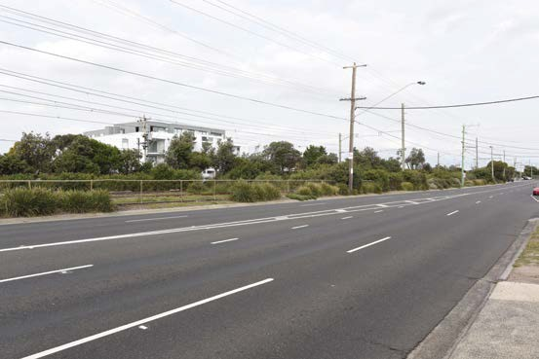 | 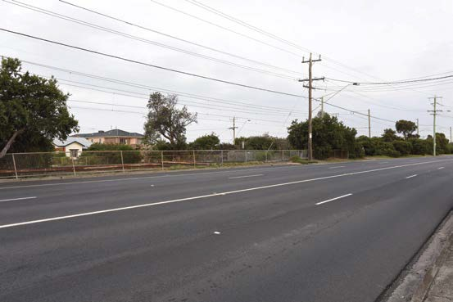

LCZ 2 – Residential
This LCZ is located within a wider coastal area and consists of a combination of old and new residential developments. Built form typically ranges from single and double storey housing, rising up to four storeys in some locations. LCZ 2 sits either side of the infrastructure corridor (LCZ 1). The residential LCZ west
of the railway line is typically subject to substantial levels of renovation and redevelopment, with less redevelopment occurring east of the railway line. The landscape incorporates scattered vegetation and limited street tree planting in residential streets. Images from this LCZ are shown in Figure 8.14.

Figure 8.14 Example of residential (LCZ 2) at Edithvale (left) and Bonbeach (right)

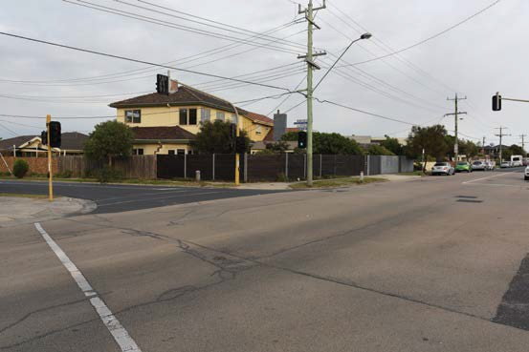 | 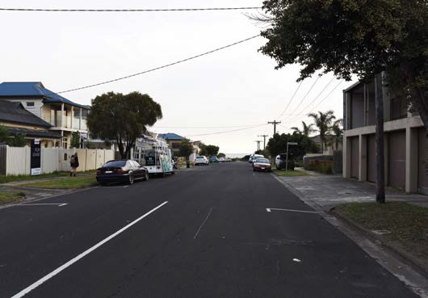

LCZ 3 – Commercial
This LCZ comprises a small linear commercial centre containing a mix of shops, small businesses and cafes/ restaurants on the western side of the Nepean Highway at both Edithvale and Bonbeach. The commercial centres are generally located in one or two storey premises with ground floor shops and residential above.
The commercial LCZs are located adjacent the Edithvale and Bonbeach train stations. The character is primarily influenced by the utilitarian nature of the road setting, with no significant level of setback from the highway and no street trees. Images from this LCZ are shown in Figure 8.15.

Figure 8.15 Example of commercial corridor (LCZ 3) at Edithvale (left) and Bonbeach (right)

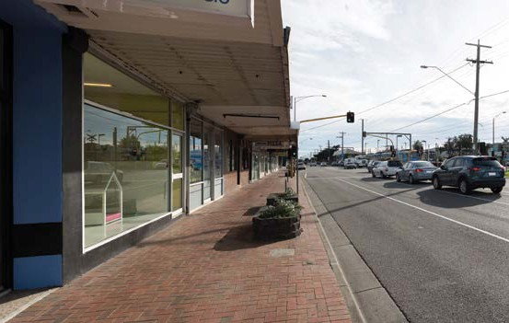 | 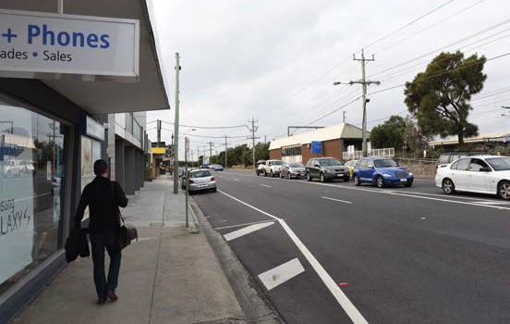

LCZ 4 – Open space
This LCZ is only relevant to Edithvale, where Beeson Reserve, situated in the centre of the project area, and Regents Park, situated on the northern boundary of the project area are located. Beeson Reserve acts as a gateway between the station and the coast, and includes formal planting, with fringing vegetation and
low scattered trees on the boundary adjacent to The Esplanade. At the northern boundary of the project area, Regents Park and small portion of the Rossdale Golf Club lie within the project area boundary. Images from this LCZ are shown in Figure 8.16.

Figure 8.16 Example of open space corridor (LCZ 4) at Edithvale (Beeson Reserve)

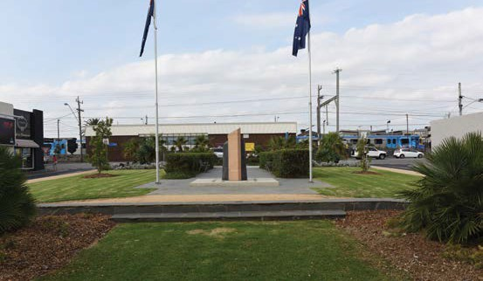 | 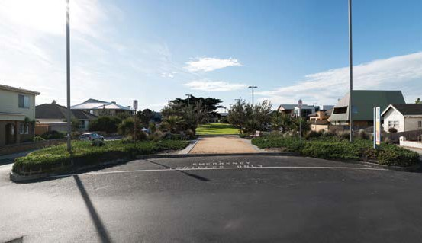

LCZ 5 – Foreshore
This LCZ forms part of a long coastal strip that extends from Mordialloc Creek to Carrum and overlooks Port Phillip Bay. The LCZ comprises low dunes and a variety of remnant vegetation. Images from this LCZ are shown in Figure 8.17.

Figure 8.17 Example of foreshore (LCZ 5) at Edithvale (left) and Bonbeach (right)

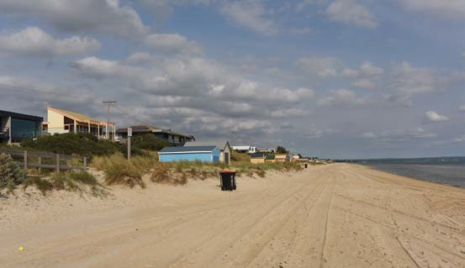 | 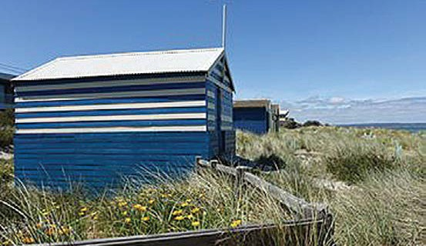
The locations of these LCZs are shown in Figure 8.18.

Figure 8.18 Landscape character zones in the vicinity of Edithvale (below) and Bonbeach (top)
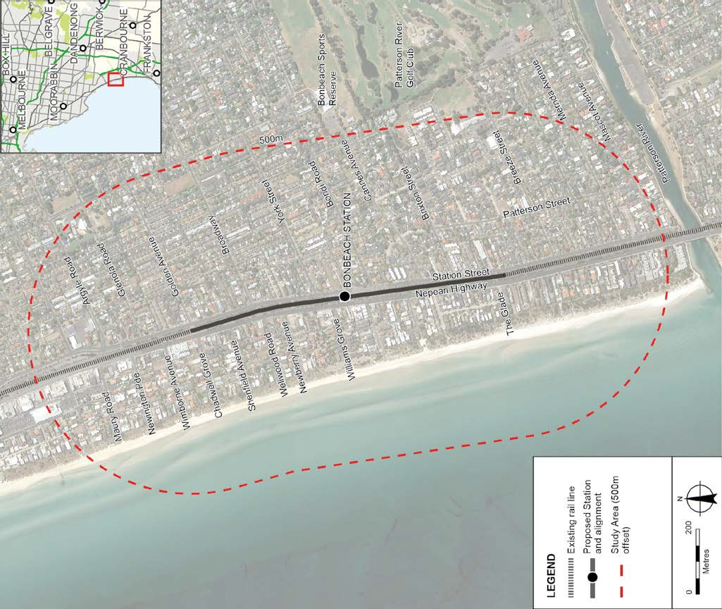
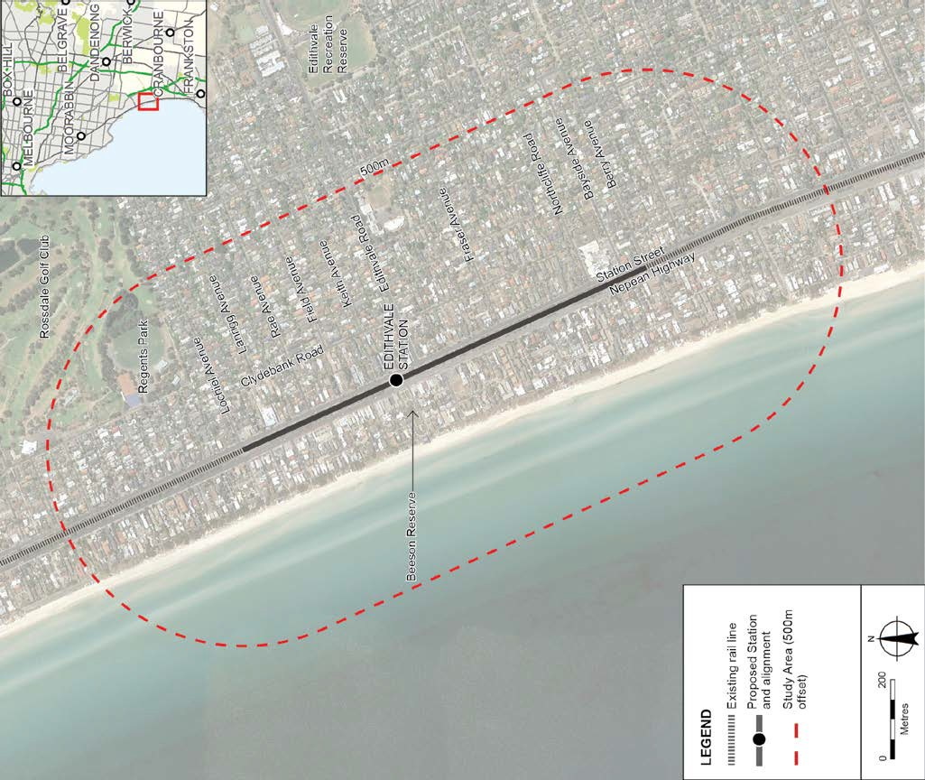

    - Construction impact assessment
The potential landscape and visual risks identified for the construction phase of the Edithvale and Bonbeach level crossing removal projects are outlined in Table 8.21.

Table 8.21 Landscape and visual risk – construction

Risk ID | Risk name | Risk pathway | Final EPR | Residual Risk
LV37 | Lighting | Lighting leads to disturbance to sensitive receptors/fauna and leads to a perceived loss of amenity. | EPR LV3 Light spillage | Negligible
LV39 | Visual impacts (construction) | Visual impact of construction activities, ancillary facilities results in perceived loss of visual amenity by residents or the community. | EPR UD2 Hoardings  EPR AQ1 Air quality (construction) | Minor

Lighting (risk LV37)
Lighting of construction areas may be required when night works are planned to occur. This is expected to be necessary during the main occupation period, and periodically at other times. Without controls, lighting has the potential to spill into adjoining residential areas and disturb the amenity.
To prevent potential impacts on residents and community facilities, measures would be developed and implemented to minimise the amount of light which spills beyond the construction area (EPR reference LV3). This would
include the use of directional lighting and screening to prevent light spill beyond the construction site. With the implementation of these controls, the risk of lighting resulting in a loss of amenity would be negligible.

Visual impact (risk LV39)
Visual impacts during construction have the potential to result from the introduction of construction activities and ancillary facilities into the existing landscape resulting in the loss of visual amenity in the area. Visual impacts could result from the following activities/features:
  - ground levelling to those areas adjoining the trench, and the resulting loss of the existing endemic tree and shrub cover within these areas
  - protection and/or relocation of utility services
  - views of machinery such as piling plant, excavators and trucks seen above work site hoardings
  - transport of spoil, excavated material and groundwater offsite, potentially visually impacting views along some local roads
  - construction of above ground elements including station and substation buildings, pedestrian overpasses and decking over the rail trench.
  - new rail infrastructure including excavation and installation of ballast, overhead line equipment and rail.
The proposed construction activities would be expected to be completed within 18 months. The main rail occupation period would comprise the most intense construction activity, and therefore the greatest potential for visual impacts, and would occur over a six-week period. During this time, works would be expected across a larger area as the existing stations are demolished, trenches are excavated and new stations are established.
Outside of the main occupation, the greatest change to views would be expected to result from piling rigs or other earthworks and traffic management. These impacts would generally be expected to be localised, and would ‘migrate’ along the rail corridor as the piling works progress along the linear alignment.
To mitigate the potential impacts caused by the construction activities, views to construction areas would be screened through the use of hoarding to minimise the extent of construction activities that would be visible to residents and the passing community (EPR reference UD2). It is noted that the use of hoarding would still result in a change to the view. Measures would be implemented to minimise the generation of dust to ensure it would not affect amenity (EPR reference AQ1).

The changes to views would generally be limited to the residents immediately adjacent to the rail corridor and passing commuters. Given the transient nature of passing commuters, the changes would be expected to have limited impact on the amenity experienced as part of their overall journey.
The risk associated with the loss of visual amenity during construction has been assessed as minor, given that hoarding would be in place to screen the main activities, controls would be implemented to mitigate dust and any impact would be temporary in nature.

Operation impact assessment
The potential landscape and visual risks identified for the operation phase of the Edithvale and Bonbeach level crossing removal projects are outlined in Table 8.22.

Table 8.22 Landscape and visual risks – operation

Risk ID | Risk name | Risk pathway | Final EPR | Residual Risk
LV37 | Lighting | Lighting leads to disturbance to sensitive receptors/fauna and leads to a perceived loss of amenity. | EPR LV2 Lighting | Negligible
LV38 | Landscape character | Change of landscape character in infrastructure corridor/commercial/ residential/open space/foreshore areas resulting in perceived loss  of amenity. | EPR LV1 Landscape and visual opportunities  EPR UD1 Urban Design Guidelines | Negligible
LV40 | Visual impact (general) | Visual impact of changes to rail infrastructure (excluding pedestrian overpasses and substation) results in perceived loss of visual amenity by residents or the community. | EPR LV1 Landscape and visual opportunities  EPR UD1 Urban Design Guidelines | Minor
LV41 | Visual Impact (ped overpasses, substation) | Visual impact of new pedestrian overpasses (Edithvale and Bonbeach) and substation (Edithvale) results in perceived loss of visual amenity by residents or the community | EPR LV1 Landscape and visual opportunities  EPR UD1 Urban Design Guidelines | Moderate

Lighting (risk LV37)
Lighting associated with the project would be generally limited to the immediate station precinct, including car parking, station building and plaza, with levels sufficient to meet relevant standards for security and safety levels. Lighting would be designed in accordance with the relevant standards to prevent unnecessary light generation (EPR reference LV2).
It is anticipated that the light condition would not be significantly different to the existing condition and therefore the risk of amenity loss due to the lighting is considered to be negligible.

Landscape character (risk LV38)
A change to the landscape within the project areas has the potential to affect the character of each area and result in a perceived loss of amenity. The main project elements that have the potential to affect the character of the landscape include:
  - transformation of an above ground rail corridor into a below-ground trench
  - new station buildings
  - pedestrian ramps and overpasses crossing the rail corridor
  - crash barriers, throw screens and security fencing surrounding the trench
  - substation at Edithvale
  - commuter car parking located on decking over part of the rail corridor
  - loss of existing vegetation.
To inform the level of risk applicable to the project, an assessment of impacts to the LCZs at each of the project areas was undertaken. The assessment of impacts is available in Technical Report J Landscape and Visual. The impacts were assessed using a specific methodology for considering landscape impacts. This methodology was then used to inform the risk assessment presented in this EES. The specific landscape assessment method identified impact ratings ranging from negligible to moderate for different locations. These ratings have been used to identify the overall level of risk for each project for each of the risks in Table 8.22.
A crash barrier and throw screen would be required around the trench for safety reasons, and this would present a new element within the landscape. The proposed crash barrier is described in Chapter 2 Rationale and project descriptions and would be a 0.8 to 1.8 metre high concrete crash barrier along the top of the trench. A screen would be included on top of the crash barrier up to a total height of 2.4 metres. Around the station areas, the proposed island platform and trench infrastructure would fill a larger width of the existing rail corridor with hard infrastructure than the current stations, leaving less room available to allow planted vegetation to soften the landscape as trees and shrubs currently do. This would also be the case near the new carpark on decking over the trench which would limit the opportunity for deep garden beds. However, the island platform design enables improved urban design outcome, improved circulation around the station as the same set of stairs and lifts can access both up and down platforms, and is a better CPTED outcome as all passengers will be on the same platform maximising passive surveillance. The application of the Urban Design Guidelines would ensure soft landscaping is included in the final design where space and safety requirements allow. The new station building would be expected to result in minimal impact to the landscape since it would be replacing an existing building of similar size at both sites.
Impacts would be expected to be greatest for the landscape within the infrastructure corridor (LCZ 1) where the main changes are occurring, as well as at the interfacing residential areas (LCZ 2) that overlook the rail corridor. It should be noted that the residential area would be expected to be impacted only at the interface with the rail corridor, and impacts would diminish with distance from the rail corridor.
Adherence to the Urban Design Guidelines applicable to each site would minimise impacts to the extent possible by ensuring the detailed design considers the existing setting and results in high quality urban design response to improve amenity (EPR references UD1 and LV1). As a result, the risk associated with a change in landscape character resulting in a perceived loss of amenity is considered negligible.

Visual impact (risk LV40 and LV41)
Changes to the landscape have the potential to affect the visual amenity experienced by nearby residents and the wider community. Some of the main project elements that could affect visual amenity include; new station buildings, safety barriers and throw screens required around the trenches, new pedestrian over passes, and the new substation building at Edithvale.
As discussed in relation to landscape character, the barrier and throw screen established around the trench would be a new visual element within the landscape. The barrier would extend the full length of the trench where there is no deck, and would alter views from some residences and businesses. Although room would be limited at some locations, soft landscaping would be provided along the trench where space allows, which would help to soften views of these new hard infrastructure elements.
The new station buildings would replace the existing stations which were constructed in the 1980s, and be constructed on a deck slightly south of their current position (see Figure 8.20). A second platform access would be located on the southern (carpark) deck. These new buildings would be designed in accordance with the Urban Design Guidelines specific to each site (EPR references UD1 and LV1). In doing so, the design would be required to consider the existing setting and implement an innovative and high-quality urban design response.

Urban Design

The existing Edithvale and Bonbeach stations have reached the end of their design life, and the projects would include their replacement with a new modern facility that is integrated and well-considered. The Urban Design Guidelines (UDGs) set out the requirements for a considered and high-quality approach to architectural, landscape and infrastructure design across the projects.
Chapter 11 Urban design approach provides details of the urban design concept for the projects. Urban design outcomes that have been achieved for other level crossing removal projects are provided below, as examples of the quality design outcome expected for these projects.

Figure 8.19 Examples of urban design outcomes for level crossing removal projects
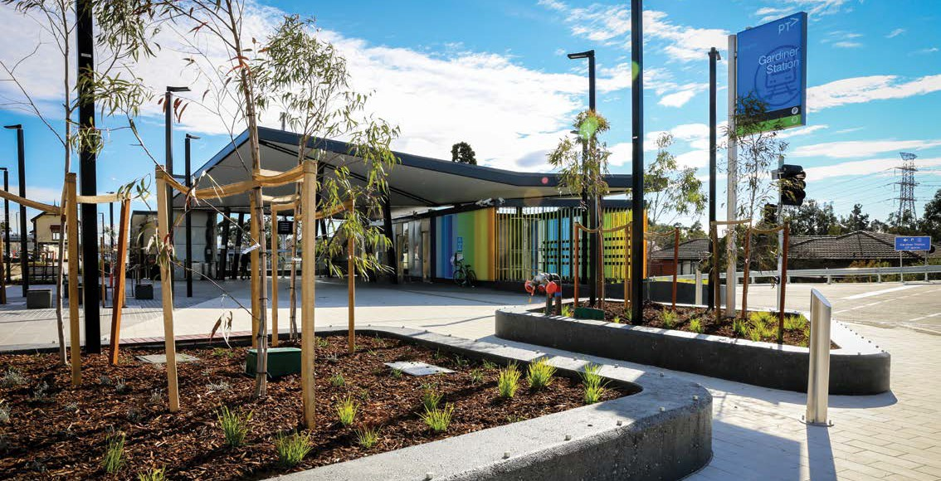
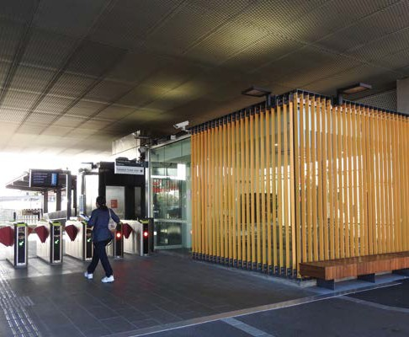
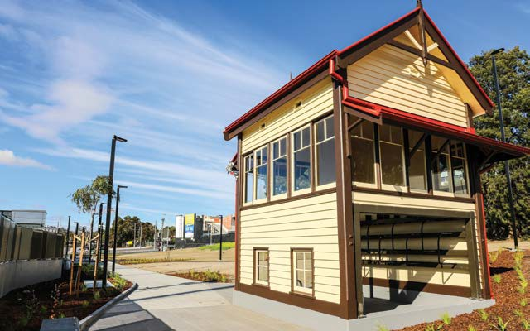

An urban design outcome that aligns with the Urban Design Guidelines has been assumed for the purpose of this assessment and has been applied to the visualisations used to assess the potential impacts of the projects. The urban design shown in photo-montages is an example of a possible design in response to the UDGs, and should be considered as an example only.
It should also be noted that many elements depicted within the photo-montages are still subject to detailed design. This includes the position of the overhead powerlines which will be determined at a later stage.
A worst-case outcome has been assumed for each viewpoint assessed, making this a conservative assessment of landscape and visual impacts.

Figure 8.20 Before and after photo-montage of a potential design outcome of the barriers and new station
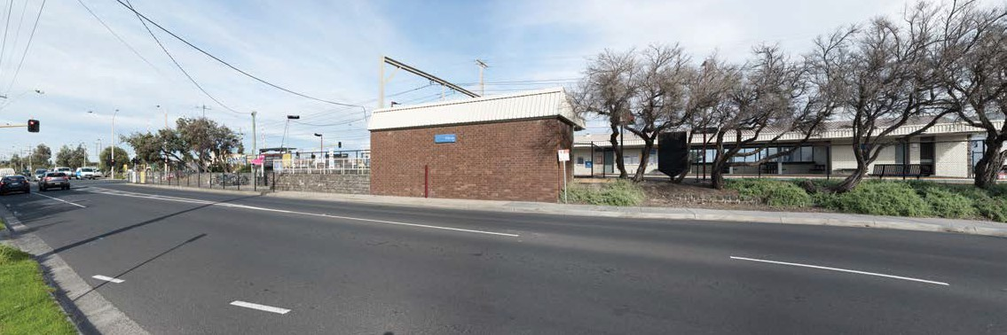
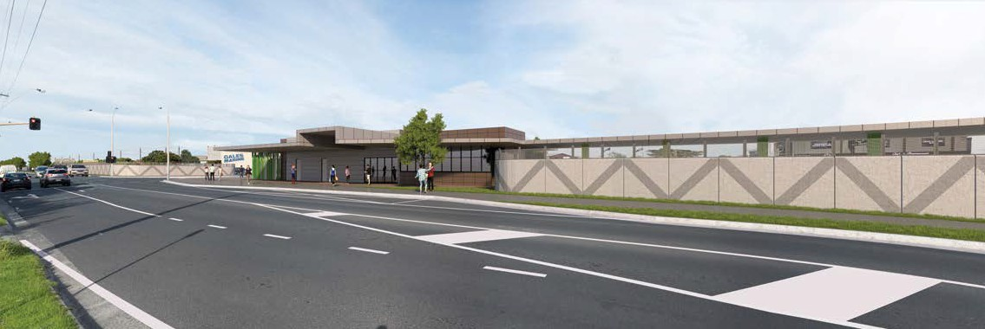

The pedestrian overpasses and substation at Edithvale would be expected to have the most significant impact due to their elevation and position as a new building within the landscape. A number of new pedestrian overpasses would be constructed to retain connectivity across the rail corridor (see Figure 8.21). These would be Disability Discrimination Act 1992 (DDA) compliant to serve all members of the community, and would therefore include a ramp up to an elevated walkway that would pass over the trench and barriers. At Edithvale, a new substation structure would be established in one of two locations on a deck adjacent to the carpark (see Figure 8.22).
The substation would be enclosed within security fencing and consist of a prefabricated building with an approximate footprint of 35 metres long, seven metres wide and six metres tall. The substation and pedestrian overpasses would be designed in accordance with the Urban Design Guidelines specific to each site (EPR reference UD1), which would include the use of soft landscaping to minimise the impact of these features where possible.
Consultation with stakeholders during the detailed design process and adherence to the Urban Design Guidelines would ensure the design of the new structures minimises the potential for visual impacts on nearby residents and the surrounding community. As a result, the risk associated with a change to views within the project areas resulting in a perceived loss of amenity would generally be considered minor, or moderate for the pedestrian overhead bridges and substation.

Figure 8.21 Before and after photo-montage of a potential design outcome of the barriers and pedestrian overhead pass
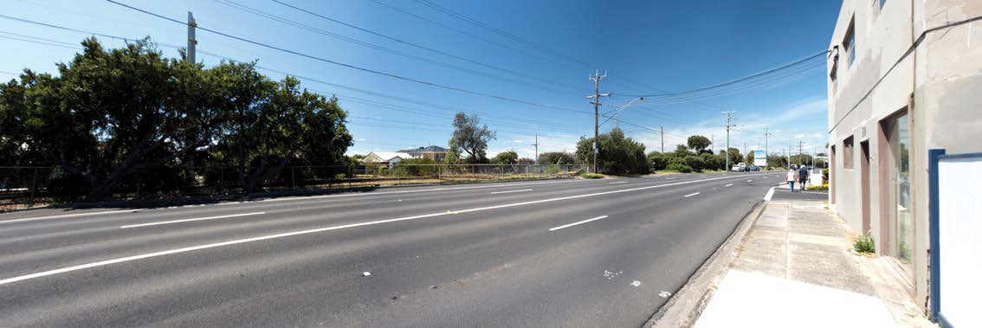
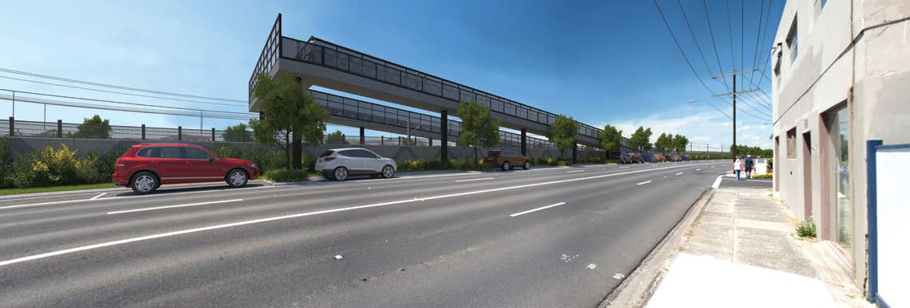

Figure 8.22 Before and after photo-montage of a potential design outcome of the barriers
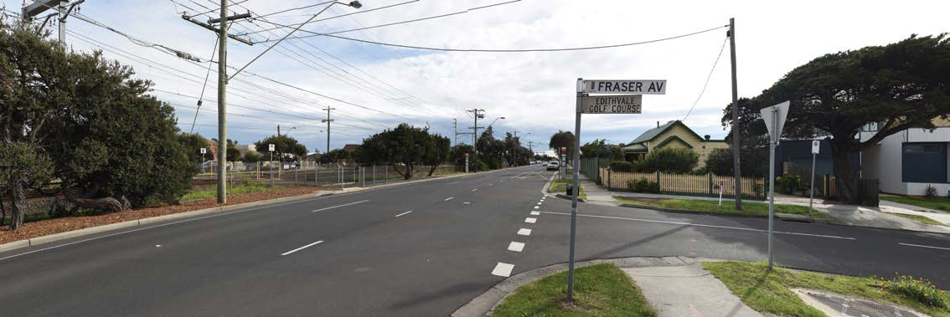
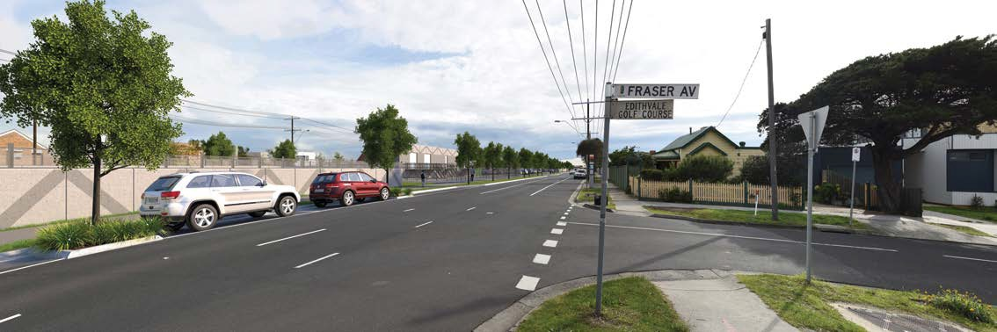

  - Ecology
The Edithvale and Bonbeach level crossing removal projects are located within a largely urbanised region, dominated by residential and, to a lesser extent, commercial development. Much of the original vegetation that would have occupied the project areas has been historically cleared, however small patches of remnant (indigenous) vegetation persist.
Some vegetation has been planted for its amenity value.
To facilitate the removal of the level crossings, excavation works would be required to construct the trench. During the construction phase, the ground surface of the project areas would be cleared. This would include the clearance of existing parts of the rail track, ballast, associated rail infrastructure (such as overhead signalling and power structures) and the clearance of vegetation. Ecological values within the project areas would be impacted during construction due to the necessary removal of vegetation, through construction activities such as stockpiling or soil compaction and from disturbance such as dust generation, noise or vibration. No effects on ecological values at the level crossing project areas have been identified for the operational phase.
An ecological impact assessment of flora and fauna within the project areas has been prepared and is provided in Technical Report D Ecology: Project Areas. This section summarises the outcomes of the assessment for the Edithvale and Bonbeach level crossing removal projects.

Existing conditions
Vegetation within the Edithvale and Bonbeach project areas is generally of poor quality – a consequence of the historical and continuing land use as an active rail line (see Figure 8.23), and the increase in development of land adjacent to the rail corridor.
Roadways line both sides of the rail corridor. An important transport route in the Nepean Highway lies to the west and Station Street (a local access road) to the east. Beyond the roadways, residential land use dominates with commercial strips opposite both Edithvale and Bonbeach railway stations on Nepean Highway. Vegetation quality within the rail corridors at Edithvale and Bonbeach reflects the continuing pressure from both weed infestations and from regular disturbance through management and maintenance within the rail corridor.

Figure 8.23 Rail corridor at Edithvale (left) and Bonbeach (right)

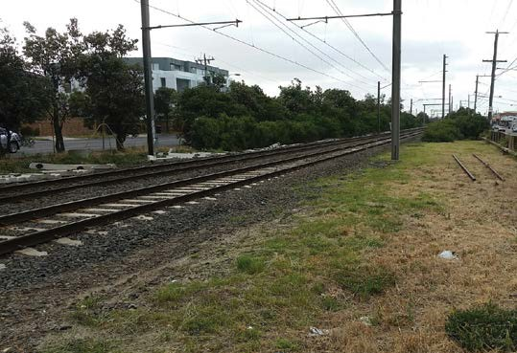 | 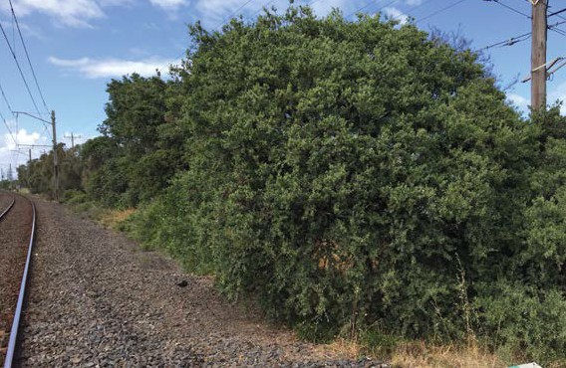

Remnant Vegetation
Remnant vegetation includes both patches of native vegetation and scattered indigenous trees and their removal is controlled through the application of the Planning and Environment Act 1987. A remnant patch of native vegetation is defined by the Department of Environment, Water, Land and Planning (DELWP, 2013) as either:
- an area of vegetation indigenous to Victoria, with or without trees, where at least 25 per cent of the total perennial (a plant with a lifecycle of more than two years) understorey plant cover is native plants, or
- an area with three or more indigenous trees where the tree canopy cover is at least 20 per cent.
A scattered tree is defined as a native canopy tree that does not form part of a remnant patch.

In Victoria, patches of remnant vegetation are classified by Ecological Vegetation Classes (EVC) which are based on the general ecological characteristics and underlying geology of the vegetation. Remnant vegetation identified and mapped at Edithvale and Bonbeach are summarised in Table 8.23.

Table 8.23 Summary of remnant native vegetation at Edithvale and Bonbeach

Vegetation | Edithvale | Bonbeach
Patches of remnant vegetation | 21 patches comprising 1.15 hectares:  - 20 patches of Coast Banksia Woodland (EVC 2) totalling 1.12 hectares  - 1 patch of Coastal Dune Scrub (EVC 160) of 0.027 hectares | 17 patches comprising 1.05 hectares:  - 14 patches of Coast Banksia Woodland (EVC 2) totalling 1 hectare  - 3 patches of Coastal Dune Scrub (EVC 160) totalling 0.05 hectares
Scattered trees | 3 | 1

The two identified EVCs are described as follows:
Coast Banksia Woodland (EVC 2)
Within the project area, Coast Banksia Woodland (EVC 2) is generally restricted to long, linear patches of vegetation outside the rail corridor. This EVC was identified by the presence of an overstorey of Coast Banksia to 15 metres in height, growing over a mid-storey shrub layer comprising nearly solely of Coast Tea-tree with the occasional planted Drooping She-oak. Ground layer vegetation is dominated by grassy and broad-leaf weed species with few indigenous species recorded (refer to Figure 8.24). Coast Banksia Woodland is classified ‘vulnerable’ in the Gippsland Plain Bioregion.

Figure 8.24 Coast Banksia Woodland at Edithvale (left) and Bonbeach (right)

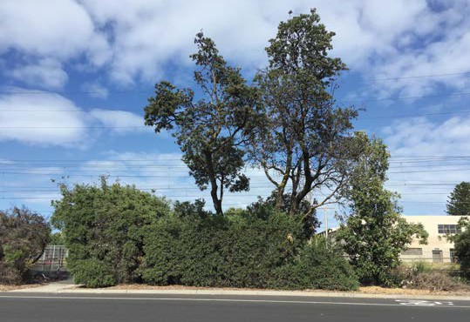 | 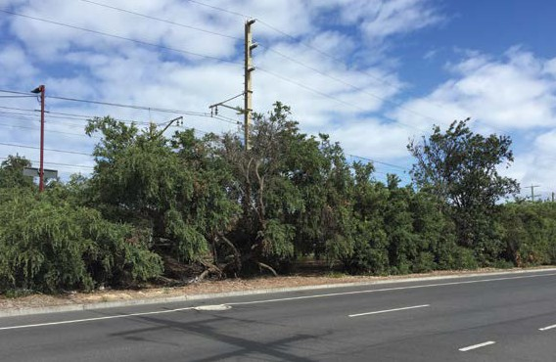

Coastal Dune Scrub (EVC 160)
Coastal Dune Scrub (EVC 160) was identified within both the Edithvale and Bonbeach project areas. The patches assessed were typically species-poor, often comprised only of Coast Tea-tree with an understorey dominated by weed species (refer Figure 8.25). Coastal Dune Scrub is considered to be ‘depleted’ in the Gippsland Plain Bioregion.

Figure 8.25 Coastal Dune Scrub at Edithvale (left) and Bonbeach (right)

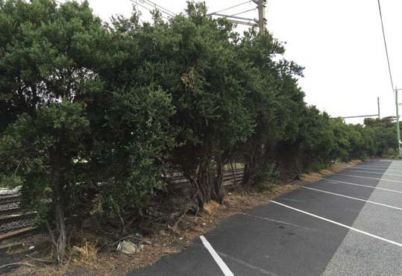 | 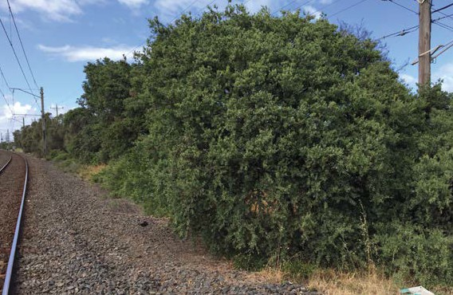

EVC 2 and EVC 160 were often difficult to distinguish as they both grow in the same sandy soil type and are often represented by similar species. For the purposes of this assessment, they were differentiated by the presence of Coast Banksia which were considered indicative of EVC 2. A total of four patches of Coastal Dune Scrub were recorded at both sites – one at Edithvale and three at Bonbeach.
In addition to the EVCs, a total of four scattered trees were identified – three at Edithvale and one at Bonbeach.

Planted vegetation
Planted vegetation includes street trees, shrubs and understorey species planted for their amenity value within urban landscapes. Such plantings may include native or exotic species and are exempt from the need for a permit to be removed. Regardless of the need for a permit, this assessment recognises the significance of this vegetation to communities and the environment.
Planted vegetation was recorded at both Edithvale and Bonbeach, and comprised both indigenous and exotic species. Amenity plantings around Edithvale Station comprise species including Silver Princess and Red- flowering Gum, with the occasional plantings of Coast Tea-tree and Coast Banksia. The plantings at Edithvale Station appeared to be regularly maintained.
A local community group is responsible for the maintenance of the amenity plantings lining the rail corridor at Bonbeach Station. Similar Eucalypt species to Edithvale have been planted at Bonbeach, and grow above a ground layer of a variety of shrubs and grasses.

Fauna
Habitat for terrestrial fauna within the project areas is limited in both extent and quality owning to the historical disturbance within the project areas. Potential habitat is primarily restricted to narrow, linear strips of vegetation on either side of the rail corridor.
Fauna species observed at Edithvale and Bonbeach include species typical of suburban environments- Australian Magpie, Australian Raven, Magpie-lark, Rainbow Lorikeet, Red Wattlebird and the exotic Common Myna and Common Starling.
No habitat suitable for threated fauna was identified.

What is a threatened species?
‘Threatened species’ refers to those species that are considered ‘threatened’ in Victoria or Australia. This includes species that are listed as:
- ‘threatened’ under the Flora and Fauna Guarantee Act 1988
- ‘vulnerable’ or ‘endangered’ on the Victorian Rare or Threatened species advisory lists or
- ‘vulnerable’, ‘endangered’ or ‘critically endangered’ under the Environment Protection and Biodiversity Conservation Act 1999.

Protected flora species
The Flora and Fauna Guarantee Act 1988 (the FFG Act) provides provides legal protection for native plants or communities whose populations are at risk. Three species classified as ‘protected’ and listed under the protected flora controls of the Act were observed during the field assessment:
- White Sallow-wattle
- Coast Wattle
- Cotton Fireweed.

Pest animals, declared weeds and pathogens
Pest animals, weeds and pathogens can have the potential to cause environmental harm and impact human health. The control of pest animals, weeds and pathogens are managed under the Catchment and Land Protection Act 1994 (CaLP Act). Under this Act, species of plants and animals can be declared as noxious weeds and pest animals. Similarly, pathogens can be listed under the CaLP Act as a potentially threatening process – a process which may have the capability to threaten the survival, abundance or evolutionary development of any flora and fauna.
No pest animals were observed within the project areas, however the Red Fox, European Rabbit and Feral Cat are likely to occur in the project areas. Of these species, the Red Fox and European Rabbit are declared as established pest animals under the CaLP Act.
Eleven weed species listed under the CaLP Act were identified at both project areas, six of which are recognised as Weeds of National Significance. While impacts will occur during the construction phase, they are permanent changes that will continue into the operation phases. Therefore they are assessed as operational impacts. These include the Bridal Creeper, Spear Thistle, English Broom, Flax-leaf Broom, African Box-thorn, Blackberry and Gorse.
Pathogens are a bacterium, virus or other microorganism that can cause disease in plants, animals or humans. Two pathogens were identified for consideration for the projects – Chytrid Fungus and Cinnamon Fungus. These pathogens are listed as potentially threatening processes.

Construction impact assessment
The ecological impact assessment evaluated the impact of the projects’ construction and operation
on the ecological values within the project areas. The local ecology risks identified for the construction phase of the Edithvale and Bonbeach level crossing removal projects are outlined in Table 8.24.

Table 8.24 Ecology risks – construction

Risk ID | Risk name | Risk pathway | Final EPRs | Residual Risk
E42 | Native vegetation removal | Removal of native vegetation (patches and scattered trees) within the project area, impacting native vegetation extent | EPR FF1 Native vegetation and habitat | Minor
E43 | Removal of protected flora | Loss of protected flora species  from within the project area reducing the abundance of that species | EPR FF2 FFG permits | Minor
E44 | Removal of habitat for threatened species | Removal of habitat for threatened flora and/or fauna species within the project area affecting the persistence of the species. | No EPR specified | Negligible
E45 | Removal of habitat (non- threatened fauna) | Removal of habitat resulting in the displacement, injury or death of wildlife protected under the Wildlife Act 1975 causing animal welfare concerns. | EPR FF4 Fauna  EPR FF6 Landscaping for wildlife  EPR UD1 Urban Design Guidelines | Minor
E46 | Disturbance to fauna (project areas) | Increase in noise, vibration and artificial light affecting fauna behaviour within or adjacent to project area resulting in a decline in fauna abundance and/or diversity | EPR AQ1 Air quality (construction)  EPR AQ2 Air quality management  EPR NV2 Construction noise  EPR SW1 Stormwater management – construction  EPR LV2 Lighting  EPR LV3 Light spillage | Negligible
E47 | Threatening process (weeds, pathogens, pests) | Spread of weeds listed under the CaLP Act resulting in the decline in quality of native vegetation in the rail corridor adjacent to the project area.  Spread, or introduction, of pathogens/ pest animals resulting in the exacerbation of a threatening process listed under the FFG Act and EPBC Act. | EPR FF3 Weeds and pathogens | Negligible
E48 | Threatening process (habitat fragmentation) | Fragmentation of the narrow habitat corridor within and beyond the rail reserve, resulting in the exacerbation of a threatening process listed under the FFG Act | EPR FF1 Native vegetation and habitat  EPR FF6 Landscaping for wildlife  EPR UD1 Urban Design Guidelines | Minor

Risk ID | Risk name | Risk pathway | Final EPRs | Residual Risk
E49 | Unintended impacts on vegetation and habitat | Unintended impacts on adjacent/ retained vegetation as a result of:  - Inappropriate placement of construction stockpiling resulting in unintended impacts to vegetation and habitat.  - Soil compaction or excavation causing root damage and vegetation loss within (or adjacent to) the project area.  - Dust generation during construction impacting the health of vegetation.  - Spills of chemicals resulting in pollution of native vegetation or (particularly Edithvale Wetland and/or Wannarkladdin Wetland) either through surface or groundwater flows.  - Unintended loss of vegetation to be retained from accidental plant/ personnel access to designated no-go areas or areas outside  of the defined project area. | EPR FF5 Protection of retained/adjacent vegetation | Negligible

Removal of vegetation (risk E42)
The projects would require the removal of native vegetation, however not all vegetation listed in Table 8.23 would be impacted. During the development of the detailed design, the disturbance footprint of the projects would likely decrease, avoiding the need for the removal of some of the vegetation within the project areas.
In a conservative scenario where all native vegetation within the project areas is required to be removed, this would equate to the loss of approximately 2.2 hectares of native vegetation and four scattered trees.
The removal of any remnant vegetation is controlled by the Planning and Environment Act 1987 and the Kingston Planning Scheme. The removal, destruction or lopping of native vegetation for the projects will be subject to the requirements of the Permitted clearing of native vegetation – Biodiversity assessment
guidelines, in accordance with the transitional arrangements established under Clause 52.17 of the planning scheme. These guidelines require that any removal of native vegetation is offset to ensure that the removal of the native vegetation would result in an equivalent contribution to Victoria’s biodiversity. The guidelines prescribe a method for determining the offset requirements based on the location, type, extent and quality of impacted vegetation.
Whilst the removal of some remnant vegetation is likely to be unavoidable, the extent of impact on native vegetation in the project areas would likely be minimised by reducing the project footprint and offsetting any vegetation removed (EPR reference FF1). Therefore, the risk of impacting the native vegetation during the projects construction phase is minor.

Protected flora species (risk E43)
Three species listed as ‘protected’ under the FFG Act were observed at the Edithvale and Bonbeach project areas. These are the White Sallow-wattle, the Coast Wattle and Cotton Fireweed. Any loss of these protected flora species during the construction phase would reduce the abundance of that species in the project areas.
While it is conservatively estimated that all vegetation within the project areas would be removed, the project footprints would be designed to minimise this impact. If these species are impacted, a ‘permit to take protected flora’ under the FFG Act would be required from DELWP (EPR reference FF2).
Obtaining this permission would not reduce the loss of the protected flora during construction of the projects, and therefore the abundance of that species in the area would be reduced. However, due to the low presence of protected flora identified within the project areas and the fact that some individuals are considered to have been planted, the impact to that species overall as a result of the projects is considered to be minor.

Removal of habitat for non-threatened fauna (risk E45)
Native and exotic trees and shrubs within the project areas have the potential to provide habitat for non- threatened fauna such as possums and birds. Minimising the clearance of vegetation and construction activities would result in a lower potential for the displacement, injury or death of non-threatened fauna species.
As design progresses, consideration would be given to the suitability of plantings to accommodate habitat for non-threatened fauna. Where possible, landscaping would incorporate native and indigenous species to provide valuable foraging resources for wildlife likely to be impacted by the projects (EPR references FF6 and UD1). Where possible, the use of mature plants would reinstate habitat at a faster rate.
Projects would consider design opportunities to avoid the removal of habitat. Where fauna habitat is identified for removal, a suitably qualified specialist would be engaged to check for fauna occupancy and ensure compliance with the Wildlife Act 1975. All necessary authorisations must be obtained prior to commencement of works (EPR reference FF4).
Minimisation of vegetation loss, the implementation of wildlife recovery (if required) and use of native flora species where possible in landscaping would ensure the risk of displacement, injury or death of wildlife protected under the Wildlife Act 1975 due to habitat removal would be minor.

Threatening processes under the Flora and Fauna Guarantee Act (risk E48)
Removal of vegetation within the project areas at Edithvale and Bonbeach would interrupt the mostly continuous vegetative link within the rail corridor of the Frankston rail line. Vegetation clearance is an ongoing impact associated with the development of land. The removal of vegetation within the project areas would contribute to a threatening process (fragmentation of vegetation strips) listed under the FFG Act.
The fragmentation of habitat within the rail corridor is a long-term and continuing issue due to the intensification of disturbance of the land over time. Minimising the project footprint would minimise the fragmentation of habitat within the rail corridor (EPR references FF1 and UD1). Landscaping around new infrastructure would consider the suitability of plantings to provide valuable feeding resources for birds that may be impacted by the projects (EPR references FF6 and UD1), which also considers the management of the displacement of non-threatened species. Where possible, landscaping would incorporate native and indigenous species to provide valuable foraging resources for bird species that may be impacted by the projects.
The consequence of further fragmentation is considered to be minor as this threatening process adds to an ongoing pre-existing issue. By considering the reduction of the project footprint and the suitability of landscaping to provide habitat and feeding resources, this risk is considered to be minor.

Pest animals, declared weeds and pathogens (risk E47)
The presence of pest animals, weeds and pathogens can cause impacts to native species and human health. To manage this risk, procedures would be implemented to prevent the spread of pest species, weeds and pathogens with priority given to controlling Weeds of National Significance (EPR reference FF3). Specific measures to manage this risk would include wash-down procedures to remove seeds from plant and equipment and measures to contain runoff from spoil stockpiles to prevent the spread of soil into native vegetation in the project areas. These measures would be utilised to prevent the spread of declared weeds and pathogens outside of the project areas.

While this risk is considered to be negligible, LXRA is committed to delivering projects with no overall increase in the diversity, coverage or spread of pest animals, weed species or pathogens within the project areas.

Unintended impacts on vegetation, habitat, fauna (risks E46, and E49)
Construction activities within and surrounding the project areas may inadvertently impact vegetation, habitat and fauna. This could occur as a result of:
- placement of stockpiling resulting in the smothering of native vegetation
- soil compaction or excavation causing root damage and vegetation loss
- dust generated during construction settling on and impacting the health of vegetation
- noise, vibration, dust or light disturbing and displacing native wildlife.
Dust would be managed in accordance with EPA Publication 480 Environmental Guidelines for Major Construction Sites in order to comply with limits set out in the SEPP (AQM) (EPR references AQ1 and AQ2). Measures to be implemented for dust management are discussed further in Section 8.7 of this chapter.
Noise would be managed in accordance with Victorian EPA’s Noise Control Guidelines in order to minimise the potential for noise impacts at sensitive receptors (EPR reference NV2). Vibration caused by construction activities are not anticipated to result in any significant impacts. However, management of vibration would be provided through vibration monitoring at sensitive receptors (EPR reference NV2). Measures to be implemented for noise and vibration are discussed further in Section 8.2 Noise and Vibration of this chapter.
Management of construction activities would include the implementation of (EPR reference FF5):
- ‘no go’ zone delineation and fencing with appropriate signage around vegetation retained in the construction areas
- best practice spill sedimentation and water runoff measures as set out within EPA Publication 480
Environmental Guidelines for Major Construction Sites (as discussed further in Section 8.6 of this chapter)
- limiting light spillage at construction sites (particularly during the 24-hour construction time during the main occupation).
Surface water runoff and runoff quality has the potential to impact on vegetation to be retained. It can cause the smothering of protected vegetation at construction sites, or disturb the quality of the soil where vegetation is growing. In addition, runoff can contribute to the spreading of weeds by transporting weed seeds. Runoff from construction sites would be managed to meet EPA water quality requirements, in accordance with EPA Publication 480 Environmental Guidelines for Major Construction Sites, SEPP (Waters of Victoria) and in consultation with Kingston City Council (EPR reference SW1). The duration and size of stockpiles would be considered in order to minimise any potential mobilisation of excavated material from runoff (EPR reference SW1). Measures to be implemented for runoff are discussed further in Section 8.6 Surface Water of this chapter.
Implementing measures to manage dust, noise and vibration, runoff and light such as dust management measures and ‘no go’ zones, would ensure retained ecological values would be sufficiently protected from construction activities. Therefore, it is unlikely that there would be an impact to retained ecological values during construction. Adopting these controls would maintain the risk at a negligible rating.

Removal of habitat for threatened species (risk E44)
The construction of the level crossings at Edithvale and Bonbeach could potentially remove habitat for threatened species protected under the FFG Act, the Victorian Rare or Threatened species advisory lists or the EPBC Act.
No threatened species have a greater than low likelihood of occurrence within the Edithvale and Bonbeach project areas, and none were observed during site inspections. Therefore, the risk of impacts to habitat
for threatened species is considered negligible.

Land use

Land use relates to the manner in which land is currently used and the way in which land use may change in the future. Land use underpins the form, function, amenity and appearance of the existing and future urban environment and the character of a place
or location, and is informed by a variety of state and local government policies.
The projects have the potential to affect land use within the project areas and on land nearby to the project areas, either temporarily or on a permanent basis. The projects would result in some temporary changes to nearby existing land uses, for a limited duration and in a contained manner during construction.
A land use impact assessment has been prepared and is provided in Technical Report F Land Use. This assessment identifies potential land use impacts, risks and relevant management and mitigation. This section summarises the outcomes of the assessment for the Edithvale and Bonbeach projects.

    - Existing conditions
The Frankston rail corridor is on land reserved for transport purposes, and provides passenger connectivity between the suburb of Frankston and Melbourne’s central business district. In the vicinity of the Edithvale and Bonbeach project areas, the rail corridor runs approximately parallel to the Port Phillip Bay foreshore and adjacent to Nepean Highway, a major north-south arterial road. Both projects are within the Kingston City Council.
Both suburbs are characterised by long-established and predominantly residential land use substantially developed from the 1950s and 1960s. Like much of metropolitan Melbourne, residential land use is experiencing increases in dwelling density primarily through redevelopment and construction of additional dwellings on existing land. The suburbs also contain a variety of parks, reserves, and community and recreational facilities including the Port Phillip Foreshore, lifesaving clubs, Beeson Reserve and the Rossdale Golf Club. There are a number of schools which are located within the study areas, including the Edithvale, Bonbeach and Chelsea Primary Schools.
As discussed in Section 8.9, both Edithvale and Bonbeach are served by small groups of commercial and retail premises along Nepean Highway. These include cafes, small shops, and personal and professional services.
The rail corridor at both project locations is generally zoned Public Use Zone 4 – Transport (PUZ4). This zoning reflects the historic, current and intended future land use for the purpose of public transport.

Construction impact assessment
The land use risks identified for the construction phase of the projects are outlined in Table 8.25.

Table 8.25 Land use risks – construction

Risk ID | Risk name | Risk pathway | Final EPR | Residual Risk
LUP25 | Inconsistent land use | The project is inconsistent with existing or future land use, including relevant land use policy | EPR LP1  Land use (construction) | Negligible

Inconsistent land use (risk LU25)
During the construction phase, the projects are anticipated to result in a number of temporary changes to existing land uses, including:
  - temporary occupation of road reserves for construction purposes
  - temporary use of site offices and construction laydown areas
  - relocation and construction of utilities.
Construction is expected to be completed within an 18-month period, and the impacts to land use are therefore expected to be limited to this duration.

Use of Roads
The temporary use of roads, or parts of roads for construction activity is inconsistent with the existing land use of the roads for transport purposes. Due to this inconsistent land use and the transport impacts discussed in Section 8.3, both projects would be constructed to:
- avoid or minimise inconsistent land uses on private and public land
- avoid or minimise inconsistency with adjacent land uses
- return and reinstate land to enable previous land uses to recommence (EPR reference LP1).
The risk relating to land use was considered negligible and would be maintained as negligible through the avoidance or minimisation of inconsistent land uses and the return and reinstatement of land (EPR reference LP1).

Utilities
The construction of the projects may require existing utilities such as water, gas, sewerage and telecommunication services to be relocated to enable the project to be constructed in a safe and efficient manner. The relocation of existing utilities both within the rail corridor and adjacent road reserves is consistent with the use of the land, and reflects existing practices. The avoidance or minimisation of inconsistent land uses and the return and reinstatement of land (EPR reference LP1) mean that the risk relating to land use is considered negligible.

Amenity impacts
Activity during the construction period may have impacts on amenity including air quality, noise and vibration and an increase in construction traffic. The impacts of these amenity matters have been considered, together with relevant EPRs to manage the identified risks, within this chapter of the EES and relevant supporting Technical Reports. The potential amenity impacts are not expected to impact on land use and as such can be considered to be negligible. Accordingly, no mitigation measures specific to managing amenity impacts on land use are considered necessary.

Laydown areas
The construction phases of the projects would require the temporary use of site offices and construction laydown areas. The location of site offices and laydown areas will be determined in accordance with the EPRs set out in Chapter 9 Environmental Management Framework.
Land utilised for site offices and construction laydown would be selected and managed to minimise land use conflict, site area, and impact to existing land uses within and adjacent to the identified areas, and be reinstated to enable previous land uses to recommence.
The following options exist for temporary site offices and construction laydown areas:
- existing industrial land in the area that would be leased for the duration of the construction of the projects
- rural land
- land used for existing passive or active recreational purposes.
If sites on land zoned for industrial purposes can be identified, it is unlikely that the projects would result in an inconsistent land use as construction laydown areas are akin to an industrial use, however LXRA may still need to seek planning approval to use the land. If rural land, or land currently used as public open space for passive or active recreation is used, this could result in a temporary land uses that are inconsistent with the land use controls affecting the land. LXRA would seek planning approval to be able to use the land.
Planning approval under any scenario would require an assessment of the potential effects appropriate to the identified site, consultation with potentially affected parties, and include specific conditions that the project would need to meet to manage any potential impacts.

Operation impact assessment
A single risk was identified in relation to land use for the operation phase of the Edithvale and Bonbeach projects and is outlined in Table 8.26.

Table 8.26 Land use risk – operation

Risk ID | Risk name | Risk pathway | Final EPR | Residual Risk
LUP25 | Inconsistent land use | The project is inconsistent with existing or future land use, including relevant land use policy | EPR LP1  Land use (construction) | Negligible

Inconsistent land use (risk LUP25)
The completed projects, including the rail trenches, station buildings, on-deck carparking and the electrical substation at Edithvale would be wholly within the existing rail corridor which is consistent with the historic, current and intended future use of the land. No land acquisition is required for the projects.
Matters relating to amenity, including air quality, landscape and visual impact, noise and vibration have been considered, together with relevant EPRs to manage the identified risks during the operational phase of the projects.
Furthermore, the projects are supported by, are consistent with, and implement a number of state and local government land use policies, including Plan Melbourne and the local planning policy framework which are discussed further in Technical Report F Land Use.
The risk of the projects resulting in a land use impact during operation that is inconsistent with existing or future land use, including those envisaged by relevant policies is therefore considered to be negligible.

This page has intentionally been left blank

