
2025 Annual
Sustainability
Report



Contents
Acknowledgement of Country 3
Introduction 4
About This Report 4
2025 Program Overview 5
What We’re Building 6
Our Sustainability Targets 7
Materiality 8
UN Sustainable Development Goals 8
Leadership 11
Performance Snapshot 11
Case Study: Setting the Standard for Sustainability Ratings 13
Case Study: La Trobe University – Engineering Partnership 14
Resource Efficiency 15
Performance Snapshot 15
Case Study: Recycled Plastic Noise Walls 19
Case Study: Circularity and Efficiency in Spoil Management 20
Case Study: Reducing Emissions from Concrete and Steel 21
Urban Ecosystems 22
Performance Snapshot 22
Case Study: Surveying Local Pollinator Species 25
Case Study: Nest Boxes to Support Habitat Reformation 26
Communities 27
Performance Snapshot 27
Case Study: EBTA Elevate 30
Economic Opportunities 32
Performance Snapshot 32
Case Study: Female Civil Construction Graduates 34
Case Study: Strategic Procurement 35
Case Study: First Nations Work Experience 36
Climate Change 37
Performance Snapshot 37
Case Study: Electric Crawler Cranes 39
Glossary 40
Terms used in this report 40
Appendix 42
About IS Ratings 42

Acknowledgement of Country
In the spirit of reconciliation, we acknowledge the Traditional Custodians
of Country throughout Victoria and their connections to land, waters
and community.
We deliver projects that touch Country across Victoria and pay our respects
to the spirit and passion of Traditional Custodians and to the ongoing living culture of Aboriginal people.
We pay our respects to Elders past and present and extend that respect
to other Aboriginal and Torres Strait Islander peoples who work with us
as we seek to grow in our understanding, engagement and partnerships.
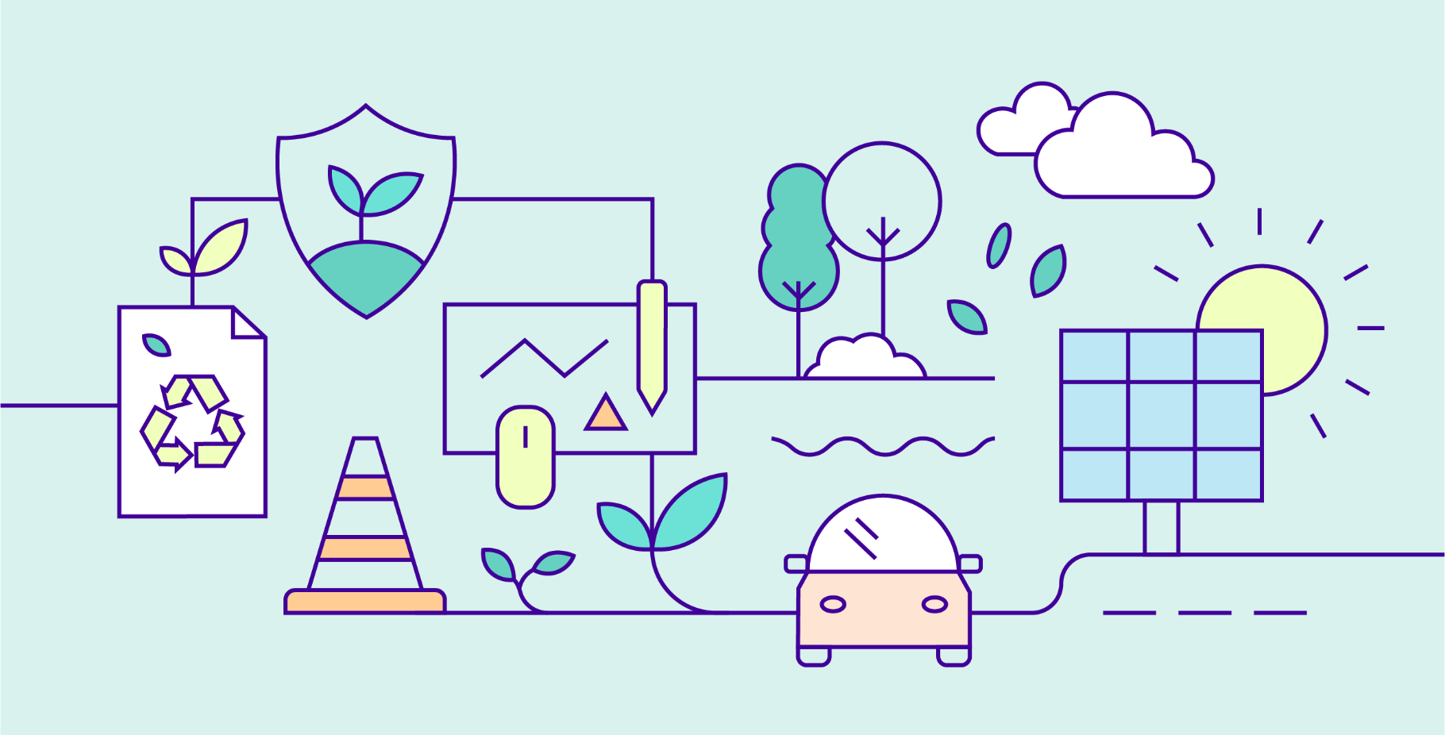

Introduction

About This Report
Each year, the North East Link Program (NELP) reports on our sustainability performance. Our commitment to public reporting drives accountability and transparency of sustainability outcomes across our program and supply chain.
This report covers the calendar year 1 January to 31 December 2025, and the data contained can be compared to
previous reports, and future reports as the program continues. 2025 saw the final two packages for NELP commence, meaning all five packages are now underway, shown on the package map (page 6).
Reporting for the North East Link Tunnels is done by the Spark Consortium (NEL Tunnels team). The M80 Ring Road Completion is reported on by the M80 Ring Road Alliance (M80RRA). The three Eastern Freeway Upgrades packages are reported on by the relevant alliance: the Burke to Tram Alliance (EBTA), the Tram to Springvale Alliance (ETSA) and the Hoddle to Burke Alliance (EHBA). The Early Works package concluded in 2024.
All measurements in this report are accurate as recorded in December 2025, and we aim to achieve all listed construction targets by the end of construction in 2028. All reporting was submitted in January 2026. Data is based on monitored
and/or estimated construction and operational impacts. Estimates are calculated using the latest design or construction information. Internal audits, and other controls, have been established to ensure the accuracy of information gathered.
The content and quality of this report has been independently reviewed by a technical advisor against the below principles of the Global Reporting Initiative, an international standard for sustainability reporting:

- Accuracy
- Balance
- Clarity
- Comparability
- Completeness
- Sustainability context
- Timeliness
- Verifiability.

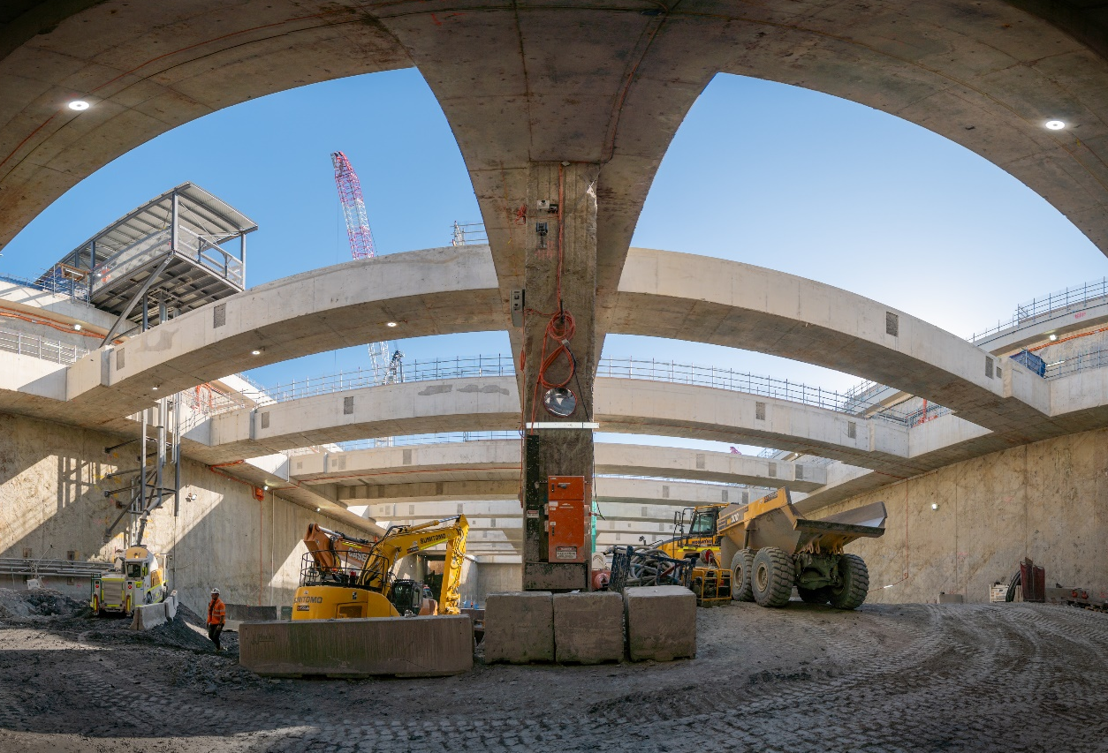

2025 Program Overview
We’re proud to be setting the standard in sustainability and delivery
outcomes with our construction partners across all packages of work.
In 2025, we executed the final two contracts for the program and their works on-site commenced in early 2026.
All five NELP packages are now underway.
It was a year of major milestones, the NEL Tunnels team had their final concrete tunnel segment finished in the Benalla precast facility, and the Tunnel Boring Machines completed 70% of their journey.
In August, the M80RRA team completed the superstructure works for the Hurstbridge Rail Tunnel – now the third longest rail tunnel on the metro network, while the NEL Tunnels team completed the last diaphragm walls at the Lower Plenty site.
Also in August, EBTA successfully mobilised two 40-tonne electric crawler cranes in an Australian-first move to reduce carbon emissions on site.
In November, the NEL Tunnels and M80RRA teams completed trial pours of concrete slabs containing site-won calcined clay in a major step forward for sustainability on site.
In December, EBTA opened two new SUP bridges to the public – the Estelle Street Bridge and the Heyington Street Bridge.
Throughout the year the packages also created opportunities for cohorts that are historically underrepresented in the construction industry. The M80RRA saw its first all-female Civil Construction Traineeship cohort graduate, while the
North East Link team delivered its First Nations Work Experience Program.

What We’re Building
We're delivering three major road projects to change the way people
move around Melbourne's north-east by car, bus, bike and foot.
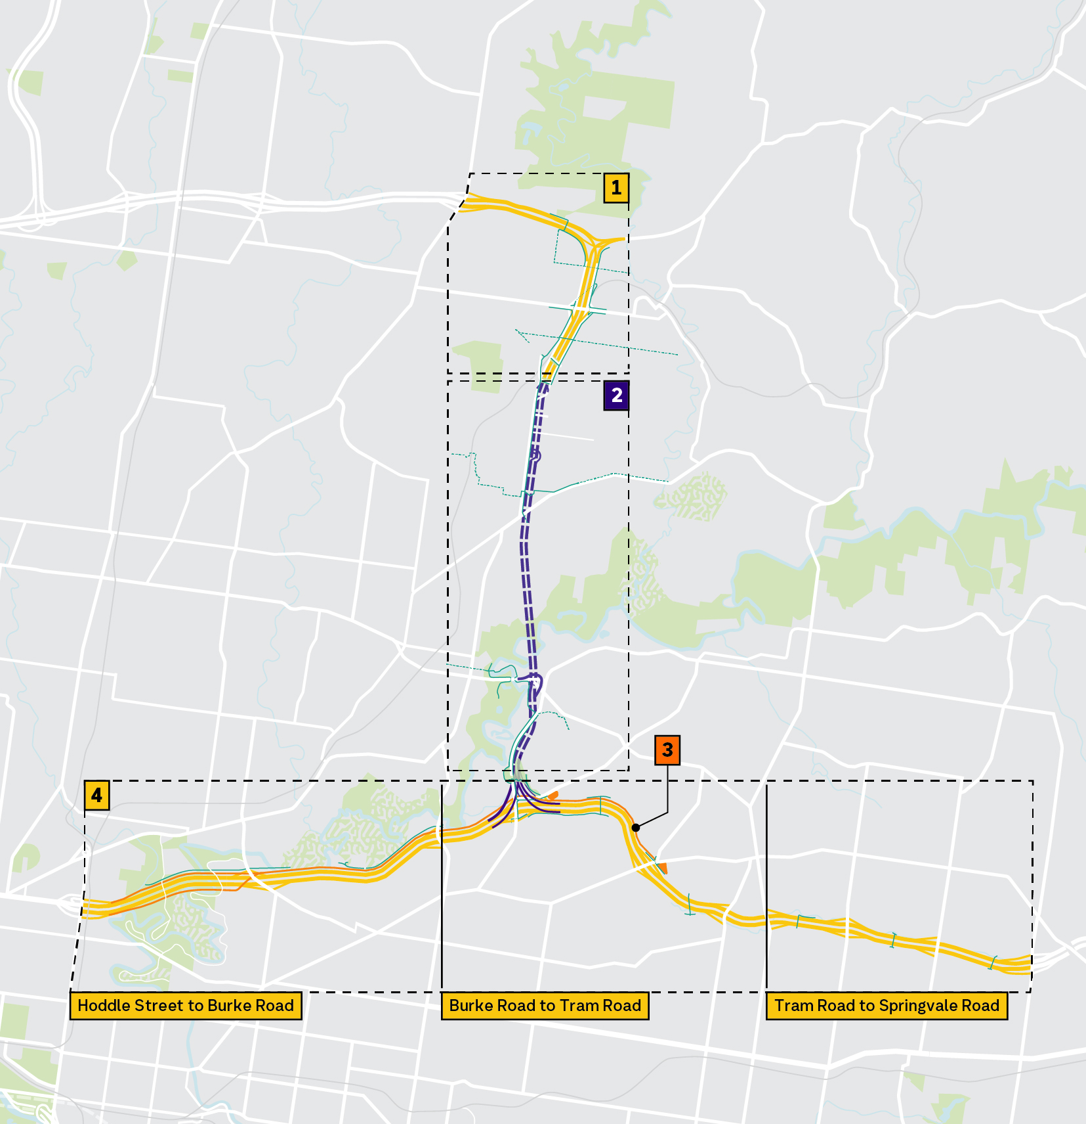
Victoria’s longest road tunnels will complete the missing link in Melbourne’s freeway network, skipping 18 sets of traffic lights and slashing travel times by up to 35 minutes. We’ll also complete the M80 Ring Road in Greensborough and upgrade the Eastern Freeway. As part of all of this, we'll also deliver Melbourne's first dedicated busway and create more than
34km of walking and cycling paths.

Big Build M80 Ring Road Completion

M80 Ring Road Alliance
Delivering new lanes, up-to-date technology, two landscaped bridges in Watsonia and new train station parking.
Construction 2024–2028.

North East Link

Spark
Delivering Victoria’s longest twin road tunnels, taking 15,000 trucks off local roads each day, returning local roads
for local trips.
Construction 2022–2028.

Big Build Eastern Busway
Burke to Tram Road Alliance,
Hoddle to Burke Alliance,
Delivering Melbourne's first dedicated busway, a new Bulleen Park & Ride,
and upgraded Doncaster Park & Ride. Construction 2024–2028.

Big Build Eastern
Freeway Upgrades

Hoddle to Burke Alliance,
Burke to Tram Road Alliance,
and Tram to Springvale Alliance
A major overhaul of the Eastern Freeway with new express lanes to slash travel times, new noise walls, and new walking and cycling links.
Construction 2024–2028.

Our Sustainability Targets
This report presents the status of North East Link Program’s performance against our sustainability objectives and targets in 2025. We set our ambitious
targets back in 2019 based on input from stakeholders and the community,
as well as technical sustainability assessments.

Key milestones in developing our Sustainability Objectives and Targets

2017–2018
Community feedback surveys on NEL’s priorities and objectives.

December 2018
Sustainability workshop with councils and state government agencies.

March 2019
Sustainability workshop with community environment groups.

April 2019
Technical assessments of greenhouse gas footprint and
renewable energy options.

April–June 2019
NEL Environment Effects Statement on public exhibition.
This included our Sustainability Approach which details our
local, regional, and global sustainability context.

July 2019
Published sustainability objectives and targets on NEL website.

2019–2021
Incorporated sustainability targets into delivery partner contracts.

December 2021
Published 2021 Sustainability Snapshot.

July 2022
Sustainability targets briefing with Wurundjeri Woi-Wurrung
Aboriginal Cultural Heritage Corporation.

2023–2025
Published Annual Sustainability Reports.

2026 We are here
Published 2025 Annual Sustainability Report.

2028 North East Link opens

Materiality
These themes and objectives were established based on a materiality assessment conducted between 2018 and 2019.
This assessment brought together a review of the policy drivers, analysis of sustainability risks and opportunities,
and community engagement feedback. Sector specific policies and instruments addressed included the UN Sustainable Development Goals, the Intergovernmental Panel on Climate Change’s Fifth Assessment Report and the Victorian
Climate Change Act 2017 among others. The outcomes from these workshops set the six sustainability themes that
form the foundation on which we set our sustainability targets – leadership, resource efficiency, urban ecosystems, communities, economic opportunities, and climate change.
This report shows the progress the program has made to date on these targets as well as case studies of some successful
and challenging initiatives.
The content and quality of this 2025 report, and the materiality assessment, have been independently reviewed against
the principles of the Global Reporting Initiative, an international standard for sustainability reporting.

UN Sustainable Development Goals
Our targets seek to both minimise our negative impacts and maximise
our positive impacts as we procure, design, build and operate the
North East Link Program.
Throughout this report, we refer to North East Link Program’s (NELP) contributions to the UN Sustainable Development Goals (SDG), a set of global goals that frame our sustainability challenges and opportunities. Visit sdgs.un.org to learn more.
As Victoria’s largest road infrastructure project, NELP has ambitious targets, leveraging its scale to drive sustainability knowledge sharing across the infrastructure industry, supporting innovation and improving practices and long‑term capability building. By completing a critical missing freeway link, NELP is improving transport efficiency by removing through-traffic and trucks from local streets, reducing congestion, noise and safety impacts in surrounding communities. Through a strong focus on social procurement, NELP is contributing to reduced inequality and inclusive economic growth by creating employment and training opportunities for priority groups and local businesses. Investment
in a dedicated busway and park‑and‑ride facilities is improving access to efficient, low‑emissions public transport, while high‑quality shared use paths are designed to strengthen community connections and encourage increased cycling as
part of everyday travel.
While NELP is designed to deliver long‑term benefits, it also presents sustainability risks that are relevant in the context of the UN SDGs. During design and construction, vegetation removal, waste generation, significant material use and prolonged construction impacts place pressure on biodiversity, resource efficiency, and community amenity. The use of emissions-intensive materials – such as concrete and steel – as well as major construction activities that are reliant on diesel as
a fuel source will also have climate impacts. Acknowledging and actively managing these impacts is important to ensure
the project makes a positive contribution to more sustainable, resilient and liveable urban outcomes over time.
The diagrams below further demonstrate how our targets address both positive and negative impacts and map the most relevant targets against the UN SDGs across the NELP lifecycle and beyond. The performance snapshots on the following pages show how the North East Link Program has sought to maximise our positive contributions and minimise our
negative contributions to our key sustainability issues and the UN SDGs.
Our aim is to work with our construction partners to exceed the ambitious sustainability targets across the design, construction and operation of the North East Link Program. We also aim to positively impact the supply chain to
raise the bar for sustainability and leave a lasting legacy. Refer to the performance snapshots for more information
about our targets.

Maximise positive contribution

SUPPLY CHAIN


9: Industry, innovation
and infrastructure
THEME: Leadership
TARGET: Implement initiatives
for sharing sustainability
knowledge gained from
the program.

SUPPLY CHAIN


10: Reduced inequalities
THEME: Economic opportunities
TARGET: Implement a social
and sustainable procurement
strategy that delivers on relevant legislative and policy frameworks, including Victoria’s Social Procurement Framework.

DESIGN


11: Sustainable cities
and communities
THEME: Communities
TARGET: Create a dedicated
Busway and provide accessible
and amenable Park and Ride
facilities connected to
shared use paths.

CONSTRUCTION
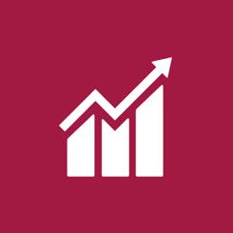

8: Decent work and
economic growth
THEME: Economic opportunities
TARGET: Implement a social and sustainable procurement strategy that delivers on relevant legislative and policy frameworks, including Victoria’s Social Procurement Framework.

CONSTRUCTION


11: Sustainable cities
and communities
THEME: Communities
TARGET: Implement initiatives that generate positive social and/or environmental outcomes and
enhance community wellbeing.

OPERATIONS


3: Good health and well-being
THEME: Communities
TARGET: Achieve at least a
10% increase (or greater) in
cyclist numbers travelling the
North East Link corridor after
three years of operation.

Minimise negative contribution

SUPPLY CHAIN


12: Responsible consumption
and production
THEME: Resource efficiency
TARGET: Maximise use of reclaimed asphalt pavement and other
recycled materials in the program.

SUPPLY CHAIN


13: Climate action
THEME: Climate change
TARGET: Reduce energy use and greenhouse gas emissions from construction and operation of NEL.

SUPPLY CHAIN


6: Clean water and sanitation
THEME: Resource efficiency
TARGET: Maximise harvest and reuse of rainwater, stormwater, wastewater, groundwater and tunnel inflow water.

CONSTRUCTION

12: Responsible consumption
and production
THEME: Resource efficiency
TARGET: Achieve landfill diversion
rates of at least 90% by volume
of inert and non-hazardous
construction waste and 60%
by volume of office waste.

OPERATIONS


15: Life on land
THEME: Urban ecosystems
TARGET: Achieve a net gain
in canopy cover by 2045.

OPERATIONS

13: Climate action
THEME: Climate change
TARGET: Achieve net zero
emissions in the operation and maintenance of North East Link.

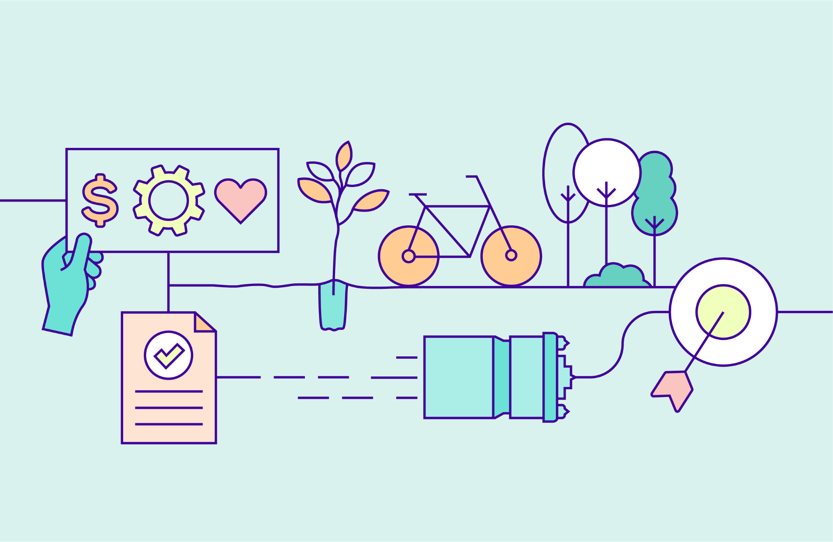

Leadership
Achieve excellent environmental, social and economic outcomes across
all phases of North East Link Program.

Performance Snapshot


UNSDG 9:
Industry, Innovation and Infrastructure

Seek opportunities to share knowledge and collaborate with stakeholders and industry peers
Target | Package | 2022 | 2023 | 2024 | 2025
Implement innovative and pioneering initiatives in sustainable design, process  or advocacy considered a first  in Victoria and/  or Australia.  IS v1.2 Inn-1  (Early Works)  IS v2.1 Inn-1 | Early Works |  Well Progressed | Well Progressed |  Complete | Not in scope
 | Tunnels |  Well Progressed | Well Progressed | Well Progressed | Well Progressed
 | M80RRA | Not in scope | Not in scope |  Well Progressed | Well Progressed
 | EBTA | Not in scope | Not in scope |  Well Progressed | Well Progressed
 | EHBA | Not in scope | Not in scope | Not in scope |  In Progress
 | ETSA | Not in scope | Not in scope | Not in scope |  In Progress
Implement initiatives for sharing sustainability knowledge gained from the program.  IS v1.2 Man-6 Level 2 (Early Works)  IS v2.1 Lea-3 Level 2 | Early Works | Well Progressed | Well Progressed | Complete | Not in scope
 | Tunnels | Well Progressed | Well Progressed | Well Progressed | Well Progressed
 | M80RRA | Not in scope | Not in scope | Well Progressed | Well Progressed
 | EBTA | Not in scope | Not in scope | Well Progressed | Well Progressed
 | EHBA | Not in scope | Not in scope | Not in scope | In Progress
 | ETSA | Not in scope | Not in scope | Not in scope | In Progress

Use sustainability rating schemes to set benchmarks and track and report performance
Target | Package | 2022 | 2023 | 2024 | 2025
Achieve a minimum of 50 points (Silver)  for the Program Rating under the  IS Rating tool  v2.1 and 74 Points (Excellent) under  IS v1.2 for  Early Works. | Early Works | Well Progressed | Well Progressed | Complete  Leading As-Built | Not in scope
 | Tunnels | Well Progressed | Well Progressed | Well Progressed | Well Progressed  Platinum Design
 | M80RRA | Not in scope | Not in scope | Well Progressed | Well Progressed
 | EBTA | Not in scope | Not in scope | Well Progressed | Well Progressed
 | EHBA | Not in scope | Not in scope | Not in scope | N/A
 | ETSA | Not in scope | Not in scope | Not in scope |  N/A
Achieve a minimum five-star Green Star rating for the Motorway  Control Centre. | Early Works |  N/A | N/A | N/A | Not in scope
 | Tunnels | Well Progressed | Well Progressed | Well Progressed | Well Progressed  Six-star Design
 | M80RRA | Not in scope | Not in scope |  N/A | N/A
 | EBTA | Not in scope | Not in scope |  N/A | N/A
 | EHBA | Not in scope | Not in scope | Not in scope | N/A
 | ETSA | Not in scope | Not in scope | Not in scope | N/A
Publicly report sustainability performance on  an annual basis. | Early Works | Complete | Complete | Complete | Not in scope
 | Tunnels |  Complete | Complete | Complete | Well Progressed
 | M80RRA | Not in scope | Not in scope |  Complete | Well Progressed
 | EBTA | Not in scope | Not in scope |  Complete | Well Progressed
 | EHBA | Not in scope | Not in scope | Not in scope |  Well Progressed
 | ETSA | Not in scope | Not in scope | Not in scope |  Well Progressed

Case Study:
Setting the Standard for Sustainability Ratings
The NEL Tunnels team achieved the highest possible design rating levels from the Infrastructure Sustainability Council (ISC) and Green Star Buildings.
Targets | Package | Current Phase | Status
Achieve a minimum of 50 points for the  Program Rating under the IS Rating tool v2.1.  Achieve a minimum five-star Green Star rating  for the Motorway Control Centre. | North East Link  Tunnels | Construction | Well Progressed
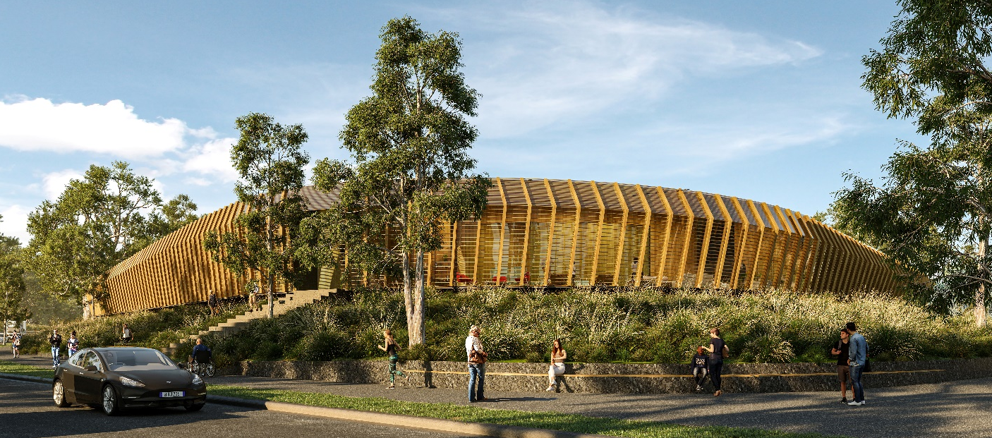
The IS rating is the leading independent sustainability benchmark for infrastructure in Australia and New Zealand, assessing outcomes across a number of categories: governance, resilience, innovation, resources, carbon, and stakeholder engagement.
In 2025, the NEL Tunnels team reached landmark sustainability milestones. With a score of 50 indicating an IS Design v2.1 Silver rating, the team was able to achieve an even higher score, receiving a Platinum rating. This represents an industry-leading approach to delivering low-carbon, high-impact infrastructure, embedding sustainability principles into every aspect of design and delivery.
The NEL Tunnels team received full points in the Innovation category, and an ‘Australia First’ recognition for its approach
to Zero-Trim Diaphragm Wall Piling. The key sustainability outcomes include:
- 95% reduction in greenhouse gas emissions through energy efficient design and a commitment to renewable energy during construction and operations
- 30% reduction in embodied carbon emissions through design efficiency, optimised concrete mixes and use
of recycled content
- strong collaboration with stakeholders and the community throughout planning and design
- a comprehensive urban design and landscape plan (UDLP) that supports both environmental and social benefits.
Further, the Motorway Control Centre (MCC), pictured above, achieved a 6 Star Green Star Design rating, representing World Leadership in sustainable buildings. The MCC’s high-performance design is set to deliver a 66% reduction in operational energy consumption and a 63% reduction in operational potable water use. The MCC achieves a 31% reduction in embodied carbon through its innovative mass timber structural system, replacing conventional steel and concrete.
The building design integrates Indigenous co-designed cultural elements, community-facing recreational spaces, on-site solar generation, vehicle washdown closed-loop water systems, and electric vehicle charging infrastructure.
Together, these achievements set a new benchmark for sustainable infrastructure in Australia, showing that large-scale projects can deliver exceptional performance on carbon, resources, innovation and social value.

Case Study:
La Trobe University – Engineering Partnership
The M80 Ring Road Completion team has partnered with La Trobe University to influence the future of sustainability initiatives in the industry.
Target | Package | Current Phase | Status
Implement initiatives for sharing sustainability knowledge gained from the program. | M80 Ring Road Completion | Construction | Ongoing
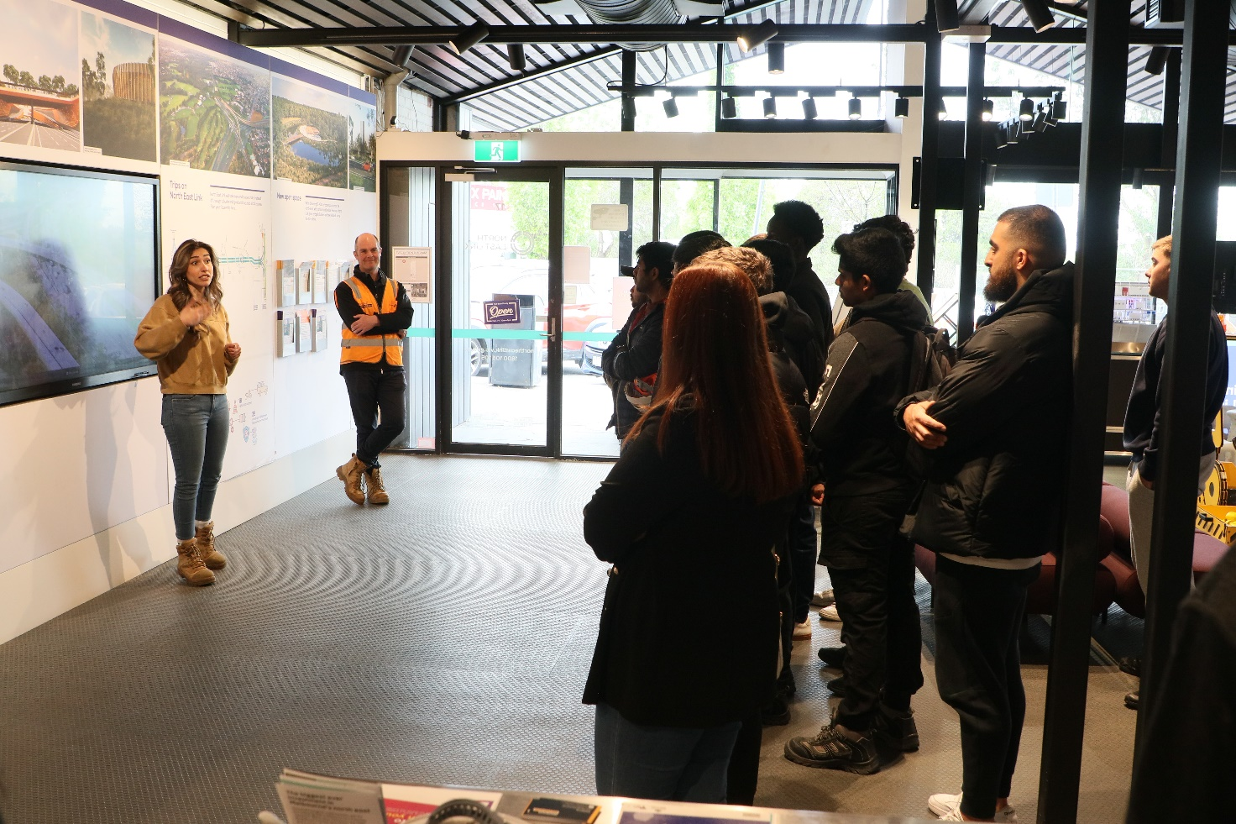
As Victoria moves towards net-zero emissions by 2045, partnerships with higher learning facilities are key in validating concepts and signalling to industry that reductions in greenhouse gas emissions are achievable.
The M80 Ring Road Alliance (M80RRA) team collaborated with La Trobe University to generate a report that documents
the decarbonisation trials and solutions on the project. The “M80 Ring Road Decarbonisation Report” also enables other industry operators to learn and improve upon the team’s learnings by providing transparent, detailed and data-driven models to build upon.
The relationship with La Trobe University is fundamental to the influence of the M80RRA's sustainability initiatives in the future. Both parties are contributing to the building and strengthening of this partnership by:
- Integrating La Trobe students into a cadet program – with students having already joined the 2024 and 2025 cohorts
- Having engineers from the M80RRA deliver lectures to La Trobe students
- Inviting 20 La Trobe students out to tour the work site, with a focus on the project and its sustainability initiatives.
Nurturing collaboration and partnerships is key to deepening the M80RRA’s connection with the local community.
By committing to fostering these relationships through education and research, the M80RRA team is ensuring that the future of sustainability is in good hands.
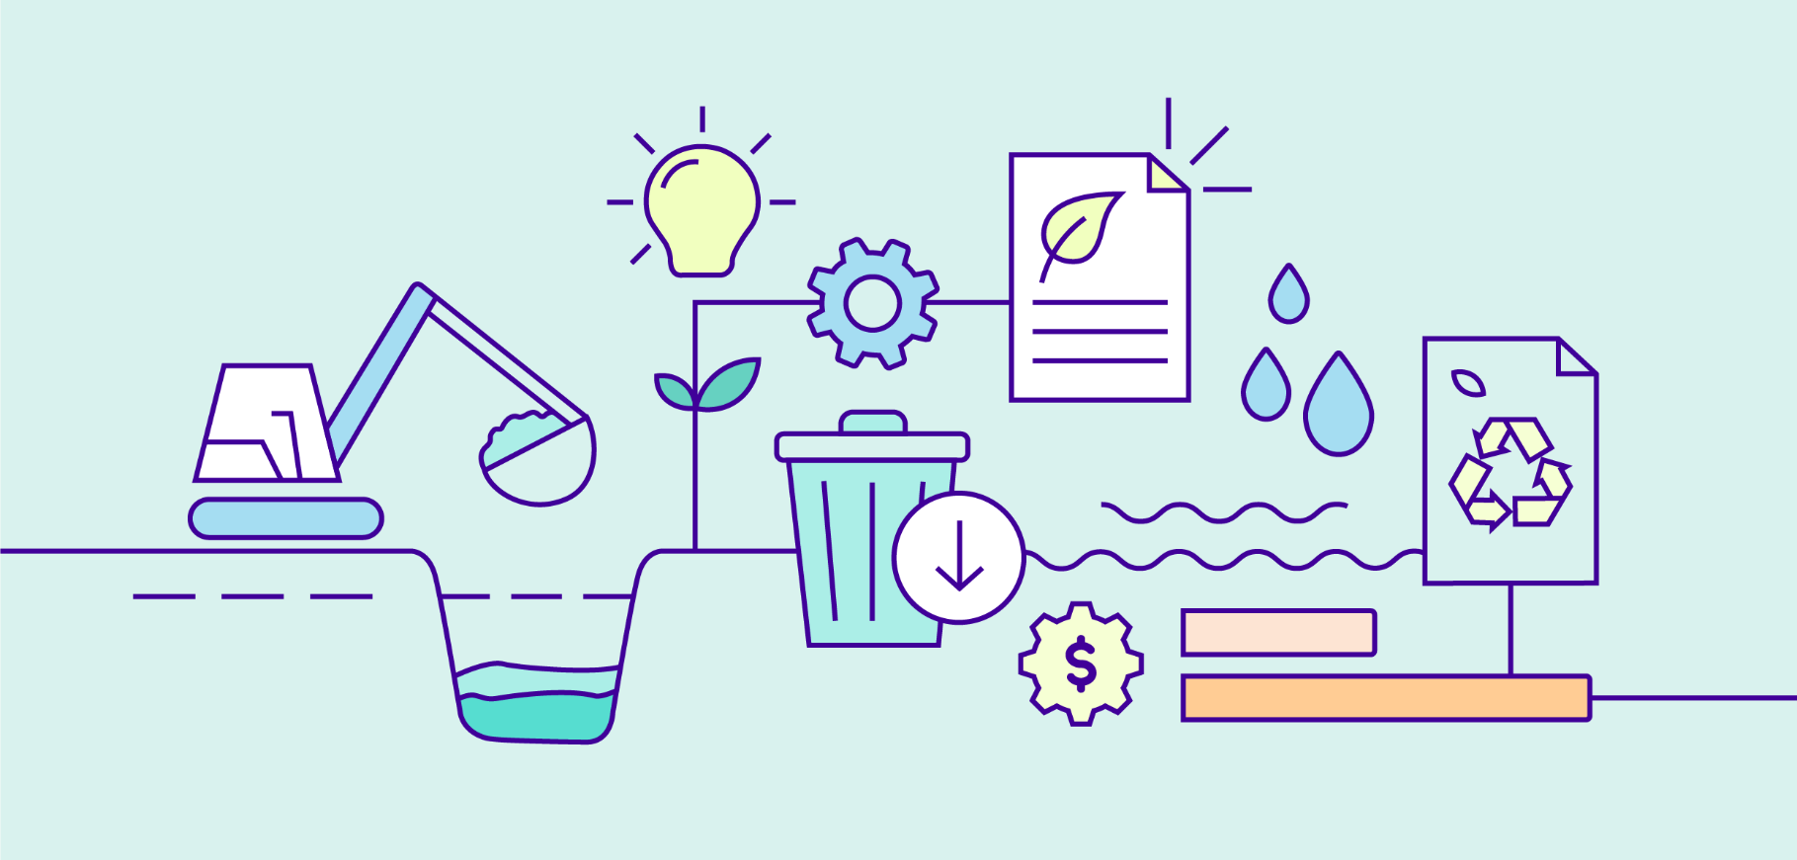

Resource Efficiency
Embedding energy, water, material and waste reduction initiatives
into the design, construction and operation of the program.

Performance Snapshot
  UNSDG 6:  Clean water  and sanitation |   UNSDG 12:  Responsible consumption and production

Reduce the use and the lifecycle impacts of all materials like concrete and steel
Target | Package | 2022 | 2023 | 2024 | 2025
Develop a Resource Efficiency Strategy and Action Plan.  IS v2.1 Rso-1 Level 2 | Early Works | N/A | N/A | N/A | Not in scope
 | Tunnels | Well Progressed | Well Progressed | Well Progressed | Well Progressed
 | M80RRA | Not in scope | Not in scope | Well Progressed | Well Progressed
 | EBTA | Not in scope | Not in scope | Well Progressed | Well Progressed
 | EHBA | Not in scope | Not in scope | Not in scope | In Progress
 | ETSA | Not in scope | Not in scope | Not in scope | In Progress
Achieve a minimum 15% reduction  in materials lifecycle impacts (measured by the materials lifecycle calculator) below the base case.  IS v1.2 Mat-1 Level 1.3 (Early Works)  IS v2.1 Rso-6 Level 1  *Early Works  target 5%. | Early Works | Well Progressed 5.3%* | Well Progressed 5.7%* | Complete  5.7%* | Not in scope
 | Tunnels |  Progressing  12% | Well Progressed 33% | Well Progressed 32% | Well Progressed  32%
 | M80RRA | Not in scope | Not in scope | Well Progressed 28% | Well Progressed 32%
 | EBTA | Not in scope | Not in scope | Well Progressed 15% | Well Progressed 27%
 | EHBA | Not in scope | Not in scope | Not in scope | In Progress
 | ETSA | Not in scope | Not in scope | Not in scope | In Progress
Reduce the amount of Portland Cement content in concrete  across the program by a minimum  of 30% (against Green Building Council of Australia reference mix  design levels). | Early Works | Well Progressed 36% | Well Progressed 30% | Complete  30% | Not in scope
 | Tunnels | Well Progressed 40% | Well Progressed 48% | Well Progressed 56% | Well Progressed  52%
 | M80RRA | Not in scope | Not in scope | Well Progressed 32% | Well Progressed 46%
 | EBTA | Not in scope | Not in scope | Well Progressed 40% | Well Progressed 55%
 | EHBA | Not in scope | Not in scope | Not in scope | In Progress
 | ETSA | Not in scope | Not in scope | Not in scope | In Progress
Maximise use of reclaimed asphalt pavement and other recycled materials  in the program. | Early Works | Well Progressed  4.5% | Well Progressed  4.2% | Complete  4.5% | Not in scope
 | Tunnels | Well Progressed 27% Asphalt  38% Other | Well Progressed 13% Asphalt  29% Other | Well Progressed 23% Asphalt  19% Other | Well Progressed 19% Asphalt  35% Other
 | M80RRA | Not in scope | Not in scope | Well Progressed 31% Asphalt  35% Other | Well Progressed  31% Asphalt  50% Other
 | EBTA | Not in scope | Not in scope | Well Progressed 12% Asphalt  45% Other | Well Progressed 29% Asphalt  45% Other
 | EHBA | Not in scope | Not in scope | Not in scope | In Progress
 | ETSA | Not in scope | Not in scope | Not in scope | In Progress
Maximise local steel by volume sourced from fabricators or contractors who are accredited suppliers for the Environment Sustainability Charter of Australian Steel Institute or  similar international association. | Early Works | Well Progressed 7% | Well Progressed 9% | Complete  9% | Not in scope
 | Tunnels | Well Progressed 50% | Well Progressed 83% | Well Progressed 89% | Well Progressed 72%
 | M80RRA | Not in scope | Not in scope | Well Progressed  40% | Well Progressed 40%
 | EBTA | Not in scope | Not in scope | Well Progressed 60% | Well Progressed 60%
 | EHBA | Not in scope | Not in scope | Not in scope | In Progress
 | ETSA | Not in scope | Not in scope | Not in scope | In Progress
Implement  a sustainable procurement  policy to ensure  that major materials have environmental labels or are  from sustainable  supply chains. Measured by material spend with environmental labels. | Early Works | Well Progressed | Well Progressed | Complete | Not in scope
 | Tunnels | Well Progressed | Well Progressed | Well Progressed  46% | Well Progressed  36%
 | M80RRA | Not in scope | Not in scope | Well Progressed  30% | Well Progressed  30%
 | EBTA | Not in scope | Not in scope | Well Progressed  30% | Well Progressed  30%
 | EHBA | Not in scope | Not in scope | Not in scope | In Progress
 | ETSA | Not in scope | Not in scope | Not in scope | In Progress

Reduce water use and maximise the use of alternatives to potable water
Target | Package | 2022 | 2023 | 2024 | 2025
Maximise harvest and reuse of rainwater, stormwater, wastewater, groundwater and tunnel inflow water. | Early Works | Well Progressed 6% | Well Progressed 19% | Complete  19.7% | Not in scope
 | Tunnels | In Progress  12% | Well Progressed 29% | Well Progressed 36% | Well Progressed  25%
 | M80RRA | Not in scope | Not in scope | Well Progressed 10% | Well Progressed  10%
 | EBTA | Not in scope | Not in scope | Well Progressed 1.8% (target 1.8%) | Well Progressed 5% (target 1.8%)
 | EHBA | Not in scope | Not in scope | Not in scope | In Progress
 | ETSA | Not in scope | Not in scope | Not in scope | In Progress
Develop Integrated Water Management projects to supply construction and post-construction uses. | Early Works | N/A | N/A | N/A | Not in scope
 | Tunnels | In Progress | Well Progressed | Well Progressed | Well Progressed
 | M80RRA | Not in scope | Not in scope | Well Progressed | Well Progressed
 | EBTA | Not in scope | Not in scope | Well Progressed | Well Progressed
 | EHBA | Not in scope | Not in scope | Not in scope | In Progress
 | ETSA | Not in scope | Not in scope | Not in scope | In Progress
Develop a water usage and sourcing strategy that includes potable and non-potable water needs, volumes  and sources that would be used and generated during construction and operation. Identify opportunities to reduce water use and maximise reuse. | Early Works | N/A | N/A | N/A | Not in scope
 | Tunnels | In Progress | Well Progressed | Well Progressed | Well Progressed
 | M80RRA | Not in scope | Not in scope | Well Progressed | Well Progressed
 | EBTA | Not in scope | Not in scope | Well Progressed | Well Progressed
 | EHBA | Not in scope | Not in scope | Not in scope | In Progress
 | ETSA | Not in scope | Not in scope | Not in scope | In Progress

Reduce waste and maximise the sustainable reuse of excavated material
Target | Package | 2022 | 2023 | 2024 | 2025
Implement initiatives to reduce spoil quantities and maximise the beneficial reuse  of uncontaminated spoil. | Early Works | Well Progressed 97.4% | Well Progressed  100% | Complete  100% | Not in scope
 | Tunnels | Well Progressed 94% | Well Progressed 97% | Well Progressed 99% | Well Progressed 99%
 | M80RRA | Not in scope | Not in scope | Well Progressed 100% | Well Progressed 100%
 | EBTA | Not in scope | Not in scope | Well Progressed  98% | Well Progressed 99%
 | EHBA | Not in scope | Not in scope | Not in scope | In Progress
 | ETSA | Not in scope | Not in scope | Not in scope | In Progress
Maximise waste diverted from  landfill and achieve landfill diversion rates of at least 90% by volume of inert and non-hazardous construction waste. | Early Works |  In Progress  81% | Well Progressed  92% | Complete  95% | Not in scope
 | Tunnels | Well Progressed 98% | Well Progressed 98% | Well Progressed 97% | Well Progressed 98%
 | M80RRA | Not in scope | Not in scope | Well Progressed 100% | Well Progressed 95%
 | EBTA | Not in scope | Not in scope | Well Progressed 99% | Well Progressed 97%
 | EHBA | Not in scope | Not in scope | Not in scope | In Progress
 | ETSA | Not in scope | Not in scope | Not in scope | In Progress
Maximise waste diverted from landfill and achieve landfill diversion rates of at least 60% by volume of office waste. | Early Works | Well Progressed 64% | Well Progressed 80% | Complete  80% | Not in scope
 | Tunnels | In Progress  32% | In Progress  27% | In Progress  48% | In Progress  50%
 | M80RRA | Not in scope | Not in scope | Well Progressed  65% | Well Progressed 67%
 | EBTA | Not in scope | Not in scope |  In Progress  30% | Well Progressed  65%
 | EHBA | Not in scope | Not in scope | Not in scope | In Progress
 | ETSA | Not in scope | Not in scope | Not in scope | In Progress

Case Study:
Recycled Plastic Noise Walls
Our delivery partners across the three packages for the Eastern Freeway Upgrades are redirecting plastic waste from the landfill to build noise walls along the freeway.
Target | Package | Current Phase | Status
Maximise use of reclaimed asphalt pavement and other recycled materials in the program. | Eastern Freeway Upgrades:  Hoddle to Burke, Burke to Tram, and Tram to Springvale | Design and Construction | Ongoing
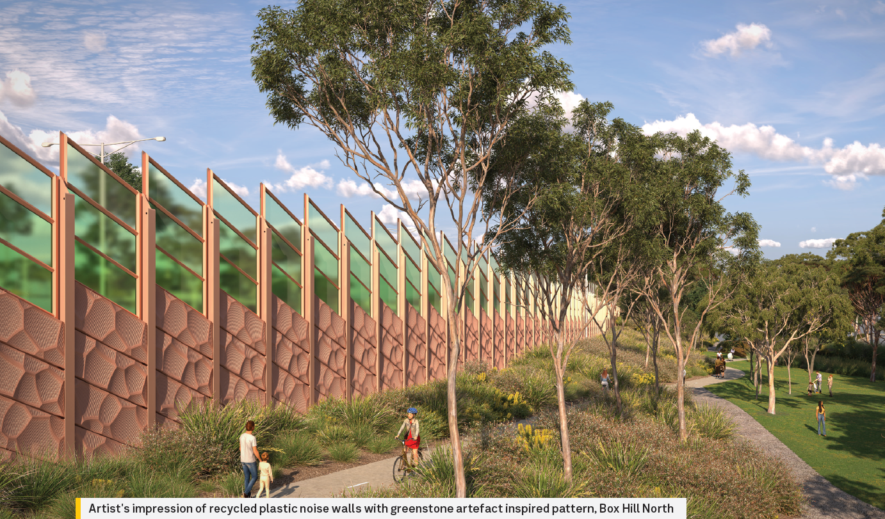
Currently, Australia recycles only 13% of end-of-life plastics¹, with the remainder either ending up in landfill or polluting
the environment. At the current rate, plastics are projected to outnumber fish in the sea by 2050.
Incorporating high levels of recycled plastic into large-scale infrastructure projects helps close the loop between recycling, design and manufacturing.
On the Eastern Freeway Upgrades: Burke to Tram Alliance (EBTA), the package team identified an opportunity to incorporate rotationally moulded recycled plastic noise walls into the design in alignment with the Victorian Government’s Recycled First Policy. These noise walls are manufactured using 75% post-consumer recycled plastic and are 100% recyclable at the end of their design life, giving a second life to materials such as milk bottles and stretch wrap.
EBTA will install more than three kilometres of recycled plastic noise walls along the corridor. This initiative is expected to divert more than 250 tonnes of locally sourced plastic from landfill while also reducing greenhouse gas emissions when compared to typical alternatives such as precast concrete. The lightweight nature of the panels also allows for smaller cranes during installation, further reducing diesel consumption and construction emissions.
Following the successful development of the initiative on EBTA, collaboration across the Eastern Freeway Upgrade packages has supported the adoption of recycled plastic noise walls within the preliminary designs of the Hoddle to Burke and Tram
to Springvale packages. The Wurundjeri Woi-wurrung Cultural Heritage Aboriginal Corporation is also being engaged in the design of the noise walls to reflect the natural features of the project area, including local rockfaces.
This initiative demonstrates how innovation piloted on one package can be scaled across others, delivering circular economy outcomes while reducing emissions and diverting plastic waste from landfill.
¹ DCCEEW Australian plastics flows and fates reporting

Case Study:
Circularity and Efficiency in Spoil Management
The North East Link Program is turning one of its largest waste streams
into a resource.
Target | Package | Current Phase | Status
Implement initiatives to reduce spoil quantities and maximise the beneficial reuse of uncontaminated spoil. | Program Wide | Construction | Ongoing
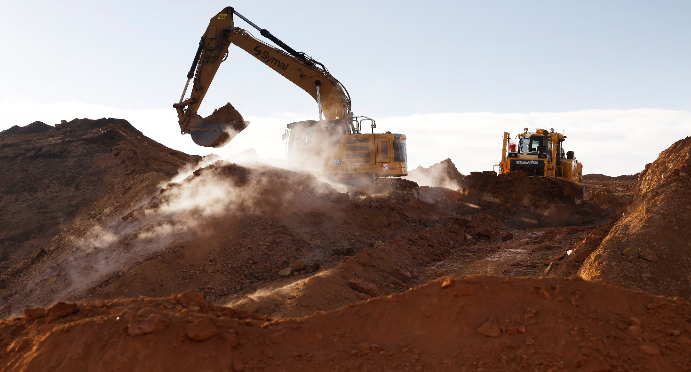
Excavation works on the project generates massive volumes of spoil, making effective management critical to its sustainability and delivery. With limited available space, the package teams have taken a highly strategic approach
to storing and reusing spoil, ensuring that suitable material is treated as a resource rather than waste.
Despite significant space constraints, spoil has been stockpiled at carefully selected locations. It is anticipated that nearly two million tonnes of spoil will be reused within the project, supporting road realignments and surface works. This approach mitigates some need for new materials on the project and reduces the number of truck movements required to transport spoil offsite – cutting down on congestion, disruptions to commuters, and transport-related emissions.
Collaboration across the packages has led to an agreement to share spoil between sites – supporting circularity, avoiding offsite storage where possible, and increasing the number of opportunities to reuse resources. Sharing spoil between
sites also reduces truck movements and facilitates coordination around the program.
For example, the M80 Ring Road Alliance has reused over 144,000 tonnes of spoil on-site to date. Of this, over
38,000 tonnes of spoil was provided to other packages on the North East Link Program for their earthworks.
The scale of spoil management required could not have been achieved without the use of advanced data platforms. Accordingly, package teams monitor spoil movements in real time and produce transparent data available for both commercial and sustainability reporting. This ensures robust tracking, streamlined operations, and confidence in the program’s performance.

Case Study:
Reducing Emissions from Concrete and Steel
The M80 Ring Road Completion has delivered another Australian-first innovation to help tackle plastic waste and carbon emissions.
Target | Package | Current Phase | Status
Achieve a minimum 15% reduction  in materials lifecycle impacts (measured by the materials lifecycle calculator) below the base case. | M80 Ring Road Completion  & Eastern Freeway Upgrades: Tram to Springvale | Design & Construction | Ongoing
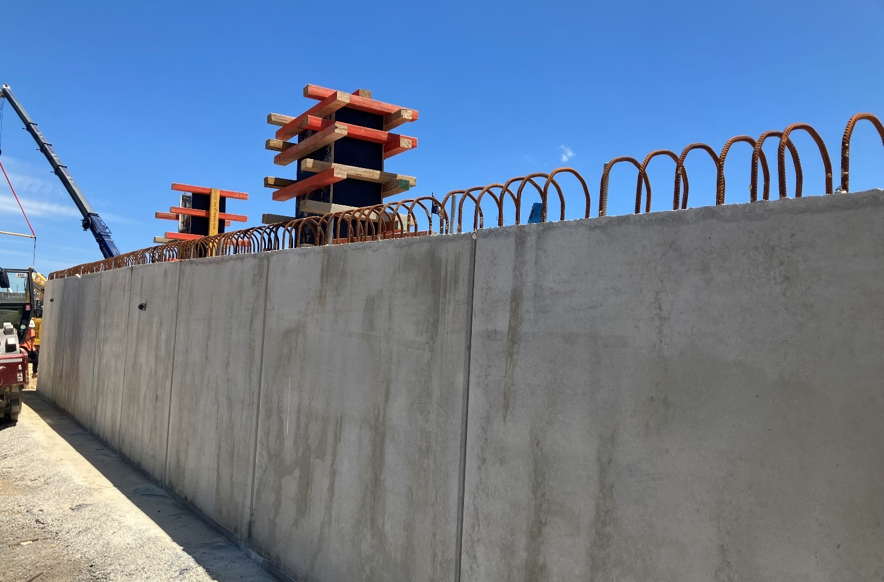
The M80 Ring Road Alliance team has partnered with Westkon and Robovoid to install Robovoid in precast retaining walls
in an emergency response area on the project.
The Robovoid insert is made from 100% Australian plastic waste, which means it also contributes to the circular economy
as currently, only 13% of plastic waste is recycled in Australia.
As construction is the third largest generator of global carbon emissions, it is vitally important to mitigate these emissions where possible. By employing Robovoid, M80RRA has reduced the amount of concrete used in the panels by 29%,
and the quantity of rebar used by 10%. Over 6.5 tonnes of CO2 emissions – or 16% – were reduced in the retaining walls.
As an added benefit, and to future-proof this innovation – Robovoid components can be removed and recycled at the
end of the assets’ life, ensuring minimal waste and promoting reuse in future projects.
The team on the Eastern Freeway Upgrade: Tram to Springvale is now looking into deploying this innovation.


Urban Ecosystems
Protecting and seeking opportunities to enhance natural environments.

Performance Snapshot


UNSDG 15:
Life on Land

Protect and enhance biodiversity and habitat links
Target | Package | 2022 | 2023 | 2024 | 2025
Reduce impacts to ecological communities by minimising the removal of native vegetation, fauna habitat and mature old trees. | Early Works | Well Progressed | Well Progressed | Complete | Not in scope
 | Tunnels | Well Progressed | Well Progressed | Well Progressed | Well Progressed
 | M80RRA | Not in scope | Not in scope | Well Progressed | Well Progressed
 | EBTA | Not in scope | Not in scope | Well Progressed | Well Progressed
 | EHBA | Not in scope | Not in scope | Not in scope | In Progress
 | ETSA | Not in scope | Not in scope | Not in scope | In Progress
Protect and enhance existing habitats, habitat connectivity and ecosystem function, where possible. | Early Works | Well Progressed | Well Progressed | Complete | Not in scope
 | Tunnels | Well Progressed | Well Progressed | Well Progressed | Well Progressed
 | M80RRA | Not in scope | Not in scope | Well Progressed | Well Progressed
 | EBTA | Not in scope | Not in scope | Well Progressed | Well Progressed
 | EHBA | Not in scope | Not in scope | Not in scope | In Progress
 | ETSA | Not in scope | Not in scope | Not in scope | In Progress
Seek opportunities to create new habitats and habitat links in consultation with local environmental and community groups. | Early Works | N/A | N/A | N/A | Not in scope
 | Tunnels | In Progress | Well Progressed | Well Progressed | Well Progressed
 | M80RRA | Not in scope | Not in scope | Well Progressed | Well Progressed
 | EBTA | Not in scope | Not in scope | Well Progressed | Well Progressed
 | EHBA | Not in scope | Not in scope | Not in scope | In Progress
 | ETSA | Not in scope | Not in scope | Not in scope | In Progress
Apply best practice retention, responsible storage and reinstatement  of topsoil to support growing conditions for local species. | Early Works | Well Progressed | Well Progressed | Complete | Not in scope
 | Tunnels | In Progress | In Progress | In Progress | In Progress
 | M80RRA | Not in scope | Not in scope |  In Progress | In Progress
 | EBTA | Not in scope | Not in scope | In Progress | In Progress
 | EHBA | Not in scope | Not in scope | Not in scope | In Progress
 | ETSA | Not in scope | Not in scope | Not in scope | In Progress
Develop a Green Infrastructure Plan and incorporate  Green Infrastructure. | Early Works | N/A | N/A | N/A | Not in scope
 | Tunnels | Well Progressed | Well Progressed | Well Progressed | Well Progressed
 | M80RRA | Not in scope | Not in scope | N/A | N/A
 | EBTA | Not in scope | Not in scope | N/A | N/A
 | EHBA | Not in scope | Not in scope | Not in scope | N/A
 | ETSA | Not in scope | Not in scope | Not in scope | N/A

Seek opportunities to improve stormwater quality and contribute to improvements
in waterway environments
Target | Package | 2022 | 2023 | 2024 | 2025
Identify opportunities to improve water quality and contribute to improved connectivity and enhancement of waterways. | Early Works | N/A | N/A | Complete | Not in scope
 | Tunnels | Well Progressed | Well Progressed | Well Progressed | Well Progressed
 | M80RRA | Not in scope | Not in scope | Well Progressed | Well Progressed
 | EBTA | Not in scope | Not in scope | Well Progressed | Well Progressed
 | EHBA | Not in scope | Not in scope | Not in scope | In Progress
 | ETSA | Not in scope | Not in scope | Not in scope | In Progress

Contribute to local urban forest outcomes
Target | Package | 2022 | 2023 | 2024 | 2025
Contribute to urban forest outcomes by replacing lost canopy and achieving a  net gain in canopy cover by 2045.  *Updated based  on revised data. | Early Works | Well Progressed | Well Progressed | Complete | Not in scope
 | Tunnels | In Progress* | In Progress* | In Progress* | In Progress
 | M80RRA | Not in scope | Not in scope | In Progress* | In Progress
 | EBTA | Not in scope | Not in scope | In Progress* | In Progress
 | EHBA | Not in scope | Not in scope | Not in scope | In Progress
 | ETSA | Not in scope | Not in scope | Not in scope | In Progress
Prioritise the retention and protection of existing vegetation. | Early Works | Well Progressed | Well Progressed | Complete | Not in scope
 | Tunnels | Well Progressed | Well Progressed | Well Progressed | Well Progressed
 | M80RRA | Not in scope | Not in scope | Well Progressed | Well Progressed
 | EBTA | Not in scope | Not in scope | Well Progressed | Well Progressed
 | EHBA | Not in scope | Not in scope | Not in scope | In Progress
 | ETSA | Not in scope | Not in scope | Not in scope | In Progress
Undertake new plantings early to optimise growth. | Early Works | Well Progressed | Well Progressed | Complete | Not in scope
Undertake new plantings early to optimise growth. | Tunnels | In Progress | In Progress | In Progress | In Progress
Undertake new plantings early to optimise growth. | M80RRA | Not in scope | Not in scope | In Progress | In Progress
Undertake new plantings early to optimise growth. | EBTA | Not in scope | Not in scope | In Progress | In Progress
Undertake new plantings early to optimise growth. | EHBA | Not in scope | Not in scope | Not in scope | In Progress
Undertake new plantings early to optimise growth. | ETSA | Not in scope | Not in scope | Not in scope | In Progress
Use indigenous species of local provenance where appropriate.  *Updated based  on revised data. | Early Works | Well Progressed | Well Progressed | Complete | Not in scope
 | Tunnels | In Progress* | In Progress* | In Progress* | In Progress
 | M80RRA | Not in scope | Not in scope | In Progress* | In Progress
 | EBTA | Not in scope | Not in scope | In Progress* | In Progress
 | EHBA | Not in scope | Not in scope | Not in scope | In Progress
 | ETSA | Not in scope | Not in scope | Not in scope | In Progress
Replanting to  occur within the project boundary wherever possible. | Early Works | Well Progressed | Well Progressed | Complete | Not in scope
 | Tunnels | In Progress | In Progress | In Progress | In Progress
 | M80RRA | Not in scope | Not in scope | In Progress | In Progress
 | EBTA | Not in scope | Not in scope | In Progress | In Progress
 | EHBA | Not in scope | Not in scope | Not in scope | In Progress
 | ETSA | Not in scope | Not in scope | Not in scope | In Progress

Case Study:
Surveying Local Pollinator Species
The team on the Eastern Freeway Upgrades: Tram to Springvale, and
Dr Luis Mata, have obtained over 1200 baseline surveys to assess the
diversity of species along the project corridor.
Target | Package | Current Phase | Status
Protect and enhance existing habitats, habitat connectivity and ecosystem function, where possible. | Eastern Freeway Upgrades: Tram to Springvale | Design | Ongoing

Populations of native insects are undergoing rapid decline, especially in urban environments. A large driver of insect loss is the clearing of vegetation that reduces habitat into smaller, disconnected patches, or removes it completely. Improvements to the general health and genetic strength of insects extend to their surrounding wildlife and plants. The movement of insects across our environment is also essential for gene flow, which improves genetic diversity and resilience.
On the Eastern Freeway Upgrades: Tram to Springvale, the team has successfully kicked off a joint biodiversity and sustainability initiative to support local pollinators. Collaborating with an entomologist, the team is supporting a scientific study to demonstrate how large linear infrastructure projects can create positive biodiversity outcomes for the smallest
of animals.
Approximately 1200 local baseline surveys have been completed, assessing the diversity of insect species along the project corridor, with a special focus on pollinators such as bees, butterflies, and hoverflies. One of which is the Sweat Bee (above), in a photo taken by Dr Luis. The survey results map the interactions between insect and plant species and determine which plants are most beneficial in maintaining insect diversity. Other flower-visiting species have also been observed and recorded, as well as bird behaviours, to better understand their interactions with local plant life.
The pollinator surveys will inform the packages landscape design, which will prioritise indigenous planting with the aim to improve pollinator abundance and diversity. Results from this work – including data gathered after the package has been delivered – will be used to develop a practical landscaping framework that highlights biodiversity restoration opportunities can be used by projects in the future.

Case Study:
Nest Boxes to Support Habitat Reformation
To mitigate the impact of habitat loss, the M80RRA and EBTA teams have installed replacement habitats in the form of nest boxes.
Target | Package | Current Phase | Status
Protect and enhance existing habitats, habitat connectivity and ecosystem function, where possible. | M80 Ring Road Completion  & Eastern Freeway Upgrades: Burke to Tram | Construction | Ongoing
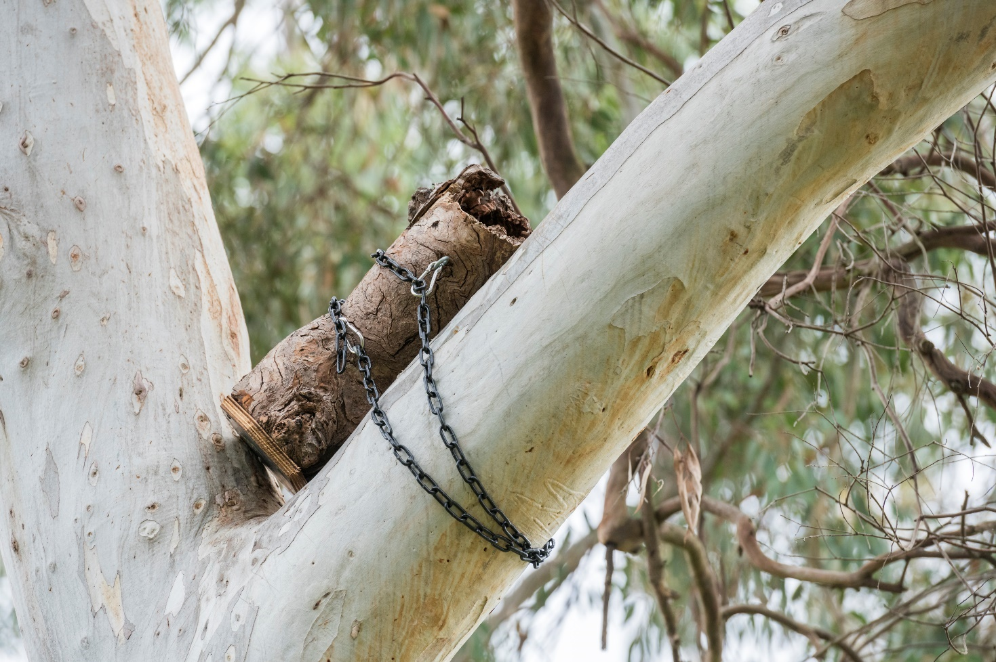
As part of the M80 Ring Road Alliance’s (M80RRA) scope of work, a significant number of trees had to be removed from
the project area. Suitable hollows for nesting and shelter can take up to 100 years to develop in nature.
The team on the M80RRA constructed nest boxes (pictured above) made from reclaimed hollows and logs from trees removed as part of the project. Ten nest boxes have been installed, with two installed at Gabonia Avenue Reserve,
four at AK Lines Reserve, and four installed at Yando Street near the underpass.
The boxes are being monitored by the team to ensure that they are functioning to benefit local fauna. Currently, they provide homes for six ringtail possums, a feathertail glider, and a hive of European bees. 30 more nest boxes are planned
to be installed in 2026. These nest boxes will support native arboreal fauna in the area, including ringtail possums, brushtail possums, gliders, tawny frogmouths, lorikeets, and rosellas.
Nest boxes are also being installed along Koonung Creek Reserve as part of the Eastern Freeway: Burke to Tram Alliance, providing additional habitat opportunities for local wildlife within the package corridor.
By providing these alternative habitats, the project can support local biodiversity while allowing nature to take its course
in creating natural hollows.


Communities
Making a positive contribution to social, cultural and community health
and wellbeing.

Performance Snapshot
UNSDG 3:  Good Health  and Well-Being | UNSDG 11: Sustainable Cities  and Communities

Enhance open space, active transport opportunities and community facilities
Target | Package | 2022 | 2023 | 2024 | 2025
Implement  initiatives that generate positive social and/or environmental outcomes and enhance community wellbeing.  IS v1.2 Hea-1 Level 2 (Early Works)  IS v2.1 Leg-1 Level 2 | Early Works | Well Progressed | Well Progressed | Complete | Not in scope
 | Tunnels | Well Progressed | Well Progressed | Well Progressed | Well Progressed
 | M80RRA | Not in scope | Not in scope | Well Progressed | Well Progressed
 | EBTA | Not in scope | Not in scope | Well Progressed | Well Progressed
 | EHBA | Not in scope | Not in scope | Not in scope | In Progress
 | ETSA | Not in scope | Not in scope | Not in scope | In Progress
Achieve at least  a 10% increase  (or greater) in cyclist numbers travelling the North East Link corridor after 3 years of operation. | Early Works | N/A | N/A | N/A | Not in scope
 | Tunnels | Well Progressed | Well Progressed | Well Progressed | Well Progressed
 | M80RRA | Not in scope | Not in scope | Well Progressed | Well Progressed
 | EBTA | Not in scope | Not in scope | Well Progressed | Well Progressed
 | EHBA | Not in scope | Not in scope | Not in scope | In Progress
 | ETSA | Not in scope | Not in scope | Not in scope | In Progress
Increase the number of homes within 500m of a connected shared use path. | Early Works | N/A | N/A | N/A | Not in scope
 | Tunnels | In Progress | Well Progressed | Well Progressed | Well Progressed
 | M80RRA | Not in scope | Not in scope | Well Progressed | Well Progressed
 | EBTA | Not in scope | Not in scope | Well Progressed | Well Progressed
 | EHBA | Not in scope | Not in scope | Not in scope | In Progress
 | ETSA | Not in scope | Not in scope | Not in scope | In Progress
Create a dedicated Busway and  provide accessible and amenable  Park & Ride facilities connected to  shared use paths,  as guided by the Urban Design Strategy.  *Updated based  on revised data. | Early Works | Well Progressed | Well Progressed | Complete | Not in scope
 | Tunnels |  N/A* | N/A* | N/A* | N/A
 | M80RRA | Not in scope | Not in scope | N/A | N/A
 | EBTA | Not in scope | Not in scope | Well Progressed | Well Progressed
 | EHBA | Not in scope | Not in scope | Not in scope | In Progress
 | ETSA | Not in scope | Not in scope | Not in scope | N/A
Seek opportunities to improve bus priority measures and facilities across the North East Link corridor.  *Updated based  on revised data. | Early Works | Well Progressed | Well Progressed | Complete | Not in scope
 | Tunnels | Well Progressed | Well Progressed | Well Progressed | Well Progressed
 | M80RRA | Not in scope | Not in scope | Well Progressed* | Well Progressed
 | EBTA | Not in scope | Not in scope | Well Progressed | Well Progressed
 | EHBA | Not in scope | Not in scope | Not in scope | In Progress
 | ETSA | Not in scope | Not in scope | Not in scope | In Progress
Achieve a high level of improvement in recreational facility standards when compared with  pre-North East Link facilities.  *Updated based  on revised data. | Early Works | Well Progressed | Well Progressed | Complete | Not in scope
 | Tunnels | Well Progressed | Well Progressed | Well Progressed | Well Progressed
 | M80RRA | Not in scope | Not in scope | Well Progressed | Well Progressed
 | EBTA | Not in scope | Not in scope | Well Progressed* | Well Progressed
 | EHBA | Not in scope | Not in scope | Not in scope | N/A
 | ETSA | Not in scope | Not in scope | Not in scope | N/A

Respect and promote cultural and historical heritage values
Target | Package | 2022 | 2023 | 2024 | 2025
Demonstrate a design philosophy and approach that recognises, protects and promotes Indigenous cultural heritage values and celebrates and interprets places  and objects of historical heritage importance. | Early Works | Well Progressed | Well Progressed | Complete | Not in scope
 | Tunnels | Well Progressed | Well Progressed | Well Progressed | Well Progressed
 | M80RRA | Not in scope | Not in scope | Well Progressed | Well Progressed
 | EBTA | Not in scope | Not in scope | Well Progressed | Well Progressed
 | EHBA | Not in scope | Not in scope | Not in scope | Well Progressed
 | ETSA | Not in scope | Not in scope | Not in scope | Well Progressed
Seek opportunities to represent Wurundjeri people’s knowledge, insights and Connections  to Country via  a meaningful, authentic and collaborative process. | Early Works | Well Progressed | Well Progressed | Complete | Not in scope
 | Tunnels | Well Progressed | Well Progressed | Well Progressed | Well Progressed
 | M80RRA | Not in scope | Not in scope | Well Progressed | Well Progressed
 | EBTA | Not in scope | Not in scope | Well Progressed | Well Progressed
 | EHBA | Not in scope | Not in scope | Not in scope | Well Progressed
 | ETSA | Not in scope | Not in scope | Not in scope | Well Progressed

Case Study:
EBTA Elevate
The team on the Eastern Freeway Upgrade: Burke to Tram has developed
a targeted behavioural change program to address the underlying
cultural drivers of risk associated with harmful gender norms and
poor stress regulation.
Target | Package | Current Phase | Status
Implement initiatives that generate positive social and/or environmental outcomes and enhance community wellbeing. | Eastern Freeway Upgrades: Burke to Tram | Construction | Ongoing
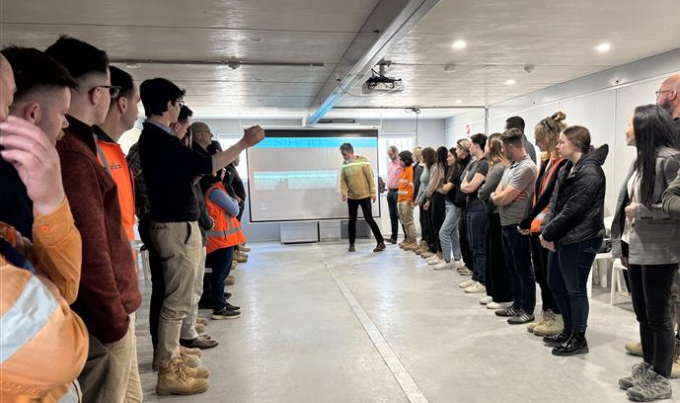
The team collected workforce insights and engagement data to identify risks to psychological safety, wellbeing and inclusion, alongside broader industry challenges. By identifying the direct link between these factors and safety, performance, and long-term workforce outcomes, the team developed Elevate.
Elevate is a capability-building program delivered to the workforce through facilitated, in-person workshops.
The program was designed specifically for the context of the infrastructure project and delivered in partnership
with Tomorrow Architects – a company specialising in evidence-based behavioural change in complex,
male-dominated environments.
Elevate prioritises practical, preventative behaviours over policy and compliance based training. The program creates safer, more inclusive, and higher-performing teams by:
- focusing on strengthening everyday behaviours
- strengthening psychological safety, trust, communication, and relational capability
- increasing awareness of gender dynamics and challenging limiting norms
- improving emotional regulation, resilience, and decision-making under pressure.
Elevate is delivered through a blended learning model that embeds behavioural change into daily work practices,
combining two high-impact workshops with peer dialogue, toolbox conversations, and on-the-job application
supported by leaders.
The first workshop, Breaking the Code, focused on unpacking harmful gender norms, building empathy, and
strengthening social capital through facilitated dialogue and reflection.
The second, Resilience and Wellbeing, focused on understanding stress responses and maintaining executive
function in high-pressure environments, equipping participants with practical tools to improve emotional regulation
and reduce reactive or harmful behaviours.
67% of participants reported that the program challenged their thinking on gender roles in both their personal and professional lives. Psychological safety, wellbeing, and understanding of gender norms were all evaluated alongside information on package-wide wellbeing, engagement data with a multi-year baseline, trends in mental health first aider engagement, and behavioural reporting.
Elevate delivered a clear shift in employees from a passive awareness of cultural risk to the development of active behaviours that support safer, more connected teams.
As a scalable, evidence-based model for addressing cultural and behavioural risk in infrastructure delivery,
Elevate can be used to support similar initiatives on future projects, contributing to safer, more inclusive outcomes
across the sector.


Economic Opportunities
Facilitating opportunities for economic development, providing a skilled
local workforce, and promoting diversity and inclusion.

Performance Snapshot
  UNSDG 8:  Decent Work and Economic Growth |   UNSDG 10:  Reduced  Inequalities

Achieve social value and sustainability outcomes through procurement
Target | Package | 2022 | 2023 | 2024 | 2025
Implement a social and sustainable procurement strategy that delivers on relevant legislative and policy frameworks, including Victoria’s Social Procurement Framework. | Early Works | Well Progressed | Well Progressed | Complete | Not in scope
 | Tunnels | Well Progressed | Well Progressed | Well Progressed | Well Progressed
 | M80RRA | Not in scope | Not in scope | Well Progressed | Well Progressed
 | EBTA | Not in scope | Not in scope | Well Progressed | Well Progressed
 | EHBA | Not in scope | Not in scope | Not in scope | In Progress
 | ETSA | Not in scope | Not in scope | Not in scope | In Progress

Promote sustainability within industry
Target | Package | 2022 | 2023 | 2024 | 2025
Require relevant contractors and suppliers to adopt and implement recognised and accredited sustainability training for staff. | Early Works | N/A | N/A | N/A | Not in scope
 | Tunnels | Well Progressed | Well Progressed | Well Progressed | Well Progressed
 | M80RRA | Not in scope | Not in scope | Well Progressed | Well Progressed
 | EBTA | Not in scope | Not in scope | Well Progressed | Well Progressed
 | EHBA | Not in scope | Not in scope | Not in scope | Well Progressed
 | ETSA | Not in scope | Not in scope | Not in scope | Well Progressed
Promote sustainability awareness  among staff  and contractors. | Early Works | Well Progressed | Well Progressed | Complete | Not in scope
 | Tunnels | Well Progressed | Well Progressed | Well Progressed | Well Progressed
 | M80RRA | Not in scope | Not in scope | Well Progressed | Well Progressed
 | EBTA | Not in scope | Not in scope | Well Progressed | Well Progressed
 | EHBA | Not in scope | Not in scope | Not in scope | In Progress
 | ETSA | Not in scope | Not in scope | Not in scope | In Progress

Case Study:
Female Civil Construction Graduates
In 2025 the M80 Ring Road Completion team celebrated the graduation
of its first all-female Civil Construction Traineeship cohort.
Target | Package | Current Phase | Status
Implement a social and sustainable procurement strategy that delivers on relevant legislative and policy frameworks, including Victoria’s Social Procurement Framework. | M80 Ring Road Completion | Construction | Ongoing
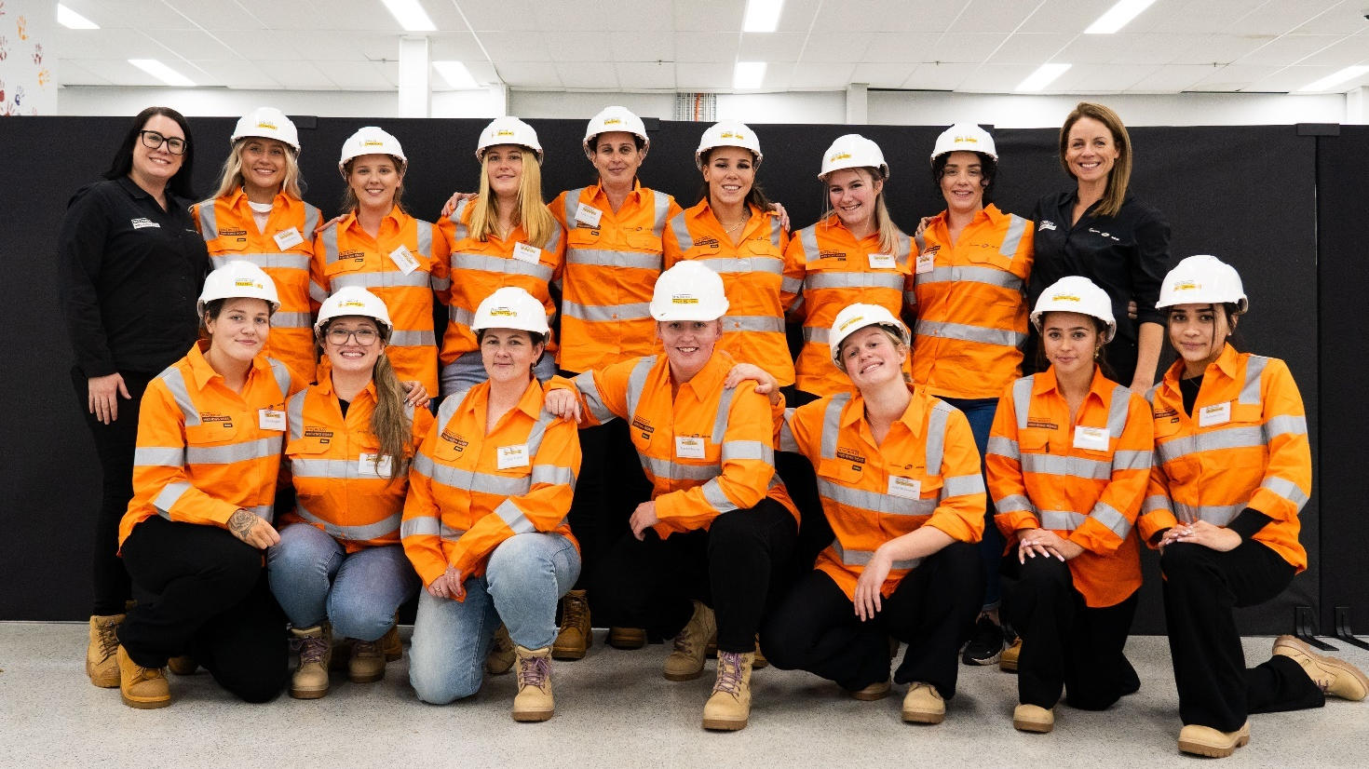
The full cohort of 14 women graduated in 2025, completing White Card training, First Aid training, and receiving
a Certificate III in Civil Construction.
The program, developed for the trainees, was designed to equip them with the skills to enter a traditionally male-
dominated industry, and to foster a sense of safety and community to enable them to confidently enter the workforce.
Throughout the course, participants were introduced to key figures within the M80 Ring Road Alliance (M80RRA) team, including the package’s Alliance Manager, superintendents, Human Resources team, members of the management team, Site General Foremen and representatives from VIDA Roads.
Training included:
- An in-depth introduction to the M80RRA’s safety and compliance system
- Site induction and manual handling training
- A session covering the Cultural Heritage Management Plan
- An introductory course at the Victorian Tunnelling Centre
A mix of dedication, hard work, training and support has laid the groundwork for this industry-first initiative, paving the
way to a safer, more inclusive, and innovative future in civil construction. This successful program continues in 2026.

Case Study:
Strategic Procurement
Teams across the North East Link Program are taking steps to embed sustainability into their contracts and set a new baseline for sustainability targets in Victoria.
Target | Package | Current Phase | Status
Implement a social and sustainable procurement strategy that delivers on relevant legislative and policy frameworks, including Victoria’s Social Procurement Framework. | Program Wide | Design & Construction | Ongoing
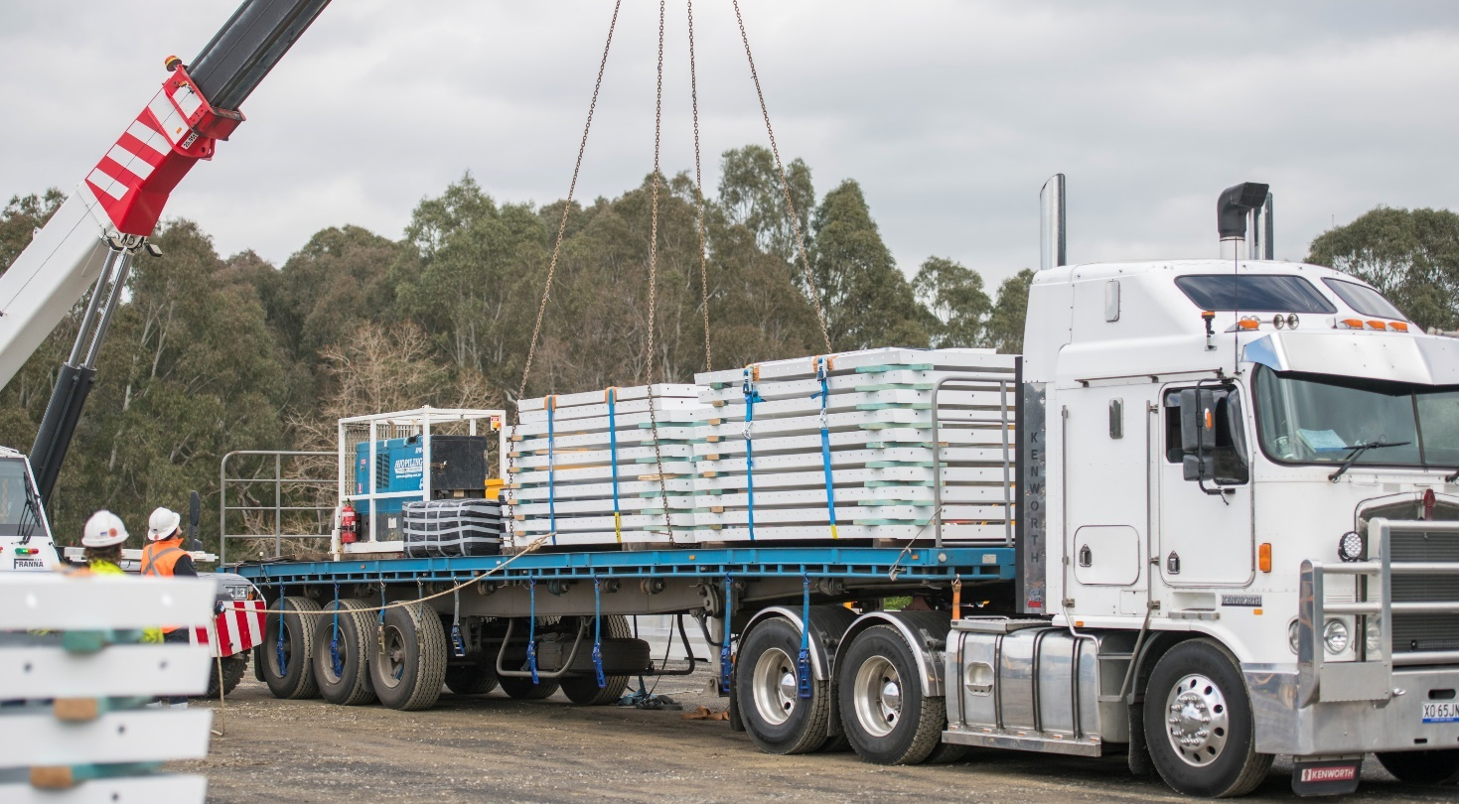
Delivery partners on the M80 Ring Road Completion, the NEL Tunnels, and the Eastern Freeways: Burke to Tram,
Hoddle to Burke, and Tram to Springvale teams are streamlining the procurement of materials to allow for more robust
and deliverable sustainability targets.
Instead of each subcontractor sourcing their own materials, delivery partners directly appointed a small number of major suppliers, from whom subcontractors receive the materials required to complete their parts of the program.
Doing so allows our delivery partners to monitor and control the use of sustainable materials on package sites, streamlines the procurement process, and enables the rapid and accurate collection of data.
On the Eastern Freeways: Burke to Tram package, the sustainability team engaged with the suppliers during the tender process, to ensure that sustainability targets were understood and achievable, which resulted in 4,000 tonnes of embodied carbon emissions being saved when compared to using no recycled materials.
This process also empowers operators to improve in other sustainability initiatives. The NEL Tunnels team are able to automatically process data on over 90% of material usage across their program. What once required hundreds of hours
of data collection, validation and consolidation now happens seamlessly in the background.
By improving data quality and efficiency, sustainability teams on the project can focus on analysing trends, modelling scenarios, identifying new carbon reduction opportunities, and supporting better decision-making across the project.

Case Study:
First Nations Work Experience
The NEL Tunnels team delivered a First Nations Work Experience Program, which offered students from Melbourne’s north-eastern suburbs a
hands-on introduction to the construction industry and life on a major infrastructure project.
Target | Package | Current Phase | Status
Implement a social and sustainable procurement strategy that delivers on relevant legislative and policy frameworks, including Victoria’s Social Procurement Framework. | North East Link Tunnels | Construction | Ongoing
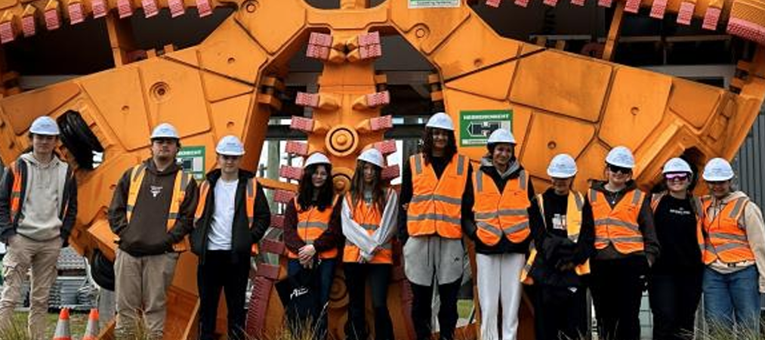
The First Nations Work Experience Program involved 15 indigenous high school students from schools across Melbourne’s northern suburbs.
The team underwent a robust engagement process with the schools and community, speaking directly with schools’
Koorie Liaison Officers, Guidance Counsellors and the Victorian Aboriginal Education Association Inc. to determine an appropriate program and schedule. This work took place over several months and included follow-up conversations
directly with students so the team could provide further clarity and guidance where needed.
In the most recent cohort, students participated in the four-day program where they were exposed to a wide range
of career pathways from cultural heritage and environment to engineering, sustainability, safety, communications,
human resources, commercial and urban planning.
Participants undertook site visits, workshops and mentoring to learn about the North East Link and its benefits for local communities, and had the opportunity to hear from a past beneficiary of the program, now working as a trainee for the environment team on the NEL Tunnels package.
Feedback from the students was positive, highlighting how the first-hand nature of the work experience program helped clarify their understanding of the industry and the complexity of large-scale projects. Many indicated an interest in pursuing careers within the construction industry.
By representing the real-world outcomes from the initiative, programs like these can inspire the next generation
of First Nations talent and build stronger connections between community and the industry.

Climate Change
Playing a part in Victoria achieving its emission reduction targets while preparing for the challenges presented by climate change.

Performance Snapshot


UNSDG 13:
Climate Action

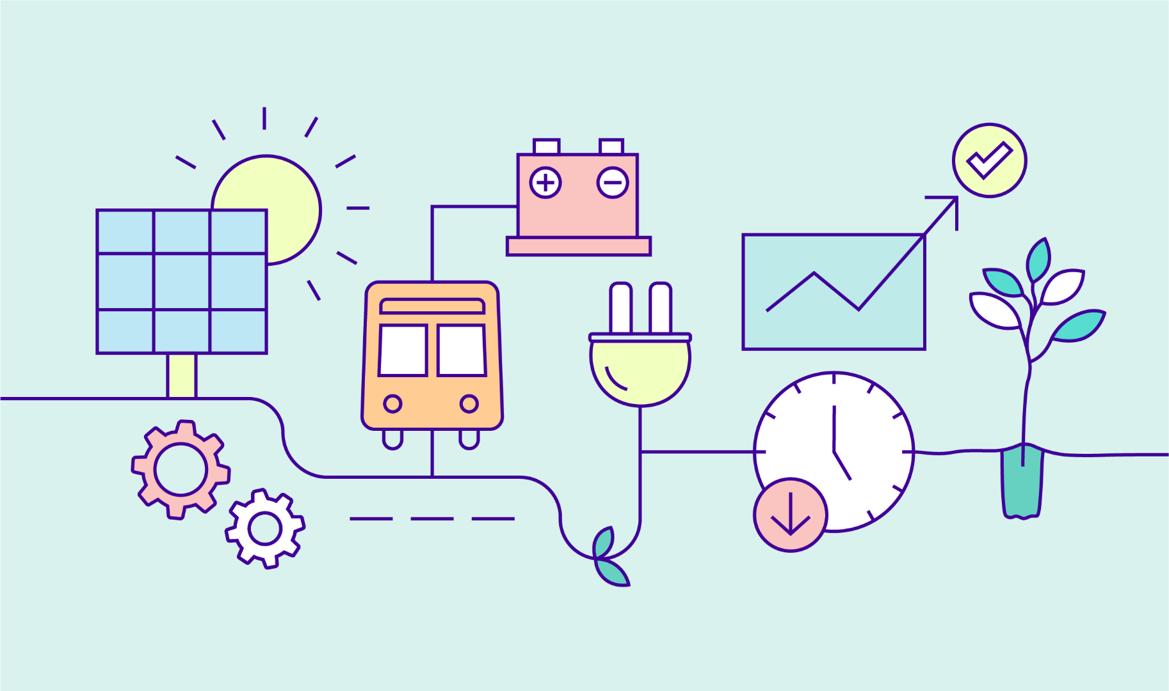
Reduce carbon emissions during construction and operation
Target | Package | 2022 | 2023 | 2024 | 2025
Analyse and implement  all feasible opportunities to reduce energy  use and greenhouse gas emissions from construction and operation of  North East Link. | Early Works | Well Progressed | Well Progressed | Complete | Not in scope
 | Tunnels | Well Progressed | Well Progressed | Well Progressed | Well Progressed
 | M80RRA | Not in scope | Not in scope | Well Progressed | Well Progressed
 | EBTA | Not in scope | Not in scope | Well Progressed | Well Progressed
 | EHBA | Not in scope | Not in scope | Not in scope | In Progress
 | ETSA | Not in scope | Not in scope | Not in scope | In Progress
Achieve at least  a 30% reduction  in carbon  emissions from  the construction  of North East Link against an ISC verified base case calculated in accordance with their independent standards.  IS v1.2 Ene-1 Level 3 (Early Works)  IS v2.1 Ene-1 Level 3  *Inclusive of Operations.  **Modelling 50% complete at the time  of reporting. | Early Works | Well Progressed 36% reduction | Well Progressed 32% reduction | Complete  25% reduction | Not in scope
 | Tunnels | Well Progressed 54% reduction | Well Progressed 81% reduction* | Well Progressed 92.2% reduction* | Well Progressed 60% reduction
 | M80RRA | Not in scope | Not in scope | In Progress**  32% reduction | Well Progressed  38% reduction
 | EBTA | Not in scope | Not in scope | Well Progressed 30% reduction | Well Progressed  31% reduction
 | EHBA | Not in scope | Not in scope | Not in scope | In Progress
 | ETSA | Not in scope | Not in scope | Not in scope | In Progress
Use at least 50%  of renewable  energy for electricity used to construct North East Link.  IS v1.2 Ene-2  Level 1.5  (Early Works)  IS v2.1 Ene-2  Level 1.5 | Early Works | Well Progressed 60% | Well Progressed 73% | Complete  73% | Not in scope
 | Tunnels | Well Progressed 100% | Well Progressed 100% | Well Progressed 100% | Well Progressed 100%
 | M80RRA | Not in scope | Not in scope | Well Progressed 100% | Well Progressed  100%
 | EBTA | Not in scope | Not in scope | Well Progressed 100% | Well Progressed  100%
 | EHBA | Not in scope | Not in scope | Not in scope | In Progress
 | ETSA | Not in scope | Not in scope | Not in scope | In Progress
Achieve net zero emissions in the operation and maintenance of  North East Link. | Early Works | N/A | N/A | N/A | Not in scope
 | Tunnels | Well Progressed | Well Progressed | Well Progressed | Well Progressed
 | M80RRA | Not in scope | Not in scope | Well Progressed | Well Progressed
 | EBTA | Not in scope | Not in scope | Well Progressed | Well Progressed
 | EHBA | Not in scope | Not in scope | Not in scope | In Progress
 | ETSA | Not in scope | Not in scope | Not in scope | In Progress

Design to be resilient to a changing climate
Target | Package | 2022 | 2023 | 2024 | 2025
Implement a Climate Resilience Plan which addresses high and extreme climate change risks. | Early Works | Well Progressed | Well Progressed | Complete | Not in scope
 | Tunnels | Well Progressed | Well Progressed | Well Progressed | Well Progressed
 | M80RRA | Not in scope | Not in scope | Well Progressed | Well Progressed
 | EBTA | Not in scope | Not in scope | Well Progressed | Well Progressed
 | EHBA | Not in scope | Not in scope | Not in scope | In Progress
 | ETSA | Not in scope | Not in scope | Not in scope | In Progress

Case Study:
Electric Crawler Cranes
A Victorian-first initiative; electric crawler cranes on the Eastern Freeway Upgrade: Burke to Tram.
Target | Package | Current Phase | Status
Analyse and implement  all feasible opportunities to reduce energy use and greenhouse gas emissions from construction and operation of North East Link. | Eastern Freeway Upgrades: Burke to Tram | Construction | Ongoing
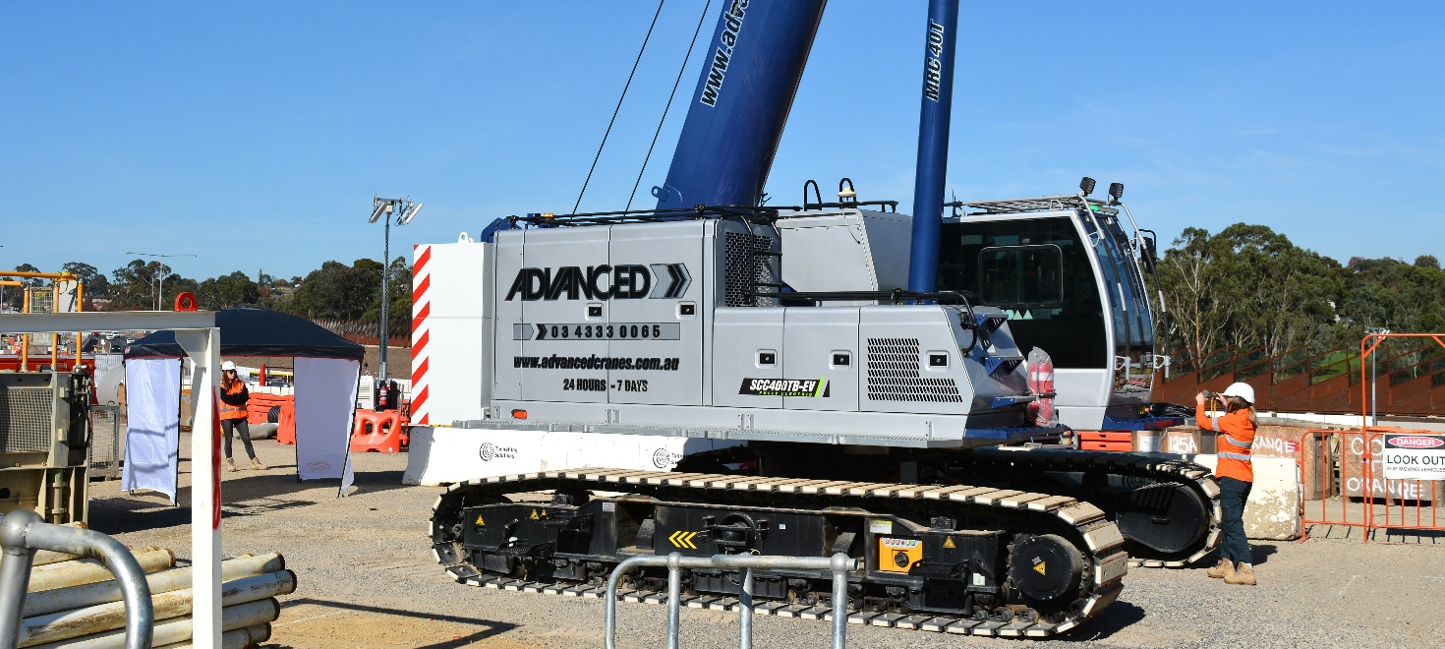
In August 2025, Eastern Freeways: Burke to Tram package successfully mobilised two 40-tonne electric cranes from Advanced Cranes and Tutt Bryant Group Limited, deployed by contractors Tunnelling Solutions and Bothar Group. The cranes are used for pipe-jacking works – lowering pipes into shafts where micro tunnelling machines are constructing new sewers. It has been an easy switch from a traditional crane to electric cranes, with the added benefit of significantly reduced noise impacts on nearby residents due to its near silent operation.
The cranes each had an onboard battery that allowed them to operate for 30 hours per full charge – the equivalent to three 10-hour shifts. They were charged directly from a standard mains connection and were able to operate while charging, enabling 24/7 operation when required.
After 2,000 hours of service, there were no technical issues, and the cranes met or exceeded productivity expectations
for the scope of works, showing identical lifting performance compared their diesel-powered equivalents.
Benefits of using the fully electric cranes included:
- avoiding the use of 17kL of diesel – equivalent to 46 tonnes of carbon dioxide emissions
- a 10% cost reduction compared to the standard diesel alternative
- a significant reduction in plant operating noise compared to the standard diesel alternative
- a significantly reduced impact on local air quality, removing the point source emission of pollutants and diesel particulates.
The initiative has also impacted the industry by exposing crane suppliers, tunnelling subcontractors and the delivery team to the benefits of fully electric plants, providing a real world example and thereby reduced perceived risks for future projects.
The use of 40-tonne fully electric crawler cranes at EBTA demonstrates that plant electrification – often considered complex, risky, or costly – can be simple, reliable, commercially viable, and highly impactful.


Glossary

Terms used in this report

Arboreal
Living in or often found in trees.

Embodied carbon
The greenhouse gas emissions impact associated with all activities involved in the production of a finished material
(e.g. activities include: raw material extraction, transport to manufacturing facilities, manufacturing).

Fabricators
A skilled tradesperson who creates value-added products from semi-finished or raw materials, such as the creation
of custom steel products from coils or bars of steel.

Green Star Rating
A comprehensive system to assess the sustainability performance of buildings. Visit gbca.org.au to learn more.

Inert and non-hazardous construction waste
Materials resulting from construction and demolition activities, including concrete, bricks, paper, plastics, glass, metal, timber, asphalt, and used, rejected or unwanted tyres.

Infrastructure Sustainability (IS) Rating
A comprehensive system to assess the sustainability performance of infrastructure. Visit www.iscouncil.org to learn more.

Mass timber
An engineered timber product that can replace the steel or concrete structural components of buildings.

Non-potable water
Lower quality water suitable for purposes other than domestic consumption (see potable water), such as toilet flushing
or dust suppression.

Potable water
High quality water that is suitable, safe, and approved for domestic consumption as set and regulated by national health
and water quality standards. This is the standard supplied by water utilities which is sometimes called town water or reticulated water.

Reinstatement
To restore a material to its original state and/or former location.

Shared use path
A pathway that can be used for both walking and cycling.

Spoil
Dirt, soil, rock, rubble, and other waste material excavated or removed during digging or tunnelling operations.

Sustainable Development Goals
A set of global goals that frame our collective sustainability challenges and opportunities. Visit sdgs.un.org to learn more.

Topsoil
The uppermost layer of soil, distinguished from other layers of soil for its rich nutrient content and high levels of
organic matter.

Tunnel Boring Machine (TBM)
A machine that excavates soil and rock. TBMs are being used to dig the tunnels for North East Link.

Tunnel inflow water
Groundwater which naturally flows into tunnels as a result of surrounding aquifer systems.

Wurundjeri Woi-wurrung Cultural Heritage Aboriginal Corporation
Visit www.wurundjeri.com.au to learn more.
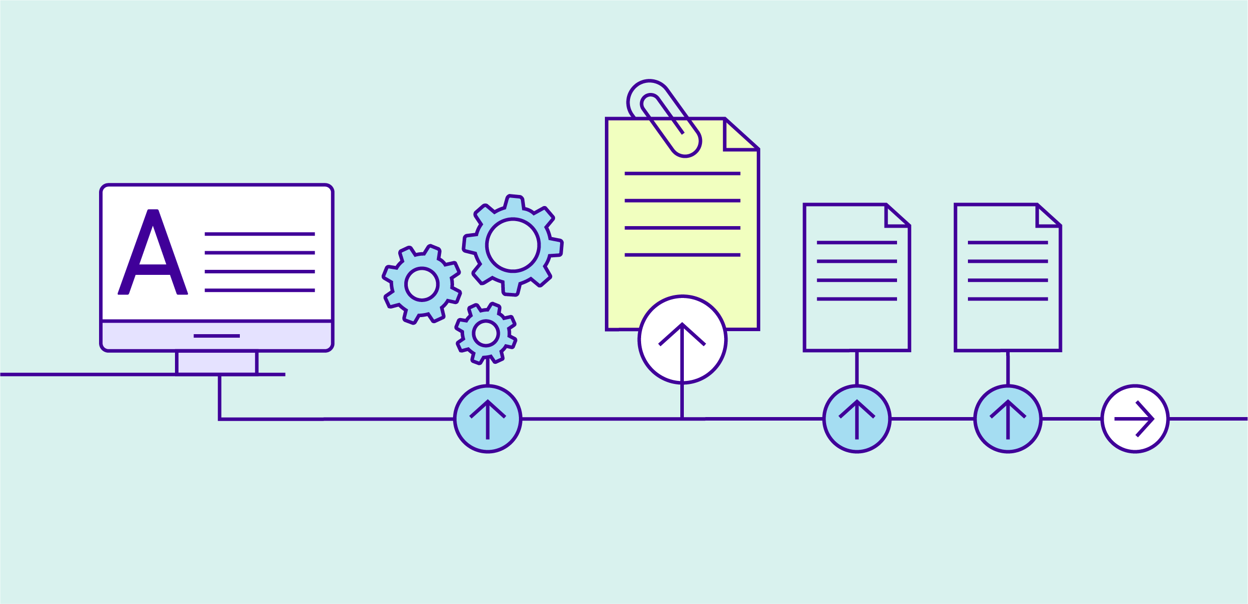

Appendix

About IS Ratings

Leadership
IS Rating version | IS Rating credit | Intent of the credit | IS Rating level | Performance requirement
v1.2 | Inn-1 | Rewards pioneering initiatives in sustainable design, process or advocacy. | N/A | One example of an innovation which is either market transforming, improves on credit benchmarks, world, national or state leading, or equivalent.
v2.1 | Inn-1 | Rewards innovative initiatives and outcomes in delivering sustainable infrastructure. | N/A | One example of an innovation which is either market transforming, improves on credit benchmarks, world, national or state leading, or equivalent.
v1.2 | Man-6 | Rewards sustainability knowledge sharing initiatives. | Level 2 | One example of sustainability knowledge shared within the project, beyond the project boundary, or from outside the project onto the project.
v2.1 | Lea-3 | Rewards new or updated knowledge on issues and outcomes important to infrastructure sustainability shared between projects and more widely within industry. | Level 2 | Two examples of sustainability knowledge shared beyond the project boundary, resulting in competency improvement or specific action. Two examples of sustainability knowledge shared from outside the project and has been utilised on the project. Two examples of sustainability knowledge shared beyond the project boundary  to the wider industry.

Resource Efficiency
IS Rating version | IS Rating credit | Intent of the credit | IS Rating level | Performance requirement
v2.1 | Rso-1 | Rewards the identification, implementation and management of resource efficiency expectations for each phase of the infrastructure life cycle and the achievement of positive circular economy outcomes. | Level 2 | A Resource Efficiency Strategy and Resource Efficiency Action Plan have been developed Resource efficiency opportunities have been identified and assessed for feasibility Performance targets for circular economy outcomes have been reviewed with external stakeholders and proactively communicated to the market.
v1.2 | Mat-1 | Rewards design and practice that reduces lifecycle environmental impacts of materials. | Level 1.3 | Monitor and model materials life cycle impacts across the infrastructure lifecycle. Monitoring and modelling demonstrate a 5% reduction in materials life cycle impacts compared to a base case footprint.
v2.1 | Rso-6 | Rewards the design and construction of the project in ways that reduce the environmental impacts of materials across the life cycle  of the infrastructure asset. | Level 1 | Monitor and model of materials life cycle impacts across the infrastructure life cycle. Monitoring and modelling demonstrates a 15% reduction in materials life cycle impacts compared to a base case footprint.

Communities
IS Rating version | IS Rating credit | Intent of the credit | IS Rating level | Performance requirement
v1.2 | Hea-1 | To reward a positive contribution to community health  and wellbeing. | Level 2 | Measures to positively contribute to community health and wellbeing for three priority issues has been identified and implemented. Monitoring of community health and wellbeing indicators related to the priority issues is undertaken at appropriate intervals during construction of the asset.
v2.1 | Leg-1 | To reward the  delivery of initiatives that contribute pronounced and  long-lasting societal  or environmental outcomes outside  of the project scope already addressed  by IS credits. | Level 2 | Initiatives have been implemented to contribute positively to society or the environment for three priority issues  or opportunities. Monitoring has been established to demonstrate the success of the legacy initiatives.

Climate Change
IS Rating version | IS Rating credit | Intent of the credit | IS Rating level | Performance requirement
v1.2 | Ene-1 | To reward monitoring and minimising of energy use and GHG emissions across the infrastructure lifecycle. | Level 3 | Monitor and model energy use and greenhouse gas emissions across the infrastructure life cycle. Monitoring  and modelling demonstrates a 30% reduction in greenhouse gas emissions compared to a base case footprint.
v2.1 | Ene-1 | To reward the reduction of energy use and carbon emissions across  the infrastructure  life cycle and  drive towards  net zero carbon. | Level 3 | Monitor and model energy use and carbon emissions for capital and operational carbon. Energy and  carbon emissions reduction opportunities have been investigated across the infrastructure life cycle and included in design and construction planning. Monitoring and modelling demonstrates a 30% reduction in energy use and carbon emissions for capital and operational carbon compared to a base case footprint.
v1.2 | Ene-2 | To reward investigation of, and use of, renewable energy. | Level 1.5 | Opportunities for use of renewable energy are fully investigated. Achieve  a 20% substitution of energy from renewable sources.
v2.1 | Ene-2 | To drive towards net zero carbon by increasing the development and use of renewable energy. | Level 1.5 | Achieve a 50% substitution of  capital and operational non-renewable energy use.

