TUN1812.1

17 December 2018

WORKS UPDATE - WHITEHALL STREET CONSTRUCTION AREAS
The Northern Portal, Tunnelling Hub and North Yarra Main Sewer Diversion sites have seen significant progress in 2018. We’ve started pipe jacking the North Yarra Main Sewer detour, excavated a large amount of the main tunnel entrance and almost finished the big shed that will store the soil and rock from tunnelling activities.
While there will be personnel on site at times, we will stop major construction works for 2018 on Friday 21 December and we’ll be back to work for 2019 on Wednesday 2 January. We’ll focus on the activities detailed below for the rest of 2018 and early 2019 as we get ready for the arrival of the Tunnel Boring Machines (TBMs) and as construction ramps up in the new year.

Tunnelling Update
Over the next few months, we’ll be preparing for tunnelling with:
- Delivery of the first TBM, named ‘Bella’, to our Northern Portal site in early January 2019 – to arrive in 89 deliveries. To ensure Bella’s safe arrival, Footscray Road will be closed for 2.5 hours in both directions, for one night in early January. More information will be available on our website and social media as delivery dates are confirmed.
Once all deliveries of the TBM parts have arrived at the Northern Portal, technicians will assemble her over three to four months before she is launched. We will continue to provide updates about her assembly and you may see some of this activity above the fence along Whitehall Street.
- Deliveries of the precast concrete lining segments for the tunnel will start to arrive from Benalla.
- State-of-the-art devices to monitor ground movement, building movement, vibration and ground water levels along the tunnel alignment will continue to be installed. Members of the project team will continue to be in touch with local residents and businesses.
01. North Yarra Main Sewer Diversion
Pipe jacking for one half of the diversion is nearly complete and the last section is expected to be completed by March next year. Once the diversion pipes are installed, crews will start the process of commissioning the new section and decommissioning the old sewer. These works will continue 24 hours a day, 7 days a week. In the coming months, there will be some short-term traffic changes on Whitehall Street. Please refer to traffic management signs and alerts closer to the time.
- January 2019 - Whitehall Street northbound lane closure near Youell Street at night. Two-way traffic maintained on southbound lane with traffic management.

- Mid February 2019 - Temporary lane closures will be implemented at the intersection of Somerville Road and Whitehall Street. Local access will be maintained with the use of detours and traffic controllers on-site to assist as required. More details will be provided closer to the date.

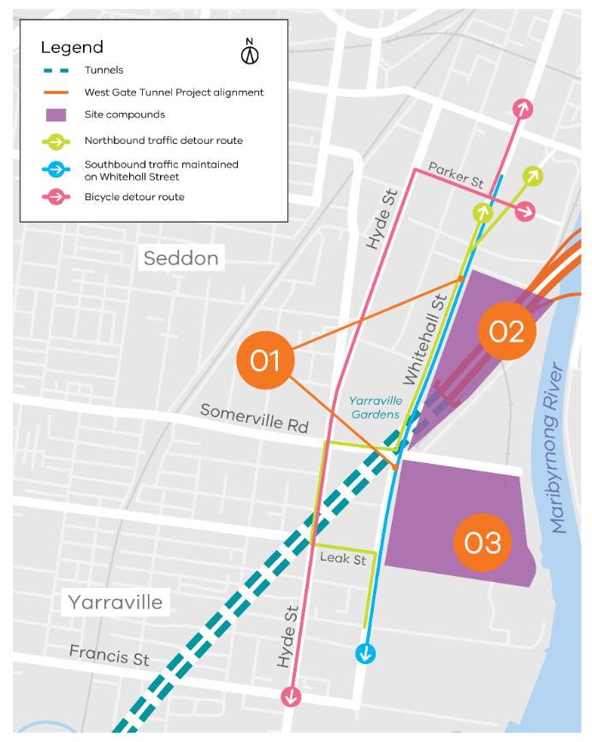
02. Northern Portal Works
Work at the Northern Portal will continue 24 hours a day, 7 days a week.
The focus will be on excavating the tunnel entrance, and assembling the large gantry cranes that will be used to put Bella (TBM) together after her arrival. The largest of these cranes is almost 30 metres tall.

03. Tunnelling Hub at 221 Whitehall Street
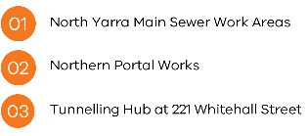
Construction will continue for the big shed. Once tunnelling starts, the excavated soil and rock will be sorted before being transported to an approved handling facility off site.
As part of these works, a fully enclosed spoil conveyor and a separate footbridge for workers will also be built over Somerville Road connecting the Northern Portal to the Tunnelling Hub.

Maribyrnong River Crossing
Utility Relocation: January 2019 – March 2019
In preparation for the Maribyrnong River bridge works early next year, utility relocation will be taking place on Maribyrnong Street, Lyons Street and Whitehall Street. Utility relocations will need to be completed before the piers can be constructed along the Maribyrnong River for the new river crossings. These works will start late January and will take up to 3 months to be completed. More information will be provided for local businesses and residents when dates are confirmed.
Contact us
Please contact us if you have any questions or feedback about these works.
westgatetunnelproject.vic.gov.au | facebook.com/westgatetunnelproject
info@wgta.vic.gov.au | @westgatetunnel
1800 105 105 | West Gate Tunnel Project  GPO Box 4509,  Melbourne Victoria 3001
For more information about the upcoming works and traffic changes, please contact us.

