Reference: TUN1905.1

30 May 2019

UPDATE: PLANNED WORKS FOR KENT AND CAMPBELL STREETS
Recharge well installation – from mid-June 2019
In April 2019, works commenced on the installation of the groundwater recharge system in Yarraville. Due to ground conditions and some rescheduling of the program, works are planned to continue for the installation of the recharge wells on Kent and Campbell Street from mid-June.
Works will include drilling wells, excavation to install covered pits, running water and electricity connections to nearby panel boxes.
The recharge system is designed to manage any impact to the groundwater table around the tunnel alignment during construction. The recharge wells will be in operation throughout tunnel construction and will remain in place until the permanent structures are complete, which will be approximately 12 – 24 months.

What to expect on Kent Street:
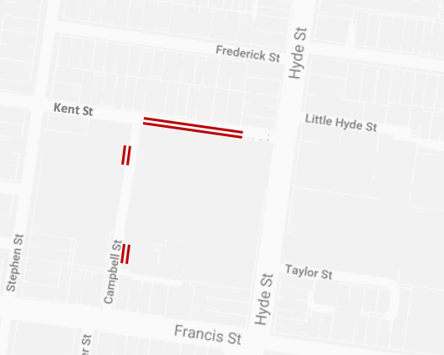
- Temporary road closures in a section of Kent Street for up to three weeks from late June;
- Work hours 7am-6pm, Monday – Saturday;
- Excavation for pit installation and water and power connections;
- Removal of one on street carpark for the duration of the well operation;
- On street parking inside the work zone will be temporarily removed during the works;
- Access to private properties will be maintained throughout the works under traffic management;
- Pedestrian footpath closures may be required at times;
The red area shows the approximate location for the Kent Street and Campbell Street recharge well works from mid-June.
- Every 3 months we may require access to the panel box and recharge well for maintenance.

What to expect on Campbell Street:
- Works for up to two weeks from mid-June; then up to four weeks in July.
- Work hours 7am–10pm, Monday – Friday due to location within the business estate;
- Minor excavation to expose any underground services in the immediate area;
- Drilling two wells up to 55 metres deep over two weeks;
- Excavation for pit installation and water and power connections;
- Traffic and parking impacts on Campbell Street within business estate;
- Pedestrian footpath closures may be required at times;
- Every 3 months we may require access to the panel box and recharge well for maintenance.
WANT TO BE KEPT IN THE LOOP FOR ROAD CLOSURES OR WORKS IN KENT AND CAMPBELL STREETS?
If you would like email updates for the works in this notification please email the project team at info@wgta.vic.gov.au and type “Kent/Campbell St Updates” in the subject line.

While we expect this work will have some low level associated noise, we will take steps to minimise noise and will monitor any impacts.
Thank you for your patience while we undertake these important activities.
Please note that works are subject to change and could be rescheduled in the event of bad weather or there are updates to the investigations scheduled. For more information about the upcoming works and traffic changes, please contact us.

Contact us
Please contact us if you have any questions or feedback about these works.

westgatetunnelproject.vic.gov.au info@wgta.vic.gov.au
1800 105 105
facebook.com/westgatetunnelproject
@westgatetunnel
West Gate Tunnel Project GPO Box 4509
Melbourne Victoria 3001
Interpreter service: 13 14 50

