WES1805.02

21 May 2018

Works notification: West Gate Freeway (outbound) between Williamstown Road and The Avenue.

Works to widen the West Gate Freeway outbound from Williamstown Road to The Avenue will start at the end of May. Construction along this section of freeway will be extensive and once completed, will provide two extra lanes for motorists travelling outbound.
Local road closures
29 May 2018 – ongoing
To allow our teams to undertake the works in your area safely and efficiently, some temporary road closures will be in place between:
- Vernier Street and Hick Street; and
- Andrews Street and Muir Street

Site fencing and access will also be established at the end of the following streets to create a safe work site between the properties and the freeway:

- Abbott Street;
- Steel Street;
- Vernier Street;
- Hick Street;
- Andrews Street; and
- Muir Street.

Access to all properties will be maintained. Some parking may be impacted at the end of each street.
The pedestrian path between LeFevre Street and Abbott Street will be closed from 29 May. Access to the pedestrian bridge will be via The Avenue and Muir Street. See map over page.
Site establishment works
29 May 2018 – ongoing
Before we start work on the outbound carriage way of the West Gate Freeway, we will be:
- clearing vegetation and trees along the freeway outbound between Melbourne Road and the New Port Rail Line. Day time clearing will take place along the road reserve between the residential properties noise wall. Night time clearing will take between the noise wall and the freeway from 4 June for up to 10 nights;
- clearing vegetation and trees during day works along the freeway inbound from The Avenue to Trenterden Street between the noise wall and freeway during the day;
- investigating utility services that may be impacted by works and potentially require relocation;
- conducting general construction activities including earthworks and piling pad construction; and
- installing temporary fencing and access gates to establish a safe working area for construction workers from Williamstown Road to Muir Street.

Installation of temporary and new noise walls
13 June 2018- ongoing
We will:
- install a temporary noise wall between Vernier Street and Muir Street from 13 June 2018;
- remove the existing noise wall between Vernier Street and Muir Street during the day from 18 June 2018; and
- construct the foundations for the new permanent noise wall with piling works, starting from 19 July.

What you could expect while we undertake these works:
- work will be conducted behind safety barriers;
- construction noise from our machinery and trucks, increasing at times while we complete piling and noise wall construction;
- an increase in construction vehicles within the area;
- dust and dirt will be minimised by using water spray trucks and covering dirt and rock when it is being transported;
- detours will be in place to help safely navigate people and vehicles around the work areas;
- traffic changes including lane and ramp closures will be required - latest traffic updates are available at westgatetunnelproject.vic.gov.au

Works will be carried from Monday to Friday 7am-6pm and Saturday 7am-3pm, however some night works will be required. When works are scheduled out of hours, or if you’re located close to the works, we will provide further information to you before works start.

Please note that works may be rescheduled in the event of bad weather or other unavoidable circumstances.

Planned works area
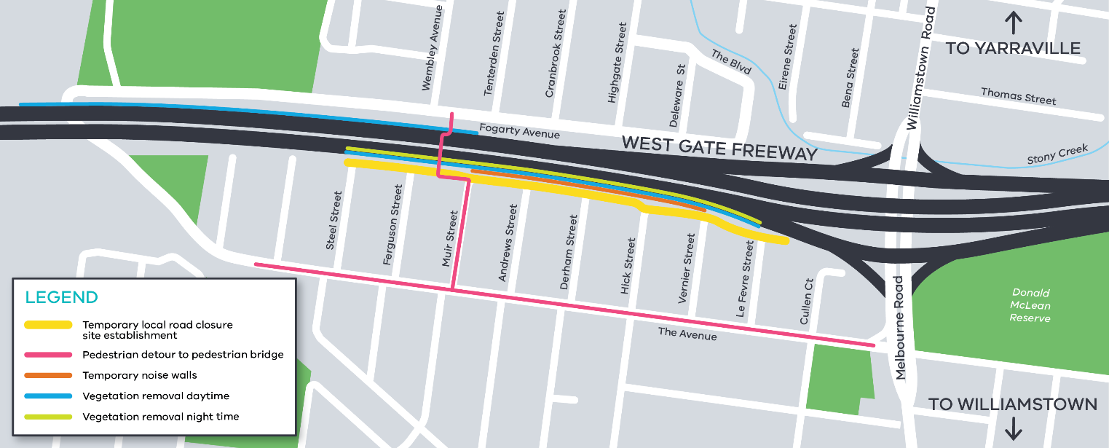

For updates and more information about our works please visit westgatetunnel.vic.gov.au or contact us using the details over page.

Contact us

Please contact us if you have any questions or feedback about these works.
westgatetunnelproject.vic.gov.au
westgatetunnelproject@wda.vic.gov.au
1800 105 105
facebook.com/westgatetunnelproject
@westgatetunnel
West Gate Tunnel Project
GPO Box 4509
Melbourne Victoria 3001
Interpreter service: 13 14 50

