WES1808.02

21 August 2018

Works reminder:

Temporary noise wall installation

Further to our notification on 21 May 2018 (reference WES1805.02), we wish to advise of ongoing works in your area, including the installation of temporary noise walls.

The existing noise walls will not be removed until the new temporary noise walls are in place. These temporary noise walls will then be in place until construction of the new noise walls are complete.

Where:
- Vernier Street to Muir Street (stage one);
- Muir Street to Strong Street (stage two); and
- Williamstown Road (Melbourne Road) to Vernier Street (stage three).
When:
- Vernier Street to Muir Street, starting from 27 August;
- Muir Street to Strong Street, starting in September; and
- Williamstown Road (Melbourne Road) to Vernier Street, starting in late 2018.

These works will generally be carried out from Monday to Friday between 7am - 6pm and Saturdays between 7am - 3pm, however some night works may be required.

If works are scheduled out of hours we will provide further information to you before works start.
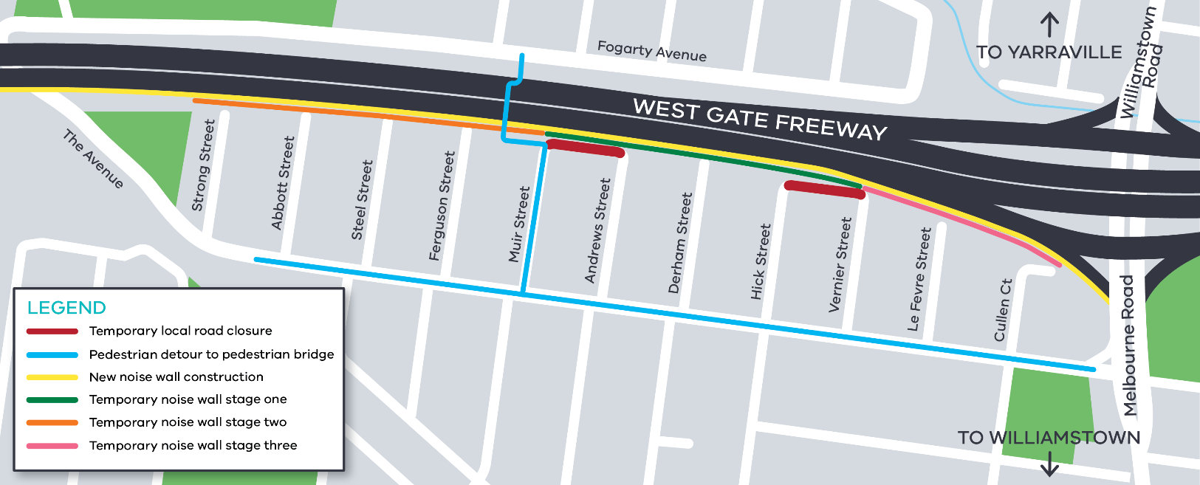
Planned works area:

In addition to the installation of temporary noise walls, construction activity scheduled for the coming weeks will include:
- utility service identification and relocation;
- removal of existing noise walls;
- piling works to establish foundations for new permanent noise walls;
- excavation and earthworks, including removal of dirt; and
- general construction activities.

What to be aware of:
- equipment used for these works include piling rigs, rock hammers, road saws and rattle guns, resulting in periods of increased construction noise;
- construction vehicles including excavators, tandem trucks, concrete trucks and pumps, earthmoving equipment and cranes will be moving in and out of the work areas;
- main access to the construction site will be via Melbourne Road with minimal site access required via local roads;
- construction noise from our machinery and trucks will increase at times while we complete piling and noise wall construction and excavation works;
- dust and dirt will be minimised by using water spray trucks, street sweepers and covering dirt and rock when it is being transported;
- access to the pedestrian bridge will remain open at all times and can be accessed via Muir Street from The Avenue; and
- traffic changes including lane, road and ramp closures may be required – latest traffic updates are available at westgatetunnelproject.vic.gov.au/traveldisruptions

Please note that works may be rescheduled in the event of bad weather or other unavoidable circumstances.

For updates and more information about our works please visit westgatetunnel.vic.gov.au or contact us using the details below.

Contact us
Please contact us if you have any questions or feedback about these works.

 | westgatetunnelproject.vic.gov.au |  | facebook.com/westgatetunnelproject
 | westgatetunnelproject@wda.vic.gov.au |  | @westgatetunnel
 | 1800 105 105 |  | West Gate Tunnel Project  GPO Box 4509, Melbourne VIC 3001
 | Interpreter service: 13 14 50

