Reference: WES1902.08
20 February 2019
Works update
Full closure of Beevers Street, Wally and Michael Courts
Thursday 28 February – Saturday 2 March 2019
Thank you for your patience so far. We’re almost there.
The works currently underway along Beevers Street will be completed ahead of schedule, so from
6pm Thursday 21 February to 10pm Wednesday 27 February access to Beevers Street will be temporarily reinstated via Millers Road, and the access track through the Italian Social Club will be closed during this time.

As we finish our trenching works on Beevers Street, we now need to do a final seal of the road. We explored a range of options as to how best to finish these works, however ultimately, to do so in the shortest time, Beevers Street will need to be temporarily closed to all vehicle traffic for three days, from Thursday 28 February to Saturday 2 March.
We apologise for this inconvenience.
During this time:
- parking is available for you at the Italian Social Club;
- there will be no impact to your waste collection throughout this time;
- 24 hours a day / 7 days a week transport services will be provided to take you to either end of Beevers Street. A taxi will travel along the access track from the Italian Social Club car park to the end of Beevers Street at the grass reserve, or alternatively around to the western end at Millers Road via Kyle Road and Clematis Avenue;
- the site team will help with taking your belongings to and from your home to your car at all times;
- the designated pedestrian track with lighting will remain in place between the Italian Social Club grass reserve and Beevers Street for those that choose to walk to and from their car;
- security personnel will be in place 24 hours a day / 7 days a week at the Italian Social Club and the worksite; and
- footpath access to your property will remain open at all times.

If you wish to be transported to your parked car at the Italian Social Club, please call or SMS our team on 0439 779 995, 24 hours a day / 7 days a week during the works.

If you require any assistance with carrying items to or from your vehicle, please ask one of our friendly onsite team who will be able to assist you or feel free to use our transport service.

When you need to move your vehicle:
- if you need access to your vehicle from Thursday 28 February to Saturday 2 March 2019, please ensure your vehicle is moved out of your driveway by 10:00pm on Wednesday 27 February;
- if you are intending to move your vehicle and park at the Italian Social Club carpark in one of the designated parking spots, please access it via Clematis Avenue or Marigold Avenue;
- please ensure you do not park your vehicle on Beevers Street during these works; and
- full driveway access will be reinstated at 8pm on Saturday 2 March.

What you could expect:
- an increase in construction vehicles in the area;
- an increase in construction noise and vibration during the day from our machinery and trucks;
- odour related to resurfacing works; and
- water spray trucks to help manage dust and dirt and loads will be covered when dirt and rock are being transported.

Emergency services will have access to Beevers Street, Wally Court and Michael Court at all times.

These works will be carried out on Thursday and Friday between 7am - 6pm and Saturday between 7am - 6pm.
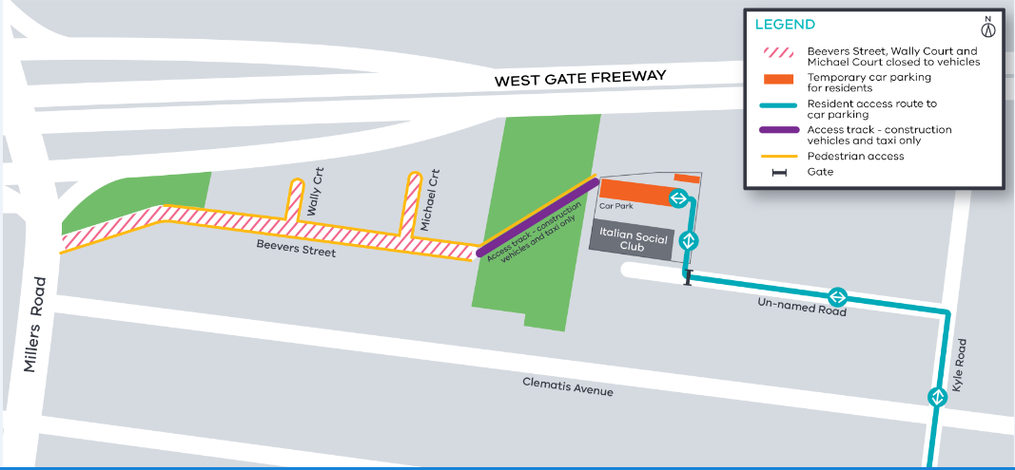
Please note that works and timings may change in the event of bad weather or other unavoidable circumstances.

Contact us
Please contact us if you have any questions or feedback about these works.
 | westgatetunnelproject.vic.gov.au |  | facebook.com/westgatetunnelproject
 | info@wgta.vic.gov.au |  | @westgatetunnel
 | 1800 105 105 |  | West Gate Tunnel Project  GPO Box 4509  Melbourne Victoria 3001
 | Interpreter service: 13 14 50

