Reference: WES1904.04
24 April 2019
Works update – temporary driveway disruption

Construction has begun on Fogarty Avenue to safely relocate some existing power lines and install new drainage. As part of these works, vehicle access to your driveway will be temporarily disrupted.
Temporary disruption to your driveway access
Monday 29 April – Friday 7 June 2019
- Fogarty Avenue will be closed between Wembley Avenue and Cranbrook Street from 29 April to 7 June 2019;
- vehicle access to your driveway will be temporarily blocked from 29 April to 7 June;
- work will progress from east to west along this section i.e. towards McIvor Reserve;
- footpath access to your property will remain;
- if you require your vehicle during this time, please ensure it is moved out of your driveway before your closure date; and
- parking along sections of Fogarty Avenue will also be temporarily unavailable during this time – please see the map overleaf for location details.
Note Fogarty Avenue is also currently closed from Cranbrook Street to Deleware Street until 31 May – please see the map below for location details.

If you require any assistance with carrying items to or from your vehicle, please ask one of our onsite team, they will be able to assist you.

When you need to move your vehicle:
- if you need access to your vehicle between the closure dates above, please ensure your vehicle is moved out of your driveway before 7am on the morning of the closure, Monday 29 April.

Where to park your vehicle:
- it is recommended that you park your vehicle on either Wembley Avenue or Tenterden Street for the duration of these works; and
- ensure you do not park your vehicle on Fogarty Avenue, between Cranbrook Street and Deleware Street during the times above. Access will be blocked and you will be unable to access your vehicle.
Waste collection:
- Please place rubbish bins on the west side of Tenterden Street for collection from Monday 29 April. Please see map overleaf for location details.

Fogarty Avenue and The Avenue
As part of the next stage of critical works, Fogarty Avenue is currently closed to through traffic between Wembley Avenue and The Avenue until late August 2019. During this time drivers are required to detour via Williamstown Road, so plan ahead, follow the detour signage and drive safe.

After August 2019, this section of road will re-open under traffic management, while works continue along Fogarty Avenue and The Avenue until later this year. Access to the sporting clubs will be maintained at all times during these works.
What you could expect:
- an increase in construction vehicles within the area;
- an increase in construction noise from our machinery and trucks;
- water spray trucks to help manage dust and dirt and covered loads when dirt and rock are being transported; and
- traffic changes will be required and signed detours will be in place – latest traffic updates are available at www.westgatetunnelproject.vic.gov.au/traveldisruptions.

These works will generally be carried out from Monday to Friday between 7am - 6pm and Saturdays between 7am - 3pm, however some night works may be required.

When works are scheduled out of hours and may have a direct impact on you, we will provide further information to you before works start.
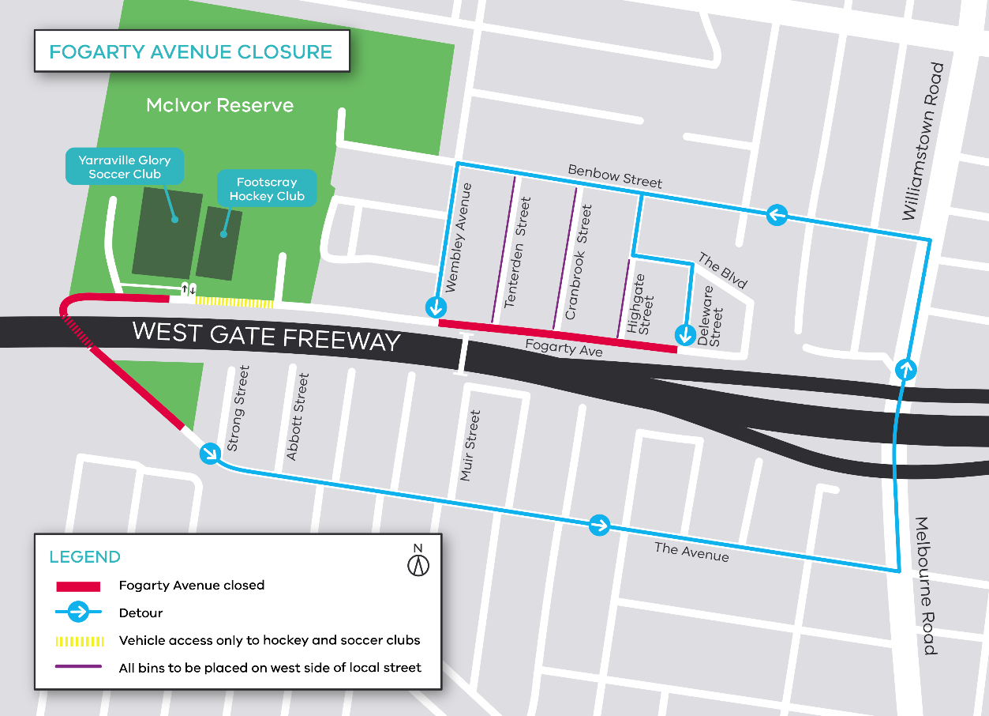

Please note that works may be rescheduled in the event of bad weather or other unavoidable circumstances.
For updates and more information about our works please visit westgatetunnelproject.vic.gov.au or contact us using the details below.

Contact us
Please contact us if you have any questions or feedback about these works.
 | westgatetunnelproject.vic.gov.au |  | facebook.com/westgatetunnelproject
 | info@wgta.vic.gov.au |  | @westgatetunnel
 | 1800 105 105 |  | West Gate Tunnel Project  GPO Box 4509  Melbourne Victoria 3001
 | Interpreter service: 13 14 50

