Reference: WES1907.03
2 July 2019
Works update – temporary driveway disruption

The safe undergrounding of the existing overhead power lines along Paringa Road is nearly complete. For the next stage of works, Paringa Road will be closed to vehicles from Tuesday 9 July until Saturday 27 July while the power poles and overhead power lines are removed. We will also install temporary noise walls along Paringa Road during this time.
Temporary disruption to your driveway access
Vehicle access to your driveway will be blocked from Tuesday 9 July until Saturday 27 July.
During this time:
- vehicle access to the works area on Paringa Road and driveway access will be blocked
- you will need to park your vehicle in a neighbouring street and walk to your property
- footpath access to your property will remain open at all times, and
- the carpark behind the 16 shops will remain open but access will be temporarily relocated to Langshaw Street.
If you require any assistance with carrying items to or from your vehicle during the day, please ask one of our friendly onsite team who will be able to assist you.

When you need to move your vehicle:
- please move your vehicle out of your driveway by 10pm on Monday 8 July 2019 if you wish to use it during the works.

Where to park your vehicle when driveway access to your property is blocked:
- it is recommended you park your vehicle nearby in a neighbouring street if you wish to use it during the closure period.

Waste collection changes:
- while Paringa Road is closed, please place your rubbish bins on the east side (the Millers Road side) of Lee Street, Bond Street, Chambers Road or Langshaw Street so they can be collected by the waste contractor
- please ensure your bin is moved by 11pm on Tuesday nights while the works are underway for collection by Council early on Wednesday mornings.

Longer term traffic changes
After the power poles and overhead power lines have been removed and the temporary noise wall is installed, Paringa Road will be reduced to one-way traffic from east to west until the new permanent noise wall is built. There will be no stopping on Paringa Road, but the footpath will remain open.

Construction of the permanent noise walls is expected to begin in August 2019. More information about this will be provided closer to the time.
What you could expect:
- an increase in construction vehicles within the area
- an increase in construction noise during the day from our machinery and trucks
- water spray trucks to help manage dust and dirt and loads will be covered when dirt and rock are being transported.

These works will generally be carried out from Monday to Friday between 7am - 6pm and Saturdays between 7am - 1pm. However, some night works might be required. If works are scheduled out of hours or if you are located close to the works, we will provide you with further information before the works start.

Please note that works and timings may change in the event of bad weather or other unavoidable circumstances.
For updates and more information about our works please visit westgatetunnel.vic.gov.au or contact us using the details below.

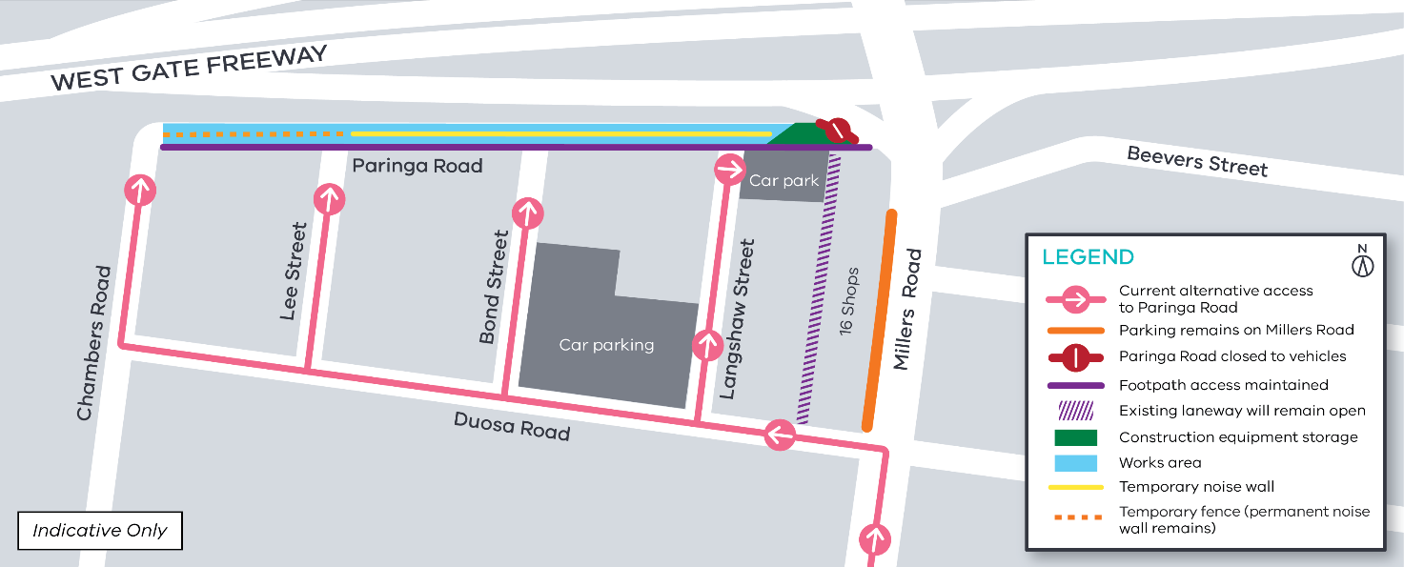

Contact us
Please contact us if you have any questions or feedback about these works.
 | westgatetunnelproject.vic.gov.au |  | facebook.com/westgatetunnelproject
 | info@wgta.vic.gov.au |  | @westgatetunnel
 | 1800 105 105 |  | West Gate Tunnel Project  GPO Box 4509  Melbourne Victoria 3001
 | Interpreter service: 13 14 50

Thank you
We appreciate our work can be disruptive and we thank you for your understanding and cooperation.

