24 February 2020 WES2002.03

Notification: Noise wall installation update
for the area north of the West Gate Freeway from Williamstown Road to the Newport Rail Bridge
The West Gate Tunnel Project includes building 9km of new noise walls for quieter homes, backyards and parks along the West Gate Freeway.
The new noise walls will be around eight to nine metres high and will be made of textured concrete panels with pale blue and green acrylic panels at the top in some sections to allow light to pass through.
As well as being more attractive, the new noise walls will provide you much better protection from freeway noise than the old noise walls. In some locations, there will also be new noise walls where there were none. They have been designed to achieve a daytime average noise level of 63dB(A) at nearby homes, which will mean a significant reduction in noise levels for many residents. Where space permits, planting will also be used to screen the noise
Our original construction program meant that, by now, we expected to be approximately half way through the installation of the new noise walls along the freeway. Unfortunately, due to complex and varied reasons, including the removal of utilities and the later-than-expected delivery of concrete panels, the installation program is delayed.
We will continue to construct noise wall piles, posts and panels wherever possible and as these work areas are made available.

Updated timeline
Area | Piles | Posts | Panels
Williamstown Road to Highgate Street | Completed | 50% complete. Remaining TBC | Date to be confirmed
Highgate Street to Muir Street overpass | Completed | Completed | Expected completion by March 2020
Muir Street overpass to Newport Rail Bridge | Expected completion by end February 2020 | Expected completion by end of April 2020 | Date to be confirmed
In the area north of the West Gate Freeway from Williamstown Road to the Newport Rail Bridge, our expected timeline is outlined in the table below. Please note that this schedule is subject to change.

Come and see us
We will be in your area to discuss noise walls and other project topics.
You are welcome to call by to chat with the team.

Date: Friday 28 February
Time: 3:30pm to 6:30pm
Location: McIvor Reserve, Yarraville

We look forward to seeing you there! Or, if you’d like us to visit you, just let us know; our contact details are on the next page.
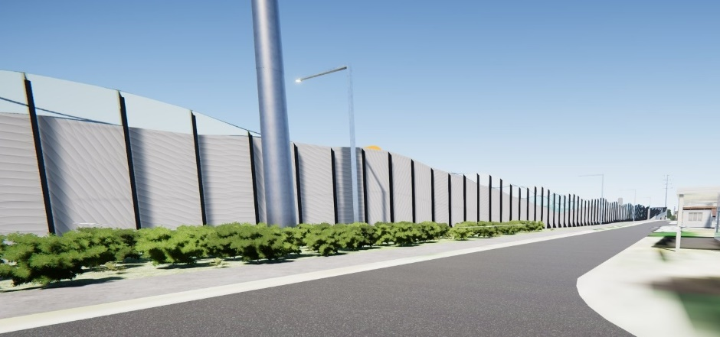
Indicative image of noise walls at the intersection of Fogarty Avenue and Highgate Street looking west

How noise walls are built
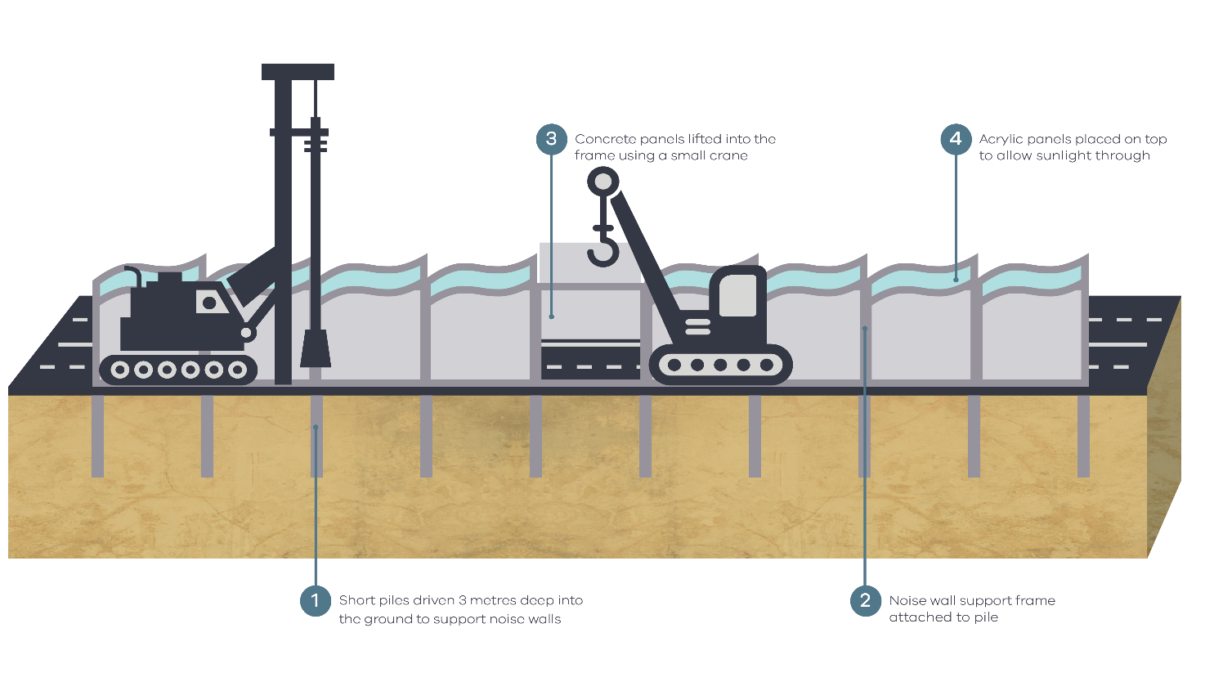

Thank you
We appreciate our work can be disruptive and thank you for your patience and cooperation.
The latest traffic updates are available at bigbuild.vic.gov.au/disruptions

westgatetunnelproject.vic.gov.au info@wgta.vic.gov.au
1800 105 105
West Gate Tunnel Project Info Centre Corner of Somerville Rd and Whitehall St Yarraville VIC 3013

Follow us on social media Please contact us if you would like this
information in an accessible format.

Translation service – For languages other than English, please call 13 14 50.

