1 June 2020 WES2006.01

Works notification: Temporary access changes to Beevers Street

Works to relocate a water main and rebuild a traffic island located across the entrance of Beevers Street is due to begin on Friday 12 June and will continue for four weeks, until Monday 6 July 2020.
Vehicle access to Beevers Street from Millers Road will be closed continuously for four weeks. A signed detour will be in place for drivers to access Beevers Street, Michael Court and Wally Court via the Italian Social Club land from Kyle Road. There will be no disruption to car parking and no impact on driveways during this time.
Pedestrians and cyclists will be able to access Beevers Street from Millers Road using the footpath on the southern side of the street, which will remain open.
The outbound exit ramp from the West Gate Freeway to Millers Road will be closed for one week during the works, and Millers Road southbound lanes will also be closed intermittently to provide additional room to complete works safely.
Works include:
- lowering the existing water main at the entrance of Beevers Street
- completing drainage works from the Millers Road outbound exit ramp and connecting to the existing network
- completing kerb, pavement and electronic traffic systems works for the Millers Road outbound exit ramp
- demolishing the existing traffic island and constructing a new traffic island on Beevers Street.

What you can expect to see and hear:
- construction vehicles using Beevers Street
- noise and vibration near the work area
- minimise dust by using water spray trucks, and covering dirt and rock while being transported
- night works may be required, which at times may be noisy.

Works area

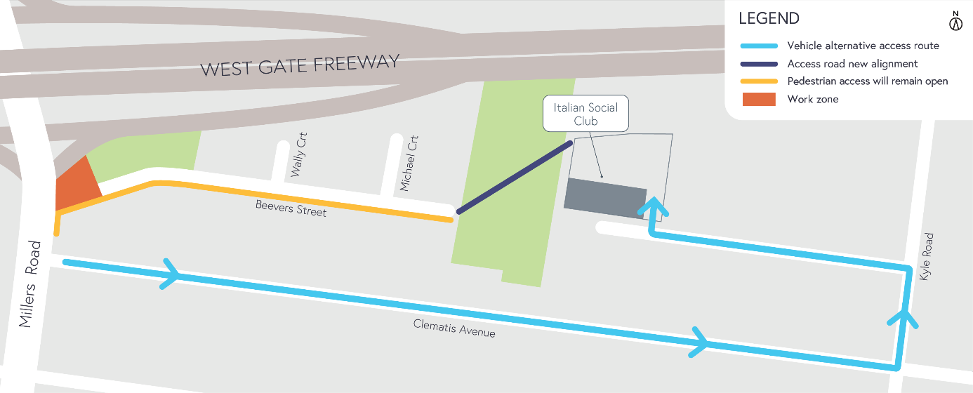
Hours of work
Our usual hours of work are Monday to Friday between 7am-6pm, and Saturdays between 7am-1pm. However, night works are sometimes required. When works are scheduled out of hours, or if you are located close to the works, we will provide you with further information before the works start.

Coronavirus COVID-19 update
The health and safety of our workers is our key priority as we continue to deliver the West Gate Tunnel Project, as is supporting physical distancing measures in line with current health advice. We have strict protocols in place to protect the safety of our construction workforce and the community. These include enhanced industrial cleaning arrangements and measures to reduce staff contact including staggered shifts and physical distancing. For more information and advice about Coronavirus, please visit coronavirus.vic.gov.au.

Thank you
We appreciate our work can be disruptive and thank you for your understanding and cooperation, particularly during these unprecedented and challenging times.

Please note that works are subject to change and may be rescheduled in the event of unexpected impacts to the construction program. Thank you for your patience during these works.

For updates and more information about our works, please visit westgatetunnelproject.vic.gov.au or call us on 1800 105 105.

