21 April 2020 WES2004.04

Works notification: West Gate Freeway from Williamstown Road to Newport Rail Bridge
Work is progressing on both sides of the West Gate Freeway between Williamstown Road and The Avenue, with the recent completion of piling along the outbound carriageway.
There is a lot more work that needs to be completed in this area including laying pavement, installing new noise wall panels, and widening and strengthening the Newport Rail Bridge.
Below is a summary of the activities you can expect to see in the area between May and August 2020.
- widening works along both sides of the West Gate Freeway
- installation of noise wall posts and panels along both sides of the West Gate Freeway
- widening and strengthening of the Newport Rail bridge
- constructing the new elevated shared use path east of Fogarty Avenue
- widening northbound lanes of Williamstown Road.

There may also be extended closures of freeway ramps and lanes. For the latest traffic details, visit our website westgatetunnelproject.vic.gov.au.

Williamstown Road outbound entry ramp
Early May
We will soon complete upgrading the new Williamstown Road outbound entry ramp by placing asphalt to create pavement for the new traffic lanes.
This will involve day and night works and include:
- minor excavation and building new ramp pavement
- installing new drainage pipes
- placing new asphalt along the ramp
- placing new concrete barriers along the ramp
- new line marking on the ramp.
There will be night works on the weekend starting Friday 1 May 2020 for these works.

Williamstown Road upgrade
Ongoing
Upgrade works on Williamstown Road are ongoing and include widening of the northbound carriageway, installing new drainage pipes and building new pavement along the western shoulder of the Williamstown Road.

The pedestrian detour on the east side under the bridge will remain in place while these works are underway. The new signalised crossing at the Williamstown Road inbound entry ramp is also now in place.

Freeway widening and noise wall installation

May – ongoing

We’re continuing to widen the freeway and replace the existing noise walls along the freeway.
This will include:
- installing noise wall posts and panels
- installing new drainage pipes
- laying new pavement
- concrete works to build retaining and noise walls
- installing concrete barriers
- upgrading electronic traffic systems including installing cables and replacing light poles and traffic lights.

Newport Rail Bridge

Ongoing until 2021
Ongoing activities to widen and strengthen the freeway bridges that pass over Newport Rail and The Avenue include installing bridge beams, replacing bridge bearings and pouring concrete.
We’re also building the remaining two bridge piers for the new outbound separated lanes. Traffic management will be in place along Fogarty Avenue/The Avenue until late 2020 while these piers are built.
Night works will be required from April through to August 2020 for these works. When works are scheduled out of hours, or if you are located close to the works, we will provide you with further information before the works start.

Traffic changes to Fogarty Avenue and The Avenue
Local traffic will be able to use The Avenue to access the south and north sides of the freeway from the end of April 2020. Traffic management will continue to be in place on The Avenue and underneath Newport Rail Bridge, throughout 2020 and 2021.
This section of road will also experience intermittent road closures during this time. Please visit westgatetunnelproject.vic.gov.au for road closure dates. You can also subscribe to weekly traffic alerts by emailing us at info@wgta.vic.gov.au.
Changes to bus route 432 are still in place and will continue in the first half of 2020. More information can be found on Public Transport Victoria’s website at www.ptv.vic.gov.au/live-travel-updates.

Fogarty Avenue shared use path

May - ongoing
Construction of a new shared use path (SUP) bridge for pedestrians and cyclists near the reserve at the east end of Fogarty Avenue will get underway in May. The new bridge will extend the Federation Trail and connect with the shared use path on the Hyde Street inbound ramp, as part of delivering more than 14 kilometres of new and upgraded paths, making it safer and easier for more people to walk or cycle.
While this work will take place within our existing construction site, the space required for the works will mean the ongoing closure of the shared use path that runs over Stony Creek and through the reserve on the east side of Fogarty Avenue.
This will include:
- piling to support the new SUP bridge
- constructing piers to support the new SUP bridge
- formwork and concrete pours to create the SUP bridge deck.

Inbound southern tunnel portal

Ongoing
The roof for the inbound southern portal will continue to be constructed through April with further concrete beam installation, steel fixing and concrete placement to the tops of the beams. Foundation works will also continue with ground anchoring, soil nailing and preparation works for piling over the next couple of months.
Installation works will be carried out during the day. However, the large oversized deliveries for the beams will arrive to site at night to minimise traffic disruption. Works at night are not expected to be noisy.

Hours of work
Our usual hours of work are Monday to Friday between 7am-6pm, and Saturdays between 7am-1pm. However, night works are sometimes required. When works are scheduled out of hours, or if you are located close to the works, we will provide you with further information before the works start.

Coronavirus COVID-19 update

The health and safety of our workers is our key priority as we continue to deliver the West Gate Tunnel Project, as is supporting physical distancing measures in line with current health advice. We have strict protocols in place to protect the safety of our construction workforce, including enhanced industrial cleaning arrangements, and measures to reduce staff contact, including staggered shifts and physical distancing. For more information and advice about Coronavirus, please visit coronavirus.vic.gov.au
What to expect during these works:
- work will be completed behind safety barriers
- construction vehicles including excavators, rollers, piling rigs, water trucks and concrete trucks will be moving in and out of the work areas via our access routes
- construction noise from work activities including machinery and trucks. Vibration might be experienced as we lay new pavement using a roller
- trucks and vehicles continuing to enter and exit our construction sites via local roads
- water spray trucks and road sweepers will be used to manage dust and dirt during works. Trucks removing dirt and rock from the site will be covered
- traffic changes including ramp, lane and road closures will be required. Signed detours will be in place.
For the latest updates visit westgatetunnelproject.vic.gov.au/traveldisruptions.

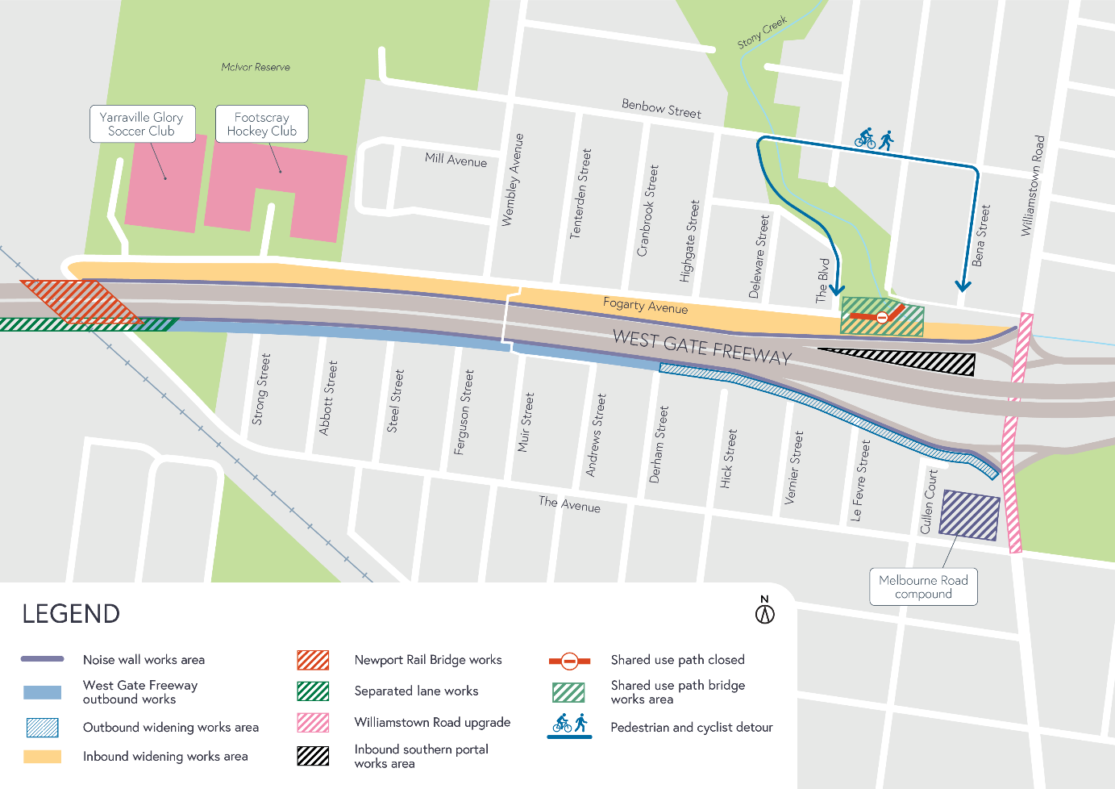
Works area

Please note that works are subject to change and may be rescheduled in the event of unexpected impacts to the construction program. Thank you for your patience during these works.
For updates and more information about our works please visit westgatetunnelproject.vic.gov.au or call 1800 105 105.

