27 August 2020 WES2008.04

Works notification: Local road changes
The West Gate Tunnel Project is carrying out the next phase of works until early October 2020 in and around the Millers Road interchange.

There are extended closures of the Millers Road inbound exit and entry ramps, as well as a four week closure of Millers Road under the freeway.

As part of these works, there will be localised impacts to your area, including some local road closures and changes from 9pm, Friday 4 September to 5am, Monday 5 October.
- Cypress Avenue will be closed in the eastbound direction towards Millers Road. This is because there is a U-turn on Millers Road and we cannot provide a safe exit during these works. Please exit via Nolan Avenue
- Primula Avenue is closed at Millers Road as there are extensive footpath and kerb works that cannot be completed safely without this closed. Detour via Burgess Street and Geelong Road
- Beevers Street direct access from northbound Millers Road lanes is closed. Access is maintained from the Millers Road outbound exit ramp
- Beevers Street can also be accessed via Marigold Avenue and the Italian Social Club during these works
- Traffic exiting from Beevers Street onto Millers Road will not be impacted
- Walking and cycling access will be maintained on Millers Road under the freeway. Please be mindful there will be construction activity underway and to follow signs and directions from anyone on-site.

Detour map
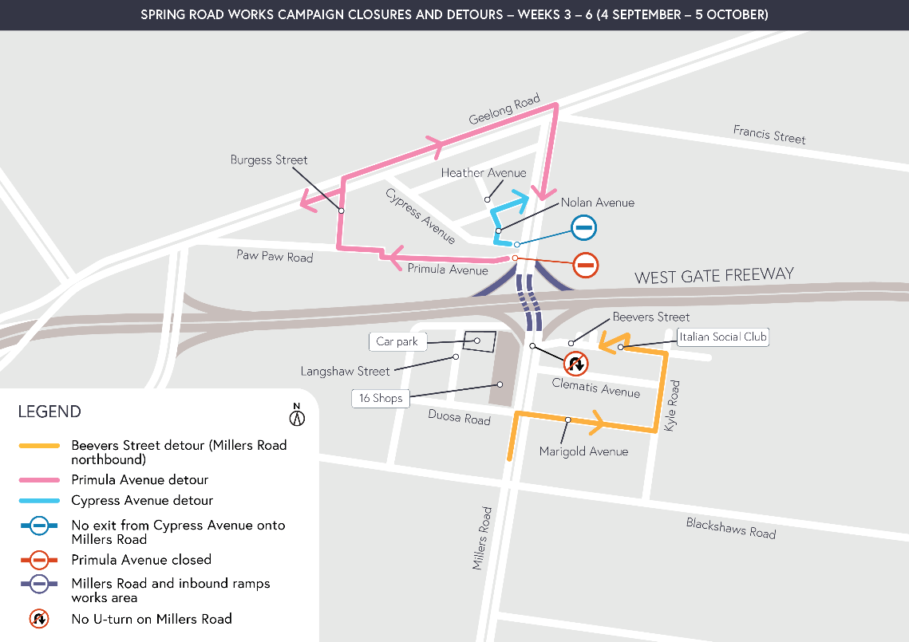

Access to 16 Shops
Some shops within the 16 Shops group will be open on Millers Road during this time. As Paringa Avenue is closed at Millers Road, please park at the rear of the shops via Duosa Road and Langshaw Street to avoid needing to get onto the freeway when you exit.

Hydro blasting
Millers Road hydro-blasting, noisy work using high-pressure water jets to remove concrete, will be completed in late September for a period of nine days. We will be completing these works during daytime hours to minimise impacts to local residents.

What you can expect during these works:
- additional traffic on local roads in the area, so allow more time for your journey
- completing disruptive or noisy activity during the day, seven days a week. While most of the work will be done during the day, at times you might notice some increased noise at night when works are scheduled out of hours. We will provide you with further information when this happens
- walking and cycling detours will be in place through the work site. Please follow the signed detour and be guided by instructions from traffic controllers on site
- dust and dirt will be minimised by using water spray trucks, street sweepers, and covering dirt and rock when it’s transported.

Hours of work
Throughout this construction campaign, we will work seven days a week from 7am to 6pm to complete as much work as possible. At times night works will be required. When works are scheduled out of hours and you are located close to the works, we will provide you with further information by email or phone calls before work starts. Details on how to register with us are below.

Coronavirus COVID-19 update
The health and safety of our workers is our key priority as we continue to deliver the West Gate Tunnel Project, as is supporting social distancing and the wearing of masks in line with current health advice. We have strict protocols in place to protect the safety of our construction workforce and the community. These include enhanced industrial cleaning arrangements, and measures to reduce staff contact, including staggered shifts and physical distancing. For more information and advice about Coronavirus, please visit coronavirus.vic.gov.au.

Sign up to get construction updates for your area directly to your inbox
To maintain safety under Stage 4 restrictions our team has temporarily paused door knocking, and letterbox dropping, notifications and reminders. During this time, we will contact impacted residents via phone and email.
If you would like to sign up to construction updates via phone or email, you can scan the QR code, email us on info@wgta.vic.gov.au or call 1800 105 105.
You can also stay up to date on the latest traffic disruptions by visiting bigbuild.vic.gov.au/disruptions and the latest construction notifications at westgatetunnelproject.vic.gov.au/construction/work-notifications
Please note that works sometimes need to be rescheduled in the event of bad weather or other unavoidable circumstances. For updates and more information about our works, please visit westgatetunnelproject.vic.gov.au or call us on 1800 105 105.

