22 January 2021 WES2101.01

Works notification: Williamstown Road interchange and Hyde Street Ramps
Work on the new Hyde Street Ramps is progressing, with a range of activities set to start on the Williamstown Road and West Gate Freeway interchange over summer and through to mid-2021.
As works continue, below is a summary of what you can expect to see in the area:
Williamstown Road and West Gate Freeway piling works
Early-February through to April 2021

establishing a new worksite on Williamstown Road, including placement of temporary traffic barriers, removing the existing traffic island and carrying out service investigations from early February
- drilling six piles on Williamstown Road – three each on the north and south sides of the freeway. These works are expected to take approximately two weeks to complete, starting late-February. These works will be carried out at night as we need to close traffic lanes to allow the work to be done safely
- putting in protection around the new piles and existing bridge piers, including installing permanent barriers
- during these works, Williamstown Road will be closed in both directions as required (under the West Gate Freeway) from 9pm to 5am. Fully signed detour routes will be in place during the road closure. For latest updates, dates of closures and detour route information visit: bigbuild.vic.gov.au/disruptions

New Hyde Street ramp – north side of the freeway, including elevated shared use path:
This ramp on the northern side of the freeway will provide a new exit ramp for inbound traffic from the West Gate Freeway to a new signalised intersection at Hyde Street.
- progressing works on the access track for our construction vehicles and working platform within the West Gate Golf Course and at the Williamstown Road inbound entry ramp
- commencing piling and bridge substructure works including pile caps, columns and crossheads at Williamstown Road inbound entry ramp and West Gate Golf Course
- progressing bridge substructure works including pile caps, columns and crossheads between Hyde Street and the Williamstown rail line continuing until late 2021
- relocating the overhead gantries above the Williamstown rail line
New Hyde Street ramp – south side of the freeway:
This ramp on the southern side of the freeway will provide a new entry ramp for outbound traffic from a new intersection at Simcock Avenue and Stephen Street through to the West Gate Freeway
- progressing bridge substructure works including pile caps, columns and crossheads at the Williamstown Road inbound exit ramp and next to Donald McLean Reserve
- commencing piling and bridge substructure works including pile caps, columns and crossheads at Hall Street and next to former Socobell site
- relocating the overhead gantries above the Williamstown rail line

Shared use path bridge – Hyde Street Reserve:

piling and concrete works in the Hyde Street Reserve and Hughes Street continues for the shared use path bridge over Stony Creek

Hours of work

Our usual hours of work are Monday to Friday between 7am-6pm, and Saturdays between 7am-1pm. However, for a number of the works outlined in this notification night works will be required. When works are scheduled out of hours and if you are located close to the works, we will provide you with further information before the works start.

Traffic impacts

As mentioned, we will need to close Williamstown Road nightly in both directions (under the West Gate Freeway) from 9pm to 5am. On-road signs will be in place to advise of detours and work zone speed limits on the freeway will be enforced. For latest updates, dates of closures and detour route information visit: bigbuild.vic.gov.au/disruptions

What to expect during these works:
- work will be completed behind safety traffic barriers
- construction vehicles including excavators, rollers, piling rigs, water trucks and concrete trucks will be moving in and out of the work areas via our access routes
- construction noise, including intermittent short term noise at night, from work activities including machinery and trucks. Vibration may be experienced from piling works
- water spray trucks and road sweepers will be used to manage dust and dirt during works. Trucks removing dirt and rock from the site will be covered
- traffic changes including lane and road closures will be required. Signed detours will be in place.

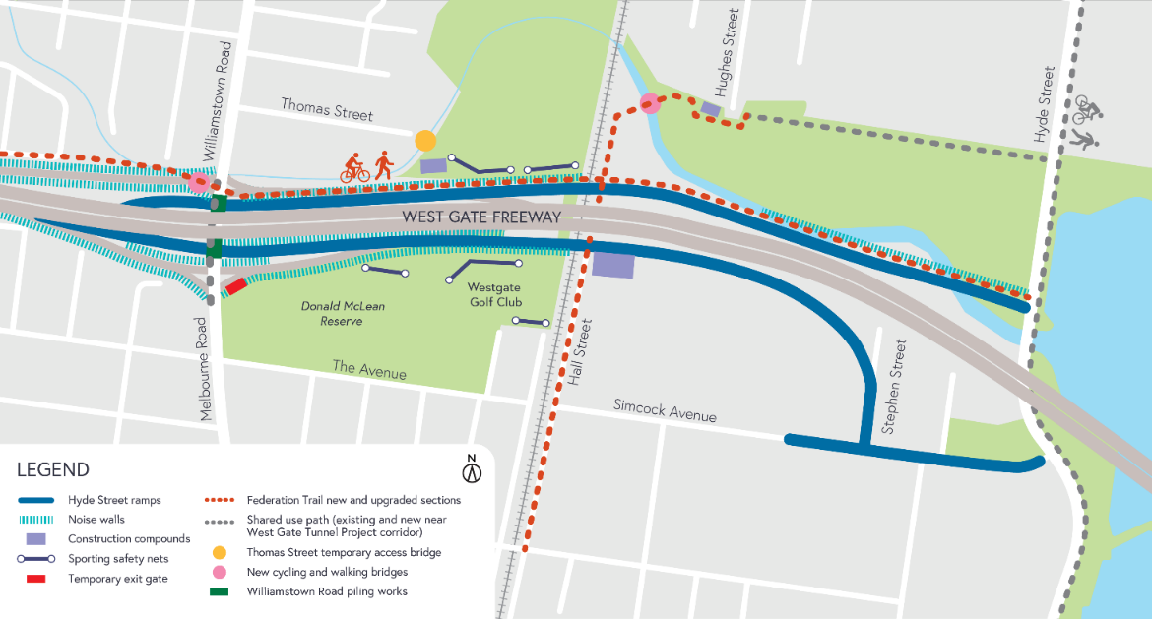
Work area:

Please note that works are subject to change and may be rescheduled in the event of unexpected impacts to the construction program. Thank you for your patience during these works.

For updates and more information about our works, please visit westgatetunnelproject.vic.gov.au or call us on 1800 105 105.

