6 November 2020

Works update: Maribyrnong River Crossings & Footscray Road

Maribyrnong River

Bridge works are progressing along the Maribyrnong River with ongoing piling works, pier and crosshead construction taking place on the west and east bank of the river. Construction along Mackenzie Road, Sims Street and Dahlenburg Street are also continuing to progress for the future Port access from the West Gate Tunnel and Footscray Road elevated roadway.

Pier and crosshead construction
Construction of the permanent pier construction is ongoing in the Maribyrnong River and marine piling for temporary structure supports will continue into November.
Pier and crosshead construction (roadway support structure) is ongoing on the west bank of the river.

Works along Mackenzie Road have made significant progress with pier and crosshead construction taking place along Sims Street.
The Dahlenburg Street diversion is scheduled to be implemented in early November, allowing the elevated road construction works to take place on Mackenzie Road throughout November.
When: November 2020. These works will be completed during the day between 7am and 5pm and some nights between 7pm and 5am.

Piling and pile cap works
Piling and pile cap (bridge foundation) construction is ongoing on the west bank of the Maribyrnong River including Maribyrnong Street and piling works are taking place adjacent to Billy Button Creek.
Bored piling commenced at Billy Button Creek in mid-October for a period of five weeks and is scheduled to finish in late November.
When: November – December 2020. These works will be completed during the day between 7am and 5pm and some nights between 7pm and 5am.

Gas relocation works
Gas relocation works along the southern end of Maribyrnong Street (towards Lyons St) are scheduled to recommence in November to be completed by the end of December 2020.
When: November – December 2020. These works will be completed during the day between 7am and 5pm.

Precast columns
Precast columns are set to arrive on site in early December for installation along Sims Street.
When: December 2020. These works will be completed during the day between 7am and 5pm and some nights between 7pm and 5am

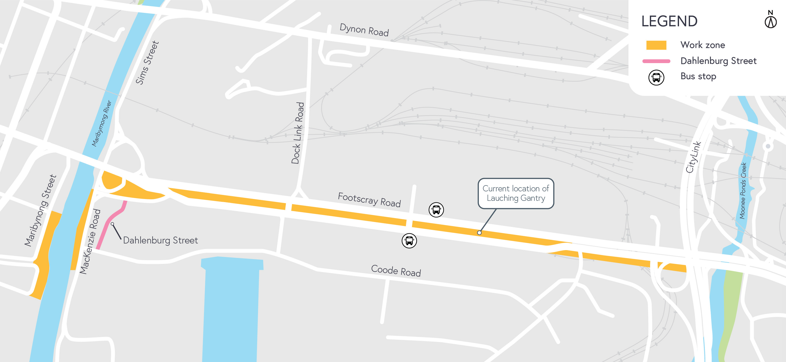

Footscray Road

Works are progressing to build the new elevated road above Footscray Road with ongoing piling works, pier erection and commissioning of the Launching Gantry taking place in the centre median. Works on the new shared use paths are also taking place near Moonee Ponds Creek and Docklands.

Launching Gantry
The launching gantry is now entering final stages of commissioning before starting to build all of the bridge spans. Once commissioning is complete, bridge span will progress heading west.
When: November – December 2020. These works will be completed during the day between 7am and 5pm and some nights between 7pm and 5am.

Bridge construction
Piling for the bridge foundations will re-commence in the centre median of Footscray Road in November and continue to the end of this year.
Bridge foundation pile cap construction also continues and the construction of bridge portal beams (roadway support structures) at the western end of Footscray Road has commenced and both activities will continue until the end of the year.
Following the installation of bridge columns between the Old Flower Market and Dock Link Road that took place in mid-October, the installation of concrete portals adjacent to Dock Link Road will take place from end November during night shift.
When: October – December 2020. These works will be completed during the day between 7am and 5pm and some nights between 7pm and 5am.

Drainage works
Drainage and pavement works are continuing along Footscray Road into November.
When: October – November 2020. These works will be completed during the day between 7am and 5pm and some nights between 7pm and 5am.

What to expect during construction
- Works completed both during the day and at night time
- We will notify you if there are any significant changes to the timing of our works
- Traffic management will be in place to manage changed conditions including temporary access
changes and signage to guide road users and cyclists
- Dust will be managed on-site with suppression methods
- Assessments have been conducted, which indicate the noise levels are expected to remain within permissible levels as documented in the project’s Environmental Performance Requirements.

Please note that works might need to be rescheduled in the event of bad weather or other unavoidable circumstances.

We thank you for your patience during these works.

westgatetunnelproject.vic.gov.au info@wgta.vic.gov.au
1800 105 105
West Gate Tunnel Project Info Centre Corner of Somerville Rd and Whitehall St Yarraville VIC 3013

Follow us on social media Please contact us if you would like this
information in an accessible format.

Translation service – For languages other than English, please call 13 14 50.

Authorised by the Victorian Government, 1 Treasury Place, Melbourne

