Chapter 22
Groundwater

Chapter 22

Groundwater
This chapter provides an assessment of the groundwater impacts associated with the construction and operation of North East Link. This chapter is based on the impact assessment presented in Technical report N – Groundwater.

Groundwater has multiple uses that benefit people and the environment. It is used for drinking water, irrigation, stock watering, industrial or commercial purposes and it supports ecosystems such as terrestrial vegetation, wetlands and waterways.
The construction and operation of North East Link has the potential to change groundwater levels and affect groundwater quality. The groundwater assessment for North East Link has investigated the potential for consequential impacts on human health, buildings and structures and the environment.
What is groundwater?
Groundwater is water beneath the earth’s surface. It is sourced from water that originates above the ground either from rainfall that has infiltrated into soil or rocks, or from surface water from rivers, streams and other waterways that has seeped into the subsurface.

The EES scoping requirements for North East Link set out the following evaluation objective:
- Catchment values – To avoid or minimise adverse effects on the interconnected surface water, groundwater and floodplain environments.
The groundwater impact assessment involved the investigation of the geological setting of North East Link, the groundwater conditions and the users of groundwater to understand how the project may change groundwater the potential impacts on human health, buildings, structures and the environment.
Other aspects relevant to the evaluation objective for groundwater include impacts related to contamination and soil, and to surface water. Assessments of these aspects are addressed in the following technical reports:
- Technical report O and Chapter 23 – Contamination and soil
- Technical report P and Chapter 24 – Surface water.

Method
Informed by the risk assessment described in Chapter 4 – EES assessment framework, the groundwater assessment comprised the activities summarised below:
- Relevant national, state and local legislation and policies were reviewed.
- A study area for groundwater was established, which included all land within two kilometres of the North East Link project boundary. The project boundary is shown in Chapter 8 – Project description.
- A desktop assessment was performed to characterise the existing geological and groundwater conditions and potential users of groundwater.
- Consultation occurred with local councils, relevant land owners and the catchment management authority Melbourne Water to obtain information relevant to the groundwater assessment.
- Field assessments were conducted, which involved installing a groundwater monitoring bore network, monitoring of groundwater levels, aquifer hydraulic testing (slug and constant rate pumping tests), and the collection and analysis of water samples to better understand the presence of groundwater within the study area.
- A numerical model to predict potential changes to groundwater from the project and to inform the assessment was developed. To address uncertainties inherent in numerical model parameters, 200 scenarios of the model were run, using different values of parameters that could meet the calibrated criteria (observed water levels, Yarra River base flows, and drawdowns recorded from the pumping test investigations).
- A risk assessment was conducted to prioritise the impact assessment and inform the development of controls.
- The potential groundwater impacts during the project’s construction and operation were assessed.
- Environmental Performance Requirements (EPRs) were developed in response to the groundwater impact assessment. The residual risk ratings and the assessment of impacts presented in this chapter assume implementation of the EPRs. Refer to Chapter 27 – Environmental management framework for the full list of the project EPRs.

Existing conditions
This section summarises the existing conditions of the groundwater study area.
The existing conditions assessment established the regional setting for the project considering contamination and soil (refer to Chapter 23 – Contamination and soil) and hydrology (refer to Chapter 24 – Surface water).
The key groundwater existing conditions have been characterised in terms of the following aspects:
- Geological setting
- Groundwater quality
- Groundwater levels
- Groundwater availability.

Geological setting
Changes in the groundwater setting due to the construction and operation of North East Link would most likely be associated with elements of the project that are constructed underground. The geological setting described in this report is therefore also focused on the elements of the North East Link project that would be constructed underground (between Watsonia railway station and the southern portal).

Geology

The geological setting described in this section focuses on the trench and tunnel section where the project would be underground, as shown in Figure 22-1 below.
The northern part of the project, including the trench, tunnel and northern portal, would be located above or within bedrock. The geology of the bedrock comprises sandstones, siltstones and shales. The project from the northern portal to the Manningham Road interchange would be mostly located within bedrock. South of the Manningham Road interchange, elements of the project would mostly be within alluvial sediments with some bedrock until near the southern portal, where the geology would consist primarily of alluvial sediments from the Yarra River and Koonung Creek floodplains.
Within the bedrock, groundwater is (mostly) transmitted through fractures, joints and other discontinuities within the rock mass. Within the alluvial sediments, groundwater is stored and transmitted through pore spaces of the sedimentary grains. This gives the bedrock a lower storage capacity than the alluvium sediments.
Where is groundwater located?
Groundwater is stored and transmitted through the tiny pore spaces between soil and rock particles, or cracks, fractures, and crevices within the rock itself. These saturated (water-filled) soils and rocks are classified into two basic types:
- Aquifers, which are geological materials such as unconsolidated sediments (gravel, sand or silt), permeable rock or fractured rock that can store and transmit large quantities of water.
- Aquitards, which are geological materials of low permeability that have a tendency to limit the flow of groundwater (such as clays and silts). Two aquifer systems exist in the vicinity of North East Link. These are Fractured Rock Aquifers or Bedrock Aquifer and Porous Media Aquifer also known as Alluvial Aquifer.

Topography and drainage
The bedrock forms undulating, rolling hills, which drop towards the Yarra River and its floodplain. The topography is highest around the M80 Ring Road (otherwise known as the Metropolitan Ring Road) at approximately 100 metres above sea level, while the Yarra River is at approximately 15 metres above sea level.
Drainage lines flow generally towards the Yarra River valley and its floodplain. Some of the larger drainage lines form permanent or seasonal waterways. A summary of waterway information is provided in Chapter 24 – Surface water.

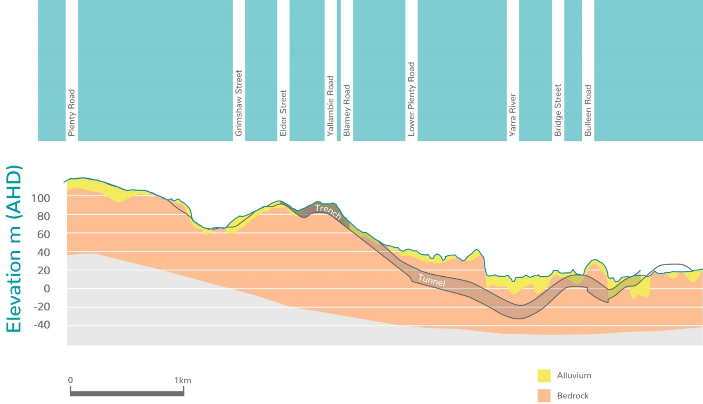
Figure 22-1 Geological setting around North East Link (trench and tunnel section)

Groundwater quality
This section summarises the groundwater quality around the project and identifies the factors that influence this quality.

Groundwater salinity in the region
Groundwater quality in the region may be influenced by the geological setting which for North East Link is broadly classified into either alluvial or bedrock aquifers.
Broad-scale mapping of groundwater salinity, represented as total dissolved solids (TDS), is shown in Figure 22-2.
Groundwater salinity around most of North East Link is approximately on average 2,700 mg/L TDS within the alluvial aquifer which reflects the interaction of waterways and shorter recharge pathways and classified generally within Segment B, but also can be within Segment A and C under SEPP (Waters). Within the bedrock aquifer, the groundwater salinity is on average 5,700 mg/L TDS and classified under Segment D. Higher salinity (Segment E) groundwater has been identified in some areas near the M80 Ring Road, the Eastern Freeway and around Simpson Barracks
Recent analysis undertaken for North East Link confirmed that groundwater salinity in the alluvial aquifer is lower than in the bedrock aquifer. This is because the alluvial aquifer has greater interaction with fresh surface water. The salinity levels in the study area are quite high overall, restricting the beneficial uses of the groundwater.

Contamination
Contamination around North East Link is described in Chapter 23 – Contamination and soil. The existence of groundwater contamination is relevant to the groundwater assessment because of the potential for groundwater changes due to the project to cause movement of the contamination.
Based on investigations to date, there is limited known groundwater contamination in the immediate vicinity of the North East Link alignment. Potential sources of contamination include land uses such as former landfills and historical industrial and commercial land use activities.
Groundwater impacting upon North East Link
Groundwater has the potential to impact on the integrity and lifespan of materials used to construct North East Link. The groundwater would mostly be from the bedrock aquifer which has elevated salinity, chloride, sulfate and hardness. This information would inform the selection of North East Link construction materials, based on their durability.

Eight landfills have been identified within the study area, however, only two are in areas that may experience changes in groundwater levels. These landfills are listed in Table 22-1.
Known areas of groundwater pollution have also been identified by EPA Victoria and are referred to as Groundwater Quality Restricted Use Zones (GQRUZ), although these are remote from the project’s construction areas.
Table 22-1 Sources of contamination in the vicinity to anticipated groundwater level changes
Sources of contamination in the vicinity of anticipated groundwater levels changes
Landfill | Borlase Reserve located north of Lower Plenty Road  Bulleen Park located under Bulleen Oval

Another area with the potential for contamination is the Bulleen Industrial Precinct. Based on the field investigations undertaken to date, contaminated groundwater has not been detected in the precinct, with the exception of petroleum hydrocarbons near the fuel service station at the intersection of Yallambie Road and Greensborough Road, and poly-fluoroalkyl substances (PFAS) at the former Bulleen Drive-in and near Watsonia railway station.

Acid sulfate soil and rock
Soils and rocks around North East Link that have the potential to generate groundwater with acidic conditions—are referred to as acid sulfate soil and rock. Stable, undisturbed, naturally occurring sulfidic soil and rock may generate acidic conditions when oxidised through exposure to oxygen during the project’s construction including excavation works, or from dewatering. Water and groundwater passing through acid sulfate soils and rock may adversely impact the receiving environment. Acid sulfate soil and rock is generally found in the following broad settings:
- Typically geologically young sediments near sea level
- Sediments and tidal lakes of marine origin, and estuarine sediments
- Coastal wetlands, mangroves and swamps
- Ligneous rich deposits
- Indurated sediments that may contain elevated concentrations of metal sulphides.
Of all these potential settings, the latter, found within the Bedrock Aquifer, have been identified as having the greatest potential to generate acidic conditions if the existing groundwater level changes.
However, based on the groundwater assessment for North East Link, the zones where water level changes are expected, are mostly in the upper parts of the aquifer where the geological materials have been weathered and subject to historical oxygenated conditions. This reduces the risk of groundwater generating acid sulfate conditions due to groundwater level changes.
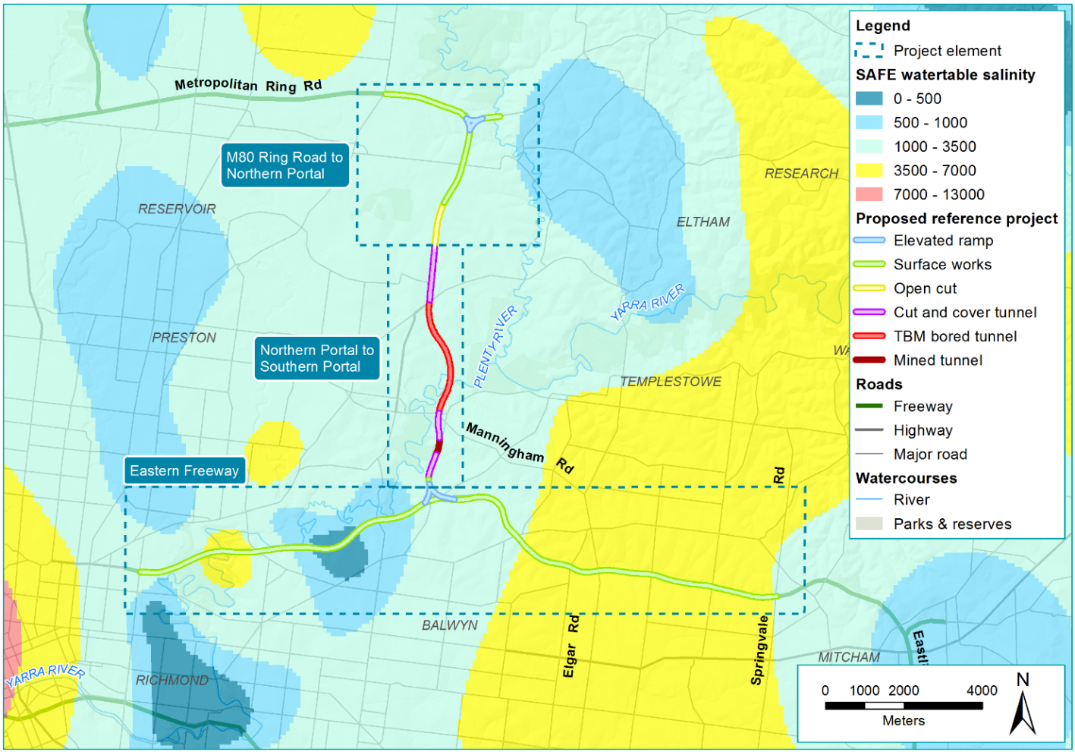
Figure 22-2 Groundwater salinity around North East Link

Groundwater levels
This section summarises the groundwater levels in the region and identifies the factors that influence groundwater depth and flow. The regional depth to groundwater is shown in Figure 22-3 below, and the water table, including regional flow on the in Figure 22-4 below which is generally towards the floodplains of the Yarra River

Groundwater depth in the region
Groundwater depth in the region around North East Link was determined based on a desktop review of existing information and measurements from groundwater monitoring bores installed for the project’s environmental assessment.

Around the M80 Ring Road and south to Lower Plenty Road, the of the depth to groundwater is greater than 10 metres below the ground surface with the exception of lower lying areas such as the Plenty River floodplain, north of Grimshaw Street and along the Hurstbridge rail corridor where groundwater is closer to the surface.
From the northern tunnel portal to the Eastern Freeway, the depth to groundwater is generally less than 10 metres below the ground surface. Within the Yarra River and Koonung Creek floodplains, the depth to groundwater can be less than five metres from the ground surface.
Around the Eastern Freeway, the depth to groundwater is generally five to 10 metres below the ground surface to the west of Bulleen Road, and potentially less than five metres below the ground surface to the east of Bulleen Road. The depth to groundwater within the floodplains of the Yarra River and Koonung Creek is even shallower.

Influences on groundwater level
Beyond geology and landform considerations, influences on groundwater levels may be natural or anthropogenic. Natural influences are broad scale and typically relate to seasonal variability of climate or drought conditions. Anthropogenic influences include groundwater extraction and the intervention of anthropogenic structures. Natural and anthropogenic influences are summarised in Table 22-2.
Table 22-2 Influences on groundwater level
Influence
Natural | Seasonal – Groundwater levels are influenced by rainfall. Water levels are highest in Winter and Spring when greater rainfall tends to occur, and lowest towards the end of Summer and Autumn. Information collected from the network of monitoring bores installed for the North East Link environmental assessment indicates an approximate seasonal variation of 1 to 1.5 metres between seasons.
 | Drought – Droughts such as the Millennium Drought (1996–2010) can have a significant influence on groundwater levels. While long-term groundwater level data does not exist in the North East Link study area, correlations with other parts of Melbourne indicate a drought influence of around three metres.
Anthropogenic | Abstraction – Groundwater resources can be developed for social and economic benefits. A review of groundwater information in the study area indicates there is limited groundwater use. It is suspected the saline groundwater that occurs in much of the study area would limit it uses.
 | Structures – Leaking water mains, sewers or stormwater drainage can influence local groundwater levels. Obvious influences from leaking structures on groundwater levels in the North East Link region have not been identified.

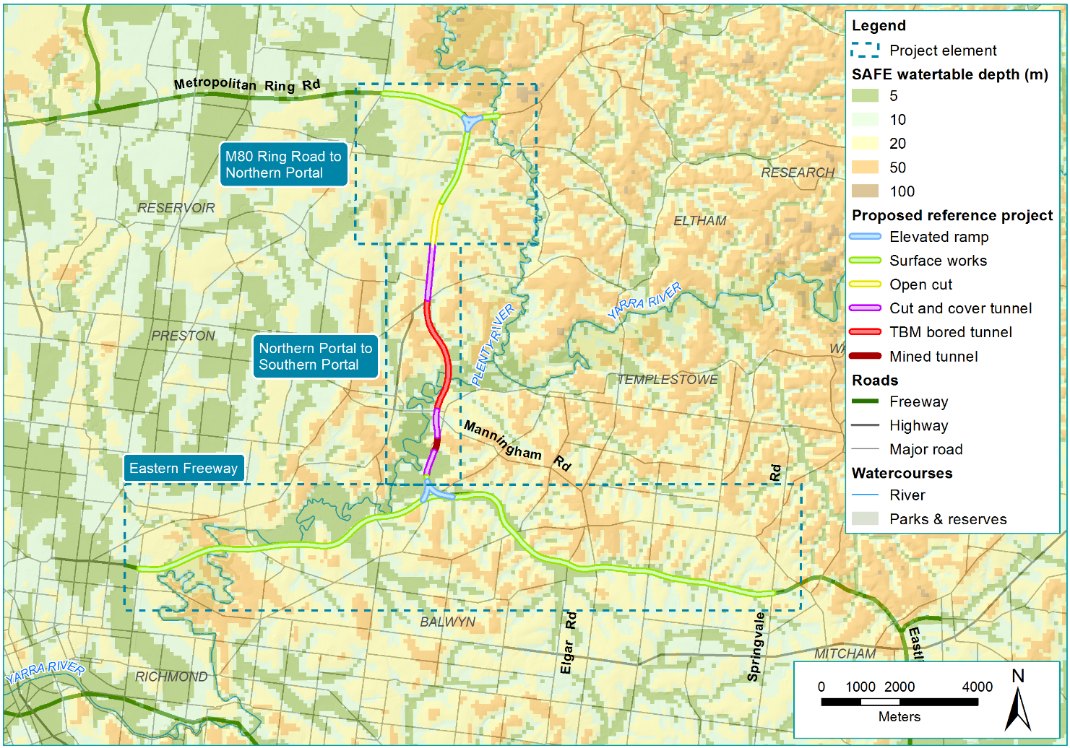
Figure 22-3 Existing depth to groundwater around North East Link
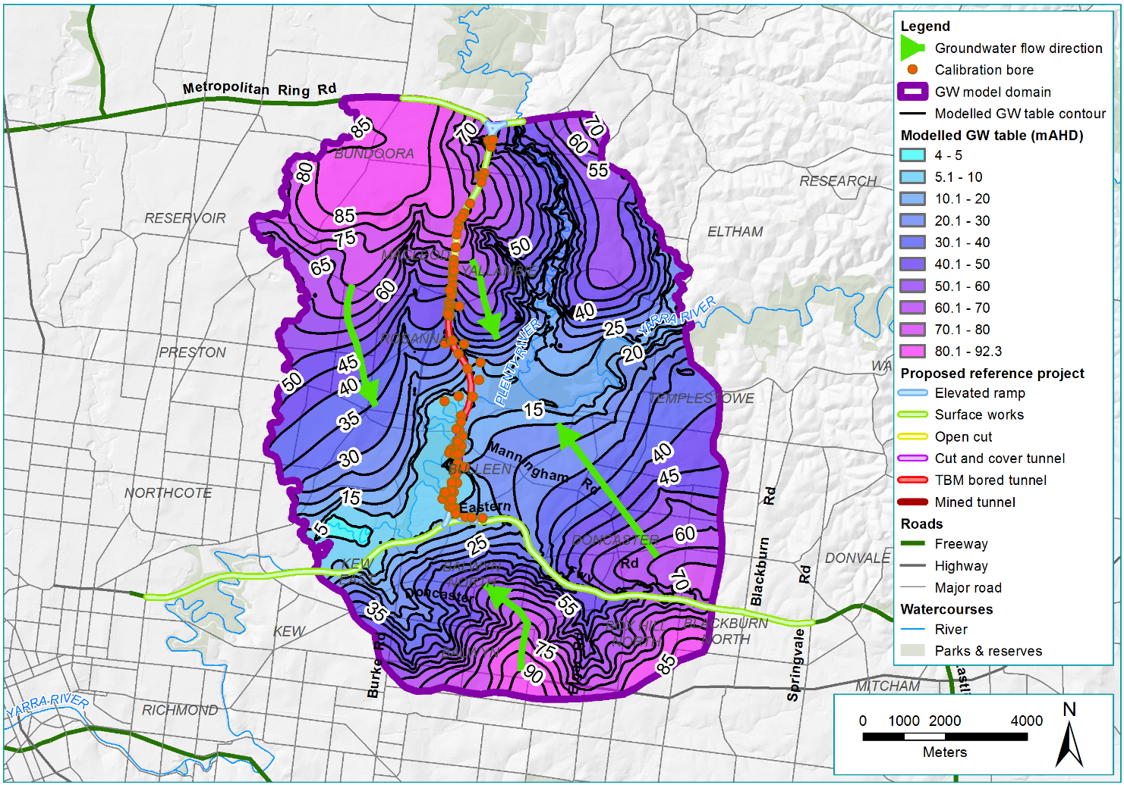
Figure 22-4 Water table, with regional flow, around North East Link

Groundwater availability
This section summarises the uses of groundwater resources in the vicinity of North East Link.

Groundwater as a resource for the environment
Groundwater dependent ecosystems are ecosystems which access groundwater to meet their water requirements.
The locations of groundwater dependent ecosystems around North East Link are shown in Figure 22-5 below.
Types of groundwater dependent ecosystems
Groundwater dependent ecosystems within the North East Link project boundary include:
- Surface expression of groundwater dependent
Surface systems, permanent or seasonal, such as rivers, creeks, swamps, lakes, wetlands and other systems that receive groundwater as a base flow.
- Subsurface expression of groundwater dependent
Terrestrial vegetation such as trees and woodlands that groundwater support seasonally or permanently. This vegetation may comprise shallow or deep-rooted communities that use groundwater to meet some or all their water needs.

Groundwater dependent ecosystems that depend on surface expression of groundwater include terrestrial vegetation such as swampy and grassy woodlands, and riparian vegetation in association with the following waterways:
- Yarra River, incorporating areas such as Banyule Swamp, Bolin Bolin Billabong and Kew Billabong
- Koonung Creek
- Plenty River
- Banyule Creek
- Salt Creek.
An assessment of groundwater dependent ecosystems that depend on subsurface expression of groundwater is provided in Chapter 25 – Ecology.

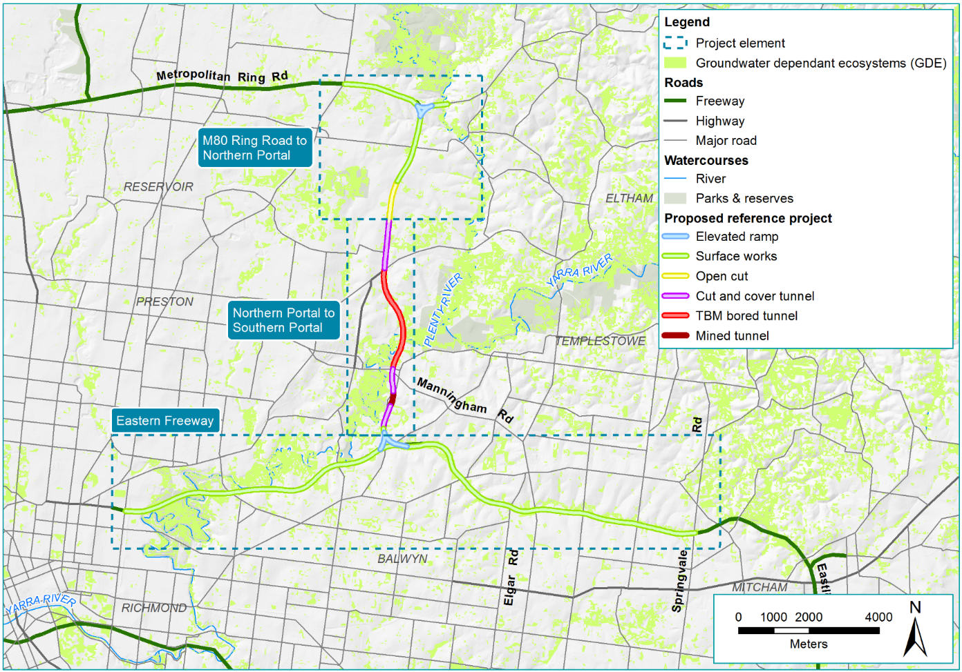
Figure 22-5 Groundwater dependent ecosystems around North East Link

Registered groundwater users
Information was obtained from the DELWP Water Management Information System, to identify and characterise groundwater uses in the region. There are 207 registered bores within one kilometre of the North East Link alignment in addition to those installed for the groundwater assessment. These are summarised by type of use in Table 22-3.
The bore locations are shown in Figure 22-6 below.
Table 22-3 Groundwater bore use within the project boundary
Registered use | Project element |  |  | Total
 | M80 Ring Road to northern portal | Northern portal to southern portal | Eastern Freeway
Groundwater investigation | 0 | 0 | 37 | 37
Stock and domestic | 0 | 3 | 4 | 7
Use not known | 11 | 9 | 52 | 72
Miscellaneous | 0 | 1 | 0 | 1
Irrigation | 1 | 0 | 0 | 1
Commercial | 0 | 1 | 0 | 1
Observation | 1 | 8 | 79 | 88
Total | 13 | 22 | 172 | 207

The majority of registered bores in the study area have been installed for groundwater investigation or groundwater observation purposes. The majority are suspected to be associated with environmental or contaminated land investigations. A large number are located at the western end of the Eastern Freeway.
Groundwater abstraction is relatively limited in the region for a number of reasons:
- The study area is within an urbanised, mostly residential setting, where potable water is readily available through a reticulation network
- The groundwater quality is generally brackish to saline which limits its use. For example, the salinity of the bedrock aquifer is generally too high to support irrigation
- Bore licensing requires a minimum set back distance of 200 metres from any waterway, lake or other extraction bore.

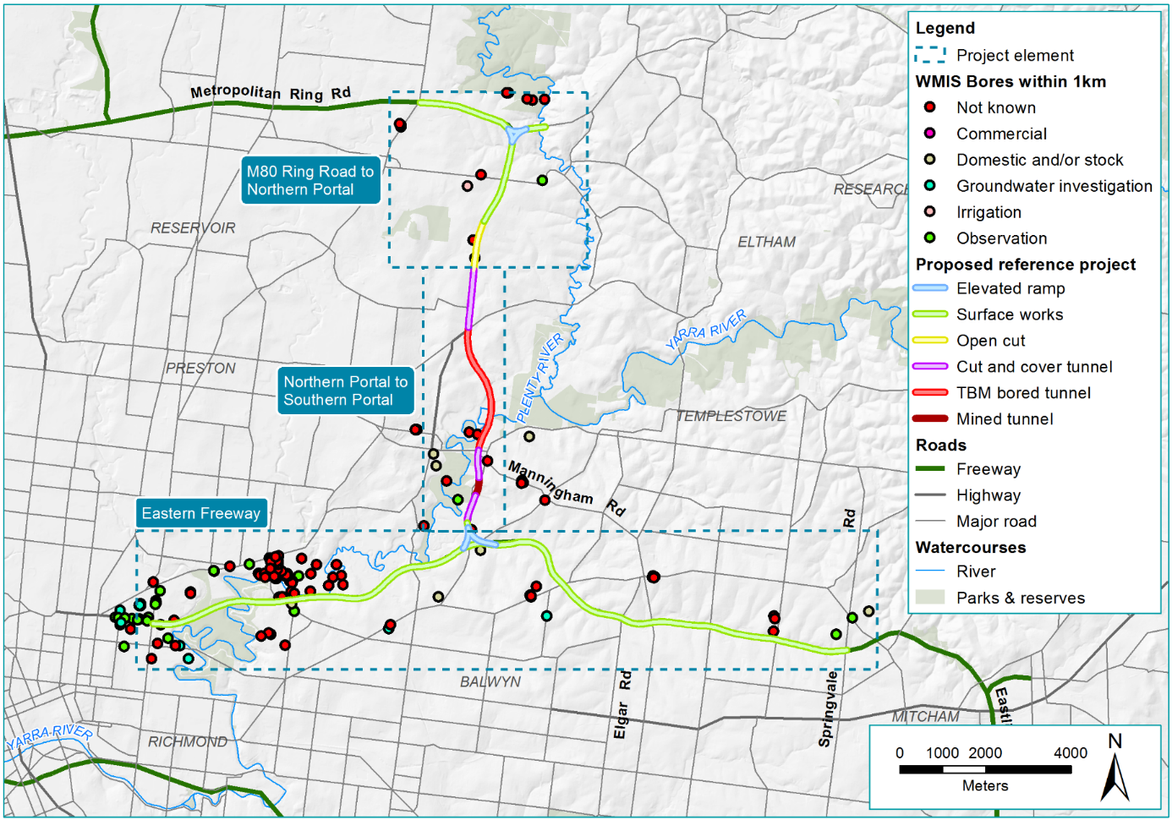
Figure 22-6 Location of groundwater bores around North East Link

Construction impact assessment

This section summarises the potential impacts of North East Link’s construction that relate to groundwater.
Construction works that intersect the groundwater table—particularly activities associated with tunnelling have the potential to impact on groundwater. Changes to groundwater levels from underground construction can reduce the availability of groundwater for existing users and groundwater dependent ecosystems.
Changes in groundwater levels and flow direction could also cause movement of existing contamination, relocating it to other places or cause subsidence and oxidation of acid generating materials.
The following sections discuss the predicted changes in the groundwater environment from the project and provide an assessment of the potential impacts on groundwater availability and quality. The assessment of implications for groundwater dependent ecosystems is provided in Chapter 25 – Ecology. The risks associated with the management of groundwater inflows during construction are examined in Section 22.3.4 below.
Describing groundwater level changes
Fluctuations in the water table occur naturally, through seasonal change, or may be human induced. Water level fluctuations may be described as:
- Groundwater ‘drawdown’ refers to the lowering of the water table from the existing groundwater level. In the context of this project, drawdown may occur from dewatering activities required to excavate structures below the water table, or groundwater seepage into structures located below the water table (which can occur to some degree even if the structures are tanked). It can also result from the extraction of groundwater for construction water supply purposes.
- Groundwater ‘mounding’ refers to the raising of the water table from the existing groundwater level. In the context of this project, mounding may occur due to structures that create a barrier to regional groundwater flow.

Predicted changes to groundwater during construction
The changes to groundwater levels from construction activities have been predicted using a numerical groundwater model. The model simulates the behaviour of groundwater, taking into account the properties of the aquifer, the design of the North East Link tunnels and their proposed construction methods and duration. Based on the modelling, the maximum extent of groundwater drawdown is predicted to occur as construction of the tunnels nears completion in 2024. The predicted change in groundwater level around the northern portal is shown in Figure 22-7. The predicted change in groundwater level around the southern portal is shown in Figure 22-8. The degree of groundwater level changes decreases with distance from the tunnels.
Groundwater levels would gradually reach a new equilibrium post-construction and once North East Link is operating. Section 22.4 describes how groundwater levels are expected to change during the project’s operation.

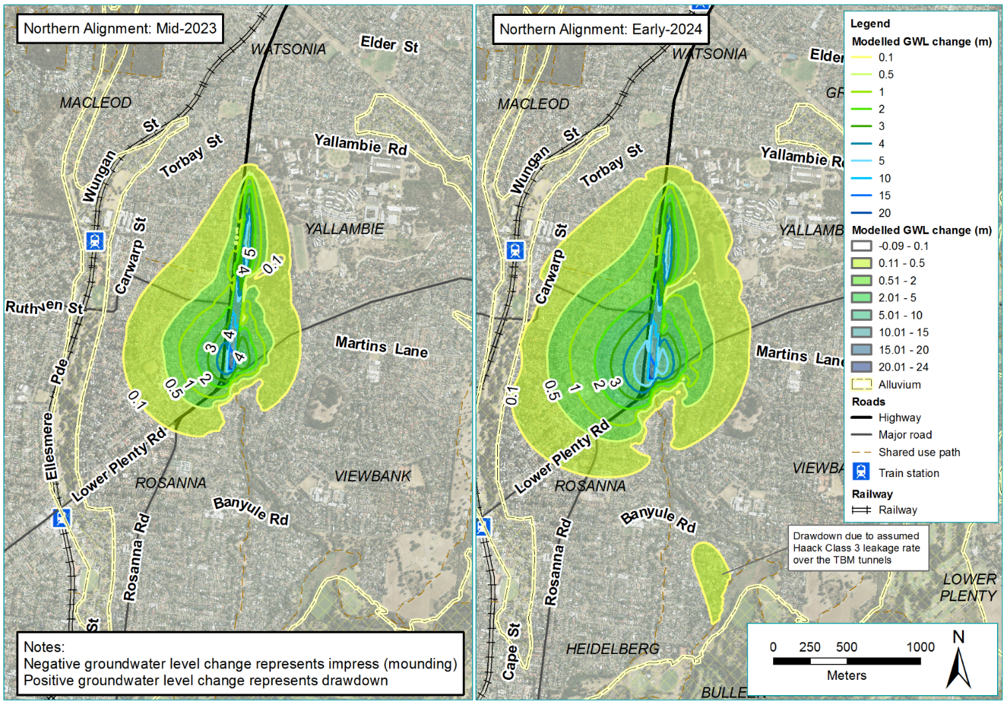
Figure 22-7 Predicted change in groundwater levels around the northern portal during construction
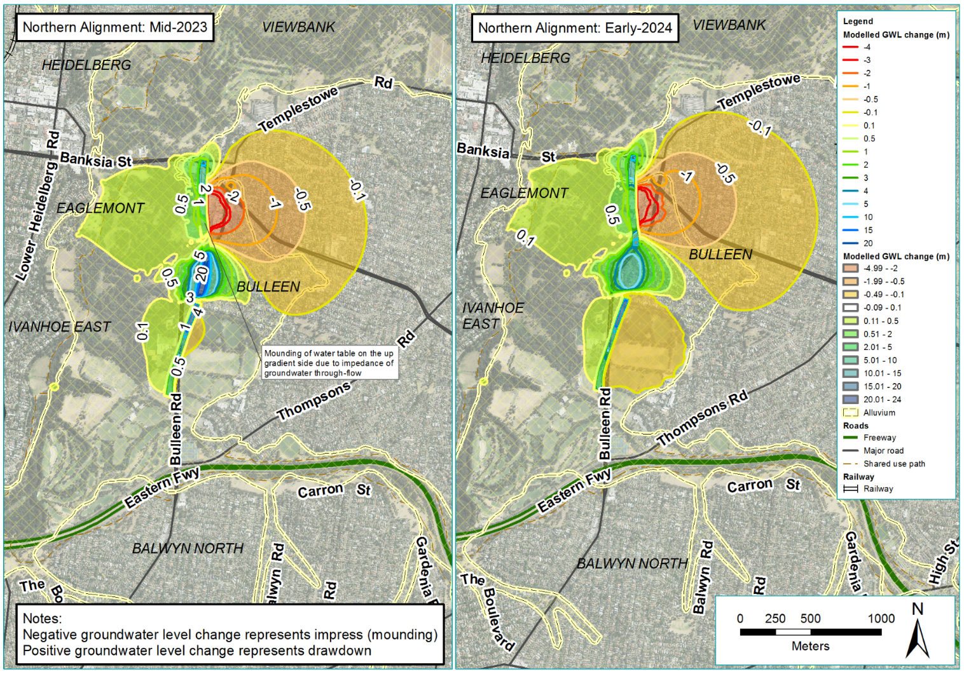
Figure 22-8 Predicted change in groundwater levels around the southern portal during construction

Groundwater availability
The construction of North East Link may change the availability of groundwater. The risk pathway associated with changes to groundwater availability is summarised in Table 22-4
Table 22-4 Risk table: Construction – changes to groundwater availability
Risk ID | Risk pathway | Risk rating
Risk GW02 | Construction activities including dewatering (or extraction of groundwater for construction water supply) result in loss of operational capacity of existing, registered, groundwater users | Low
Construction activities including extracting groundwater for use in construction or dewatering may deplete groundwater and affect its availability for existing users (risk GW02). Groundwater is a possible alternative water source to mains water during construction. Dewatering of the trench and tunnel sections during construction may cause drawdown that could continue once the project is operating.
How changes to groundwater affects availability

Changes to groundwater availability are shown schematically in Figure 22-9. A bore is located near to the project. When the project is constructed, water levels are drawn down as a result of construction dewatering or inflow into a drained or un-tanked structure. The change in water levels at the private bore can effect bore operation.
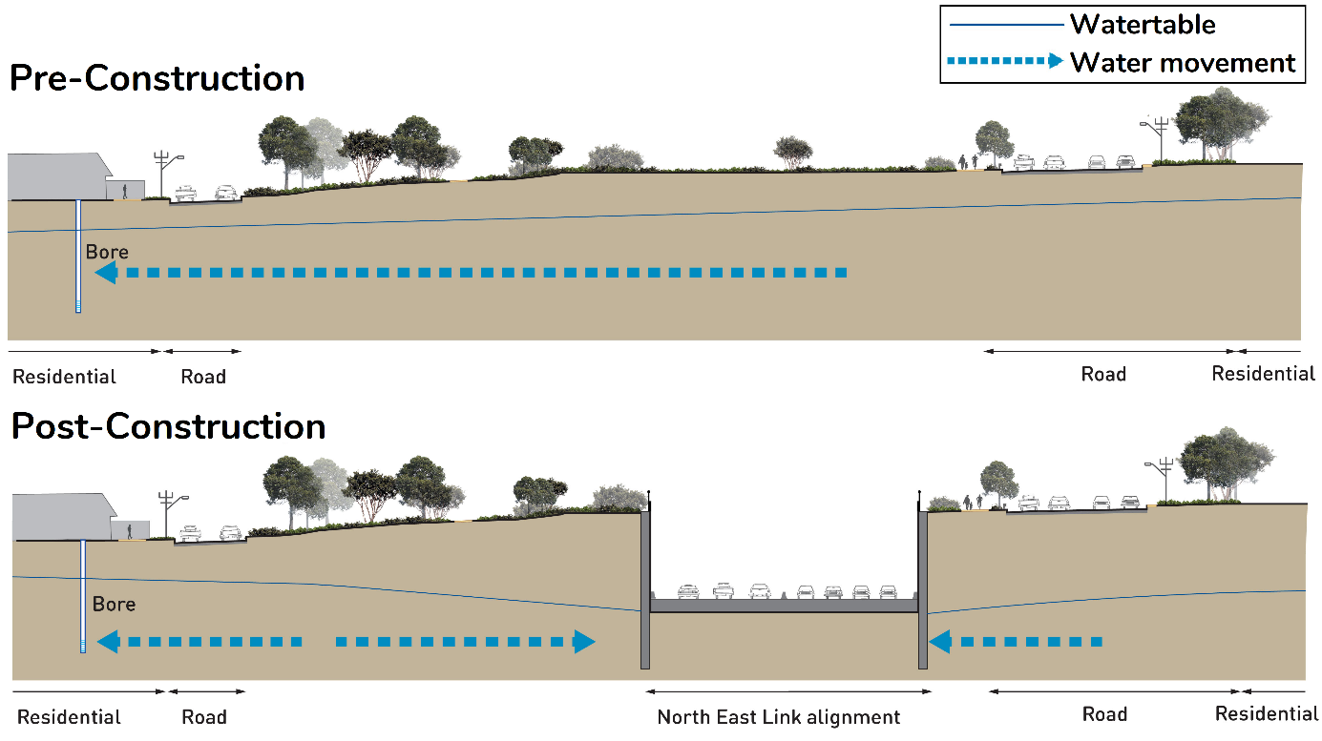
Figure 22-9 Schematic of how changes to groundwater can affect availability
Opportunity to use groundwater as an alternative water supply for the project’s construction activities would be limited as the groundwater is generally too saline and bore yields have been low.
Dewatering from construction would create drawdown that may limit the availability of groundwater. In terms of abstractive groundwater use, there are limited groundwater users within the predicted drawdown extents. However, groundwater dependent ecosystems such as terrestrial vegetation may be impacted by these changes. This is discussed in Chapter 25 – Ecology.
To manage the impact of drawdowns on existing groundwater users, a number of approaches have been applied including requirements under the Water Act. The North East Link tunnels would be designed and constructed to minimise groundwater drawdown (EPR GW03). Groundwater monitoring would be undertaken prior to construction to establish baseline water level and quality conditions. Monitoring would continue throughout construction to confirm that potential impacts from construction are being adequately managed and to identify if any additional measures would be required (EPR GW02).
Additionally, a review would be conducted to confirm the status of bore use within the construction drawdown area and if required, a plan would be developed and implemented to maintain water supply. This would be developed as part of the project’s Groundwater Management Plan which would define controls to protect groundwater impacts from construction activities (EPR GW04).

Changes to groundwater quality
The construction of North East Link may change the quality of groundwater. The risk pathways associated with changes to groundwater availability are summarised in Table 22-5 and discussed below.
Table 22-5 Risk table: Construction – changes to groundwater quality
Risk ID | Risk pathway | Risk rating
Risk GW01 | Construction activities that result in the degradation of groundwater quality via spills, storage and handling of hazardous materials, such as fuels. | Low
Risk GW03 | Construction activities including dewatering (and water supply) result in a water level drawdown of a magnitude in areas having in situ sulfidic sediments or rock that results in generation of acidic groundwater conditions. | Low
Risk GW04 | Construction activities including dewatering (or extraction of groundwater for construction water supply) result in the dislocation of delineated, contaminated groundwater plumes. | Low

Changes to groundwater quality
Construction activities may change groundwater quality and have the potential to affect the availability of groundwater for use (risk GW01). Groundwater quality changes may arise during construction from:
- Spillage, improper handling, storage and application of hazardous materials
- Reinjection of groundwater seepage
- Leaching from imported backfill, chemical additives to grouts and sealing resins
- Fluids used during artificial recharge activities.
Construction activities may result in localised groundwater quality impacts as a result of spillage, storage or improper handling of hazardous materials. The likelihood of such environment incidents is low because the construction would be required to implement controls to manage chemicals, fuels and hazardous materials to manage such risks (EPR CL5). Furthermore, pollutants need sufficient time and a pathway to reach the groundwater environment (that is, travel through the soil to the groundwater environment). It is a reasonable expectation that incident response procedures would occur promptly, for example, the use of spill kits or containment, and this would reduce the severity of the consequence.
To manage this impact, a groundwater monitoring program would be developed and implemented to monitor groundwater quality (EPR GW02). A Groundwater Management Plan would be developed and implemented to protect groundwater quality and to manage the project’s interaction with groundwater (EPR GW04). The Groundwater Management Plan would be implemented pre-construction and continue once the project is operating to confirm groundwater quality. Controls would also be required to manage chemicals, fuels and other hazardous materials (EPR CL5) under the Construction Environment Management Plan (CEMP).

Changes to groundwater quality from acid sulfate soil and rock
Construction activities such as dewatering may result in water level drawdown that exposes acid sulfate soil and rock which generates acidic groundwater conditions (risk GW03).
Acidic groundwater could adversely affect underground buildings and structures, the environment and other users of groundwater.

How groundwater quality may change from acid sulfate soil and rock

Changes to groundwater quality from acid sulfate soil and rock are shown schematically in Figure 22-10 below. The reduction in water levels may expose potential acid sulfate soil and generate acid plumes. When the project is constructed, water levels are drawdown as a result of construction dewatering or inflow into a drained or un-tanked structure. The reduction in water level can expose and oxidise potential acid sulfate soil leading to the migration of acidic groundwater impacting underground structures and environments.
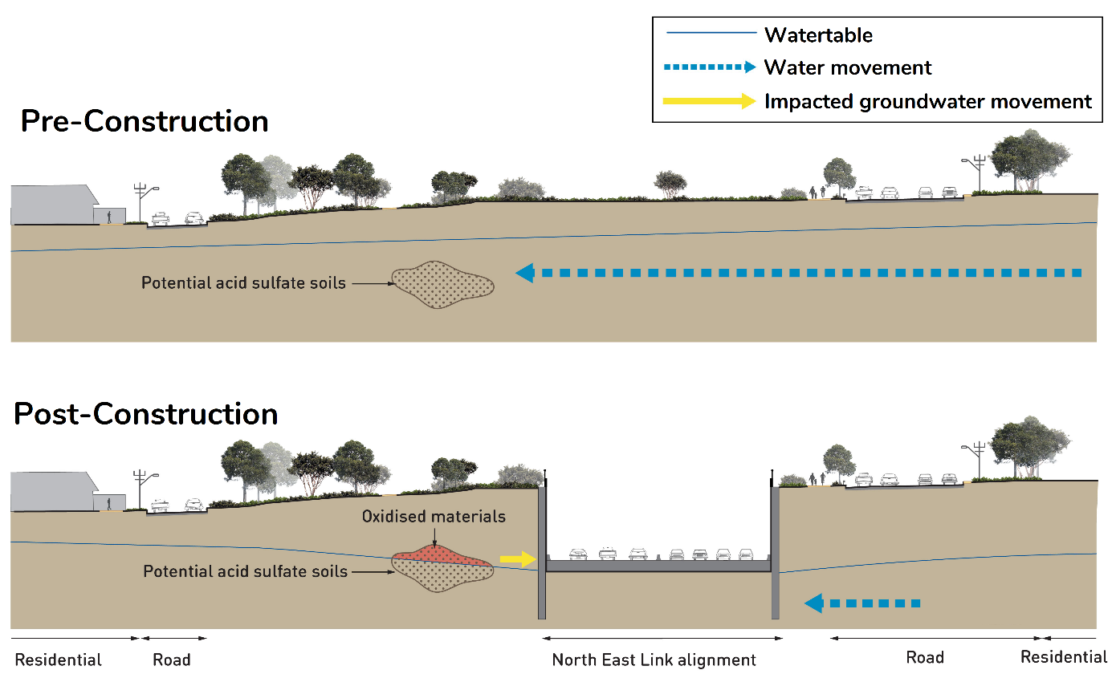
Figure 22-10 Schematic changes to groundwater quality from acid sulfate soil and rock

Within the predicted extent of drawdown, the risk of the project generating acidic groundwater conditions is considered to be low based upon:
- Acid sulfate soil and rock around the project is generally deeper than 20 metres below the ground surface around the project. Rock at shallower depths is highly likely to have been previously oxidised from natural groundwater movement and weathering.
- Only the deepest excavations may encounter potential acid-generating materials. These are located at the northern portal and the Manningham Road interchange.
- The duration of construction is likely to provide a limited opportunity for rainfall to pass through oxidised soil and rock.
- Sources of potential acid sulfate soil and rock within excavations are removed during construction.
To manage this potential impact, a pre-construction, construction and post-construction groundwater monitoring program would be implemented to monitor groundwater quality (EPR GW02). The tunnel drainage would be designed, and construction methods adopted to minimise changes to groundwater levels during the project’s construction (EPR GW03).

Changes to groundwater quality from contamination
Construction activities such as dewatering can cause water level drawdown which mobilises the migration of contaminated groundwater plumes (risk GW04). Figure 22-11 shows how this mobilization and migration can change groundwater quality.

How groundwater quality may change due to mobilisation of contamination
Changes to groundwater quality from contamination are shown schematically in Figure 22-11 below. The reduction in water levels may mobilise contaminated groundwater plumes. When the project is constructed, water levels change from drawdown as a result of construction dewatering or inflow into a drained or un-tanked structure. The change in water can influence the location of the contaminated groundwater plume and environments usually in the direction of regional flow.
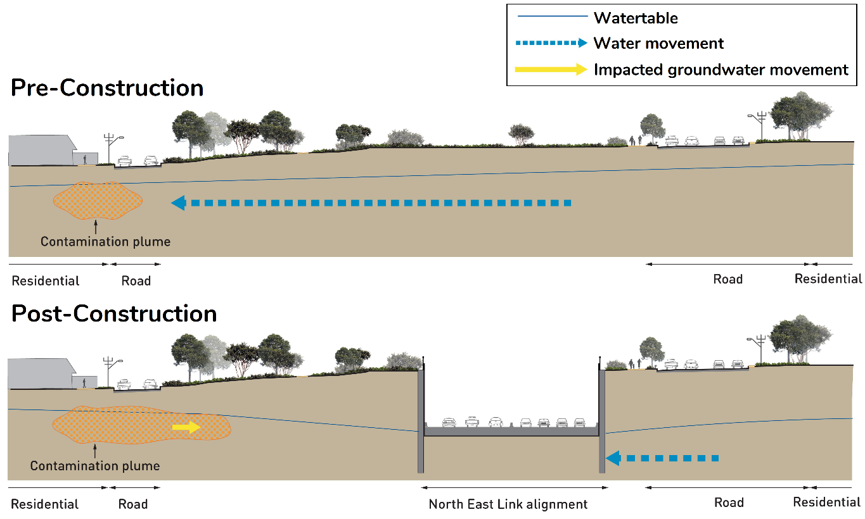
Figure 22-11 Schematic showing the mobilisation of contamination in groundwater
Investigations to date have not identified significant areas of groundwater contamination in the North East Link study area. Known and potential sources of contamination are discussed in Chapter 23 – Contamination and soil.
Nevertheless, given the previous land uses, there is a possibility that groundwater contamination may exist in some discrete locations within the project boundary. This includes potential hydrocarbon contamination at the fuel service station on the corner of Greensborough Road and Yallambie Road, and PFAS contamination at the former Bulleen Drive-in site. These would be further investigated during the detailed design of the project.
Disturbance of any contamination including waste materials would be managed through the development and implementation of a Spoil Management Plan to mitigate impacts to the environment and human health (EPR CL1). The preparation of the Spoil Management Plan would entail further investigations to characterise spoil and would include practice measures to manage spoil during construction. This is discussed further in Chapter 23 – Contamination and soil.
Additionally, a pre-construction, construction and post-construction groundwater monitoring program would be undertaken to establish baseline water quality and determine if changes occur (EPR GW02). The tunnel drainage would be designed and construction methods would be adopted to minimise changes to groundwater levels during construction with any contaminated groundwater required to be effectively managed (EPR GW03). A review would also be conducted to confirm the status of extraction bores within the estimated construction drawdown area and if required, a plan would be developed and implemented to protect water (EPR GW04).

Disposal of groundwater
The disposal of groundwater collected from water flowing into excavations and structures during the project’s construction may generate impacts. The risk pathway associated with the discharge of groundwater is summarised in Table 22-6 and discussed below.
Table 22-6 Risk table: Construction – disposal of groundwater
Risk ID | Risk pathway | Risk rating
Risk GW05 | Management of groundwater seepage into construction excavations results in unacceptable impacts at the point of discharge. | Low

Management of groundwater inflow during construction
Groundwater that flows into excavations or structures during construction would be managed to ensure that potential impacts are reduced at areas of discharge (risk GW05). The management of water disposal would depend upon water quality and if the water was approved for release at certain locations.
Captured groundwater could be reused during construction or released into sewers and waterways or reinjected into aquifers to provide hydraulic control on drawdowns. Discharge into these systems may require treatment to meet regulatory requirements and monitoring so that compliance is achieved.
The project’s Groundwater Management Plan would need to include requirements and construction methods to protect groundwater quality (EPR GW04). The methods for managing groundwater interception during construction would include:
- Identification, treatment, disposal and handling of contaminated seepage water and slurries including vapours in accordance with relevant legislation and guidelines
- Assessment of barrier and damming effects
- Subsidence management
- Dewatering and potential impacts on acid sulfate soils, including unconsolidated sediments and lithified sedimentary rock
- Protection of waterways and potential groundwater dependent ecosystems
- Management of unexpected contaminated groundwater (eg using treatments, hydraulic controls, grouting and exclusion methods)
- Contingency actions when interventions are required.
The disposal of wastewater collected during construction must be approved by the relevant authorities (such as EPA Victoria, Melbourne Water, City West Water or Yarra Valley Water depending on the proposed disposal method) prior to the discharge occurring (EPR SW03).

Operation impact assessment
This section summarises the potential impacts of North East Link’s operation that relate to groundwater.
The tunnels and other underground infrastructure would continue to influence groundwater conditions near the project once it was operating. While levels of groundwater drawdown are expected to be less, but occur over a greater area in the operation phase than during construction, there remains potential for groundwater-related impacts during this phase as the aquifer readjusts.
The predicted changes in the groundwater environment are discussed in the following sections, along with an assessment of the potential effects on groundwater availability, groundwater flow and groundwater quality. The evaluation of implications for groundwater dependent ecosystems is provided in Chapter 25 – Ecology. Additionally, Section 22.4.3 below examines the risks associated with management of groundwater inflows during the project’s operation.

Predicted changes to groundwater during operation
Once construction is completed, groundwater levels would gradually reach a new equilibrium. Groundwater modelling has been used to predict the extent of groundwater drawdown and any groundwater mounding due to barriers created by the tunnels through to 2075. The predicted change in groundwater level around the northern portal is shown in Figure 22-12. The predicted change in groundwater level around the southern portal is shown in Figure 22-13.
Drawdown is predicted to be between 0.1 and 0.5 metres south of Blamey Road, which is within the seasonal groundwater level fluctuation. Predicted drawdowns indicate that water levels would recover generally within three metres of pre-construction water levels and (three to four metres of drawdown) at the northern portal, Manningham Road interchange, and southern portal. No drawdown is anticipated around the M80 Ring Road or the Eastern Freeway during the project’s operation.

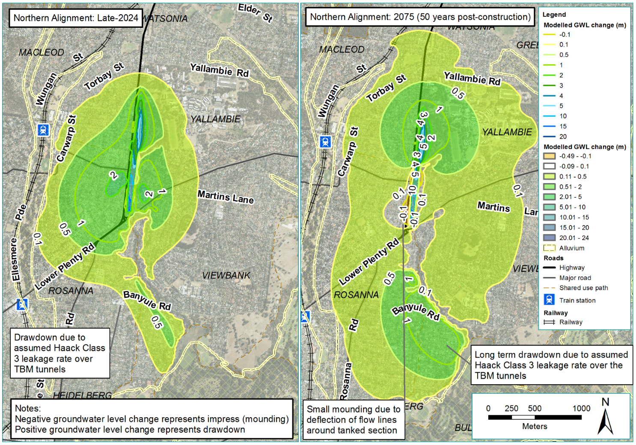
Figure 22-12 Predicted change in groundwater levels around the northern portal during operation
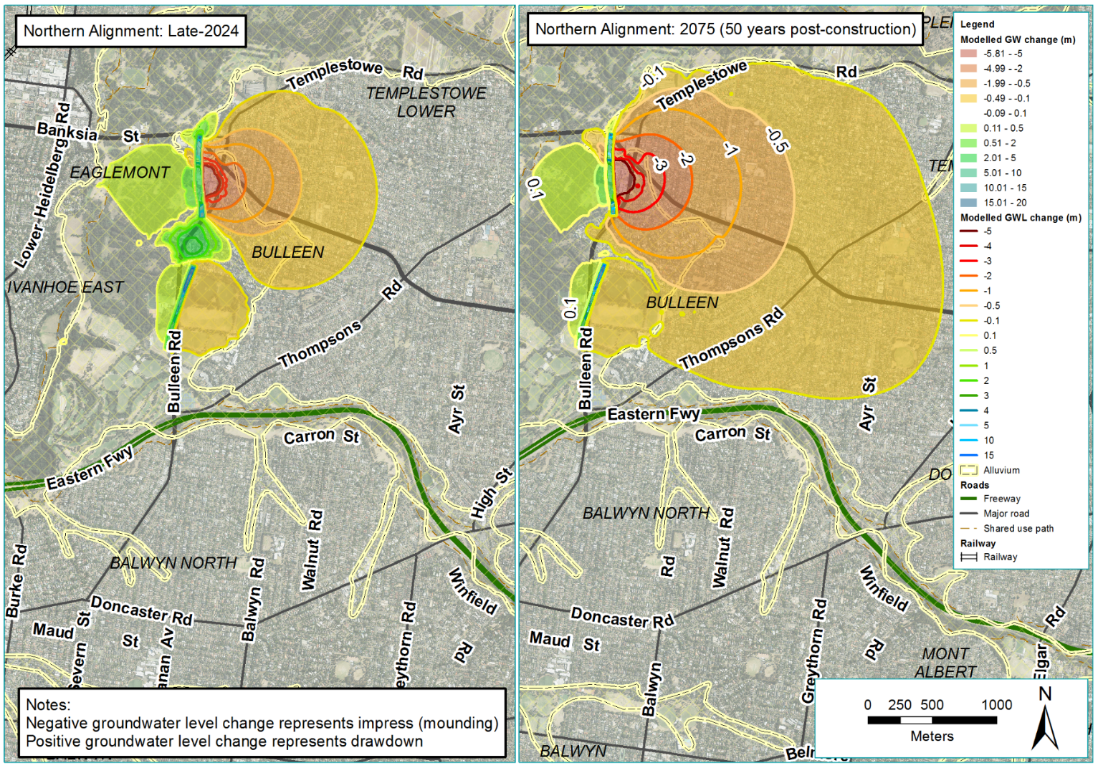
Figure 22-13 Predicted change in groundwater levels around the southern portal during operation

Groundwater availability
The operation of North East Link may impact on groundwater availability. The risk pathways associated with these changes are summarised in Table 22-7 and discussed below.
Table 22-7 Risk table: Operation – changes from groundwater movement
Risk ID | Risk pathway | Risk rating
Risk GW07 | Long term groundwater seepage into drained structures results in loss of operational capacity of existing, registered, groundwater users | Low
Risk GW10 | Buried structures such as tunnels and long cut-off walls, results in the creation of a barrier to groundwater flow and changes to groundwater levels. | Low

Changes to groundwater availability
Groundwater may seep into underground structures such as the trench and tunnels during the project’s operation and reduce the groundwater supply for existing users (risk GW07).
Only a couple of private groundwater users have been identified within the area of predicted drawdown. The predicted change in water level is not considered to affect the operation of these bores and is within the 10 per cent change range recommended by Southern Rural Water.
Existing groundwater users would be identified prior to construction (EPR GW04), and monitoring of groundwater would ensure that changes to water levels and quality are managed (EPR GW02).
Ground dependent ecosystems, mainly around the tunnels and the northern extent of the trench, may be impacted by these changes and are discussed further in Chapter 25 – Ecology.

The project creating a barrier to groundwater flow
The tunnels and trench could create a barrier to groundwater flow and further changes to groundwater levels (risk GW10). This would most likely occur where a barrier is perpendicular to the regional groundwater flow direction. The assessment used the predicted extents of groundwater level changes shown in Figure 22-12 and Figure 22-13 in Section 22.4.1.
Around the M80 Ring Road the project would not be expected to impede regional groundwater flow as flow in this area is southwards and would be broadly parallel with the project. Between the northern extent of Waratah Crescent and Lower Plenty Road, a slight mounding of 0.5 metres is predicted but this would be within the range of seasonal fluctuation of groundwater and so would not impact significantly on Banyule Creek.
Between Lower Plenty Road and Bridge Street, the tunnels would not create groundwater mounding. South of Bridge Street where the tunnels would align parallel to the Yarra River, the tanked tunnel structure is predicted to influence groundwater levels as follows:
- On the down gradient or western side of the project, a reduction in pre-construction water levels would occur due to less through-flow
- Small drawdowns are predicted to extend beneath the Yarra River which may reduce the hydraulic gradient between the Yarra River and groundwater, with no loss of flow from the Yarra River, as gradients would still result in discharge from groundwater to the waterway
- A drawdown of 0.1 to 0.5 metres is predicted at Bolin Bolin Billabong with the potential effects discussed in Chapter 25 – Ecology
- On the up gradient, or eastern side, mounding or a rise in water levels is predicted. The mounding is expected to raise water levels up to six metres east of Bulleen Road and five metres east of Manningham Road.
The resulting depth to ground water from mounding from modelling indicates that levels may rise to be within five metres of the ground surface in areas between the project and Bulleen Road and Manningham Road, as shown in Figure 22-14 below.
If water levels rise to within two metres of the ground surface, water logging or salinity may become potential risks. Shallow waters can lead to water leaking into underground structures such as rooms and basements or create buoyancy effects from hydrostatic uplift on multi-level underground car parks, sewers and underground storage tanks. However, the area where mounding is predicted be the greatest is within the project boundary, and this area would be acquired for the project. Assessment and requirements for the protection of utilities at risk in this area is discussed in Chapter 21 – Ground movement.
The project’s design and construction would be informed by the groundwater model to predict changes in groundwater levels and flow and quality, as they are affected by construction, and develop mitigation strategies (EPR GW01). Monitoring would inform control measures for groundwater changes during the project’s construction (EPR GW02).

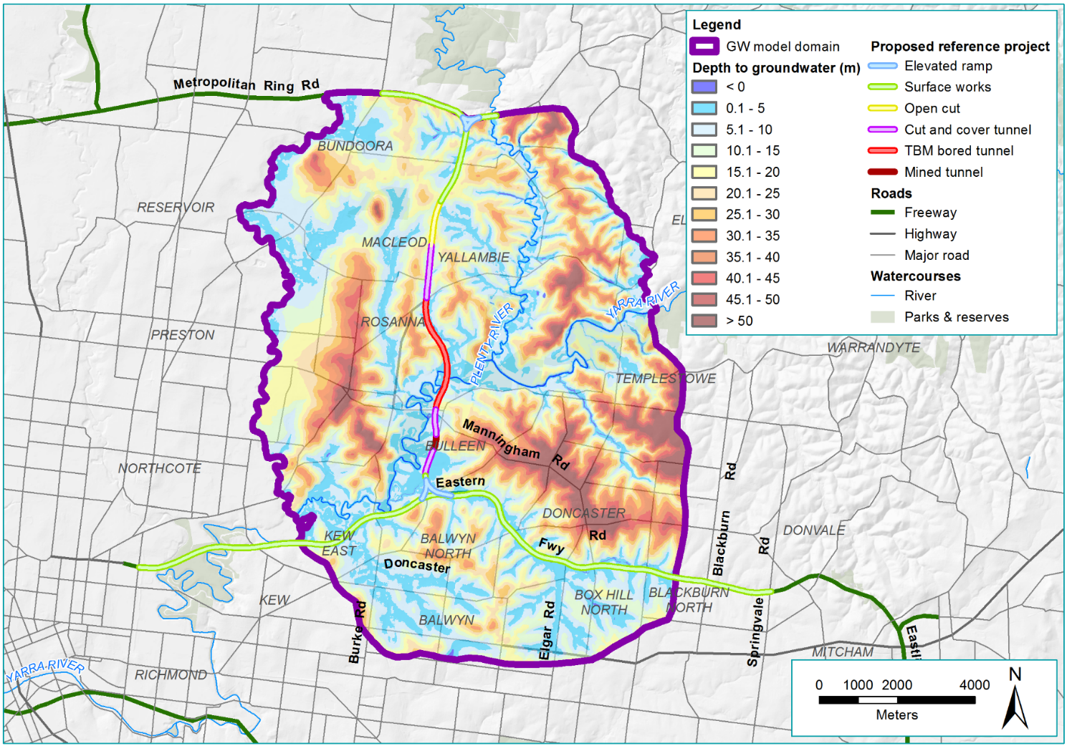
Figure 22-14 Predicted depth to groundwater around North East Link during operation of the project

Changes to groundwater quality
The operation of North East Link may cause changes to groundwater quality. The risk pathways associated with changes to groundwater quality are summarised in Table 22-8 and discussed below.
Table 22-8 Risk table: Operation – changes to groundwater quality
Risk ID | Risk pathway | Risk rating
Risk GW06 | Traffic accidents, spillage of hazardous materials, or events resulting in generation of contaminated stormwater runoff result in the degradation of groundwater quality. | Low
Risk GW08 | Long-term groundwater seepage into drained structures results in a groundwater drawdown in areas of in situ sulfidic sediments or rock and generates acidic conditions | Low
Risk GW09 | Long-term groundwater seepage into drained structures results in the dislocation of delineated, contaminated groundwater plumes. | Low

Changes to groundwater quality
Activities during the project’s operation may result in changes to groundwater quality and affect the availability of groundwater for use (risk GW06).
Groundwater quality change may arise from:
- Spillage of hazardous materials
- Management of stormwater runoff.
Traffic accidents, which could occur on any part of the road network, may result in the release of contaminants. With accidents generally being local with a rapid emergency services response, the potential for contaminants migrating to the groundwater system would be low. Roadside water run-off generally contains oil, grease, heavy metals and other potential contaminants. Run-off would be collected by roadside drainage and with the subsequent management of surface water, the potential for direct contamination of groundwater would be low.
To minimise the potential of spilled liquids ending up in waterways, the project would include spill containment features on new and upgraded roads (such as the M80 Ring Road to the Eastern Freeway) (EPR SW2). This would contain the spill from the types of heavy vehicles expected to use North East Link.
An emergency response plan would be developed for existing roads (such as the Eastern Freeway and certain sections around the M80 Ring Road) that details a procedure to contain hazardous spills.
Water Sensitive Urban Design (WSUD) principles would be used to manage the stormwater around the project (EPR SW11). This would include water treatment features such as grass swales, wetlands, bioretention ponds and storage dams to filter and treat stormwater captured from new road surfaces. These measures, combined with the controls that prevent and contain pollution events, would mean the potential for direct contamination of groundwater would be low. Further information on drainage design and stormwater management is provided in Chapter 24 – Surface water.
Groundwater monitoring would continue post-construction (EPR GW02) to evaluate groundwater restoration. Monitoring would be undertaken for a minimum of two years after construction or until acceptable restoration of groundwater has been confirmed.
Additionally, an Operation Environmental Management Plan for management, monitoring, reuse and disposal of groundwater inflows during the project’s operation would be developed and implemented (EPR GW05).

Changes to groundwater quality from acid sulfate soil and rock
During the project’s operation, even with tanking of underground structures, some groundwater may seep into the trench and tunnels, with the associated drawdown exposing acid sulfate soil and rock and generating acidic groundwater conditions (risk GW08). Acidic groundwater could adversely affect underground buildings and structures, the environment and users of groundwater.
The risk of oxidising acid-generating soil and rock would be greatest during the project’s construction when dewatering would be most significant. Recovery of water levels would occur when tanked conditions were achieved at construction completion. While full recovery of water levels may not be achieved, the magnitude of drawdown would reduce potential acid generating soil, and rock are likely to be re-saturated, thus reducing the risk of acidic conditions being continually generated. While post-construction drawdown radial extents would be greater, the magnitude of drawdown over these areas would be small and generally within the same magnitude as seasonal fluctuations. This means that existing oxidised and weathered soil and rock would be exposed. Accordingly, the potential for impacts on groundwater quality is considered to be low.
To manage this impact pre-construction, construction and post-construction, a groundwater monitoring program would characterise groundwater quality and manage construction activities. This includes monitoring water levels and quality after construction completion (EPR GW02).

Changes to groundwater quality from contaminated groundwater
During the project’s operation, groundwater may seep into underground structures such as the trench and tunnels with associated drawdown causing movement of any contaminated groundwater plumes (risk GW09) in the vicinity. Contaminated groundwater could adversely affect the environment and other users of groundwater. Potential sources of contamination are discussed in Chapter 23 – Contamination and soil.
Existing contamination would be identified and managed during the project’s construction. While the radial extents of drawdown are predicted to be greater during the project’s operation, the magnitude of drawdown is expected to be significantly less than during its construction.
Potential sources of groundwater contamination considered in the assessment were the Bulleen Industrial Precinct, the former Bulleen Drive-in and sites of existing and former service stations. While significant contamination is not known to exist at these locations, analytical modelling was used to estimate potential contamination movement. The modelling predicted relatively small migration distances. At the location of the former Bulleen Landfill under Bulleen Oval, some groundwater drawdown is predicted and it is expected that any contamination with groundwater would be captured in the adjacent tunnel, from where it would require appropriate disposal. However, it is important to note investigations have not identified leachate and contamination in this area and tunnel would not capture all contaminated groundwater. To manage these risks, further investigations to be undertaken for the preparation of a Spoil Management Plan (EPR CL01) would characterise existing contamination in the vicinity of the project. Groundwater monitoring would establish groundwater quality pre-construction and would continue during the project’s construction and for a minimum of two years post-construction to verify acceptable water quality (EPR GW02). Further, the tunnels would be designed to minimise changes to groundwater (EPR GW03) and groundwater intercepted during the project’s operation would be managed in accordance with regulatory requirements (EPR GW05).

Disposal of groundwater
Impacts associated with the disposal of groundwater, collected from water flowing into structures during North East Link’s operation, may arise from the construction of North East Link.
The risk pathways associated with the disposal of groundwater are summarised in Table 22-9 and discussed below.
Table 22-9 Risk table: Operation – disposal of groundwater
Risk ID | Risk pathway | Risk rating
Risk GW11 | Management (disposal) of groundwater seepage entering into tunnels/portals, results in the unacceptable impacts (eg salt loads, contamination) to point of discharge (eg waterway, sewer, groundwater) | Low
Risk GW12 | Unexpected contaminated groundwater seepage is not treated by the tunnel wastewater treatment plant resulting in groundwater being released to receiving environments (sewer, surface waters) or hazards to maintenance staff. | Low

The potential impacts associated with each of the risk pathways above are discussed in the following section.

Management of groundwater inflow during operation
Water that enters the tunnels during operation, either as groundwater seepage or as stormwater, may impact the receiving environment if not managed appropriately (risk GW11).
While the tunnels would be tanked to limit groundwater inflow, minor seepage would occur, albeit at the significantly less volumes than during the project’s construction. Water can also enter the tunnel system as stormwater run-off during rain events, including from vehicles using the tunnels. These two wastewater sources would be separated within the tunnel to facilitate effective treatment.
Captured groundwater could be discharged into sewers, waterways or reinjected into aquifers as a source of recharge. Discharge into these systems may require treatment to meet regulatory requirements, would require approval from the relevant authorities and monitoring would be needed so that compliance is verified. The tunnel system would be designed with drainage to minimise change to groundwater and manage disposal (EPR GW03). Measures for management, monitoring, reuse and disposal of groundwater from inflow during the project’s operation would be required to comply with regulatory requirements (EPR GW05). The disposal of water collected from stormwater or vehicle run-off in the tunnel system would need approval from the relevant authorities before discharge to sewers or waterways (EPR SW03).
The potential for unexpected contaminated groundwater seepage to be inadequately treated and discharged to receiving environments (risk GW12) is considered highly unlikely given the tanked design that minimises groundwater inflows, the intention to characterise groundwater contamination (EPR CL01) and the requirements to manage intercepted groundwater during operation (EPR GW05).

Conclusion
This chapter has identified and assessed existing conditions, potential impacts and associated risks to groundwater for North East Link.
Overall, the study area can be broadly simplified into a bedrock aquifer system, which underlies the entire project, and an alluvial aquifer, which overlies the bedrock system, but is restricted laterally to the Yarra River floodplain and other major drainage lines.
North East Link would mostly be constructed at or above the natural surface, except between Watsonia railway station and Bulleen Park. In this section, the trench and tunnels would intersect with the groundwater table.
Groundwater quality within the study area is generally brackish to saline which limits its use and there is minimal existing abstraction due to the project’s location in an urbanised, mostly residential setting, with potable water available through a widespread reticulation network.
The changes in groundwater would not be expected to result in any impacts on human health, buildings. The assessment determined that no regional changes to groundwater within the study area would occur and the majority of changes to groundwater levels would be located adjacent to the tunnel system.
Application of the project EPRs (described in full in Chapter 27 – Environmental management framework) would minimise impacts associated with groundwater by adopting a design of tanking structures to minimise long-term groundwater inflows. In addition, a Groundwater Management Plan would protect groundwater quality and manage the interception of groundwater during construction. During the project’s operation, measures for management, monitoring, reuse and disposal of groundwater inflows would comply with relevant legislation and guidelines
Based on the EES evaluation objective at the beginning of this chapter, effects of the project on groundwater have been assessed and EPRs have been identified to minimise or avoid impacts to human health, buildings and structures and the environment.

